Validation Figures

Weihsueh Chiu

2020-07-28

## Second Validation

Calibration using data until June 20. Validation with data through July 22.

Example states: one from each major region of the US: New York (Northeast), Ohio (Midwest), Texas (South), and Washington (West).

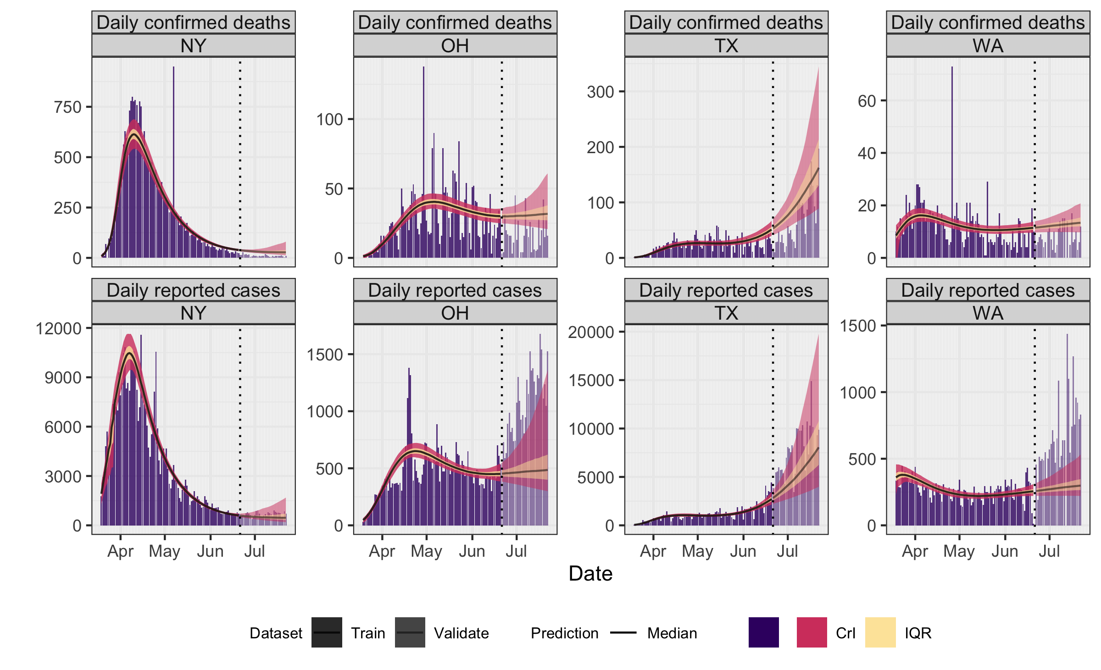

Next are scatter plots showing overall calibration and validation of model.

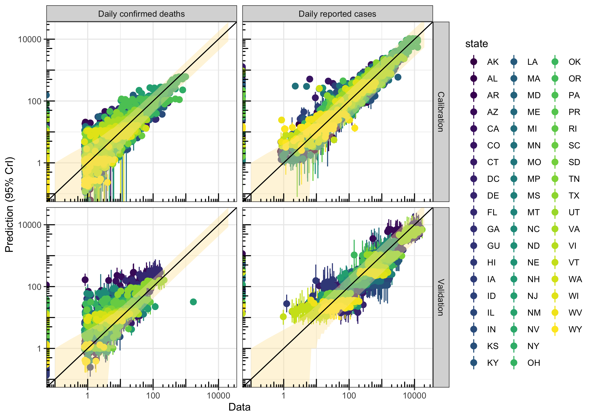

Each panel shows data versus predictions for daily deaths (left column) or cases (right column), with calibration results shown in the top panels (through June 20) and validation results in the bottom panels (through July 22). Each point includes the 95% CrI for the prediction. The band centered on the y=x line shows the additional 95% CrI for the negative binomial likelihood, which is used to account for day-to-day variation in reporting.