Figures_CritTestingTracing

Weihsueh Chiu

7/31/2020

## Load results

## Critical values of testing and tracing rates to achieve R[eff](t)<1

If critical value of testing > 1 per day, then an infinite value is assigned to represent that it cannot be achieved.

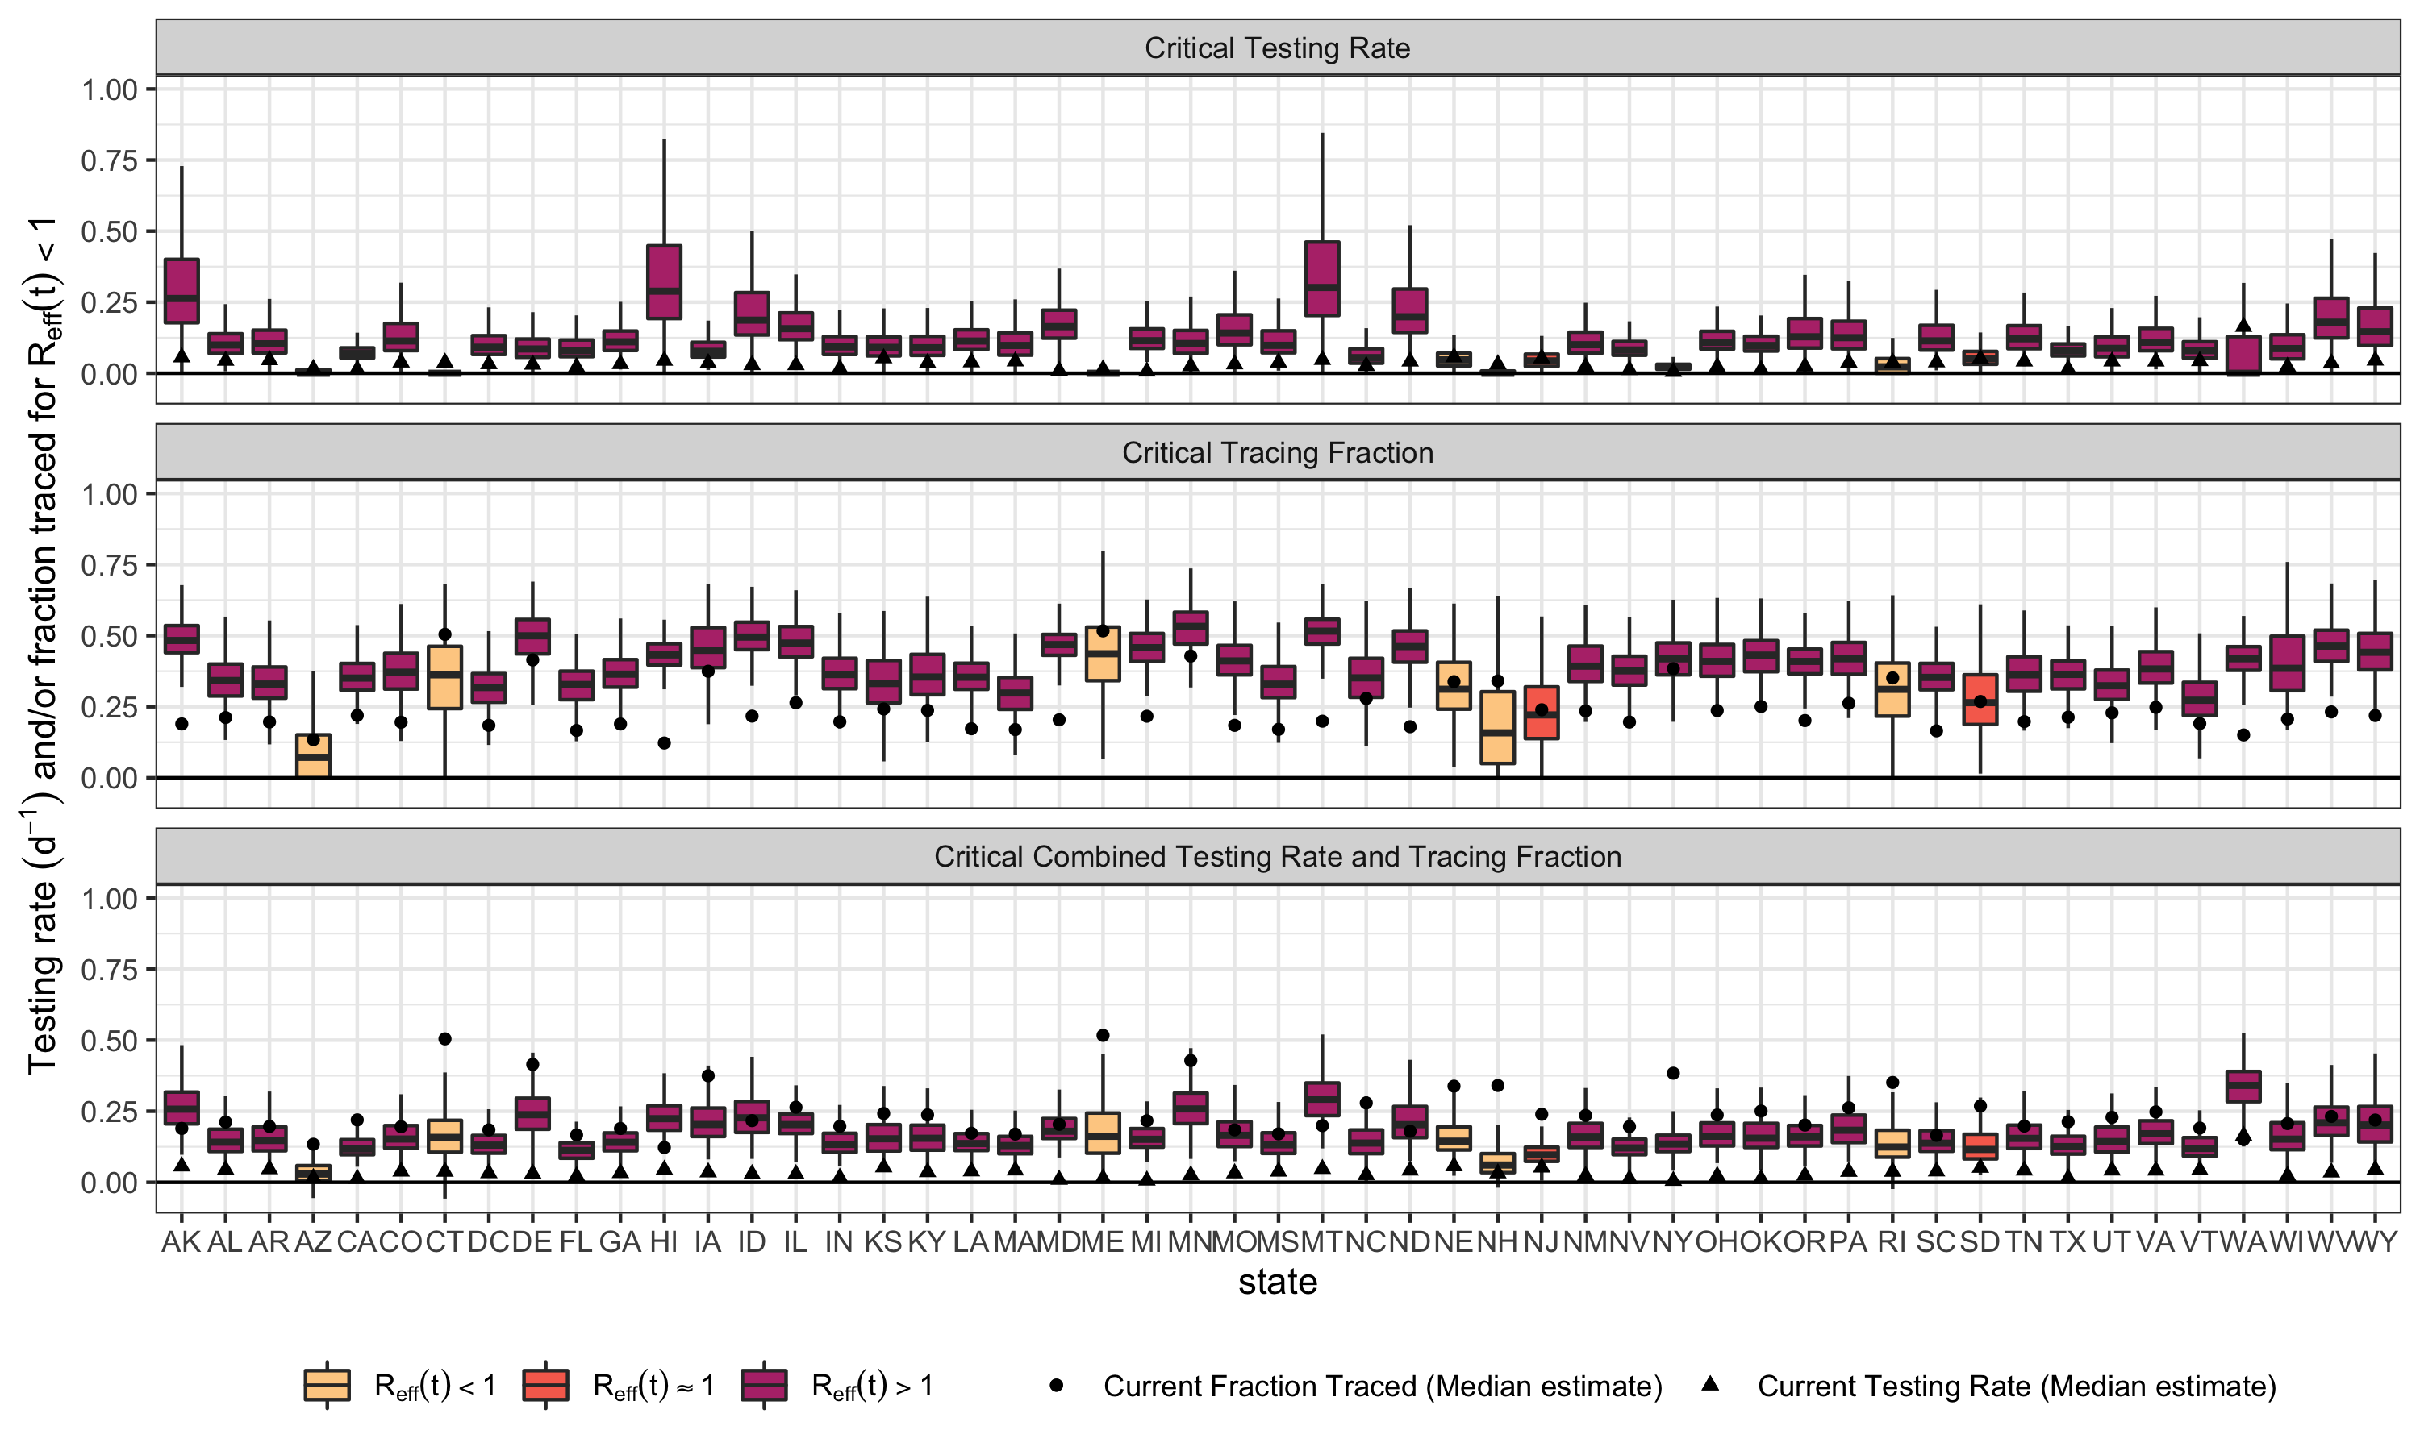

## Critical values of testing and tracing rates to achieve R(t)<1

Critical testing/tracing using R(t) and assuming complete reopening (using c0 and beta0 instead of c and beta). If critical value of testing > 1 per day, then an infinite value is assigned to represent that it cannot be achieved.fitparms.dfvariable==“thetamin”]<-“ThetaMin”

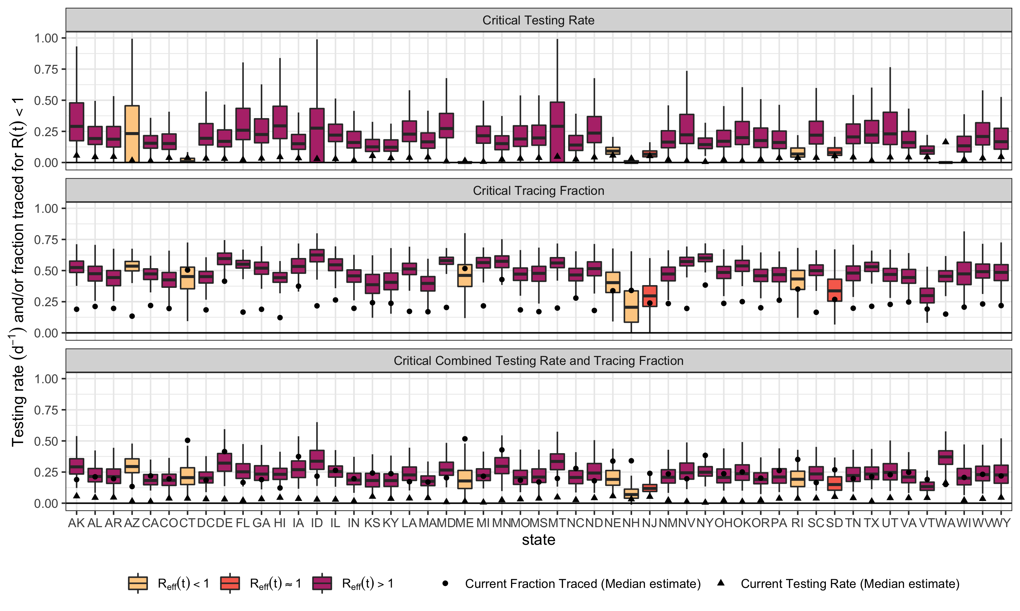

## Critical values of fold-increases in testing and tracing to achieve R[eff](t)<1

If critical value of testing > 1 per day, then an infinite value is assigned to represent that it cannot be achieved.

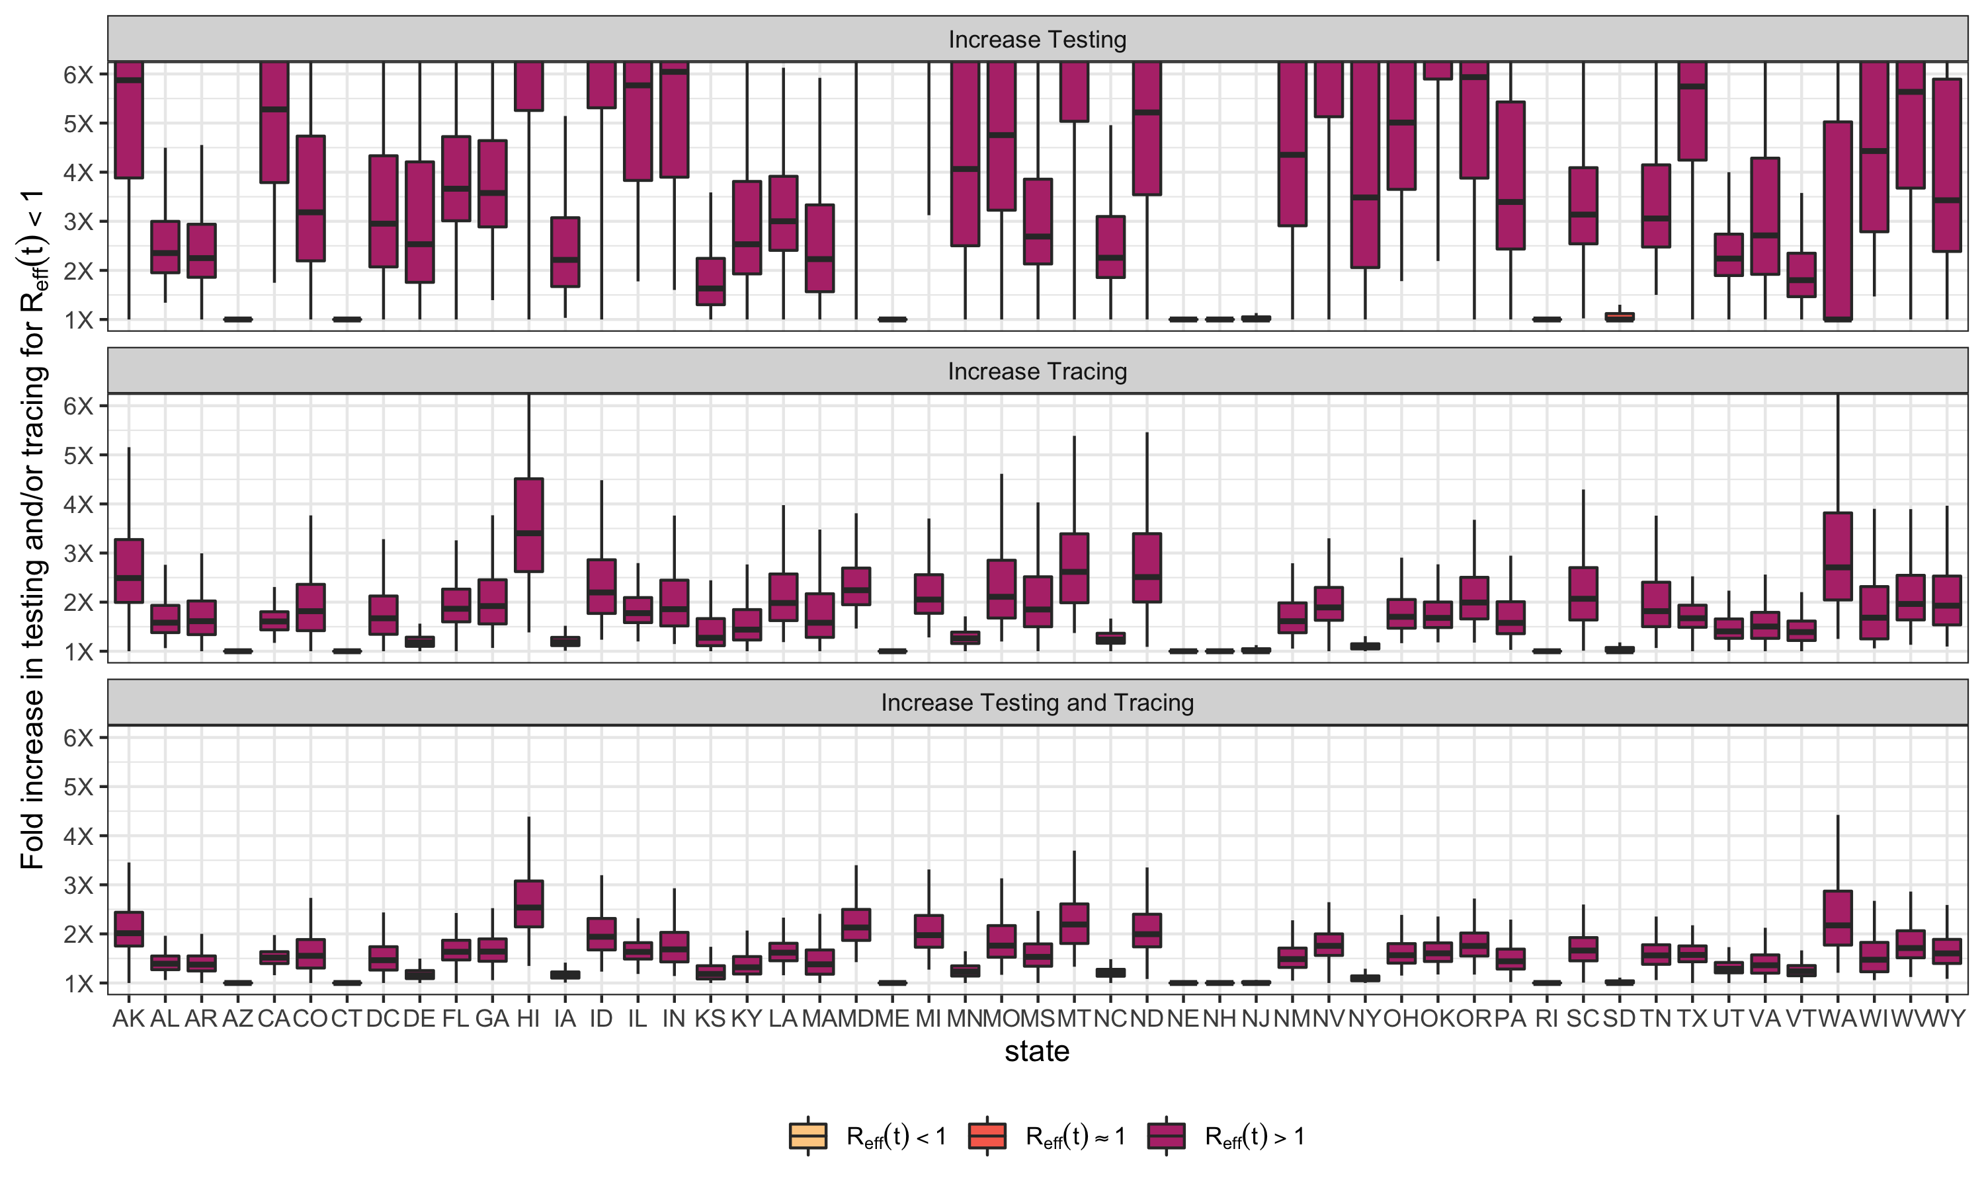

## Critical values of fold-increases in testing and tracing to achieve R(t)<1

Critical testing/tracing using R(t) and assuming complete reopening (using c0 and beta0 instead of c and beta). If critical value of testing > 1 per day, then an infinite value is assigned to represent that it cannot be achieved.fitparms.dfvariable==“thetamin”]<-“ThetaMin”

