Check Case Data Trend

Weihsueh Chiu

7/30/2020

## Load case data with 7-day rolling mean (centered)

## Peaks in the range of concern

First we are only worred about states with peaks after June 20 and before July 22. So looking at the graph, that leaves the states up to Georgia (GA).

## Warning: Removed 3 rows containing missing values (geom_path).

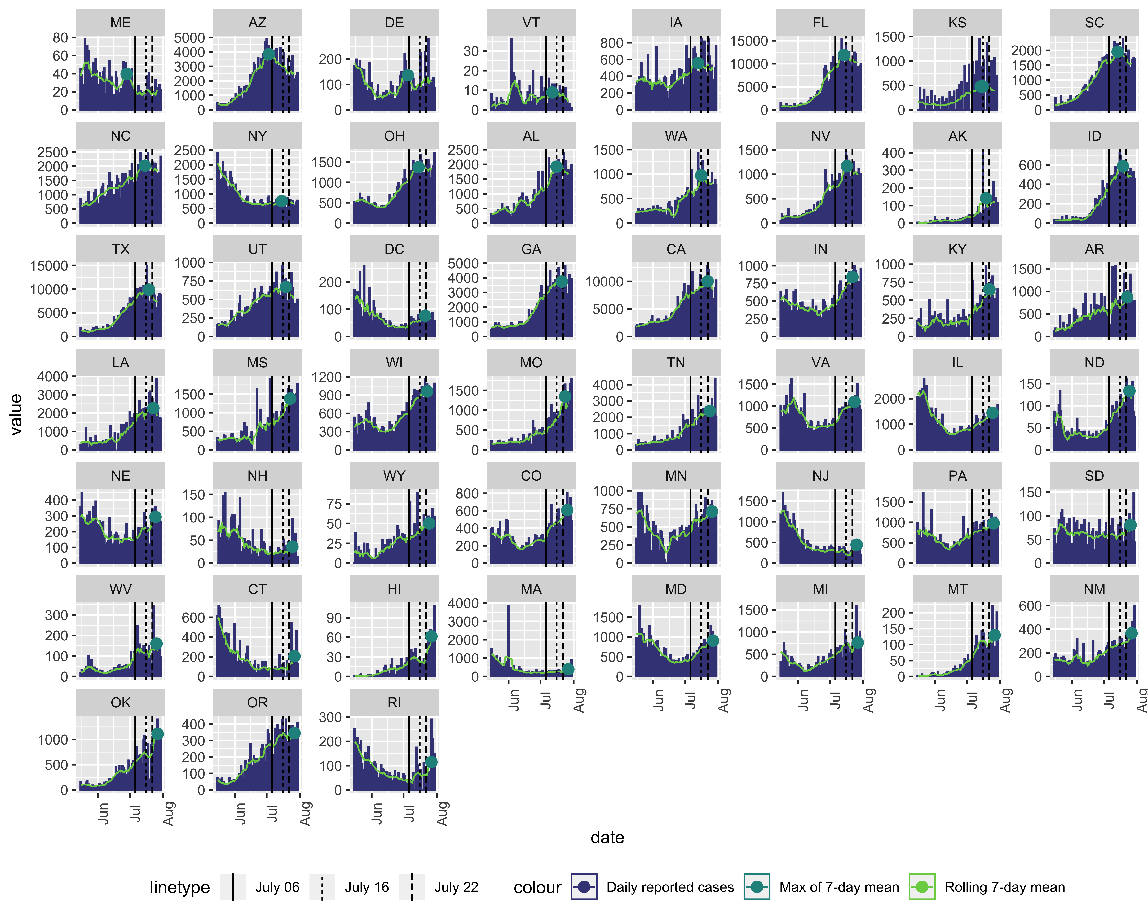

## Look for re-opened and then re-sheltered states

Next, we are only worried about states that have clearly re-opened and then re-sheltering, so that excludes ME, DE, VT, NY, and DC.

## Warning: Removed 3 rows containing missing values (geom_path).

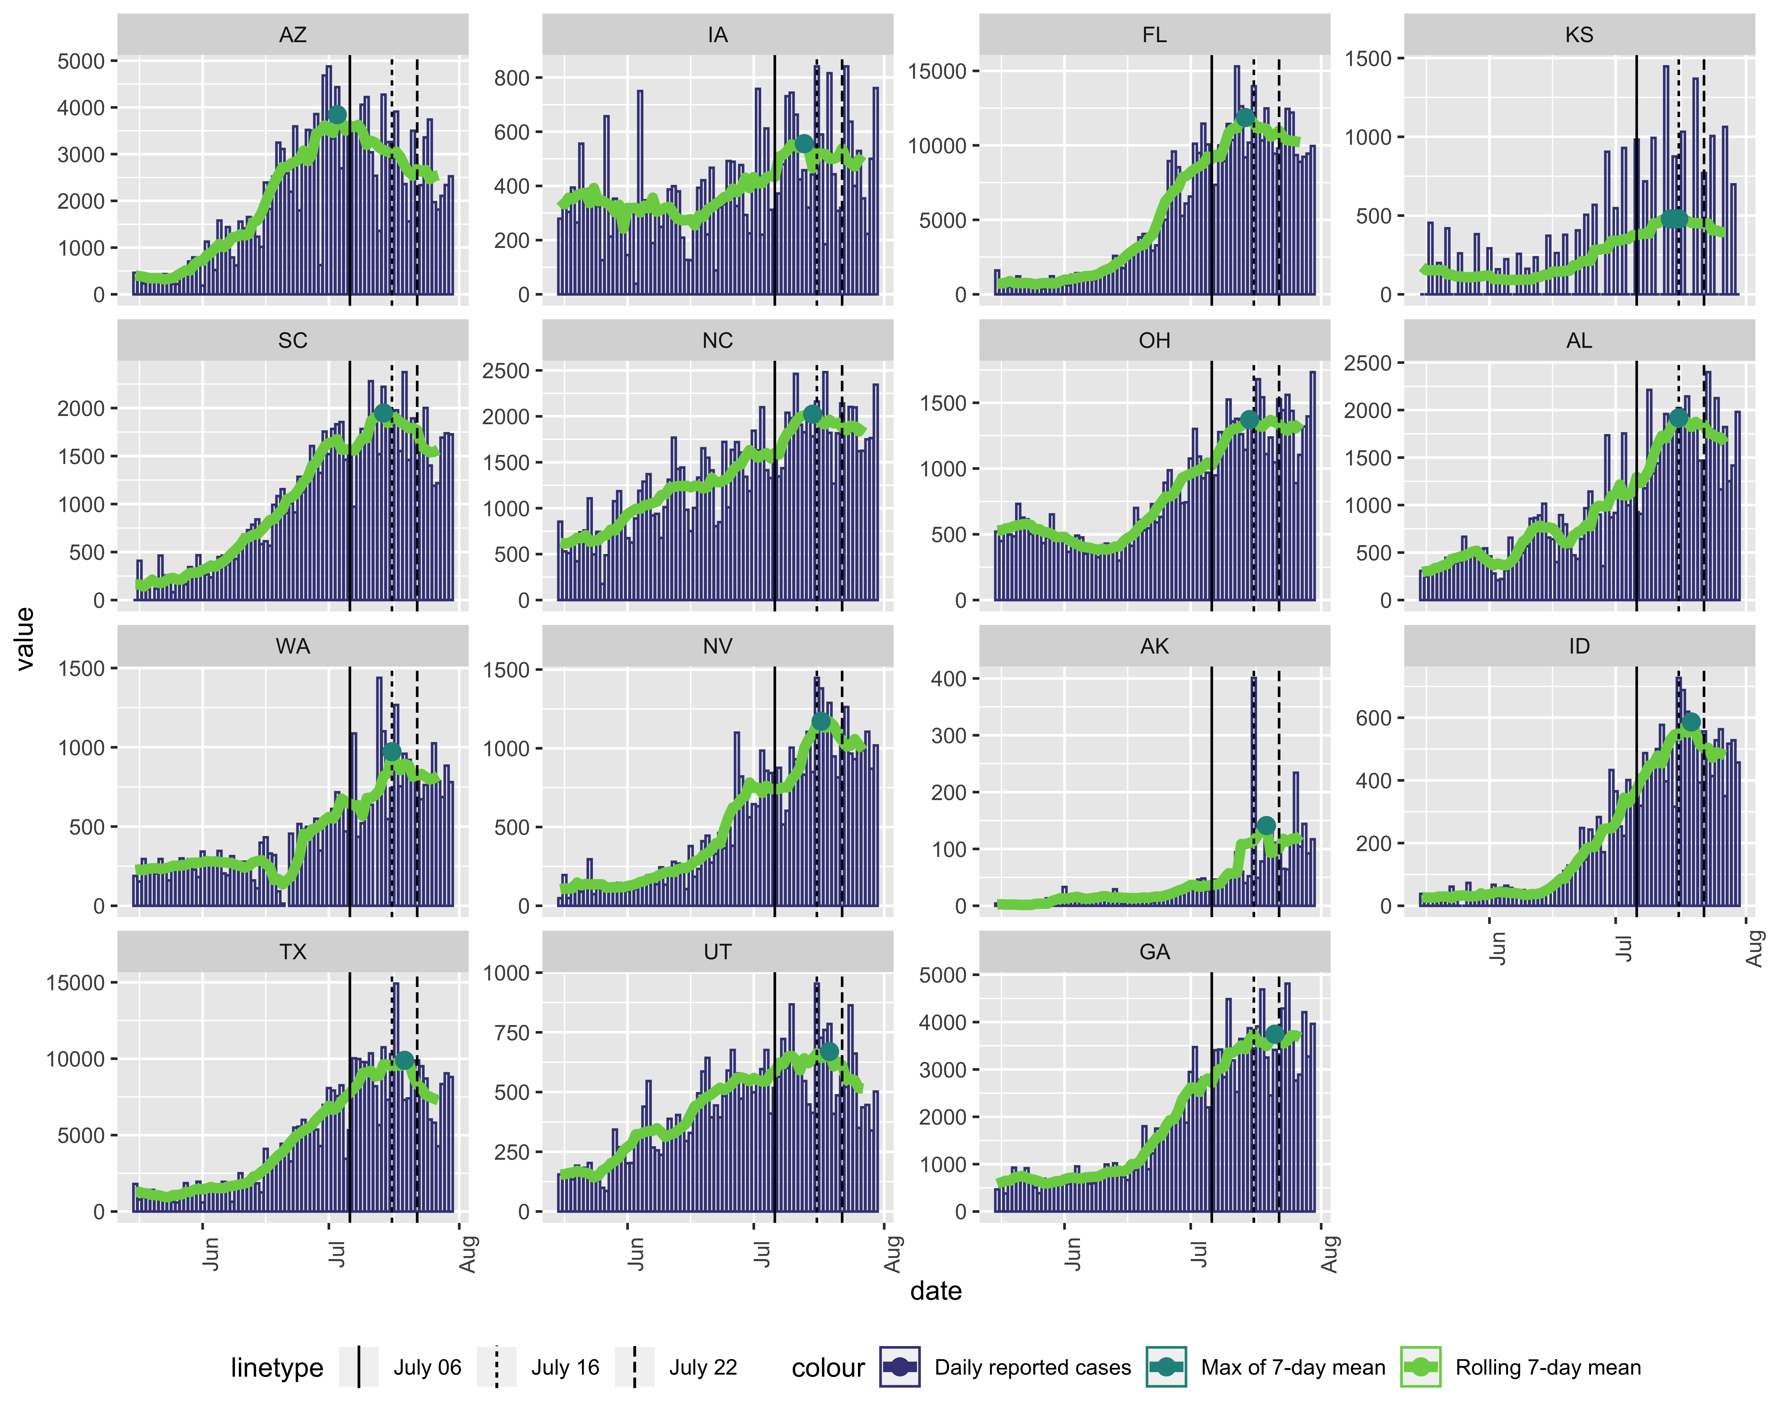

That leaves 15 states where there is a potential “plateau” or “decline” indicating a reversal of re-opening.

## date numDate state fips variable value ismax  
## 2 2020-07-03 185 AZ 4 meanpositiveIncrease 3844.0000 TRUE  
## 5 2020-07-13 195 IA 19 meanpositiveIncrease 556.0000 TRUE  
## 6 2020-07-14 196 FL 12 meanpositiveIncrease 11870.0000 TRUE  
## 7 2020-07-14 196 KS 20 meanpositiveIncrease 479.1429 TRUE  
## 8 2020-07-14 196 SC 45 meanpositiveIncrease 1948.7143 TRUE  
## 9 2020-07-15 197 KS 20 meanpositiveIncrease 479.1429 TRUE  
## 10 2020-07-15 197 NC 37 meanpositiveIncrease 2023.5714 TRUE  
## 12 2020-07-15 197 OH 39 meanpositiveIncrease 1372.5714 TRUE  
## 13 2020-07-16 198 AL 1 meanpositiveIncrease 1917.7143 TRUE  
## 14 2020-07-16 198 KS 20 meanpositiveIncrease 479.1429 TRUE  
## 15 2020-07-16 198 WA 53 meanpositiveIncrease 972.5714 TRUE  
## 16 2020-07-17 199 NV 32 meanpositiveIncrease 1171.1429 TRUE  
## 17 2020-07-19 201 AK 2 meanpositiveIncrease 141.1429 TRUE  
## 18 2020-07-19 201 ID 16 meanpositiveIncrease 586.2857 TRUE  
## 19 2020-07-19 201 TX 48 meanpositiveIncrease 9893.2857 TRUE  
## 20 2020-07-19 201 UT 49 meanpositiveIncrease 669.5714 TRUE  
## 22 2020-07-21 203 GA 13 meanpositiveIncrease 3745.4286 TRUE