Morris_meta

Weihsueh Chiu

February 9, 2017

## Morris Latency last trial animal details

Only included studies that had standard deviation data extracted. Effect measure is log ratio of mean between treated and control, times 100 (which for small values is close to the % change). Random effects models were fit for overall effect, linear in log10(dose), linear in dose, and linear-quadratic in dose. Sensitivity analysis included leaving one study out at a time and using only the highest dose from each study.

The results show a statistically significant overall effect of PBDE treatment that is also robust to leaving out individual studies, using only the highest dose group in each study, and leaving out individual studies using the highest dose group only. There was also low or no heterogeneity (<25%, not statistically significant in primary analysis and all sensitivity analyses). Use of a linear model in log10(dose), a linear model in dose, or a linear-quadratic model did not reduce heterogeneity, and in some cases increased it. Thus, there is no evidence of a dose-response gradient.

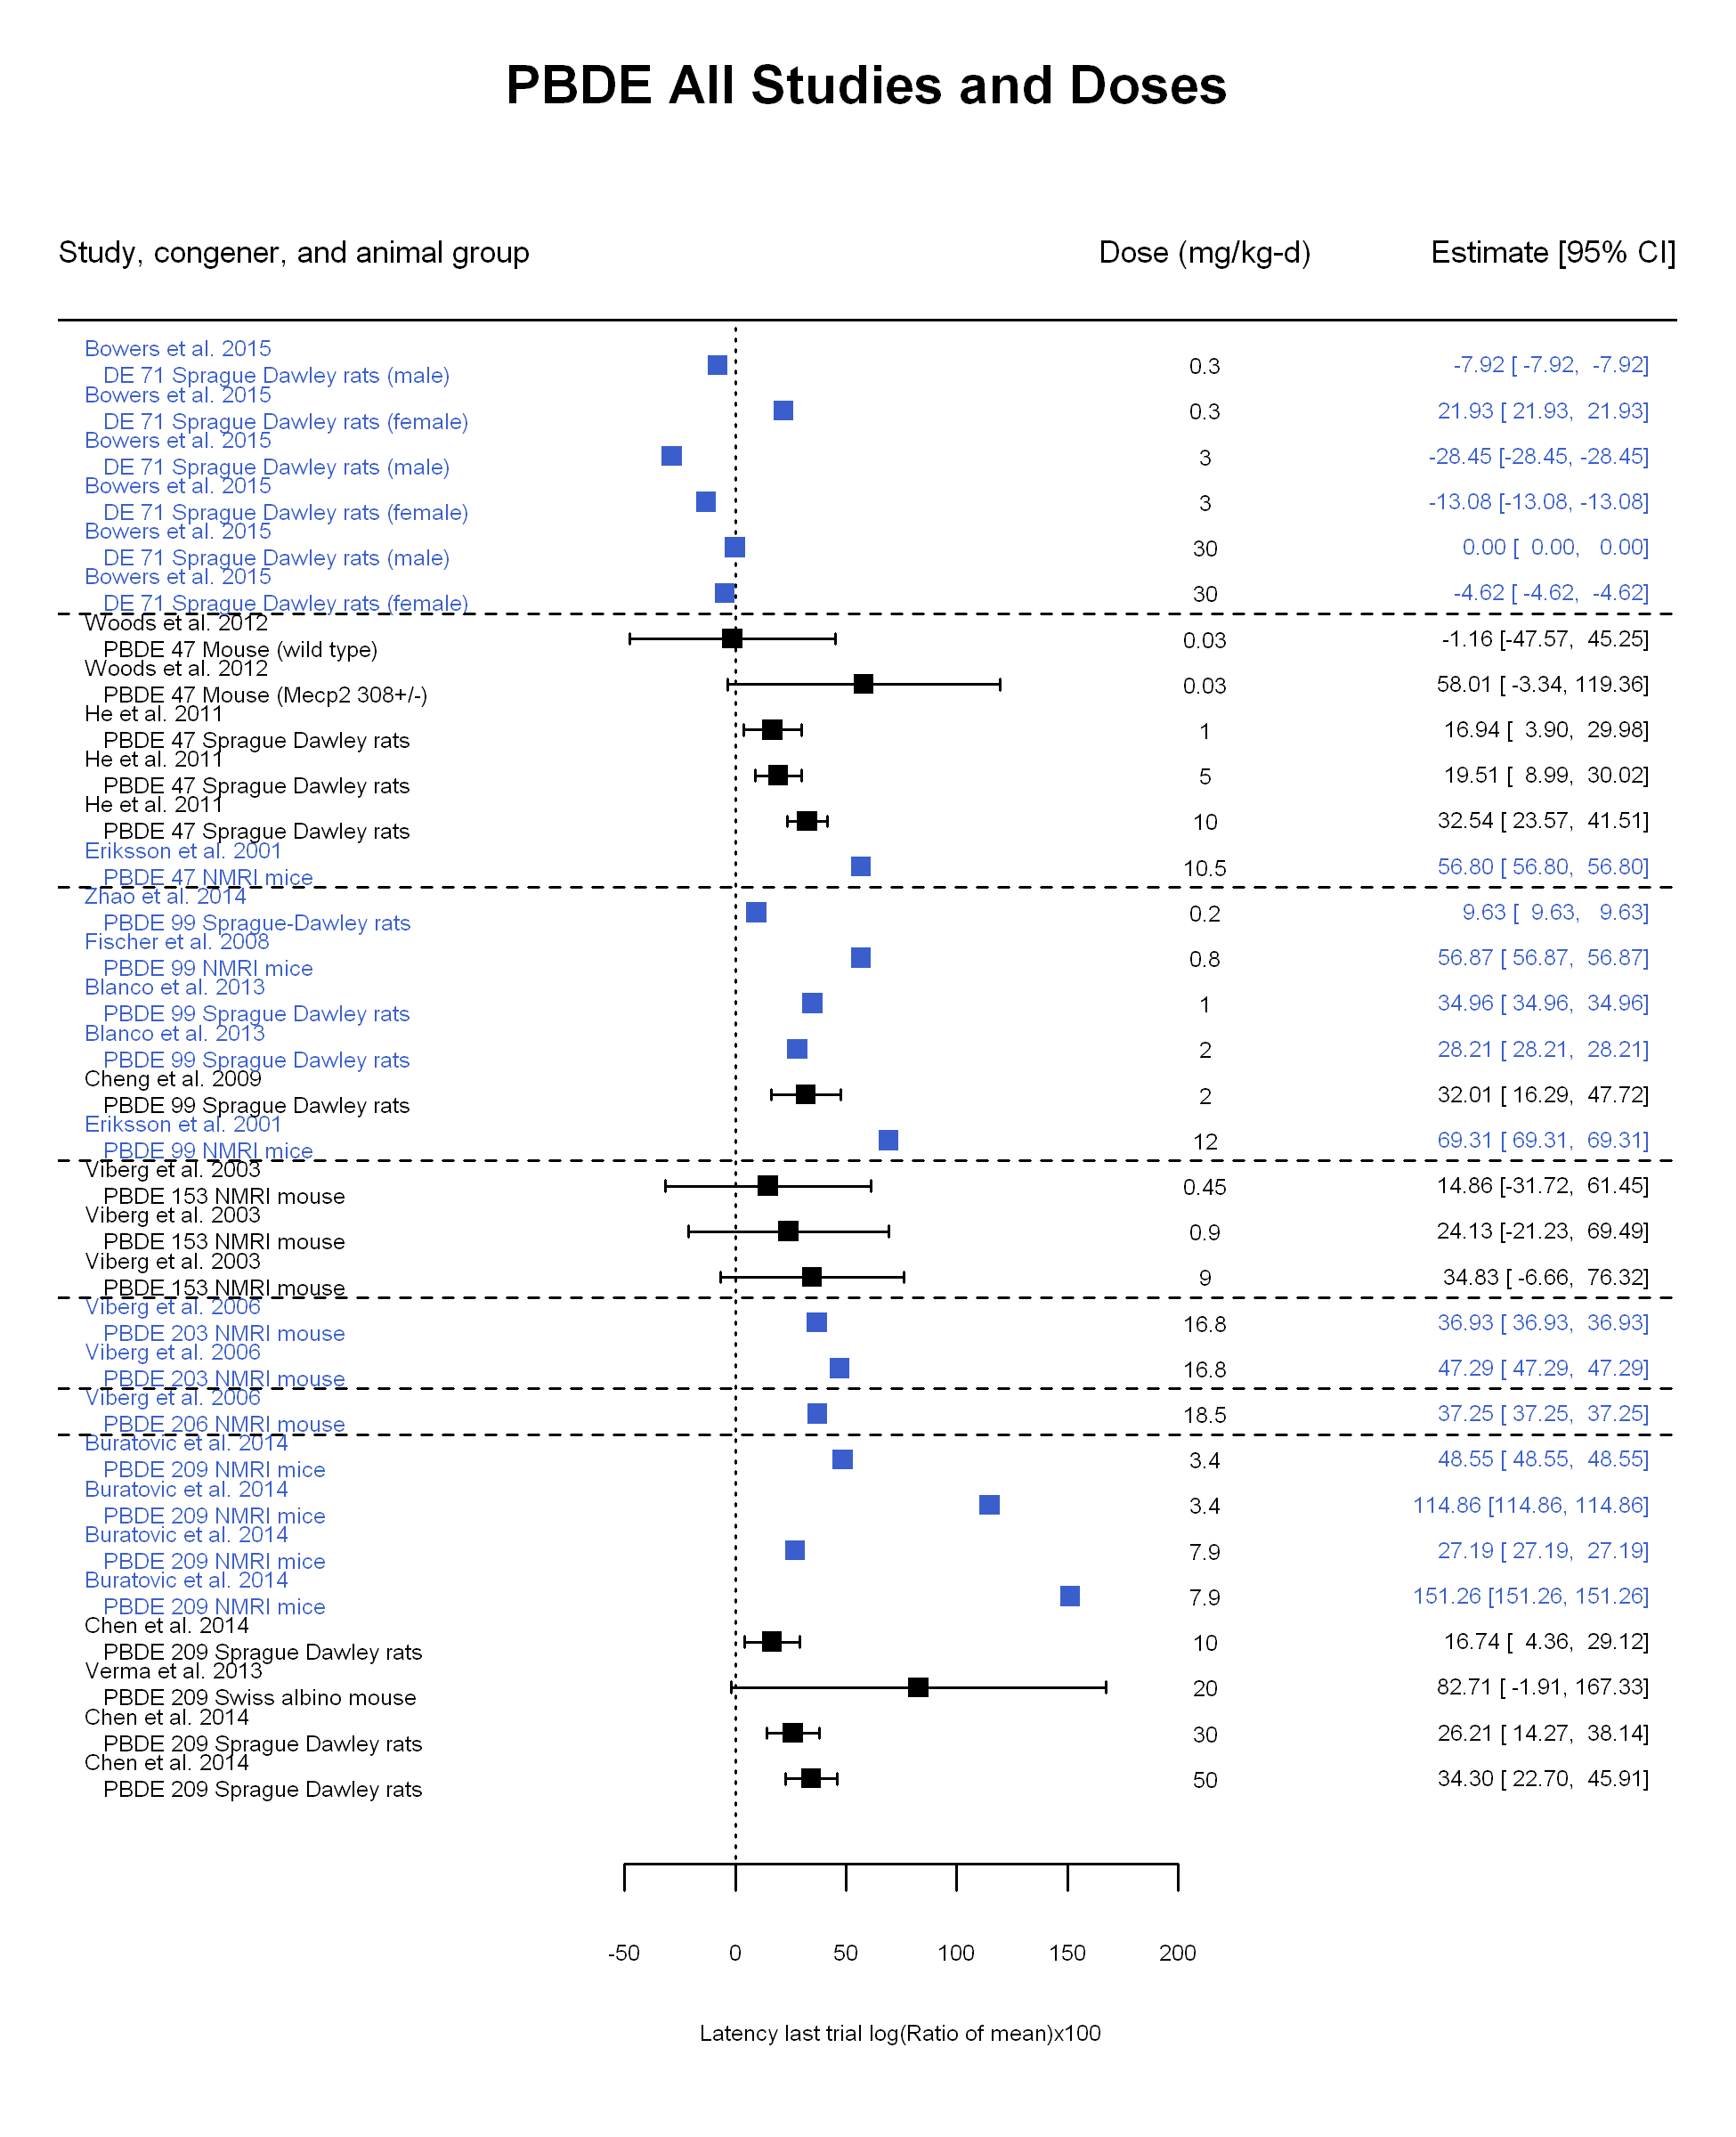

## [1] "Overall Effect---------------------"

## Warning in rma(yi, vi = vi, slab = slab, data = dat.forest): Studies with  
## NAs omitted from model fitting.

##   
## Random-Effects Model (k = 13; tau^2 estimator: REML)  
##   
## logLik deviance AIC BIC AICc   
## -48.0740 96.1480 100.1480 101.1178 101.4813   
##   
## tau^2 (estimated amount of total heterogeneity): 21.6031 (SE = 32.8579)  
## tau (square root of estimated tau^2 value): 4.6479  
## I^2 (total heterogeneity / total variability): 24.46%  
## H^2 (total variability / sampling variability): 1.32  
##   
## Test for Heterogeneity:   
## Q(df = 12) = 14.5248, p-val = 0.2685  
##   
## Model Results:  
##   
## estimate se zval pval ci.lb ci.ub   
## 25.7579 2.7736 9.2867 <.0001 20.3217 31.1942 ***   
##   
## ---  
## Signif. codes: 0 '***' 0.001 '**' 0.01 '*' 0.05 '.' 0.1 ' ' 1

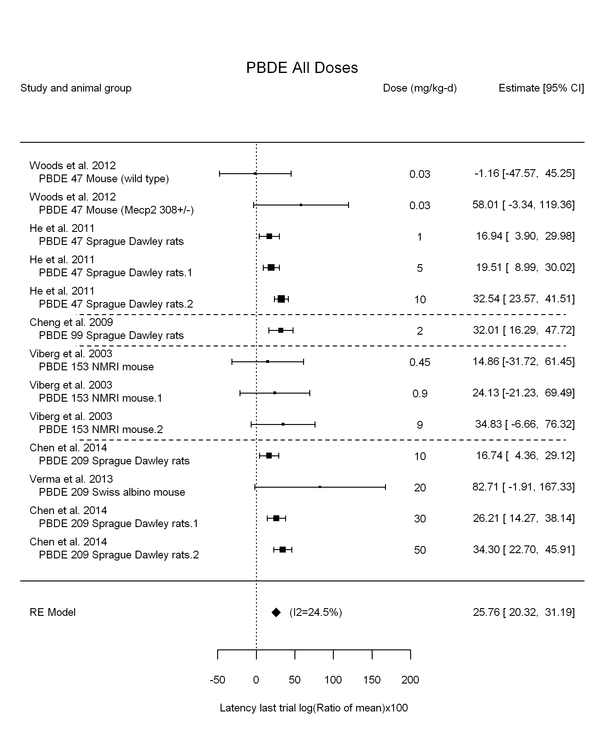

## [1] "Leave one out---------------------"

## Warning in rma(yi, vi = vi, slab = slab, data = dat.loo): Studies with NAs  
## omitted from model fitting.

##   
## Random-Effects Model (k = 13; tau^2 estimator: REML)  
##   
## tau^2 (estimated amount of total heterogeneity): 21.6031 (SE = 32.8579)  
## tau (square root of estimated tau^2 value): 4.6479  
## I^2 (total heterogeneity / total variability): 24.46%  
## H^2 (total variability / sampling variability): 1.32  
##   
## Test for Heterogeneity:   
## Q(df = 12) = 14.5248, p-val = 0.2685  
##   
## Model Results:  
##   
## estimate se zval pval ci.lb ci.ub   
## 25.7579 2.7736 9.2867 <.0001 20.3217 31.1942 ***   
##   
## ---  
## Signif. codes: 0 '***' 0.001 '**' 0.01 '*' 0.05 '.' 0.1 ' ' 1

## Warning in rma(yi, vi = vi, slab = slab, data = dat.loo): Studies with NAs  
## omitted from model fitting.

##   
## Random-Effects Model (k = 10; tau^2 estimator: REML)  
##   
## tau^2 (estimated amount of total heterogeneity): 24.4797 (SE = 34.7224)  
## tau (square root of estimated tau^2 value): 4.9477  
## I^2 (total heterogeneity / total variability): 32.02%  
## H^2 (total variability / sampling variability): 1.47  
##   
## Test for Heterogeneity:   
## Q(df = 9) = 14.1248, p-val = 0.1180  
##   
## Model Results:  
##   
## estimate se zval pval ci.lb ci.ub   
## 25.7667 2.9062 8.8661 <.0001 20.0706 31.4627 ***   
##   
## ---  
## Signif. codes: 0 '***' 0.001 '**' 0.01 '*' 0.05 '.' 0.1 ' ' 1

## Warning in rma(yi, vi = vi, slab = slab, data = dat.loo): Studies with NAs  
## omitted from model fitting.

##   
## Random-Effects Model (k = 13; tau^2 estimator: REML)  
##   
## tau^2 (estimated amount of total heterogeneity): 21.6031 (SE = 32.8579)  
## tau (square root of estimated tau^2 value): 4.6479  
## I^2 (total heterogeneity / total variability): 24.46%  
## H^2 (total variability / sampling variability): 1.32  
##   
## Test for Heterogeneity:   
## Q(df = 12) = 14.5248, p-val = 0.2685  
##   
## Model Results:  
##   
## estimate se zval pval ci.lb ci.ub   
## 25.7579 2.7736 9.2867 <.0001 20.3217 31.1942 ***   
##   
## ---  
## Signif. codes: 0 '***' 0.001 '**' 0.01 '*' 0.05 '.' 0.1 ' ' 1

## Warning in rma(yi, vi = vi, slab = slab, data = dat.loo): Studies with NAs  
## omitted from model fitting.

##   
## Random-Effects Model (k = 13; tau^2 estimator: REML)  
##   
## tau^2 (estimated amount of total heterogeneity): 21.6031 (SE = 32.8579)  
## tau (square root of estimated tau^2 value): 4.6479  
## I^2 (total heterogeneity / total variability): 24.46%  
## H^2 (total variability / sampling variability): 1.32  
##   
## Test for Heterogeneity:   
## Q(df = 12) = 14.5248, p-val = 0.2685  
##   
## Model Results:  
##   
## estimate se zval pval ci.lb ci.ub   
## 25.7579 2.7736 9.2867 <.0001 20.3217 31.1942 ***   
##   
## ---  
## Signif. codes: 0 '***' 0.001 '**' 0.01 '*' 0.05 '.' 0.1 ' ' 1

## Warning in rma(yi, vi = vi, slab = slab, data = dat.loo): Studies with NAs  
## omitted from model fitting.

##   
## Random-Effects Model (k = 10; tau^2 estimator: REML)  
##   
## tau^2 (estimated amount of total heterogeneity): 26.7591 (SE = 50.0966)  
## tau (square root of estimated tau^2 value): 5.1729  
## I^2 (total heterogeneity / total variability): 22.40%  
## H^2 (total variability / sampling variability): 1.29  
##   
## Test for Heterogeneity:   
## Q(df = 9) = 10.4082, p-val = 0.3185  
##   
## Model Results:  
##   
## estimate se zval pval ci.lb ci.ub   
## 25.5958 3.7056 6.9073 <.0001 18.3329 32.8587 ***   
##   
## ---  
## Signif. codes: 0 '***' 0.001 '**' 0.01 '*' 0.05 '.' 0.1 ' ' 1

## Warning in rma(yi, vi = vi, slab = slab, data = dat.loo): Studies with NAs  
## omitted from model fitting.

##   
## Random-Effects Model (k = 12; tau^2 estimator: REML)  
##   
## tau^2 (estimated amount of total heterogeneity): 21.6124 (SE = 32.8685)  
## tau (square root of estimated tau^2 value): 4.6489  
## I^2 (total heterogeneity / total variability): 26.04%  
## H^2 (total variability / sampling variability): 1.35  
##   
## Test for Heterogeneity:   
## Q(df = 11) = 12.7943, p-val = 0.3070  
##   
## Model Results:  
##   
## estimate se zval pval ci.lb ci.ub   
## 25.5246 2.7795 9.1831 <.0001 20.0768 30.9724 ***   
##   
## ---  
## Signif. codes: 0 '***' 0.001 '**' 0.01 '*' 0.05 '.' 0.1 ' ' 1

## Warning in rma(yi, vi = vi, slab = slab, data = dat.loo): Studies with NAs  
## omitted from model fitting.

##   
## Random-Effects Model (k = 13; tau^2 estimator: REML)  
##   
## tau^2 (estimated amount of total heterogeneity): 21.6031 (SE = 32.8579)  
## tau (square root of estimated tau^2 value): 4.6479  
## I^2 (total heterogeneity / total variability): 24.46%  
## H^2 (total variability / sampling variability): 1.32  
##   
## Test for Heterogeneity:   
## Q(df = 12) = 14.5248, p-val = 0.2685  
##   
## Model Results:  
##   
## estimate se zval pval ci.lb ci.ub   
## 25.7579 2.7736 9.2867 <.0001 20.3217 31.1942 ***   
##   
## ---  
## Signif. codes: 0 '***' 0.001 '**' 0.01 '*' 0.05 '.' 0.1 ' ' 1

## Warning in rma(yi, vi = vi, slab = slab, data = dat.loo): Studies with NAs  
## omitted from model fitting.

##   
## Random-Effects Model (k = 10; tau^2 estimator: REML)  
##   
## tau^2 (estimated amount of total heterogeneity): 17.1389 (SE = 47.6616)  
## tau (square root of estimated tau^2 value): 4.1399  
## I^2 (total heterogeneity / total variability): 13.54%  
## H^2 (total variability / sampling variability): 1.16  
##   
## Test for Heterogeneity:   
## Q(df = 9) = 9.0374, p-val = 0.4338  
##   
## Model Results:  
##   
## estimate se zval pval ci.lb ci.ub   
## 27.1265 3.6191 7.4953 <.0001 20.0331 34.2199 ***   
##   
## ---  
## Signif. codes: 0 '***' 0.001 '**' 0.01 '*' 0.05 '.' 0.1 ' ' 1

## Warning in rma(yi, vi = vi, slab = slab, data = dat.loo): Studies with NAs  
## omitted from model fitting.

##   
## Random-Effects Model (k = 11; tau^2 estimator: REML)  
##   
## tau^2 (estimated amount of total heterogeneity): 21.5003 (SE = 32.8496)  
## tau (square root of estimated tau^2 value): 4.6368  
## I^2 (total heterogeneity / total variability): 27.53%  
## H^2 (total variability / sampling variability): 1.38  
##   
## Test for Heterogeneity:   
## Q(df = 10) = 12.1625, p-val = 0.2743  
##   
## Model Results:  
##   
## estimate se zval pval ci.lb ci.ub   
## 25.8684 2.8006 9.2368 <.0001 20.3793 31.3574 ***   
##   
## ---  
## Signif. codes: 0 '***' 0.001 '**' 0.01 '*' 0.05 '.' 0.1 ' ' 1

## Warning in rma(yi, vi = vi, slab = slab, data = dat.loo): Studies with NAs  
## omitted from model fitting.

##   
## Random-Effects Model (k = 13; tau^2 estimator: REML)  
##   
## tau^2 (estimated amount of total heterogeneity): 21.6031 (SE = 32.8579)  
## tau (square root of estimated tau^2 value): 4.6479  
## I^2 (total heterogeneity / total variability): 24.46%  
## H^2 (total variability / sampling variability): 1.32  
##   
## Test for Heterogeneity:   
## Q(df = 12) = 14.5248, p-val = 0.2685  
##   
## Model Results:  
##   
## estimate se zval pval ci.lb ci.ub   
## 25.7579 2.7736 9.2867 <.0001 20.3217 31.1942 ***   
##   
## ---  
## Signif. codes: 0 '***' 0.001 '**' 0.01 '*' 0.05 '.' 0.1 ' ' 1

## Warning in rma(yi, vi = vi, slab = slab, data = dat.loo): Studies with NAs  
## omitted from model fitting.

##   
## Random-Effects Model (k = 12; tau^2 estimator: REML)  
##   
## tau^2 (estimated amount of total heterogeneity): 25.2777 (SE = 36.6419)  
## tau (square root of estimated tau^2 value): 5.0277  
## I^2 (total heterogeneity / total variability): 27.26%  
## H^2 (total variability / sampling variability): 1.37  
##   
## Test for Heterogeneity:   
## Q(df = 11) = 13.9160, p-val = 0.2377  
##   
## Model Results:  
##   
## estimate se zval pval ci.lb ci.ub   
## 25.1185 2.9977 8.3792 <.0001 19.2431 30.9939 ***   
##   
## ---  
## Signif. codes: 0 '***' 0.001 '**' 0.01 '*' 0.05 '.' 0.1 ' ' 1

## Warning in rma(yi, vi = vi, slab = slab, data = dat.loo): Studies with NAs  
## omitted from model fitting.

##   
## Random-Effects Model (k = 13; tau^2 estimator: REML)  
##   
## tau^2 (estimated amount of total heterogeneity): 21.6031 (SE = 32.8579)  
## tau (square root of estimated tau^2 value): 4.6479  
## I^2 (total heterogeneity / total variability): 24.46%  
## H^2 (total variability / sampling variability): 1.32  
##   
## Test for Heterogeneity:   
## Q(df = 12) = 14.5248, p-val = 0.2685  
##   
## Model Results:  
##   
## estimate se zval pval ci.lb ci.ub   
## 25.7579 2.7736 9.2867 <.0001 20.3217 31.1942 ***   
##   
## ---  
## Signif. codes: 0 '***' 0.001 '**' 0.01 '*' 0.05 '.' 0.1 ' ' 1

## Warning in rma(yi, vi = vi, slab = slab, data = dat.loo): Studies with NAs  
## omitted from model fitting.

##   
## Random-Effects Model (k = 13; tau^2 estimator: REML)  
##   
## tau^2 (estimated amount of total heterogeneity): 21.6031 (SE = 32.8579)  
## tau (square root of estimated tau^2 value): 4.6479  
## I^2 (total heterogeneity / total variability): 24.46%  
## H^2 (total variability / sampling variability): 1.32  
##   
## Test for Heterogeneity:   
## Q(df = 12) = 14.5248, p-val = 0.2685  
##   
## Model Results:  
##   
## estimate se zval pval ci.lb ci.ub   
## 25.7579 2.7736 9.2867 <.0001 20.3217 31.1942 ***   
##   
## ---  
## Signif. codes: 0 '***' 0.001 '**' 0.01 '*' 0.05 '.' 0.1 ' ' 1

## [1] "Linear in log10(dose)---------------------"

## Warning in rma(yi, vi = vi, slab = slab, data = dat.forest, mods =  
## ~log10(dose)): Studies with NAs omitted from model fitting.

##   
## Mixed-Effects Model (k = 13; tau^2 estimator: REML)  
##   
## logLik deviance AIC BIC AICc   
## -43.5308 87.0617 93.0617 94.2554 96.4903   
##   
## tau^2 (estimated amount of residual heterogeneity): 11.6435 (SE = 28.5366)  
## tau (square root of estimated tau^2 value): 3.4123  
## I^2 (residual heterogeneity / unaccounted variability): 14.58%  
## H^2 (unaccounted variability / sampling variability): 1.17  
## R^2 (amount of heterogeneity accounted for): 46.10%  
##   
## Test for Residual Heterogeneity:   
## QE(df = 11) = 11.7526, p-val = 0.3825  
##   
## Test of Moderators (coefficient(s) 2):   
## QM(df = 1) = 2.0289, p-val = 0.1543  
##   
## Model Results:  
##   
## estimate se zval pval ci.lb ci.ub   
## intrcpt 20.8433 4.3080 4.8382 <.0001 12.3997 29.2869 ***  
## log10(dose) 5.7369 4.0276 1.4244 0.1543 -2.1571 13.6308   
##   
## ---  
## Signif. codes: 0 '***' 0.001 '**' 0.01 '*' 0.05 '.' 0.1 ' ' 1

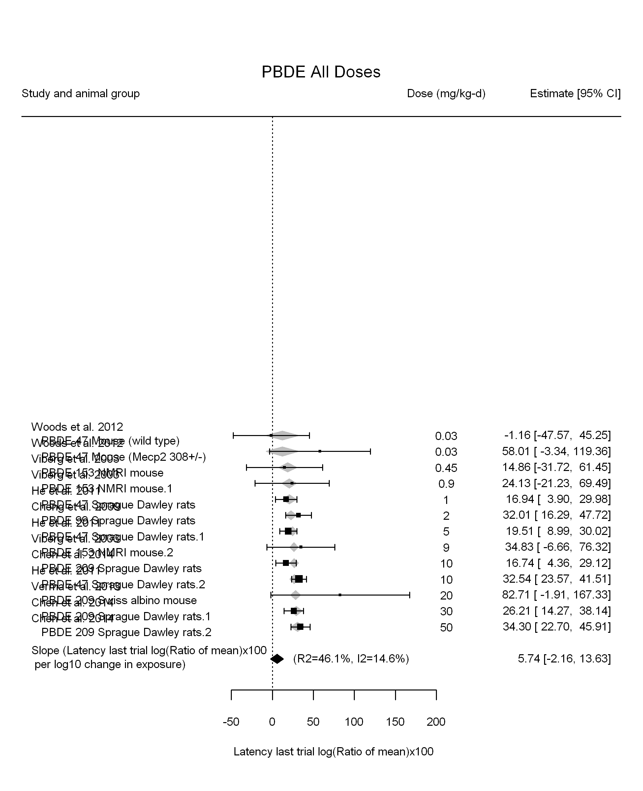

## [1] "Linear in dose---------------------"

## Warning in rma(yi, vi = vi, slab = slab, data = dat.forest, mods = ~dose10  
## - : Studies with NAs omitted from model fitting.

##   
## Mixed-Effects Model (k = 13; tau^2 estimator: REML)  
##   
## logLik deviance AIC BIC AICc   
## -55.5809 111.1618 115.1618 116.1316 116.4951   
##   
## tau^2 (estimated amount of residual heterogeneity): 293.0472 (SE = 180.2633)  
## tau (square root of estimated tau^2 value): 17.1186  
## I^2 (residual heterogeneity / unaccounted variability): 81.59%  
## H^2 (unaccounted variability / sampling variability): 5.43  
##   
## Test for Residual Heterogeneity:   
## QE(df = 12) = 67.6572, p-val < .0001  
##   
## Model Results:  
##   
## estimate se zval pval ci.lb ci.ub   
## dose10 9.6062 2.9680 3.2367 0.0012 3.7892 15.4233 **  
##   
## ---  
## Signif. codes: 0 '***' 0.001 '**' 0.01 '*' 0.05 '.' 0.1 ' ' 1

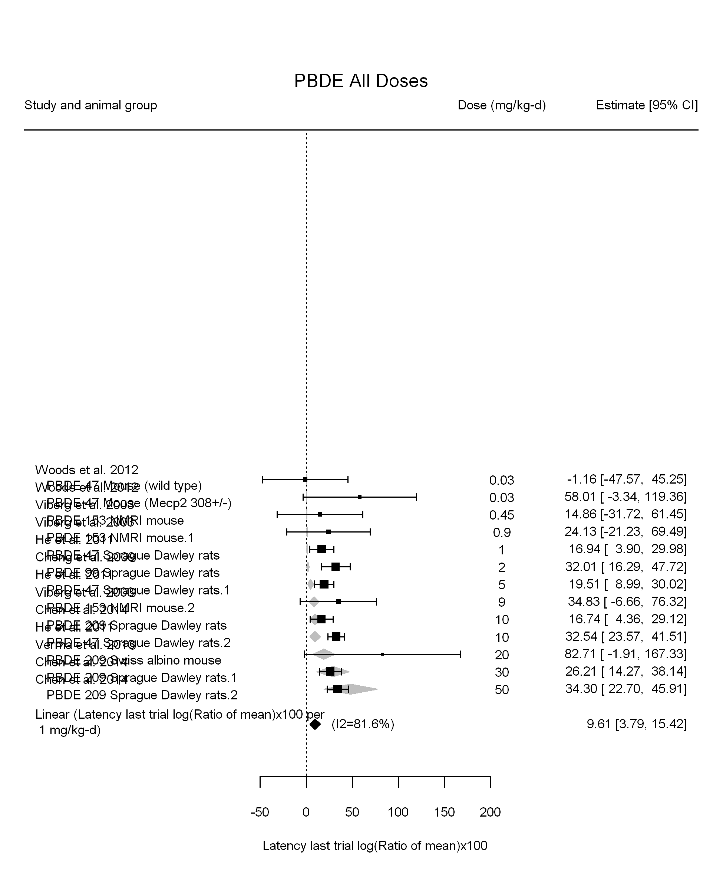

## [1] "Linear or LinearQuadratic in dose---------------------"

## Warning in rma(yi, vi = vi, slab = slab, data = dat.forest, mods = ~dose10  
## + : Studies with NAs omitted from model fitting.

##   
## Mixed-Effects Model (k = 13; tau^2 estimator: REML)  
##   
## logLik deviance AIC BIC AICc   
## -49.4642 98.9284 104.9284 106.1221 108.3570   
##   
## tau^2 (estimated amount of residual heterogeneity): 193.7341 (SE = 140.1324)  
## tau (square root of estimated tau^2 value): 13.9188  
## I^2 (residual heterogeneity / unaccounted variability): 72.33%  
## H^2 (unaccounted variability / sampling variability): 3.61  
##   
## Test for Residual Heterogeneity:   
## QE(df = 11) = 37.4190, p-val < .0001  
##   
## Test of Moderators (coefficient(s) 1,2):   
## QM(df = 2) = 19.4712, p-val < .0001  
##   
## Model Results:  
##   
## estimate se zval pval ci.lb ci.ub   
## dose10 28.0654 8.5944 3.2655 0.0011 11.2207 44.9101 **  
## I(dose10^2) -4.4504 1.9629 -2.2673 0.0234 -8.2976 -0.6032 *  
##   
## ---  
## Signif. codes: 0 '***' 0.001 '**' 0.01 '*' 0.05 '.' 0.1 ' ' 1

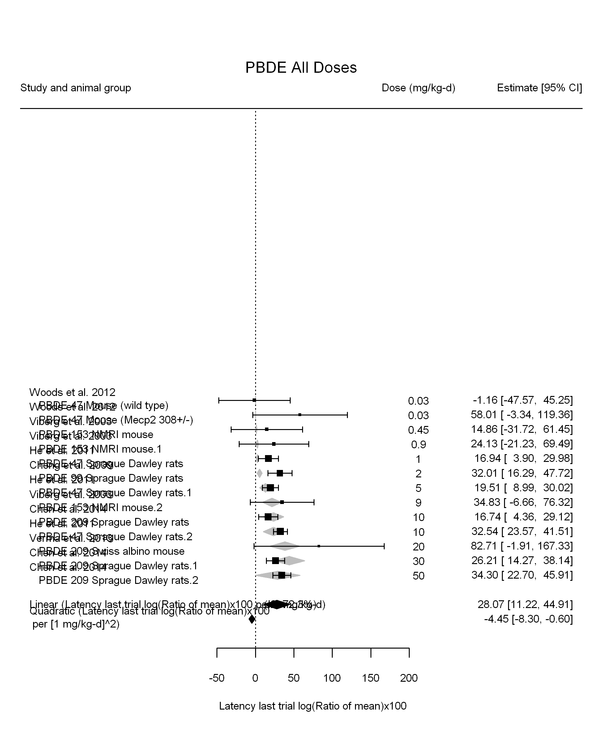

## [1] ""

## [1] ""

## m ci.lb ci.ub bmr  
## 1 5.078999 3.163383 12.87616 4.879016

## [1] ""

## m ci.lb ci.ub bmr  
## 1 1.789198 1.108641 4.489398 4.879016

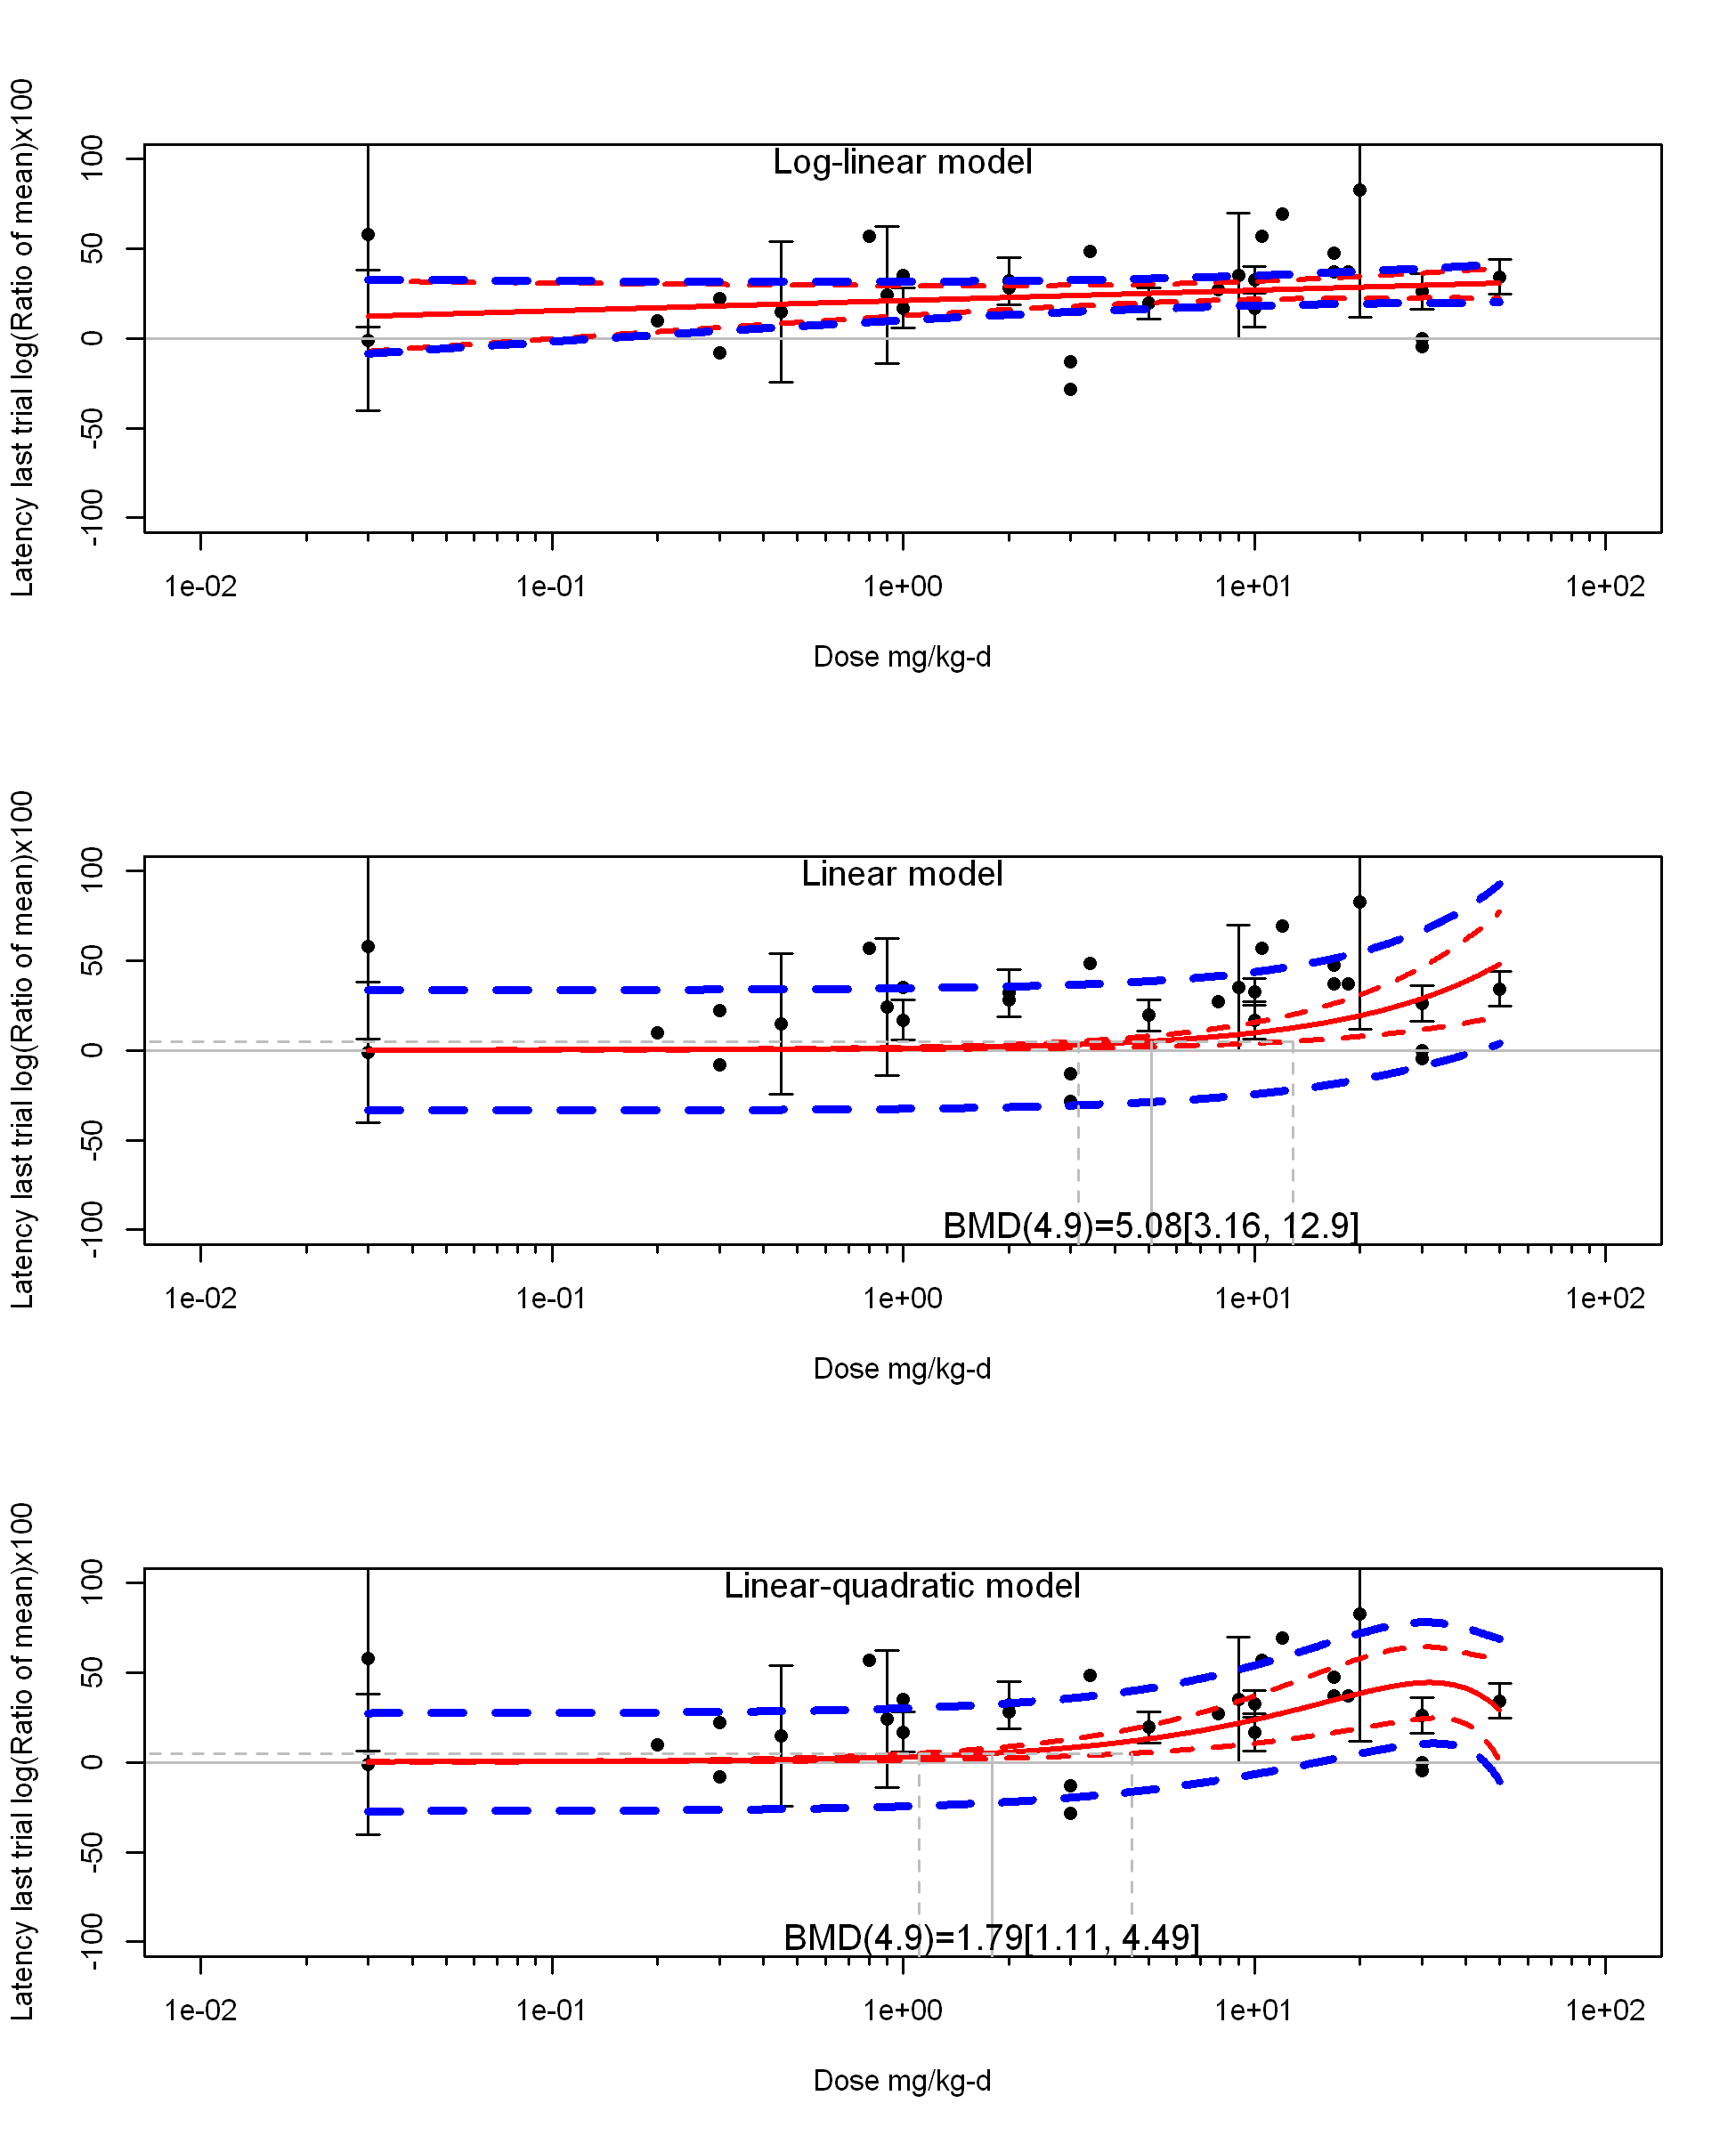

## [1] "Latency last trial log(Ratio of mean)x100 Highest Dose"

## [1] "Highest Dose Overall Effect---------------------"

## Warning in rma(yi, vi = vi, slab = slab, data = dat.forest): Studies with  
## NAs omitted from model fitting.

##   
## Random-Effects Model (k = 7; tau^2 estimator: REML)  
##   
## logLik deviance AIC BIC AICc   
## -24.2468 48.4937 52.4937 52.0772 56.4937   
##   
## tau^2 (estimated amount of total heterogeneity): 0.0000 (SE = 33.9638)  
## tau (square root of estimated tau^2 value): 0.0012  
## I^2 (total heterogeneity / total variability): 0.00%  
## H^2 (total variability / sampling variability): 1.00  
##   
## Test for Heterogeneity:   
## Q(df = 6) = 4.1262, p-val = 0.6596  
##   
## Model Results:  
##   
## estimate se zval pval ci.lb ci.ub   
## 32.9504 3.2048 10.2815 <.0001 26.6690 39.2317 ***   
##   
## ---  
## Signif. codes: 0 '***' 0.001 '**' 0.01 '*' 0.05 '.' 0.1 ' ' 1

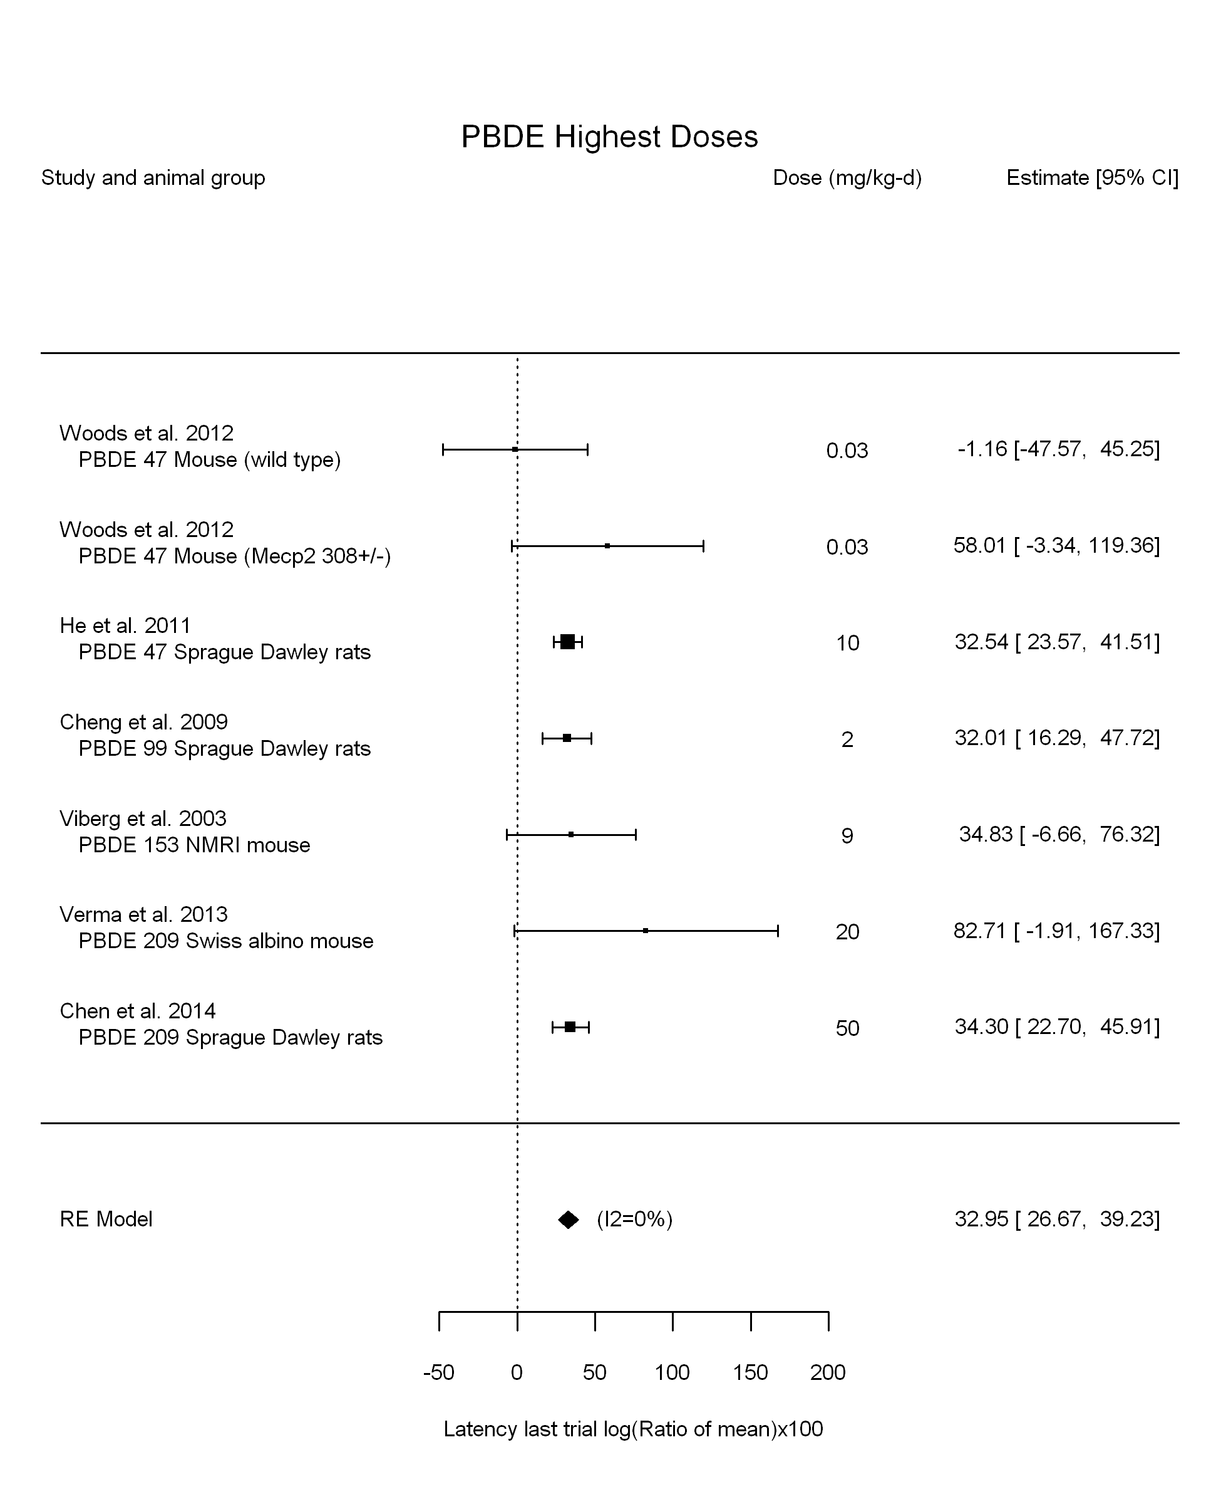

## [1] "Highest Dose Leave one out---------------------"

## Warning in rma(yi, vi = vi, slab = slab, data = dat.loo): Studies with NAs  
## omitted from model fitting.

##   
## Random-Effects Model (k = 7; tau^2 estimator: REML)  
##   
## tau^2 (estimated amount of total heterogeneity): 0.0000 (SE = 33.9638)  
## tau (square root of estimated tau^2 value): 0.0012  
## I^2 (total heterogeneity / total variability): 0.00%  
## H^2 (total variability / sampling variability): 1.00  
##   
## Test for Heterogeneity:   
## Q(df = 6) = 4.1262, p-val = 0.6596  
##   
## Model Results:  
##   
## estimate se zval pval ci.lb ci.ub   
## 32.9504 3.2048 10.2815 <.0001 26.6690 39.2317 ***   
##   
## ---  
## Signif. codes: 0 '***' 0.001 '**' 0.01 '*' 0.05 '.' 0.1 ' ' 1

## Warning in rma(yi, vi = vi, slab = slab, data = dat.loo): Studies with NAs  
## omitted from model fitting.

##   
## Random-Effects Model (k = 6; tau^2 estimator: REML)  
##   
## tau^2 (estimated amount of total heterogeneity): 0.0000 (SE = 34.1401)  
## tau (square root of estimated tau^2 value): 0.0021  
## I^2 (total heterogeneity / total variability): 0.00%  
## H^2 (total variability / sampling variability): 1.00  
##   
## Test for Heterogeneity:   
## Q(df = 5) = 4.1181, p-val = 0.5325  
##   
## Model Results:  
##   
## estimate se zval pval ci.lb ci.ub   
## 32.9062 3.2422 10.1494 <.0001 26.5517 39.2608 ***   
##   
## ---  
## Signif. codes: 0 '***' 0.001 '**' 0.01 '*' 0.05 '.' 0.1 ' ' 1

## Warning in rma(yi, vi = vi, slab = slab, data = dat.loo): Studies with NAs  
## omitted from model fitting.

##   
## Random-Effects Model (k = 7; tau^2 estimator: REML)  
##   
## tau^2 (estimated amount of total heterogeneity): 0.0000 (SE = 33.9638)  
## tau (square root of estimated tau^2 value): 0.0012  
## I^2 (total heterogeneity / total variability): 0.00%  
## H^2 (total variability / sampling variability): 1.00  
##   
## Test for Heterogeneity:   
## Q(df = 6) = 4.1262, p-val = 0.6596  
##   
## Model Results:  
##   
## estimate se zval pval ci.lb ci.ub   
## 32.9504 3.2048 10.2815 <.0001 26.6690 39.2317 ***   
##   
## ---  
## Signif. codes: 0 '***' 0.001 '**' 0.01 '*' 0.05 '.' 0.1 ' ' 1

## Warning in rma(yi, vi = vi, slab = slab, data = dat.loo): Studies with NAs  
## omitted from model fitting.

##   
## Random-Effects Model (k = 7; tau^2 estimator: REML)  
##   
## tau^2 (estimated amount of total heterogeneity): 0.0000 (SE = 33.9638)  
## tau (square root of estimated tau^2 value): 0.0012  
## I^2 (total heterogeneity / total variability): 0.00%  
## H^2 (total variability / sampling variability): 1.00  
##   
## Test for Heterogeneity:   
## Q(df = 6) = 4.1262, p-val = 0.6596  
##   
## Model Results:  
##   
## estimate se zval pval ci.lb ci.ub   
## 32.9504 3.2048 10.2815 <.0001 26.6690 39.2317 ***   
##   
## ---  
## Signif. codes: 0 '***' 0.001 '**' 0.01 '*' 0.05 '.' 0.1 ' ' 1

## Warning in rma(yi, vi = vi, slab = slab, data = dat.loo): Studies with NAs  
## omitted from model fitting.

##   
## Random-Effects Model (k = 6; tau^2 estimator: REML)  
##   
## tau^2 (estimated amount of total heterogeneity): 0.0000 (SE = 57.2316)  
## tau (square root of estimated tau^2 value): 0.0004  
## I^2 (total heterogeneity / total variability): 0.00%  
## H^2 (total variability / sampling variability): 1.00  
##   
## Test for Heterogeneity:   
## Q(df = 5) = 4.0526, p-val = 0.5419  
##   
## Model Results:  
##   
## estimate se zval pval ci.lb ci.ub   
## 32.3906 3.8114 8.4983 <.0001 24.9204 39.8609 ***   
##   
## ---  
## Signif. codes: 0 '***' 0.001 '**' 0.01 '*' 0.05 '.' 0.1 ' ' 1

## Warning in rma(yi, vi = vi, slab = slab, data = dat.loo): Studies with NAs  
## omitted from model fitting.

##   
## Random-Effects Model (k = 6; tau^2 estimator: REML)  
##   
## tau^2 (estimated amount of total heterogeneity): 0.0000 (SE = 33.9917)  
## tau (square root of estimated tau^2 value): 0.0009  
## I^2 (total heterogeneity / total variability): 0.00%  
## H^2 (total variability / sampling variability): 1.00  
##   
## Test for Heterogeneity:   
## Q(df = 5) = 2.7907, p-val = 0.7322  
##   
## Model Results:  
##   
## estimate se zval pval ci.lb ci.ub   
## 32.6747 3.2137 10.1674 <.0001 26.3760 38.9734 ***   
##   
## ---  
## Signif. codes: 0 '***' 0.001 '**' 0.01 '*' 0.05 '.' 0.1 ' ' 1

## Warning in rma(yi, vi = vi, slab = slab, data = dat.loo): Studies with NAs  
## omitted from model fitting.

##   
## Random-Effects Model (k = 7; tau^2 estimator: REML)  
##   
## tau^2 (estimated amount of total heterogeneity): 0.0000 (SE = 33.9638)  
## tau (square root of estimated tau^2 value): 0.0012  
## I^2 (total heterogeneity / total variability): 0.00%  
## H^2 (total variability / sampling variability): 1.00  
##   
## Test for Heterogeneity:   
## Q(df = 6) = 4.1262, p-val = 0.6596  
##   
## Model Results:  
##   
## estimate se zval pval ci.lb ci.ub   
## 32.9504 3.2048 10.2815 <.0001 26.6690 39.2317 ***   
##   
## ---  
## Signif. codes: 0 '***' 0.001 '**' 0.01 '*' 0.05 '.' 0.1 ' ' 1

## Warning in rma(yi, vi = vi, slab = slab, data = dat.loo): Studies with NAs  
## omitted from model fitting.

##   
## Random-Effects Model (k = 6; tau^2 estimator: REML)  
##   
## tau^2 (estimated amount of total heterogeneity): 0.0000 (SE = 67.5856)  
## tau (square root of estimated tau^2 value): 0.0016  
## I^2 (total heterogeneity / total variability): 0.00%  
## H^2 (total variability / sampling variability): 1.00  
##   
## Test for Heterogeneity:   
## Q(df = 5) = 4.1106, p-val = 0.5336  
##   
## Model Results:  
##   
## estimate se zval pval ci.lb ci.ub   
## 33.3426 4.4881 7.4292 <.0001 24.5462 42.1391 ***   
##   
## ---  
## Signif. codes: 0 '***' 0.001 '**' 0.01 '*' 0.05 '.' 0.1 ' ' 1

## Warning in rma(yi, vi = vi, slab = slab, data = dat.loo): Studies with NAs  
## omitted from model fitting.

##   
## Random-Effects Model (k = 5; tau^2 estimator: REML)  
##   
## tau^2 (estimated amount of total heterogeneity): 0.0000 (SE = 34.1510)  
## tau (square root of estimated tau^2 value): 0.0006  
## I^2 (total heterogeneity / total variability): 0.00%  
## H^2 (total variability / sampling variability): 1.00  
##   
## Test for Heterogeneity:   
## Q(df = 4) = 1.3967, p-val = 0.8448  
##   
## Model Results:  
##   
## estimate se zval pval ci.lb ci.ub   
## 33.3233 3.2520 10.2471 <.0001 26.9495 39.6971 ***   
##   
## ---  
## Signif. codes: 0 '***' 0.001 '**' 0.01 '*' 0.05 '.' 0.1 ' ' 1

## Warning in rma(yi, vi = vi, slab = slab, data = dat.loo): Studies with NAs  
## omitted from model fitting.

##   
## Random-Effects Model (k = 7; tau^2 estimator: REML)  
##   
## tau^2 (estimated amount of total heterogeneity): 0.0000 (SE = 33.9638)  
## tau (square root of estimated tau^2 value): 0.0012  
## I^2 (total heterogeneity / total variability): 0.00%  
## H^2 (total variability / sampling variability): 1.00  
##   
## Test for Heterogeneity:   
## Q(df = 6) = 4.1262, p-val = 0.6596  
##   
## Model Results:  
##   
## estimate se zval pval ci.lb ci.ub   
## 32.9504 3.2048 10.2815 <.0001 26.6690 39.2317 ***   
##   
## ---  
## Signif. codes: 0 '***' 0.001 '**' 0.01 '*' 0.05 '.' 0.1 ' ' 1

## Warning in rma(yi, vi = vi, slab = slab, data = dat.loo): Studies with NAs  
## omitted from model fitting.

##   
## Random-Effects Model (k = 6; tau^2 estimator: REML)  
##   
## tau^2 (estimated amount of total heterogeneity): 0.0000 (SE = 39.0418)  
## tau (square root of estimated tau^2 value): 0.0018  
## I^2 (total heterogeneity / total variability): 0.00%  
## H^2 (total variability / sampling variability): 1.00  
##   
## Test for Heterogeneity:   
## Q(df = 5) = 4.1097, p-val = 0.5337  
##   
## Model Results:  
##   
## estimate se zval pval ci.lb ci.ub   
## 33.1298 3.4961 9.4762 <.0001 26.2775 39.9820 ***   
##   
## ---  
## Signif. codes: 0 '***' 0.001 '**' 0.01 '*' 0.05 '.' 0.1 ' ' 1

## Warning in rma(yi, vi = vi, slab = slab, data = dat.loo): Studies with NAs  
## omitted from model fitting.

##   
## Random-Effects Model (k = 7; tau^2 estimator: REML)  
##   
## tau^2 (estimated amount of total heterogeneity): 0.0000 (SE = 33.9638)  
## tau (square root of estimated tau^2 value): 0.0012  
## I^2 (total heterogeneity / total variability): 0.00%  
## H^2 (total variability / sampling variability): 1.00  
##   
## Test for Heterogeneity:   
## Q(df = 6) = 4.1262, p-val = 0.6596  
##   
## Model Results:  
##   
## estimate se zval pval ci.lb ci.ub   
## 32.9504 3.2048 10.2815 <.0001 26.6690 39.2317 ***   
##   
## ---  
## Signif. codes: 0 '***' 0.001 '**' 0.01 '*' 0.05 '.' 0.1 ' ' 1

## Warning in rma(yi, vi = vi, slab = slab, data = dat.loo): Studies with NAs  
## omitted from model fitting.

##   
## Random-Effects Model (k = 7; tau^2 estimator: REML)  
##   
## tau^2 (estimated amount of total heterogeneity): 0.0000 (SE = 33.9638)  
## tau (square root of estimated tau^2 value): 0.0012  
## I^2 (total heterogeneity / total variability): 0.00%  
## H^2 (total variability / sampling variability): 1.00  
##   
## Test for Heterogeneity:   
## Q(df = 6) = 4.1262, p-val = 0.6596  
##   
## Model Results:  
##   
## estimate se zval pval ci.lb ci.ub   
## 32.9504 3.2048 10.2815 <.0001 26.6690 39.2317 ***   
##   
## ---  
## Signif. codes: 0 '***' 0.001 '**' 0.01 '*' 0.05 '.' 0.1 ' ' 1

## [1] "Highest Dose Linear or LinearQuadratic in dose---------------------"

## Warning in rma(yi, vi = vi, slab = slab, data = dat.forest, mods = ~dose10  
## - : Studies with NAs omitted from model fitting.

##   
## Mixed-Effects Model (k = 7; tau^2 estimator: REML)  
##   
## logLik deviance AIC BIC AICc   
## -29.9674 59.9349 63.9349 63.5184 67.9349   
##   
## tau^2 (estimated amount of residual heterogeneity): 677.8855 (SE = 583.6652)  
## tau (square root of estimated tau^2 value): 26.0362  
## I^2 (residual heterogeneity / unaccounted variability): 88.45%  
## H^2 (unaccounted variability / sampling variability): 8.66  
##   
## Test for Residual Heterogeneity:   
## QE(df = 6) = 51.1279, p-val < .0001  
##   
## Model Results:  
##   
## estimate se zval pval ci.lb ci.ub   
## dose10 10.0085 5.0739 1.9725 0.0485 0.0639 19.9531 *  
##   
## ---  
## Signif. codes: 0 '***' 0.001 '**' 0.01 '*' 0.05 '.' 0.1 ' ' 1

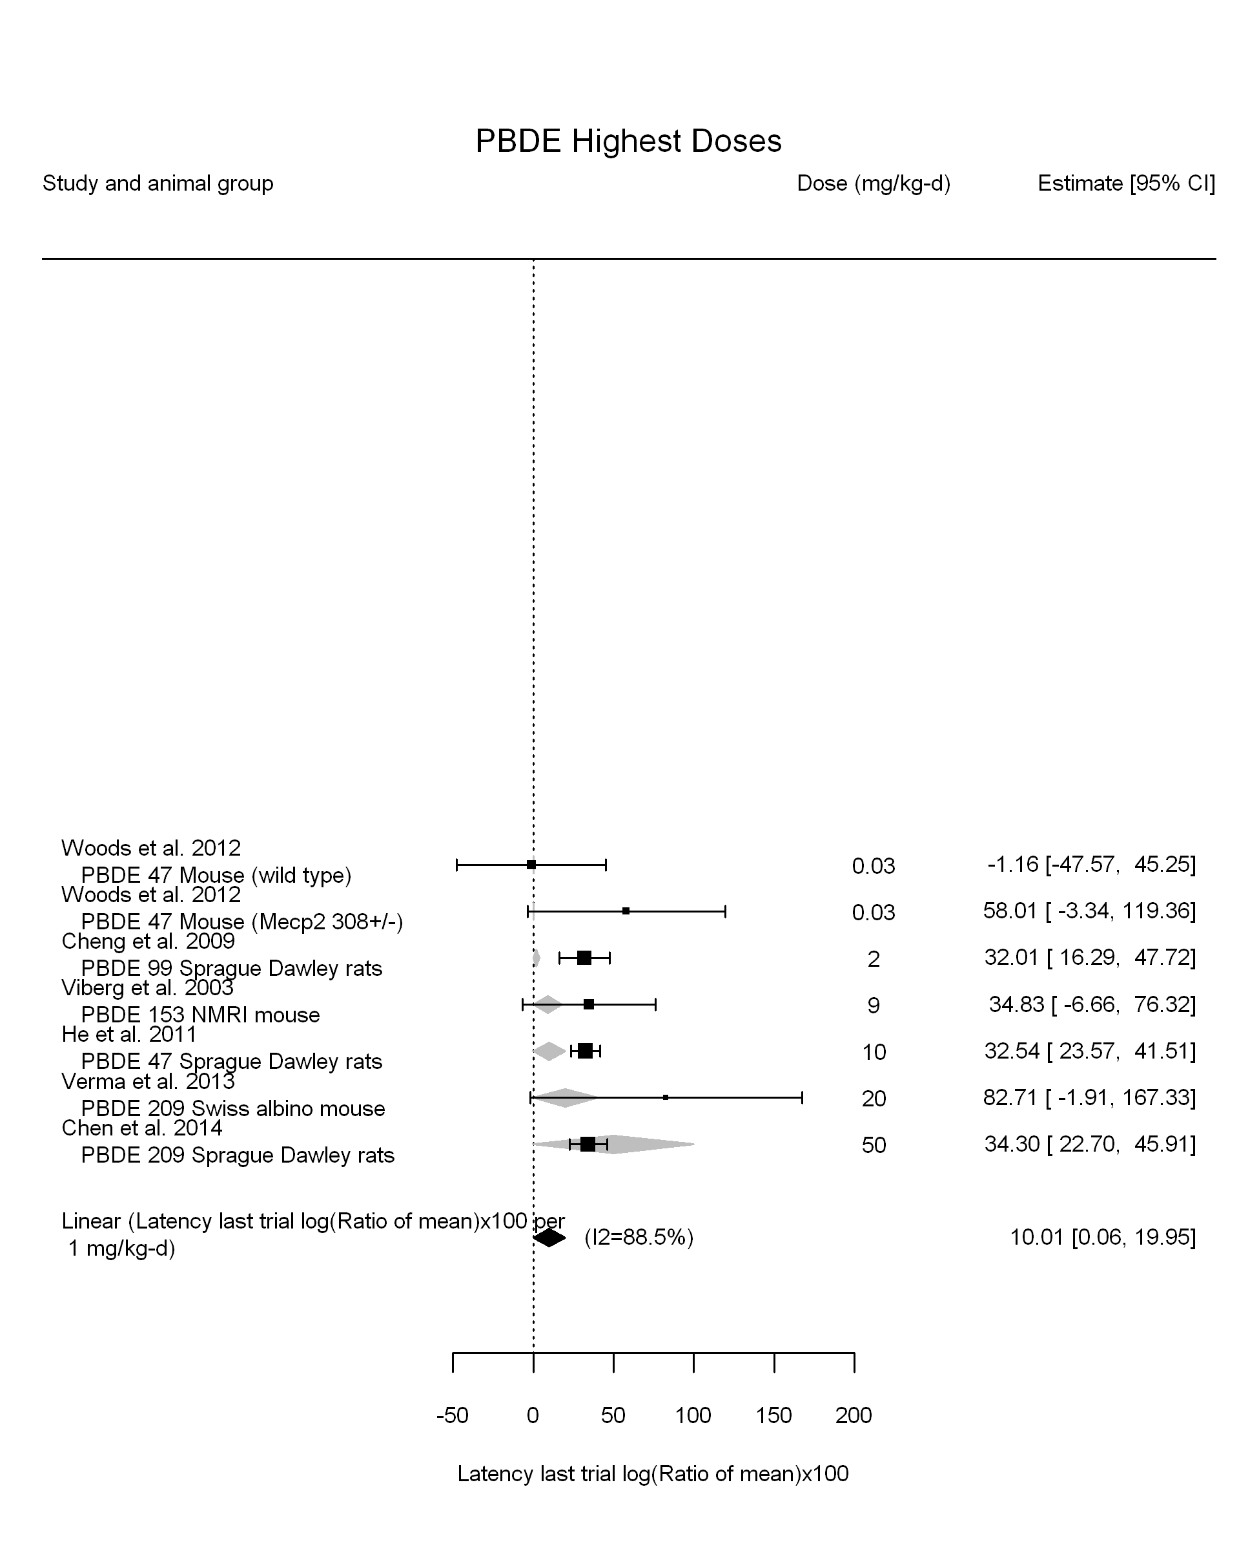

## [1] "Highest Dose Linear in log10(dose)---------------------"

## Warning in rma(yi, vi = vi, slab = slab, data = dat.forest, mods =  
## ~log10(dose)): Studies with NAs omitted from model fitting.

##   
## Mixed-Effects Model (k = 7; tau^2 estimator: REML)  
##   
## logLik deviance AIC BIC AICc   
## -20.3061 40.6123 46.6123 45.4406 70.6123   
##   
## tau^2 (estimated amount of residual heterogeneity): 0.0000 (SE = 38.9113)  
## tau (square root of estimated tau^2 value): 0.0018  
## I^2 (residual heterogeneity / unaccounted variability): 0.00%  
## H^2 (unaccounted variability / sampling variability): 1.00  
## R^2 (amount of heterogeneity accounted for): 0.00%  
##   
## Test for Residual Heterogeneity:   
## QE(df = 5) = 3.6703, p-val = 0.5978  
##   
## Test of Moderators (coefficient(s) 2):   
## QM(df = 1) = 0.4559, p-val = 0.4996  
##   
## Model Results:  
##   
## estimate se zval pval ci.lb ci.ub   
## intrcpt 29.4765 6.0615 4.8629 <.0001 17.5961 41.3568 ***  
## log10(dose) 3.4020 5.0386 0.6752 0.4996 -6.4735 13.2775   
##   
## ---  
## Signif. codes: 0 '***' 0.001 '**' 0.01 '*' 0.05 '.' 0.1 ' ' 1

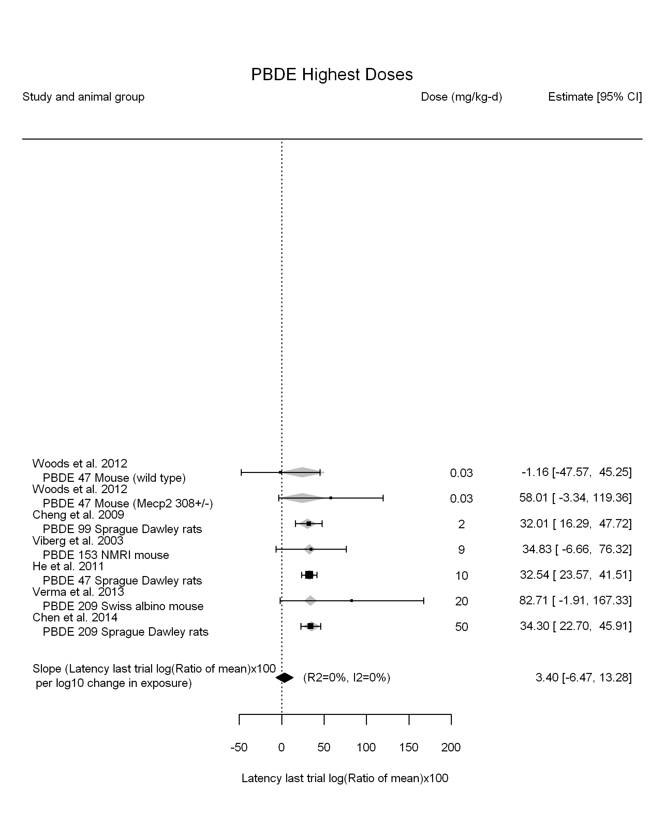

## [1] "Highest Dose LinearQuadratic in dose---------------------"

## Warning in rma(yi, vi = vi, slab = slab, data = dat.forest, mods = ~dose10  
## + : Studies with NAs omitted from model fitting.

##   
## Mixed-Effects Model (k = 7; tau^2 estimator: REML)  
##   
## logLik deviance AIC BIC AICc   
## -23.3934 46.7869 52.7869 51.6152 76.7869   
##   
## tau^2 (estimated amount of residual heterogeneity): 255.6317 (SE = 342.7060)  
## tau (square root of estimated tau^2 value): 15.9885  
## I^2 (residual heterogeneity / unaccounted variability): 55.56%  
## H^2 (unaccounted variability / sampling variability): 2.25  
##   
## Test for Residual Heterogeneity:   
## QE(df = 5) = 12.9782, p-val = 0.0236  
##   
## Test of Moderators (coefficient(s) 1,2):   
## QM(df = 2) = 14.0531, p-val = 0.0009  
##   
## Model Results:  
##   
## estimate se zval pval ci.lb ci.ub   
## dose10 48.5572 16.0839 3.0190 0.0025 17.0333 80.0810 **  
## I(dose10^2) -8.3355 3.3318 -2.5018 0.0124 -14.8657 -1.8053 *  
##   
## ---  
## Signif. codes: 0 '***' 0.001 '**' 0.01 '*' 0.05 '.' 0.1 ' ' 1

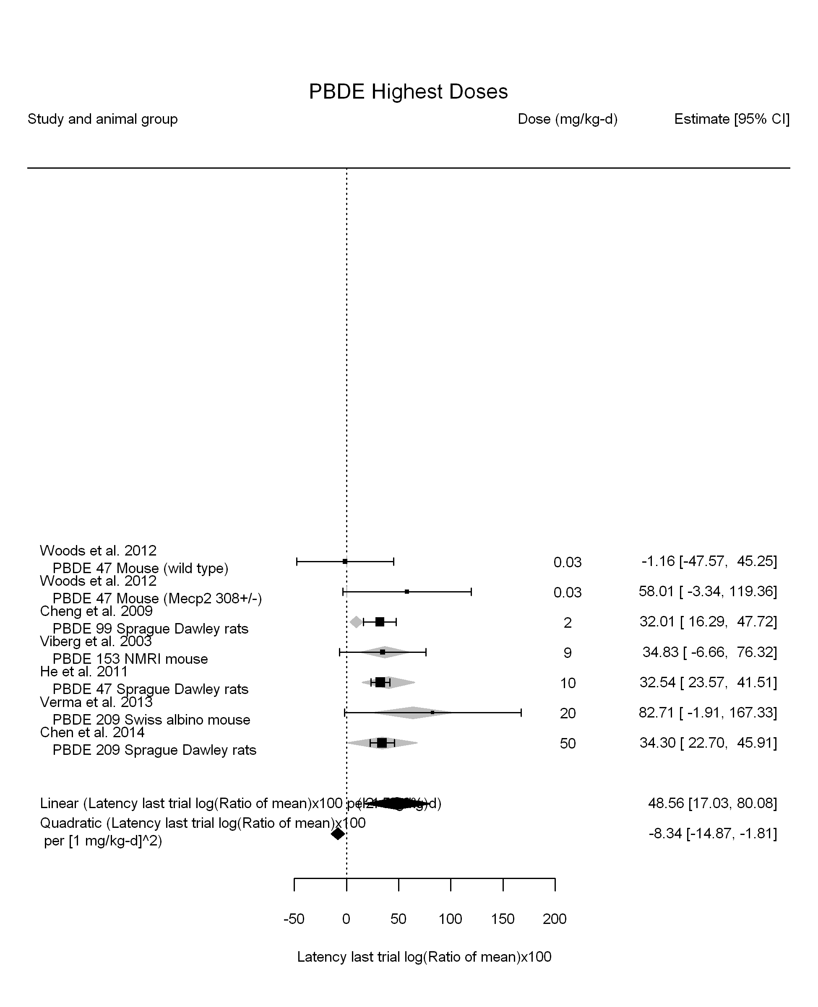

## [1] ""

## [1] ""

## m ci.lb ci.ub bmr  
## 1 4.874862 2.445232 NA 4.879016

## [1] ""

## m ci.lb ci.ub bmr  
## 1 1.02275 0.6162432 2.965127 4.879016

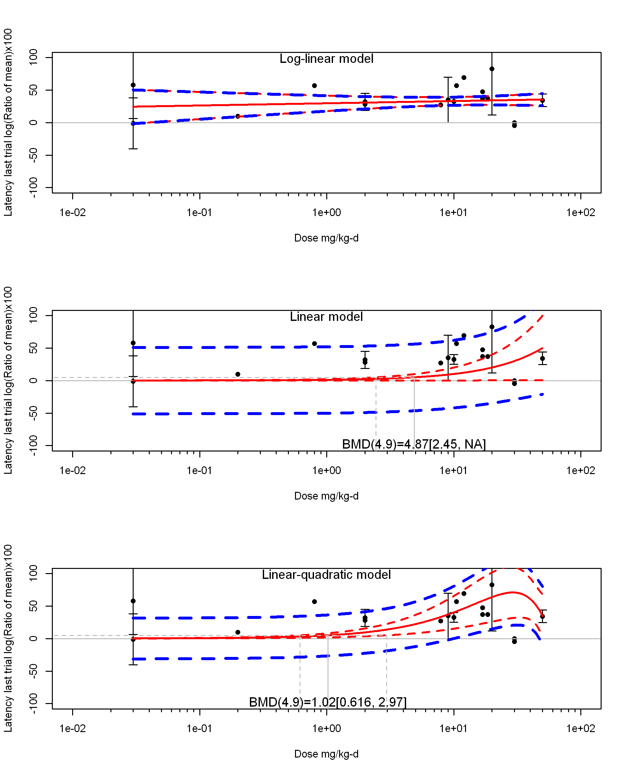

write.csv(results.sum,file="PBDE.meta-results-v2.csv")  
write.csv(bmd.results.sum,file="PBDE.meta-bmd-results-v2.csv")

## [1] "Overall Effect---------------------"  
##   
## Random-Effects Model (k = 3; tau^2 estimator: REML)  
##   
## logLik deviance AIC BIC AICc   
## -8.2811 16.5622 20.5622 17.9485 32.5622   
##   
## tau^2 (estimated amount of total heterogeneity): 0 (SE = 512.6504)  
## tau (square root of estimated tau^2 value): 0  
## I^2 (total heterogeneity / total variability): 0.00%  
## H^2 (total variability / sampling variability): 1.00  
##   
## Test for Heterogeneity:   
## Q(df = 2) = 0.3980, p-val = 0.8196  
##   
## Model Results:  
##   
## estimate se zval pval ci.lb ci.ub   
## 25.4040 13.0535 1.9461 0.0516 -0.1804 50.9884 .   
##   
## ---  
## Signif. codes: 0 '***' 0.001 '**' 0.01 '*' 0.05 '.' 0.1 ' ' 1

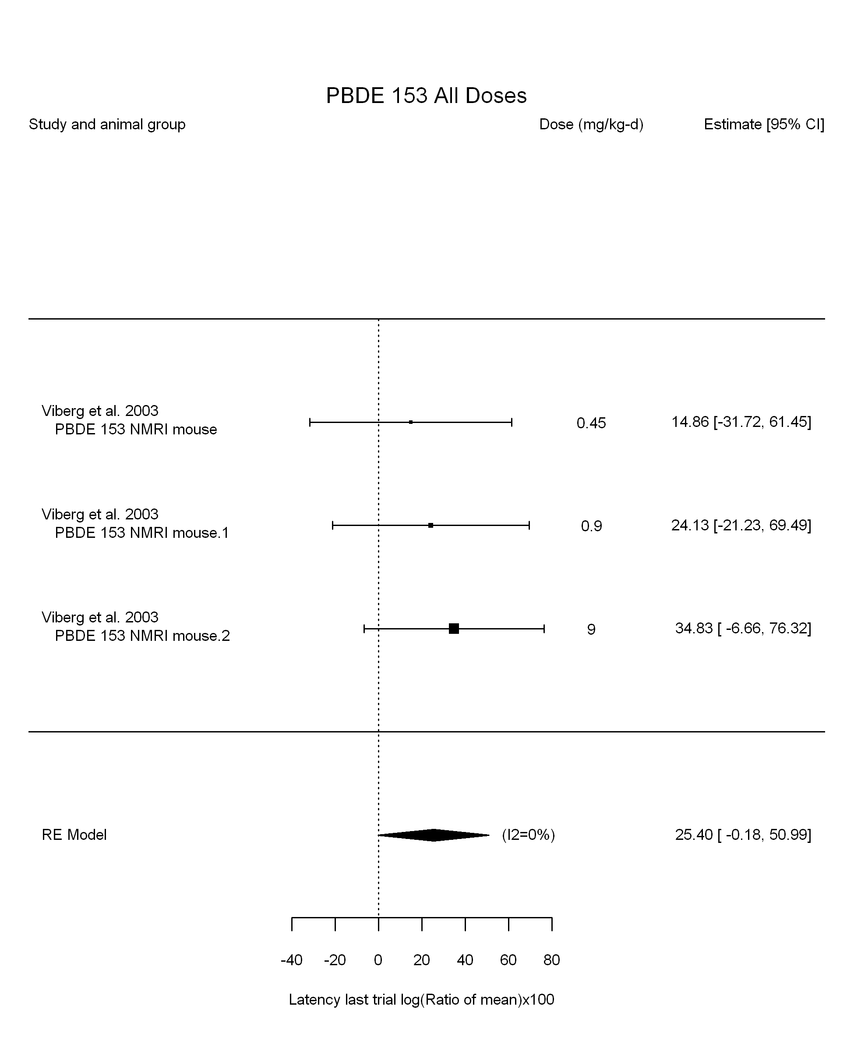

## [1] "Leave one out---------------------"  
## [1] "Linear in log10(dose)---------------------"  
##   
## Mixed-Effects Model (k = 3; tau^2 estimator: REML)  
##   
## logLik deviance AIC BIC AICc   
## -4.0798 8.1597 14.1597 8.1597 38.1597   
##   
## tau^2 (estimated amount of residual heterogeneity): 0 (SE = 768.3333)  
## tau (square root of estimated tau^2 value): 0  
## I^2 (residual heterogeneity / unaccounted variability): 0.00%  
## H^2 (unaccounted variability / sampling variability): 1.00  
## R^2 (amount of heterogeneity accounted for): NA%  
##   
## Test for Residual Heterogeneity:   
## QE(df = 1) = 0.0242, p-val = 0.8765  
##   
## Test of Moderators (coefficient(s) 2):   
## QM(df = 1) = 0.3738, p-val = 0.5409  
##   
## Model Results:  
##   
## estimate se zval pval ci.lb ci.ub   
## intrcpt 21.9860 14.2003 1.5483 0.1216 -5.8460 49.8180   
## log10(dose) 14.0256 22.9399 0.6114 0.5409 -30.9358 58.9870   
##   
## ---  
## Signif. codes: 0 '***' 0.001 '**' 0.01 '*' 0.05 '.' 0.1 ' ' 1

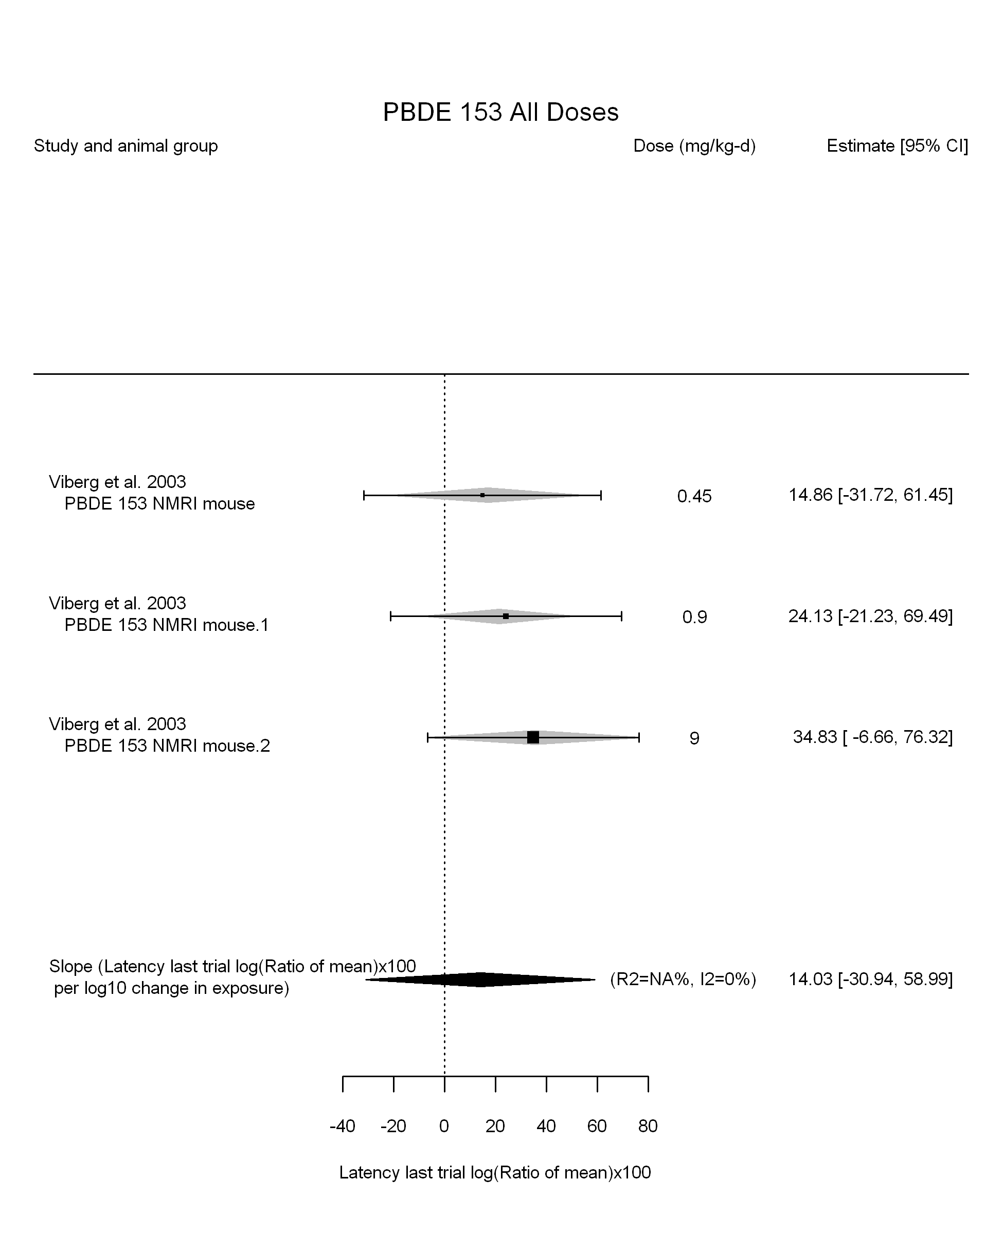

## [1] "Linear in dose---------------------"  
##   
## Mixed-Effects Model (k = 3; tau^2 estimator: REML)  
##   
## logLik deviance AIC BIC AICc   
## -8.6916 17.3833 21.3833 18.7696 33.3833   
##   
## tau^2 (estimated amount of residual heterogeneity): 0 (SE = 549.0845)  
## tau (square root of estimated tau^2 value): 0  
## I^2 (residual heterogeneity / unaccounted variability): 0.00%  
## H^2 (unaccounted variability / sampling variability): 1.00  
##   
## Test for Residual Heterogeneity:   
## QE(df = 2) = 1.0895, p-val = 0.5800  
##   
## Model Results:  
##   
## estimate se zval pval ci.lb ci.ub   
## dose10 41.1727 23.4000 1.7595 0.0785 -4.6903 87.0358 .  
##   
## ---  
## Signif. codes: 0 '***' 0.001 '**' 0.01 '*' 0.05 '.' 0.1 ' ' 1

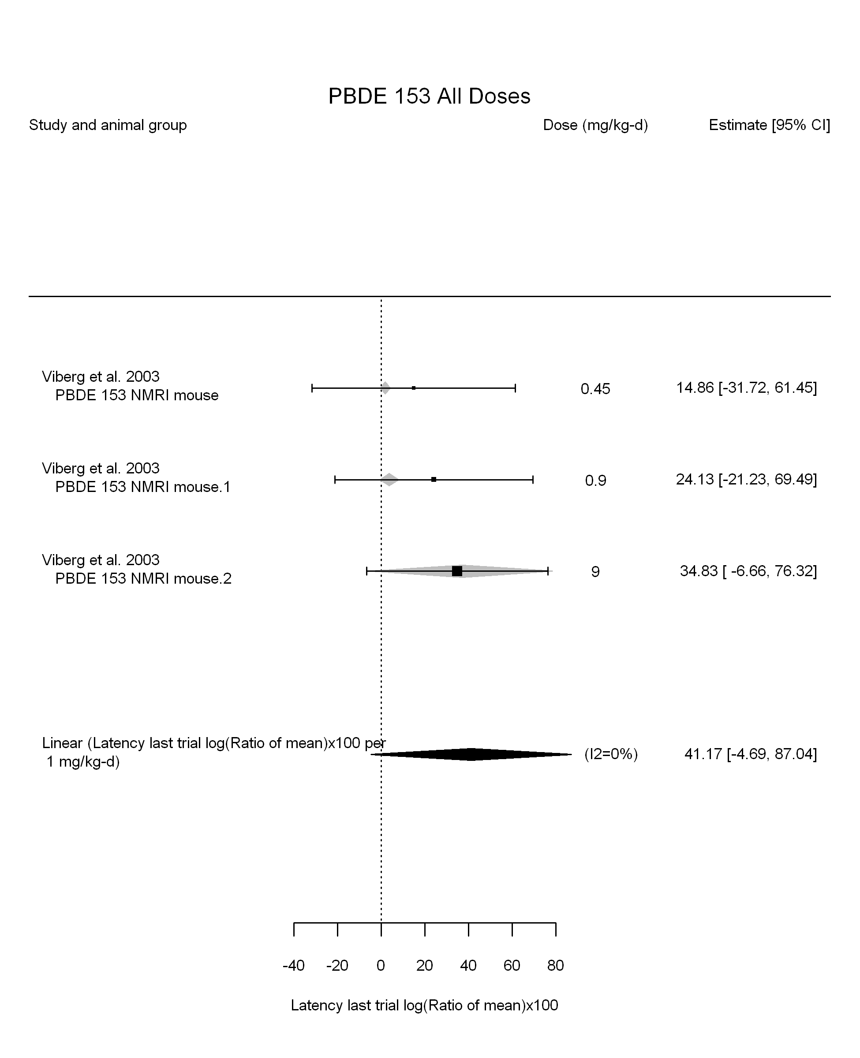

## [1] "Linear or LinearQuadratic in dose---------------------"  
##   
## Mixed-Effects Model (k = 3; tau^2 estimator: REML)  
##   
## logLik deviance AIC BIC AICc   
## -4.0851 8.1702 14.1702 8.1702 38.1702   
##   
## tau^2 (estimated amount of residual heterogeneity): 0 (SE = 789.9124)  
## tau (square root of estimated tau^2 value): 0  
## I^2 (residual heterogeneity / unaccounted variability): 0.00%  
## H^2 (unaccounted variability / sampling variability): 1.00  
##   
## Test for Residual Heterogeneity:   
## QE(df = 1) = 0.0069, p-val = 0.9336  
##   
## Test of Moderators (coefficient(s) 1,2):   
## QM(df = 2) = 4.1785, p-val = 0.1238  
##   
## Model Results:  
##   
## estimate se zval pval ci.lb ci.ub   
## dose10 304.4705 254.1354 1.1981 0.2309 -193.6258 802.5668   
## I(dose10^2) -295.3045 283.8176 -1.0405 0.2981 -851.5767 260.9677   
##   
## ---  
## Signif. codes: 0 '***' 0.001 '**' 0.01 '*' 0.05 '.' 0.1 ' ' 1

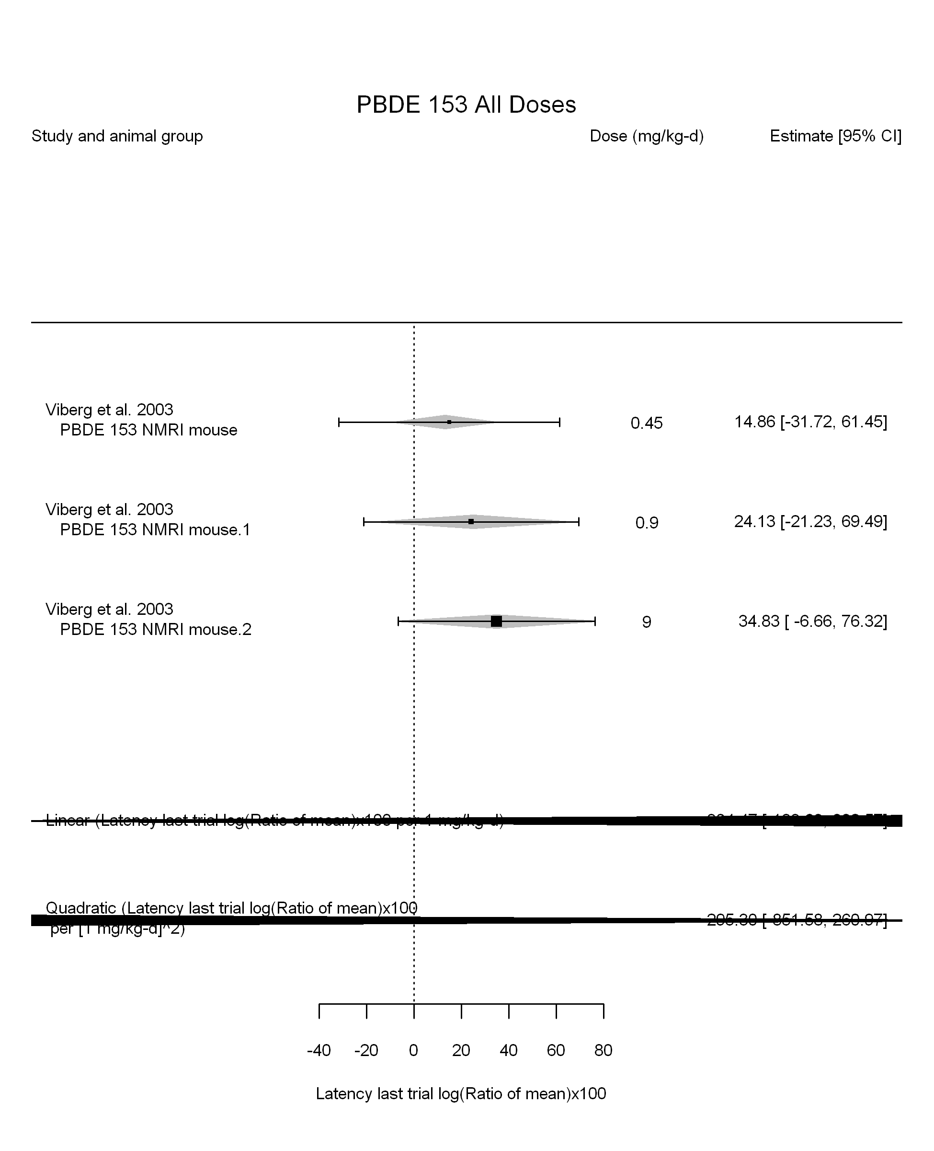

## [1] ""

## [1] ""  
## m ci.lb ci.ub bmr  
## 1 1.185011 0.5605751 NA 4.879016

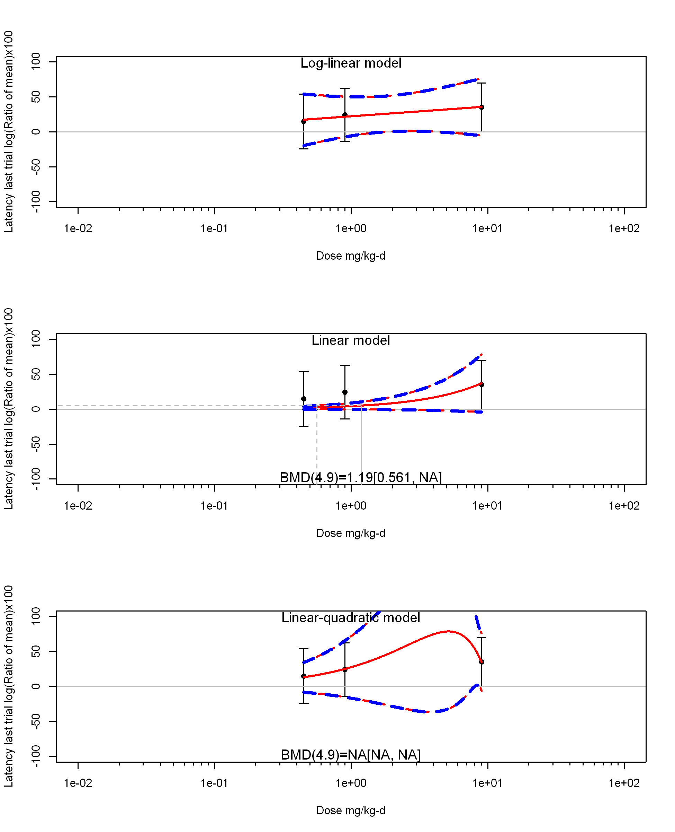

## [1] ""  
## m ci.lb ci.ub bmr  
## 1 NA NA NA 4.879016  
## [1] "Latency last trial log(Ratio of mean)x100 Highest Dose"  
## [1] "Overall Effect---------------------"  
##   
## Random-Effects Model (k = 4; tau^2 estimator: REML)  
##   
## logLik deviance AIC BIC AICc   
## -12.5747 25.1493 29.1493 27.3466 41.1493   
##   
## tau^2 (estimated amount of total heterogeneity): 40.4225 (SE = 77.6797)  
## tau (square root of estimated tau^2 value): 6.3579  
## I^2 (total heterogeneity / total variability): 42.27%  
## H^2 (total variability / sampling variability): 1.73  
##   
## Test for Heterogeneity:   
## Q(df = 3) = 5.8197, p-val = 0.1207  
##   
## Model Results:  
##   
## estimate se zval pval ci.lb ci.ub   
## 26.6942 5.0557 5.2800 <.0001 16.7852 36.6032 ***   
##   
## ---  
## Signif. codes: 0 '***' 0.001 '**' 0.01 '*' 0.05 '.' 0.1 ' ' 1

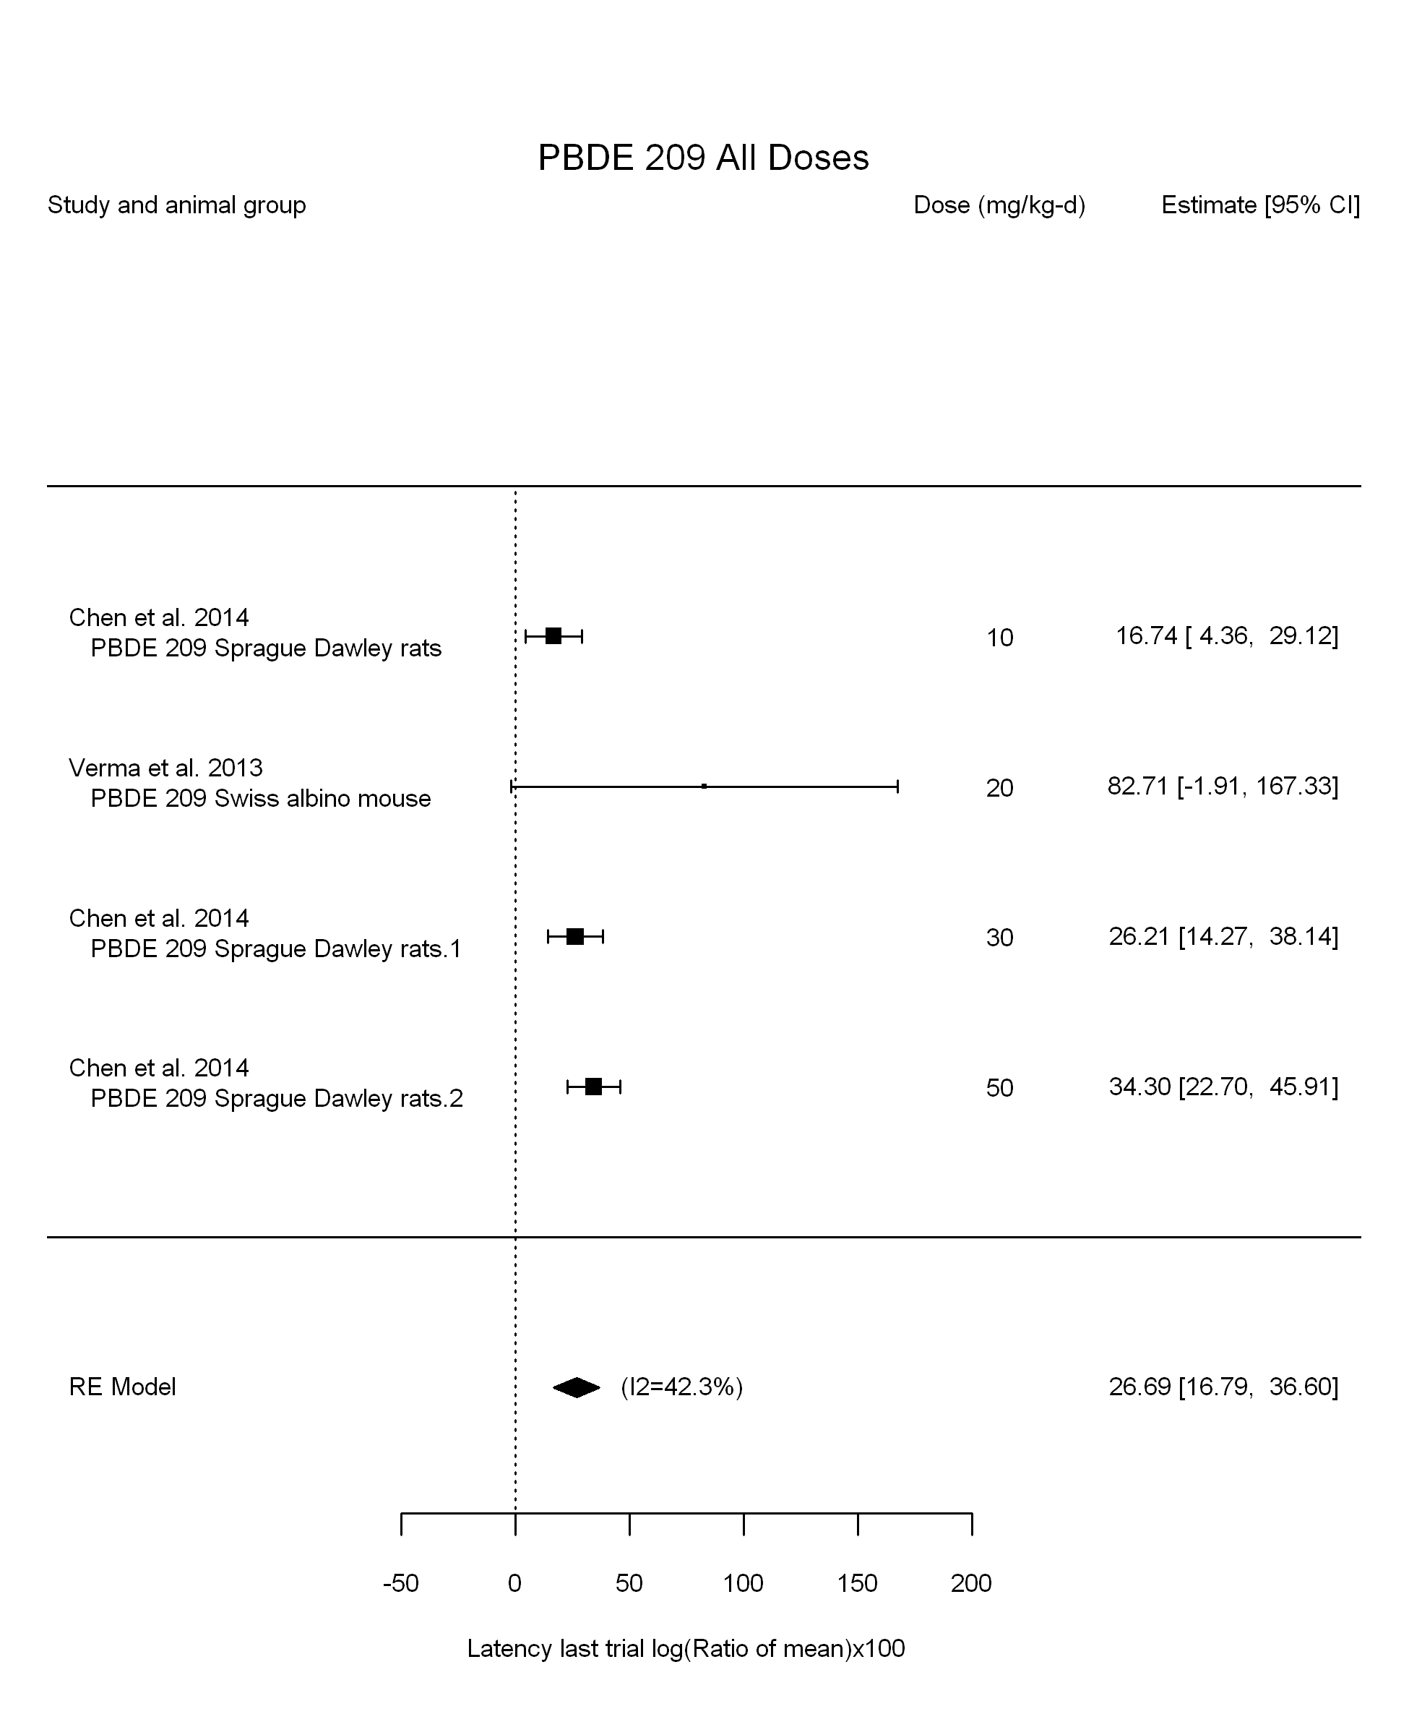

## [1] "Leave one out---------------------"  
## [1] "Linear in log10(dose)---------------------"  
##   
## Mixed-Effects Model (k = 4; tau^2 estimator: REML)  
##   
## logLik deviance AIC BIC AICc   
## -8.2393 16.4786 22.4786 18.5580 46.4786   
##   
## tau^2 (estimated amount of residual heterogeneity): 0.0000 (SE = 51.8264)  
## tau (square root of estimated tau^2 value): 0.0017  
## I^2 (residual heterogeneity / unaccounted variability): 0.00%  
## H^2 (unaccounted variability / sampling variability): 1.00  
## R^2 (amount of heterogeneity accounted for): 100.00%  
##   
## Test for Residual Heterogeneity:   
## QE(df = 2) = 1.9748, p-val = 0.3725  
##   
## Test of Moderators (coefficient(s) 2):   
## QM(df = 1) = 3.8449, p-val = 0.0499  
##   
## Model Results:  
##   
## estimate se zval pval ci.lb ci.ub   
## intrcpt -7.1429 17.5148 -0.4078 0.6834 -41.4714 27.1855   
## log10(dose) 23.9203 12.1990 1.9608 0.0499 0.0107 47.8299 *  
##   
## ---  
## Signif. codes: 0 '***' 0.001 '**' 0.01 '*' 0.05 '.' 0.1 ' ' 1

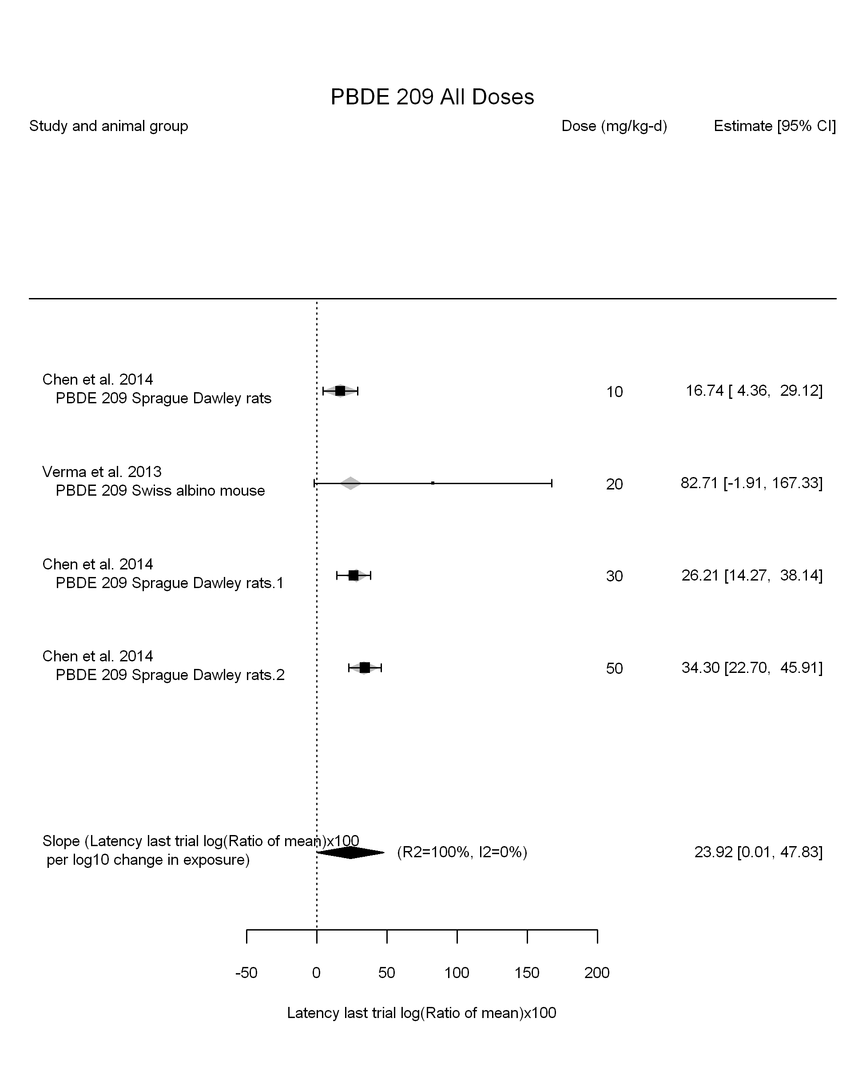

## [1] "Linear in dose---------------------"  
##   
## Mixed-Effects Model (k = 4; tau^2 estimator: REML)  
##   
## logLik deviance AIC BIC AICc   
## -12.6644 25.3288 29.3288 27.5261 41.3288   
##   
## tau^2 (estimated amount of residual heterogeneity): 16.0659 (SE = 54.1485)  
## tau (square root of estimated tau^2 value): 4.0082  
## I^2 (residual heterogeneity / unaccounted variability): 22.14%  
## H^2 (unaccounted variability / sampling variability): 1.28  
##   
## Test for Residual Heterogeneity:   
## QE(df = 3) = 5.2378, p-val = 0.1552  
##   
## Model Results:  
##   
## estimate se zval pval ci.lb ci.ub   
## dose10 7.6967 1.2141 6.3392 <.0001 5.3171 10.0764 ***  
##   
## ---  
## Signif. codes: 0 '***' 0.001 '**' 0.01 '*' 0.05 '.' 0.1 ' ' 1

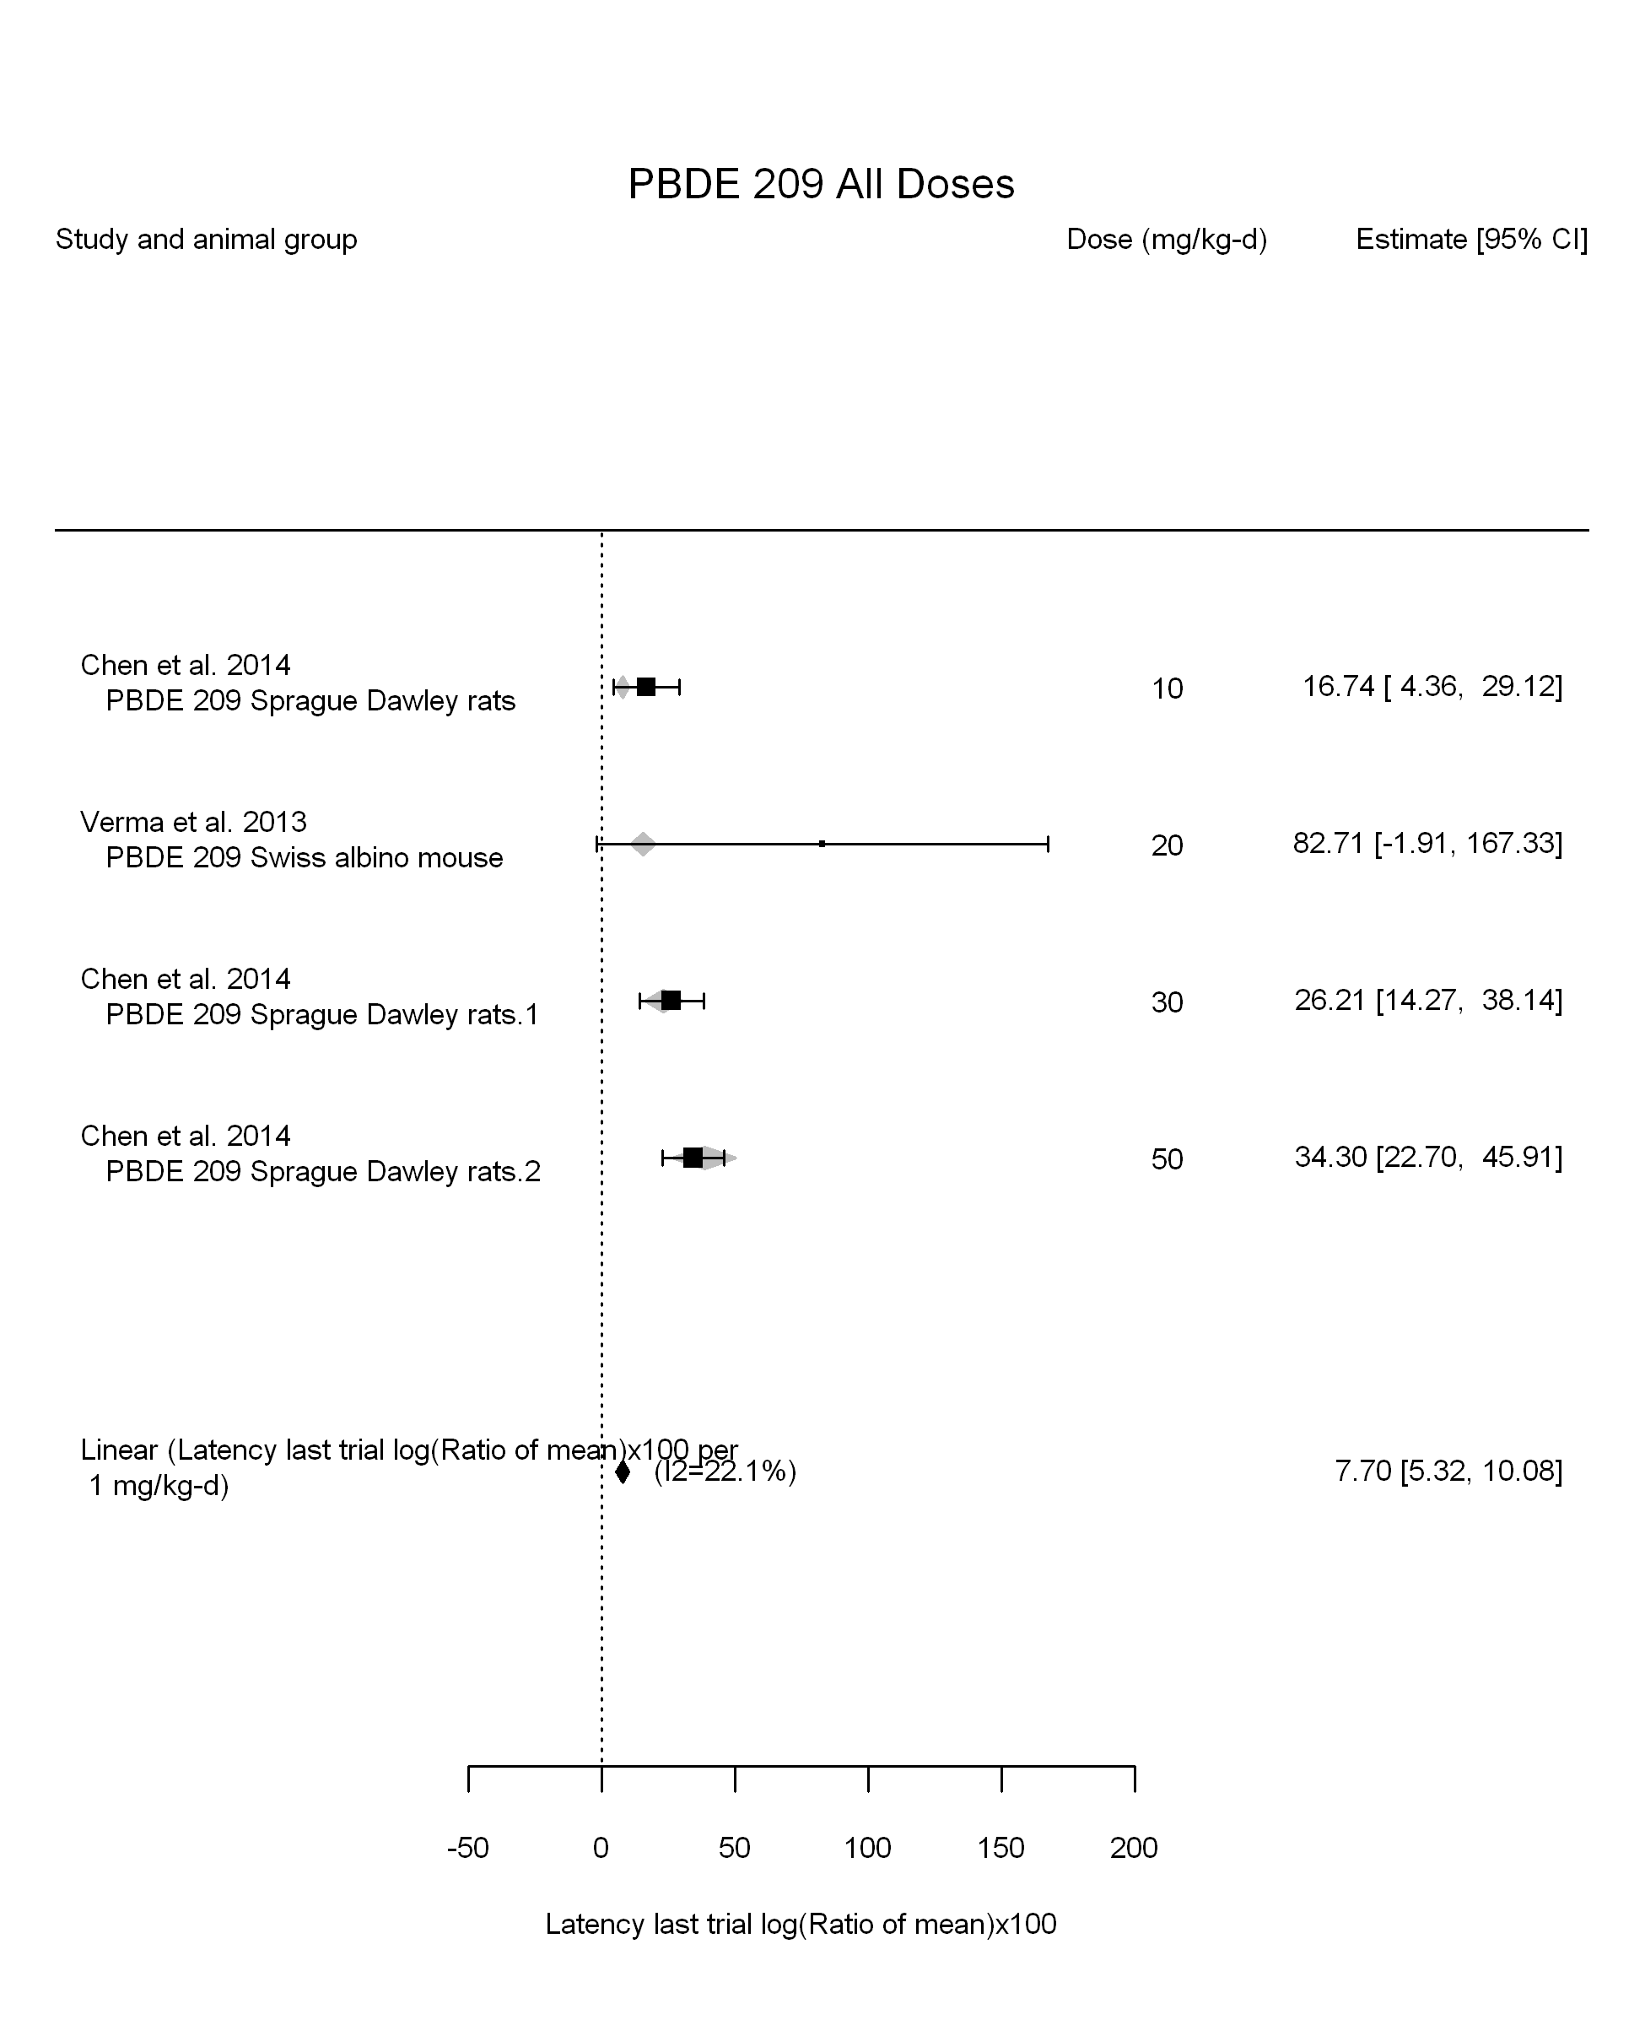

## [1] "Linear or LinearQuadratic in dose---------------------"  
##   
## Mixed-Effects Model (k = 4; tau^2 estimator: REML)  
##   
## logLik deviance AIC BIC AICc   
## -8.4705 16.9410 22.9410 19.0204 46.9410   
##   
## tau^2 (estimated amount of residual heterogeneity): 0.0000 (SE = 55.0329)  
## tau (square root of estimated tau^2 value): 0.0016  
## I^2 (residual heterogeneity / unaccounted variability): 0.00%  
## H^2 (unaccounted variability / sampling variability): 1.00  
##   
## Test for Residual Heterogeneity:   
## QE(df = 2) = 2.5913, p-val = 0.2737  
##   
## Test of Moderators (coefficient(s) 1,2):   
## QM(df = 2) = 60.1825, p-val < .0001  
##   
## Model Results:  
##   
## estimate se zval pval ci.lb ci.ub   
## dose10 14.6846 4.4400 3.3073 0.0009 5.9824 23.3869 ***  
## I(dose10^2) -1.5995 0.9832 -1.6268 0.1038 -3.5266 0.3276   
##   
## ---  
## Signif. codes: 0 '***' 0.001 '**' 0.01 '*' 0.05 '.' 0.1 ' ' 1

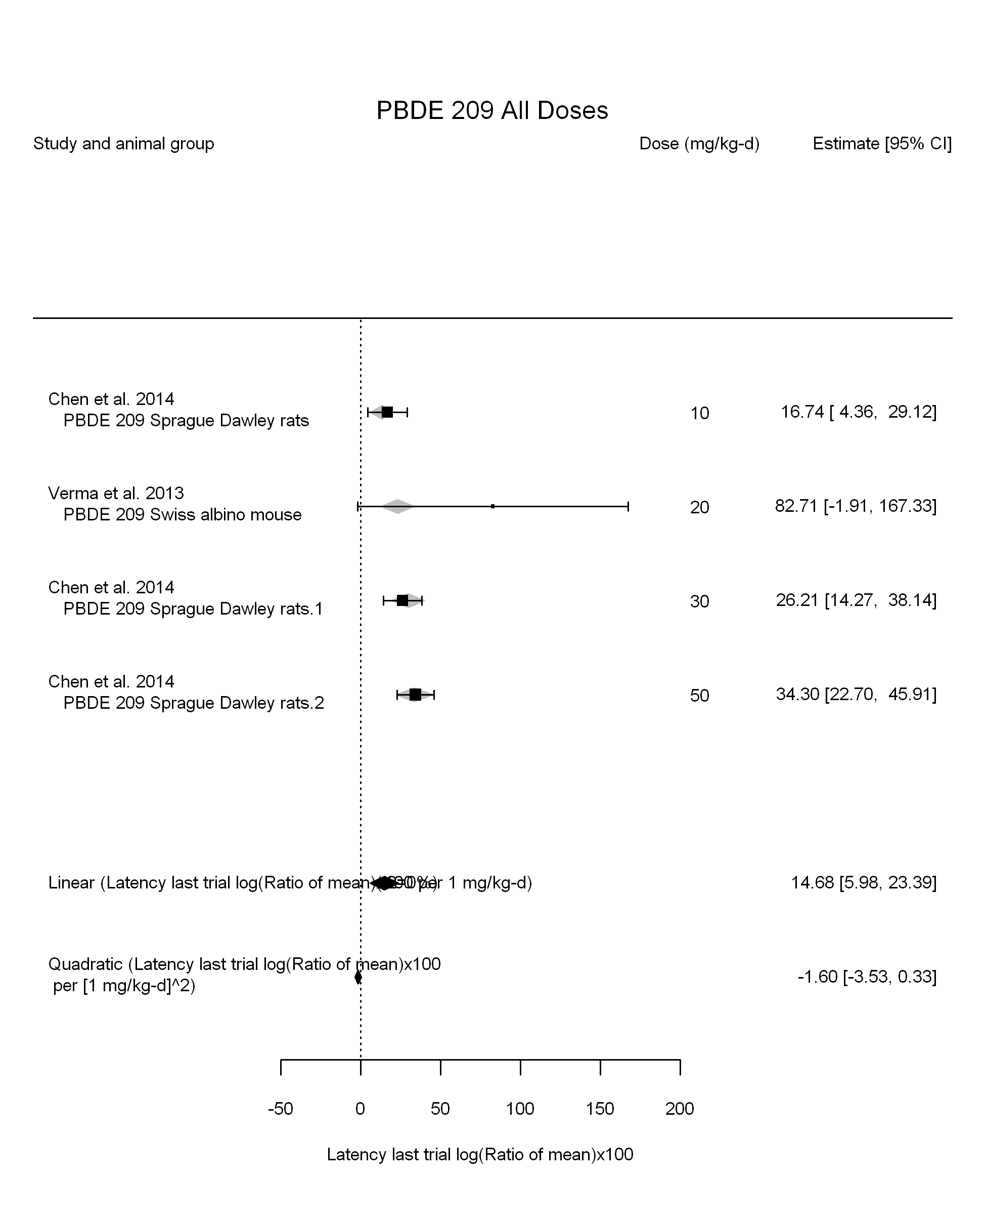

## [1] ""

## [1] ""  
## m ci.lb ci.ub bmr  
## 1 6.339069 4.842018 9.176166 4.879016

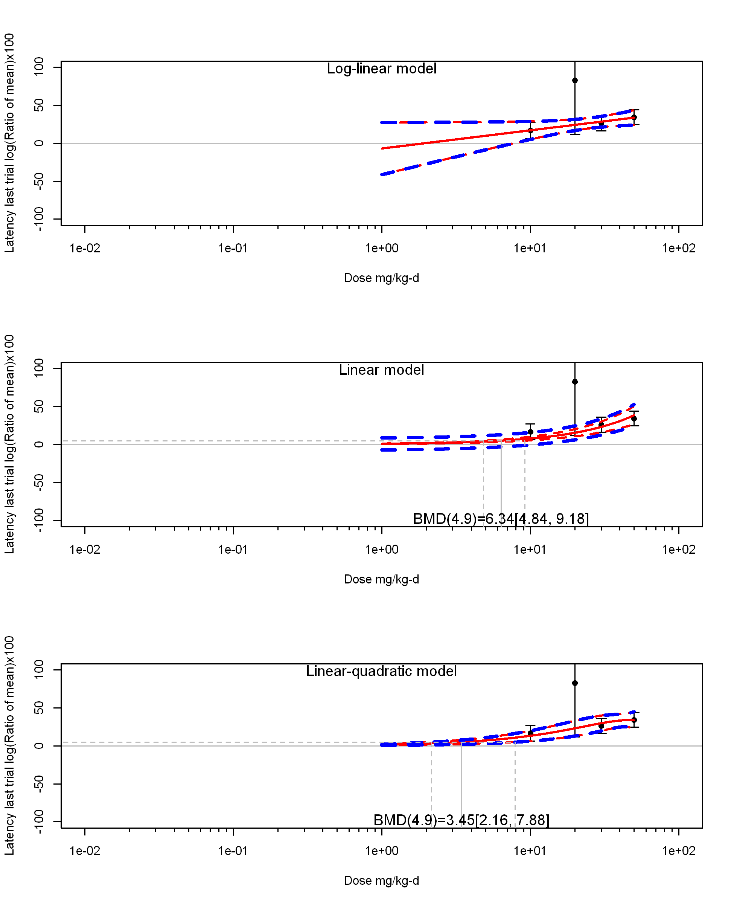

## [1] ""  
## m ci.lb ci.ub bmr  
## 1 3.452353 2.155208 7.878898 4.879016  
## [1] "Latency last trial log(Ratio of mean)x100 Highest Dose"  
## [1] "Highest Dose Overall Effect---------------------"  
##   
## Random-Effects Model (k = 2; tau^2 estimator: REML)  
##   
## logLik deviance AIC BIC AICc   
## -4.9520 9.9040 13.9040 9.9040 25.9040   
##   
## tau^2 (estimated amount of total heterogeneity): 221.9995 (SE = 1656.8286)  
## tau (square root of estimated tau^2 value): 14.8996  
## I^2 (total heterogeneity / total variability): 18.95%  
## H^2 (total variability / sampling variability): 1.23  
##   
## Test for Heterogeneity:   
## Q(df = 1) = 1.2338, p-val = 0.2667  
##   
## Model Results:  
##   
## estimate se zval pval ci.lb ci.ub   
## 39.6115 15.1280 2.6184 0.0088 9.9612 69.2617 **   
##   
## ---  
## Signif. codes: 0 '***' 0.001 '**' 0.01 '*' 0.05 '.' 0.1 ' ' 1

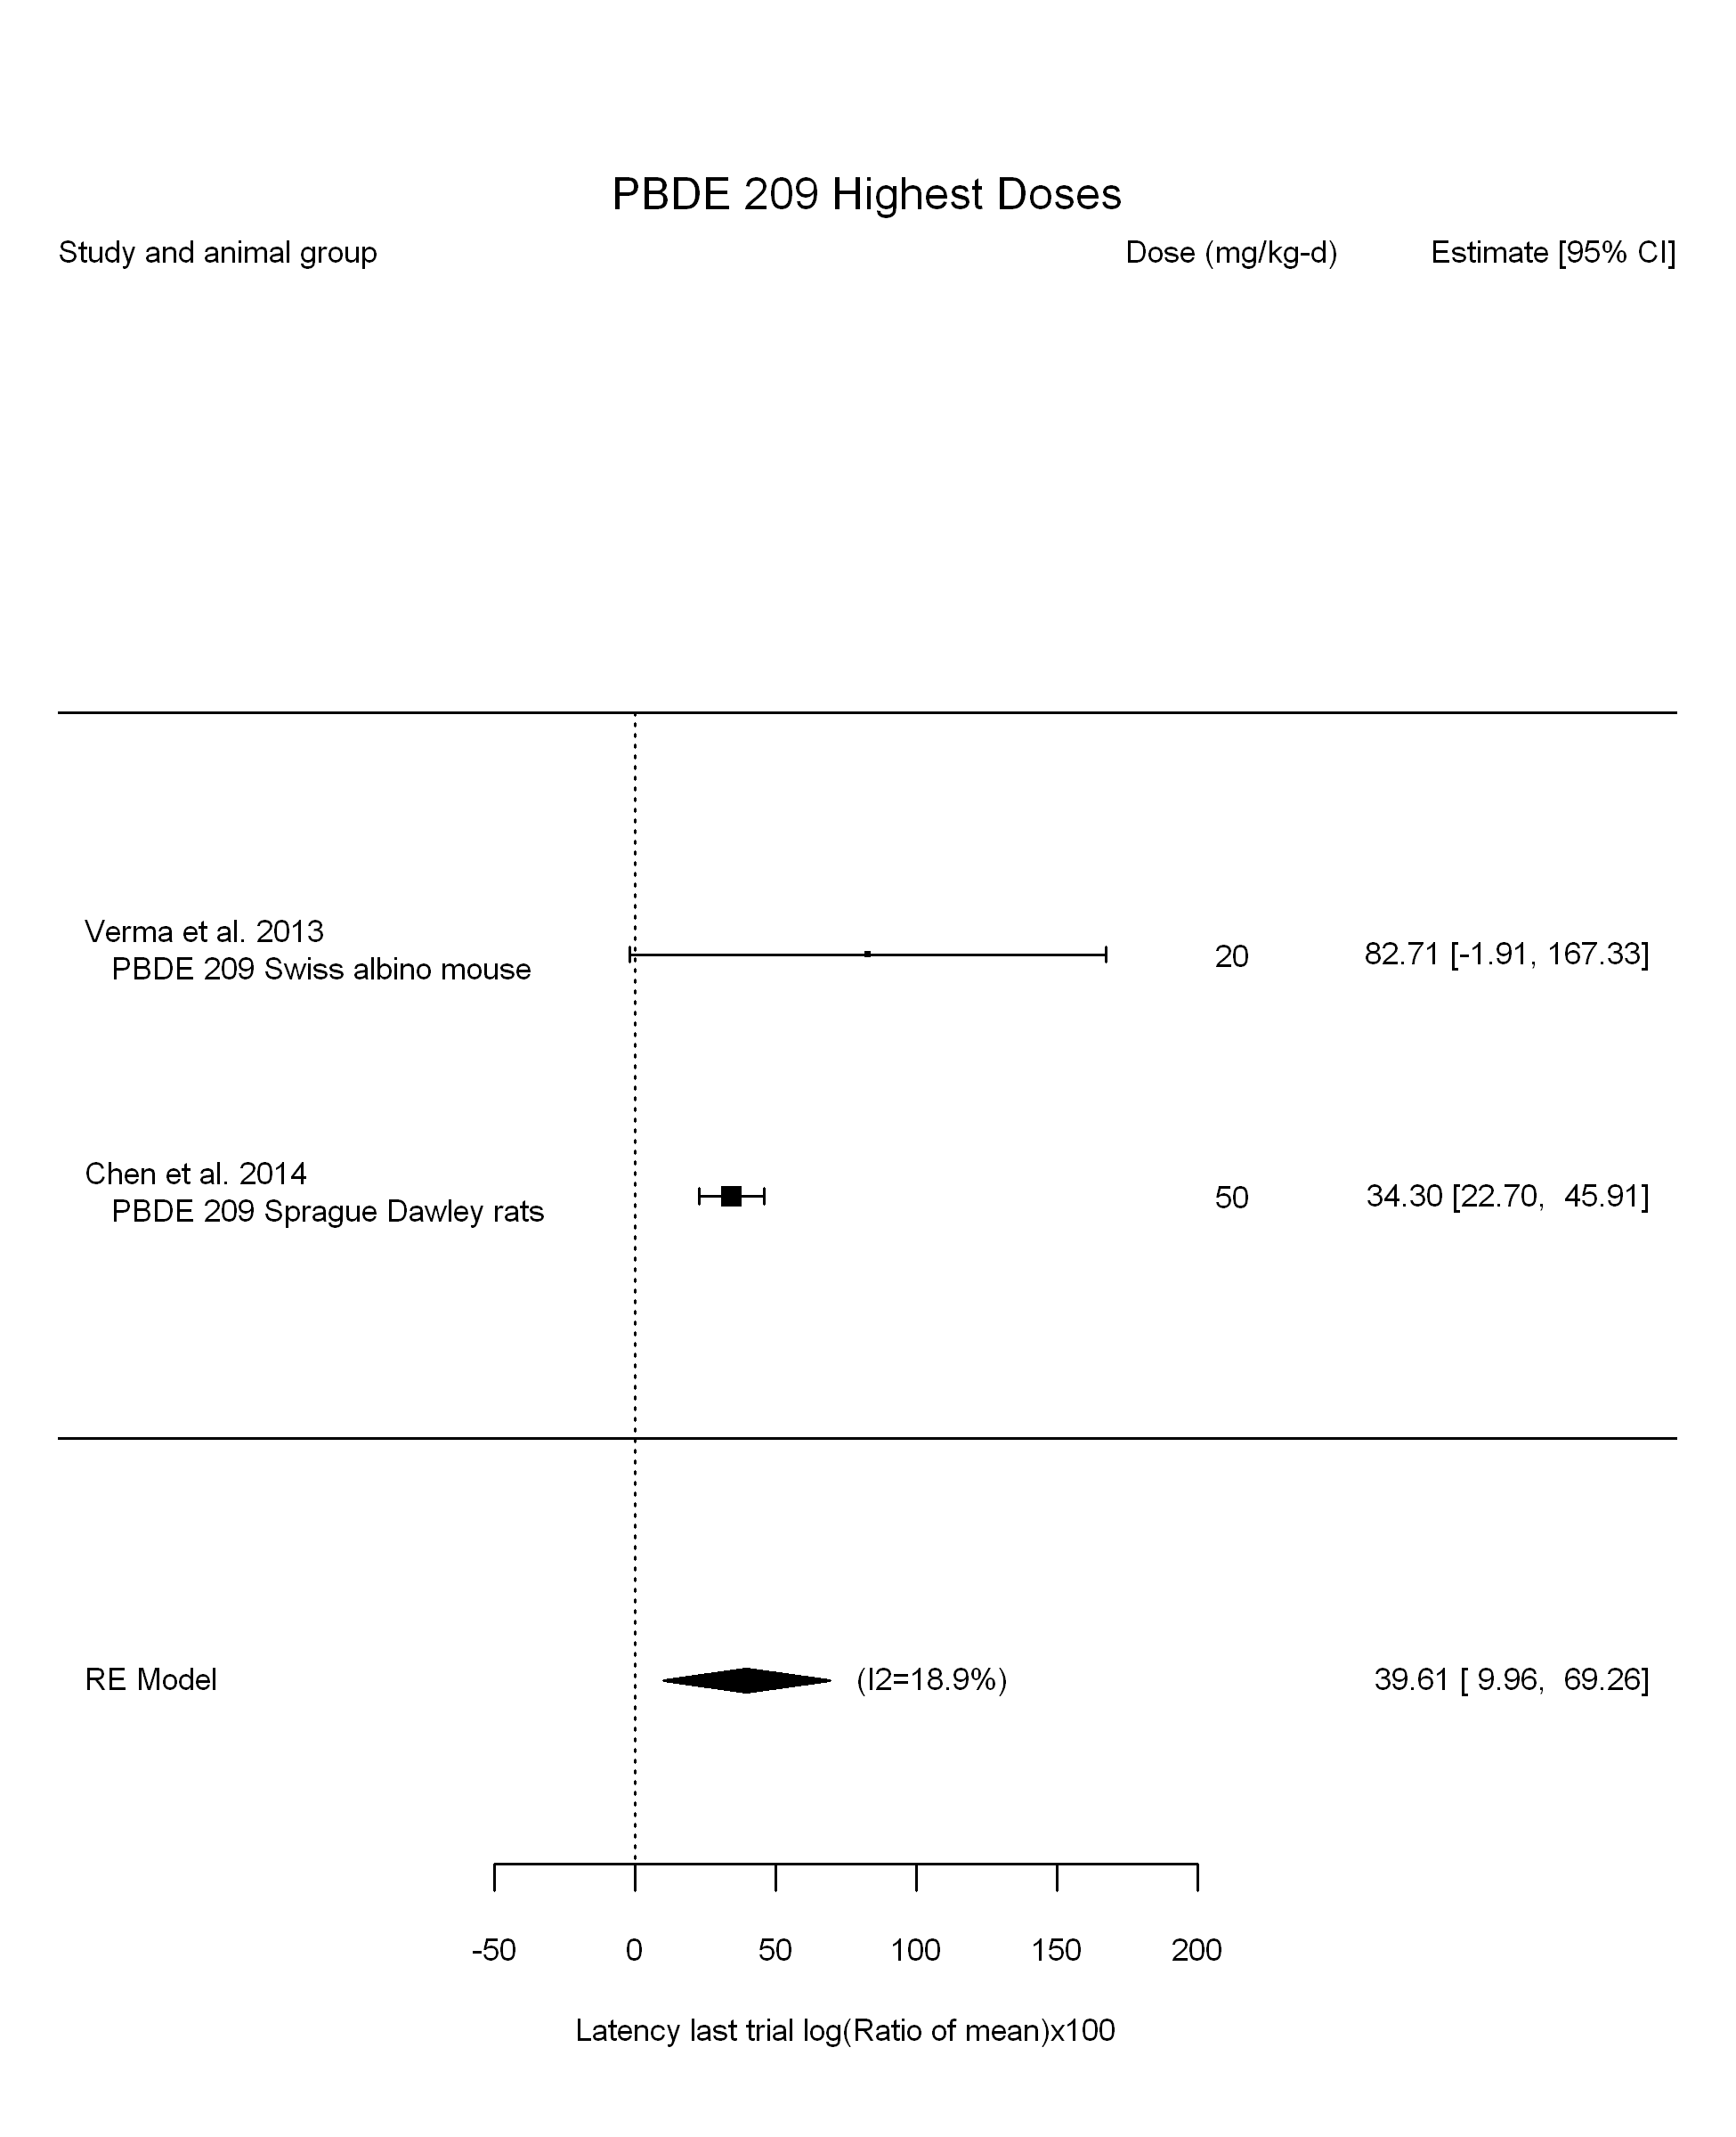

## [1] "Highest Dose Leave one out---------------------"  
## [1] "Highest Dose Linear or LinearQuadratic in dose---------------------"  
##   
## Mixed-Effects Model (k = 2; tau^2 estimator: REML)  
##   
## logLik deviance AIC BIC AICc   
## -5.5786 11.1573 15.1573 11.1573 27.1573   
##   
## tau^2 (estimated amount of residual heterogeneity): 2490.9020 (SE = 5802.0664)  
## tau (square root of estimated tau^2 value): 49.9089  
## I^2 (residual heterogeneity / unaccounted variability): 60.71%  
## H^2 (unaccounted variability / sampling variability): 2.55  
##   
## Test for Residual Heterogeneity:   
## QE(df = 1) = 2.5454, p-val = 0.1106  
##   
## Model Results:  
##   
## estimate se zval pval ci.lb ci.ub   
## dose10 9.7894 9.6155 1.0181 0.3086 -9.0566 28.6355   
##   
## ---  
## Signif. codes: 0 '***' 0.001 '**' 0.01 '*' 0.05 '.' 0.1 ' ' 1

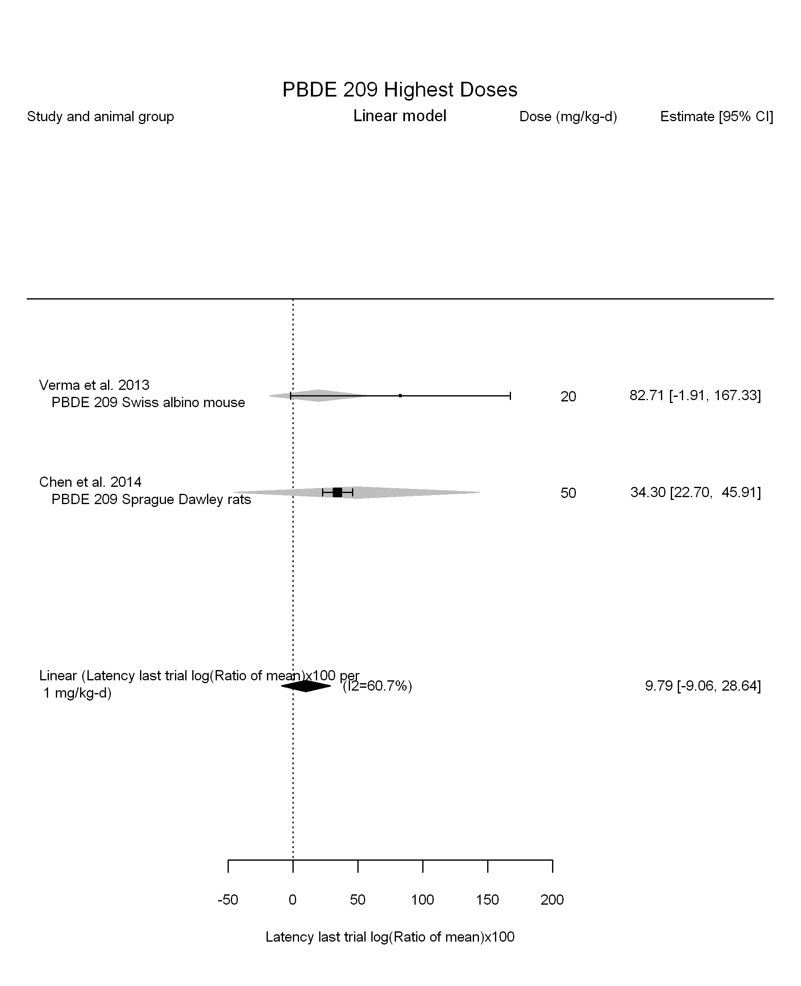

## [1] ""  
## m ci.lb ci.ub bmr  
## 1 3.452353 2.155208 7.878898 4.879016

## Warning in if (dim(dat.now[1]) > 2) {: the condition has length > 1 and  
## only the first element will be used

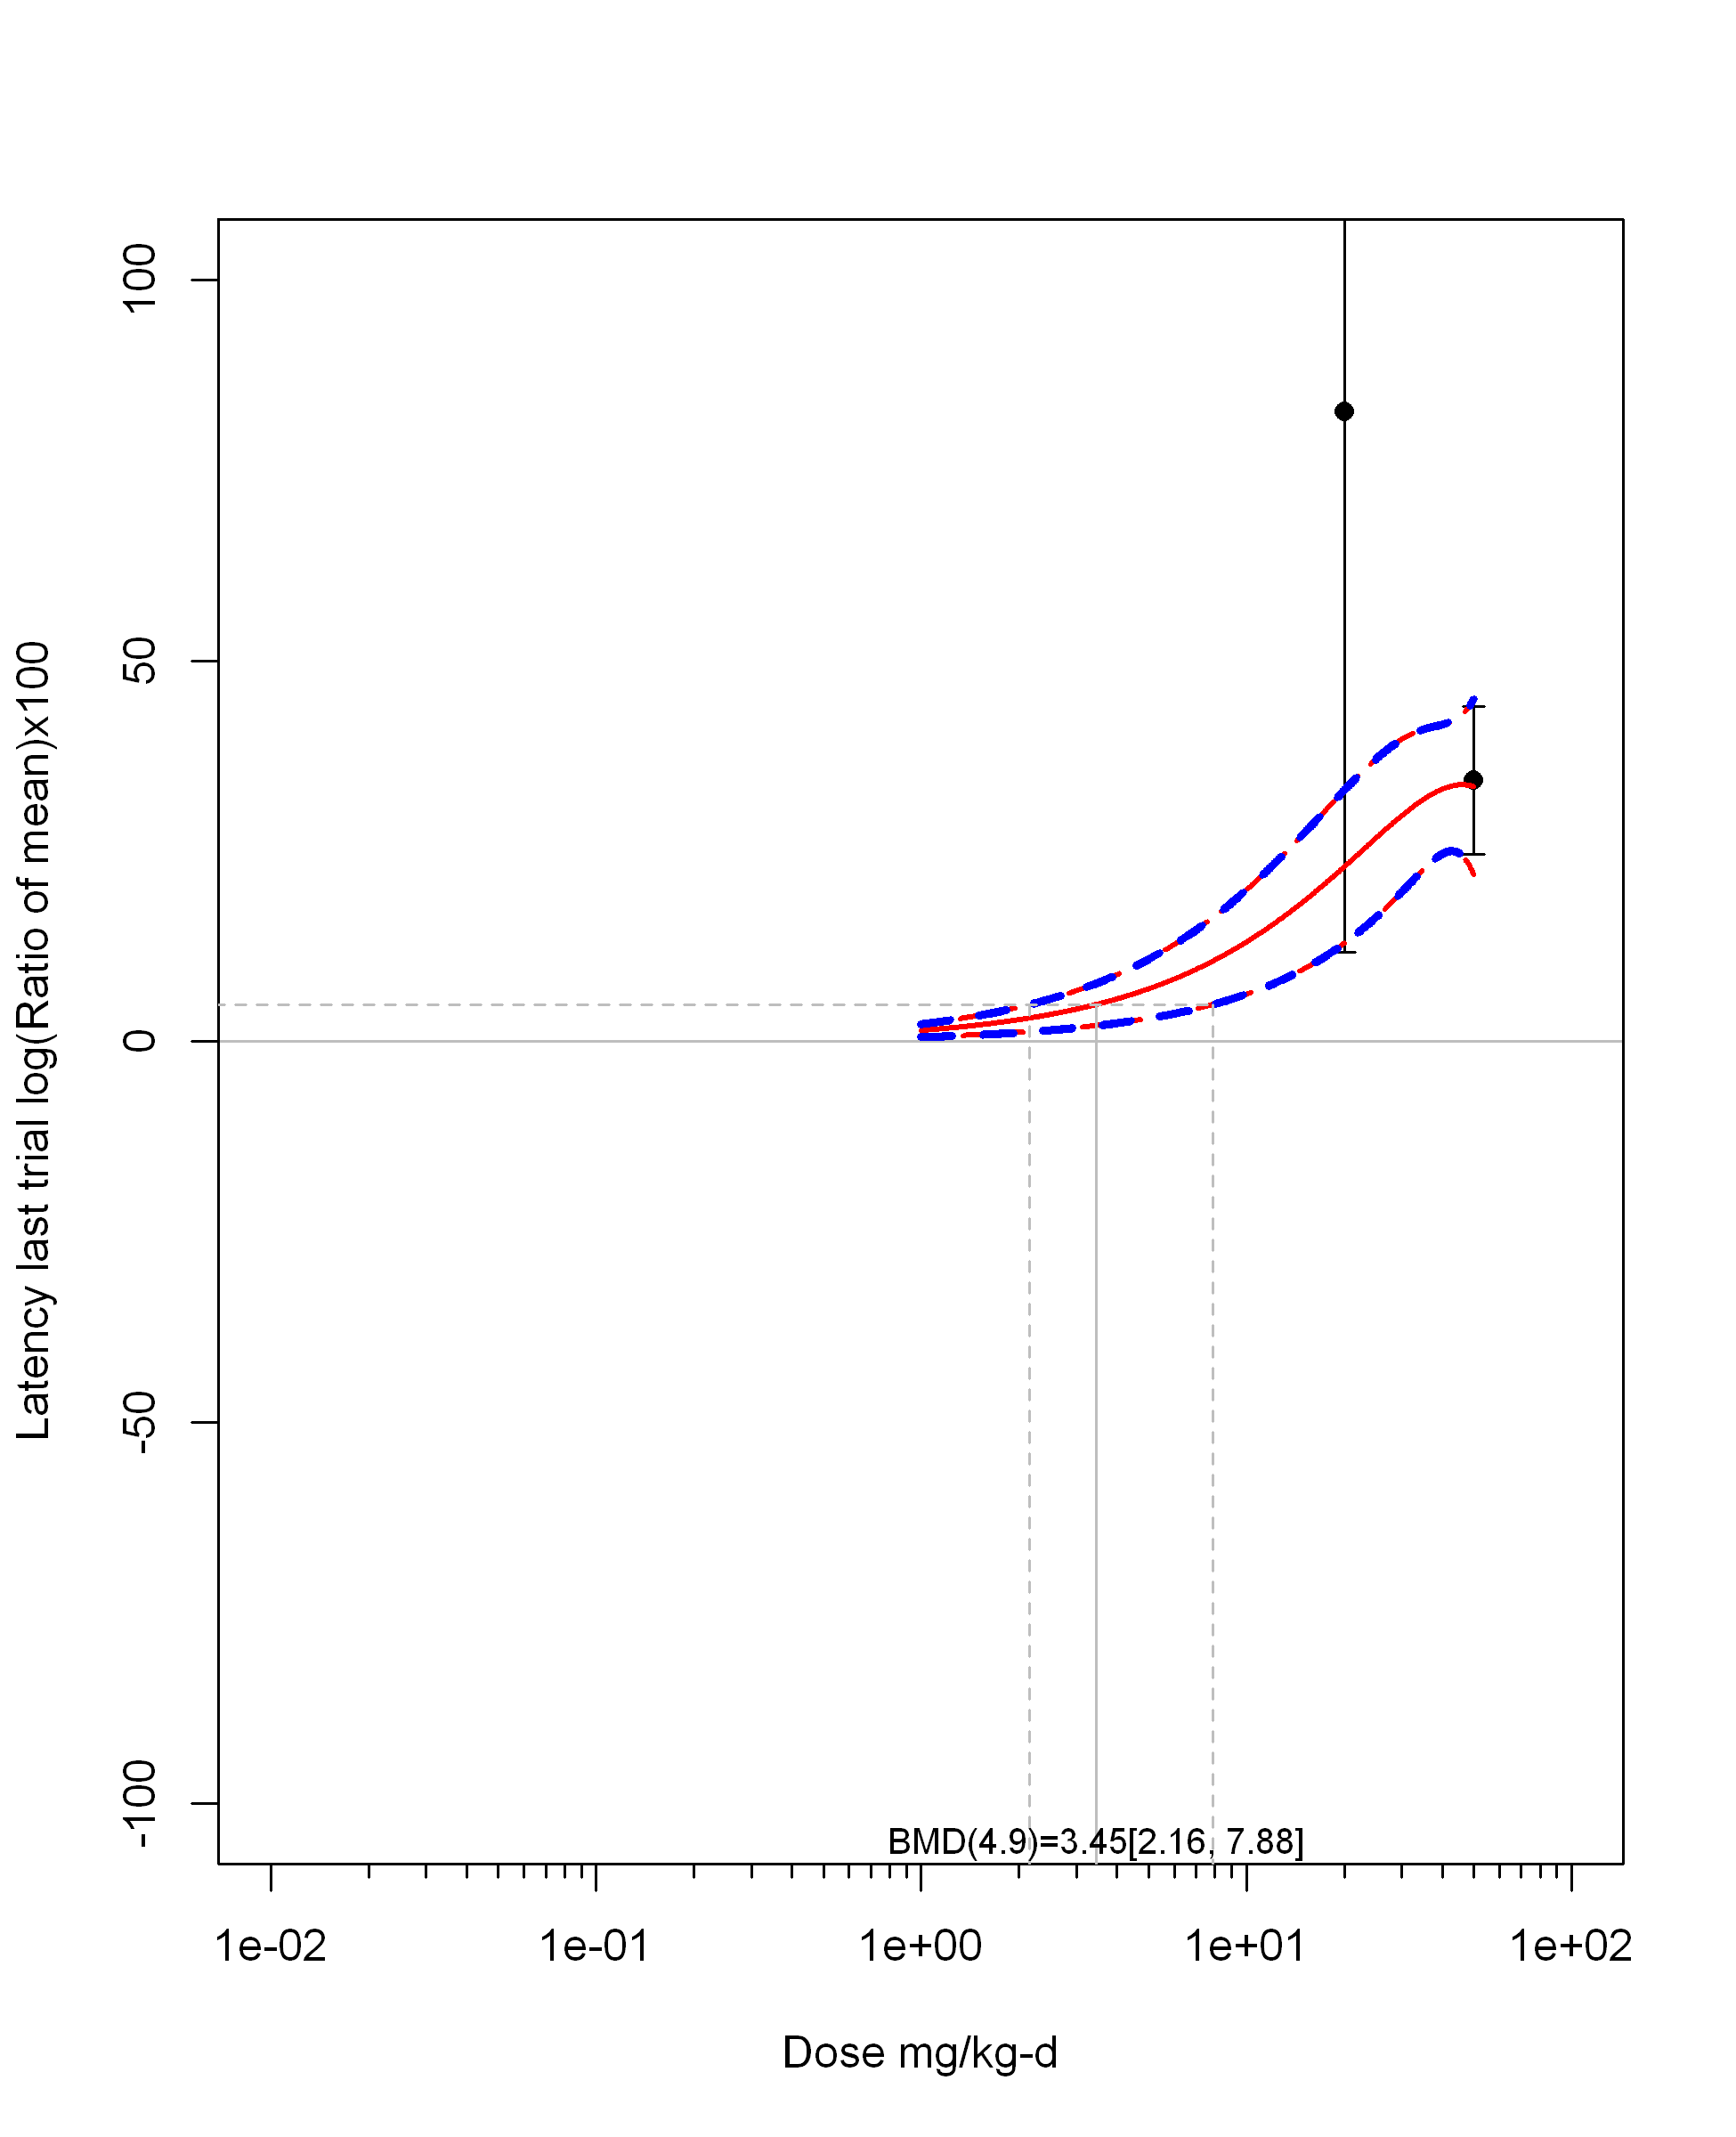

## [1] "Overall Effect---------------------"  
##   
## Random-Effects Model (k = 5; tau^2 estimator: REML)  
##   
## logLik deviance AIC BIC AICc   
## -16.5045 33.0090 37.0090 35.7816 49.0090   
##   
## tau^2 (estimated amount of total heterogeneity): 45.1818 (SE = 74.8909)  
## tau (square root of estimated tau^2 value): 6.7217  
## I^2 (total heterogeneity / total variability): 44.43%  
## H^2 (total variability / sampling variability): 1.80  
##   
## Test for Heterogeneity:   
## Q(df = 4) = 7.5572, p-val = 0.1092  
##   
## Model Results:  
##   
## estimate se zval pval ci.lb ci.ub   
## 23.5552 4.8537 4.8531 <.0001 14.0422 33.0682 ***   
##   
## ---  
## Signif. codes: 0 '***' 0.001 '**' 0.01 '*' 0.05 '.' 0.1 ' ' 1

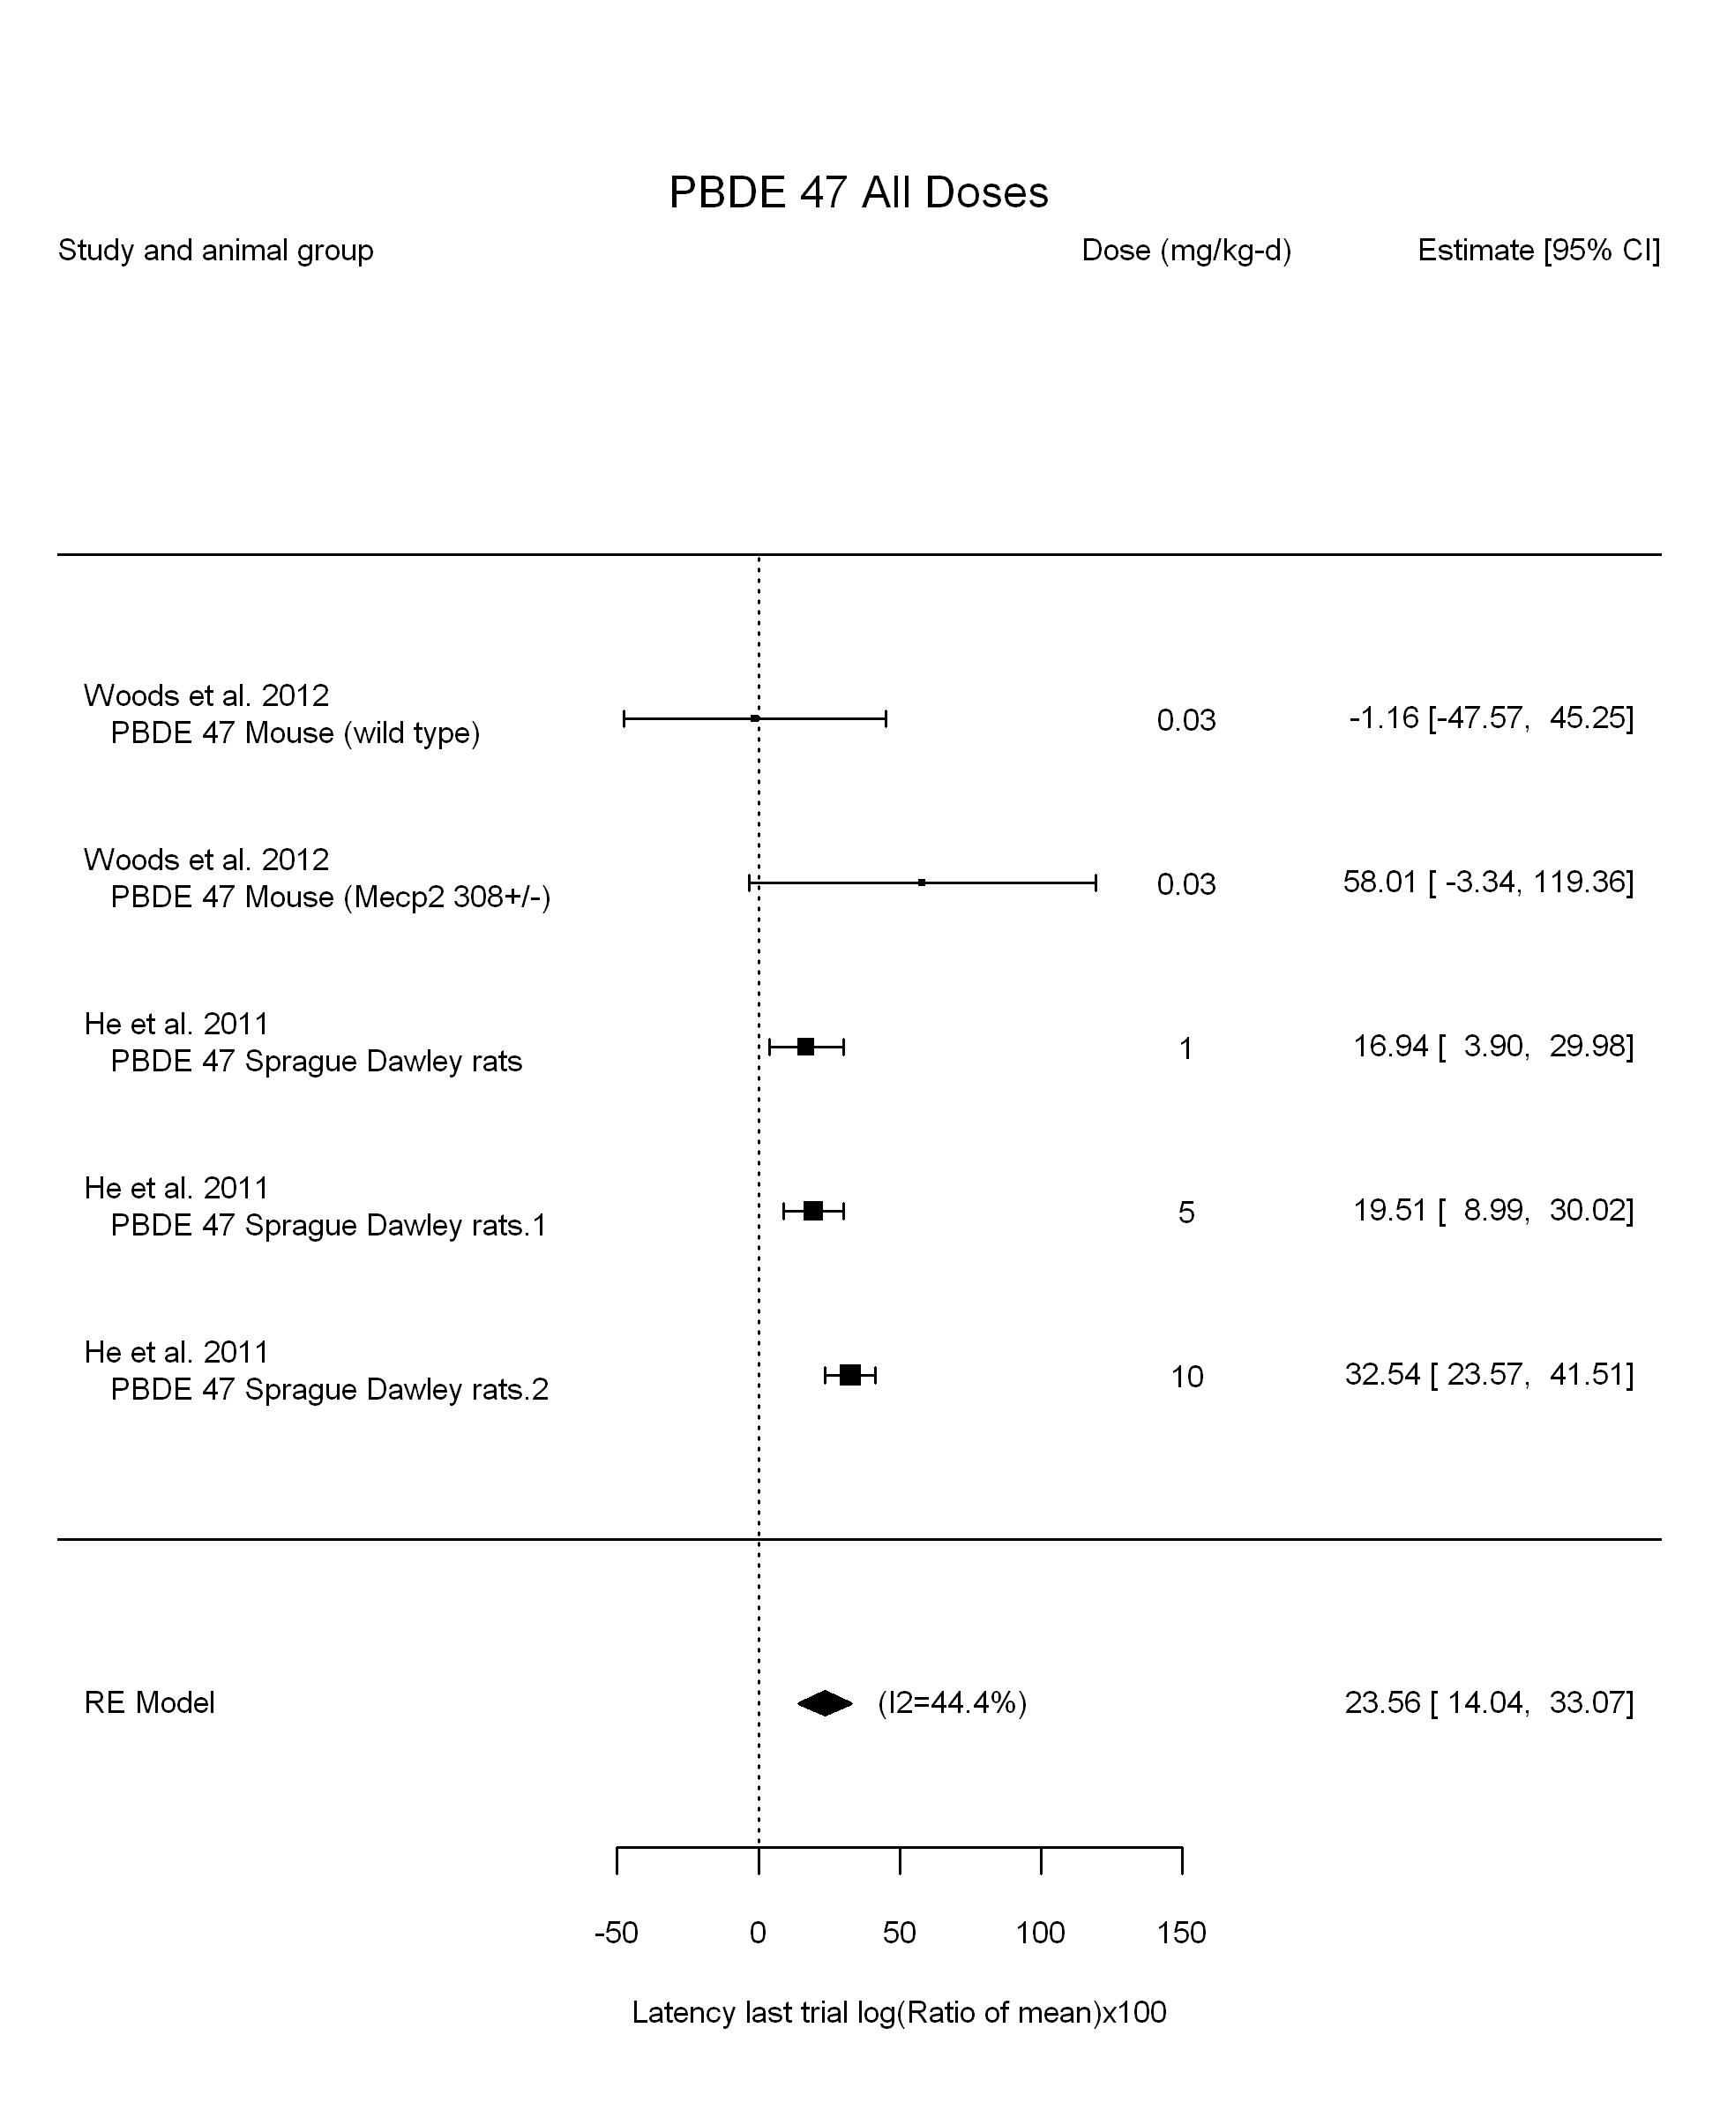

## [1] "Leave one out---------------------"  
## [1] "Linear in log10(dose)---------------------"  
##   
## Mixed-Effects Model (k = 5; tau^2 estimator: REML)  
##   
## logLik deviance AIC BIC AICc   
## -12.3222 24.6445 30.6445 27.9403 54.6445   
##   
## tau^2 (estimated amount of residual heterogeneity): 22.2583 (SE = 61.8974)  
## tau (square root of estimated tau^2 value): 4.7179  
## I^2 (residual heterogeneity / unaccounted variability): 27.79%  
## H^2 (unaccounted variability / sampling variability): 1.38  
## R^2 (amount of heterogeneity accounted for): 50.74%  
##   
## Test for Residual Heterogeneity:   
## QE(df = 3) = 5.1513, p-val = 0.1610  
##   
## Test of Moderators (coefficient(s) 2):   
## QM(df = 1) = 1.1019, p-val = 0.2939  
##   
## Model Results:  
##   
## estimate se zval pval ci.lb ci.ub   
## intrcpt 20.0182 5.4996 3.6400 0.0003 9.2392 30.7972 ***  
## log10(dose) 7.1887 6.8483 1.0497 0.2939 -6.2338 20.6111   
##   
## ---  
## Signif. codes: 0 '***' 0.001 '**' 0.01 '*' 0.05 '.' 0.1 ' ' 1

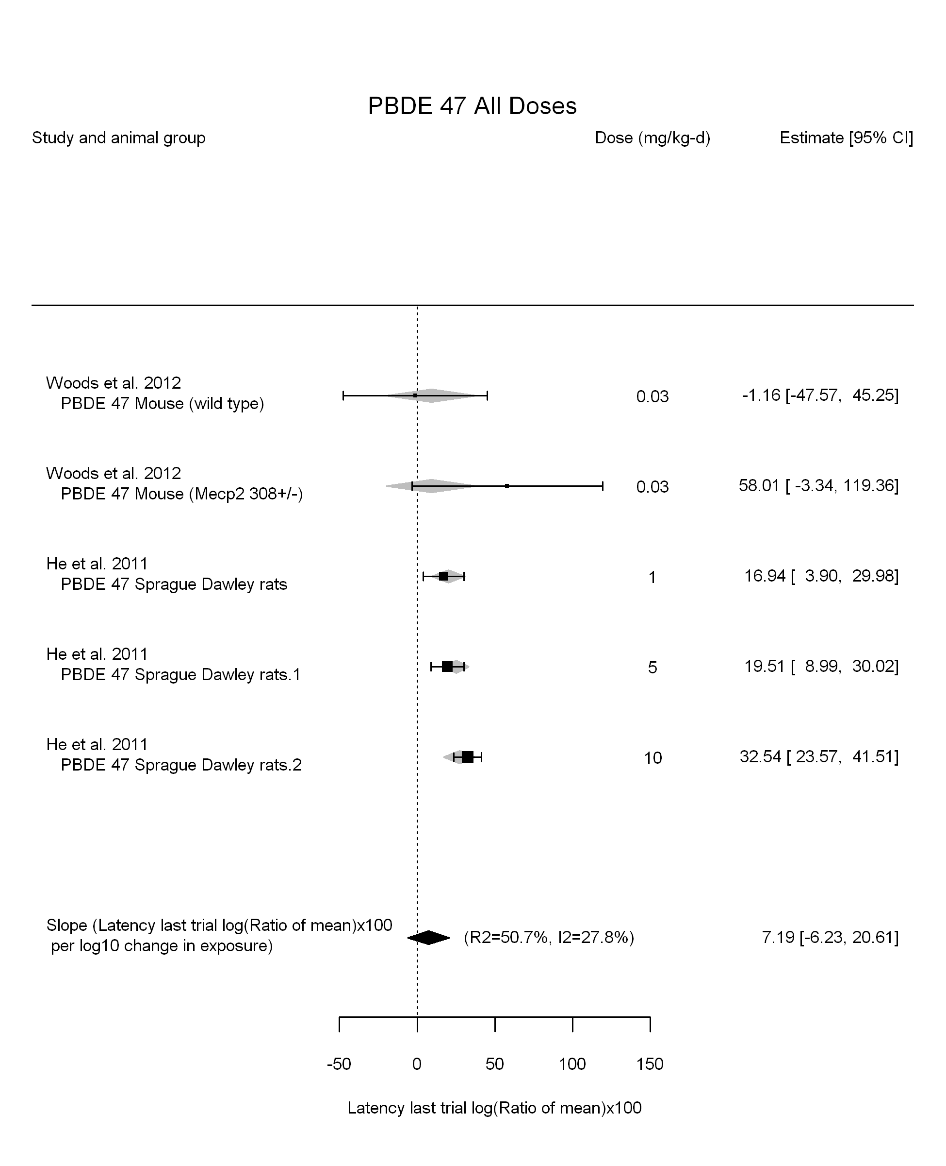

## [1] "Linear in dose---------------------"  
##   
## Mixed-Effects Model (k = 5; tau^2 estimator: REML)  
##   
## logLik deviance AIC BIC AICc   
## -17.4502 34.9003 38.9003 37.6729 50.9003   
##   
## tau^2 (estimated amount of residual heterogeneity): 45.7052 (SE = 79.5803)  
## tau (square root of estimated tau^2 value): 6.7606  
## I^2 (residual heterogeneity / unaccounted variability): 41.56%  
## H^2 (unaccounted variability / sampling variability): 1.71  
##   
## Test for Residual Heterogeneity:   
## QE(df = 4) = 7.8887, p-val = 0.0957  
##   
## Model Results:  
##   
## estimate se zval pval ci.lb ci.ub   
## dose10 34.5508 7.3584 4.6954 <.0001 20.1286 48.9729 ***  
##   
## ---  
## Signif. codes: 0 '***' 0.001 '**' 0.01 '*' 0.05 '.' 0.1 ' ' 1

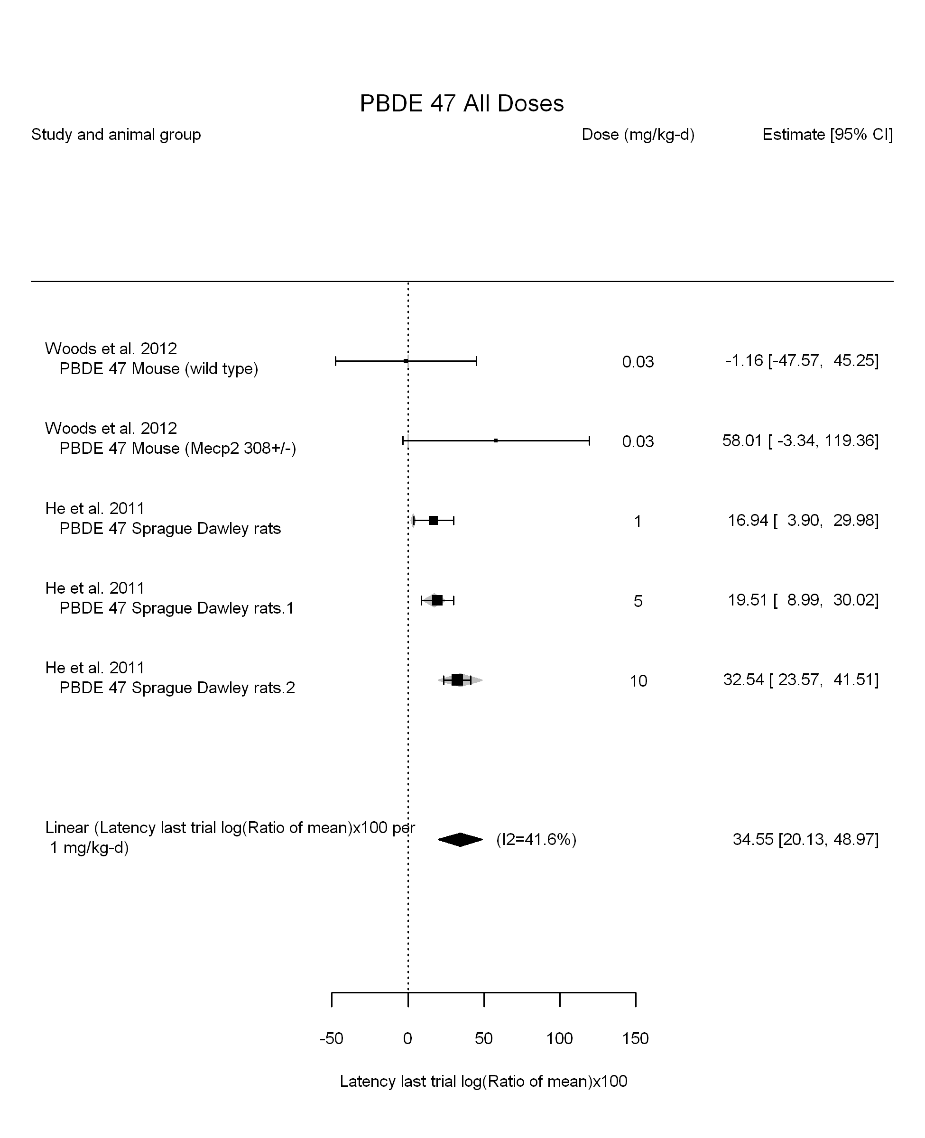

## [1] "Linear or LinearQuadratic in dose---------------------"  
##   
## Mixed-Effects Model (k = 5; tau^2 estimator: REML)  
##   
## logLik deviance AIC BIC AICc   
## -14.0092 28.0183 34.0183 31.3142 58.0183   
##   
## tau^2 (estimated amount of residual heterogeneity): 104.9129 (SE = 201.5818)  
## tau (square root of estimated tau^2 value): 10.2427  
## I^2 (residual heterogeneity / unaccounted variability): 48.02%  
## H^2 (unaccounted variability / sampling variability): 1.92  
##   
## Test for Residual Heterogeneity:   
## QE(df = 3) = 6.6769, p-val = 0.0829  
##   
## Test of Moderators (coefficient(s) 1,2):   
## QM(df = 2) = 12.2650, p-val = 0.0022  
##   
## Model Results:  
##   
## estimate se zval pval ci.lb ci.ub   
## dose10 60.9568 44.9393 1.3564 0.1750 -27.1225 149.0361   
## I(dose10^2) -29.1857 48.7046 -0.5992 0.5490 -124.6450 66.2736   
##   
## ---  
## Signif. codes: 0 '***' 0.001 '**' 0.01 '*' 0.05 '.' 0.1 ' ' 1

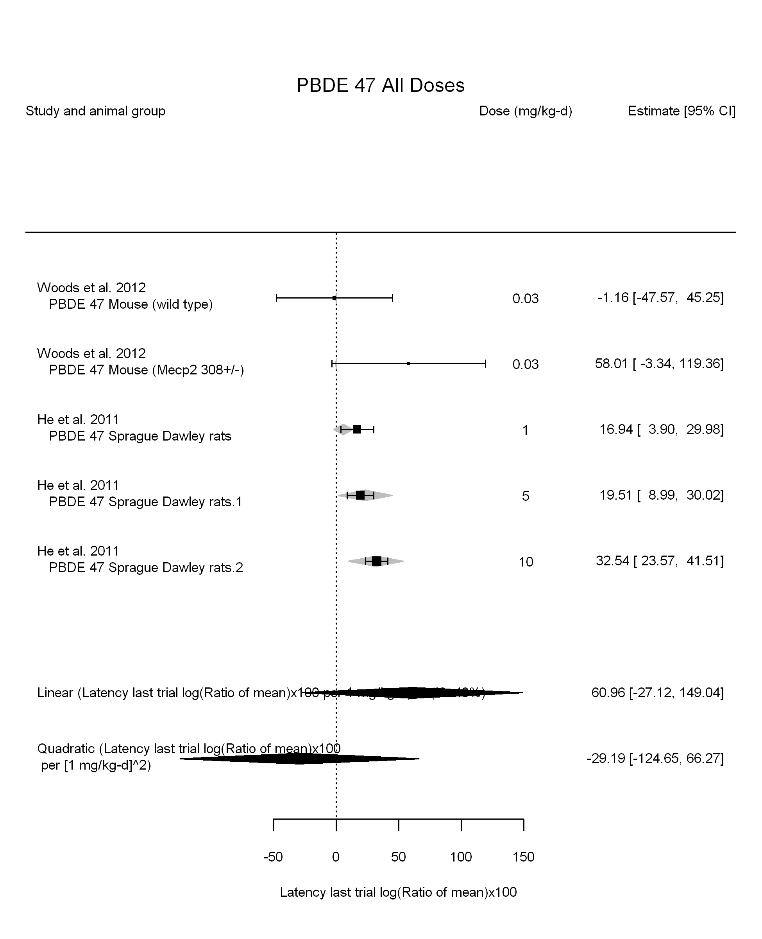

## [1] ""

## [1] ""  
## m ci.lb ci.ub bmr  
## 1 1.412124 0.9962639 2.423913 4.879016

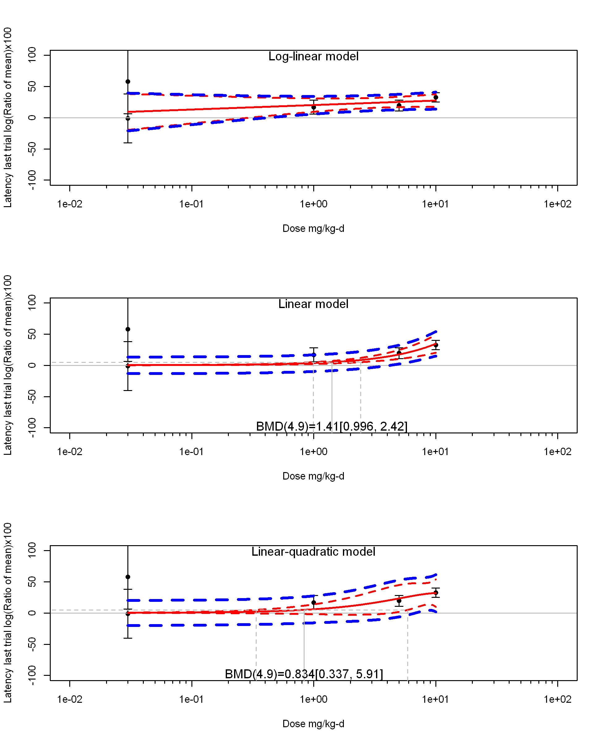

## [1] ""  
## m ci.lb ci.ub bmr  
## 1 0.8336806 0.3366585 5.905232 4.879016  
## [1] "Latency last trial log(Ratio of mean)x100 Highest Dose"  
## [1] "Highest Dose Overall Effect---------------------"  
##   
## Random-Effects Model (k = 3; tau^2 estimator: REML)  
##   
## logLik deviance AIC BIC AICc   
## -9.2579 18.5159 22.5159 19.9022 34.5159   
##   
## tau^2 (estimated amount of total heterogeneity): 0.0000 (SE = 328.7155)  
## tau (square root of estimated tau^2 value): 0.0017  
## I^2 (total heterogeneity / total variability): 0.00%  
## H^2 (total variability / sampling variability): 1.00  
##   
## Test for Heterogeneity:   
## Q(df = 2) = 2.6650, p-val = 0.2638  
##   
## Model Results:  
##   
## estimate se zval pval ci.lb ci.ub   
## 31.8669 4.4490 7.1627 <.0001 23.1470 40.5867 ***   
##   
## ---  
## Signif. codes: 0 '***' 0.001 '**' 0.01 '*' 0.05 '.' 0.1 ' ' 1

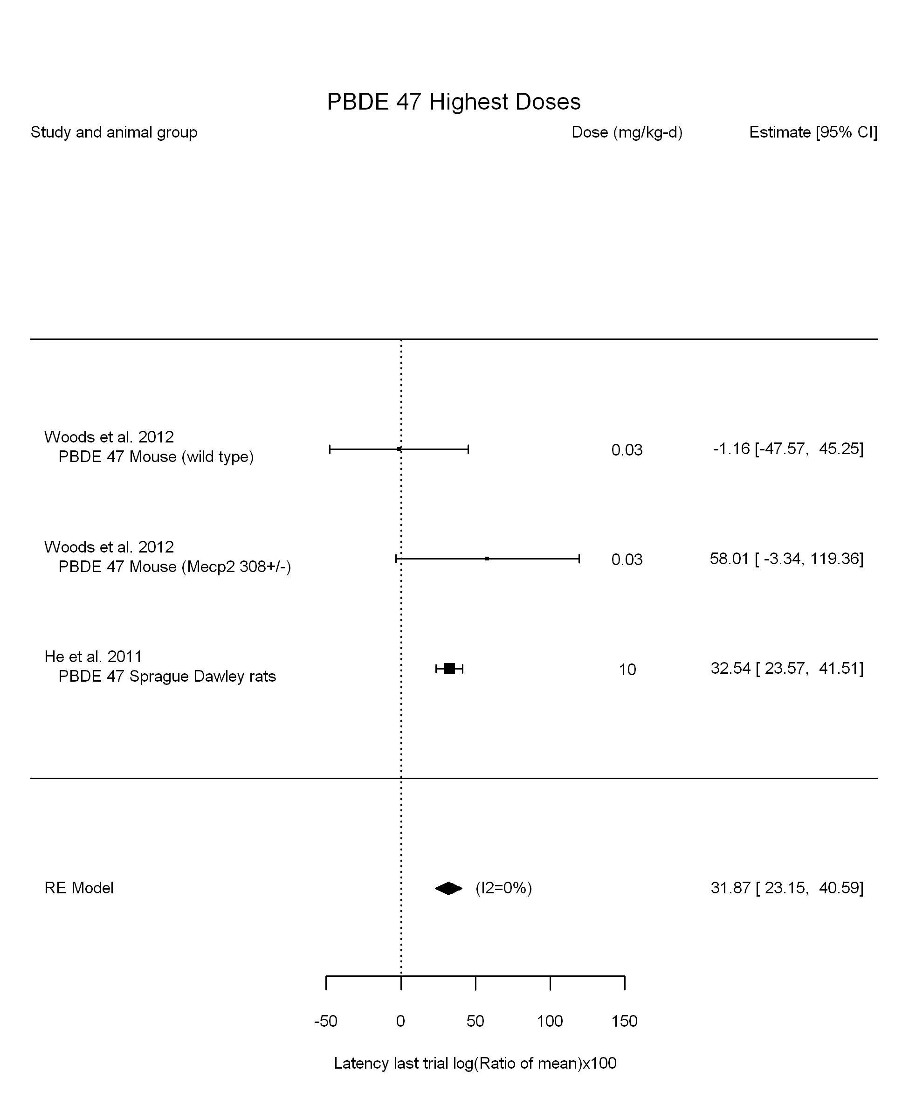

## [1] "Highest Dose Leave one out---------------------"  
## [1] "Highest Dose Linear or LinearQuadratic in dose---------------------"  
##   
## Mixed-Effects Model (k = 3; tau^2 estimator: REML)  
##   
## logLik deviance AIC BIC AICc   
## -10.1027 20.2054 24.2054 21.5917 36.2054   
##   
## tau^2 (estimated amount of residual heterogeneity): 397.3576 (SE = 1112.2583)  
## tau (square root of estimated tau^2 value): 19.9338  
## I^2 (residual heterogeneity / unaccounted variability): 35.78%  
## H^2 (unaccounted variability / sampling variability): 1.56  
##   
## Test for Residual Heterogeneity:   
## QE(df = 2) = 3.4255, p-val = 0.1804  
##   
## Model Results:  
##   
## estimate se zval pval ci.lb ci.ub   
## dose10 32.5934 20.4527 1.5936 0.1110 -7.4931 72.6798   
##   
## ---  
## Signif. codes: 0 '***' 0.001 '**' 0.01 '*' 0.05 '.' 0.1 ' ' 1

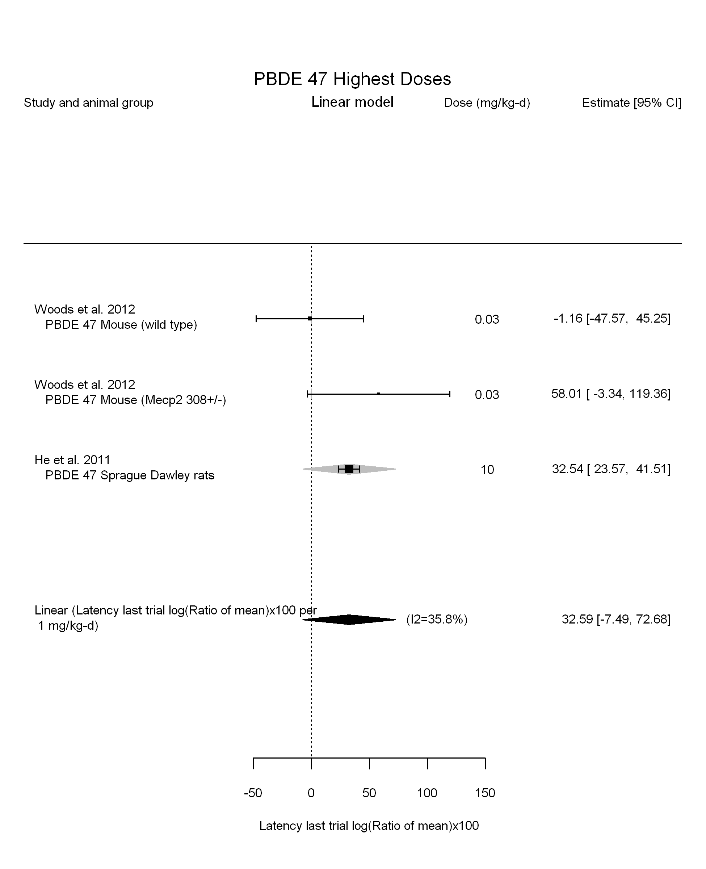

## [1] ""  
## m ci.lb ci.ub bmr  
## 1 0.8336806 0.3366585 5.905232 4.879016

## Warning in if (dim(dat.now[1]) > 2) {: the condition has length > 1 and  
## only the first element will be used

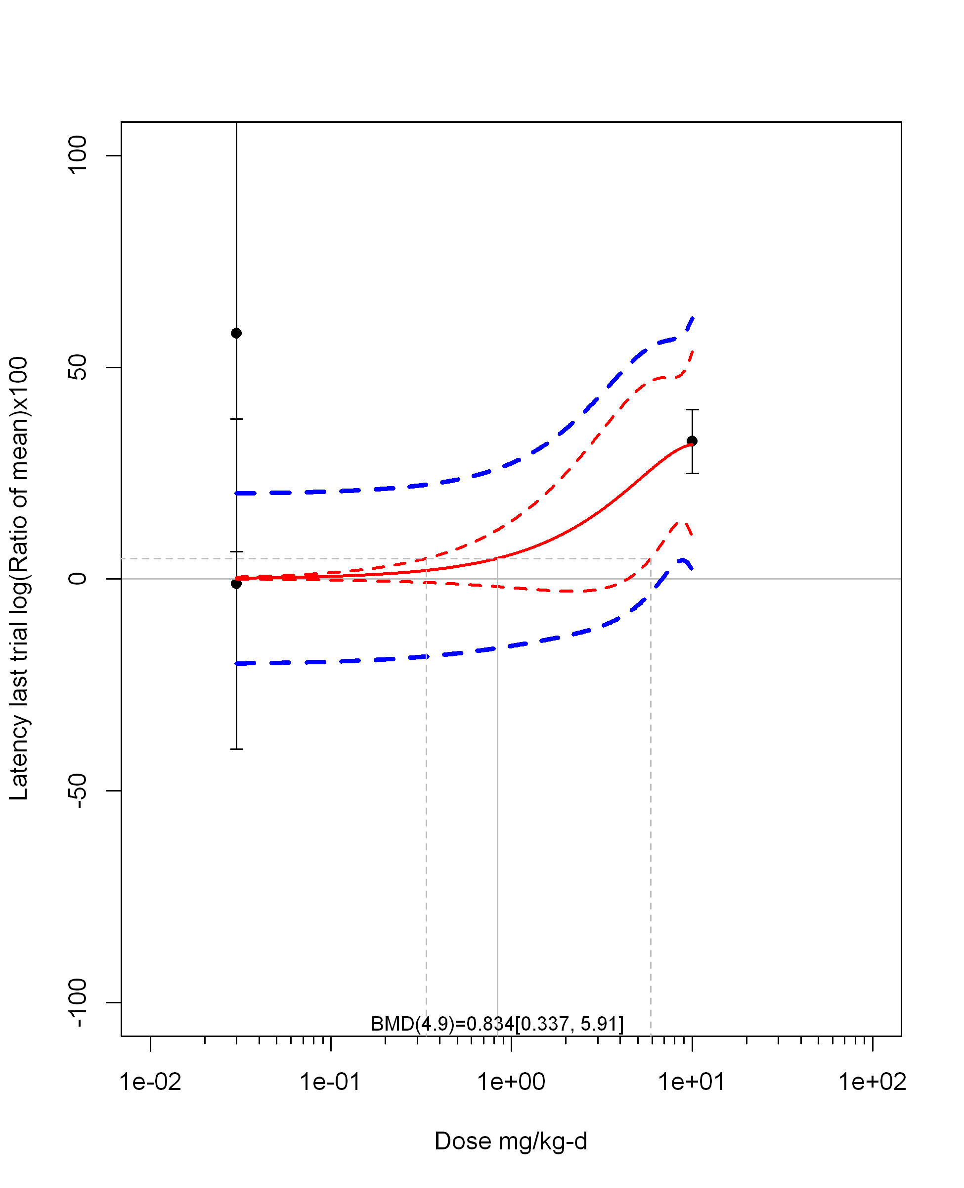

## [1] "Highest Dose Linear in log10(dose)---------------------"  
##   
## Mixed-Effects Model (k = 3; tau^2 estimator: REML)  
##   
## logLik deviance AIC BIC AICc   
## -5.1528 10.3057 16.3057 10.3057 40.3057   
##   
## tau^2 (estimated amount of residual heterogeneity): 980.4391 (SE = 2475.9368)  
## tau (square root of estimated tau^2 value): 31.3120  
## I^2 (residual heterogeneity / unaccounted variability): 56.00%  
## H^2 (unaccounted variability / sampling variability): 2.27  
## R^2 (amount of heterogeneity accounted for): 0.00%  
##   
## Test for Residual Heterogeneity:   
## QE(df = 1) = 2.2728, p-val = 0.1317  
##   
## Test of Moderators (coefficient(s) 2):   
## QM(df = 1) = 0.0315, p-val = 0.8592  
##   
## Model Results:  
##   
## estimate se zval pval ci.lb ci.ub   
## intrcpt 29.5059 22.3704 1.3190 0.1872 -14.3393 73.3510   
## log10(dose) 3.0364 17.1140 0.1774 0.8592 -30.5065 36.5793   
##   
## ---  
## Signif. codes: 0 '***' 0.001 '**' 0.01 '*' 0.05 '.' 0.1 ' ' 1

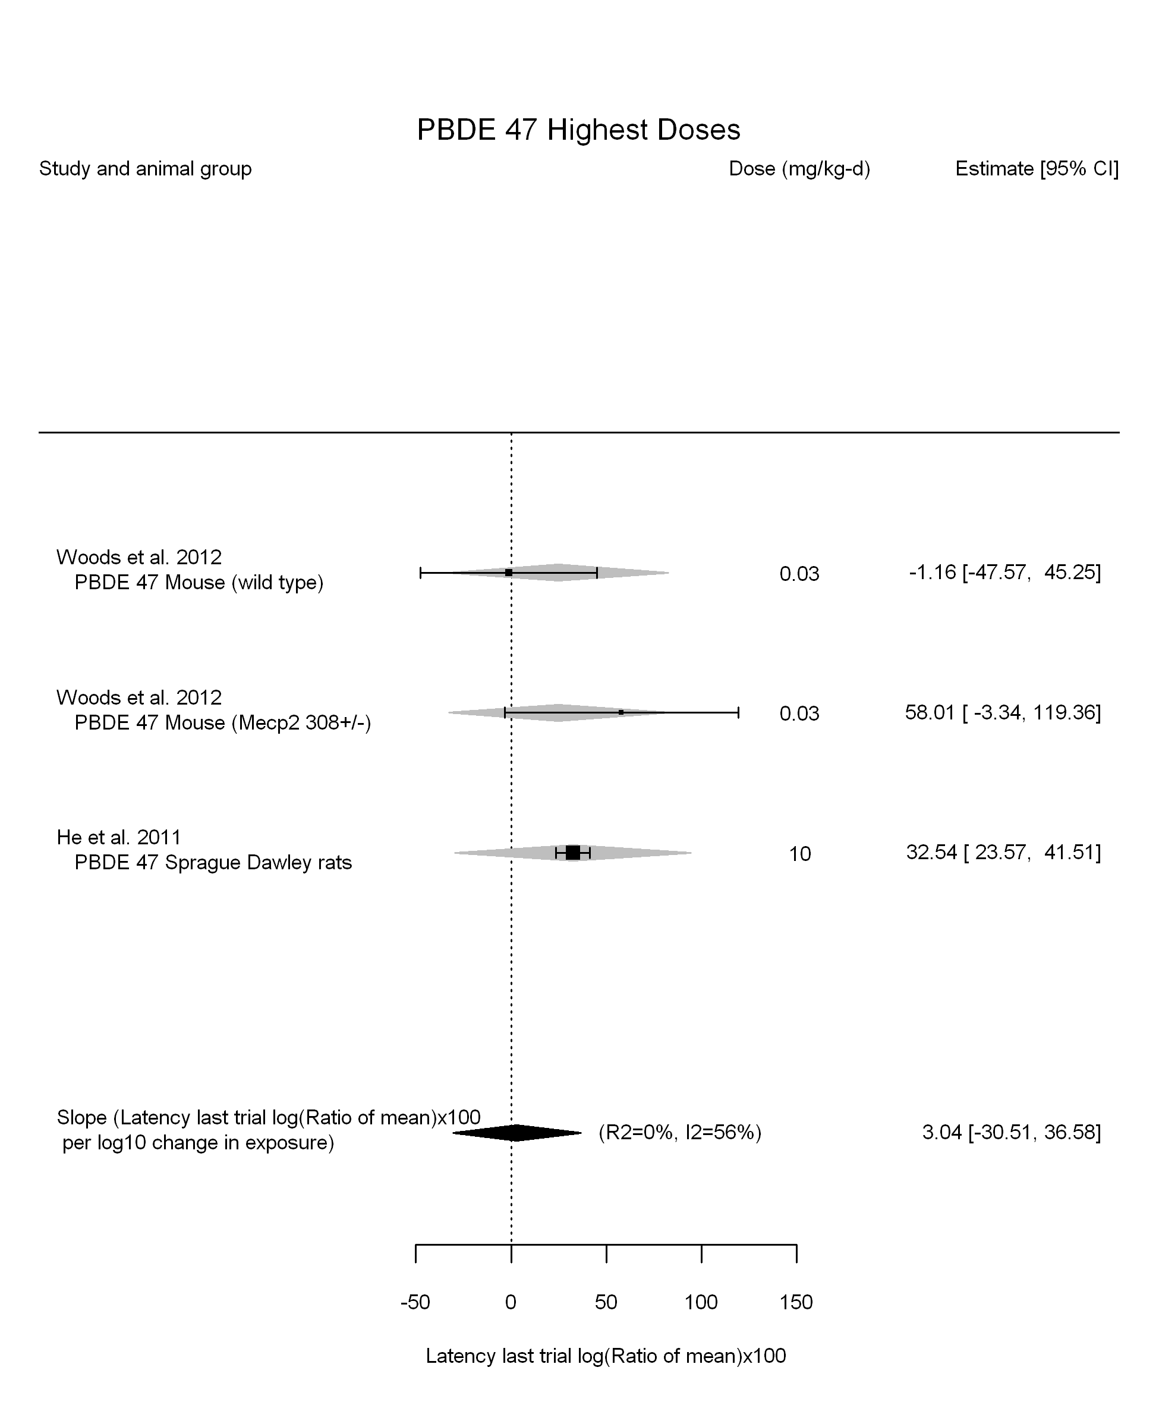

## [1] "Highest Dose LinearQuadratic in dose---------------------"  
##   
## Mixed-Effects Model (k = 3; tau^2 estimator: REML)  
##   
## logLik deviance AIC BIC AICc   
## -5.1528 10.3057 16.3057 10.3057 40.3057   
##   
## tau^2 (estimated amount of residual heterogeneity): 980.4391 (SE = 2475.9368)  
## tau (square root of estimated tau^2 value): 31.3120  
## I^2 (residual heterogeneity / unaccounted variability): 56.00%  
## H^2 (unaccounted variability / sampling variability): 2.27  
##   
## Test for Residual Heterogeneity:   
## QE(df = 1) = 2.2728, p-val = 0.1317  
##   
## Test of Moderators (coefficient(s) 1,2):   
## QM(df = 2) = 1.7751, p-val = 0.4117  
##   
## Model Results:  
##   
## estimate se zval pval ci.lb  
## dose10 8318.7915 9820.7741 0.8471 0.3970 -10929.5721  
## I(dose10^2) -8286.2493 9820.8254 -0.8437 0.3988 -27534.7134  
## ci.ub   
## dose10 27567.1551   
## I(dose10^2) 10962.2148   
##   
## ---  
## Signif. codes: 0 '***' 0.001 '**' 0.01 '*' 0.05 '.' 0.1 ' ' 1

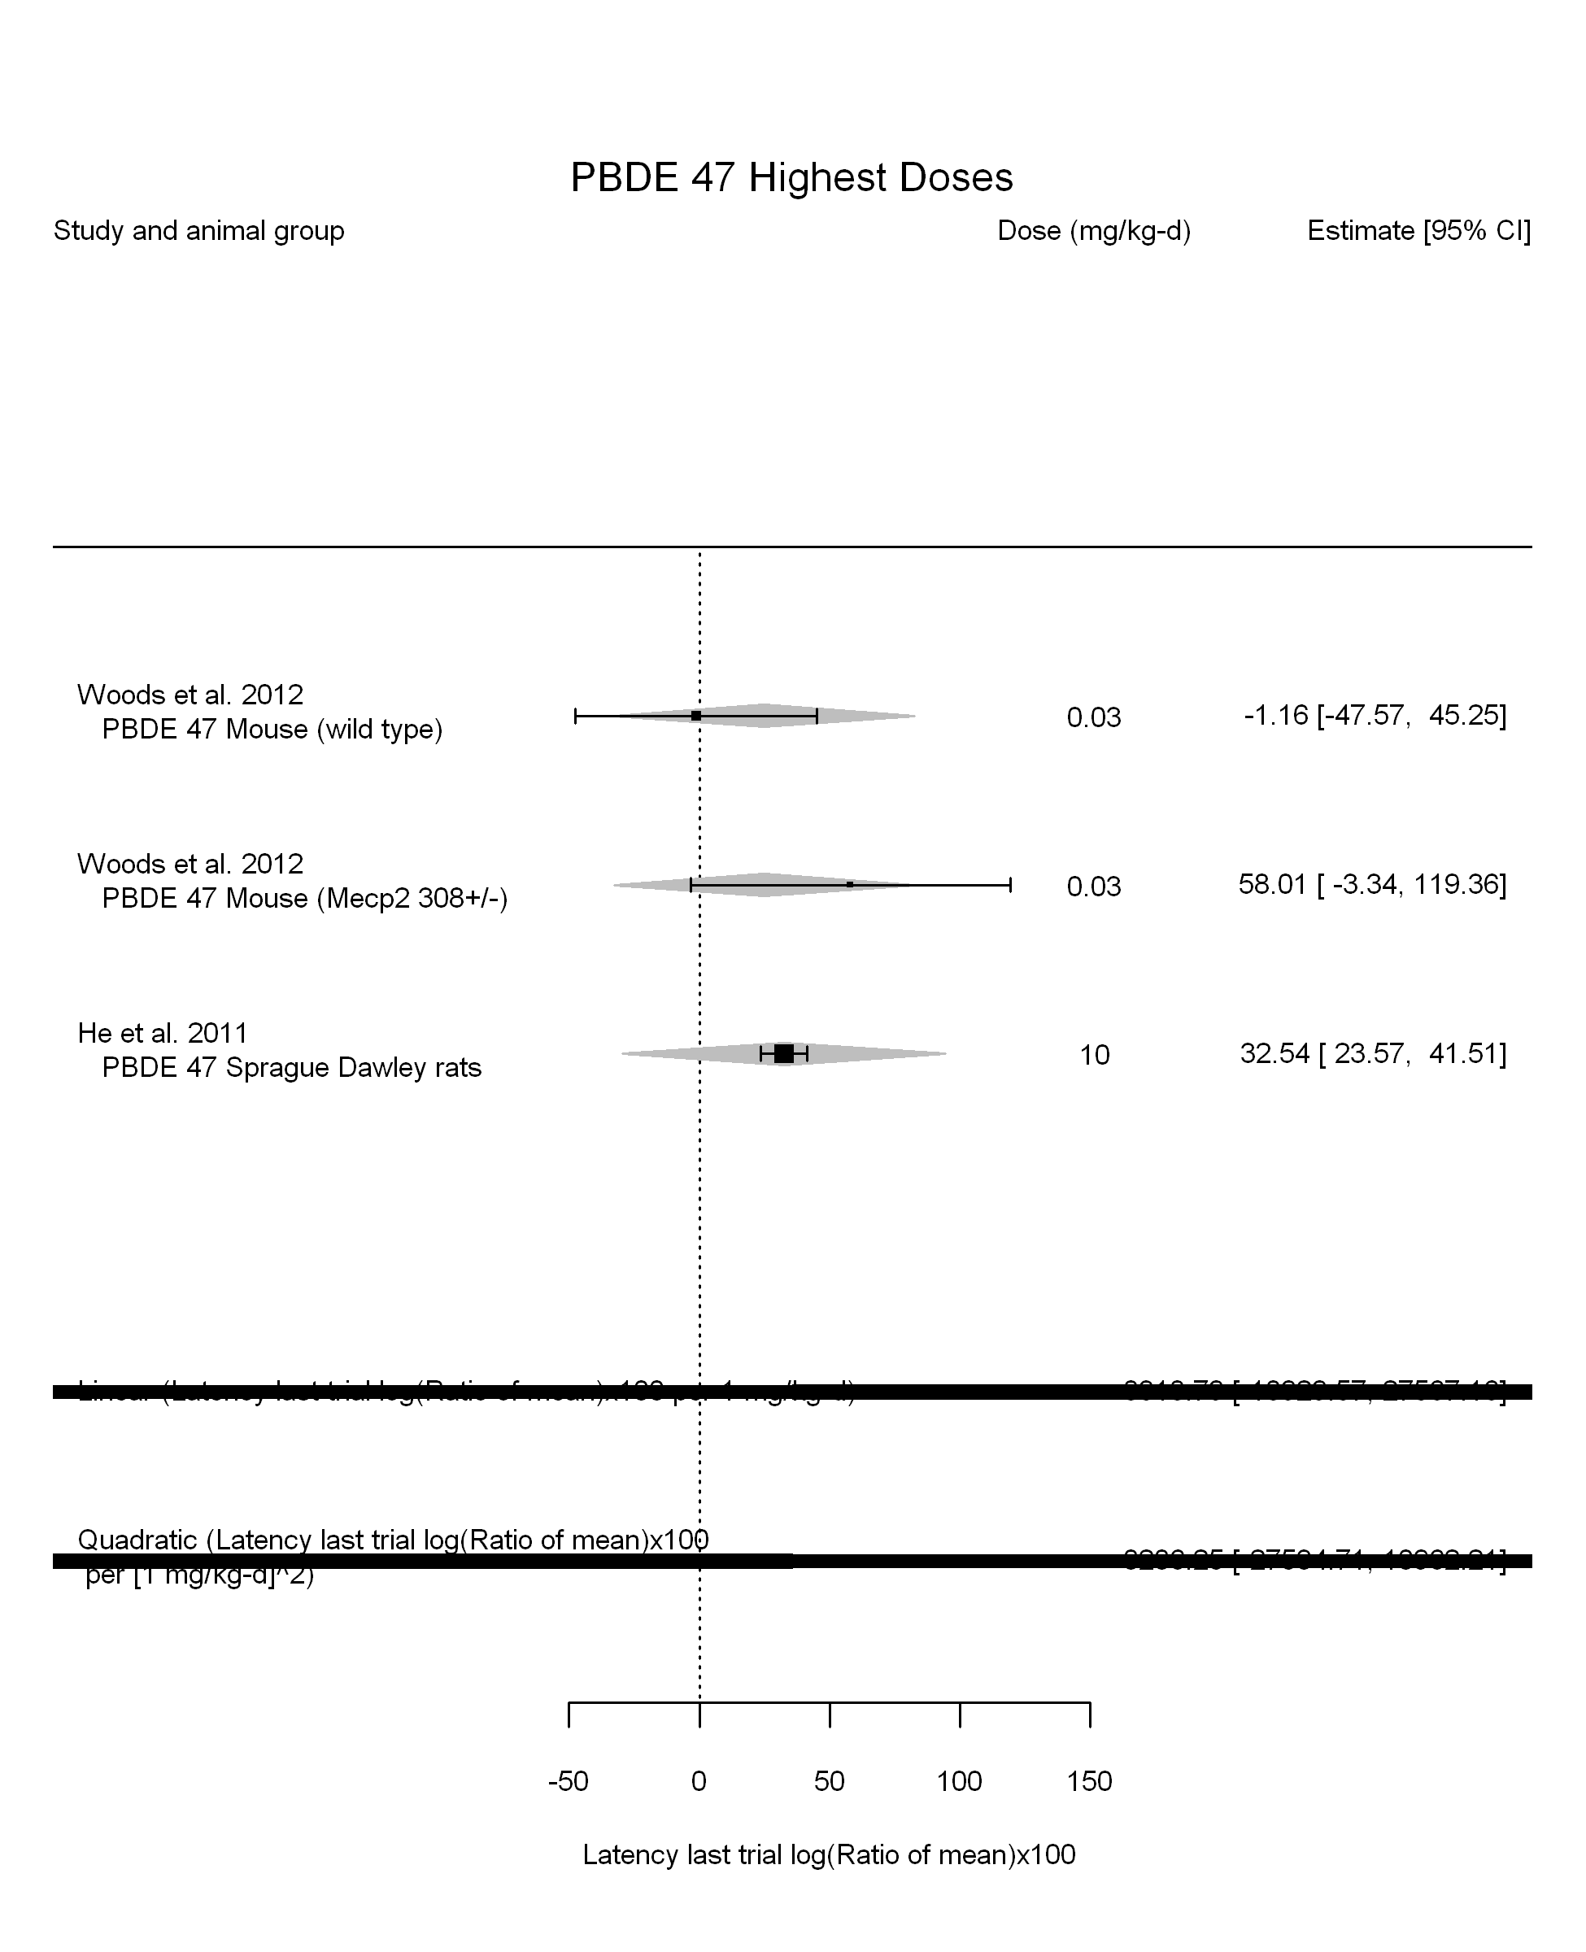

## [1] ""

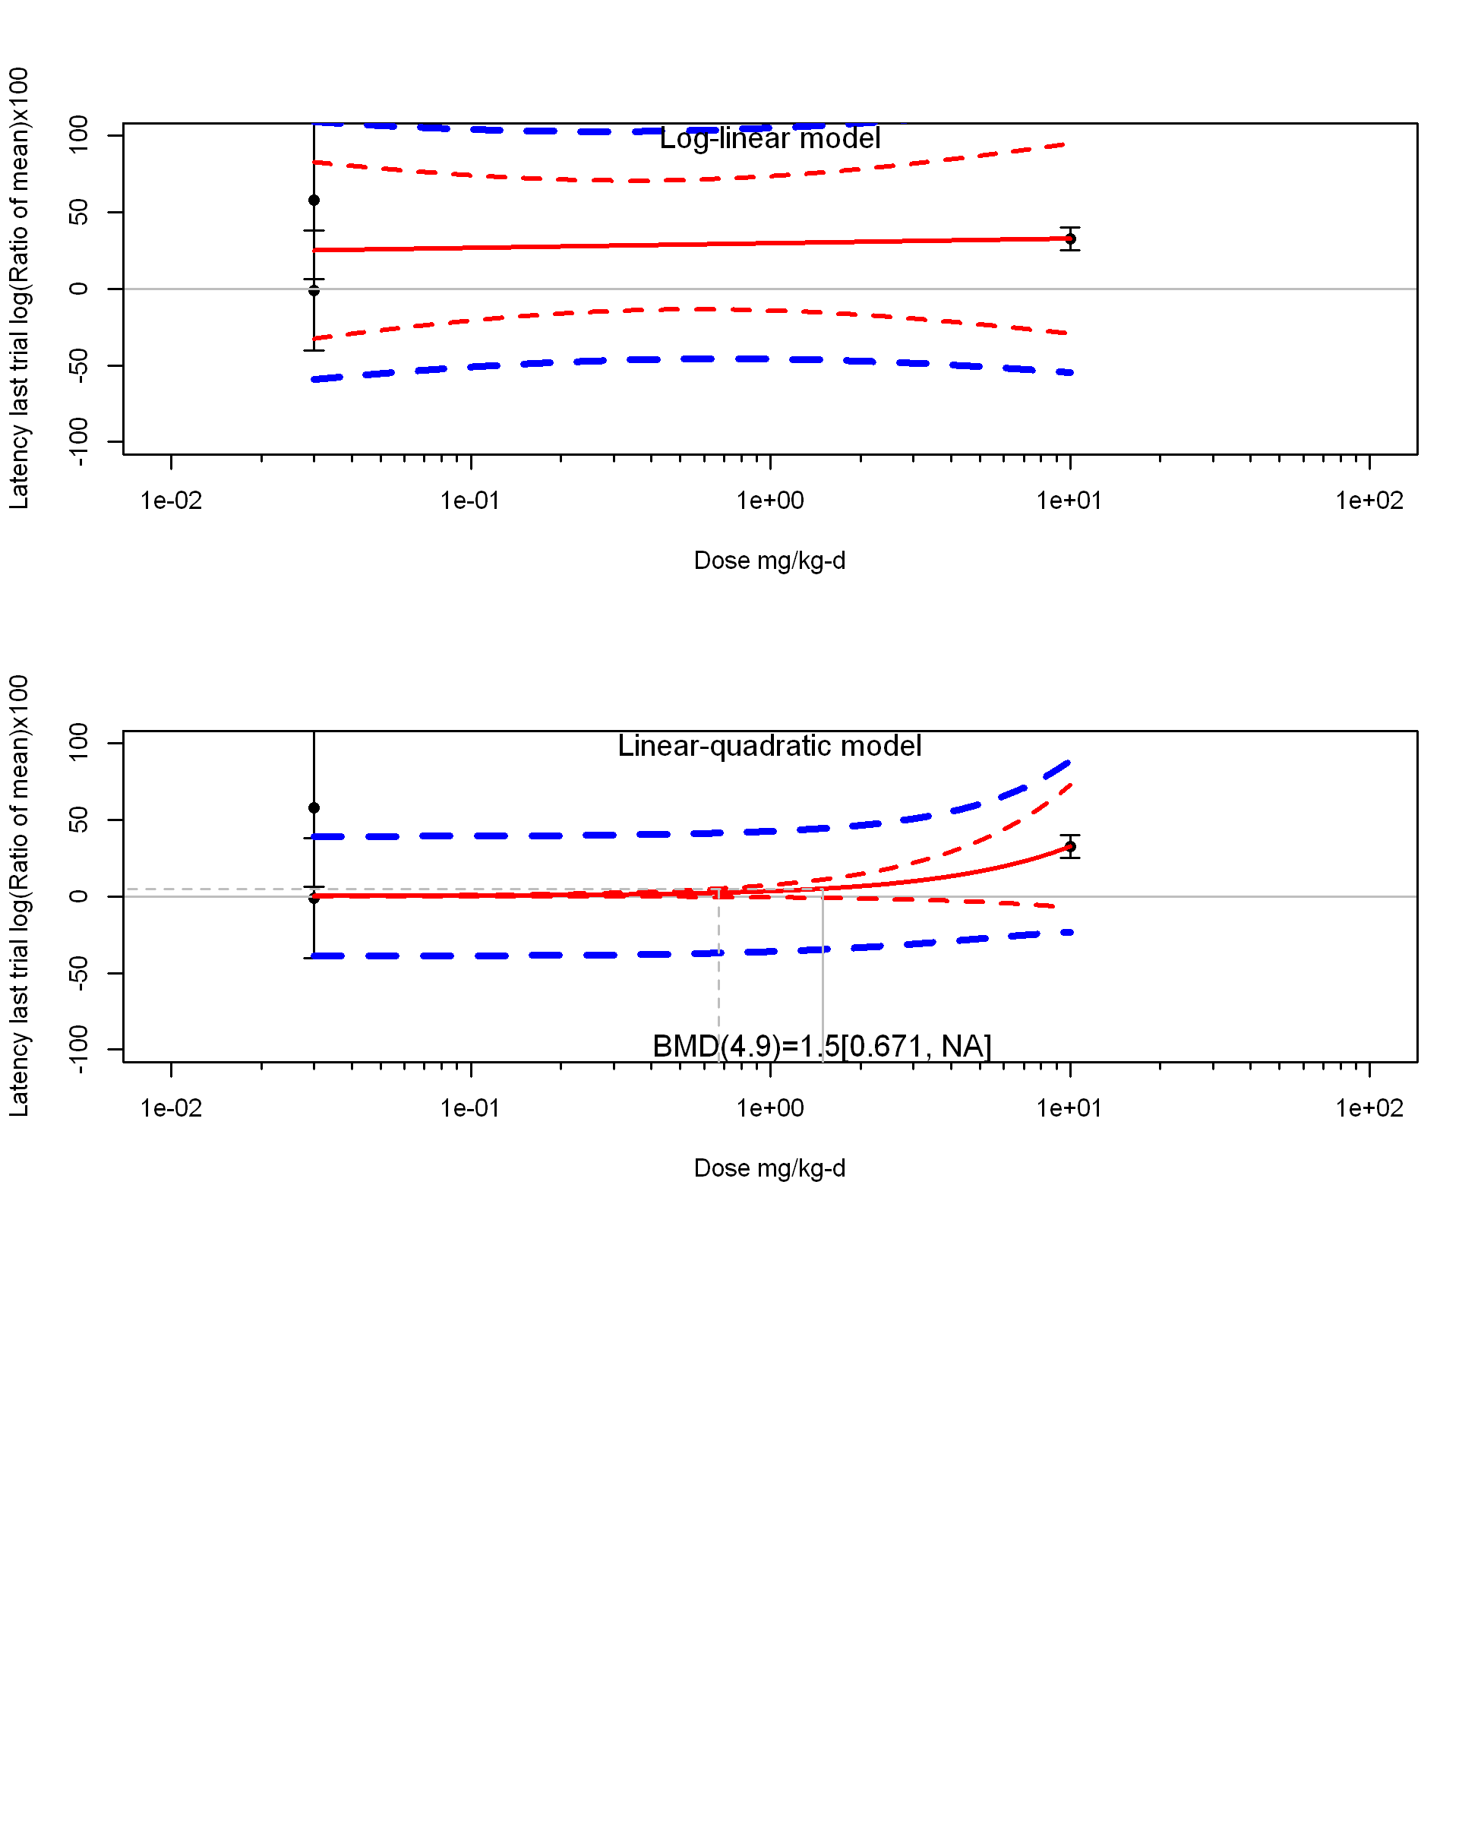

## [1] ""  
## m ci.lb ci.ub bmr  
## 1 1.49693 0.6712997 NA 4.879016