Smewt: a decentralized media manager

About Smewt
Smewt is a universal collection manager/seamless p2p client.

Smewt will look like a classic media manager to the user, however it has some more interesting features, which should be transparent to the user, as much as possible:

- navigation only through metadata: Amarok showed it is not only possible, but also immensely useful, although Amarok is limited by the use of SQL backend, which only allows a restricted of queries. Ideally, Smewt would be a nicely thought interface to the data that is indexed by Nepomuk.

- interface with a smewt-dlman, which abstracts all the downloading and resource access. The smewt-dlman daemon should also allow some form of access control to the files, so the user can choose exactly with whom he wants to share which files.

All this combined makes it possible to decentralize storage of data, be it through public p2p or private sharing with friends, and it removes the tedious task of knowing where to have to save these files.
Thus people will only care about which files they want and who they want to share them with. All of the
mundane tasks related to file management and directories selection for sharing will be done automatically.

Another indirect consequence, which is for the good of humanity, is that it will remove the discrepancy between the incoming folder and the place, usually a different, not shared folder, where the actual file is archived. This means that people will seed torrents all the time and ultimately torrents will live the maximum they can, ie: as long as someone has the file, it is shared and downloadable from him. Rare files have a much better availability also.

Smewt will support any or all of these types (through plugins):
music (amarok), music videos, movies, series, mangas, roms, linux distros (.iso), photos, pdf organizer, office documents, etc...

Plugins allow to define any kind of media, and consist in:
- A schema of attributes that need to be indexable
- One or more design to present this data from within Smewt, eg: an html template with css stylesheet
- A function to convert from the metadata to a local URL available for storage

Ideally, plugins should as much as possible play nice with Nepomuk or similar external desktop search technologies

Screenshots
Smewt dealing with games:
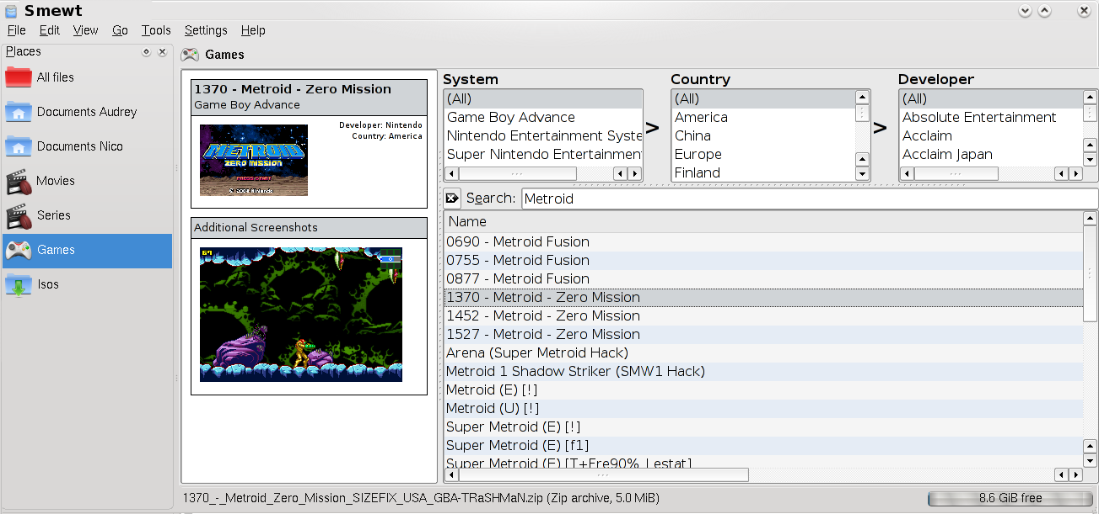

Smewt dealing with movies:
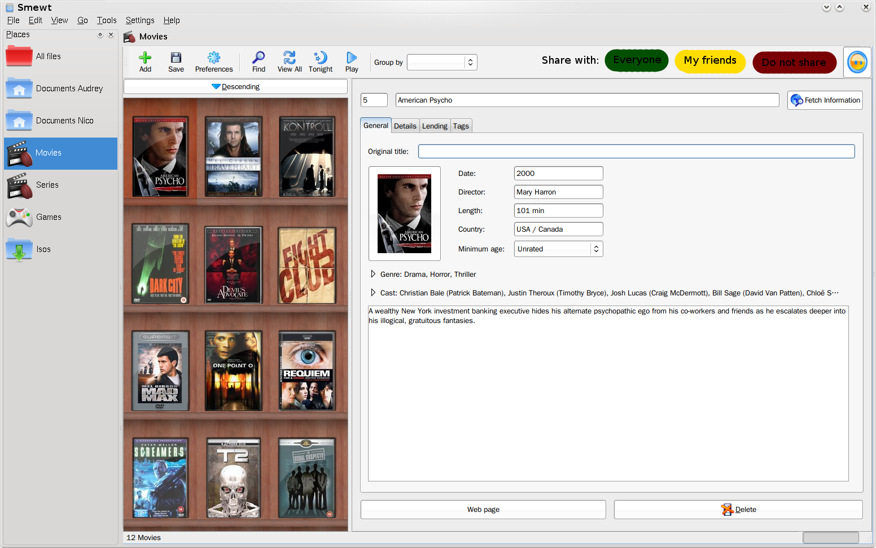

Smewt dealing with series: here, the user clicked on a link and smewt launched some heuristics to try to
guess the metadata associated with the file

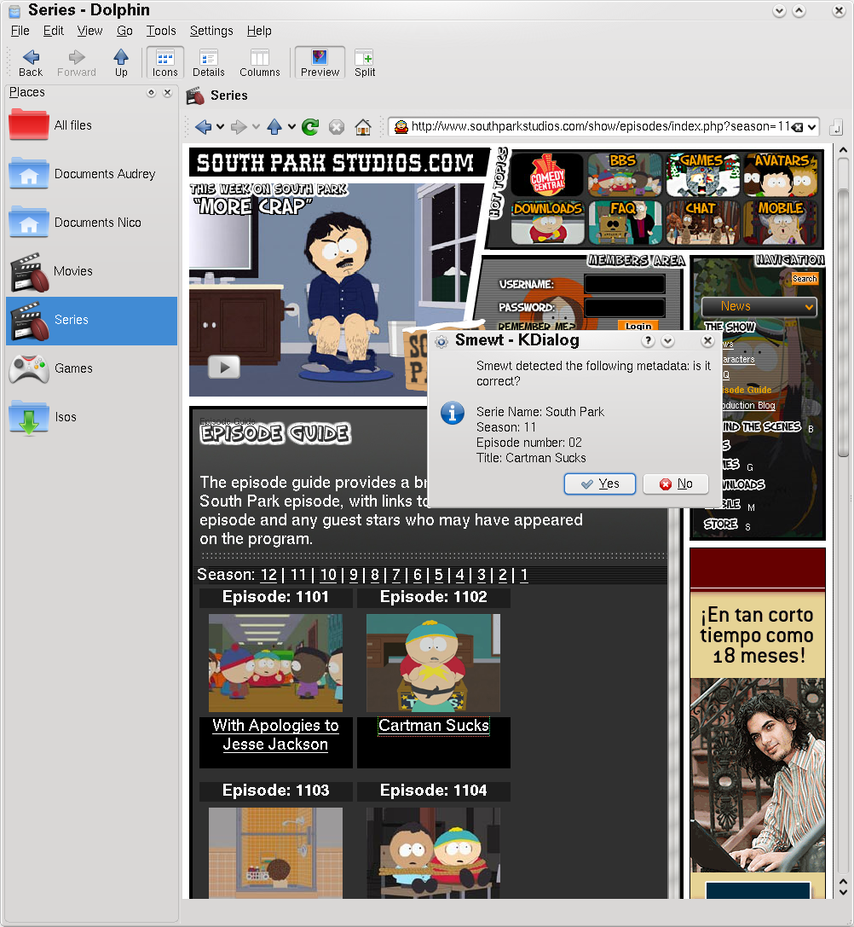

Interface

everything webkit, skins can be made in css and people can use ajax
technology to more easily integrate with online services such as
facebook, flicker, etc...
qt widgets also support css skinning so we can have skins for the complete UI

make the interface all in webkit not in plasma, to be able to have tabs for both metadata and browsing the web or your friends place. use bookmarks and speed dial to remember the most visited sites
Anyway, we can always (can we?) embed a QGraphicsView in a QWebKit page, if necessary for more elaborate displays (ex: coverflow, etc...)

to make it skinnable:
mediaTypePlugins set their icon by calling SkinManager.getIcon(‘mediatype/movies’)

SkinManager knows that ‘mediatype/movies’ points to ‘/usr/share/oxygen/applications/kaffeine.svg’ and returns the corresponding icon.

also share ratings and comments from your friends, browse movies that amaury liked most, that most of your friends liked, etc... Have an easy graphical way to perform powerful queries, a good search dialog which would also allow results to be stored as a new view (=virtual folder)

Each media type has a default action: listen to a track, play a rom, or burn an iso, etc... which should be prominent and very easy to access.

dolphin kpart view for isos, sortable by dl date, by name, by distros using the grouped view

have a digikam kpart that allows to deal with photos

media type (series, movies, isos) selection is done in the same way dolphin does places

dolphin kpart for people who prefer "old style" file navigation
(instead of metadata interface)

Smewt-dlman
maybe better: smewtd, which cares about indexing all the files, checking access control to them, also acts as a download and sharing manager, with different backends for connection, such as ssh, emule, bittorrent, etc...

There should be a smewt-dlman daemon that manages all sftp, bittorrent, kad downloads from a single place
That way user filtering and access control will be done directly within smewt, and not through some complex sshd_config files (also: more easily portable file access schemes)

need to have bandwidth throttling so as to be able to give maximum
priority for uploading to friends first, and public p2p only as a
background task such as seti-online. except here you wouldn't use your
spare cpu cycles and bandwidth to be looking for alien messages, but
for spreading culture and the media you enjoy around you!

the uuid of the file is still its absolute path on the disk, or the uuid is a md5 or sha1 hash, and the location on disk only an attribute of it? If it is an attribute, it also means we can have more than one of them, for instance we could have file.urls = [ ‘file:///data/movie.mkw’, ‘ed2k://abcd1234/movie.mlw’, ‘friend:///momo/data/movie.mkw’ ]

storage plugins are devices to convert from metadata to disk information to store files locally
when downloading, both the content and metadata are sent, and a uuid is then computed which is where the file should be stored, which is dictated by the user preferences.
-> there are no more "save as..." dialogs

Smewtd should also be able to monitor an Incoming folder, such as the one from eMule or Bittorrent, and ask the user whether some files that just landed there should be automatically stored where smewt stores its stuff, while adding metadata to it at the same time.
For this, we could also define a StringTemplateDistance, that will tell for instance that 'ep_1x02_Title2.avi' is closer to '1x03_Random_title.avi' than 'season 1 ep 2 title2.avi', although the metadata extracted would hint at the opposite. This would help in guessing where to store the file (use case: downloading the latest ep from a serie, stronger similarity with the files downloaded from the same source & release group)

Friend management / Identification

There should be a friend manager (KDE-PIM?) that allows to easily import a friend’s public key.

get lists of possible friends through kde pim/akonadi contacts

Metadata fetcher plugins

when the user browse a website and clicks on a link, smewt launches heuristic programs to try to guess the metadata associated to the file. Heuristics are based on the file URL, the website from which the link originated, and the content of the html page.

So for instance, one could do:

def debianHeuristic(iso, url, site, html):
if site.contains('debian.org'):
iso.distro = 'debian'
if url.contains('debian-testing'):
iso.version = 'lenny'

Heuristics should be very easy to add as plugins so as to allow a community to generate these plugins

make web profiles to store user/password for sites such as anidb.net, imdb.com, discogs.com, shareconnector, private bittorrent sites, etc...

use LinkingOpenData; huge DB already in RDF format!

Marketing ;-)
- “Smewt: a smart media manager” better than “decentralized”

Technology choice (and issues)

- free as in beer (Qt) or as in speech (KDE)?
- Identification & connection system:
  - Jabber (allow for exchange of ip address)
  - ssh keys
- Database storage system:
  - Soprano: the future anyway? allows for Lucene search
  - SQL: tried solution
Actual action on the file: do we want to embed Amarok, digikam, k3b, etc... or launch them as external processes? → probably external processes, lighter on the app and we do not depend on a specific kpart to be available, but the user can choose which app he prefers. Actually, for media which doesn’t have one action in isolation of the other files of the same type (ie: mp3, photos vs. movies which once you click play, you leave smewt interface), we still might want to embed specific kparts such as digikam, etc... because they provide an interface which is already very nice
- Do we want smewt to also send information about files to a central server so that it can act as a fake file identifier, we would then have a huge media DB, such as anidb.net, but for all types of media. Ed2k links would not be available for legal reasons, but it would be nice to have UUID + metadata
- More issues?

Use cases

Miscellaneous ideas

for local files (initial import of database), smewt can also use strigi/nepomuk to try to guess metadata

(by default, new files are shared with no one, or only with friends, configurable depending on the filetype)

dolphin kpart to browse user folders. make sure that user metadata gets also copied when getting files in this way

different kinds of view in smewt for each media (ex for series: view all series, single serie, single episode, ...)
a view can send the user to another view (serie → episode)
expose the list of available views the way ktorrent does it

create webplugin_tvu, when browsing with webkit and clicking the ed2k link, it should
send it automatically to download to amule with the correct path already (ie: series/season/01. title.avi')
instead of in the Incoming folder

when looking at metadata for an episode, if the file is not on the hard drive yet, we may look into
amule temp files, and then print a progress bar in smewt and allow the user to preview the file

in a class, have a way to relay signals from some inner element to the outside as the class's own signal

