

nuclear.
report
Timo Schlumpf
DVIZ 2025

Contents
Motivation 3
Exploratory Work 4
Target Audience 5
General Public & Students 5
Scientists & Educators 5
Energy Analysts & Policy Makers 5
Nuclear Sceptics 5
Visualizations 6
Colors 6
Basic Charts 6
Area Charts 6
Line Charts 6
Bar Charts 6
Custom Visualizations 7
Timelines 7
Scrollable Map 8
World Map 8
Libraries 9
Citations & Data Sources 10
Work Summary 11

Motivation
I have always been fascinated by the very layer that defines our understanding of reality: physics. The process of describing the world we experience in numbers and expressions is an awfully beautiful, although complex one. Nuclear physics is just a small part of that giant ocean, yet it remains near and dear to my heart because of that child-like fascination. It is also the sole field that had the most exposure to the public, closely followed up by astrophysics – yet it remains misunderstood and feared.
My motivation for this project is to allow a peek under the hood of the energy industry and give comparisons and paint a narrative which even the youngest ones on this planet can follow. The nuclear energy industry is getting more hate than it deserves, and I want to help in changing that.

Exploratory Work
The exploratory process began with immersing myself in documentaries¹ about nuclear catastrophes and science, which inspired the direction for my project. This helped in understanding the topics’ scope as well as forming a message to convey to the reader.
Following this inspiration, I conducted a more “systematic” exploration by diving deep into archives and literature, reading about not just the famous Chernobyl & Fukushima Daiichi disasters. Less famous cases like the 3-mile island accident², Kramatorsk³, and SL-1⁴ - equally, if not more fascinating, yet barely anyone knows about them. This “surprise” led to reading about the Demon Core⁵, a criticality incident highlighting the dangers of careless handling of radioactive materials.
Next, I turned my attention towards a more recent problem, the climate crisis and discovered some surprising statistics linking deaths to energy sources. This shift gave my project more of a data-oriented direction which I followed immediately.
I went through countless datasets on Kaggle & OurWorldInData, and decided on the following:
- Electricity production by source⁶
- Share of electricity production by source⁷
- Death rates per unit of electricity production⁸
- List of worldwide nuclear reactors⁹
- Major nuclear plant incidents¹⁰
This gave me a solid foundation from which I could start visualizing.

Target Audience
The target audience is broad, yet specific enough to retain engagement and understanding.

General Public & Students
Anyone curious about climate change, nuclear physics, risks and benefits of nuclear power. The visualizations aim to simplify the complex data into a more understandable format, so that even younger audiences or those without specific education can follow.

Scientists & Educators
People with a fascination for physics, energy technology or environmental science – those that want a deeper, data-driven understanding of the subject.

Energy Analysts & Policy Makers
Professionals in the energy sector or those creating the rules and laws for them. This data story aims to give everyone an even playing field and understanding of the subject.

Nuclear Sceptics
People with a deep fear or scepticism of nuclear physics & energy. Providing clear visualizations helps in “easing the mind” and helps fight against the propaganda spread in the 90s.

Visualizations

Colors
The story itself uses a muted color palette, mainly consisting of black and off-white. This makes sure that the design itself does not take focus away from the data, while keeping a charming and aesthetically pleasing look. The visualizations always use the same, pastel palette: dark gray, gray, light gray, orange, blue, green and yellow. The contrast between dark and bright colors aims to paint the data in a way that makes the “clean” energy sources look more appealing than the others, without lying or changing the data.

Basic Charts
I used a variety of charts in my story. Most of them are either line or area-charts, as those represent my data in a clear, understandable way.

Area Charts
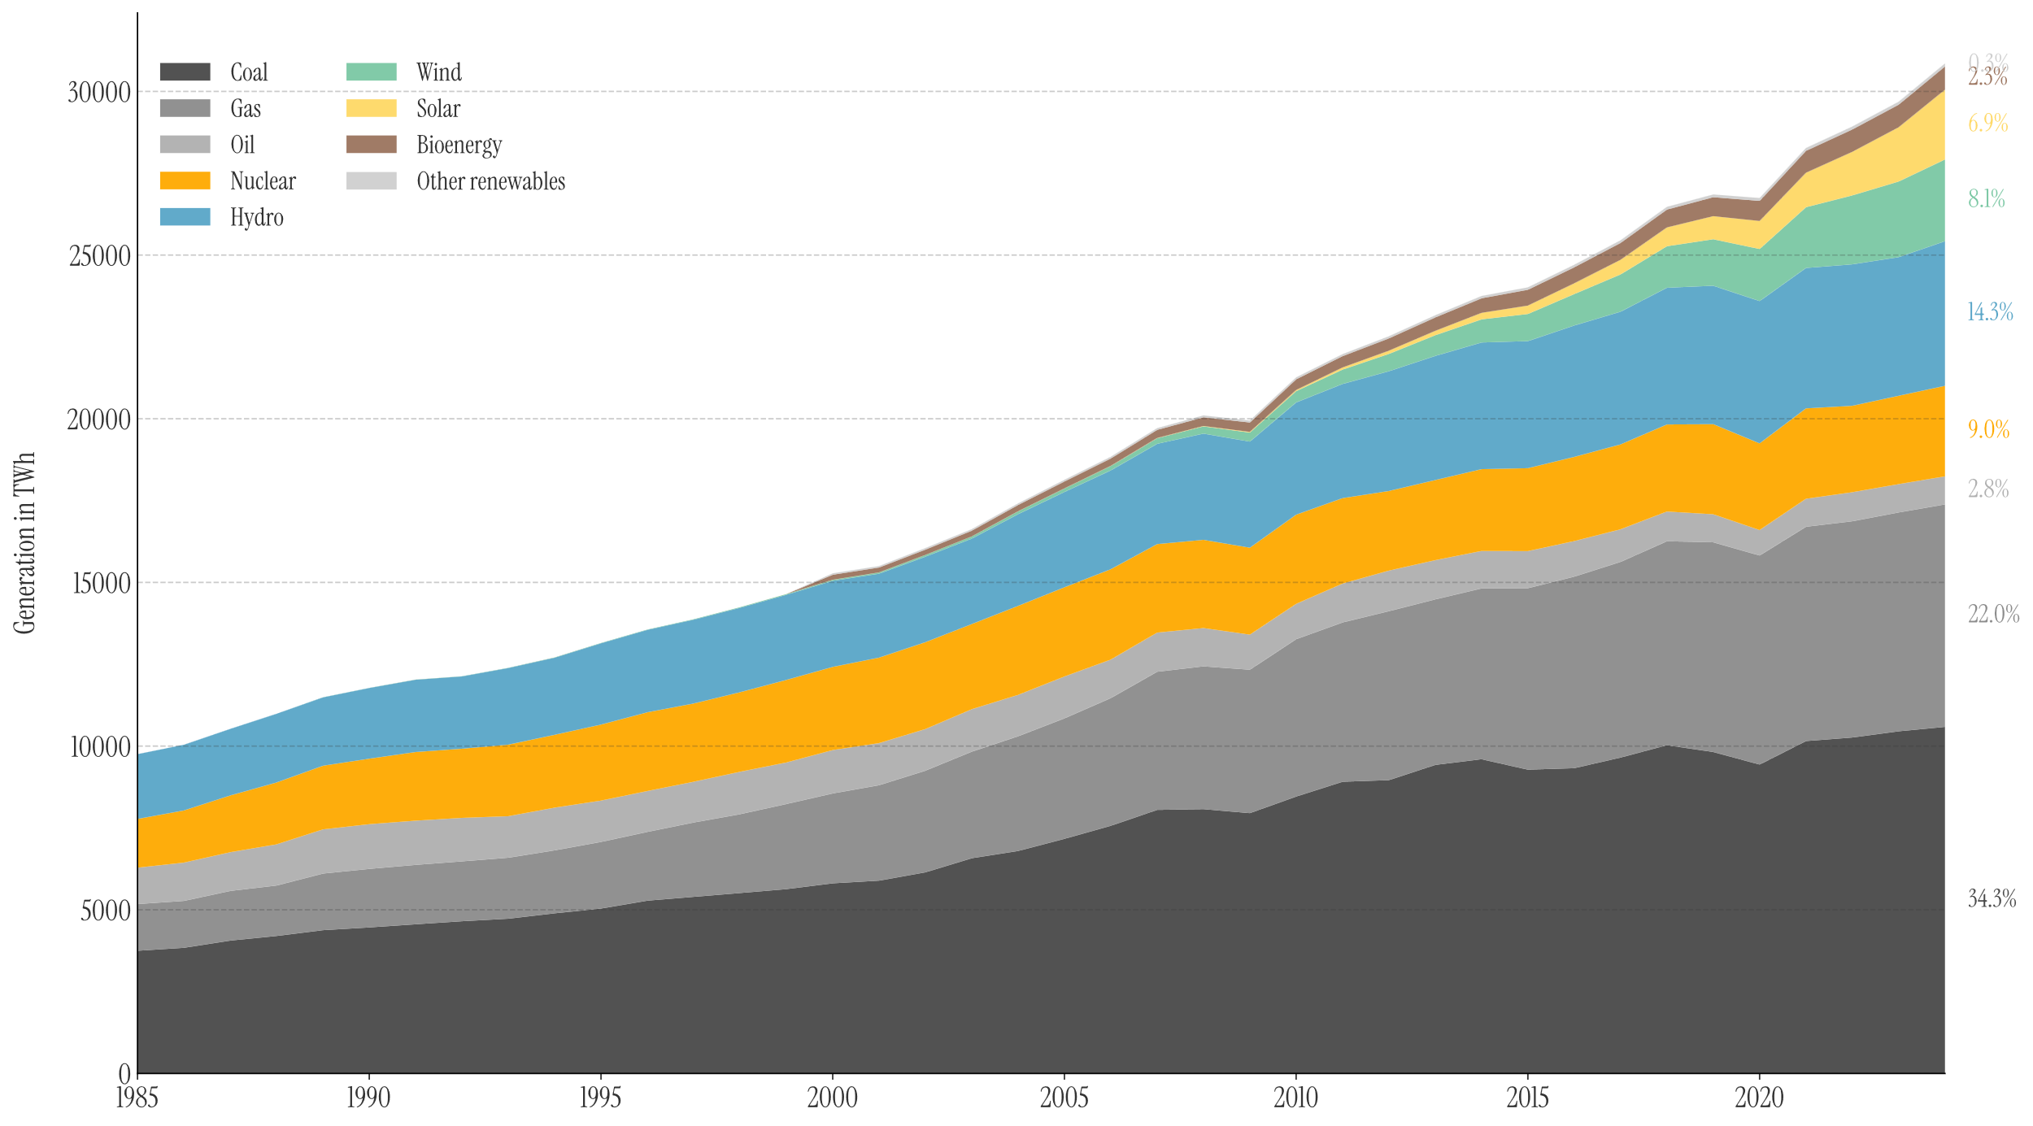
I used a singular area chart to visualize the vast amount of energy produced by each source. This chart type properly allows the data to shine and shows just how much energy demands have risen in the past few decades.

Line Charts
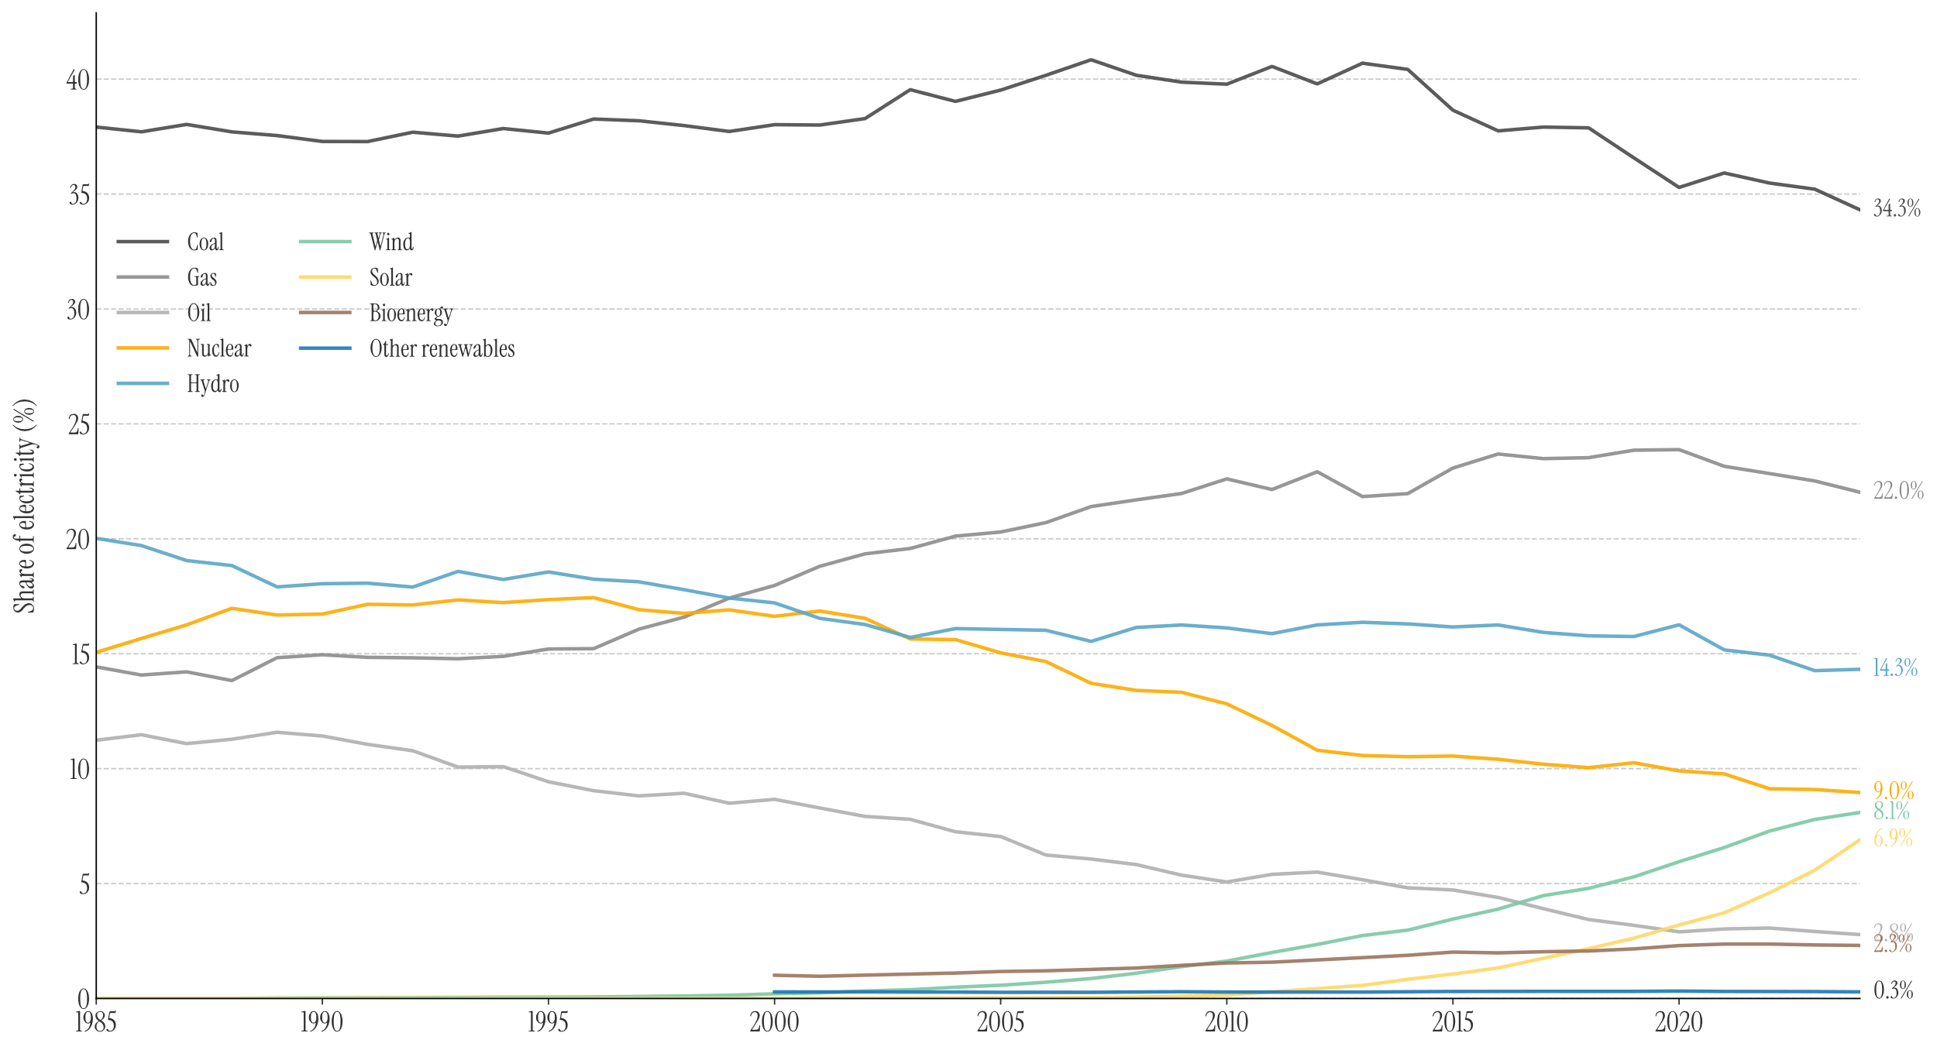
A line chart was used to visualize what share of power is produced by each source. I’ve chosen a line chart as it is the simplest form of chart, perfect for visualizing changes over time.

Bar Charts
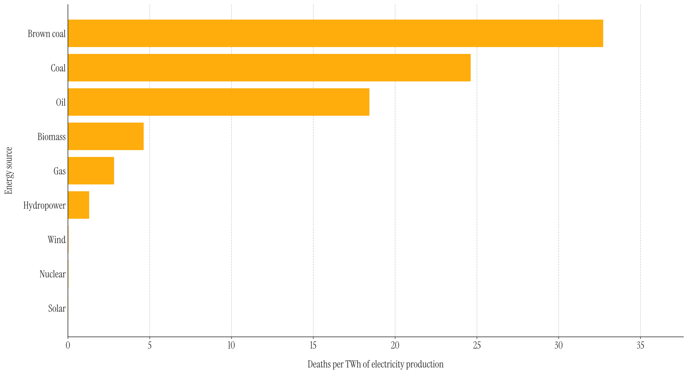
A bar chart was used to display the difference between the energy sources and their “Deaths per Terawatt-hour”. The bar chart is perfect for visualizing differences between entities, which is why I chose it for this chart.

Custom Visualizations
As plain charts didn’t get the point across enough, I opted for a few custom visualizations, which present the data in a bit of an unconventional but still interesting way.

Timelines
Timelines are a powerful tool to show changes over time, similar to a line chart. Custom timelines further allow to display even more information than possible with a traditional chart, such as descriptions, names, dates, etc.

“How did we get here?”
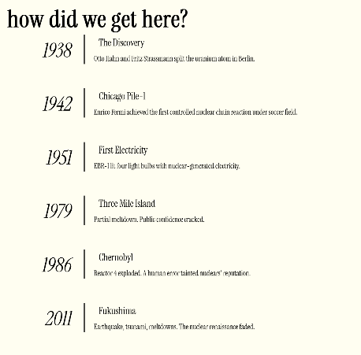
The discovery timeline is a simple list, which shows key events in a chronological order. It uses a similar view to “atomic heart”, but a bit broader to give an overview before going into details. This chart serves more as a story element rather than an actual “data diagram”, which led to it being designed in a more spacious way.

“Atomic Heart”
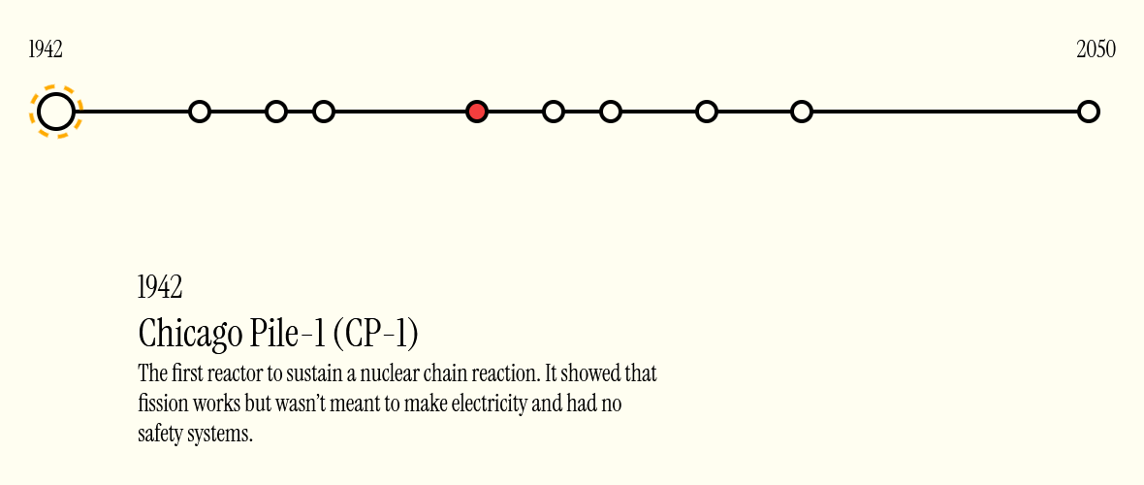
The timeline is used to show the progress made in reactor innovation. The timeline features highlighted points which show key changes in reactor designs, as well as properly calculated spacings between the points to accurately reflect the time between them. I decided on this type of visualization, as no other “traditional” chart type would be able to display this amount of information in a digestible way.

Scrollable Map
To properly visualize the difference in deaths between energy sources, a custom scrollable map¹¹ was implemented. The data is comprised of Deaths per source per year, as well as mathematically accurate distances between the “bubbles” to convey the vast differences as impactfully as possible. The entire section is also set on an almost black background; this further helps to bring across the dark nature of the subject. As the proper scale can’t be shown in this report, I encourage you to go explore it for yourself!

World Map
As a final piece, a custom world map was created. The map features all “nuclearly” active countries, those that were or no longer are. It is enhanced with colormapping using the previously mentioned colors, aswell as a hover-over effect to show more details about the country and its phase-out details.
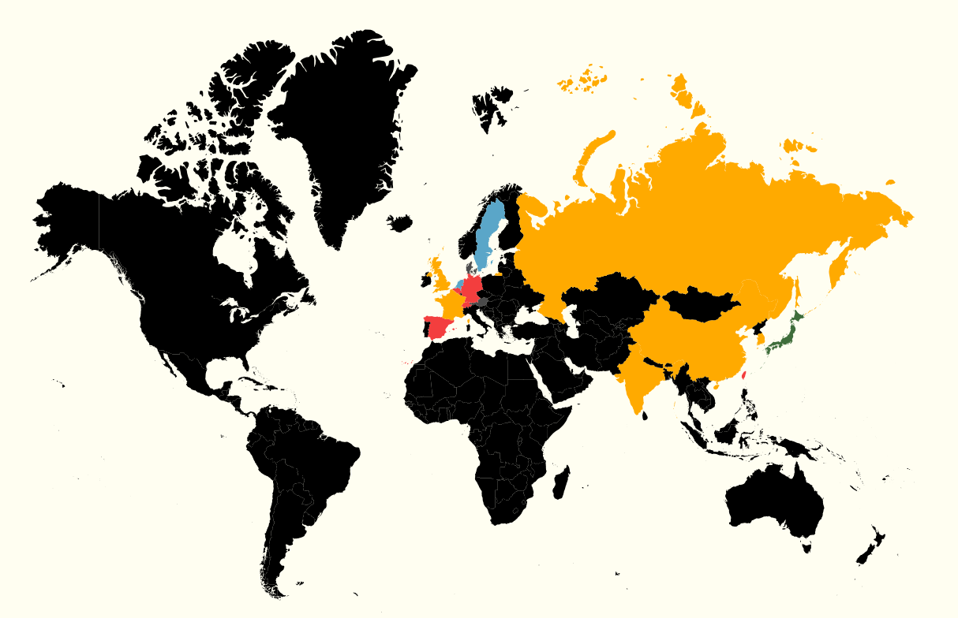

Libraries
No libraries were used, except:
- Matplotlib for generating line, bar & area charts
- Pandas for cleaning, transforming and preparing data
- Dotenv for managing color schemes across Jupyter notebooks!
All other visualizations and components are custom and handmade. The reason for this is the same we started this project in the first place: to learn something.

Citations & Data Sources
- Kyle Hill, Documentaries about nuclear catastrophes (11.2025)
- 3 Mile Island Accident (11.2025)
- Kramatorsk radiological accident (11.2025)
- SL-1 (11.2025)
- Demon Core Criticality Accident (11.2025)
- Electricity production by source (2024)
- Share of electricity production by source (2024)
- Death rates per unit of electricity production (2021)
- World nuclear power reactors (2023)
- Major nuclear plant incidents (1957-2011)
- Lightning safety awareness level in Malaysia (2021)

Work Summary
Date | Hours | Done by | Description
15.12.25 | 5 | Timo | Initial setup; data consolidation
17/22.12.25 | ~15 | Timo | Basic structure; timeline visualizations
05.12.25 | 7 | Timo | “Traditional” Diagrams; History & Evolution sections done
06.12.25 | 7 | Timo | “Deaths” Section finished; start on final world map
07.12.25 | 7 | Timo | World map done; Report cleanup

