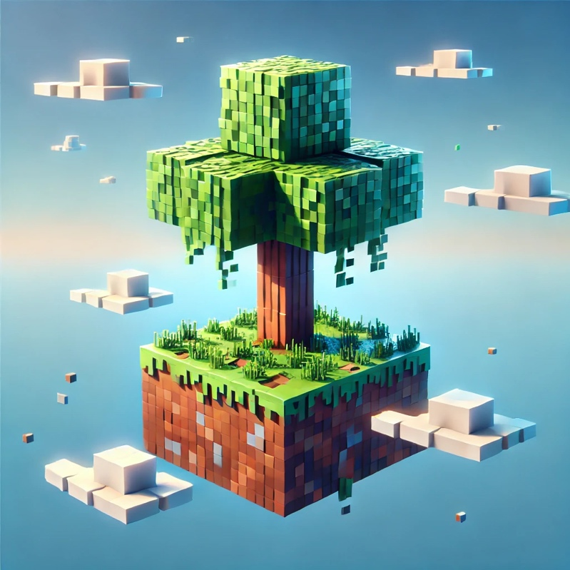
(Re)creating a videogame soundtrack with AI

Table of Contents
Introduction 3
Prompt Engineering 4
Goals 4
Constraints 5
Final Prompt 6
“Music” Generation Process 7
Choosing a Generator 7
Working with Udio 7
Output Evaluation 8
Philosophical Implications 9
Limits on Creativity 9
Authorship & Artistic Integrity 10
Interpretation 11
Conclusion 12
References 13

Introduction
Discourses on gaming and music frequently exclude video game soundtracks. Nevertheless, they provide indispensable depth and emotion, rendering a game incomplete without them. A case in point is the video game Minecraft, which features an iconic soundtrack composed by Daniel Rosenfeld, also known as C418.

His ambient, minimalist compositions provide a tranquil, nostalgic backdrop that enhances the game's open-world experience, thereby rendering moments of exploration and creation both immersive and reflective. The straightforwardness of the soundtrack reflects the blocky yet limitless universe of Minecraft, enabling players to become immersed in a world where the music is both soothing and contemplative. The Minecraft soundtrack has gradually become as esteemed as the game itself, demonstrating that a skilfully crafted score can transform gameplay into an indelibly memorable and emotionally resonant experience.
It is therefore pertinent to consider the extent to which AI can emulate such a nuanced and intricate composition. While it is beyond the scope of this discussion to speculate on the limitations of AI in this regard, it is nevertheless interesting to speculate on the extent to which it might be able to evoke the nostalgic and serene feelings that C418's compositions elicit.

Prompt Engineering
“Prompt engineering is the process of structuring an instruction that can be interpreted and understood by a generative artificial intelligence model. A prompt is natural language text describing the task that an AI should perform. A prompt for a text-to-text language model can be a query such as "what is Fermat's little theorem?” ~ Wikipedia

Engineering a prompt shares certain similarities with programming. At the outset, straightforward objectives can be achieved with relative facility. However, as soon as more complex and nuanced tasks are introduced — for example, the recreation of a specific musical style — the process can become quite tedious.

Goals
The objective of this prompt is to create a musical composition that evokes the nostalgic ambience of C418's "Sweden." It is imperative that the composition does not directly reference C418, as outlined in the constraints. The aim is to capture the essence of that nostalgic feeling.

While these objectives may appear straightforward, they are, in fact, quite challenging to achieve.

Constraints
The constraints of copyright and ethical considerations played a significant role in shaping my approach to this project.
While my objective was to evoke the nostalgic essence of Minecraft's soundtrack, I was obliged to exercise caution to avoid direct replication and thus respect copyright. The music of Minecraft, composed by C418, is iconic and protected by intellectual property laws. Therefore, any direct copying of the soundtrack or use of its unique melodies would constitute an infringement of these rights. Fortunately, the majority of models prohibit requests that contain copyrighted material, which accelerated the creation process. As a consequence of this restriction, it was necessary to utilise descriptive terminology in the prompt in order to evoke a comparable emotional ambience, rather than replicating the original soundtrack itself.
This necessitated a delicate equilibrium between inspiration and originality, with the aid of AI to generate a work that was "inspired by" the original, rather than a mere reproduction. From an ethical standpoint, this experience gave rise to questions pertaining to authorship and ownership in the context of AI-generated art. The question of creative ownership is rendered complex by the fact that the song was created by an AI based on the author's prompts. The AI generated the song autonomously, yet the final output was significantly influenced by my input, resulting in a shared authorship model. From an ethical standpoint, this raises questions about credit. The AI model itself was trained on vast amounts of data, likely including music and sound patterns from various sources, and contributed to the project in a way that could blur the lines of originality. It is therefore essential to recognize and navigate these ethical boundaries, particularly as AI-generated art becomes increasingly common in digital spaces, challenging traditional notions of creativity, ownership, and inspiration.

Final Prompt
"a soundtrack similar to minecrafts soundtrack - with clear, concise notes and an ambient, relaxing, emotional and slow sound. it should invoke a feeling of nostalgia, while emboding the process of creation."

In order to achieve optimal results, it was necessary to give each word in the prompt careful consideration on numerous occasions before selecting it. The term "clear, concise notes" was selected because one of the most notable characteristics of the Minecraft soundtrack is the purity and clarity of each sound, which enables listeners to become immersed without distraction.

The description of the music as "ambient, relaxing, emotional, and slow" was intended to direct the AI toward a calming tone that does not demand the listener's attention but instead gently enhances the environment, much like the original music in Minecraft does as players build and explore. Finally, the intention was that the concepts of "nostalgia" and "the process of creation" would add layers of introspection, reminiscent of both the game and the memories it has created for players over time.

“Music” Generation Process

Choosing a Generator
The selection of an appropriate AI generation tool was a crucial aspect of this project, as it directly impacted the nature and quality of the resulting output. In order to achieve my objective of creating a musical composition inspired by the Minecraft soundtrack, I sought a tool that would allow for extensive customization while also producing a clear and precise sound. After evaluating a number of potential options, I selected Udio, a text-based music generation tool renowned for its capacity to generate ambient and experimental sounds. Udio's ability to interpret descriptive prompts provided the flexibility I required to approximate the distinctive ambience of the Minecraft soundtrack without resorting to a direct replication.

Working with Udio
The Udio platform offers a straightforward user experience. The tool offers a plethora of customization options, including the ability to select the genre, choose the length of the song, adjust the prompt strength, and even upload an existing audio file to build upon. However, this latter option was not available for use in this instance, as C418's music is blocked by their copyright system.
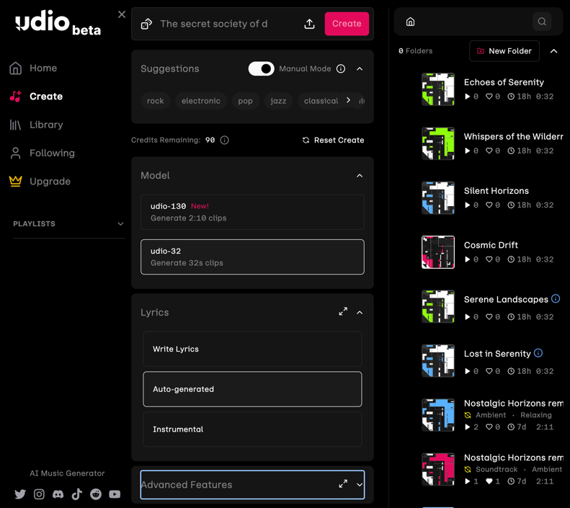
I utilized the default settings with the exception of increasing the track length to one minute. The prompt input process was straightforward, as there is no character limit for the prompt.
Two additional "customization" options are available for generated songs: one allows the user to extend the current song by a chosen length, while the other remixes a selected segment of the generated piece.

Output Evaluation
In assessing the quality of the AI-generated tracks, I concentrated on four principal criteria: fidelity, clarity, evocative quality, and comparison to C418's original compositions for the video game Minecraft. Additionally, the ethical implications of utilizing AI for the replication of a well-known and cherished soundtrack were thoroughly contemplated.
The AI-generated music did succeed in capturing some of the core ambient qualities of C418's style, such as the soft, mellow tones and relaxed pace. However, it proved unable to reproduce the distinctive harmonic simplicity that characterizes the Minecraft soundtrack. The resulting pieces appeared to lack a discernible structure, evoking a sense of aimlessness rather than the characteristic calm and looping patterns observed in C418's work. One of the challenges inherent to the generation of music through AI, particularly in the context of ambient or minimalistic compositions, is the attainment of a high degree of precision and sharpness in the individual notes. The resulting audio was unfortunately of a lower quality than desired, with a lack of clarity that prevented it from creating the desired immersive experience. The directive to produce "clear, concise notes" was included in the prompt to guide the AI toward a more refined sound. However, the resulting notes still exhibited a lack of sharpness, which is crucial for achieving an auditory experience that is reminiscent of that found in Minecraft.
The emotional aspect of nostalgia proved to be a significant challenge for the AI in terms of accurately capturing the nuances of this complex human emotion. Although the generated pieces had a calming quality, they lacked the distinct emotional pull that makes the original Minecraft soundtrack so memorable. Nostalgia is a complex emotion that is challenging to quantify and convey, even with carefully crafted prompts. This is because it relies heavily on personal and cultural associations that AI may not fully comprehend or replicate.
A comparison of the generated tracks with those of C418 revealed that the AI was unable to fully capture the depth and emotional resonance of the original Minecraft soundtrack. C418's compositions for Minecraft extend beyond the realm of ambient music, evoking a sense of wonder and openness that resonates with the game's vast and blocky landscapes. While the generated music demonstrated technical competence, it lacked the immersive quality that sets C418's compositions apart.

Philosophical Analysis
The application of AI to recreate a nostalgic, human experience—such as the ambience of Minecraft's soundtrack—raises significant philosophical questions about creativity, consciousness, and the nature of emotions. The core of this analysis is the distinction between human-made and machine-made art. Can an AI, lacking experiences, memories, or emotions, authentically recreate or comprehend a sentiment like nostalgia? This question is consistent with the ideas of philosophers such as John Searle, who posited in his "Chinese Room" thought experiment that syntax does not equate to semantics. Similarly, AI tools like Udio may generate sound patterns that imitate the structure of nostalgic music but lack any true comprehension of the concept of nostalgia or the reasons behind its resonance with humans.

Limits on Creativity
From an existential standpoint, this project illuminates how AI functions as both an extension of human creativity and a reflection of our limitations. As Heidegger observed in his concept of "technē," (The Greek term for both "art" and "craftsmanship"), technology serves as a means of revelation, uncovering aspects of the self and the world that might otherwise remain hidden.
In this instance, the deficiencies of AI in generating authentic, emotionally resonant music reveal the profoundly human dimensions of nostalgia, memory, and artistic intention—qualities that are inherently resistant to mechanical reproduction. The AI was unable to comprehend the rationale behind my association of the Minecraft soundtrack with personal nostalgia and a sense of creativity, which I as the creator of the project had experienced. This underscores the fact that a significant portion of human art is not merely based on structural elements but also on lived experiences and individual interpretations.

Authorship & Artistic Integrity
Furthermore, this project raises ethical concerns regarding authorship, agency, and artistic integrity in AI-generated art. The AI functioned as a creative partner, yet it did not exhibit any intentional or emotional responses to its contributions. This gives rise to questions of authorship, namely whether the designation of "creator" remains applicable in instances where a machine is responsible for the production of a significant portion of the content. In his work, the French philosopher Roland Barthes posited the concept of "The Death of the Author," which suggests that once a work of art is created, its interpretation and analysis belong to the audience rather than the creator. In the context of AI-generated art, this concept is further complicated by the fact that the AI itself lacks authorship, meaning, or intent. In this context, the "author" becomes a composite of the human input and the AI's algorithmic processes, resulting in an artwork that is essentially a collaboration between human intuition and machine execution.

AI-generated art prompts us to reflect on the nature of creativity and, more profoundly, the essence of feeling. While AI can emulate the outward form of human art, it remains fundamentally distinct from the human experiences, memories, and emotional landscapes that imbue art with its profound meaning. This philosophical inquiry underscores a paradox: AI enhances our creative capacities, yet its limitations serve to highlight the uniquely human qualities it can never fully replicate.

Interpretation
The AI-generated song serves as an exploration of the tension between human nostalgia and machine interpretation. Minecraft's soundtrack is famously evocative, inviting listeners into a serene space that feels both timeless and deeply personal. This ambiance is woven with nostalgia and subtlety, which is what I wanted to recreate in my prompt. However, the AI's rendering of this emotional landscape was incomplete. The lack of clarity and muffled notes in the output signify a gap between the descriptive prompts and the AI's execution, suggesting that while the AI can mimic the structure of a nostalgic soundtrack, it cannot fully embody the personal or emotional weight behind it.
This project illuminates a broader theme in the relationship between humans and AI: the ability to create versus the ability to understand. While AI tools can replicate patterns and generate sounds reminiscent of certain genres or emotions, they lack the consciousness to "feel" or interpret these elements, often resulting in art that resonates superficially rather than deeply. Philosophically, this raises the question of whether AI can ever truly replicate or express human nostalgia - a complex emotion rooted in memory, cultural context, and individual experience. From a cultural perspective, this AI-generated song underscores our growing fascination with reinterpreting our past through technology. The choice of Minecraft, a game that has shaped the lives of countless players, highlights how our digital and physical worlds collide to shape collective and individual memories.
In this sense, using AI to recreate such a significant part of my childhood reflects a broader trend of using technology to revisit, reinterpret, and even preserve aspects of our lives and culture. Through this analysis, it becomes clear that while AI offers valuable tools for creation, it ultimately remains a reflection of human intent and memory - drawing from our instructions without truly capturing the essence of what we want.

Conclusion
This project offered a distinctive chance to examine the nexus of AI and individual creativity, elucidating both the potential and constraints of employing AI instruments in artistic production. The objective was to capture the nostalgic and serene qualities of the Minecraft soundtrack, which is deeply tied to the researcher's own memories and experiences.
While the AI was effective in creating a similar ambient sound, its limitations in clarity, emotional resonance, and interpretive depth fell short of the desired outcome, underscoring the challenges of translating human sentiment into machine-generated art. Furthermore, the project underscored significant copyright and ethical considerations, emphasizing the responsibilities inherent in balancing inspiration and replication, and in acknowledging the role of AI in the creative process.

References
- C418’s “Sweden”
- Archive containing all outputs
- Wikipedia Article on “Prompt Engineering”
- Final version
- Cover art: ChatGPT
- Text Correction: Deepl

