**Stock Market Prediction - Dangers of Extrapolation**

In this article we explore the dangers of extrapolation. The Oxford Dictionary defines the term “extrapolation” as to *“extend the application of a method or conclusion to an unknown situation by assuming that existing trends will continue*.” In its purest sense, extrapolation is not a scientific principle, however, humans by their very nature tend to use extrapolation quite frequently … to extrapolate real estate prices, population growth, the stock market index, etc. Now, let us consider an example to illustrate how extrapolation can be a dangerous technique.

Table 1 contains the closing year end level of the Australian Stock Exchange (ASX) All Ordinaries Price Index for the years 2000 to 2007 inclusive.

*Table 1: ASX AllOrds Index (2001-2007)*

|  |  |
| --- | --- |
| **Year** | **ASX All Ordinaries Price Index** |
| 2000 | 3155 |
| 2001 | 3360 |
| 2002 | 2976 |
| 2003 | 3306 |
| 2004 | 4053 |
| 2005 | 4709 |
| 2006 | 5644 |
| 2007 | 6421 |

The ASX AllOrds index, established in January 1980 at a base index of 500 points, is the oldest share index in Australia. The index consists of the largest 500 companies, as determined by market capitalisation.

As can be seen from Table 1, during the 2000 to 2007 period the index range from just under 3000 points to just under 6500 points. The index peaked at 6873 points during November 2007. Currently (in Q1 of 2016) it is hovering around the 5000 mark.

The data in Table 1 were graphed using Excel and are plotted in Figure 1 below. A quadratic trend-line (i.e. 2nd order polynomial) was fitted to the data points. The equation for the trend-line is given in the figure, with an R value of 0.98 indicating an extremely good fit. It is of course possible to fit a 5th order polynomial and achieve prefect fit with R = 1, however one could argue that doing so would be a classic case of over-fitting.

*Figure 1: ASX AllOrds Index (2001-2007)*

Figure 1 clearly indicates the presence of an upward trend. Many naïve speculators assumed that such trend would continue into the future. Now, let us extrapolate to 2008 and 2009. This yields the figures given in Table 2 below:

*Table 2: Extrapolated results for 2008 & 2009*

|  |  |
| --- | --- |
| **Year** | **Extrapolated Result** |
| 2008 | 7803 |
| 2009 | 9246 |

So, at the end of 2008 the AllOrds index value was extrapolated to be 7803 points. Similarly, at the end of 2009 the AllOrds index value was extrapolated to be 9426 points. Thus if one had invested in an index-tracking stock or a mutual fund that mirrored the AllOrds stock index, such investment would have tripled over the period from 2000 to 2009, producing a very lucrative ROI indeed!. Trivially, this was not actually the case, as the AllOrds index did in fact peak during November 2007 at 6873 points. The true index values for the years 2008 and 2009 were 3659 and 4883 points respectively, reflecting the Global Financial Crisis (GFC). The extrapolated result for 2009 is almost double the true 2009 index figure, quite a margin of error.

Now, bear in mind, the extrapolation was only for the next 2 years, it was not into the distant future. Extrapolating to year end 2015 would give a result of approximately 22000 points. The actual 2015 year end figure is merely 5296 points. Extrapolation results were computed using the quadratic equation … just image what the extrapolated results would be if the 5th order polynomial is used!

Figure 2 shows the fluctuations in the index over the last 10 years. Note the market peak of 6873 points achieved in November 2007, followed by the stock market crash during 2008 and 2009. The lowest point (3112 points) in the graph occurred during March 2009, 54% less than the November 2007 high. In February 2013, the index rose by 28.4 (0.59%) to 5010 points, passing 5000 for the first time since the GFC. The index has yet to recover to pre-crash levels and, as mentioned above, is currently in or around the 5000 point level.

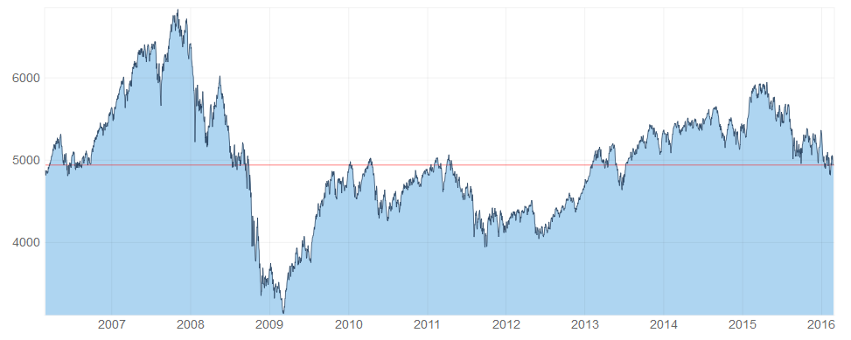

*Figure 2: AllOrds index (last 10 years)*

*(Source: http://www.marketindex.com.au/all-ordinaries)*

The moral of the story is that one should always proceed with caution when venturing down the extrapolation route. Finally a cartoon to demonstrate the dangers of extrapolation:

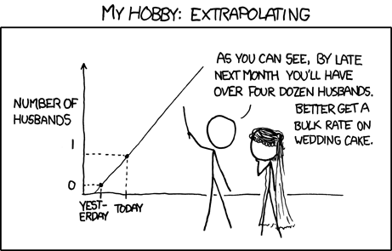

*(Source:* [*www.quora.com*](https://www.quora.com/What-are-some-good-statistics-jokes)*)*