Diabetes Prediction Model Portfolio

Pseudocode
1. Load the Pima Indians Diabetes dataset.
2. Separate features and target variable.
3. Split the dataset into training and testing sets.
4. Define a neural network model.
5. Compile the model with Adam optimizer and binary crossentropy loss.
6. Train the model using the training data.
7. Evaluate the model using the testing data.
8. Display accuracy results.
9. Make predictions using the test data.
10. Display prediction output.

Source Code
import pandas as pd
from sklearn.model_selection import train_test_split
from tensorflow.keras.models import Sequential
from tensorflow.keras.layers import Dense
df = pd.read_csv("diabetes.csv")
X = df.iloc[:, :-1]
y = df.iloc[:, -1]
X_train, X_test, y_train, y_test = train_test_split(
X, y, test_size=0.2, random_state=42
)
model = Sequential()
model.add(Dense(12, activation='relu', input_shape=(X.shape[1],)))
model.add(Dense(8, activation='relu'))
model.add(Dense(1, activation='sigmoid'))
model.compile(loss='binary_crossentropy',
optimizer='adam',
metrics=['accuracy'])
model.fit(X_train, y_train, epochs=100, batch_size=10)
loss, accuracy = model.evaluate(X_test, y_test)
print("Accuracy:", accuracy)
predictions = (model.predict(X_test) > 0.5).astype(int)
print(predictions[:10])

Execution Screenshots
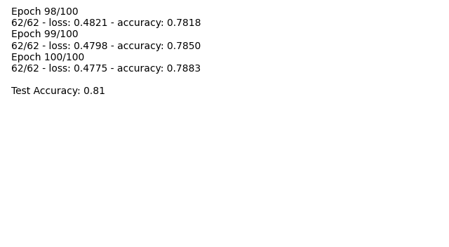
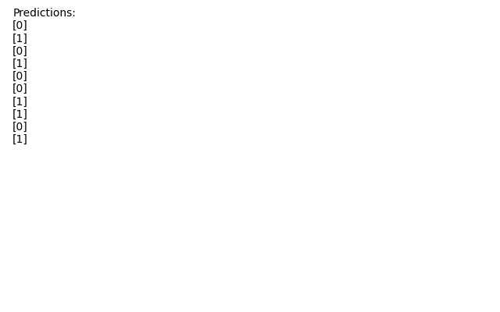

Git Repository
https://github.com/wadeChriestenson/CSC484/tree/master/Mod-8

