CPE 301 EMBEDDED SYSTEM DESIGN S 2015

TITLE: IMU WIFI IOT

GOAL:

* Read data from IMU6050 to ATMega328P
* Send data from ATMega328P to ESP8266
* Have ESP8266 module upload data to ThingSpeak cloud service

DELIVERABLES:

An IoT device capable of uploading IMU gathered data via WiFi

LITERATURE SURVEY:

Allows for gathering of data that can be accessed and analyzed by anyone on the web.

COMPONENTS:

* ATMega328P – main controller of device, reads data from sensor and pushes the data to a Wifi module
* IMU6050 – Gathers data, utilizes I2C communication standard to send data to ATMega328P
* ESP8266 – used to upload gathered data to ThingSpeak cloud service via WiFi, communicates with ATMega328P via UART

SCHEMATICS:

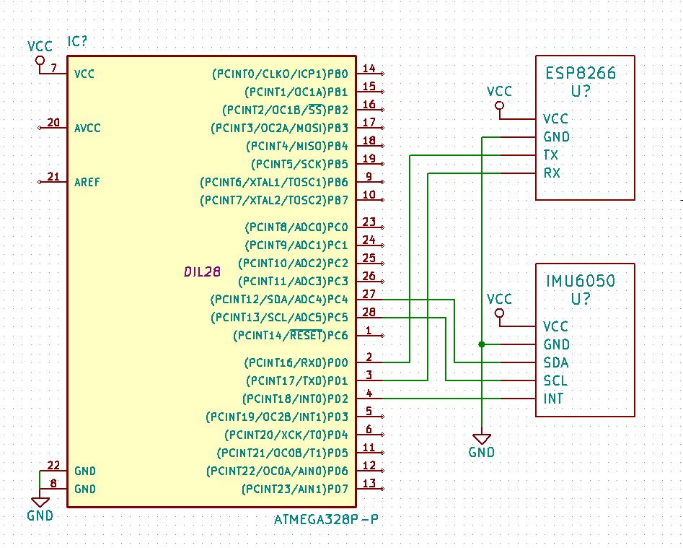

INITIAL PCB\*: (work in progress)

IIMPLEMENTATION:

* Implemented on bread board

SNAPSHOTS/SCREENSHOTS\*: (work in progress)

<http://imgur.com/e0RSq6i>

CODE: (work in progress)

REFERENCE:

Name: Brandon Wade Page 1/1