Brandon Wade

CPE301 – SPRING 2016

Design Assignment 0

**DO NOT REMOVE THIS PAGE DURING SUBMISSION:**

The student understands that all required components should be submitted in complete for grading of this assignment.

|  |  |  |  |
| --- | --- | --- | --- |
| **NO** | **SUBMISSION ITEM** | **COMPLETED (Y/N)** | **MARKS**  **(/MAX)** |
| 0. | COMPONENTS LIST AND CONNECTION BLOCK DIAGRAM w/ PINS |  |  |
| 1. | INITIAL CODE OF TASK 1/A |  |  |
| 2. | INCREMENTAL / DIFFERENTIAL CODE OF TASK 2/B |  |  |
| 3. | INCREMENTAL / DIFFERENTIAL CODE OF TASK 3/C |  |  |
| 4. | INCREMENTAL / DIFFERENTIAL CODE OF TASK 4/D |  |  |
| 5. | INCREMENTAL / DIFFERENTIAL CODE OF TASK 5/E |  |  |
| 6. | SCHEMATICS |  |  |
| 7. | SCREENSHOTS OF EACH TASK OUTPUT |  |  |
| 8. | SCREENSHOT OF EACH DEMO |  |  |
| 9. | VIDEO LINKS OF EACH DEMO |  |  |
| 10. | GOOGLECODE LINK OF THE DA |  |  |
|  |  |  |  |
|  |  |  |  |

|  |  |  |  |
| --- | --- | --- | --- |
| 0. | COMPONENTS LIST AND CONNECTION BLOCK DIAGRAM w/ PINS |  |  |

Atmel Studio 7.0

|  |  |  |  |
| --- | --- | --- | --- |
| 1. | INITIAL CODE OF TASK 1/A |  |  |

;

; DA0.asm

;

; Created: 2/15/2016 4:15:51 PM

; Author : Brandon Wade

;

LDI R16, 31 ; load number 1 into R16

LDI R17, 31 ; load number 2 into R17

LDI R18, 31 ; load number 3 into R18

LDI R19, 31 ; load number 4 into R19

LDI R20, 31 ; load number 5 into R20

ADD R16, R17 ; R16 = R16 + R17, no chance of unsgined overflow

ADD R16, R18 ; R16 = R16 + R18, no chance of unsgined overflow

ADD R16, R19 ; R16 = R16 + R19, no chance of unsgined overflow

ADD R16, R20 ; R16 = R16 + R20, no chance of unsgined overflow

BRCS OF ; check carry bit for unsigned overflow, branch to OF if true

LDI R21, 0 ; R21 gets 0

OUT PORTB, R21 ; PORTB.2 gets 0

JMP DONE ; jump to end

OF:

LDI R21, 2 ; R21 gets 2

OUT PORTB, R21 ; PORTB.2 gets 1

DONE:

JMP DONE ; program done

|  |  |  |  |
| --- | --- | --- | --- |
| 6. | SCHEMATICS |  |  |

Simluation, no Schematics

|  |  |  |  |
| --- | --- | --- | --- |
| 7. | SCREENSHOTS OF EACH TASK OUTPUT |  |  |

TASK 1/A:

PORTB.2 Indicates unsigned overflow of sum of five numbers

No overflow condition:

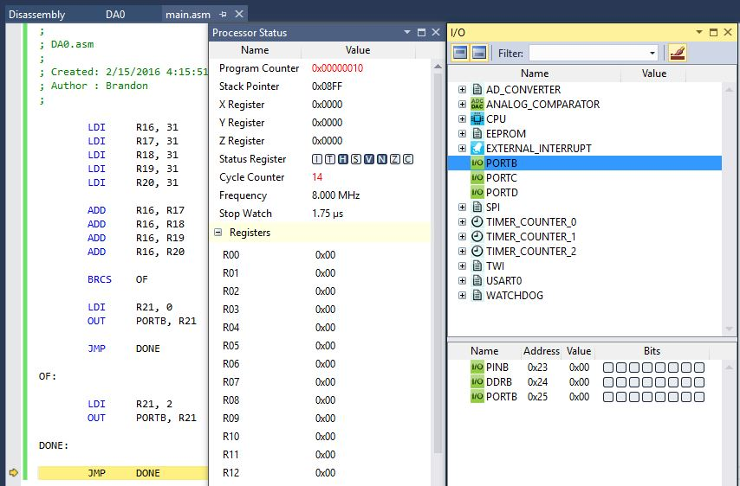

Execution Time = 1.75 us

Number of Cycles = 14

Overflow condition:

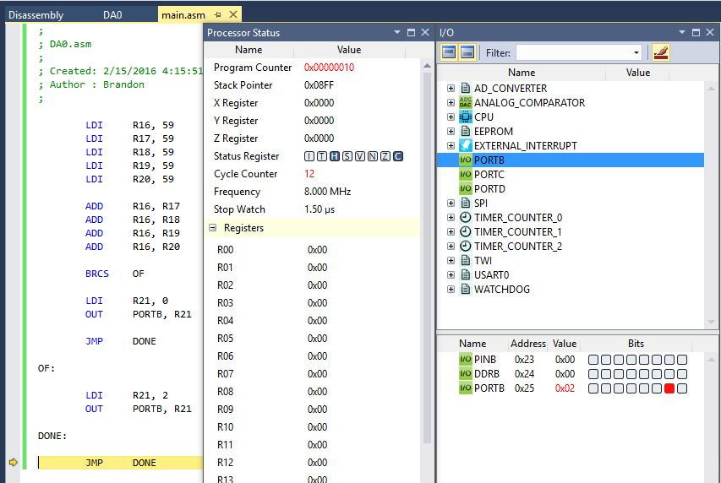

Execution Time = 1.5 us

Number of Cycles = 12

|  |  |  |  |
| --- | --- | --- | --- |
| 8. | SCREENSHOT OF EACH DEMO |  |  |

TASK 1/A:

Simulation, no demo

|  |  |  |  |
| --- | --- | --- | --- |
| 9. | VIDEO LINKS OF EACH DEMO |  |  |
| N/A | | | |
| 10. | GOOGLECODE LINK OF THE DA |  |  |
| https://github.com/wadeb1/KF3HF6ZFMP.git | | | |

**Student Academic Misconduct Policy**

<http://studentconduct.unlv.edu/misconduct/policy.html>

“This assignment submission is my own, original work”.

Brandon Wade