Brandon Wade

CPE301 – SPRING 2016

Design Assignment 3

**DO NOT REMOVE THIS PAGE DURING SUBMISSION:**

The student understands that all required components should be submitted in complete for grading of this assignment.

|  |  |  |  |
| --- | --- | --- | --- |
| **NO** | **SUBMISSION ITEM** | **COMPLETED (Y/N)** | **MARKS**  **(/MAX)** |
| 0. | COMPONENTS LIST AND CONNECTION BLOCK DIAGRAM w/ PINS |  |  |
| 1. | INITIAL CODE OF TASK 1/A |  |  |
| 2. | INCREMENTAL / DIFFERENTIAL CODE OF TASK 2/B |  |  |
| 3. | INCREMENTAL / DIFFERENTIAL CODE OF TASK 3/C |  |  |
| 4. | INCREMENTAL / DIFFERENTIAL CODE OF TASK 4/D |  |  |
| 5. | INCREMENTAL / DIFFERENTIAL CODE OF TASK 5/E |  |  |
| 6. | SCHEMATICS |  |  |
| 7. | SCREENSHOTS OF EACH TASK OUTPUT |  |  |
| 8. | SCREENSHOT OF EACH DEMO |  |  |
| 9. | VIDEO LINKS OF EACH DEMO |  |  |
| 10. | GOOGLECODE LINK OF THE DA |  |  |
|  |  |  |  |
|  |  |  |  |

|  |  |  |  |
| --- | --- | --- | --- |
| 0. | COMPONENTS LIST AND CONNECTION BLOCK DIAGRAM w/ PINS |  |  |

Atmel Studio 7.0

ATMega328P Chip

Breadboard

Max232cpe Chip

Serial Cable

LM34

LM34

ATmega328P

PD0

PD1

PC0

Computer

D9 Connector

2

3

Max232cpe

R1OUT T1OUT

T1IN R1IN

|  |  |  |  |
| --- | --- | --- | --- |
| 1. | INITIAL CODE OF TASK 1/A |  |  |

// Brandon Wade CPE 301 DA 2

#include <avr/io.h>

#include <stdint.h> // needed for uint8_t

#include <avr/interrupt.h>

#define FOSC 8000000 // Clock Speed

#define BAUD 9600

#define MYUBRR FOSC/16/BAUD -1

volatile char ReceivedChar;

volatile *uint8_t* ADCvalue; // Global variable, set to volatile if used withISR

void usart_init (void)

{

UCSR0B = (1<<TXEN0)|(1<<RXEN0); // enable USART transmitter

UCSR0C = ((1<<UCSZ01)|(1<<UCSZ00)|(0<<UMSEL00)); // character size is 8 bits, asynchronous usart

UBRR0H = 0x0;

UBRR0L = 51; // for baud of 9600

}

void adc_init (void)

{

ADMUX = 0; // use ADC0

ADMUX |= (1 << REFS0); // use AVcc as the reference

ADMUX |= (1 << ADLAR); // Right adjust for 8 bit resolution

ADCSRA |= (1 << ADPS2) | (1 << ADPS1) | (0 << ADPS0); // 64 prescale for 8Mhz

ADCSRA |= (1 << ADATE); // Set ADC Auto Trigger Enable

ADCSRB = 0; // 0 for free running mode

ADCSRA |= (1 << ADEN); // Enable the ADC

ADCSRA |= (1 << ADIE); // Enable Interrupts

ADCSRA |= (1 << ADSC); // Start the ADC conversion

}

void timer_init (void)

{

TCNT1H = 0xC2;

TCNT1L = 0xF6; // set count

TCCR1A = 0x00; // normal mode

TCCR1B = 0x04; // set pre scalar

TIMSK1 = 0x01; // enable timer interrupt

}

void usart_send (unsigned char ch)

{

while(! (UCSR0A & (1<<UDRE0))); // wait till the transmit buffer is ready to receive data

UDR0 = ch; // send character to output buffer

}

ISR(ADC_vect)

{

ADCvalue = ADCH; // only need to read the high value for 8 bit

}

ISR(TIMER1_OVF_vect)

{

//while(!(UCSR0A & (1<<RXC0)));

char c;

c = ADCvalue; // get temp

usart_send(c / 10 + '0'); // print 10s place

usart_send(c % 10 + '0'); // print 1s place

usart_send('F'); // print unit

usart_send('\n'); // end line

}

int main(void)

{

timer_init(); // initialize timer

usart_init(); // initialize usart

adc_init(); // initialize adc

sei(); // enable global interrupts

while(1) // loop forever

{

}

return 0;

}

|  |  |  |  |
| --- | --- | --- | --- |
| 6. | SCHEMATICS |  |  |

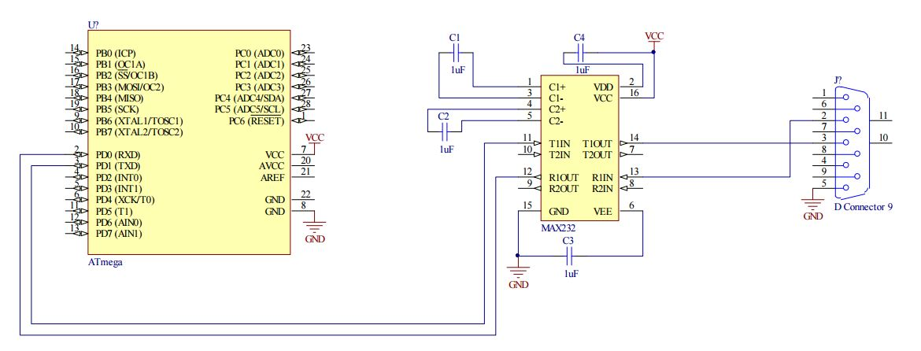

MAX232 used as interface with serial connector

|  |  |  |  |
| --- | --- | --- | --- |
| 7. | SCREENSHOTS OF EACH TASK OUTPUT |  |  |

TASK 1/A: Continuous Display of Temperature in F

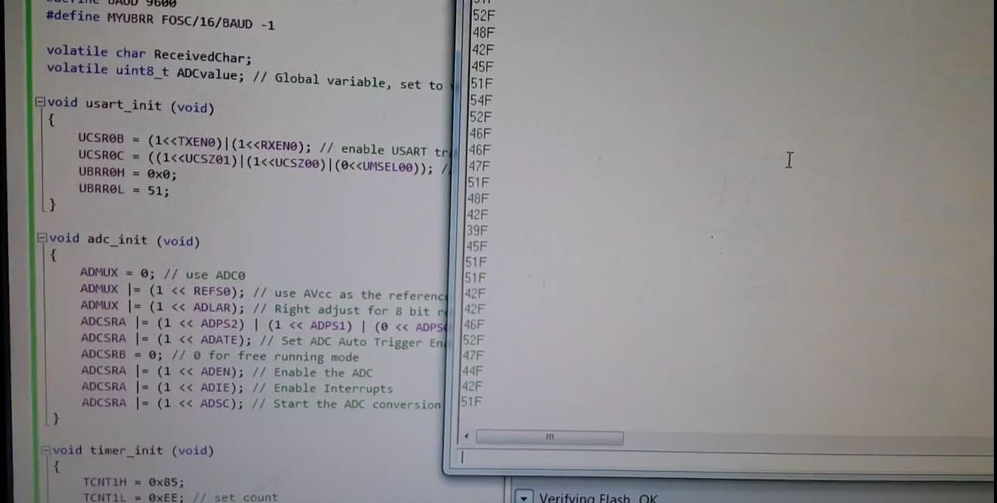

Using termite terminal, the temperature picked up from the LM34 was converted to text and continuously outputted to the screen with units

|  |  |  |  |
| --- | --- | --- | --- |
| 8. | SCREENSHOT OF EACH DEMO |  |  |

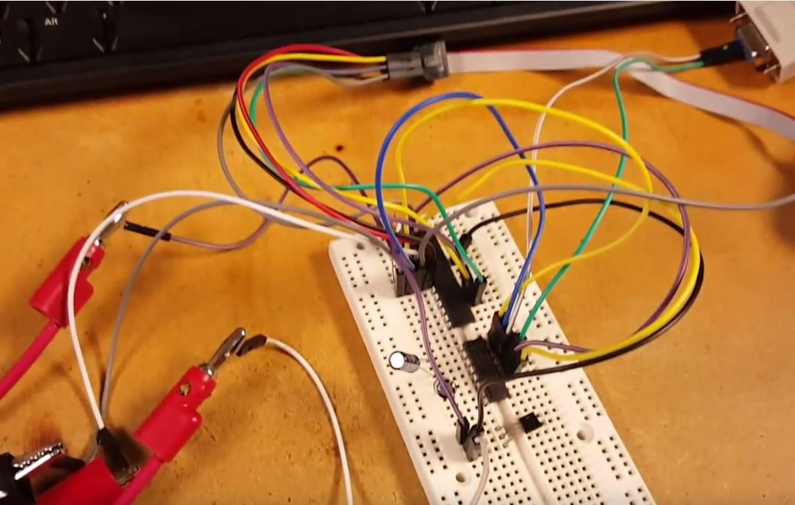

ATMega328P chip is located toward the top of the breadboard with the MAX232 chip located just beneath. The output of this chip was connected directly to the D9 serial connector. Below the MAX232 is the LM34 chip which is connected to the ADC0 port of the ATMega328P chip.

|  |  |  |  |
| --- | --- | --- | --- |
| 9. | VIDEO LINKS OF EACH DEMO |  |  |
| Task1 - <https://www.youtube.com/watch?v=EFPLDnbBsKY> | | | |
| 10. | GOOGLECODE LINK OF THE DA |  |  |
| <https://github.com/wadeb1/KF3HF6ZFMP.git> | | | |

**Student Academic Misconduct Policy**

<http://studentconduct.unlv.edu/misconduct/policy.html>

“This assignment submission is my own, original work”.

Brandon Wade