The ATM Simulator, Part 1
Introduction

This lab will get you started and guide you through the development of the first part of HW4, which covers the basic functions of an ATM simulator that lets a customer deposit or withdraw cash, check their balance, and print a receipt. If the customer is “admin”, it will even perform some basic administrator functions such as adding accounts, and viewing all accounts and all transactions.
Part 2 (for advanced students) will guide the development of additional capabilities such as viewing the last five transactions (for customers), and deleting accounts and viewing sorted versions of all accounts and transactions (for admin).
Whichever option you choose (skill building & part1 or both part1 & 2) you will turn in your completed code in one submission to Canvas.
Setting up the Project
To begin working on this project, download and expand the file A4.zip onto your computer.
This folder contains the following files:
ATM_part1.cpp – The program shell where you will write your program
ATM.exe – A working ATM simulator that you can use to check your version against
accounts.txt – The data file containing ATM account information
transactions.txt – The data file containing a list of all the ATM transactions
accountsBAK.txt – Backup to the accounts file (in case you need to go back to original file)
transactionsBAK.txt – Backup to the transaction file (in case you need to go back to original file)
Open the file ATM_part1.cpp, which is the starting point for your project, and run it. It works, however several functions are missing. Read through the file and notice the overall structure – after the #include statements, there are a collection of 17 function prototypes (of which 4 are commented out until Part 2). After the prototypes comes the main function, a fairly small program that sets up a few variables
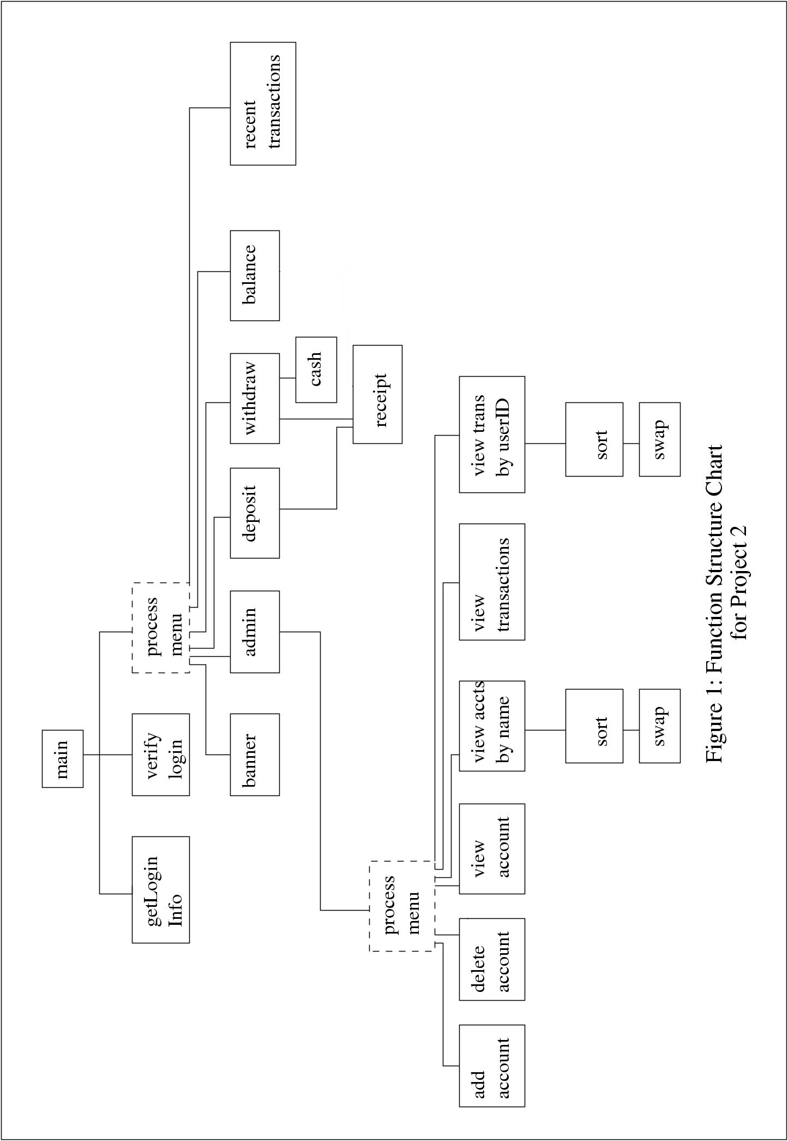
and a menu of choices, and uses functions to handle all the tasks the simulator needs to perform. This is very typical of most large projects.
In this part 1 of the project you will define about 8 functions using several functions already defined in the file as models. The overall layout of the project is shown in the function structure chart of figure 1. This chart illustrates how the different function modules are connected to each other using an abbreviated style discussed in Chapter 10 of your Hennefeld text.
Since you will be moving between several functions as you work on the project, you’ll need to learn some additional methods of navigating to the function definition you are looking for. You can continue using the old way, which is to scroll through the file until you find the function (they are arranged alphabetically). Or, you can click the Project tab on Bloodshed’s workspace window and locate the function by double-clicking its name in the workspace window. (You may need to enable class browsing—click Tools > EditorOptions > ClassBrowsing > EnableClassBrowsing).

Exercise 1: To begin this project, locate the definition of the getLoginInfo() function beneath the definition of main(). In order to work properly, this function needs to prompt the customer for the name and PIN number and return these values using pass by reference. Complete this function now. When you have it working, you will be able to log in as customer test, using the PIN 111.

Setting up a new Banner
The ATM starting program already includes a definition of the banner() and verifyLogin() function. You will need to change the Bank of America banner by visiting the web site http://www.schnoggo.com/figlet.html and typing in your own phrase as a banner and copying the ASCII artwork it generates into the banner function, adding the appropriate cout syntax around it. Note, because most ASCII artwork uses \ (which C++ uses to ‘escape’ other characters) you will have to ‘escape’ the \ character by doing a global replace where all occurrences of \ in your message are replaced with \\.
Exercise 2: modify your banner function to display the message you want your ATM to show.

Layout of the Files
You can view what the accounts.txt and transactions.txt files look like below. The accounts.txt file contains columns for userID, name, and PIN, while the transactions file contains date, time, userID, transactionCode (W for withdraw, D for deposit), money, and the final balance after transaction.
Notice that accounts.txt no longer contains the balance of the account. Only transactions maintains the running balance. In order to find someone’s current balance you would have to search transactions.txt for the last entry by the customer’s userID. For example, in the file below, the current balance of test (userID 1111) is 4957.78, while the current balance of Westin (userID 3456) is 9705.21.

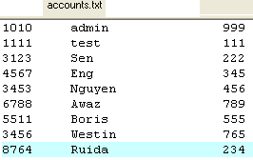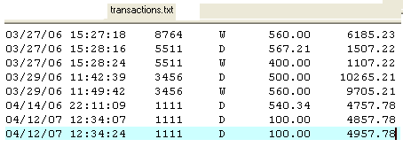

Exercise 3: In main, to retrieve one’s balance, a customer simply enters menu selection B. You can observe the switch statement case for B in main passing the customer’s validated userID to getBalance():

case 'B': case 'b': /*to see the balance*/
cout<<"Your balance is "<<getBalance(UserID)<<endl;

This function needs to be defined. Do this now: visit the definition of getBalance( ) below main. Notice that the function already has variables declared. You simply need to write a loop that examines the transactions file for records that match validID and capture the balance of these in validBalance. (Read in the data into the appropriate variables listed).

By definition, when the loop completes, validBalance will contain the last balance of the customer. The function then returns validBalance so other functions (including main) can use it.

Finish the getBalance function and test it by invoking menu option B after logging in as test 111. Verify that you are indeed showing the correct balance.

Overview of the Deposit Function
Take a moment to examine the verifyLogin() function again. This function is the same as the one you wrote for lab 9—it reads through the accounts file until it finds a matching username and password and returns true or false depending on the success of the search. Also, the person’s userID is returned pass by reference for further use in the other functions. As we continue to process the ATM customer’s requests, we will pass their validID to the function doing the processing. That function will then use that information to retrieve the customer’s balance and modify the transaction file.
The deposit function is invoked with a customer’s validated userID. It then proceeds to
- retrieve the current date and time
- accept the customer’s deposit amount—money—using cin
- retrieve the balance by passing validID to the getBalance function (defined in exercise 3)
- add money to balance
- print a receipt showing the new balance and amount deposited (not defined)
- append all the transaction information to the end of the transactions file
Appending to the end of a file
You’ll recall that normally when a pre-existing file is opened, its original contents are destroyed. One exception to this allows adding (appending) to the end of an already existing output file by opening the file with the option ios::app, as in the following statement taken from the deposit function:
ofstream trans("transactions.txt", ios::app);
Now, any data sent to the file will be added to the end of the pre-existing transactions file. The output format for the transaction file can be copied into your withdraw function. A transaction consists of a date, time, userID, transaction code (for now, this is either ‘W’ for withdraw, or ‘D’ for deposit), money, and balance. You might now be asking how the date and time from the computer is sampled.

Accessing Date and Time
When recording a transaction, the deposit function needs to record the date and time the transaction took place. Because the tools for accessing this information come from the old C language, we have simplified this step by creating an extra function getDateAndTime that returns the data in strings for easy use. If variables date and time are declared as strings, then after calling the function:
getDateAndTime(date, time);
both date and time will hold the strings for the system date and time.
Try out the deposit function to verify that it works properly with your definition of getBalance being used inside it.

Exercise 4: Once you are confident that deposit works, you can then go on to fill in the definition for the withdraw function. As the following pseudocode shows, this function works very similar to deposit. However, one key difference is that money (the variable amount the customer wishes to withdraw) should be declared an integer. The input value also needs to be verified to be 1) less than the customer’s balance, 2) larger than 0, and 3) a multiple of $20. Checking for 3) is performed using the boolean logic test (money%20 ==0)

Pseudocode for withdraw Function (refer to deposit function for help)
- get the date and time
- Input money, the amount the customer wishes to withdraw
- Verify that money is less or equal to balance, that it is a multiple of $20, and greater than 0. If not all of these is true, prompt customer to reenter money. Use && or || to chain booleans together.
- Calculate the new balance
- Give cash by calling the cash function (already defined).
- Print a receipt using transaction code ‘W’ (just call the receipt function for now, you will get to write that later.
- Record the transaction at the end of the transactions.txt file using transaction code ‘W’ (convert money to float using float(money))
- Then, close the transaction file.

Exercise 5: You now have two functions that need to use the receipt function to display a receipt. The type of receipt (withdraw or deposit) is controlled using the transaction code (pass ‘W’ for withdraw, and ‘D’ for deposit). Depending on the character code, this function will print one of the following receipts, formatted as follows for withdrawals and deposits:
-------------------------------------------
Bank of America Account:1111
Date: 04/15/06 Time: 01:01:28
Deposit: $521.23
Balance: $4738.67
-------------------------------------------
-------------------------------------------
Bank of America Account:1111
Date: 04/15/06 Time: 01:02:55
Withdrawal: $400.00
Balance: $4338.67
-------------------------------------------
Write the receipt function definition so that it closely matches the above examples. You will notice that the receipt must print the date and time as well. Since it’s cumbersome to pass this information from the deposit or withdrawal functions, simply copy the code that accesses date and time from your previous work.

Administrator Mode
A special mode has been designed into the ATM simulator to allow a bank official to manage customer accounts. This includes adding and deleting accounts, viewing all accounts, viewing the accounts sorted by name, and viewing transactions sorted by either time or userID.
Administrator mode is activated by a user pressing choice ‘A’ in the main menu. This choice is not displayed in the menu, and only the administrator (userID of 1010) may activate the choice ( you can see how this is accomplished by examining the switch statement in the main program.)

Administrator mode is handled by the function admin, which you’re now going to write as part of exercise 6.
Exercise 6: fill in the definition of the admin function. This function parallels main very closely, and you can use the main function as a model. However, it is much simpler than main. Like main, it will display a menu of choices, and then use a switch statement to activate the appropriate function to handle the choice. The menu for admin will look like the following:

############ ADMINISTRATOR MODE ############
Please Choose from the following:
A -- Add Account
D -- Delete Account
U -- View Accounts unsorted
N -- View Accounts sorted by Name
T -- View Transactions unsorted
R -- View Transactions sorted by UserID
Q -- Quit

After displaying the menu, allow the user to input a choice and use a switch statement to process it. For part one, only the following choices will be processed by the switch statement: A, U, T and Q

Choice A will activate function add_acct, choice U will activate function view_accounts and choice T will activate function view_transactions. These are all void functions that have no parameters.

Adding an Account
Now that you have defined the admin function, it’s time to create the functions that it uses. The first of these is add_acct, which adds a new account to the accounts.txt file. This function will ask the administrator to input the customer name, ID, PIN, and balance. It then appends this information using the precise format to the end of the accounts.txt file.
Advanced students may want to verify that the new user ID is not already taken by another customer in the accounts file. Otherwise, when testing this function, just make sure that you do not choose a redundant user ID.
After adding the user to the accounts file, you also need to append a transaction entry for the new customer to the end of the transactions file. The transaction code for adding an account will be ‘A’, and the money field will be the same as the initial balance.
Exercise 7: Using the above description, fill in the definition for the add_acct function. Test your solution by adding a new user, then exiting the system and logging in with the new user’s information. Make sure you can withdraw and deposit money from and to the new account.
Exercise 8: You can now finish part 1 of project 2 by filling in the definitions for the view_accounts and view_transactions functions. These functions simply display the entire contents of the accounts or transactions file using the same formatting as used in the other functions you’ve written.

For readability, make sure you start the display with a header line indicating the information displayed in each column.

