The ATM Simulator, Part 2
Introduction
This lab will guide you through the completion of the HW4, Part 2. In this part 2 of the project, you will complete the main menu tasks by creating the function to view recent transactions (the last five transactions), and then you will finish the admin menu tasks by creating functions to delete an account, and provide a sorted view of the accounts and transactions files.
Getting started on Part 2
Before beginning part 2, make sure you have completed all of the work in part 1. In this part of the project you will add about 4 additional function definitions to the same file you have been working on in part1 (for safety, before beginning part 2, rename this file to something like ATM_part2.cpp). These new functions will all use one of the programmer defined struct data types Account or Transaction that you will declare at the top of the main program (beneath the #include statements and ahead of all the function prototypes).
As a refresher, the overall layout of the project is shown in the function structure chart of figure 1. This chart illustrates how the different function modules are connected to each other using an abbreviated style discussed in Chapter 10 of your Hennefeld text. Again, since you will be moving between several functions as you work on the project, you may wish to click the Project tab on Bloodshed’s workspace window and locate the function you wish by double-clicking its name in the workspace window.

Exercise 1: To begin part 2 add statements to the top of main (beneath the #include statements and ahead of all the function prototypes) that declare a struct type to represent an ATM Account, and an additional struct type to represent an ATM Transaction. These structs should identify all the data used to represent an Account or a Transaction (for example, a Transaction will need to store a Date, time, userID, transaction code, amount, and balance). Remember to make sure that the data types of the different components of your struct match the kind of data you are trying to store. You can borrow the code for struct Account from Lab11Structs.cpp.
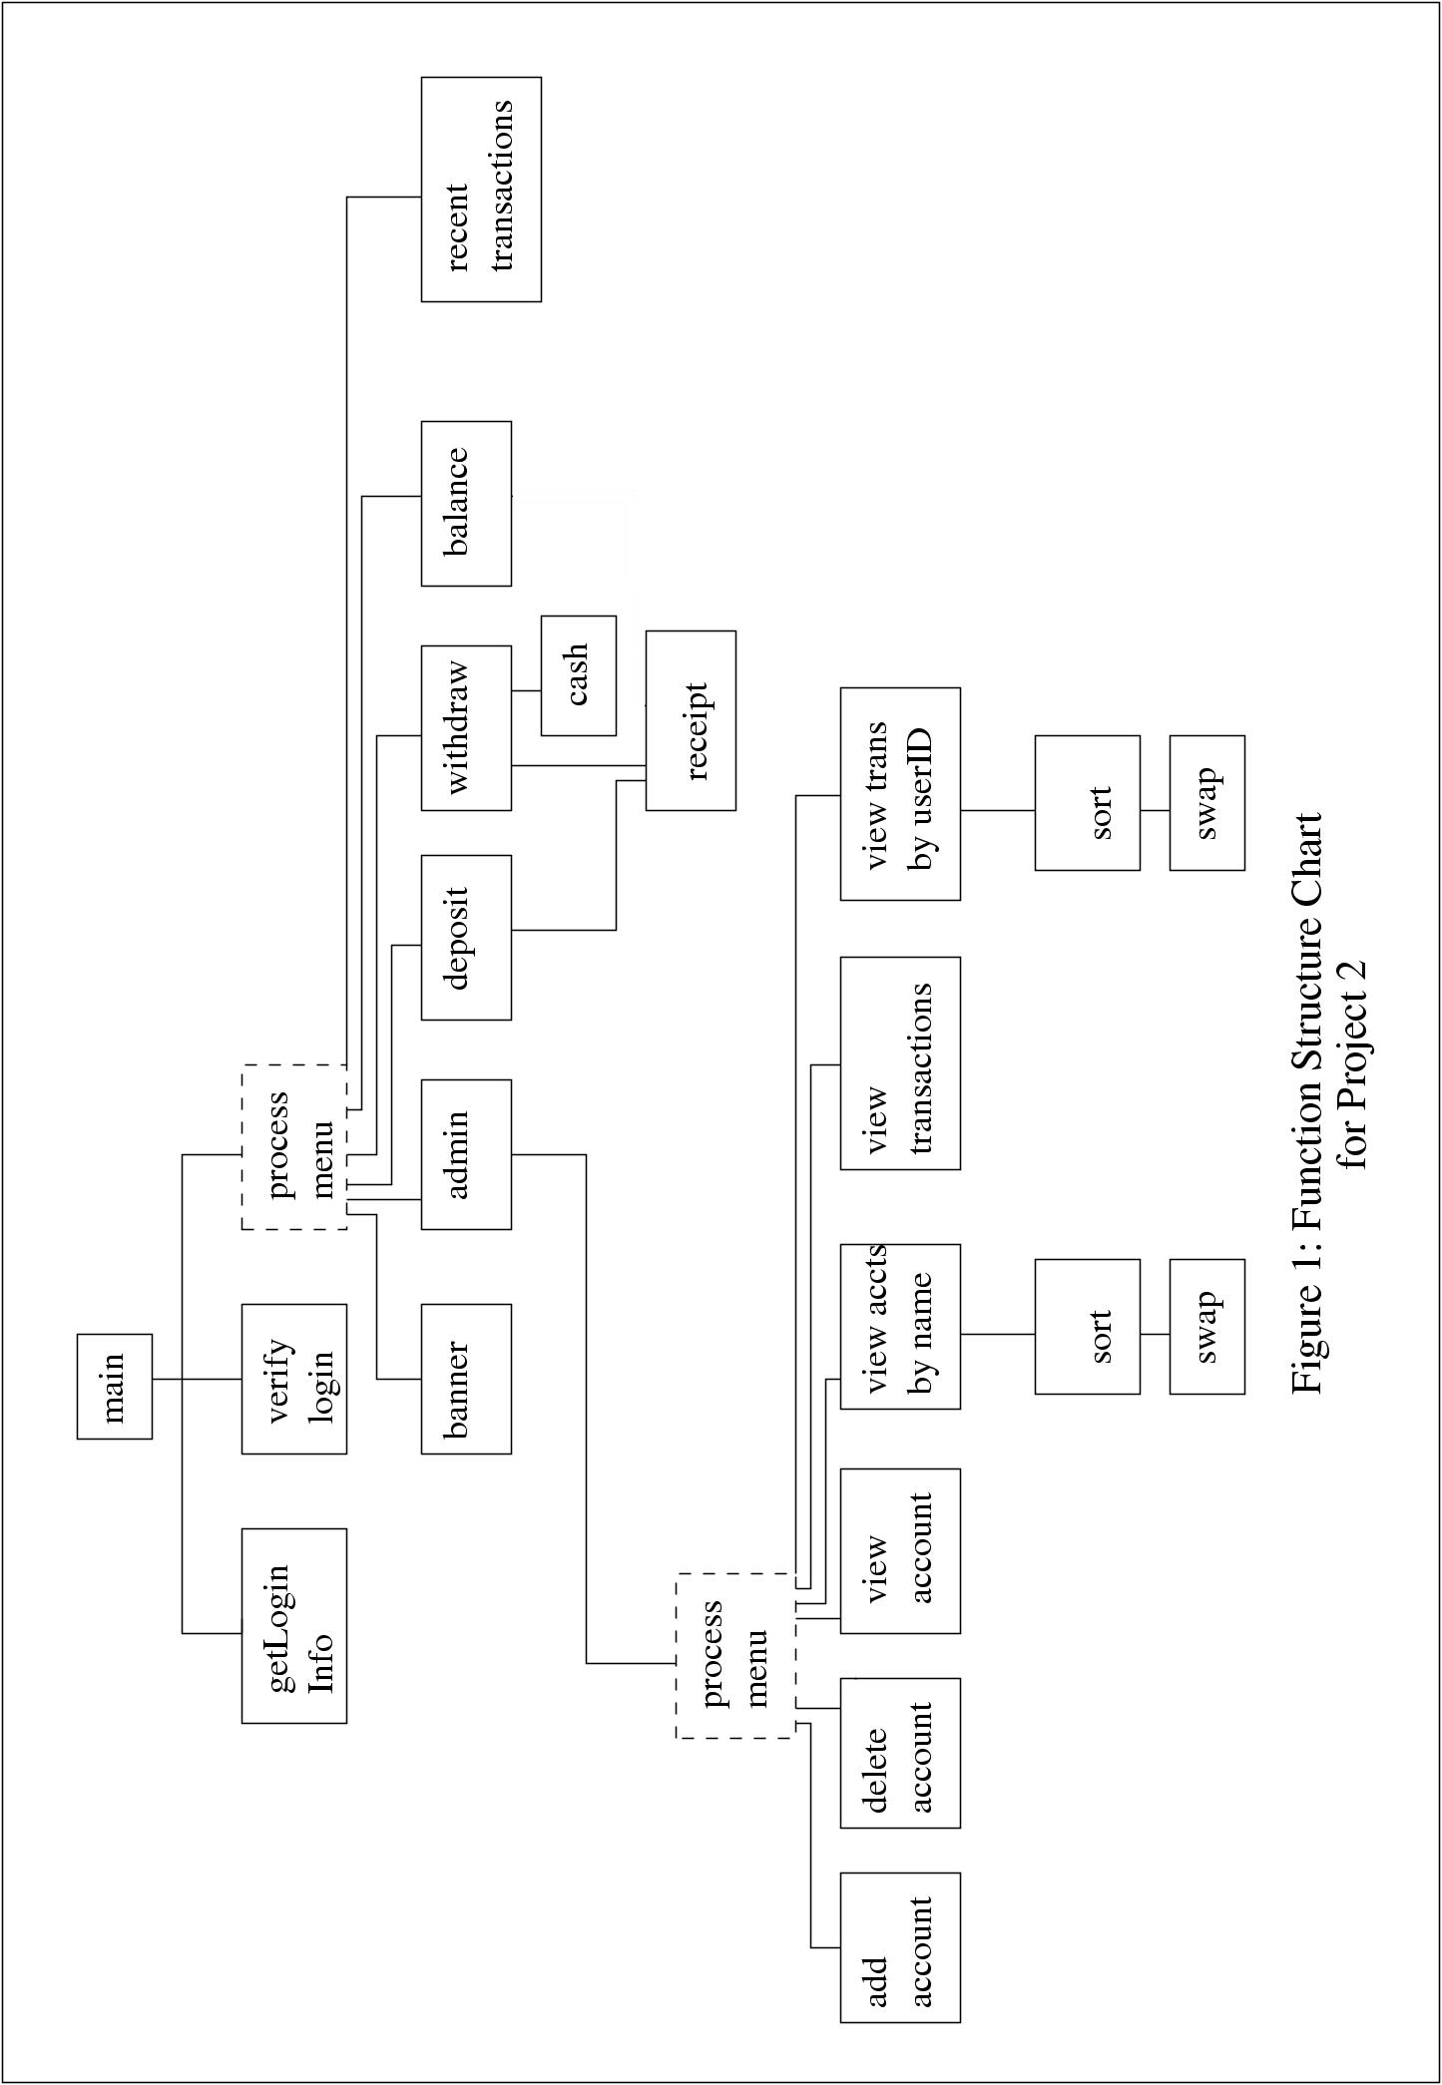

Viewing the Recent Transactions
The function prototype for viewing the recent transactions is commented out near the top of the file.
//void recent_transactions(int userID);
Uncomment this prototype, then copy and paste it at the bottom of the file. Remove the ; at the end of your copy and start writing the definition of the function.
This function will need to read through the entire transaction file and save only the transactions that match the userID parameter into an array of transactions. For example, if user test is trying to view recent transactions, it will only load transactions that have a userID of 1111 into the array. After reading through the file, it will only display the last five transactions in the array, from earliest in time, to latest in time. If there are less than five transactions in the array, it will only display the number of transactions that have been read. Refer to Problem 9 in Lab10Arrays.cpp for a simpler version of this problem that you have already solved.
Exercise 2: Develop your recent_transactions function as described above. Test this function by viewing the recent transactions of two different ATM users.

Deleting an Account from the Accounts file
The function prototype for deleting accounts is commented out near the top of the file.
//void delete_acct();
Uncomment this prototype, then copy and paste it at the bottom of the file. Remove the ; at the end of your copy and start writing the definition of the function. This function is only activated by user admin, and you should make sure your menu in the admin function has been modified to present this choice to admin and properly execute the function if admin chooses it. You might realize the similarity between this function and Problem 11 in Lab11Arrays.cpp, which tackles a similar but simpler problem in deleting a test score value from the scores.txt file.
This function will prompt the admin user for an account holder’s name to delete. If the name is in the accounts file, it will remove that account from the file and confirm the user has been deleted. If the name is not in the accounts file, it will display an error message like “user not found” and return (to the admin function where it was invoked).
To solve this task, you will need to read the entire accounts file into an array (and close the input file stream). Then reopen the accounts.txt file as an output stream and write the entire array (except for the user record that is going to be deleted) back into the file (using the appropriate formatting).
Be very careful with this function. If you mess up the accounts file you will need to restore both the accounts and the transactions file from the backup copies provided in the project folder. A good technique in your first attempt is to write the output to a new file like accounts2.txt and check that the formatting and data is handled correctly before switching the output back to accounts.txt
Exercise 3: Develop your delete_acct function as described above.
After removing the name from the accounts file, a transaction with transaction code ‘X’ should be added to the transactions file. It should look like a withdrawal of the customer’s entire balance, leaving a balance of 0.00.

Viewing Sorted Accounts
The function prototype for viewing sorted accounts is commented out near the top of the file.
//void view_accounts_by_name();
Uncomment this prototype, then copy and paste it at the bottom of the file. Remove the ; at the end of your copy and start writing the definition of the function. This function is only activated by user admin, and you should make sure your menu in the admin function has been modified to present this choice to admin and properly execute the function if admin chooses it. If you have finished Problem 11 in Lab11Structs.cpp, you have already solved this problem. You will need to load the entire accounts.txt file into an array and sort it by name, then display it with proper column headings.

You can simply copy your solution to the Sort function from problem 11 (the one that works with an array of Account) into the program (adding a prototype at the top of the file) and any other functions it needs (such as Swap, if you are using it) and refer to these in your solution to view_accounts_by_name.

Exercise 4: Develop your view_accounts_by_name function as described above.

Viewing Sorted Transactions

Exercise 5: Reproduce and modify your solution to Exercise 4 to implement the view_transactions_by_userID function. This function should display all transactions in the transactions.txt file, only show them sorted by userID.

Turning in the Project
When you’re finished, congratulations! Simply turn in a your project source code to Canvas
following the normal turn in procedures.

