% Written for course Pattern Recognition
% Written under the guidance of
% "Pattern Classification" 2nd Edition
% R. O. Duda, P. E. Hart, D. G. Stork
% John Wiley & Sons , New York ,2001

%% Copyright (c) 2007 , RenWei , Xidian UNIV.
% $ Revision : 1.0 (just to give it a professional look) $
% $ http://blog.csdn.net/wadefelix (Welcome! You can Email me there) $
第二章习题2(c)图
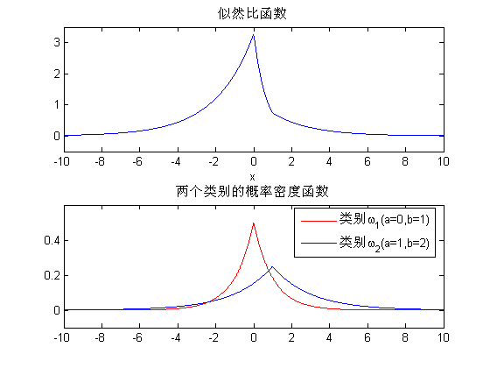
第二章上机题
第1题
function [y] = randn_dc( u , E )
%% RANDN_DC generate a d-component column vector
%% ---------------------------------------------
%% u - the d-component mean column vector
%% E - the d-by-d covariance matrix
%% y - a d-component column vector with mean of u and covariance of E
[A,p] = chol( E );
miu = A'\u;
x = miu + randn(size(miu));
y = A'*x;
%% ch2.1(a).

function [gix] = g_i_x( x, u_i, E_i, P_w_i)
%% Discriminant function for the Normal density
%% --------------------------------------------
%% x - the d-component vector-valued random variable with normal
%% distrbution
%% u_i - the d-component mean vector
%% E_i - the d-by-d covariance matrix
%% P_w_i - the prior probability of w_i
d = length(x);
y = x-u_i;
gix=-0.5*y'*inv(E_i)*y-0.5*d*ln(2*pi)-0.5*ln(det(E_i))+ln(P_w_i);
%% ch2.1(b)

function [ Dist ] = euclidean( x , u_i )
%% EUCLIDEAN calculate the Euclidean norm between two vectors x and u_i
%% ----------------------------------------------------------------------
%% where,
%% x is the sample vectors
%% u_i is the is the d-component mean vector
%% Dist is the Euclidean distance between x and u_i
Dist = norm(x,u_i); %% call the Matlab build-in function
% ch2_1(c)

function [ Maha ] = mahalanobis( x , u , E )
%% MAHALANOBIS calculate the mahalanobis distance between x and u
%% --------------------------------------------------------------
%% where,
%% x is is a d-component column vector
%% u is the d-component mean vector
%% E is is the d-by-d covariance matrix
%% Maha is the mahalanobis distance between x and u
y = x-u;
Maha = sqrt(y'*inv(E)*y);
% ch2_1(d)

第2题
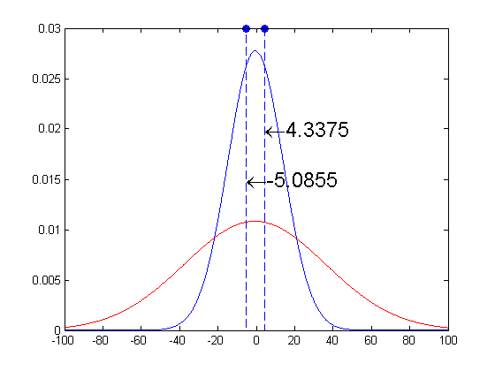
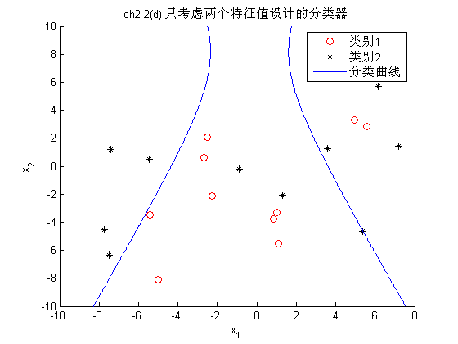
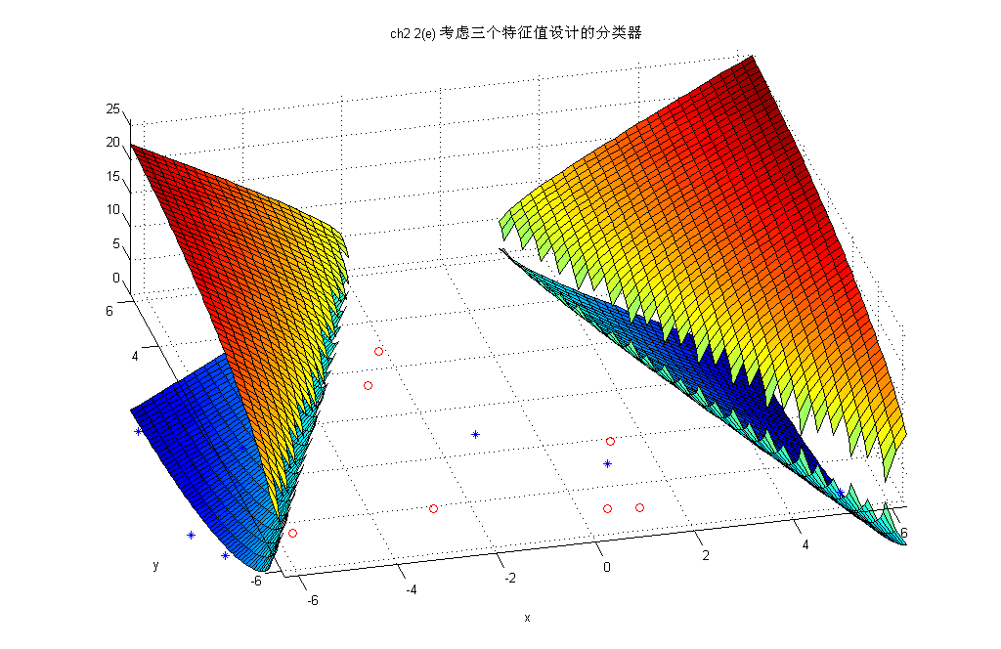
% ch2.2
clear all;
close all;
clc
load ch2data.mat
sig_w1 = var(w1(:,1));
c_w1 = mean(w1(:,1));
P_w1 = .5;
sig_w2 = var(w2(:,1));
c_w2 = mean(w2(:,1));
P_w2 = .5;
x = -100:0.1:100;
y1 = gaussmf(x,[sig_w1, c_w1])/(sqrt(2*pi)*sig_w1); % call the matlab build-in function
y2 = gaussmf(x,[sig_w2, c_w2])/(sqrt(2*pi)*sig_w2); % GAUSSMF Gaussian curve membership function.
plot(x,y1,'b',x,y2,'r');
x0 = ch2_2a(sig_w1 , c_w1 , P_w1, sig_w2 , c_w2 , P_w2);
hold on;stem(x0,[.03 .03],'fill','--');
P_error = ch2_2b(x0,c_w1,sig_w1,c_w2,sig_w2)
[P_error_B] = ch2_2c(P_w1,P_w2,c_w1,c_w2,sig_w1,sig_w2)

%% ch2.2(a)
function [x0] = ch2_2a( sig_w1 , c_w1 , P_w_1, sig_w2 , c_w2 , P_w_2)
E1 = sig_w1;
u1 = c_w1;
W1 = -0.5*inv(E1);
w_1 = inv(E1)*u1;
w10 = -0.5*u1'*inv(E1)*u1 -0.5*log(det(E1)) + log(P_w_1);
E2 = sig_w2;
u2 = c_w2;
W2 = -0.5*inv(E2);
w_2 = inv(E2)*u2;
w20 = -0.5*u2'*inv(E2)*u2 -0.5*log(det(E2)) + log(P_w_2);
f = [(W1-W2) w_1-w_2 w10-w20]; % f=g1-g2
x0 = roots(f);

%ch2_2b.m
function [P_error] = ch2_2b(x0,c_w1,sig_w1,c_w2,sig_w2)
p_error1 = normcdf([x0(1) x0(2)],c_w1,sig_w1);
p_error2 = normcdf([x0(1) x0(2)],c_w2,sig_w2);
P_error=1-(p_error1(2)-p_error1(1)) + (p_error2(2)-p_error2(1));
% ch2_2(c)
function [P_error_B] = ch2_2c(P_w1,P_w2,c_w1,c_w2,sig_w1,sig_w2)
P_error_B = sqrt(P_w1*P_w2)*...
exp( ...
-(1/8*(c_w2-c_w1)'*inv((sig_w1+sig_w2)./2)*(c_w2-c_w1) +...
0.5*log((det(sig_w1+sig_w2)./2)/sqrt(det(sig_w1)*det(sig_w2))))...
);

% ch2.2(d)
clear all;
close all;
clc;
load ch2data.mat
sig_w1 = diag(var(w1(:,1:2)));
c_w1 = mean(w1(:,1:2))';
P_w1 = .5;
sig_w2 = diag(var(w2(:,1:2)));
c_w2 = mean(w2(:,1:2))';
P_w2 = .5;
% % B界误差
[P_error_B] = ch2_2c(P_w1,P_w2,c_w1,c_w2,sig_w1,sig_w2)
% % 符号运算求解求解分类器
W1 = -0.5*inv(sig_w1);
w_1 = inv(sig_w1)*c_w1;
w10 = -0.5*c_w1'*inv(sig_w1)*c_w1 -0.5*log(det(sig_w1)) + log(P_w1);
W2 = -0.5*inv(sig_w2);
w_2 = inv(sig_w2)*c_w2;
w20 = -0.5*c_w2'*inv(sig_w2)*c_w2 -0.5*log(det(sig_w2)) + log(P_w2);
% 符号运算
syms x1 x2
x = [x1; x2];
g1 = transpose(x)*W1*x +w_1'*x + w10;
g2 = transpose(x)*W2*x +w_2'*x + w20;
f = g1-g2;
% % 作图
figure,hold on
plot(w1(:,1),w1(:,2),'ro'),plot(w2(:,1),w2(:,2),'k*')
ezplot(f,[-10 10 -10 10])
title('ch2 2(d) 只考虑两个特征值设计的分类器'),legend('类别1','类别2','分类曲线')

%% ch2 2(e)
clear all
close all
clc
load 'ch2data.mat'
E1 = diag(var(w1));
u1 = mean(w1)';
P_w_1 =.5;
W1 = -0.5*inv(E1);
w_1 = inv(E1)*u1;
w10 = -0.5*u1'*inv(E1)*u1 -0.5*log(det(E1)) + log(P_w_1);
E2 = diag(var(w2));
u2 = mean(w2)';
P_w_2 =.5;
W2 = -0.5*inv(E2);
w_2 = inv(E2)*u2;
w20 = -0.5*u2'*inv(E2)*u2 -0.5*log(det(E2)) + log(P_w_2);
syms x y z
xA = [x;y;z];
g1 = transpose(xA)*W1*xA +w_1'*xA + w10;
g2 = transpose(xA)*W2*xA +w_2'*xA + w20;
func = g1-g2;
s_fz = solve(func,'z');
figure,hold on;
ezsurf(s_fz(1));
ezsurf(s_fz(2));
plot3(w1(:,1),w1(:,2),w1(:,3),'ro');
plot3(w2(:,1),w2(:,2),w1(:,3),'b*');
title('ch2 2(e) 考虑三个特征值设计的分类器');
%% B界误差
[P_error_B] = ch2_2c(P_w_1,P_w_2,u1,u2,E1,E2)

第三章
function [p] = HMM_Forward(aij,bjk,VT,w_init)
% HMM Forward
% ---------------------------------------
% aij is the transition probability array
% bjk is the probability array of the emission of a visible state
% VT is a particular sequence of T visible states
% w_init is the initial state
T = length(VT);
C = size(bjk,1);
alpha = zeros(C,T);
% alpha矩阵有C行T列，C隐状态的数量，T为观察序列的时间长度
% alpha(c,t)表示时间t处处于c隐状态,且发出了t处的观测状态的几率
alphaj0=zeros(C,1);
% w_init=1+1;%初始的隐状态
alphaj0(w_init,1)=1;
for t=1:T;
for c=1:C;
if t==1;
alpha(c,t)=alphaj0'*aij(:,c)*bjk(c,VT(t)+1);
else
alpha(c,t)=alpha(:,t-1)'*aij(:,c)*bjk(c,VT(t)+1);
end
end
end
p=alpha(1,T);
%EOF

function [p] = HMM_Backward(aij,bjk,VT,w_init)
% HMM Backward
% ---------------------------------------
% aij is the transition probability array
% bjk is the probability array of the emission of a visible state
% VT is a particular sequence of T visible states
% w_init is the initial state
T = length(VT);
C = size(bjk,1);
beta = zeros(C,T);
betaT = zeros(C,1);
betaT(VT(T)+1,1)=1;
for t=T:-1:1;
for i=1:C;
if t==T;
%beta(i,t)=aij(i,:)*betaT*bjk(i,VT(t)+1);
beta(i,t)=calcb(aij(i,:),bjk(:,VT(t)+1),VT(t),betaT,T);
else
%beta(i,t)=aij(i,:)*beta(:,t+1)*bjk(i,VT(t)+1);
beta(i,t)=calcb(aij(i,:),bjk(:,VT(t)+1),VT(t),beta(:,t+1),T);
end
end
end
p=beta(w_init,1);
% SubFunction to calculate beta(i,t)
function [b]=calcb(aijrow,bjkcul,VTt,betacul,length_VT)
b=0;
for j=1:length_VT;
b=b+betacul(j,1)*aijrow(1,j)*bjkcul(j,1);
end
% EOF

function [Path]=HMM_decode(aij,bjk,VT,w_init)
% HMM Decode
% ---------------------------------------
% aij is the transition probability array
% bjk is the probability array of the emission of a visible state
% VT is a particular sequence of T visible states
% w_init is the initial state
% Note: WT ,w_init and Path's indexes are both begin with 0
T = length(VT);
C = size(bjk,1);
alpha = zeros(C,T);
% alpha矩阵有C行T列，C隐状态的数量，T为观察序列的时间长度
% alpha(c,t)表示时间t处处于c隐状态,且发出了t处的观测状态的几率
alphaj0=zeros(C,1); % w_init%初始的隐状态
alphaj0(w_init+1,1)=1;
for t=1:T;
for c=1:C;
if t==1;
alpha(c,t)=alphaj0'*aij(:,c)*bjk(c,VT(t)+1);
else
alpha(c,t)=alpha(:,t-1)'*aij(:,c)*bjk(c,VT(t)+1);
end
end
end
[temp Path] = max(alpha);
Path = Path - 1;
% EOF

% Sample 3
% Page 109
clear all
clc
load Sample3.mat
w0=1+1;
pF=HMM_Forward(aij,bjk,VT,w0)
pB=HMM_Backward(aij,bjk,VT,w0)
OUTPUT：
pF =0.0011
pB =0.0011
% Sample 4 - HMM decode
% Page 111
clear all
close all
clc
load Sample3
VT=[ 1 3 2 0];
VT=VT;
Path=HMM_decode(aij,bjk,VT,1)
OUTPUT:
Path = 3 2 1 0

第四章
function [w,a] = PNN_Training(x,Tc,c)
% 输入：
% x 为样本矩阵，每列代表一个样本
% c 为类别数量
% Tc 是x样本矩阵中每个样本所属的类别的矩阵
[m,n] = size(x);
a = zeros(n,c);
w = zeros(size(x));
for j=1:n;
tempcol=x(:,j);
tempnorm=norm(tempcol);
if abs(tempnorm)<1e-6
x(:,j)=zeros(m,1);
else
x(:,j)=tempcol./tempnorm;
end
w(:,j)=x(:,j);
a(j,Tc(j))=1;
end

function [class]=PNN_Classification(w,a,x,delta)
%% Probabilistic Neural Network Classification
% delta : a parameter set by user and determines the width of the effective Gaussian window
% w and a are generated by PNN_Training function
% x is the data to be classificated
[m,n]=size(x);
calss=zeros(1,n);
for i=1:n;
class(i)=subf_PNN_Classifiction(w,a,x(:,i),delta);
end
return
%% SubFunction
function [class]=subf_PNN_Classifiction(w,a,x,delta)
deltapow=delta.^2;
n_x=norm(x);
if abs(n_x)<1e-6
x=zeros(size(x));
else
x=x/n_x;
end
[n,c]=size(a);
g = zeros(1,c);
for k=1:n;
netk=w(:,k)'*x;
g(find(a(k,:)))=g(find(a(k,:)))+exp((netk-1)/(deltapow));
end
[maxv,class] = max(g);
% EOF

function [p]=kn_nearest_neighbor_estimation_1D(x,k,myaxis)
p = zeros(size(myaxis));
r=0;stepdist=myaxis(2)-myaxis(1);
n=length(x);
for i=1:length(myaxis)
r=0;
kn=howmanyin(x,myaxis(i),r);
while kn<k
r=r+stepdist;
if r>myaxis(length(myaxis))-myaxis(1)
break;
end
kn=howmanyin(x,myaxis(i),r);
end
Vn=r*2;
p(i)=(kn/n)/Vn;
end

第五章
% ch5_2(a)
% 使用批处理感知器算法以w1和w2为训练数据进行训练
% Algorithm 3 : batch perceptron
clear all
close all
clc
load ch5data
y = [ [ones(1,10);w3'] , -[ones(1,10);w2'] ];
Yset = [];
a = zeros(size(y,1),1);
eta = 0.1;
theta = 0.001;
k = 1; % 第一个循环
Yset = updateYset( y ,a );
ysum = sum(Yset,2);
a = a + eta*ysum;
while norm(eta*ysum)>theta
k=k+1;
Yset = updateYset(y,a);
if isempty(Yset)
ysum=zeros(size(y,1),1);
else
ysum = sum(Yset,2);
end
a = a + eta*ysum;
end
disp(strcat('循环次数k=', num2str(k)))
disp('解向量是'),a

% 算法4 : 固定增量单样本感知器
% Algorithm 4 : fixed-increment single sample perceptron
clear all
close all
clc
load ch5data
y = [ [ones(1,10);w1'] , ...
-[ones(1,10);w2'] ];
a = [ 0 0.1 .1]';
n = size(y,2);
k = -1;
while isempty(find(a'*y<0)) == 0
k = mod(k+1,n);
if a'*y(:,k+1)<0
a = a + y(:,k+1);
end
end
disp('solution vector is '),a

% 算法5 : 带裕量的变增量感知器
% Algorithm 5 : variable-increment perceptron with margin
clear all
close all
clc
load ch5data
y = [ [ones(1,10);w1'] , ...
-[ones(1,10);w2'] ];
a = [ 0 0 .1]';
n = size(y,2);
k = -1;
b = .1; % 裕量
eta = 1;
while ~isempty(find(a'*y<b))
k = mod(k+1,n);
if a'*y(:,k+1)<0
a = a + eta*y(:,k+1);
eta = updateeta();
end
end
disp('solution vector is '),a

% 算法6 : 批处理变增量感知器
% Algorithm 6 : batched increment perceptron
clear all
close all
clc
load ch5data
y = [ [ones(1,10);w1'] , ...
-[ones(1,10);w2'] ];
a = [ 0 0 0]';
n = size(y,2);

k = 1; % 第一个循环
Yset = updateYset( y ,a );
ysum = sum(Yset,2);
eta = .1;
a = a + eta*ysum;
while ~isempty(Yset)
% k=k+1;
Yset = updateYset(y,a);
if isempty(Yset)
ysum=zeros(size(y,1),1);
else
ysum = sum(Yset,2);
end
eta = updateeta();
a = a + eta*ysum;
end
disp('解向量是'),a

% 算法8 : 批处理裕量松弛算法
% Algorithm 8 : batch margin relaxtion procedure
clear all
close all
clc
load ch5data
y = [ [ones(1,10);w3'] , ...
-[ones(1,10);w2'] ];
a = [ 0.1 0.1 0.1]';
n = size(y,2);
b = .1;
Yset = updateYset( y ,a , b );
ysum = alg8Ysetsum(Yset,a,b);
eta = 1;
a = a + eta*ysum;
while ~isempty(Yset)
% k=k+1;
Yset = updateYset(y,a,b);
if isempty(Yset)
ysum=zeros(size(y,1),1);
else
ysum = alg8Ysetsum(Yset,a,b);
end
eta = updateeta();
a = a + eta*ysum;
end
disp('解向量是'),a

% 算法9 : 单样本裕量松弛算法
% Algorithm 9 : single sample margin relaxation procedure
clear all
close all
clc
load ch5data
y = [ [ones(1,10);w1'] , ...
-[ones(1,10);w3'] ];
a = [ 0 1 .1]';
n = size(y,2);
k = -1;
eta = 1;
b = 0.1;
while ~isempty(find(a'*y<b))
k = mod(k+1,n);
if a'*y(:,k+1)<b
a = a + eta*(b-a'*y(:,k+1))/(norm(y(:,k+1)).^2)*y(:,k+1);
end
end
disp('solution vector is '),a

% Written for course Pattern Recognition
% Written under the guidance of
% "Pattern Classification" 2nd Edition
% R. O. Duda, P. E. Hart, D. G. Stork
% John Wiley & Sons , New York ,2001

%% Copyright (c) 2007 , RenWei , Xidian UNIV.
% $ Revision : 1.0 (just to give it a professional look) $
% $ http://blog.csdn.net/wadefelix (Welcome! You can Email me there) $

