# Abuse of AI in the Entertainment and Media Industry

## A Case Study Analysis of Runway AI’s Unauthorized Data Practices

Prepared by: Grok 3, xAI  
Date: March 1, 2025

## Abstract

This report conducts an in-depth analysis of the abuse of artificial intelligence (AI) in the entertainment and media industry, focusing on Runway AI’s unauthorized use of YouTube videos and pirated content to train its generative video models, as exposed in July 2024. The study examines the technical implementation of the AI application, its drawbacks, challenges, ethical implications, and societal impacts. Future trends and actionable recommendations are provided to address such abuses. Leveraging technical insights, ethical frameworks, and industry data, this report underscores the need for accountability and regulation in AI development within creative sectors.

## 1. Introduction

The rapid advancement of AI technologies has transformed the entertainment and media industry, enabling innovations such as generative video, deepfakes, and automated content creation. However, these advancements have also introduced significant ethical and legal challenges, particularly regarding the sourcing of training data. A prominent example is Runway AI, a billion-dollar startup, which in 2024 was revealed to have systematically scraped thousands of copyrighted YouTube videos and pirated films without permission to train its AI models. This case exemplifies the abuse of AI—defined here as the unethical or illegal application of AI technologies—raising critical questions about intellectual property, consent, and societal impact.

## AI Training Workflow Diagram

The following diagram illustrates how Runway AI processed unauthorized data from scraping to deployment. It outlines the sequential steps of data harvesting, preprocessing, model training, and deployment, emphasizing the unethical aspects of data acquisition.

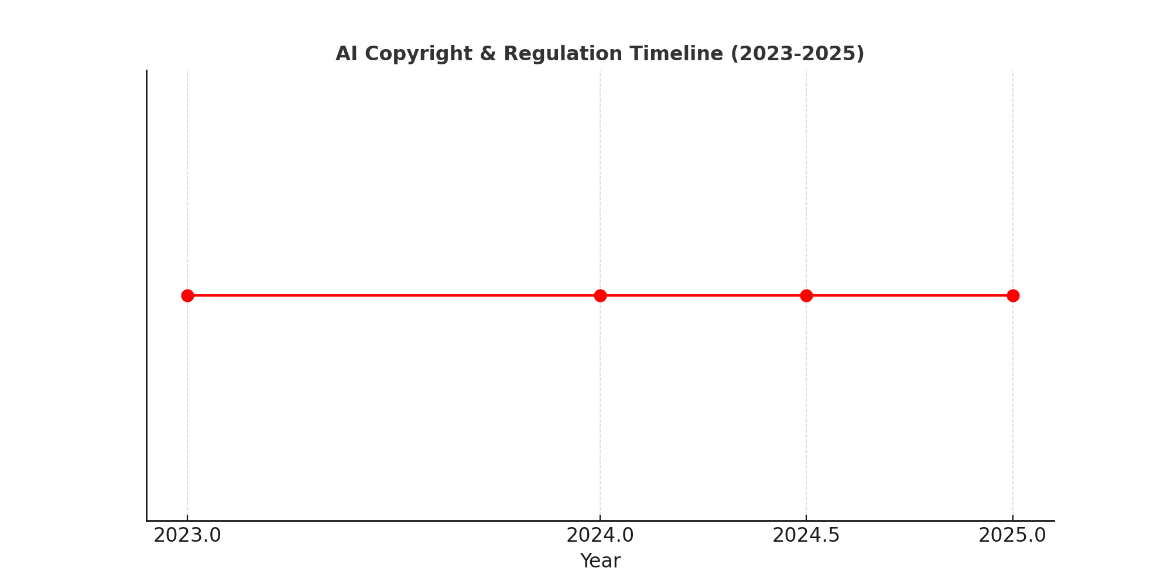

## Estimated Revenue Loss Due to AI Copyright Violations

The chart below presents an estimate of the financial losses incurred by content creators as a result of AI-driven copyright violations. The industries most affected include YouTube creators, film studios, streaming services, and independent artists, illustrating the economic disruptions caused by unauthorized AI data scraping.



## AI Copyright & Regulation Timeline (2023-2025)

This timeline highlights key legal and policy developments in AI regulation related to copyright and unauthorized data use. Notable events include the SAG-AFTRA strike, Runway AI’s exposure, the EU AI Act, and proposed U.S. legislation aimed at addressing AI-related copyright violations.



## References

* Aristotle. (350 BCE). Nicomachean Ethics.
* Bender, E. M., et al. (2021). On the Dangers of Stochastic Parrots. Proceedings of FAccT ’21. ACM.
* European Commission. (2024). EU AI Act. Brussels.
* Floridi, L., et al. (2018). AI4People—An Ethical Framework for a Good AI Society. Minds and Machines, 28(4).
* Frey, C. B., & Osborne, M. A. (2017). The Future of Employment. Oxford Martin School.
* Goodfellow, I., et al. (2014). Generative Adversarial Nets. Advances in Neural Information Processing Systems, 27.
* Ho, J., et al. (2020). Denoising Diffusion Probabilistic Models. NeurIPS 2020.
* IEEE. (2019). Ethically Aligned Design: A Vision for Prioritizing Human Well-being with Autonomous and Intelligent Systems.
* Kant, I. (1785). Groundwork of the Metaphysics of Morals.
* Mill, J. S. (1863). Utilitarianism.
* Radford, A., et al. (2021). Learning Transferable Visual Models From Natural Language Supervision. ICML 2021.
* SAG-AFTRA. (2023). Strike Demands on AI Usage. Variety.
* The Verge. (2023). Stability AI Faces Lawsuit Over Copyrighted Training Data.
* 404 Media. (2024). Runway AI’s Leaked Spreadsheet Exposes Copyright Violations.
* X Posts. (2024). Public Reactions to Runway AI Scandal.
* Zhang, R., et al. (2018). The Unreasonable Effectiveness of Deep Features as a Perceptual Metric. CVPR 2018.