All RSS Feed configurations are done in Alma.

For complete RSS feed documentation in the Ex Libris Customer Center, see:

<http://customercenter.exlibrisgroup.com/DocumentationCenter/Ex%20Libris%20Documentation/Alma/OLH/index.html#page/Resource%2520Management/ALM_res_mgt_configuration_RSS.html>

**RSS Quick Start Instructions**

1. First, under **General Configuration / Configuration Menu / General Configuration / Other Settings**, set the **rss_discovery_url** variableto:

http://alliance-primo.hosted.exlibrisgroup.com/primo_library/libweb/action/dlSearch.do?institution=*01ALLIANCE_UPUGS*&vid=*UPUGS*&tab=default_tab&indx=1&bulkSize=10&query=any,contains,@@ALMA_IND@@&search_scope=*upugs_alma*

Be sure to change the institutionally-specific values in the URL, shown in *italics* above, to values relevant to your institution.

1. Next, create a logical set of physical items, **under Resource Management / Search and Sets / Manage Sets**. This set of items will be the items that your RSS feed will draw from. You can play with different selection criteria. Here is an example of some basic conditions to select recent books:

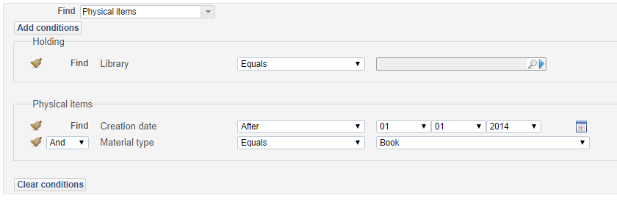

1. Then, create an RSS Publishing Profile, under **Resource Management / Configuration Menu / Publishing Profiles**. This publishing profile will select items from a specific managed set, for inclusion in the RSS feed to be published.
   * Note that **RSS feed name** should not include any spaces.
   * The **Set Name** refers to the managed set you want to publish from.
   * **Max number of days ago** refers to how far back you want to pull items from, based on the “received date” of the physical item. **Min number of days ago** refers to how recently an item to be selected might have been received, again based on physical item receive date. So, a value set of **30** and **2** would select books from the managed set received between 2 and 30 days ago.
   * You can schedule the feed to run and update on a regular basis, using the **Scheduling** parameter.

Here is an example of a basic RSS publishing profile:

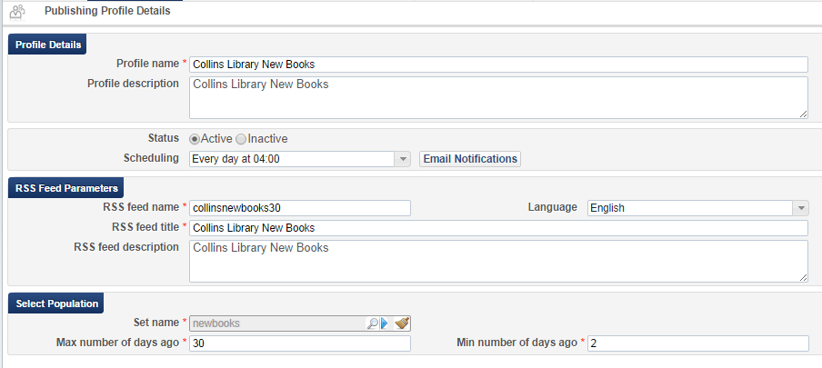

1. Once the profile is created, run the publishing profile to generate the initial RSS feed. If you set a **Scheduling** value, the profile will run automatically at the set interval.
2. You can test your resulting RSS feed at the published URL for the feed, which will use the following pattern:

https://na01.alma.exlibrisgroup.com/rep/getFile?institution_code=*01ALLIANCE_UPUGS*&file=*collinsnewbooks30*&type=rss

where the institution_code parameter is set to the code of your institution, and file parameter is set to the RSS feed name you assigned when you set up the publishing profile.

The output should look similar to the following:

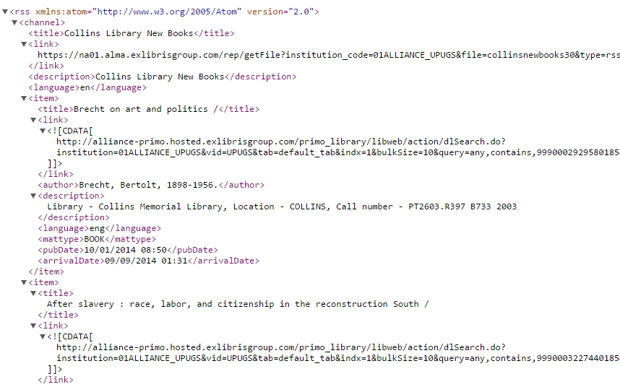

For complete Alma RSS feed documentation in the Ex Libris Customer Center, see:

<http://customercenter.exlibrisgroup.com/DocumentationCenter/Ex%20Libris%20Documentation/Alma/OLH/index.html#page/Resource%2520Management/ALM_res_mgt_configuration_RSS.html>