Individual differences in circadian rhythms measured at a global scale
Alex R Wade
2026-06-05
Abstract
Human cognition and physical performance vary across the day, and individuals differ systematically in when they peak: the morning-preferring “larks” and evening-preferring “owls” of chronotype research. We asked whether these rhythms appear in large-scale behavioral traces from ranked League of Legends matches. Using ~92.7 million games drawn from the top ~1,000 players on each of 8 regional servers, we built per-player hourly time series of in-game behavior (two principal components of performance, PC1 and PC2) and of a skill-outcome measure (the change in matchmaking rating, ΔMMR). Play volume is governed by local time: correcting each server by its fixed UTC offset collapses the eight play-volume curves onto one evening-peaked schedule, cutting the across-server spread in mean play hour from 5.83 h to 1.12 h. Within-subject Lomb–Scargle periodograms revealed a sharp circadian peak: across servers the N-weighted best period was 23.96 h for PC1 and 23.94 h for PC2, and the population playtime periodogram peaked at exactly 24.0 h on every server. Per-player peak phases were individually significant for 21.4% of players on PC1 and 18.5% on PC2. Pooling these significant phases, a two-component von Mises mixture was preferred over a single component by both BIC and AIC for PC1 and PC2. Parametric-bootstrap likelihood-ratio tests supported both comparisons, a quantitative signature of two chronotype-like clusters. In contrast, ΔMMR carried essentially no circadian signal (0.3% of players FDR-significant; no server reached the threshold for a modality test). Behavior is strongly time-of-day structured and bimodally so, consistent with larks and owls; competitive success is not. We discuss implications for digital behavior research, including how temporal self-selection and platform ecology can shape observed performance patterns.

1. Introduction
Almost every measured aspect of human physiology and behavior oscillates with a period of approximately 24 hours, driven by an endogenous circadian clock that is entrained to the local light–dark cycle [1]. These rhythms reach into cognition: attention, working memory, reaction time and executive control all show reliable time-of-day modulation [2]. But the phase of these rhythms differs between people. The morningness–eveningness dimension (colloquially “larks” versus “owls”) is a stable trait [3, 4], and the distribution of chronotypes in a population is broad and roughly continuous [5].
Chronotype matters for performance. When the timing of a demanding task is misaligned with a person’s internal clock (social jet lag), outcomes suffer. Using 3.4 million learning-management-system logins, [6] showed that the majority of students are chronically misaligned with their class schedules and that greater misalignment predicts lower grades. In elite sport, [7] found that an athlete’s peak performance time tracks their circadian phenotype, with intra-day swings as large as ~26%. In gamers with gaming disorder, eveningness has been linked to disrupted sleep and higher gaming-disorder risk [8], and competitive performance in esports is a structured, trainable skill set rather than mere reflex [9].
Online competitive gaming is also a large-scale setting for observing human behavior under recurring demands, social coordination, and feedback-driven self-regulation. Millions of timestamped, standardized, skill-graded matches are played around the clock, across the globe, by the same individuals over months. If circadian structure shapes behavior, it should be legible in this telemetry. League of Legends (LoL), a five-versus-five multiplayer game operated on geographically separated regional servers, is well suited to this question: each server has a known local time zone, allowing matches to be aligned to local hour, and matchmaking continuously updates each player’s skill estimate.
We test three questions:
- Existence. Do individual players show ~24 h rhythms in their in-game behavior?
- Bimodality (larks vs owls). If rhythms exist, is the population of peak times bimodal (clustering into morning-peaking and evening-peaking groups) rather than a single mode?
- Consequence. Does the outcome of play (skill change, ΔMMR) carry the same circadian signature as behavior, or is success time-invariant?
This design lets us separate rhythmicity in behavioral expression (how people play) from rhythmicity in competitive outcomes (whether they gain rating), a distinction central to digital behavior research where performance metrics are partly shaped by platform rules.
We address these with a within-subject spectral analysis of ~8,000 high-ranked players, replicated independently across 8 servers and combined by an N-weighted meta-analysis.

2. Methods

2.1 Data provenance and aggregation
The analysis reuses the large longitudinal League of Legends cohort provided by Riot Games and described by Aung et al. [10] and Vardal et al. [11]. Its defining feature is the sampling design: a random sample of players who registered new accounts at the start of a competitive season (accounts with no prior ranked history), followed across one entire season (21 January to November 2016) of default five-versus-five ranked Solo/Duo-queue play. Because every account enters ranked play at the same default matchmaking rating and is then observed continuously, the cohort offers an unusually clean within-subject view of each player’s full activity and skill trajectory, the property our within-player periodogram and ΔMMR analyses depend on. Each match row carries the per-minute performance fields we reduce by PCA together with the player’s pre-match rating, from which ΔMMR is derived. The same data lineage underpins prior work on this cohort: early-season learning rate predicts end-of-season skill [10], and the temporal spacing of practice (rather than its timing) shapes performance gains [11].
Riot Games supplied the raw match records as CSV files, which we loaded into a columnar store and queried through an embedded DuckDB analytical database [12], from which we materialized an hourly aggregate table. The specific on-disk format is incidental to the analysis. We analyzed the eight regional servers used by the source-dataset papers [10, 11]: BR1, EUN1, EUW1, JP1, LA1, LA2, NA1 and OC1, together contributing ≈92.7 million ranked games; the remaining platforms (ID1, TR1 and the PBE1 public-beta realm) were excluded as small or unreliable. For each server we selected the top_n_players = 1000 most active accounts and retained the first max_hour_limit = 5000 hours (~208 days) of each player’s history to bound edge effects. Each match timestamp was converted to the server’s local hour using a fixed per-server UTC offset, so that “9 a.m.” means the same wall-clock experience on every server.
To check that this conversion does what it claims, we counted the analyzed cohort’s games in each hour of the day, per server, in UTC and in local time (9.55 million games). We summarized each server’s schedule by the circular mean of its game-weighted play hour, measured the across-server circular standard deviation of those means before and after the offset, and regressed each server’s mean UTC play hour on its UTC offset. A common local schedule predicts a slope of −1 and a collapse in the across-server spread (Section 3.1).

2.2 Behavioral features and principal components
We derived seven rate features per game (gold, damage dealt, kills, deaths, assists, neutral creeps and enemy creeps, each per minute), plus the fraction of time spent dead. Population-level hourly features were standardized and reduced by sign-oriented principal component analysis (SVD); per-game player records were then projected onto this fixed basis so that every player is scored on a common set of axes. The first two components dominate:
- PC1 (≈62% of variance) loads positively on all activity features, a general in-game output / engagement intensity axis (high PC1 = a busy, high-tempo game).
- PC2 (≈19% of variance) contrasts farming/economy (creeps, gold) against time spent dead, an economy-versus-attrition axis.
A complementary “success-aware” PCA that included win rate was computed for descriptive comparison. As a direct skill-outcome metric we also computed ΔMMR, the within-player change in matchmaking rating from one game to the next.

2.3 Within-subject periodograms
For each player and each metric (PC1, PC2, ΔMMR) we placed the game-level scores on their irregular real-time stamps and computed a Lomb–Scargle periodogram [13, 14] over periods of 6–48 h (player_n_freq = 2000 frequencies) using astropy.timeseries.LombScargle [15, 16]. The Lomb–Scargle estimator is appropriate here because match times are unevenly spaced. The (evenly spaced) frequency grid is anchored so that exactly 24 h is a grid node, allowing a true circadian peak to be reported at 24.0 h rather than snapping to a neighboring bin. Per-player periodograms were then incoherently averaged within each server–metric cell (averaging power, which is phase-blind), and the period of maximum mean power was recorded as that cell’s best period. A population-level periodogram of raw activity (TIMEPLAYED) was computed analogously over 6–48 h.

2.4 Phase estimation and multiple-testing control
To locate when in the day each player peaks, we fitted a fixed 24 h sinusoid by ordinary least squares to each player’s series, converted the fitted lag to a local peak hour in $[0,24)$, and tested the joint significance of the sinusoid. Across the players in each server–metric cell, the resulting $p$-values were corrected with the Benjamini–Hochberg false-discovery-rate procedure [17] at $α=0.05$. Only FDR-significant peak phases entered the modality analysis.

2.5 Circular modality: one versus two chronotypes
Peak hours are circular. For each server–metric cell with at least 20 FDR-significant phases we fitted two circular models to the phases (expressed as angles) [18–20]:
- a one-component von Mises distribution (mean direction $μ$ and concentration $κ$ estimated from the resultant length); and
- a two-component von Mises mixture fitted by expectation–maximization.
For each fit we report the fitted log likelihood and compare models by both the Akaike Information Criterion (AIC) [21] and Bayesian Information Criterion (BIC) [22], charging 2 free parameters to the one-component fit and 5 to the mixture: $\text{AIC}=2k−2logL$ and $\text{BIC}=klogn−2logL$. Positive $Δ\text{AIC}={\text{AIC}}_{1}−{\text{AIC}}_{2}$ and $Δ\text{BIC}={\text{BIC}}_{1}−{\text{BIC}}_{2}$ favor two components.
Because the usual chi-squared likelihood-ratio reference distribution is not valid for finite-mixture comparisons, we assessed the final pooled likelihood improvement with a parametric bootstrap. For each metric, we generated 1,000 datasets of the observed size from its fitted one-component model, refitted both models, and compared the simulated likelihood-ratio statistics with the observed statistic. We used the add-one correction $p=\left(r+1\right)/\left(B+1\right)$, where $r$ is the number of bootstrap statistics at least as large as observed and $B=1,000$.
We report both a per-server tally and a final pooled fit that aggregates significant phases across servers (using only cells with ≥20 phases). As an assumption-light companion, we also summarized the same phases with phase-count-weighted circular kernel density estimates ($κ=4$).

2.6 Across-server meta-analysis and quality control
All headline numbers are N-weighted across servers: period peaks are weighted by the number of valid players, phase fractions by players analyzed, and population metrics by games played. Implementation used NumPy [23], SciPy [24], pandas [25] and Matplotlib [26].
 Outlier handling
Two server-level period estimates (both from JP1) were clear outliers and were excluded from the period meta-analysis: its ΔMMR peak (44.4 h, an implausible near-double of the circadian period) and its PC1 peak (8.0 h, a flip onto the third harmonic of the daily cycle). Outliers were flagged within each metric by a median/MAD modified $z$-score (|z| > 3.5) combined with an absolute-deviation gate (> 3 h from the median); the gate keeps genuine near-circadian values (peaks one or two grid bins either side of 24 h) while still catching harmonics and long-period artifacts, and it also decides the case where the 24 h-anchored grid collapses the MAD to zero by placing most servers on the same bin. After exclusion PC1 and ΔMMR rest on 7 servers / 7,000 players each; PC2 retains all 8.

3. Results

3.1 Play volume is set by local time, not UTC
The clearest daily signal in the data is how much people play, and local time governs it. Each server spreads its games unevenly across the day, with a deep trough in the small hours and a broad evening peak carrying 6–10% of that server’s games in each hour (Figure 1). Plotted against UTC, the eight curves are displaced from one another in time-zone order, from OC1 (UTC+10) on the left to LA1 (UTC−6) on the right. Applying the fixed per-server UTC offset collapses them onto one evening-peaked schedule: the across-server circular standard deviation of the mean play hour falls from 5.83 h in UTC to 1.12 h in local time, and the pooled local mean play hour is 19.1 h.
The displacement is the time zone and nothing else. Regressing each server’s mean UTC play hour on its UTC offset gives a slope of −0.92 (r = −0.98), against the −1 predicted if every server keeps the same local schedule. Two features of the exposure schedule are operational rather than behavioral: JP1 records almost no play between 05:00 and 11:00 local, and LA1 and LA2 each lose a single hour, at 03:00–04:00 and 06:00–07:00 local respectively, which are the same hour (09:00–10:00) in UTC. Fixed-UTC gaps are daily server maintenance, not sleep. JP1’s seven-hour gap is what pulls the slope away from −1; excluding JP1 the slope is −0.99 (r = −0.98) and the local-time standard deviation falls to 0.94 h.
Local hour is therefore the meaningful axis for everything that follows, and the rhythms reported below cannot be inherited from pooling servers in the wrong time frame. The residual across-server spread of 1.12 h bounds how much of any phase structure a time-zone error could manufacture, which is far smaller than the ~14 h separating the two behavioral modes reported in Section 3.4.
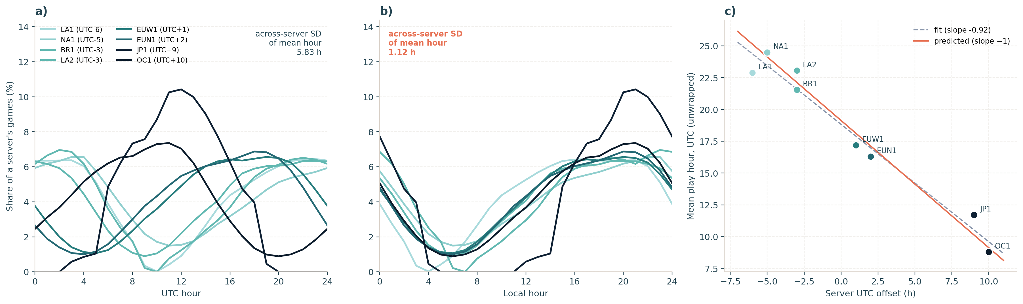
Figure 1: Play volume by hour of day on the eight servers (9.55 million games from the 8,000 analyzed players). (a) Share of each server’s games falling in each UTC hour; servers are colored by UTC offset (light = west, dark = east) and the curves are displaced in time-zone order. (b) The same curves against local hour, after the fixed per-server UTC offset, collapsing onto a common evening-peaked schedule. (c) Each server’s mean UTC play hour against its UTC offset; the fitted slope (−0.92) sits close to the −1 expected if all servers keep the same local schedule (solid line, drawn through the pooled local mean of 19.1 h). JP1’s flat interval at 05:00–11:00 local, and the single missing hour on LA1 and LA2 (both 09:00–10:00 UTC), are daily server-maintenance windows rather than behavior.

3.2 Behavior is rhythmic; success is not
Within-subject periodograms show a sharp circadian peak for behavior and only noise for outcome. For a single representative server (NA1), PC1 and PC2 each produce a clean spike at ~24 h above a flat background, whereas ΔMMR yields a broad, low, ragged spectrum with no dominant period (Figure 2).
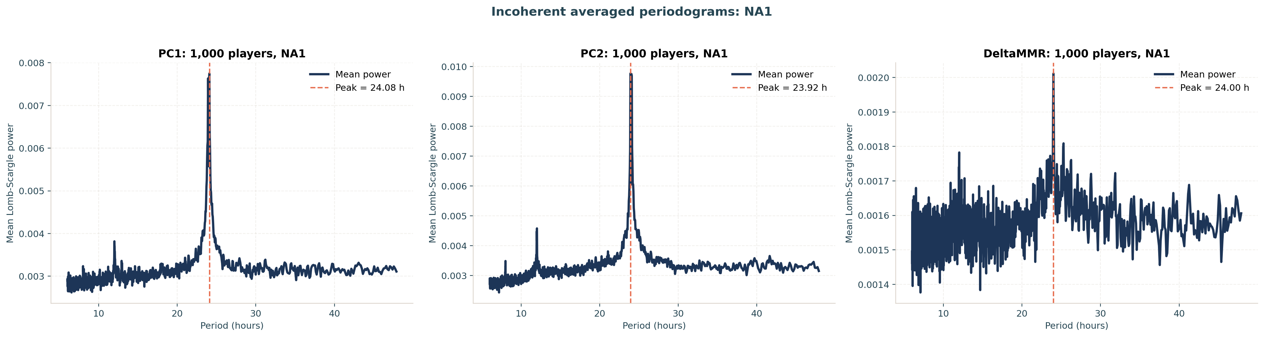
Figure 2: Incoherently averaged within-subject Lomb–Scargle periodograms for one server (NA1, 1,000 players). PC1 (left, peak 24.08 h) and PC2 (center, 23.92 h) show sharp circadian spikes above a flat background; ΔMMR (right) is a weak, noisy spectrum with peak power roughly an order of magnitude smaller, its nominal 24.00 h peak barely rising above the noise.
This pattern is consistent across all servers. The N-weighted best period is 23.96 h for PC1 (SEM 0.029) and 23.94 h for PC2 (SEM 0.020), both indistinguishable from 24 h, with small between-server scatter; the ΔMMR peak averages exactly 24.00 h (after removing the JP1 outlier) but rests on a far weaker peak (Table 1).
Table 1: N-weighted within-subject best periods.
Metric | Servers | Players | Best period (h) | SEM (h)
PC1 | 7 | 7,000 | 23.96 | 0.029
PC2 | 8 | 8,000 | 23.94 | 0.020
ΔMMR | 7 | 7,000 | 24.00 | 0.015

The fraction of individually FDR-significant players tells the same story: 21.4% of players have a significant ~24 h rhythm in PC1 and 18.5% in PC2, but only 0.3% do in ΔMMR (26 of 8,000 players). Behavior is strongly clock-locked; the outcome of competition is essentially clock-agnostic.
For reference, the population-level periodogram of raw activity (TIMEPLAYED) behaves as expected: with the 24 h-anchored grid it peaks at exactly 24.0 h on every one of the eight servers.

3.3 What the components mean
The N-weighted PCA loadings (Figure 3) confirm this reading: PC1 loads positively on every activity feature (an overall output/engagement axis), while PC2 separates farming and economy from time spent dead. The success-aware decomposition (lower panel) places only a modest positive win-rate loading on its leading component (N-weighted 0.29), reinforcing that the dominant behavioral axes describe how a game is played rather than whether it is won.
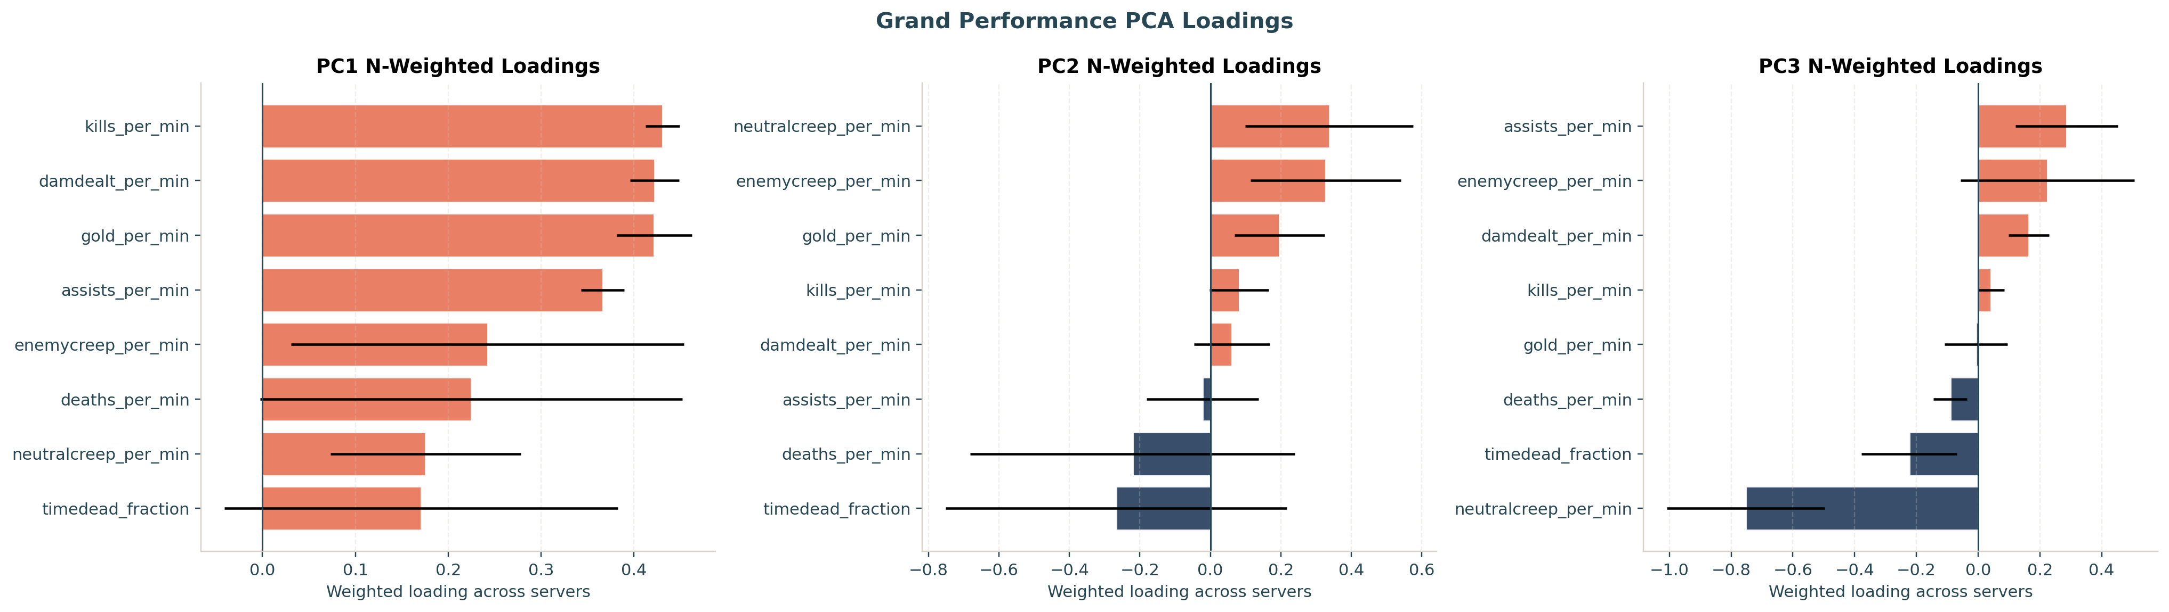
(a) Performance PCA: PC1 is an all-positive output/engagement axis (~62% variance); PC2 contrasts economy against time-dead (~19%).

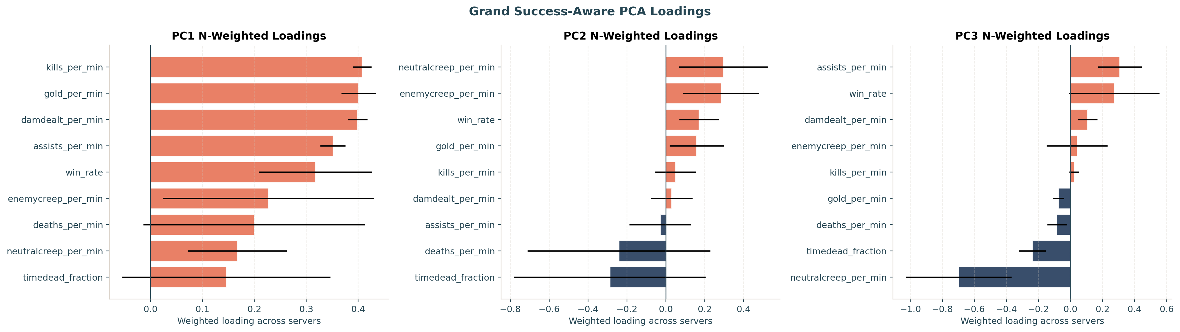
(b) Success-aware PCA (win rate included): win rate loads only modestly on the leading components.

Figure 3: N-weighted PCA loadings across servers; whiskers show between-server spread.

3.4 Two chronotypes: the peak-phase distribution is bimodal
The central question is the shape of the peak-time distribution. Pooling all FDR-significant phases and comparing circular models, both behavioral components prefer a two-component von Mises mixture (Figure 4, Table 2):
- PC1: the two-component fit improved the log likelihood from −3,112.0 to −3,092.2 ($Δ\text{AIC}=33.6$; $Δ\text{BIC}=17.2$; likelihood ratio = 39.6). None of 1,000 one-component-null bootstrap samples matched this improvement ($p<.001$). Its peaks were 21.5 h and 7.1 h (weights 0.57 / 0.43): an evening-peaking “owl” cluster and a morning-peaking “lark” cluster of nearly equal size.
- PC2: the log likelihood improved from −2,675.8 to −2,650.7 ($Δ\text{AIC}=44.3$; $Δ\text{BIC}=28.4$; likelihood ratio = 50.3), again with zero of 1,000 null-bootstrap exceedances ($p<.001$). Its peaks were 9.4 h and 19.9 h (weights 0.65 / 0.35): again a morning and an evening mode.
ΔMMR could not be tested for modality at all: no server reached the 20-significant-phase threshold, so the pooled ΔMMR cell is empty.
Table 2: Pooled circular bimodality test on FDR-significant peak phases. The bootstrap $p$-values use the add-one correction; zero of 1,000 null replicates exceeded either observed likelihood-ratio statistic.
Metric | Phases | log L 1 | log L 2 | AIC 1 | AIC 2 | BIC 1 | BIC 2 | Bootstrap $p$
PC1 | 1,713 | −3,112.0 | −3,092.2 | 6,227.9 | 6,194.3 | 6,238.8 | 6,221.6 | <.001
PC2 | 1,465 | −2,675.8 | −2,650.7 | 5,355.7 | 5,311.4 | 5,366.2 | 5,337.8 | <.001
ΔMMR | 0 | n/a | n/a | n/a | n/a | n/a | n/a | n/a

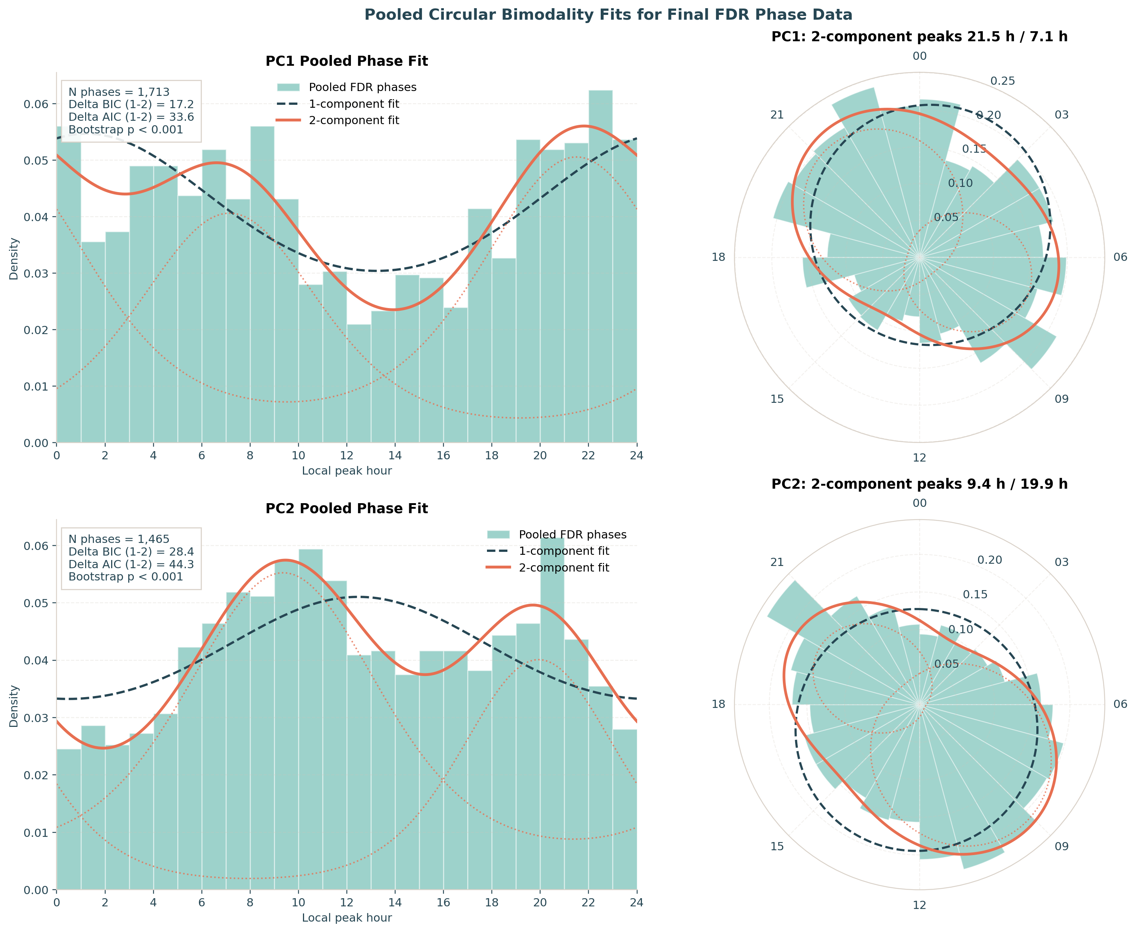
Figure 4: Pooled circular bimodality fits. For PC1 (top) and PC2 (bottom): histograms of FDR-significant local peak hours with the one-component fit (dashed) and two-component mixture (solid; dotted components), shown in both hour-domain (left) and polar (right) views. Both metrics show two clear modes (a morning and an evening cluster), and the mixture is preferred by BIC and AIC, with parametric-bootstrap $p<.001$.
The per-server tally is consistent: across servers, FDR-significant PC1 phases split 816 (one-component-preferred) to 897 (two-component-preferred) and PC2 704 to 761: a majority of server-level phases independently favor the two-cluster description, which is what produces a decisive pooled preference once power is aggregated.
An assumption-light kernel-density view (Figure 5) reproduces the same landscape: the phase-count-weighted circular density of PC1 peaks concentrates around the late evening (weighted peak 22.4 h) while PC2 peaks in the morning (9.8 h), each with a secondary lobe, the smooth-density counterpart of the two-component fits.
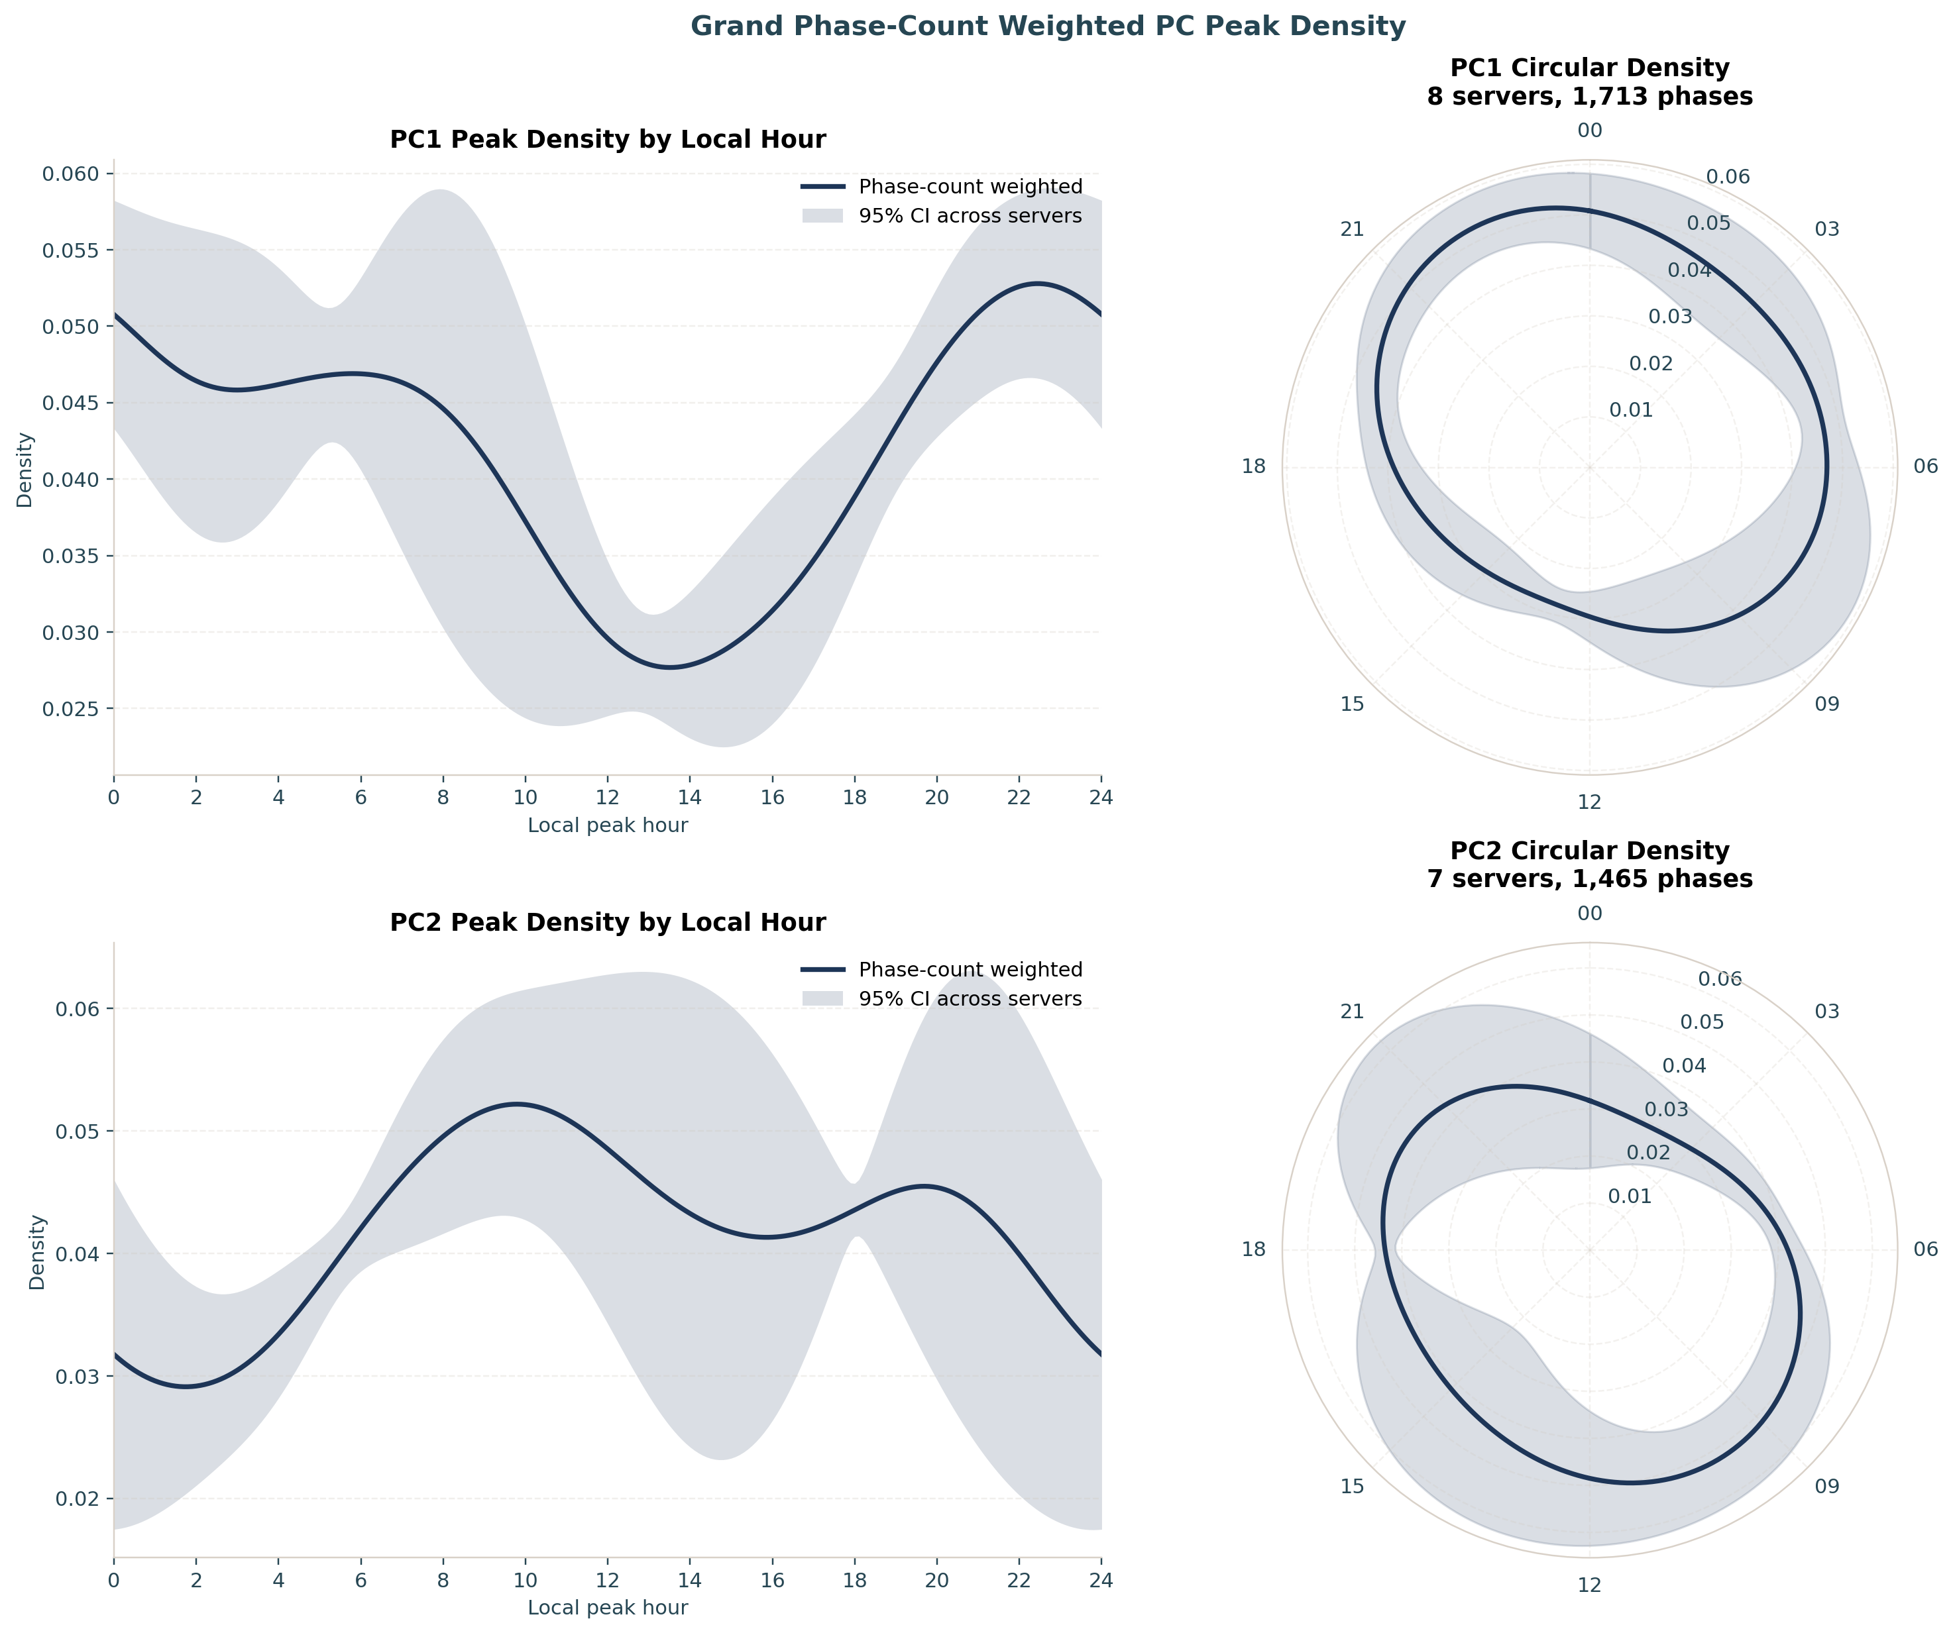
Figure 5: Phase-count-weighted circular kernel density of FDR-significant peak hours (κ = 4), with 95% across-server bands. The bimodal structure seen in the von Mises fits is reproduced without assuming a parametric mixture.

4. Discussion
Three findings stand out. First, circadian rhythms are real and strong in LoL play behavior: within-subject periodograms peak crisply at 24 h for both behavioral principal components, the estimate is stable to three significant figures across 8 independent servers, and more than one in five players carries an individually significant daily rhythm. This large naturalistic analysis complements educational [6] and athletic [7] big-data work.
Second, the population of peak times is bimodal. Both PC1 and PC2 prefer a two-component von Mises mixture, recovering a morning cluster and an evening cluster in each case. This pattern is consistent with the lark/owl framing in chronotype research [3, 4], and the result survives a stringent pipeline (per-player FDR control, concordant BIC and AIC penalties against the more complex model, a parametric-bootstrap likelihood-ratio check, and an outlier-screened meta-analysis) and a non-parametric density cross-check. We are careful about the label: what we measure is a behavioral phase: the hour at which a player’s in-game output peaks, which is not the physiological dim-light melatonin onset. Behavioral phase is shaped by chronotype but also by school, work and social schedules. The bimodality is genuine; whether each mode maps one-to-one onto a biological chronotype is a question of interpretation that our data cannot settle.
Third, competitive success is essentially time-invariant. ΔMMR shows no within-subject circadian rhythm (0.3% FDR-significant; no server testable for modality), even though the very same players, on the very same games, show clear rhythms in how they play. The matchmaking system is designed to hold win rate near 50% by pairing players of similar skill, which mechanically suppresses any outcome rhythm; and because both teams in a match share the same server clock, a pure time-of-day effect cancels within every game and cannot move the result. The two timescales behave differently: on this very cohort, across-season skill change is highly structured and predictable (early-season learning rate forecasts end-of-season rating [10]), yet the within-day timing of skill change leaves no detectable circadian mark. Prior analyses of this same dataset deliberately set MMR aside as a match-to-match performance measure, precisely because it is governed by the (opaque, win/loss-weighted) matchmaking algorithm rather than by momentary individual play [11]; our null is the chronobiological counterpart of that caution. For a competitive player the practical implication is twofold: playing style varies with the time of day, but the matchmaking ladder largely cancels its effect on measured skill.
For digital-behavior research, the implication is that temporal behavioral phenotypes can be pronounced even when headline success metrics look flat. This gap matters for how we read digital performance traces: a null effect in an outcome variable can still hide psychologically meaningful time-of-day structure. It also suggests that interventions framed around timing (for example scheduling, training routines, or nudges) may alter engagement and play style more readily than rank outcomes in strongly equilibrating systems.

4.1 Limitations
This is an observational analysis of a self-selected, highly active, high-ranked population (top ~1,000 per server), so the chronotype mixture we recover need not match the general public. Phases are inferred from a fitted 24 h sinusoid on irregular match times rather than from continuous physiological recording. Local hour uses a single per-server UTC offset and does not model daylight-saving transitions or the within-region spread of true time zones; the residual across-server spread this leaves is 1.12 h (Section 3.1). Daily maintenance windows remove a few hours of exposure from JP1, LA1 and LA2 (Figure 1), which censors those hours rather than sampling them. The two-component von Mises model is the simplest test for bimodality and does not exclude richer multi-modal or continuous structure. The parametric bootstrap tests how often an improvement this large arises from a fitted one-component von Mises model, conditional on the retained pooled phases; it does not repeat the upstream phase estimation and FDR-selection pipeline or model dependence within servers. Finally, the headline meta-analysis weights servers by N; alternative weightings (e.g. equal-server) give qualitatively the same conclusions but slightly different point estimates.

4.2 Conclusion
Across 8 global servers and ~8,000 players, League of Legends behavior is circadian and the distribution of personal peak times is bimodal (a data-driven echo of larks and owls), while competitive outcome is not. Match telemetry from a popular game provides a quantitative window into human chronobiology, and the analysis pipeline here (within-subject Lomb–Scargle, FDR-controlled phase estimation, information-criterion-compared circular mixtures, and parametric-bootstrap model checking, meta-analyzed across servers) is a reusable template for similar questions in other large behavioral datasets.

Declarations

4.3 Ethics approval and consent to participate
Not applicable. This study used secondary analysis of de-identified gameplay telemetry supplied under prior data-sharing agreements and did not involve direct interaction with human participants.

4.4 Consent for publication
Not applicable.

4.5 Availability of data and materials
The analysis code (riot_analysis.py, grand_analysis.py) and the de-identified derived outputs that underlie every figure and statistic in this paper (the per-server and grand summary tables under results/) are openly available at https://github.com/wadelab/MSc2026_LoL_Release. The shared outputs carry no player account identifiers or raw matchmaking ratings: the per-account selection lists are withheld, and only de-identified aggregates are released. The raw match records are proprietary to Riot Games and restrictions apply to their availability: they were used for the current study under the terms governing the longitudinal research cohort of Aung et al. [10] and Vardal et al. [11], and so are not publicly available. We do not redistribute them, and the pipeline rebuilds a local DuckDB cache from the converted store on demand.

4.6 Competing interests
The author declares that they have no competing interests.

4.7 Funding
No specific funding was received for this work.

4.8 Abbreviations
LoL: League of Legends; MMR: matchmaking rating; FDR: false discovery rate; AIC: Akaike Information Criterion; BIC: Bayesian Information Criterion.

4.9 Authors’ contributions
A.R.W. designed the study, performed the analysis, and wrote the manuscript. The author read and approved the final manuscript.

4.10 Acknowledgements
The author thanks Riot Games for the generous donation of the match data that made this study possible.

References
1. Roenneberg T, Kuehnle T, Juda M, et al (2007) Epidemiology of the human circadian clock. Sleep Medicine Reviews 11:429–438. https://doi.org/10.1016/j.smrv.2007.07.005
2. Schmidt C, Collette F, Cajochen C, Peigneux P (2007) A time to think: Circadian rhythms in human cognition. Cognitive Neuropsychology 24:755–789. https://doi.org/10.1080/02643290701754158
3. Horne JA, Östberg O (1976) A self-assessment questionnaire to determine morningness-eveningness in human circadian rhythms. International Journal of Chronobiology 4:97–110
4. Roenneberg T, Wirz-Justice A, Merrow M (2003) Life between clocks: Daily temporal patterns of human chronotypes. Journal of Biological Rhythms 18:80–90. https://doi.org/10.1177/0748730402239679
5. Adan A, Archer SN, Hidalgo MP, et al (2012) Circadian typology: A comprehensive review. Chronobiology International 29:1153–1175. https://doi.org/10.3109/07420528.2012.719971
6. Smarr BL, Schirmer AE (2018) 3.4 million real-world learning management system logins reveal the majority of students experience social jet lag correlated with decreased performance. Scientific Reports 8:4793. https://doi.org/10.1038/s41598-018-23044-8
7. Facer-Childs E, Brandstaetter R (2015) The impact of circadian phenotype and time since awakening on diurnal performance in athletes. Current Biology 25:518–522. https://doi.org/10.1016/j.cub.2014.12.036
8. Hsu T-W, Yen J-Y, Yeh W-C, Ko C-H (2024) Circadian typology and physical activity in young adults with gaming disorder. Medicina 60:1950. https://doi.org/10.3390/medicina60121950
9. Nagorsky E, Wiemeyer J (2020) The structure of performance and training in esports. PLOS ONE 15:e0237584. https://doi.org/10.1371/journal.pone.0237584
10. Aung MT, Bonometti V, Drachen A, et al (2018) Predicting skill learning in a large, longitudinal MOBA dataset. In: 2018 IEEE conference on computational intelligence and games (CIG). IEEE
11. Vardal O, Bonometti V, Drachen A, et al (2022) Mind the gap: Distributed practice enhances performance in a MOBA game. PLOS ONE 17:e0275843. https://doi.org/10.1371/journal.pone.0275843
12. Raasveldt M, Mühleisen H (2019) DuckDB: An embeddable analytical database. In: Proceedings of the 2019 international conference on management of data (SIGMOD). pp 1981–1984
13. Lomb NR (1976) Least-squares frequency analysis of unequally spaced data. Astrophysics and Space Science 39:447–462. https://doi.org/10.1007/BF00648343
14. Scargle JD (1982) Studies in astronomical time series analysis. II. Statistical aspects of spectral analysis of unevenly spaced data. The Astrophysical Journal 263:835–853. https://doi.org/10.1086/160554
15. Astropy Collaboration (2018) The Astropy project: Building an open-science project and status of the v2.0 core package. The Astronomical Journal 156:123. https://doi.org/10.3847/1538-3881/aabc4f
16. VanderPlas JT (2018) Understanding the lomb-scargle periodogram. The Astrophysical Journal Supplement Series 236:16. https://doi.org/10.3847/1538-4365/aab766
17. Benjamini Y, Hochberg Y (1995) Controlling the false discovery rate: A practical and powerful approach to multiple testing. Journal of the Royal Statistical Society: Series B (Methodological) 57:289–300. https://doi.org/10.1111/j.2517-6161.1995.tb02031.x
18. Fisher NI (1993) Statistical analysis of circular data. Cambridge University Press, Cambridge
19. Mardia KV, Jupp PE (2000) Directional statistics. John Wiley & Sons, Chichester
20. Berens P (2009) CircStat: A MATLAB toolbox for circular statistics. Journal of Statistical Software 31:1–21. https://doi.org/10.18637/jss.v031.i10
21. Akaike H (1974) A new look at the statistical model identification. IEEE Transactions on Automatic Control 19:716–723. https://doi.org/10.1109/TAC.1974.1100705
22. Schwarz G (1978) Estimating the dimension of a model. The Annals of Statistics 6:461–464. https://doi.org/10.1214/aos/1176344136
23. Harris CR, Millman KJ, Walt SJ van der, et al (2020) Array programming with NumPy. Nature 585:357–362. https://doi.org/10.1038/s41586-020-2649-2
24. Virtanen P, Gommers R, Oliphant TE, et al (2020) SciPy 1.0: Fundamental algorithms for scientific computing in Python. Nature Methods 17:261–272. https://doi.org/10.1038/s41592-019-0686-2
25. McKinney W (2010) Data structures for statistical computing in Python. In: Proceedings of the 9th python in science conference. pp 56–61
26. Hunter JD (2007) Matplotlib: A 2D graphics environment. Computing in Science & Engineering 9:90–95. https://doi.org/10.1109/MCSE.2007.55

