**Wireless Bridge Networking**

**Router and Access Point**

A **wireless bridge** receives a signal from your **wireless** router and sends it out to wired devices, thereby extending your **wireless network**.

A **wireless bridge** connects two wired networks together over Wi-Fi. The **wireless bridge** acts as a client, logging in to the primary router and getting an Internet connection, which it passes on to the devices connected to its LAN Jacks.

When should you use a wireless bridge?

It describes connecting two parts of a **wireless** network separated by a distance. For example, a WGE101 **wireless bridge could** be **used to** connect a gaming console in a remote bedroom **to** the main part of the network. This technique is useful even in small networks.

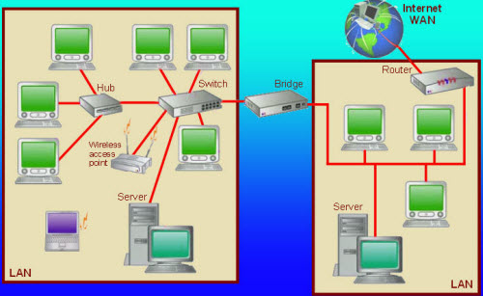

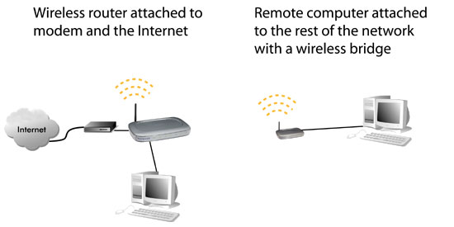

What is wireless bridge mode?

**Bridge mode** lets you connect two routers without the risk of performance issues. **Bridge mode** is the configuration that disables the NAT feature on the modem and allows a router to function as a DHCP server without an IP Address conflict. ... **Bridge mode** fixes this by letting multiple routers share one single Wi-Fi network.

What is a wireless bridge vs access point?

While **wireless** bridges are designed to integrate two physically separated networks through a radio link, an **access point** connects multiple **wireless** devices with a router.

Difference Between Access Points and Routers

The **router** acts as a hub that sets up a local area network and manages all of the devices and communication in it. An **access point**, on the other hand, **is** a sub-device within the local area network that provides another location for devices to connect from and enables more devices to be on the network.

Is wireless access point a router?

An **access point** is a device that creates a **wireless** local area network, or WLAN, usually in an office or large building. An **access point** connects to a wired **router**, switch, or hub via an Ethernet cable, and projects a **Wi-Fi** signal to a designated area.

Can all routers be used as access points?

Many **routers** in the last few years **can** work in **Access Point** mode which **can** be turned on using the interface. Note: Some Wi-Fi **routers** feature an **Access Point** mode (you'll see that in its features list if it does). If that's the case for your **Router** B, you **can** just turn this mode on and it will start working as an **AP**

Is AP mode better than router mode?

**AP mode** is more used to transfer wired connection into wireless. It works like a switch. Usually, it is behind a **router**. ... When Internet access from DSL **or** cable **modem** is available for one user but more users need to share the Internet, please use the **Router Mode**.

Is access point slower than router?

Even with a better **access point**, it's pretty hard to achieve 100 Mbps in the 2.4 GHz band. 70ish Mbps is about the highest one can expect to get with most devices. ... An **AP** (connected by Ethernet) will deliver the full Wi-Fi speed that its hardware can handle. This could be worse, equal to, or better **than** the **router**.

Which is better access point or bridge mode?

From what I understand, **Bridge mode** often turns off **access point mode**. But some devices can do both simultaneously. If you want just advantage then you'd at least need that. Then the only advantage with **Bridge mode** is the ability to connect 2 **Bridge mode** devices / Wireless Bridges to each other wirelessly

What is AP mode on router?

Access point (**AP**) **mode** enables your **router** to function as a gateway for wireless devices to connect to. In **AP mode**, your NETGEAR **router** extends your existing WiFi instead of creating a new WiFi network.

Is Bridge mode the same as access point?

While wireless bridges are designed to integrate two physically separated networks through a radio link, an **access point** connects multiple wireless devices with a router. ... A **bridge** can also be used to connect an existing ethernet network with an **access point**.

what is the range limit of an access point and router

it is useful to know that, when using the traditional 2.4 GHz band, Wi-Fi **access points** generally reach the signal up to 150 feet (45 metres) indoors and 300 feet (91 metres) in open areas.

How far can a wireless access point reach?

Furthermore, it is useful to know that, when using the traditional 2.4 GHz band, **Wi-Fi access points** generally **reach** the signal up to 150 feet (45 metres) indoors and 300 feet (91 metres) in open areas.

What is the maximum range of a WiFi router?

A typical **wireless router** in an indoor point-to-multipoint arrangement using 802.11n and a stock antenna might have a **range** of 50 metres (160 ft) or less. Outdoor point-to-point arrangements, through use of directional antennas, can be extended with many kilometers (miles) between stations.

**Differences** the router to access point

The **router** acts as a hub that sets up a local area network and manages all of the devices and communication in it. An **access point**, on the other hand, is a sub-device within the local area network that provides another location for devices to connect from and enables more devices to be on the network.