What is Network Topologies?

Network topology refers to how the nodes and links in a network are arranged. A network node is a device that can send, receive, store, or forward data. A network link connects nodes and may be either cabled or wireless links. Understanding topology types provides the basis for**building a successful network**.

[Network topology is the arrangement of the elements of a communication network. Network topology can be used to define or describe the arrangement of various types of telecommunication networks,](https://www.bing.com/ck/a?!&&p=1735517e8c829145JmltdHM9MTY3ODMyMDAwMCZpZ3VpZD0wZjkwZmViOS0yMmUxLTZkYWEtMzEyNS1lYzc5MjNiMzZjMjMmaW5zaWQ9NTYyMg&ptn=3&hsh=3&fclid=0f90feb9-22e1-6daa-3125-ec7923b36c23&psq=what+are+the+lesson+about+topology+network&u=a1aHR0cHM6Ly9lbi53aWtpcGVkaWEub3JnL3dpa2kvTmV0d29ya190b3BvbG9neQ&ntb=1" \o "en.wikipedia.org" \t "_blank)

There are 2 “types” of network topology:

* **Physical topology**refers to the actual physical layout of the devices on the network.
* **Logical topology** refers to how data is passed through the network. For example, 10 devices can be connected to one router physically, but they are split into 2 separate virtual networks within the router itself.

What are the limitations of physical topologies?

Physical topologies are difficult to change as organizational needs change. For this reason, physical networks are not as agile as logical networks, and cannot be as easily reconfigured when users increase or devices are added. In addition, the networks' dependency on physical connections places more demands on security teams, which have to rely on firewalls and switch configurations to protect networks.

Logical topologies, on the other hand, are crafted by defining, using, and enforcing fields in packet headers, and therefore can easily be changed to meet changing requirements--as long as the physical underlay has the capacity and scalability to support the needs of the logical topology.

Physical network topologies use to play a much more significant role in network design. Today, as long as the physical underlay is robust and scalable, the emphasis is on designing logical or virtual topologies

Layered architecture

Commonly used in the enterprise campus and branches, layered architecture--typically comprised of three layers--is a widely adopted model for designing a reliable, scalable, and cost-efficient network that serves users who directly connect to it. The layers are:

* Access layer: provides workgroup and user access to the network
* Distribution layer: provides policy-based connectivity and controls the boundary between the access and core layers
* Core layer: provides fast transport between distribution switches within the enterprise  
  In smaller networks, not all layers may be physically present.

Spine-and-leaf architecture

In this two-layer architecture, commonly found in data centers, every lower-tier switch (leaf layer) is connected to each of the top-tier switches (spine layer) in a full-mesh topology. The leaf layer consists of access switches that connect to devices such as servers. The spine layer is the backbone of the network and is responsible for interconnecting all leaf switches.

Modern trends affecting network topology design

Digital transformation

Networks do much of the heavy lifting for enterprises that are undergoing digital transformation. They must support user mobility, cloud applications, and smart things (IoT), as well as enforce security--all activities that are growing rapidly.

Logical topologies that support digital transformation must be policy-driven and automated, and they must provide sufficient information--such as telemetry--so their performance can be measured and issues can be identified and remediated.

Intent-based networking

Modern organizations are realizing the value that networks can provide for their businesses and are taking steps to make them intelligent. Intent-based networks transform a hardware-centric, manual network into a controller-led network that captures business intent and translates it into policies that can be automated and applied consistently across the network.

The goal is for the network to continuously monitor and adjust network performance to help assure desired business outcomes. To effectively support intent-based networking, topologies must be agile and network devices must be programmable.

Network devices

Attributes of network devices such as routers, switches, and wireless are critical to the design and maintenance of logical topologies. Network devices must support and interpret packet headers that create topologies. They must also be programmable through APIs so that existing topologies may be modified and new ones defined without manual configurations.

Network controllers

Having a central dashboard that you can use to specify policies for network control--and that can orchestrate the network--is critical for building agile network topologies. Such controllers program the network devices in the entire network and remove the burden of manual configuration, making the process faster and error-free. Controllers can also collect and analyze data to make sure the network is meeting user and business needs--and can take corrective actions if it is not.

7 Types of Computer Network Topology (With Diagrams)

the various types of computer network topology. By now, you should already realize that computer networks are not created by “randomly plugging more devices into a router”.

There are many ways to deal with the layout of a computer network, and it takes careful planning to make sure that things work properly in a large network. Just what are the various network topologies, their advantages, and disadvantages?

1) POINT-TO-POINT

A point-to-point network is the most basic form of topology where we directly connect one device to another, without any “middleman” between them. Yep, end of story. If you have connected a smartphone to a laptop using a USB cable before, then congratulations, that is a legit point-to-point network.



THE ADVANTAGES

A fast, simple, and convenient way to connect 2 devices together.

THE DISADVANTAGES

Well, there really isn’t any disadvantages to it.

2) BUS TOPOLOGY

In computer terms, a bus is an “expressway” that is used to transfer data from one component to another. In networking, the bus topology stays true to that definition, where every computer device is connected to a single trunk cable (what we call the backbone).

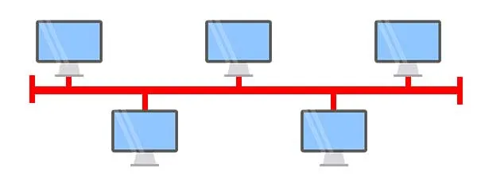

THE ADVANTAGES

* Cost-effective as it uses fewer cables than the other topologies; It only has one main trunk cable and a “drop line” to each attached device.
* Very straightforward, easy to understand, and maintain.
* Easy to expand as well, just “insert” another node into the trunk.
* Good for small networks that do not have too many devices.

THE DISADVANTAGES

* The entire network will shut down if there is a break in the trunk cable.
* One trunk cable is shared between multiple devices. So the more devices we attach to the bus network, the slower it will become.
* There is a limit to how far we can physically stretch out one piece of cable – Maybe across one room at best.

3) RING TOPOLOGY

A ring topology can be best described as devices connected together in a closed-loop daisy chain. Well, the easier way to think of it is a game of computer musical chairs. How it works is kind of confusing though:

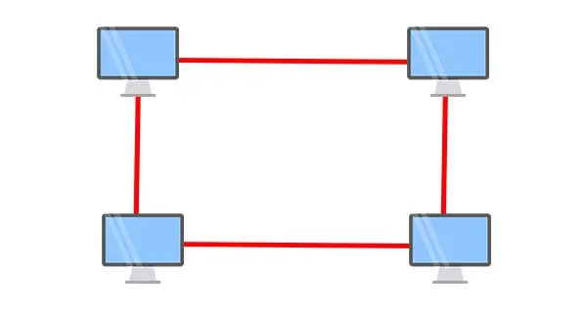

* Data transmission in a ring network is usually unidirectional.
* For example, devices A, B, C, and D are connected together in a closed loop. If A wants to send data to D, it has to be passed through B and C to reach D. It is not possible to “reverse the flow” and directly send from A to D.
* Also, collisions will happen if all the devices start to send data at the same time. In order to prevent that, a token will be passed around in the network – Only nodes with the token are permitted to send data.
* In large ring networks, there can be multiple tokens to speed up the process.
* To improve reliability and efficiency, ring networks can be made bidirectional by having another separate set of connections; I.E. Each node will have a “forward ring” and “backward ring”. This is called a Dual Ring Topology.

THE ADVANTAGES

* Ring networks can span over a longer physical distance, as the nodes will regenerate the message as it is being passed across.
* Adding more nodes will not slow down the entire network, as only nodes that have the token can transmit data; A larger ring network will just have multiple tokens being passed around.
* Relatively affordable and easy to build/expand a ring network, as it is essentially just putting the devices into a closed daisy chain.

THE DISADVANTAGES

* Depending on how the ring network is configured, a single break in the network can technically still function normally. But with 2 broken nodes, the ring network will essentially collapse into 2 separate halves.
* It is an absolute pain to add or remove a node, as it will affect the rest of the network.

4) STAR TOPOLOGY

In a star topology, all the devices are connected to a central device. This device will then control all the data traffic flow within the entire network. A good example of such a topology is a home wireless network, where all the desktops, laptops, tablets, printers, and smartphones are connected to a single wireless router.

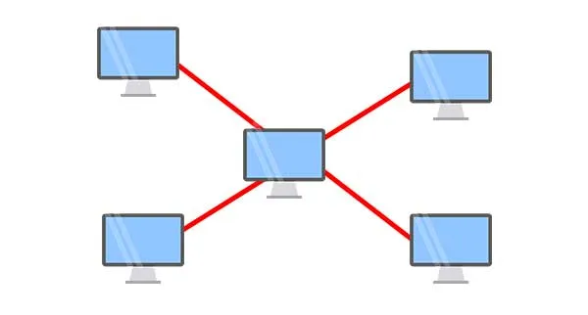

THE ADVANTAGES

* Relatively easy to set up and maintain – Just connect or disconnect devices from the central hub.
* A broken node will not affect the rest of the network.

THE DISADVANTAGES

* The network performance and the number of connections are limited by the central device.
* A good central hub or router can be very costly.
* Single point of failure. If the central node goes down, the entire network collapses.

5) TREE TOPOLOGY

In a tree topology, there is a “top-level node” followed by several “sub-level nodes” and “sub-sub-level nodes”, effectively forming a hierarchy. Depending on how tree networks are built, you can even think of them as an extension of the star network, with a star within a star.

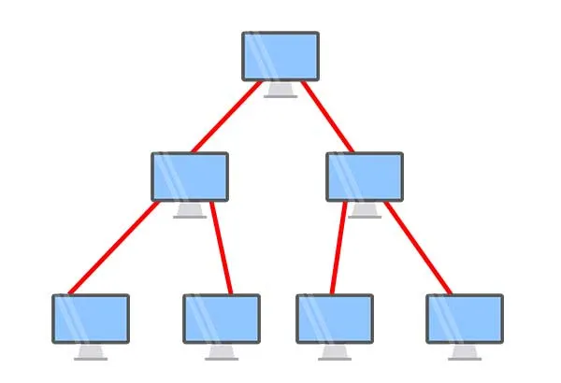

THE ADVANTAGES

* Good for large networks that are divided into groups. For example, an organization with various departments – Training, finance, marketing, etc…
* Easier to manage as the network is divided into segments.
* Quite robust when configured properly. If a sub-network breaks, it will not affect the rest of the network.

THE DISADVANTAGES

* Costly to build, as it involves a lot of network equipment and cables.
* Depending on how the tree network is built again – If the “top-level node” or central hub goes down, the entire network can be crippled.

6) MESH TOPOLOGY

Unlike the star network, a mesh network is one where “everyone is connected to everyone”. Yes, a mesh network can be simply thought of as the spider web of networking.

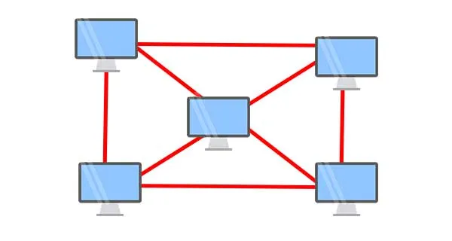

* **Full Mesh Topology**: Where every node is connected to each other within the network. Although very expensive, the full mesh offers the highest level of redundancy.
* **Partial Mesh Topology**: The less expensive option where not all nodes are connected to each other, but still has a level of “good enough” connections. Of course, it does not offer as much redundancy as the full mesh.

THE ADVANTAGES

* Very robust network. A broken line or two will not cause the entire network to collapse.
* It is relatively easy to troubleshoot and find a broken node when a certain route goes down.

THE DISADVANTAGES

* Very costly. Involves a lot of networking and cable work.
* It may not be easy to expand, as adding an additional node to the network will mean more costs and configuration changes.

7) HYBRID TOPOLOGY

A hybrid network is simply one that adopts two or more different topologies… This actually happens quite often as organizations grow in size over time. Of course, the network itself will inherit whatever the advantages and disadvantages the various topologies have.

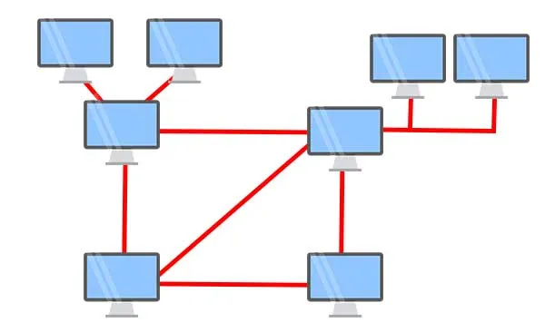

THE ADVANTAGES

* Flexible design.
* Scalable. Expand as the organization needs, and shrink if needed.

THE DISADVANTAGES

* Complex in design. The network engineer has to know various topologies and network gimmicks.
* It may not be the most cost-effective, as it may involve the use of many different networking devices.

# What Is Network Architecture?