**The Space Shuttle Challenger O-Ring Blow Out and Temperature Risk**

The O-rings in the booster rockets on the space shuttle are designed to expand when heated to seal different chambers of the rocket so that solid rocket fuel is not ignited prematurely. According to engineering specifications, the O-rings expand by some amount, say at least 5%, to ensure a safe launch. When an O-ring does not expand by at least this amount there is a risk of a “blow-out” failure where fuel leaks out and may ignite outside the booster shell and very likely to cascade into an explosion. This was estimated to occur 1 out of 1000 times when the expansion is less than 5%.

O-ring degradation during flight was a known risk. What was unknown is the relationship between temperature and O-ring degradation. The table below shows data on the number of O-rings that failed to expand more than 5% (an “incident”) and the temperature at launch.

|  |  |  |
| --- | --- | --- |
| **Temp** | **Issues** | **Incident** |
| 53 | 11 | 1 |
| 57 | 4 | 1 |
| 58 | 4 | 1 |
| 63 | 2 | 1 |
| 66 | 0 | 0 |
| 67 | 0 | 0 |
| 67 | 0 | 0 |
| 67 | 0 | 0 |
| 68 | 0 | 0 |
| 69 | 0 | 0 |
| 70 | 4 | 1 |
| 70 | 0 | 0 |
| 70 | 4 | 1 |
| 70 | 0 | 0 |
| 72 | 0 | 0 |
| 73 | 0 | 0 |
| 75 | 0 | 0 |
| 75 | 4 | 1 |
| 76 | 0 | 0 |
| 76 | 0 | 0 |
| 78 | 0 | 0 |
| 79 | 0 | 0 |
| 81 | 0 | 0 |

1. Prepare a scatter plot of the data. Does there appear to be a linear relationship between these variables?



Yes, a linear relationship seems plausible in the range given.

1. Obtain a simple linear regression model to estimate the amount of O-ring incidents as a function of atmospheric temperature. What is the estimated regression function? Is temperature a significant predictor of incidents?

> chal_lin_mdl <- lm(I ~ T, data=Challenger)

> summary(chal_lin_mdl)

Call:

lm(formula = I ~ T, data = Challenger)

Residuals:

Min 1Q Median 3Q Max

-2.3025 -1.4507 -0.4928 0.7397 5.5337

Coefficients:

Estimate Std. Error t value Pr(>|t|)

(Intercept) 18.36508 4.43859 4.138 0.000468 ***

T -0.24337 0.06349 -3.833 0.000968 ***

---

Signif. codes: 0 ‘***’ 0.001 ‘**’ 0.01 ‘*’ 0.05 ‘.’ 0.1 ‘ ’ 1

Residual standard error: 2.102 on 21 degrees of freedom

Multiple R-squared: 0.4116, Adjusted R-squared: 0.3836

F-statistic: 14.69 on 1 and 21 DF, p-value: 0.0009677

Temperature seems to be highly significant

1. Interpret the R2

About 38% of the variability in # of incidents is accounted for by temperature discounting for additional variability due to the small amount of data

1. Suppose that NASA ofﬁcials are considering launching a space shuttle when the temperature is 29 degrees. What number of O-ring incidents should they expect at this temperature, according to your model?

> chall.predict <- predict(chal_lin_mdl, data.frame(T=29), interval="prediction")

> chall.predict

fit lwr upr

1 11.30726 4.334273 18.28025

We expect 11 incidents. With 95% confidence we expect between 4 and 18 O-ring incidents when the temperature is 29 degrees.

1. On the basis of your analysis of these data, determine the risk of a blow out. You can assume O-ring blowouts are independent. You want the probability of at least one blow out in N incidents. So consider the probability of no blowouts in N incidents. P(at least one blowout in N incidents) = 1 – P(no blowout in N incidents). Would you recommend that the shuttle be launched if the temperature is 29 degrees? Why or why not?

P(no blowout in N incidents) = (1-p[blowout 1 incident])^N

So P(at least one blowout in N incidents) = 1 - P(no blowout in N incidents) = 1 - (1-p[blowout 1 incident])^N

Expect 11 incidents, so P(at least one blowout in 11 incidents) = 0.0195 or about 2%

For safety, use upper 99.99999% CI limit:

> chall.predict <- predict(chal_lin_mdl, data.frame(T=29), interval="prediction", level=.9999999)

> chall.predict

fit lwr upr

1 11.30726 -15.19309 37.80761

Expect with very high confidence at worst 38 incidents, so P(at least one blowout in 38 incidents) = 0.03634 or about 4%

Under this analysis we would probably decide to launch (as they did). But this is wildly speculating out of the relevant range and is extremely RISKY. We really don’t know what the relationship is at such low temperatures. If we are going to speculate, we should be very conservative.

Let’s look at the residuals:

|  |
| --- |
| rstandard(chal_lin_mdl)  1 2 3 4 5 6 7 8  3.13349241 -0.26015592 -0.12993113 -0.51301924 -1.12702251 -1.00492390 -1.00492390 -1.00492390  9 10 11 12 13 14 15 16  -0.88439525 -0.76507445 1.29959760 -0.64661304 1.29959760 -0.64661304 -0.41091233 -0.29299924  17 18 19 20 21 22 23  -0.05532437 1.91872752 0.06516420 0.06516420 0.31142666 0.43809109 0.70106999 |
|  |
| |  | | --- | | > | |

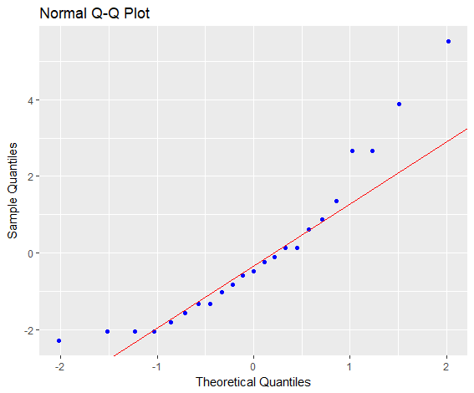

The point with 11 incidents at 53 degrees is clearly a major outlier (more than 3 std errs) in the linear model.

We might consider an extreme model that would not have this as an outlier. Let’s look at the power law model I = aT^b. We can use the log transform to get this:

> chal_exp_mdl <- lm(log(I+1) ~ log(T), data=Challenger)

> summary(chal_exp_mdl)

Call:

lm(formula = log(I + 1) ~ log(T), data = Challenger)

Residuals:

Min 1Q Median 3Q Max

-0.73570 -0.48512 -0.05119 0.20462 1.49398

Coefficients:

Estimate Std. Error t value Pr(>|t|)

(Intercept) 21.064 5.477 3.846 0.000939 ***

log(T) -4.852 1.292 -3.755 0.001166 **

---

Signif. codes: 0 ‘***’ 0.001 ‘**’ 0.01 ‘*’ 0.05 ‘.’ 0.1 ‘ ’ 1

Residual standard error: 0.6417 on 21 degrees of freedom

Multiple R-squared: 0.4017, Adjusted R-squared: 0.3732

F-statistic: 14.1 on 1 and 21 DF, p-value: 0.001166

Looks about as good as the linear model, but no more outliers:

> residuals(chal_exp_mdl)

1 2 3 4 5 6 7 8

0.68486902 0.16242508 0.24680895 0.13719945 -0.73570002 -0.66273698 -0.66273698 -0.66273698

9 10 11 12 13 14 15 16

-0.59085492 -0.52002226 1.15922909 -0.45020882 1.15922909 -0.45020882 -0.31352512 -0.24660060

17 18 19 20 21 22 23

-0.11545881 1.49397910 -0.05119363 -0.05119363 0.07483815 0.13664727 0.25795236

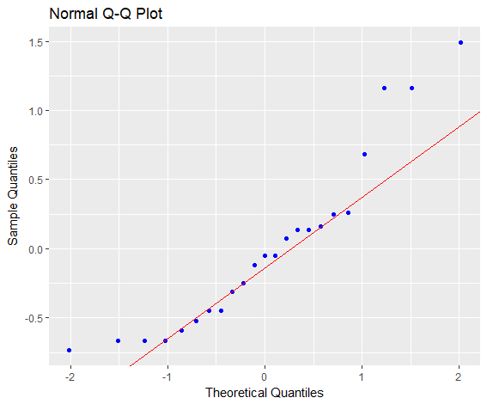

> chall.predict <- predict(chal_exp_mdl, data.frame(T=29), interval="prediction", level=.95)

> exp(chall.predict)

fit lwr upr

1 112.8145 7.537247 1688.562

Under this model, we expect N=113 incidents so P(at least one blowout in 11 incidents) = 0.1061 or about 11% which is already over safety margin. If we were to be even more conservative, the upper 95% CI gives N=1689 and P(at least one blowout in 11 incidents) =0.81527 or about 82%!!!!

Maybe we are being too conservative? Let’s look at the sensitivity and how low the temperature can be before we are over the 5% safety margin.

Here’s what the # incidents and prob of blowout look like with 95% PI’s:

> T = data.frame(T=20:90);

> chall.preds <- predict(chal_exp_mdl, newdata = T, interval="prediction")

> plot(T,chall.preds[,1], type="l")

> lines(T, chall.preds[,3], type='l', lty=3, col="red")

> lines(T, chall.preds[,2], type='l', lty=3, col="red")

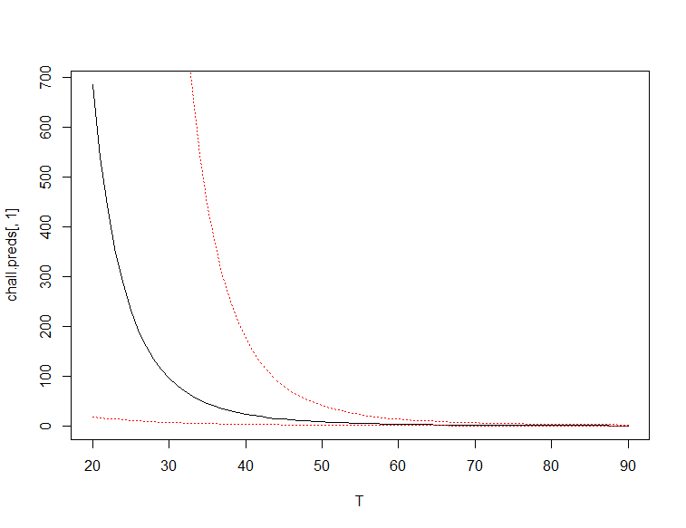

> blow <- function(I,p) {1-(1-p)^I}

> plot(T, blow(chall.preds[,3],1/1000), type="l", lty=3, col="red")

> lines(T, blow(chall.preds[,2],1/1000), type="l", lty=3, col="red")

> lines(T, blow(chall.preds[,1],1/1000), type="l", lty=1, col="black")  
> segments(20,.05, 90,.05, lty=2)

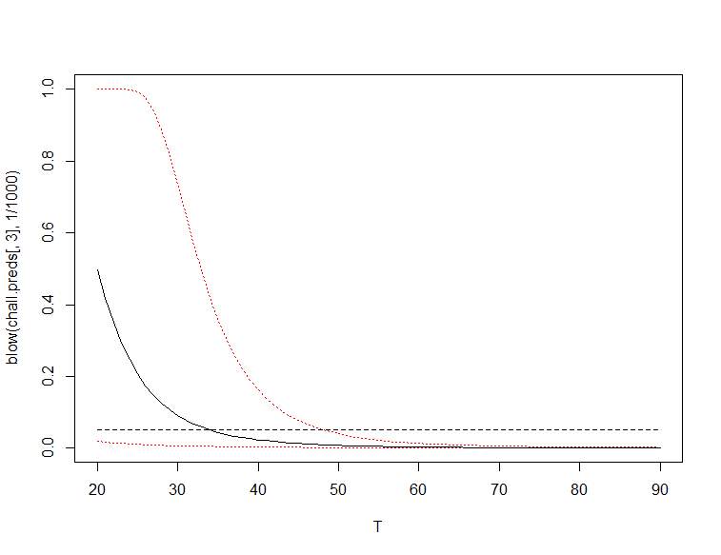

> min(T[blow(chall.preds[,1],1/1000) < .05])

[1] 35

> min(T[blow(chall.preds[,3],1/1000) < .05])

[1] 49

Looks like need to be at least 35 degrees to be within 5% safety margin on average, and to be at least 49 degrees to be 95% confident for no more that 5% blowout likelihood. So looks like 29 degrees is not even close to the safety margin, so DON’T LAUNCH

Because we are predicating outside the relative range of the data, we have no basis for selecting the linear model over the power model. In fact, the power model is more justifiable on the basis that (1) no low temperature outliers, (2) fits engineering concerns about decreased expansion at low temps, (3) it’s the more risk averse (conservative) model.

**1.  Identify Risk** — NASA managers had known the design of the solid rocket boosters (SRBs) contained a potentially catastrophic flaw in the O-rings since 1977, but failed to address it properly.  
**2.  Analyze Data** — The O-rings, as well as other critical components, had no test data to support the expectation of a successful launch in such cold conditions. Engineers who

worked on the Shuttle delivered a biting analysis: “We're only qualified to 40° F. No one was even thinking of 18° F. We were in no man's land.”  
**3.**  **Control Risk** — NASA had “Launch Fever” that morning and disregarded advice not to launch. Later, we learned that concerns about the launch never made it up the chain of command. It was these lapses in judgment that triggered this catastrophic event.  
**4.  Transfer Risk** — While there may be some risk transferred to an insurance company for a satellite aboard, there is no place to transfer the loss of life in this case. NASA put all shuttle launches on hold for 32 months and some would argue that they never recovered from the damage to their reputation.  
**5.**  **Measure Results** — This is where we ask the question, “What went wrong?” In fact, the Rogers Commission did an extensive review. They found NASA’s organization culture and decision-making processes had been key contributing factors to the accident. NASA managers had known since 1977 that the design of the solid rocket boosters (SRB’s) contained a potentially catastrophic flaw in the O-rings yet failed to address it properly. They also disregarded warnings (an example of “go fever”) from engineers about the dangers of launching because of the low temperatures that morning, while also failing to adequately report these technical concerns to their superiors.