**­­Exercise: MicroSlo Advertising and Unit Price**

Use the MicroSlo proforma income spreadsheet. This is a one-year pro forma income statement (or cost-profit statement) for the MicroSlo company. The company sells microwave slow cookers, for use in restaurants. The owner will draw a salary of $80,000 per year. There is also a manager of operations, who will draw a salary of $60,000 per year. The corporate tax rate (based on gross profit and ignore deductions and such for now) is expected to follow the IRS Tax Rate Table (such as from https://www.irs.gov/pub/irs-pdf/i1120.pdf) in each of the two years. Each MicroSlo cooker will require $40 in materials costs and $25 in labor costs in the first year. There will be three sales people. Their salary is expected to average $30,000 per person. Factory rent will be $3,000 per month.

You have the following market data on demand based on unit price and amount you spend on advertising. The unit price must be more than $100/unit and your cash flow does not enable you to spend more than $5000/month on advertising. What balance of unit price and advertising will maximize your Net profit?

|  |  |  |
| --- | --- | --- |
| **unit sold (1 month)** | **price** | **Advertising ( 1 month)** |
| 245 | 200 | 0 |
| 238 | 205 | 0 |
| 230 | 210 | 0 |
| 254 | 195 | 0 |
| 263 | 190 | 0 |
| 261 | 185 | 0 |
| 255 | 200 | 500 |
| 249 | 200 | 600 |
| 251 | 200 | 700 |
| 251 | 200 | 800 |
| 262 | 200 | 900 |
| 256 | 200 | 1000 |

1 month without specifying months. Sequential? Random?

Need annual data. This will increase variability! Var(12*X) = 12^2*Var(X). Cannot assume constant so must look at Var(X). So probably converting everything to monthly is best here.

We will have to assume that maximizing monthly gross profit will maximize annual gross profit. NOTE that is NOT always true! If there is correlation between demand month to month then it’s possible that maximizing monthly demand will not produce the maximum annual demand.

Looks like data was collected “experimentally” where Advertising set to 0 and Price increased $5 per month, then Price set to $200 and Advertising incremented $100/month starting with $500 (min advertising cost?)

* This will bias characteristics if all data is used!
* Not randomly sampled
* May be time series
* Probably this was done because data was very hard/expensive to collect. Must be careful how this data is used! Not fully representative range of values. Only good for determining kind of relationships. Probably cannot rely entirely on empirical models. Will need some “theory” to substantiate models.

Main task is to develop a model that predicts sales from price and advertising:

* Want to know how to describe relationships between these variables

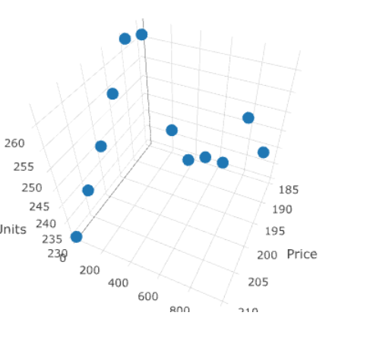

Demand seems strongly inversely related to Price

Demand seems somewhat positively related to Advertising

Does advertising reduce the variability of demand?

There’s some pretty clear nearly multi-linear relationship here. Maybe it’s hard to see, but looking at the backside:

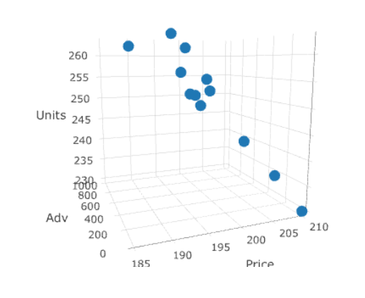

Do you see how it nearly lines up? This is like looking at the edge of a slice through all three variables. We should look for this relationship!

It may be tough to get from the data because of the way it was collected, but there is probably an interaction between price and advertising. In theory advertising will “shift” the demand curve in a way where increased advertising suggests a higher demand for all prices. It does not change demand elasticity (the slope). At least in theory…

1. Do a break-even analysis to determine what the minimum price must be charged. Is there a maximum?

Need this to set rational constraints e.g. cannot set price less than break-even or we will lose money.

Use solver for quick easy solution given a demand level. Can do this for different demand levels to get data and plot the breakeven function. BUT in this case, it’s simple enough to just derive the function:

Gross = TR – TC = P*Q – (FC+DQ*VC) = 0 🡪 P = FC/Q + VC



If there is no relation between price and demand, then no maximum (!). But if any inverse relation, then most likely a max due to dampening effects of increased price on demand (total revenue will increase then decrease).

1. Analyze the demand-price-advertising data. Describe how price effects demand, how advertising effects demand, and if there are simultaneous price-advertising effects. What model may be useful for predicting demand based on price and advertising? What is the relevant range?

Hint: Make sure you understand what data was collected and what to use for given investigations. Look at non-linear terms and interactions. How does advertising effect demand in theory (economically)?

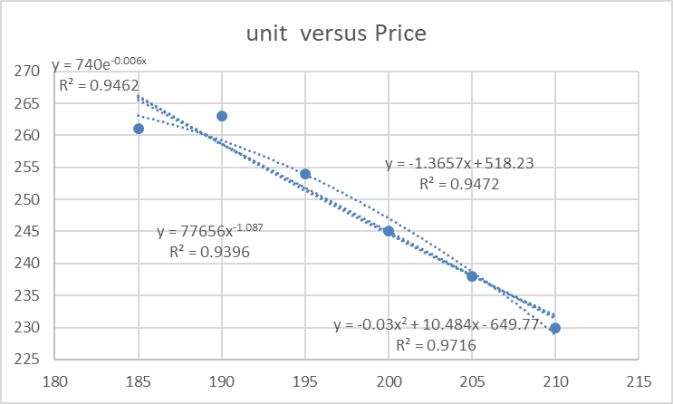

Linear and exponential both good fit. Exponential has better matching characteristics:

curve(740*exp(-0.006*x),0,500)

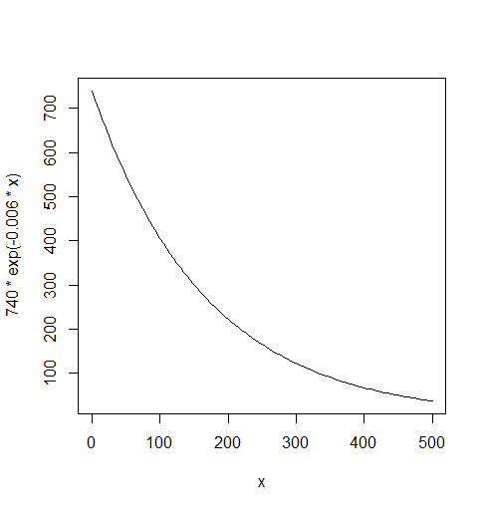

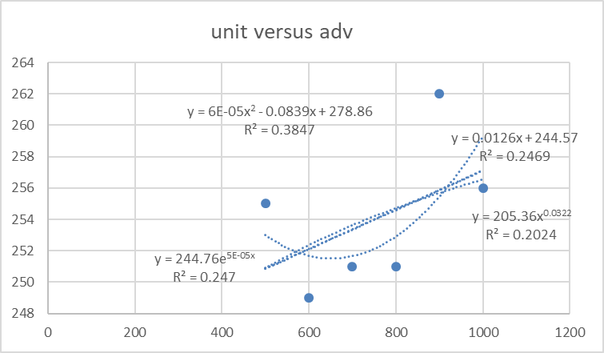

curve(244.76*exp(5E-05*x),0,5000)

Linear and exponential both good fit. Polynomial better but probably overfitting and characteristics are wrong. Exponential has better matching characteristics:

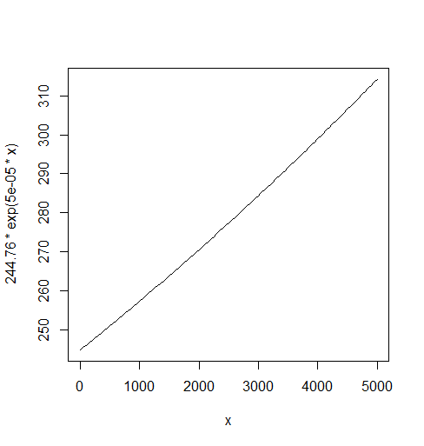

Not good! Implies more adv infinitely increases demand ☹. Power matches characteristics better:

curve(205.36*x^0.0322,0,5000)

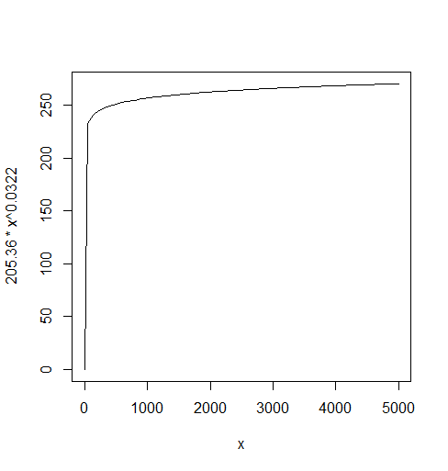



Looks like Adv “raises” the demand-price curve. The question here is, does advertising increases the demand for a fixed price or does it “interact” and change the slope of the demand-price curve. Because we don’t have different prices for different advertising levels (just $200 per unit), this data is insufficient to determine which of these is what “causes” the demand-price curve to rise. So we should choose a model that seems to match our “theory” best and gives good results.

Let’s look at all possible linear models with price, advertising, and price*advertising (the interaction term) to determine which of these “features” suits our problem best.

OLSRR or leaps package may be helpful here to look at feature selections.

mdl <- lm(units ~ price + adv + priceXadv, data = price_advertising)

k <- ols_all_subset(mdl)

Index N Predictors `R-Square` `Adj. R-Square` `Mallow's Cp`

<int> <int> <chr> <chr> <chr> <chr>

1 1 1 price 0.63723 0.60095 18.74876

2 2 1 adv 0.10717 0.01789 57.83182

3 3 1 priceXadv 0.10717 0.01789 57.83182

4 4 2 price adv 0.87794 0.85082 " 3.00000"

5 5 2 price priceXadv 0.87794 0.85082 " 3.00000"

6 6 2 adv priceXadv 0.10717 0.01789 57.83182

7 7 3 price adv priceXadv 0.87794 0.85082 " 3.00000"

Both the price + priceXadv model and price + adv, so while there is evidence of interaction, it seems that it doesn’t matter if we account for it or not (in terms of predicting demand). So go with the simpler price + adv model.

mdl_lin <- lm(units ~ price + adv, data = price_advertising)

summary(mdl_lin)

Call:

lm(formula = units ~ price + adv, data = price_advertising)

Residuals:

Min 1Q Median 3Q Max

-4.5577 -2.6276 -0.6196 2.5718 6.1830

Coefficients:

Estimate Std. Error t value Pr(>|t|)

(Intercept) 518.367456 35.854135 14.458 1.55e-07 ***

price -1.366539 0.181270 -7.539 3.55e-05 ***

adv 0.011953 0.002837 4.213 0.00226 **

---

Signif. codes: 0 ‘***’ 0.001 ‘**’ 0.01 ‘*’ 0.05 ‘.’ 0.1 ‘ ’ 1

Residual standard error: 3.799 on 9 degrees of freedom

Multiple R-squared: 0.8779, Adjusted R-squared: 0.8508

F-statistic: 32.37 on 2 and 9 DF, p-value: 7.755e-05

Adv and price both highly significant predictors (good!). Let’s check if the breakeven has a min and a max (for adv const):

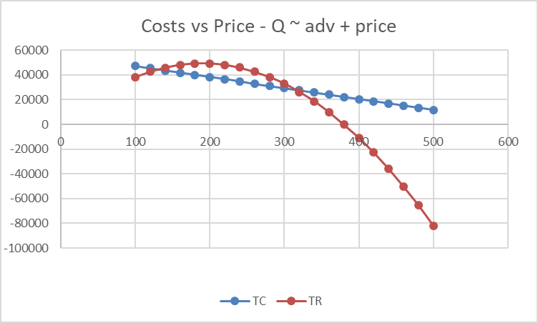

Yes! Excellent. Max GP will be at biggest difference between the two breakeven points of $140 - $300 (around $250 here). Now check if Adv has a max. by holding price constant in this range because outside of this range there is no way Adv will have a max. Might as well use $250:

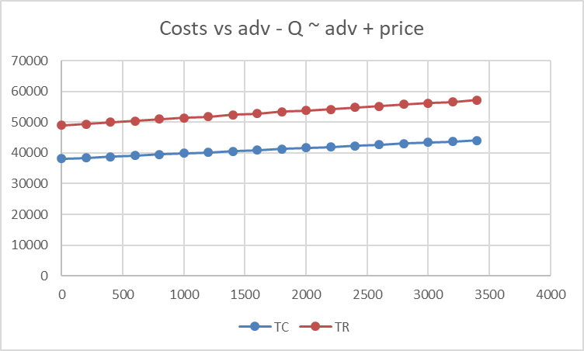

Uh oh… looks like there is no max break even. This implies that for a given price the more you put into adv the higher the GP without limit. So say you choose a price of $250 to max the GP when there is $0 adv, then you would always want to put as much on adv as possible. In this case, $5000 is the max. Both the values for price and adv are out of the relevant range for our models and so the prediction that these would give the max GP would be highly unreliable. If we are going to predict outside the relative range, we need to have a lot of confidence that our models describe the relationship well outside the relevant range.

When we looked at the characteristics of the linear models (above) outside the relevant ranges we did NOT believe they represented the relationship well. It would be very risky to use the linear models to determine price and adv that maximized GP.

Consider transforming data match theories. We saw that an exponential relationship seems to fit demand-price and a power law for demand-adv. Let’s look at what models we get for these.

Units = a*exp(b*price)*adv^c

What’s nice about this model is that it naturally accounts for interactions which we already believe is happening here. We could use non-linear regression, but in this case we can transform the non-linear model into a linear one by considering log(units):

log(units) = log(a) + b*price + c*log(adv)

We now transform the data to get the variables needed for the above model

price_advertising$logUnits = log(units)

price_advertising$logAdv = log(adv+1)

We transform to log(adv + 1) for adv because we have some $0 values and log(0) is undefined. This will not cause any disturbance in the model. If we want we can use adv +1 in the model to match the transform.

mdl_exp <- lm(logUnits ~ price + logAdv, data = price_advertising)

summary(mdl_exp)

Call:

lm(formula = logUnits ~ price + logAdv, data = price_advertising)

Residuals:

Min 1Q Median 3Q Max

-0.0188578 -0.0119146 0.0004132 0.0068512 0.0297485

Coefficients:

Estimate Std. Error t value Pr(>|t|)

(Intercept) 6.6079456 0.1532816 43.110 9.71e-12 ***

price -0.0055387 0.0007754 -7.143 5.41e-05 ***

logAdv 0.0056438 0.0014482 3.897 0.00364 **

---

Signif. codes: 0 ‘***’ 0.001 ‘**’ 0.01 ‘*’ 0.05 ‘.’ 0.1 ‘ ’ 1

Residual standard error: 0.01622 on 9 degrees of freedom

Multiple R-squared: 0.8642, Adjusted R-squared: 0.8341

F-statistic: 28.65 on 2 and 9 DF, p-value: 0.0001252

All terms highly significant (expected) and although this model has lower adj R2 than the linear model, it actually has a lower standard error. The demand predictions will be off typically by exp(.01622) = 1.0163 units which is notably less than the 3.799 units for the linear model. Yay!

Let’s check the breakeven points:

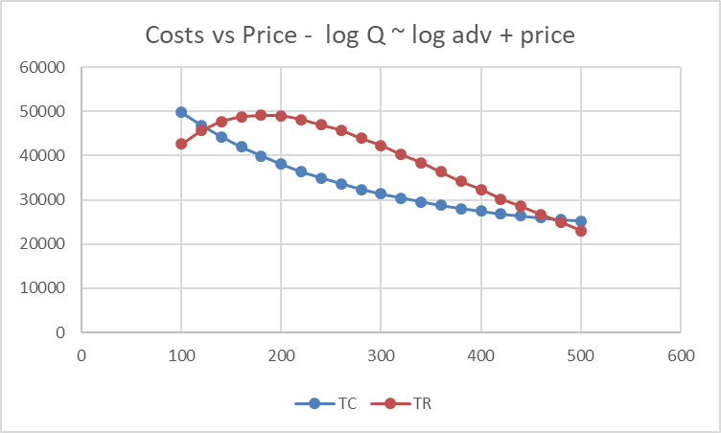  
Good! Max must be between the two intersection points $120-$480. Look like it’s around $240 so let’s take a look at different advertising amounts here and see if there’s a max advertising amount:

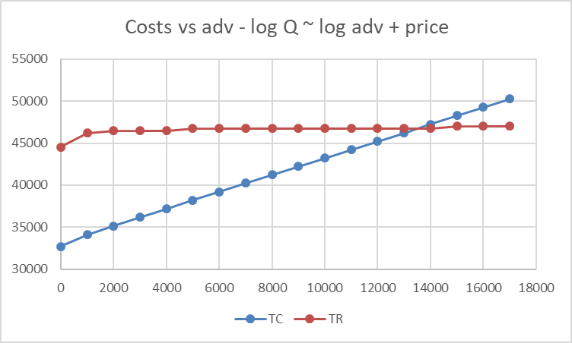

Unlike the linear model, when price is fixed at something higher than the breakeven price these intersect, so there is a maximum advertising amount. Yay!

Using goal seek I found a min breakeven price of $125 just to check. So we can’t spend more than about $14,000/month on advertising or out GP will go negative. It’s ok that this is way above our maximum of $5,000 since the optimal value for advertising will surely be much less than the breakeven adv max. Ok, we’re ready to optimize this model!

1. Use the model to find a price and monthly advertising amount that maximizes monthly demand. Is the solution reasonable and reliable? Does maximizing demand also maximize profit? Do a sensitivity analysis to determine the degree of confidence you can have in using this optimal value.

Look at linear and exp demand-price breakeven. Let’s look at a bunch of GP vs Price for different adv levels series1 = $0/month, series2 = $500/month, series3 =$1000/month, …

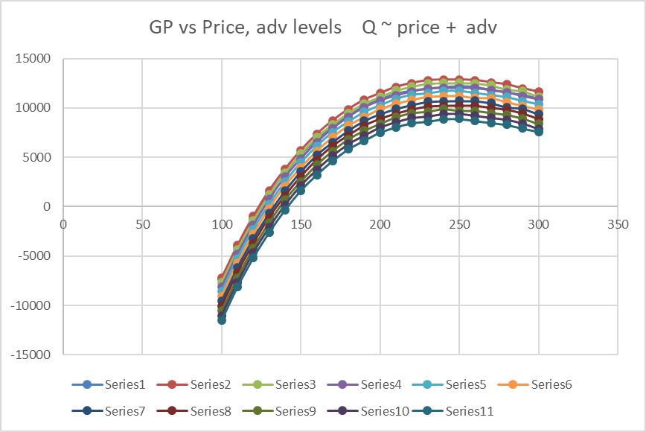

A heat map (contour map) on the data table is helpful to see where the maximum is (I used Excel’s conditional formatting). Low values are red and high values are green. The maximum value in the table is in red text.



And the winner is… Series2 (adv $500/month) with a price around $240 and GP $12,877. Using solver we get a more precise answer



The solution is not particularly sensitive:



We see from the above that a price as low as $220 or as high as $278 will drop the GP to no less than about $12,600 Thus, the optimal price can be off by as much as 24% and we would only be off the maximum by no more than 3%.



The optimal advertising level is even less sensitive. For adv between $140 and $270 the GP drops at most to about $13,010. So we can be off by 65% and the maximum will be off by no more than 0.08%.

Reliability though is an important question. That is, if we use these optimal values, how often will we actually get the max GP? The problem here is that not only are the optimal price and advertising amount based on models estimated from sample data, but also that the demand is stochastic (has randomness). Our models once again can help us answer this question. We note that the regression models assume the residuals (the errors in predictions) are Normally distributed and that we can get a confidence interval for the demand prediction give the optimal price and advertising. Note that we don’t want the prediction interval here since we are interested in the “expected” demand over many months (well, 12 to be exact) and not a particular month:

new <- data.frame(price=254.344456600769, logAdv=log(176.317889603753))

a <- predict(mdl_exp, new, interval="confidence", se.fit=TRUE)

exp(a$fit)

fit lwr upr

1 186.4923 169.2459 205.4962

So with 95% confidence when price is $254.34 and advertising is $176.32 the demand will fall between 169 and 205 units. This translates into a 95% confidence GP interval of $9,656 to $16,473

exp(a$se.fit)

[1] 1.043829

We can use this as the variability and the assumption of Normality to determine how often we will get a GP greater than $13,011 per month (using the optimal price and adv amounts) on average, then scale this to an annual amount (don’t forget to scale the variability by 12^2) to see how likely we will get more than 12*$13,011 annually.

> new <- data.frame(Price=200, logAdv=log(1000))

>

> a <- predict(mdl_exp, new, interval="confidence", se.fit=TRUE)

>

> exp(a$fit)

fit lwr upr

1 254.4704 250.5071 258.4963

*For Price $200 and Adv $1000/mo we get 95% CI for GP of $10,718 to $9,914. A much small variability than the optimal but a lower potential upside*

*> new <- data.frame(Price=190, logAdv=log(1))*

*>*

*> a <- predict(mdl_exp, new, interval="confidence", se.fit=TRUE)*

*>*

*> exp(a$fit)*

*fit lwr upr*

*1 258.6784 253.5735 263.886*

*$8,146, $9,208 also much lower variability but way lower potential upside.*

*The high variability in the optimal is due to the predicting outside the relevant range. This variability raises doubt about the achieving the max GP. If this is a concern, then we can add a penalty or constraint for variability in the optimization problem and we can find an optimal value with a desired level of reliability. But this is a more complicated analysis.*

1. Find a price and monthly advertising amount that maximizes Net profit. Note that this will be a non-linear problem. Is the solution reasonable and reliable? Do a sensitivity analysis to determine the degree of confidence you can have in using this optimal value.