**YMCA “Hallowine” Silent Auction**

**Case Exercise: Data wrangling, modeling, analytics with descriptive statistics**

The Windward YMCA in Kailua, HI holds an annual fund raising event every Halloween called Hallow-wine. Business and individuals donate items to offer at a silent auction. Due to limited space and management overhead they can only offer a limited number of items at the auction. Items that do not get bid on at the auction are given away, given back to the donors, or thrown out (i.e. no salvage value). However generally a donor is willing to give a cash donation of approximately 40% of the value of the item in lieu of donating the item. The Executive Director Bill Hastings has a spreadsheet of items for the auction in the previous year but is unsure how to make use of this data to help improve the auction this year.

Tasks:

Let’s use the 6-steps in the BA problem solving process to address this case.

In this case you should make use of bar chart, percentiles, pareto, bubble chart, ANOVA

Lessons of this case are:

* Become familiar with the BA process
* Review some basic descriptive stats
* Review some inferential stats
* Experience using imperfect models to find “good enough” results (how to avoid going too far in pursuit of perfection or correctness)

Step 1. Recognizing the problem

1. What is the gap between what happened previously and what Bill thinks should be happening this year?

Many items went unsold or underbid. Missed opportunity to get cash donation for such items. Had to turn away some items due to lack of space. Would like to understand what kinds of items are of high eatdirt

interest and are likely to get bid up. Would like to get cash donation and turn away items that are not of high interest or get underbid.

Step 2. Defining the problem

1. What are the questions that if answered would address the gap?

Q1: What kinds of items raise the most money?

Q2: What kinds of items are of highest interest?

Q3: What do we use to determine if an item should be turned away?

Q4: What encourages sales?

1. What would satisfactory answers look like?

Q1: “80% of the funds raised came from X,Y,Z, …”, “On Average the highest amounts raised come from X,Y,Z,… in this order”

Q2: “On Average the highest amounts bids come from X,Y,Z,… in this order”

Q3: If the expected sale value is less than 40% of it’s assessed value ask for a donation.

Q4: Set the min bid for item X with value Y at Z

3. Structuring the problem

a. What are the key decisions to be made and how do the relate to the questions?

D1: What categories of items should we solicit or discourage? (prescriptive)

D2: Item X should be accepted or refused? (predictive, prescriptive)

D3: What should the min bid and increment should be set for item X? (descriptive)

b. What are the important factors to consider in making the decisions?

D1: Item expected sale amount per category, interest of category

D2: expected sale amount for item, likely alternative cash donation

D3: Impact of min bid and increment on interest and sale amount

c. What data is needed and is it available or easily obtained?

Available: Sales, Value, Increment, Min bid, category

Add Sales/Value, # bids, Value – Min, Value/Min, dummy “Sold”

Clean data (handle missing values in Increment, remove items not used)

4. Analyzing the problem

a. How will you represent the decision problems? What models can you use (descriptive, predictive, prescriptive)?

Bubble plot of Sales vs Value:

ggplot(data=Hallo_Wine_auction_items_2009_Analysis, aes(x=Value, y=`sales price`, fill=Category, color=Category)) + geom_point() + geom_segment(data=YMCA, mapping=aes(x=0,xend=2000,y=0,yend=2000*.4))



Pareto of % of sales by category

sales = aggregate(Hallo_Wine_auction_items_2009_Analysis$`sales price`, by=list(Category=Hallo_Wine_auction_items_2009_Analysis$Category), FUN=sum)

sales <- sales[order(sales$x, decreasing =TRUE),]

barplot(sales$x/sum(sales$x), names.arg=sales$Category)

Pareto of % of average sales by category

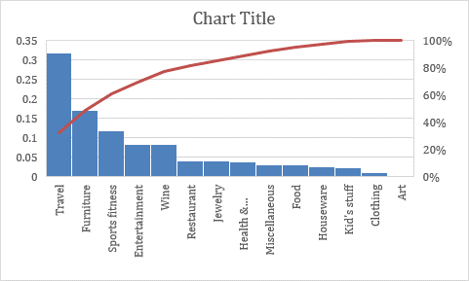

b. What confidence can you have in the results?

c. Are the assumptions reasonable?

5. Interpreting results and making a decision

a. Analyze the models and discuss the implications for the decisions

6. Implementing the solution

a. How should the results be used for this year’s auction?

b. What are the limitations, cautions, and possible exceptions?