Q1. Write a program that uses function template called min to determine the smaller of two arguements. The program should work for integers,characters and floating-point number as arguements to this function.
#include<iostream>

using namespace std;
template <class T>
T smin(T x , T y){
if(x>y) return y;
return x;
}

int main(){
int a,b;
cout<<"enter the values of a and b(both integers):";
cin>>a>>b;
b=smin(a,b);
cout<<"Min of and b is:";
cout<<b<<endl;
float c,d;
cout<<"enter the values of c and d(both float):";
cin>>c>>d;
cout<<"Min of c and d is:"<<smin(c,d)<<endl;
char e,f;
cout<<"enter the values of e and f(both characters):";
cin>>e>>f;
cout<<"Min of e and f is:"<<smin(e,f);
return 0;
}
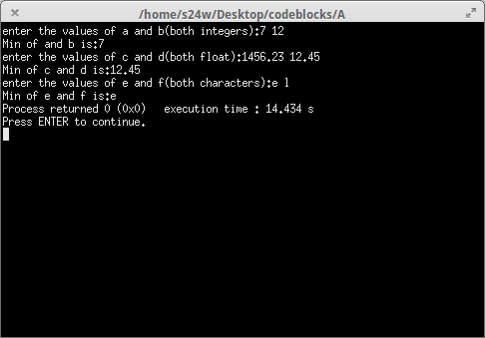

Q2.Write a program to explain class template by creating a template T for a class named pair having two data members of type T which are inputted by a constructor and a member funtion get_max() return the greatest of two numbers to main. Note: the value of T depends upon the data type specified during object creation.
#include<iostream>

using namespace std;

template <class T>
class spair{
T a,b;
public:
spair(T x, T y){a=x,b=y;}
T getmax(){
if(a>b) return a;
return b;
}

};
int main(){
spair<int> s(3,40);
cout<<"Max of two integers (a and b):";
cout<<s.getmax()<<endl;
spair<char> r('r','b');
cout<<"Max of two characters (a and b):";
cout<<r.getmax()<<endl;
spair<float> t(12.56,15.10);
cout<<"Max of two float (a and b):";
cout<<t.getmax()<<endl;
return 0;
}
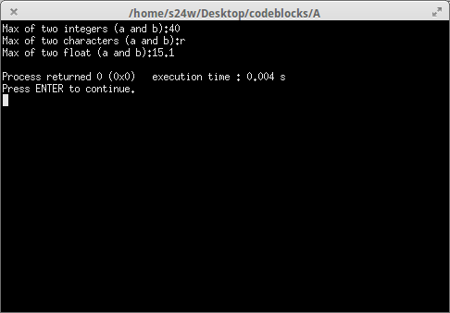

Q3.Write a program in C++ to overload cin,cout stream operators to input and display objects of a class student which contains student details like name,roll no.,class , age.
Eg : class stuednt {.......}
void main()
{
student st;
cin>>st;
cout<<st;
}
#include<iostream>
#include<stdio.h>
using namespace std;

class student{
char name[200];
int age,roll_no,cls;
public:
friend ostream& operator<<(ostream &,student&);
friend istream& operator>>(istream &,student&);
};
istream& operator>>(istream &obj, student &s){
cout<<"Enter Student Details\n";
cout<<"Name:"; fflush(stdin); obj>>s.name;
cout<<"Age:"; obj>>s.age;
cout<<"Roll No:"; obj>>s.roll_no;
cout<<"Class:";obj>>s.cls;
cout<<endl;
return obj;
}
ostream& operator<<(ostream &obj, student &s){
obj<<"Student Details\n";
obj<<"Name:"<<s.name<<endl;
obj<<"Age:"<<s.age<<endl;
obj<<"Roll No:"<<s.roll_no<<endl;
obj<<"Class:"<<s.cls<<endl;
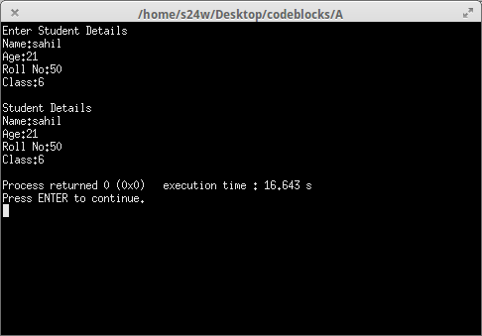
return obj;
}
int main(){
student s;
cin>>s;
cout<<s;
return 0;
}

Q4. Write a 3D which inherits another class 2D , for 3 dimensional calculations. Using these classes define any 2 points in a 3D space and find the distance between them.The formula for finding the distance between any 2 pts in 3D space is:
Distance=SquareRoot(xd*xd+yd*yd+zd*zd)
Where xd=x2-x1
yd=y2-y1
zd=z2-z1
#include<iostream>
#include<stdio.h>
#include<math.h>

using namespace std;
class cls_3D;
class cls_2D{
int x,y;
public:
cls_2D(){ }
cls_2D(int a,int b){
x=a,y=b;
}
void print1(){
printf("x=%d,y=%d ",x,y);
}
int get_x(){
return x;
}
int get_y(){
return y;
}
};

class cls_3D:public cls_2D{
int z;
public:
cls_3D(int a,int b,int c):cls_2D(a,b){
z=c;
}
void print2(){
printf("z=%d\n",z);
}

float distance(cls_3D obj){
int xd=this->get_x()-obj.get_x();
int yd=this->get_y()-obj.get_y();
int zd=z-obj.z;
int dis=(xd*xd)+(yd*yd)+(zd*zd);
float ans=(float)sqrt(dis);
return ans;
}
};
int main(){
cls_3D point1(1,2,3);
cls_3D point2(2,3,4);
cout<<"Point 1 coordinates are:";
point1.print1();
point1.print2();
printf("\n");
cout<<"Point 2 coordinates are:";
point2.print1();
point2.print2();

float dis=point1.distance(point2);
printf("Distance between point1 and point2 is:%.4f",dis);
return 0;
}

