EEG Motif Discovery — Results & Figures
Companion results file (plots organized by task, channel, and encoding).

This document contains the output figures generated by the EEG motif discovery pipeline. Figures are grouped by task and include motif-shape plots (mean ± SEM), diversity boxplots, and per-channel motif-frequency summaries.

Run parameters (summary)
Dataset | HBN-EEG (ds005505), ages 5–21 (participants.tsv used for age grouping)
Age grouping | 3 equal-size age groups (quantile split): Group1 (young), Group2 (middle), Group3 (old)
Tasks in this file | DespicableMe (passive) ; RestingState (passive)
Window length | L = 10 samples per window (x-axis shows positions 0–9)
Encodings | CTM (global structure) and OPM (relative order)
Preprocessing | Bandpass filter 1–45 Hz; ICA + ICLabel artifact removal; z-score normalization per channel
Motif rule (displayed on plots) | IN ≥ 80% in one age group; OUT ≤ 20% in the other groups
Notes | Motif-shape plots show only the group(s) that produced motifs passing the rule. If a group is missing, it means no qualifying motifs were found for that group for that channel/encoding.

Task: DespicableMe
Task type: Passive (movie watching).

Motif-shape plots (mean ± SEM)
Each plot shows the mean window shape across all motif windows that passed the rule, with a shaded band of ±SEM.

As shown in Figure 1, this plot is for CTM on channel E9 (L=10).
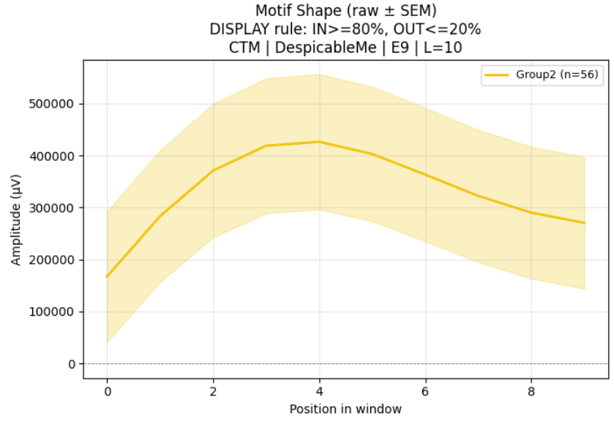
Figure 1. CTM motif shape — DespicableMe — Channel E9 — L=10 — rule IN≥80%, OUT≤20%.

As shown in Figure 2, this plot is for OPM on channel E9 (L=10).
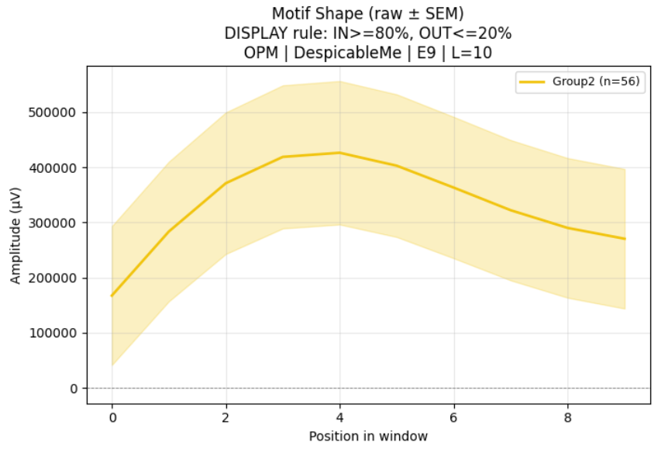
Figure 2. OPM motif shape — DespicableMe — Channel E9 — L=10 — rule IN≥80%, OUT≤20%.

As shown in Figure 3, this plot is for CTM on channel E15 (L=10).
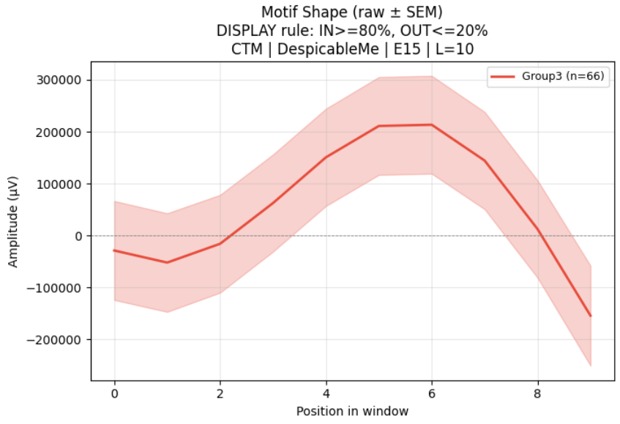
Figure 3. CTM motif shape — DespicableMe — Channel E15 — L=10 — rule IN≥80%, OUT≤20%.

As shown in Figure 4, this plot is for OPM on channel E24 (L=10).
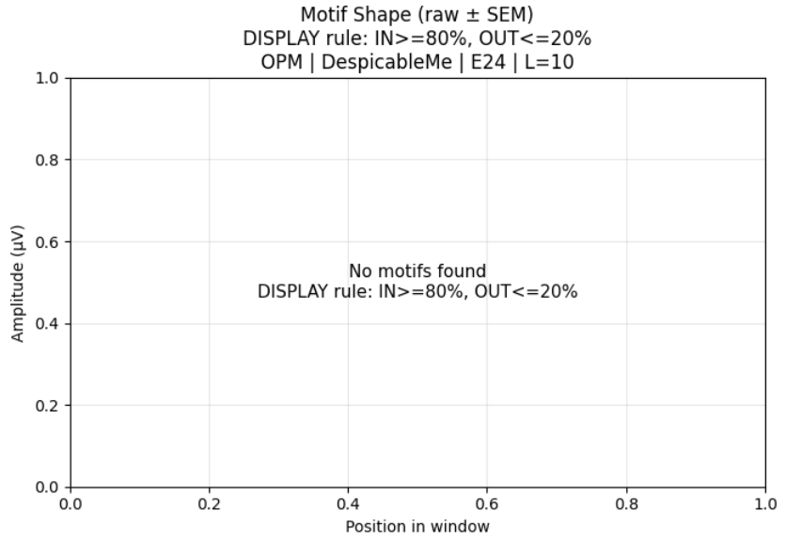
Figure 4. OPM motif shape — DespicableMe — Channel E24 — L=10 — rule IN≥80%, OUT≤20%.

As shown in Figure 5, this plot is for OPM on channel E1 (L=10).
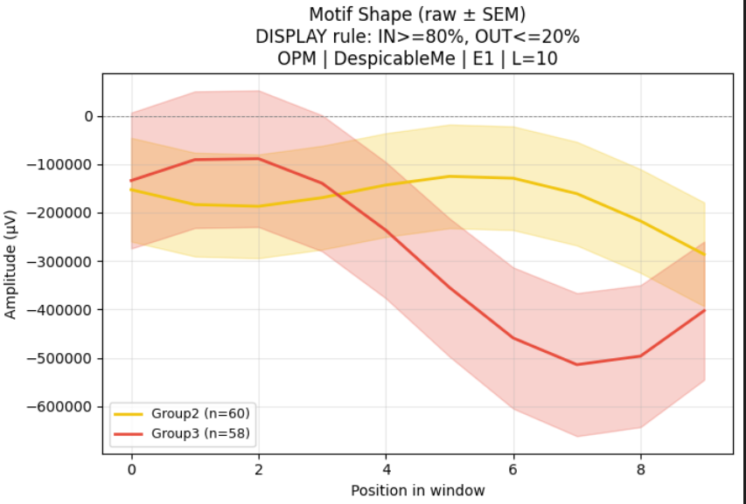
Figure 5. OPM motif shape — DespicableMe — Channel E1 — L=10 — rule IN≥80%, OUT≤20%.

As shown in Figure 6, this plot is for OPM on channel E5 (L=10).
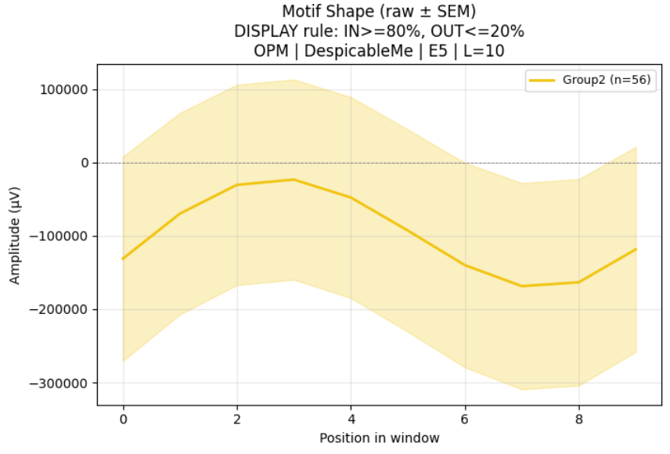
Figure 6. OPM motif shape — DespicableMe — Channel E5 — L=10 — rule IN≥80%, OUT≤20%.

As shown in Figure 7, this plot is for OPM on channel E8 (L=10).
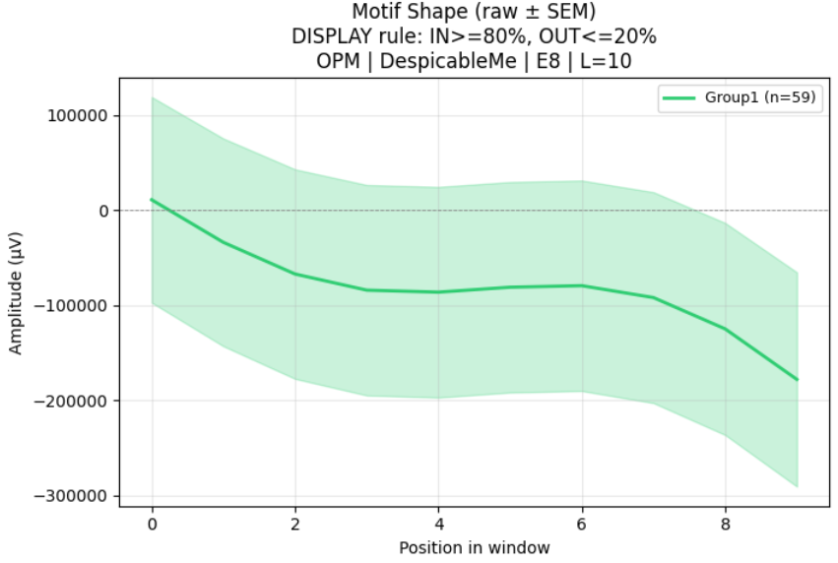
Figure 7. OPM motif shape — DespicableMe — Channel E8 — L=10 — rule IN≥80%, OUT≤20%.

As shown in Figure 8, this plot is for OPM on channel E10 (L=10).
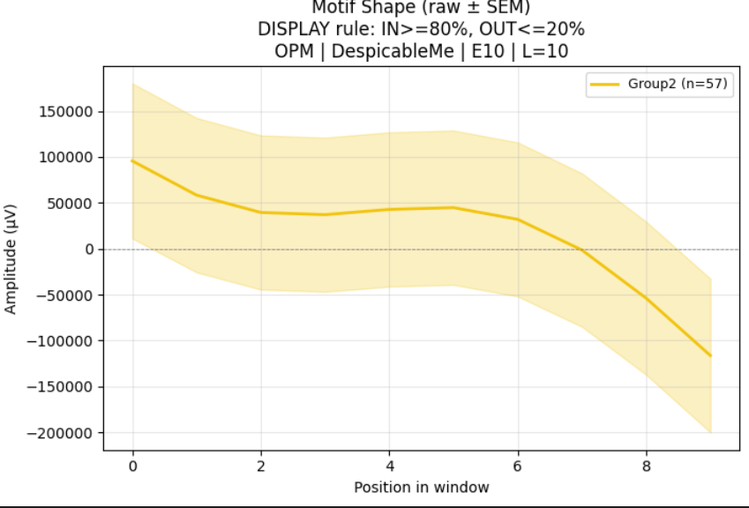
Figure 8. OPM motif shape — DespicableMe — Channel E10 — L=10 — rule IN≥80%, OUT≤20%.

As shown in Figure 9, this plot is for OPM on channel E23 (L=10).
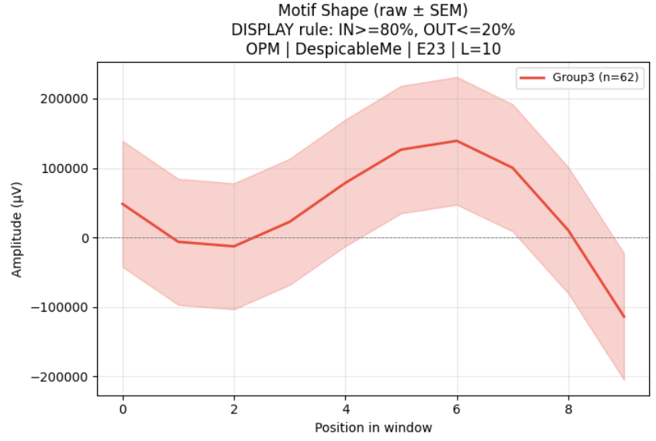
Figure 9. OPM motif shape — DespicableMe — Channel E23 — L=10 — rule IN≥80%, OUT≤20%.

Diversity per subject (boxplots)
Diversity is computed per subject as (number of unique codes) / (total codes) for the given channel and encoding.

As shown in Figure 10, this plot is for CTM on channel E9 (L=10).
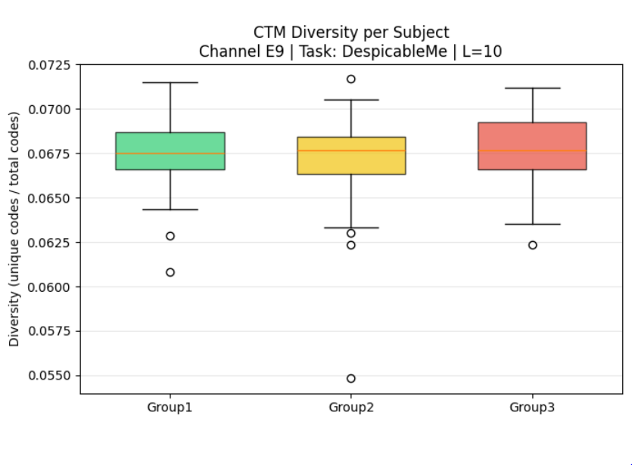
Figure 10. CTM diversity per subject — DespicableMe — Channel E9 — L=10.

As shown in Figure 11, this plot is for OPM on channel E9 (L=10).
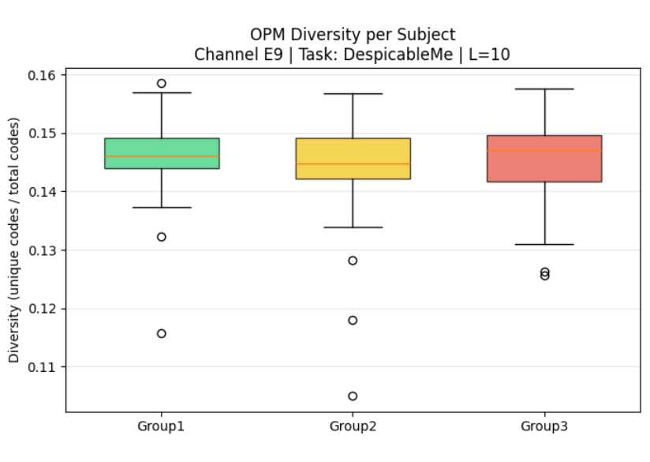
Figure 11. OPM diversity per subject — DespicableMe — Channel E9 — L=10.

As shown in Figure 12, this plot is for CTM on channel E15 (L=10).
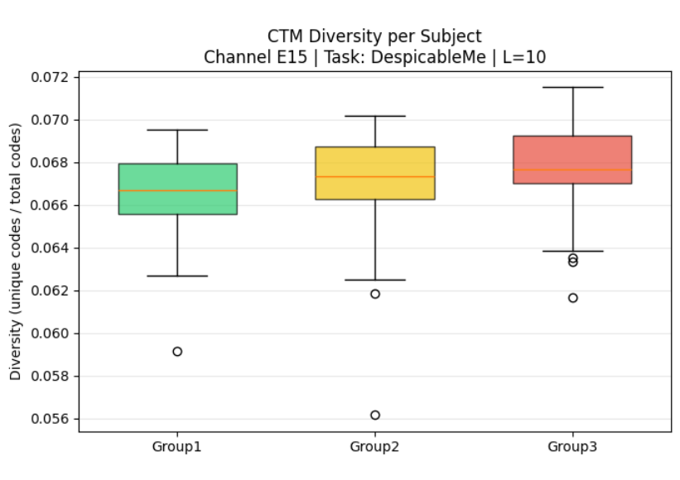
Figure 12. CTM diversity per subject — DespicableMe — Channel E15 — L=10.

As shown in Figure 13, this plot is for OPM on channel E24 (L=10).
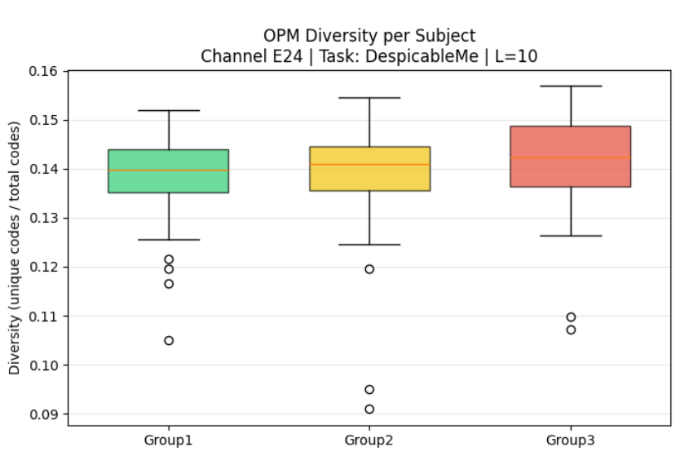
Figure 13. OPM diversity per subject — DespicableMe — Channel E24 — L=10.

As shown in Figure 14, this plot is for OPM on channel E1 (L=10).
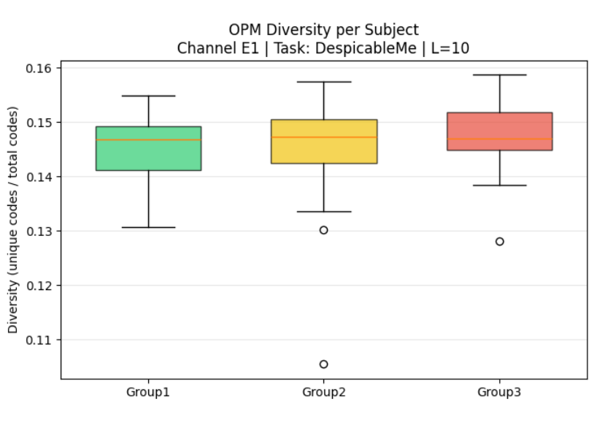
Figure 14. OPM diversity per subject — DespicableMe — Channel E1 — L=10.

As shown in Figure 15, this plot is for OPM on channel E5 (L=10).
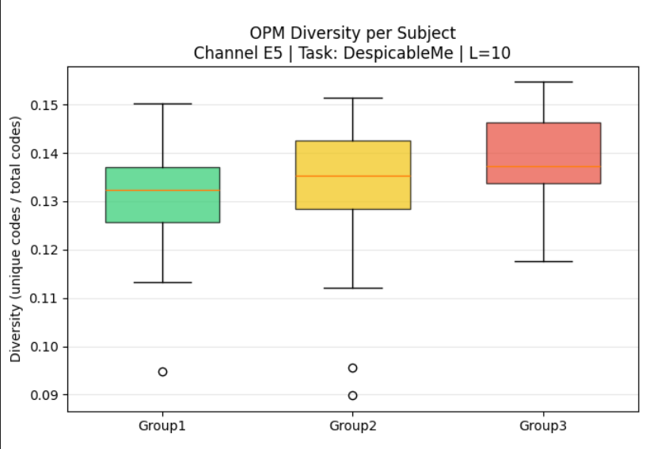
Figure 15. OPM diversity per subject — DespicableMe — Channel E5 — L=10.

As shown in Figure 16, this plot is for OPM on channel E8 (L=10).
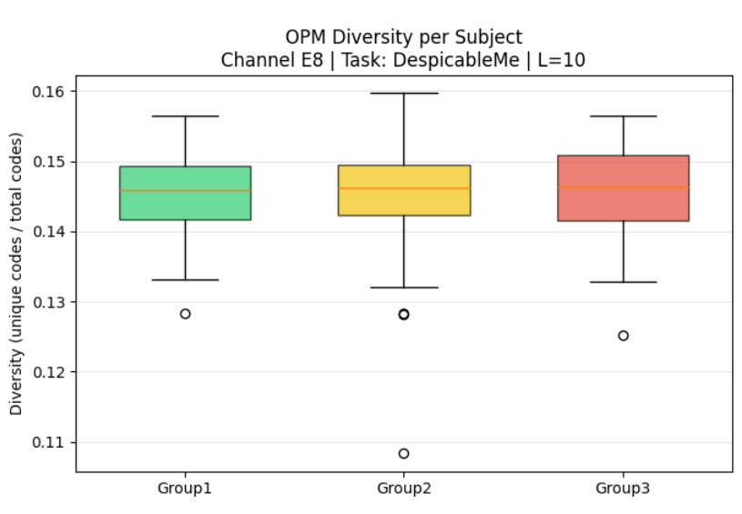
Figure 16. OPM diversity per subject — DespicableMe — Channel E8 — L=10.

Motif frequency per channel (median %)
Bar charts summarize the median percentage of windows that are motifs, per channel and age group.

As shown in Figure 17, this figure summarizes motif frequency across channels using OPM.
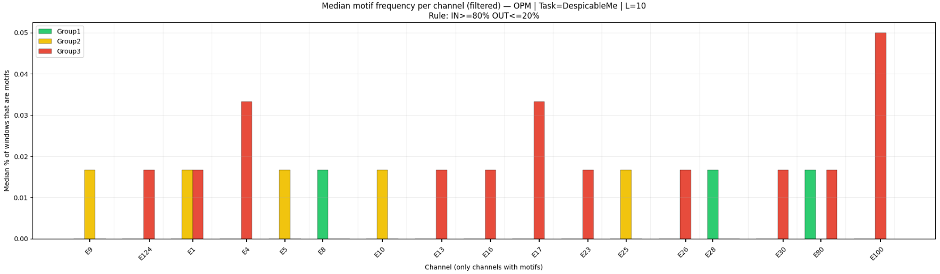
Figure 17. Median motif frequency per channel (filtered) — OPM — DespicableMe — L=10 — rule IN≥80%, OUT≤20%.

As shown in Figure 18, this figure summarizes motif frequency across channels using CTM.
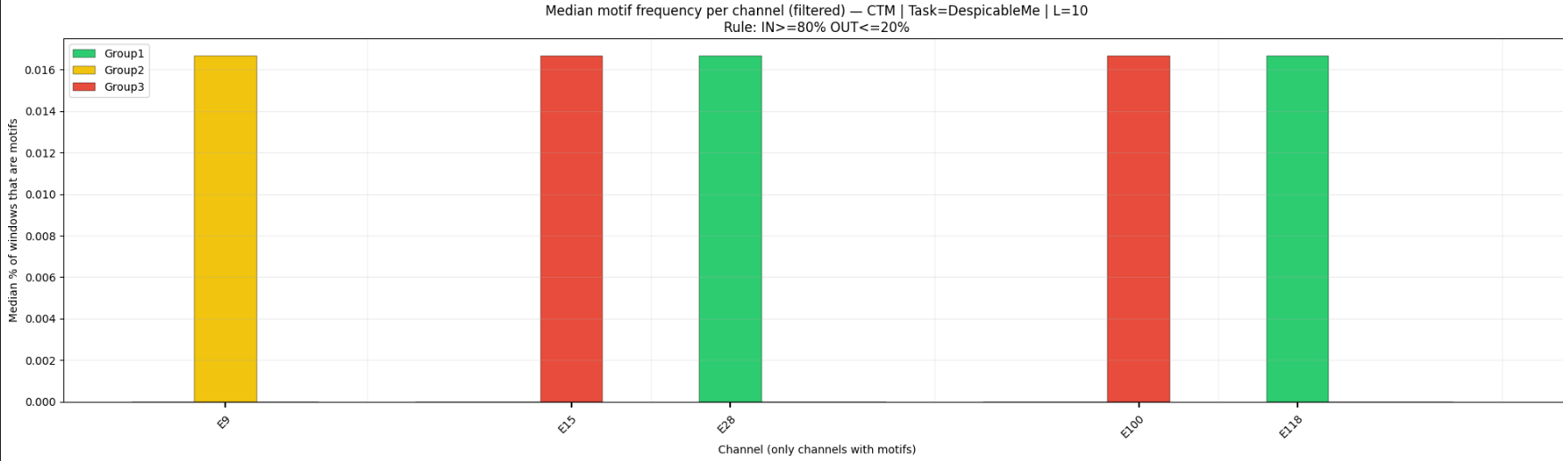
Figure 18. Median motif frequency per channel (filtered) — CTM — DespicableMe — L=10 — rule IN≥80%, OUT≤20%.

Task: RestingState
Task type: Passive (resting state).

Motif-shape plots (mean ± SEM)
Each plot shows the mean window shape across all motif windows that passed the rule, with a shaded band of ±SEM.

As shown in Figure 19, this plot is for CTM on channel E17 (L=10).
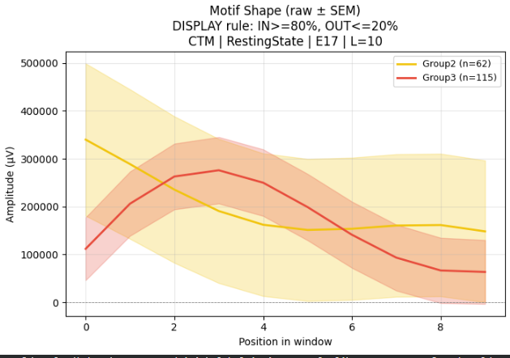
Figure 19. CTM motif shape — RestingState — Channel E17 — L=10 — rule IN≥80%, OUT≤20%.

As shown in Figure 20, this plot is for OPM on channel E14 (L=10).
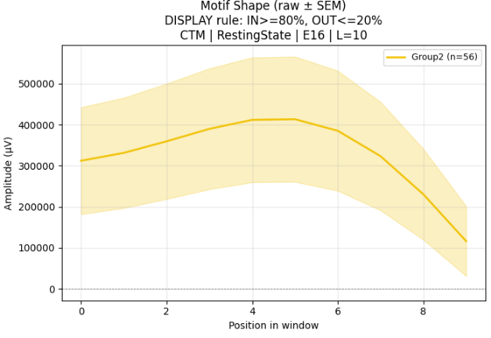
Figure 20. OPM motif shape — RestingState — Channel E14 — L=10 — rule IN≥80%, OUT≤20%.

As shown in Figure 21, this plot is for OPM on channel E90 (L=10).
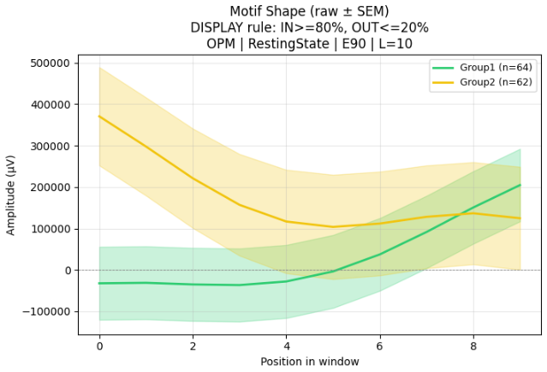
Figure 21. OPM motif shape — RestingState — Channel E90 — L=10 — rule IN≥80%, OUT≤20%.

Motif frequency per channel (median %)
Bar charts summarize the median percentage of windows that are motifs, per channel and age group.

As shown in Figure 22, this figure summarizes motif frequency across channels using CTM.
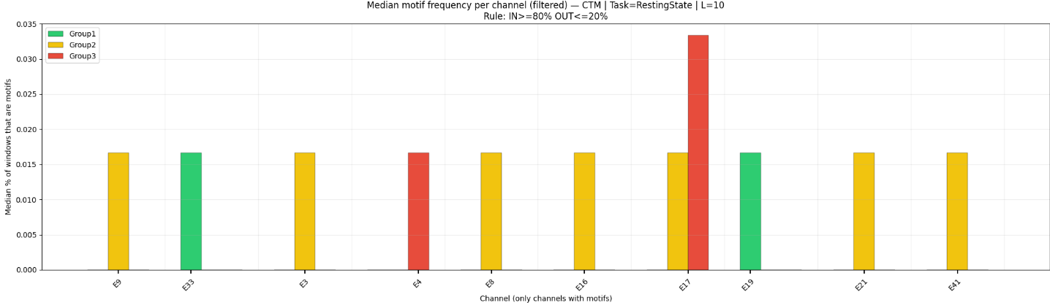
Figure 22. Median motif frequency per channel (filtered) — CTM — RestingState — L=10 — rule IN≥80%, OUT≤20%.

As shown in Figure 23, this figure summarizes motif frequency across channels using OPM.
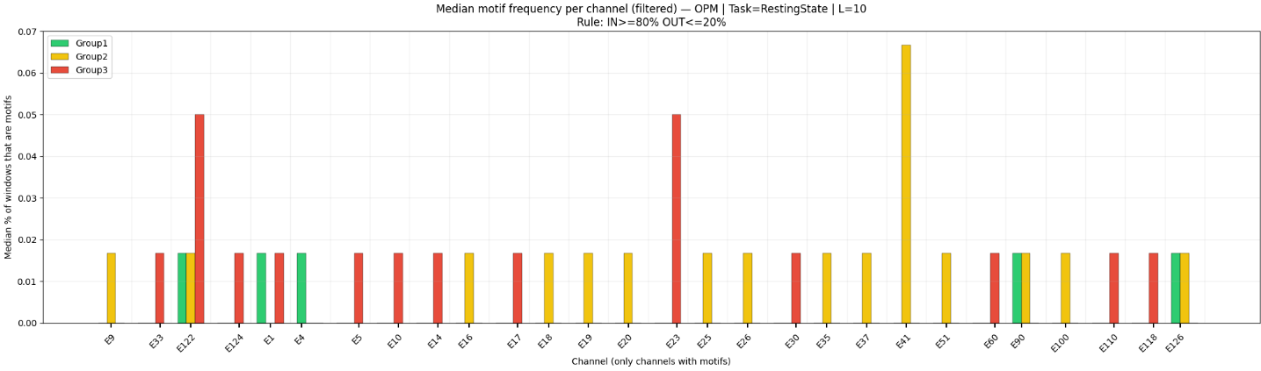
Figure 23. Median motif frequency per channel (filtered) — OPM — RestingState — L=10 — rule IN≥80%, OUT≤20%.

