
DataTales
Group Project

Table of Contents

INTRODUCTION 1
DATA PREPROCESSING 3
SETUP & INSTALLATION 8
REFERENCES 13

INTRODUCTION
The Problem
In the current emerging academic practices, total study hours cannot be the only element to consider when justifying a student's performance. It is also possible that everyday habits, lifestyle choices, and personal experiences can have an impact on a student's academia. Although previous studies have examined independent variables such as study time or sleep time, there is a knowledge gap regarding the joint effect of these diverse influences (Lakhani, 2024; Mary, 2024). For example, would a student who spends more hours studying and sleeps badly perform better than one who studies and spends enough hours sleeping? To answer these questions, a broader, data-driven strategy is needed rather than subjective methods. Answering the question of the relationship between various habits, situations, and exam performance, we will identify trends that provide informative findings for students seeking self-improvement and educators seeking to enhance their existing teaching techniques.

The Goal
To build an interactive dashboard that presents actionable insights on the correlation between student habits and academic results, which will enable educators and students to make better decisions in order to improve academic results.
Target Audience:
- Primary: Educational administrators and academic advisors.
- Secondary: Parents who are seeking their student’s improvement insights
- Tertiary: Researchers in educational psychology and policymakers.

The Dataset
A student's performance depends on their personal habits, lifestyle, and environmental factors. To achieve this multidimensional outlook, the dataset used in this project was developed with the same purpose: to study the influential relationships between student habits and academic success. The dataset, "Student Habits vs Academic Performance", is acquired from Kaggle’s open-source repository (Nath, 2025). It contains 1,000 student records, which include individual features related to daily lifestyle habits, socio-demographic characteristics, and final exam performance. The dataset grabs an all-inclusive assessment of a student’s life via numerous variables.

The Dashboard
The Student Performance Explorer Dashboard has been developed using Dash and Plotly within a Jupyter Notebook environment.
This interactive dashboard allows users to visually analyse student data and explore patterns in academic performance, lifestyle habits, and socio-economic factors.
The dashboard aims to:
- Present student data through clear and interactive visualisations.
- Help identify relationships between study habits, mental health, and exam outcomes.
- Support data-driven discussions on student wellbeing and performance.

DATA PREPROCESSING
Our Analysis Flow:
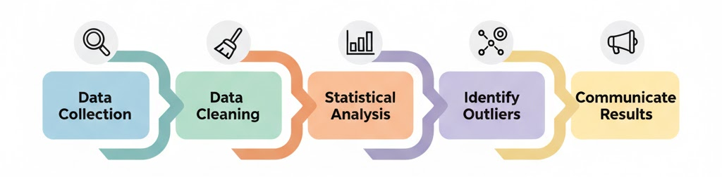
Figure 1: Analysis Flow
This section outlines the steps taken to prepare and analyse the dataset before creating the dashboard visualisations. The goal was to ensure the data was clean, consistent, and structured to support accurate insights.
The raw dataset (student_habits_performance.csv) was imported using the pandas library for cleaning and transformation.
Steps performed:
- Data Import and Initial Inspection
The dataset was loaded into a panda DataFrame and inspected using .head() and .info() to understand its shape, data types, and completeness.
df_student = pd.read_csv('student_habits_performance.csv')
df_student.head()
df_student.info()

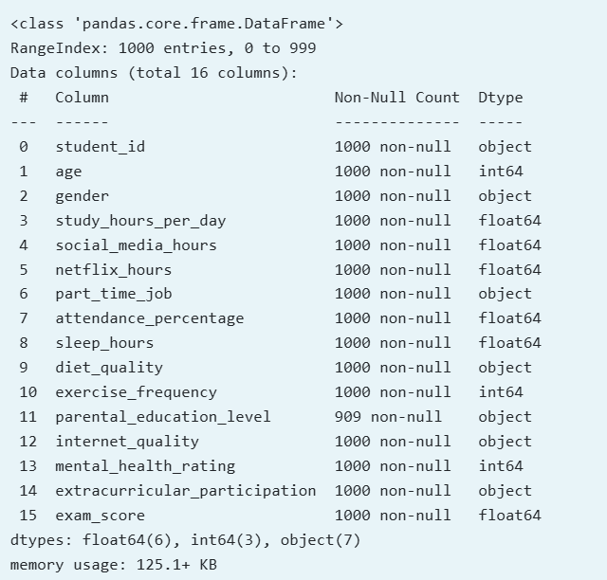
Figure 2: About the Data
This revealed 1000 records and 16 columns, including both numerical (e.g., exam_score, sleep_hours) and categorical variables (e.g., diet_quality, internet_quality).
- Handling Missing Values
A check for missing data using .isnull().sum()
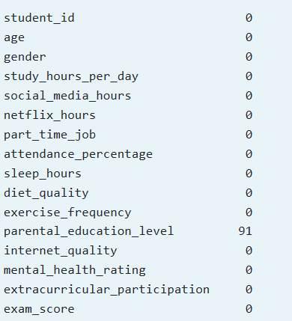
Figure 3: Missing Values
The output confirmed 91 missing values in 'parental_education_level'.
Since 'parental_education_level' is not needed for our current study hypotheses, we decided to drop this column entirely rather than imputing the missing data:
df_student = df_student.drop('parental_education_level', axis=1)
This ensured that subsequent analyses used only complete and relevant data.
- Data Type Verification and Conversion
Each column’s data type was reviewed to confirm correct formatting (e.g., numeric vs. categorical). No explicit conversions were required as all data types aligned correctly with their content.
While exploring the data characteristics, we analysed numerical columns (such as `exam_score`) to understand their distribution (mean, median, standard deviation) and categorical columns (like `diet_quality`) to determine the frequency of each category.
For Example:
Diet Quality Counts Output (`value_counts()`):
diet_quality
Fair 437
Good 378
Poor 185

- Feature Engineering and Transformation
Continuous numerical columns were grouped into categorical “bins” to enhance interpretability and visualisation clarity.
Examples:
- Sleep Hours were categorised into:
    - <7 hrs (below optimal)
    - 7–9 hrs (optimal)
    - >9 hrs (above optimal)
# Bin 'sleep_hours' into groups for H4
bins = [0, 7, 9, float('inf')]
labels = ['<7 hrs', '7-9 hrs', '>9 hrs']
df_student['sleep_hours_group'] = pd.cut(df_student['sleep_hours'], bins=bins, labels=labels, right=False)

- Exam Scores were similarly binned (e.g., “Low,” “Average,” “High”) for grouped analysis and colour-coded plots.
- Social media Hours were grouped into usage categories (Low, Moderate, High, Very High) to simplify pattern detection.
- Outlier Detection
Outliers are data points that are significantly different from others. We use box plots to visually identify them. The plot below shows the distribution of Exam Scores:
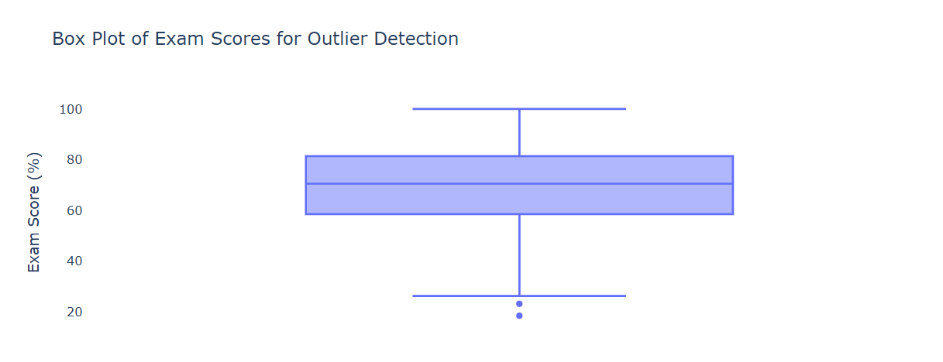
Figure 4: Outlier Detection
The box represents the interquartile range (IQR), the line inside is the median, and the 'whiskers' typically extend to 1.5 times the IQR from the box edges. Points beyond the whiskers are potential outliers.
For this dataset, all data appears within logical bounds (e.g., `exam_score` 0-100). An 'outlier' in context (like a student with high study hours but a low score) is not necessarily an error, but a valid data point representing real student experiences. Therefore, no outliers were removed based solely on this plot.
Summary of Data Readiness
After preprocessing and EDA:
- Dataset reduced from 16 to 15 columns (after dropping one irrelevant feature)
- Missing values were handled
- Key features were transformed into usable categories
Dataset confirmed ready for interactive dashboard development

SETUP & INSTALLATION
    - Prerequisites
Before running the dashboard, ensure the following software is installed on your system:
  - Anaconda Navigator: for managing Python environments and launching Jupyter Notebook.
  - Python 3.9 or later.
  - Jupyter Notebook: pre-installed within Anaconda.

    - Project Folder Setup
- Download the Project ZIP
All required files are provided in a single ZIP folder
Figure 5: ZIP Folder
- Extract the ZIP folder
- Locate the downloaded file on your computer.
- Extract it to your preferred location.
- Extraction will automatically create the correct folder structure and place all necessary files.
The extracted folder should look something like this:
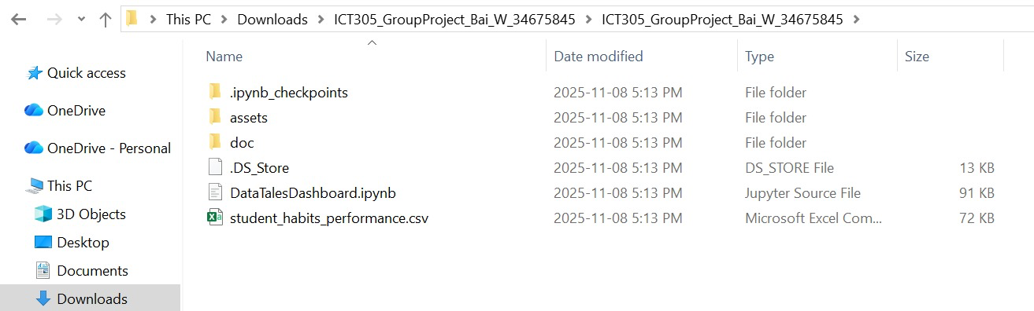
Figure 6: Project Folder Structure
File Descriptions:
- Assets folder: comprises of the logos and style.css which is used in the dashboard.
- DataTalesDashboard.ipynb: Jupyter Notebook containing the dashboard code.
- student_habits_performance.csv: Dataset file used for analysis.

    - Setting up the Anaconda-Navigator
Open the Anaconda Prompt from your Start Menu.
Enter these commands to install required packages:
1. pip install dash
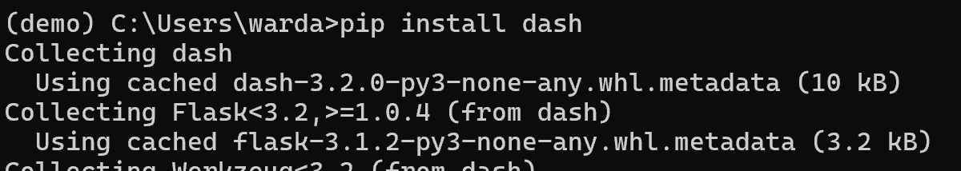
Figure 7: Dash installation
2. pip install dash_bootstrap_components
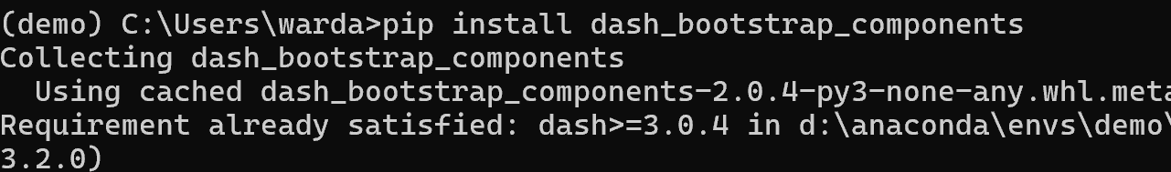
Figure 8: Dash_bootstrap_components installation

3. pip install pandas
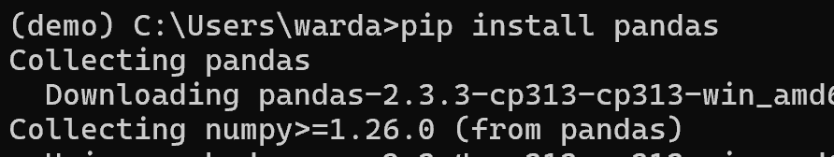
Figure 9: Pandas installation

    - Launching Jupyter Notebook
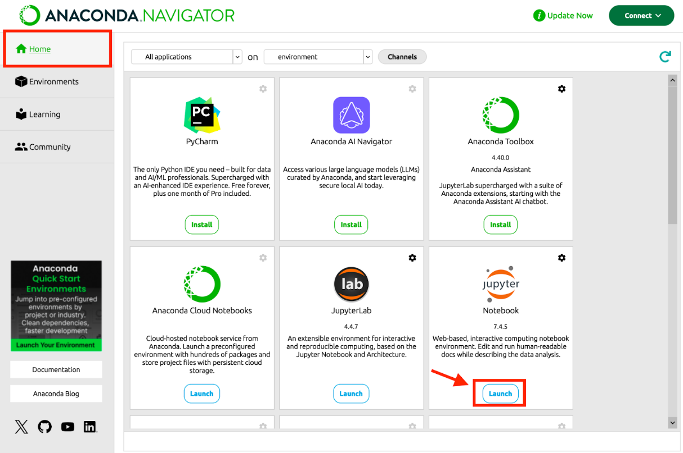
Figure 10: Navigate to Jupyter Notebook

Navigate to your extracted folder where DataTalesDashboard.ipynb is located:
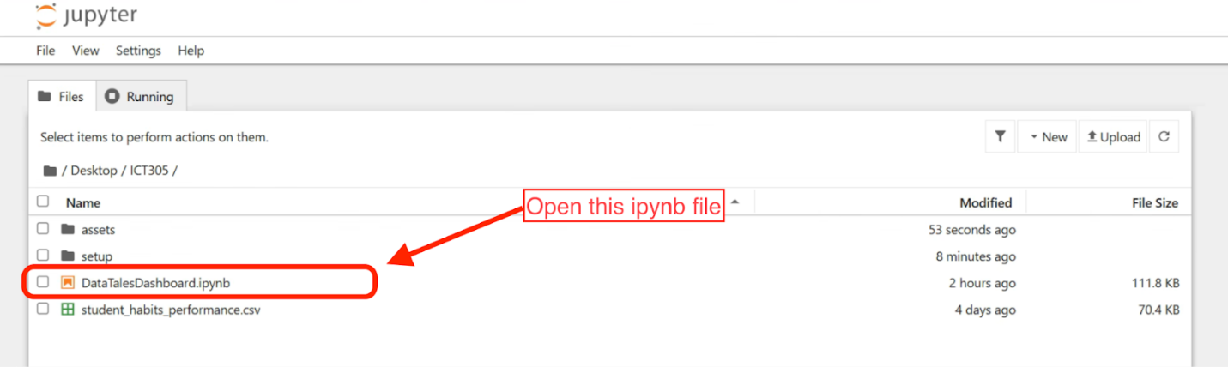
Figure 11: Launching the Notebook
    - Restarting the Jupyter Kernel and Launching the Dashboard
- After installation, restart the Jupyter Notebook kernel to apply changes:
  - In Jupyter, go to Kernel > Restart.
  - This ensures that the newly installed libraries are loaded correctly.
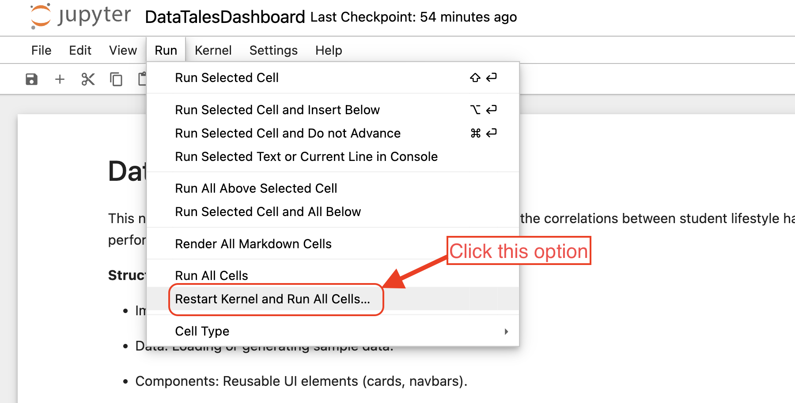
Figure 12: Restarting Kernel and Run all cell
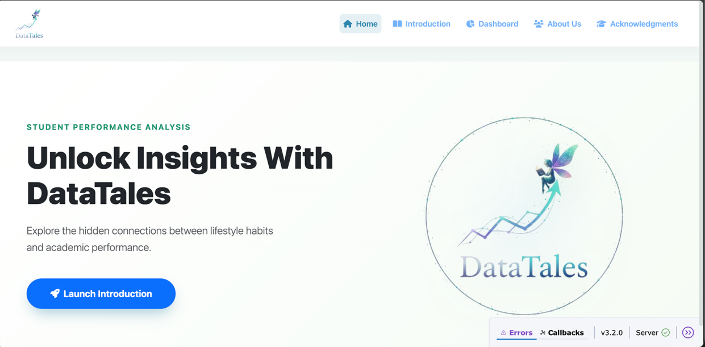
Figure 13: Screenshot of after running all cell
Additional Guidance if needed
- Stopping or Restarting the Dashboard
- After viewing the dashboard in your browser, you may stop it before re-running the notebook.
- Click the Stop button in the Jupyter toolbar or go to Kernel > Interrupt
- This releases the local server, allowing the dashboard to be started again without errors.
- Common Issues and Solutions
Issue | Cause | Solution
Dashboard not updating | The previous server is still running | Stop the current cell and restart the kernel

Table 1: Common Issues

REFERENCES
Lakhani, K. (2024). Sleep Patterns and Alertness in Class. The International Journal of Indian Psychology, 12(4). https://doi.org/10.25215/1204.157
Mary, B. J. (2024, December 30). A Quantitative Study of the Impact of Daily Study Hours on Academic Performance Among High School Students. ResearchGate. https-://www.researchgate.net/publication/387534719...
Nath, J. (2025). Student Habits vs Academic Performance. Kaggle.com. https://www.kaggle.com/datasets/jayaantanaath/student-habits-vs-academic-performance/data
The 'DataTales' logo and ‘Analysis Flow’ was designed with assistance from Google's Gemini 2.5 Pro.

