PIKVAIDYA AI: An Explainable Multimodal Ai
Framework For Crop Disease Diagnosis And
Context-Aware Smart Farming Recommendations

A Synopsis Report submitted
in
partial fulfilment of the requirements of the degree of
Bachelor of Technology
by
Washikar Tejas Uday | PRN: 23SC114281175
Wadkar Deepak Vishwas | PRN: 23SC114281174
Magdum Aryan Manoj | PRN: 23SC114281178
Under Guidance of:
Mr. Gurunath Machhale

Department of Computer Science and Engineering
School of Engineering and Technology
Faculty of Science and Technology
Sanjay Ghodawat University, Kolhapur
October 2026

Sanjay Ghodawat University, Kolhapur
Established under section 2(f) of UGC Act 1956
Sanjay Ghodawat University Act XL of 2017 of Govt. Of Maharashtra | Approved by PCI, COA & AICTE
Department of Computer Science and Engineering

CERTIFICATE
This is to certify that the project synopsis entitled “PikVaidya AI: An Explainable Multimodal AI Framework for Crop Disease Diagnosis and Context-Aware Smart Farming Recommendations” submitted by the below-mentioned students is work done by them and submitted during the 2026-2027 academic year, in partial fulfilment of the requirements for the Project Phase I Sanjay Ghodawat University, Kolhapur.
Names | PRN | Div
Washikar Tejas Uday | 23SC114281175 | B.Tech C
Wadkar Deepak Vishwas | 23SC114281174 | B.Tech C
Magdum Aryan Manoj | 23SC114281178 | B.Tech C

Mr. Gurunath Machhale | Dr. Ashish Patil | Dr. Deepika Patil
Project Guide | Project Coordinator | Head Of Department

Contents

No. | Particulars | Page No.
1 | Introduction | 1
2 | Literature Review | 1
3 | Motivation and Problem Statement | 8
4 | Objectives and Scope | 8
5 | System Architecture | 9
6 | AI Components and Decision Engine | 10
7 | Agricultural RAG and Knowledge Base | 11
8 | Context-Aware Recommendation Engine and Multilingual Farmer Assistant | 12
9 | Database Design | 13
10 | Technology Stack and Backend Design | 13
11 | System Methodology and Process Flowchart | 14
12 | Expected Outcomes | 16
13 | Evaluation Methodology | 16
14 | Security, Privacy and Safety | 17
15 | Project Timeline and Development Roadmap | 17
16 | Team Roles and Responsibilities | 18
17 | Project Innovation and Contribution | 18
18 | Limitations | 18
19 | Requirements | 19
20 | Future Scope | 19
21 | Conclusion | 19
 | References | 20

1. Introduction
PikVaidya AI is a farmer-focused AI decision-support framework for crop disease diagnosis and smart farming advice. It combines a crop image, the farmer's description, crop and farm details, soil and weather context, and verified agricultural knowledge in one workflow. The result is a possible diagnosis, an estimate of how severe the problem is, a visual explanation of why the system thinks so, and a recommendation in Marathi or English.
The pipeline follows the research direction of the project: crop image, disease detection, severity estimation, soil and weather context, multimodal fusion, explainable AI (XAI), retrieval-augmented (RAG) recommendation, and a multilingual farmer assistant. A final uncertainty check decides whether the recommendation is shown, or whether the system asks for more information or refers the case to an expert.
PikVaidya AI is an advisory and decision-support system. It does not claim 100% automatic diagnosis, and it does not replace agricultural officers, scientists, agronomists or laboratories. The first version is limited to about three to five crops and a manageable set of crop-health problems for which datasets can be obtained, trained, validated and evaluated. Candidate crops are cotton, sugarcane, soybean, tomato and onion.

1.1 Project Background
AI-based agricultural advisory already exists. The Government of Maharashtra launched the MahaVISTAAR-AI farm advisory app in May 2025 [20], a national platform, Bharat-VISTAAR, followed in February 2026 [27], and Maharashtra announced an AI-powered plant pest and disease detection system in 2026 [21]. Research on combining images with weather or soil data, on explainable plant disease models and on agricultural RAG systems has also grown quickly (Section 2). This synopsis therefore does not claim that any single component is new. The project contribution is a bounded, integrated and openly evaluated framework built on existing work.

1.2 Need for the Proposed System
A farmer may notice leaf spots, yellowing or drying without knowing the technical name of the problem. The same visible symptom can have different causes depending on crop stage, recent rainfall, humidity and soil condition. A useful first-level assistant must therefore collect the image and this context, estimate severity, explain its reasoning in simple terms, and say clearly when it is not sure. For example, if a farmer reports white spots on cotton leaves after heavy rain, the system should not declare a confirmed disease. It should list possible causes, show which part of the leaf and which conditions influenced the result, retrieve relevant advisories, and indicate its uncertainty.

2. Literature Review

2.1 Scope and Method of the Review
The review covers image-based disease detection, deep learning (CNN and Vision Transformer) models, severity estimation, soil-based and weather-based disease analysis, multimodal image-plus-context diagnosis, explainable AI, uncertainty estimation, RAG and LLM-based agricultural assistants, and multilingual advisory systems. Foundational papers [1], [2], [3], [6] are included together with recent work from 2024-2026. Sources are peer-reviewed journals and conference proceedings where available. Preprints [17]-[19] and news reports about government platforms [20], [21], [27] are marked as such.
Entries were prepared from the published abstracts and the accessible full texts. Where only an abstract was available, a feature described as missing means not reported in the text consulted; it does not prove

that the feature is absent from the work. Accuracy values are quoted as published by the authors on their own datasets, so they cannot be compared directly across
studies.

2.2 Comparative Research Table
Table 1 (next pages) lists, for each study, who did the work, what was proposed, how it was done, what was achieved, the limitations or research gap, a possible improvement and the relevance to PikVaidya AI.
Table 1: Comparative analysis of related research
Sr. | Researcher(s) / Year | Paper / System and objective | Methodology / technology | Main contribution / findings | Limitations / research gap |  | Possible improvement | Relevance to PikVaidya AI
A. Image-based crop disease detection

1 | Mohanty,  Hughes and  Salathé (2016)  [1] | Using deep learning for image-based plant disease detection. Objective: show that smartphone-assisted disease diagnosis is technically feasible. | Deep CNN trained on the  PlantVillage set: 54,306 leaf images, 14 crop species, 26 diseases (plus healthy). | Reported 99.35% accuracy on a held-out test set from images collected under controlled conditions. | Accuracy was much lower on images from outside the controlled set, and the authors call for more diverse training data. Image-only; no severity, context or advice. |  | Field-condition images, augmentation, and added context and knowledge layers. | Foundation for the image module; motivates field-realistic evaluation.
2 | Ferentinos  (2018)  [2] | Deep learning models for plant disease detection and diagnosis. Objective: compare CNN models on a large open image set. | Several CNN architectures trained on 87,848 images; 25 plants; 58 [plant, disease] classes including healthy. | Best model reached a 99.53% success rate; presented as an advisory or early-warning tool. | Simple leaf images from an open database; the abstract itself says the approach still needs extension to real cultivation conditions. Image-only; no severity or recommendation. |  | Train and test on fieldcaptured images; add context and explanation. | Gives candidate backbones for the baseline image model.
3 | Ramcharan et al. (2017) [3] | Deep learning for imagebased cassava disease detection. Objective: detect cassava diseases and pest damage from field images for mobile use. | Transfer learning of a CNN on cassava images taken in the field in Tanzania; three diseases and two pestdamage types. | Class accuracies of  95-98%; overall 93% on data not used in training. | Single crop; image-only; no severity, weather, soil, explanation or advisory in the reported work. |  | Extend to more crops; combine with weather and soil context and a knowledge layer. | Supports transfer learning on field images and mobile deployment.
4 | Singh et al. (2020) [4] | PlantDoc: a dataset for visual plant disease detection. Objective: provide nonlaboratory images for plant disease detection. | 2,598 annotated internetscraped images, 13 species, 27 classes (diseased and healthy); three classifiers benchmarked. | Showed that modelling with the dataset can raise classification accuracy by up to 31%. | Small and web-sourced; images only; no context or severity labels. |  | Larger, geographically diverse field datasets with metadata (location, date, stage). | Used for field-realistic evaluation of the image model.
5 | Ergun (2025) [5] | Attention-enhanced hybrid model for mango leaf disease (MangoLeafCMDFFAMNet).  Objective: improve classification with CNN and Transformer features. | ConvNeXt and Vision  Transformer features combined by dynamic fusion with a feature attention module. | Reports superiority over baseline models on mango leaf disease classification. | Single crop; image-only; abstract does not report severity, soil, weather, advice or uncertainty. |  | Test on multi-crop field data; add context and calibrated confidence. | Supports comparing CNN, ViT and hybrid backbones.
B. Severity estimation

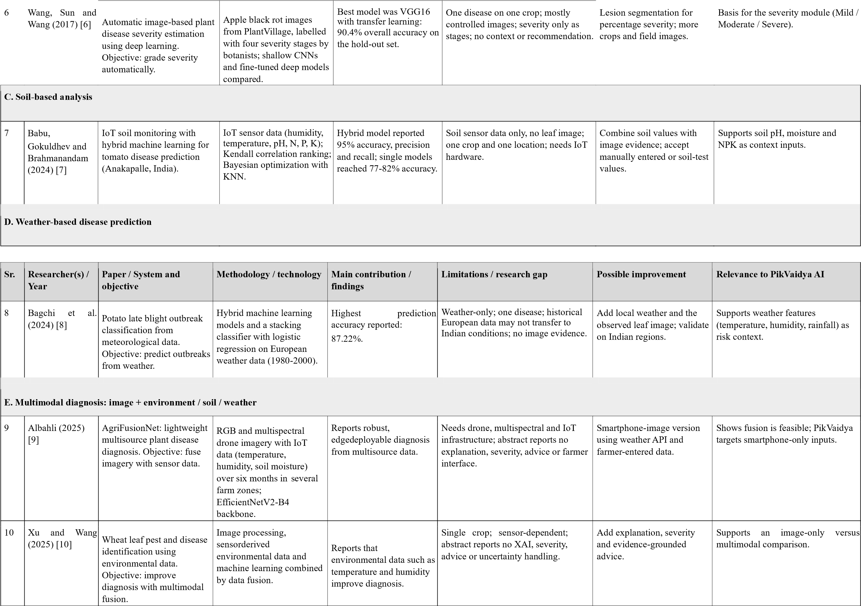
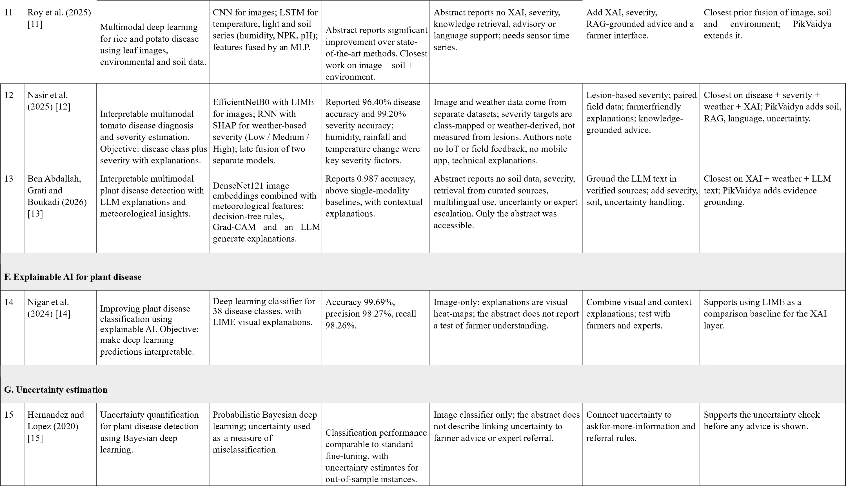

Sr. | Researcher(s) / Year | Paper / System and objective | Methodology / technology | Main contribution / findings | Limitations / research gap | Possible improvement | Relevance to PikVaidya AI
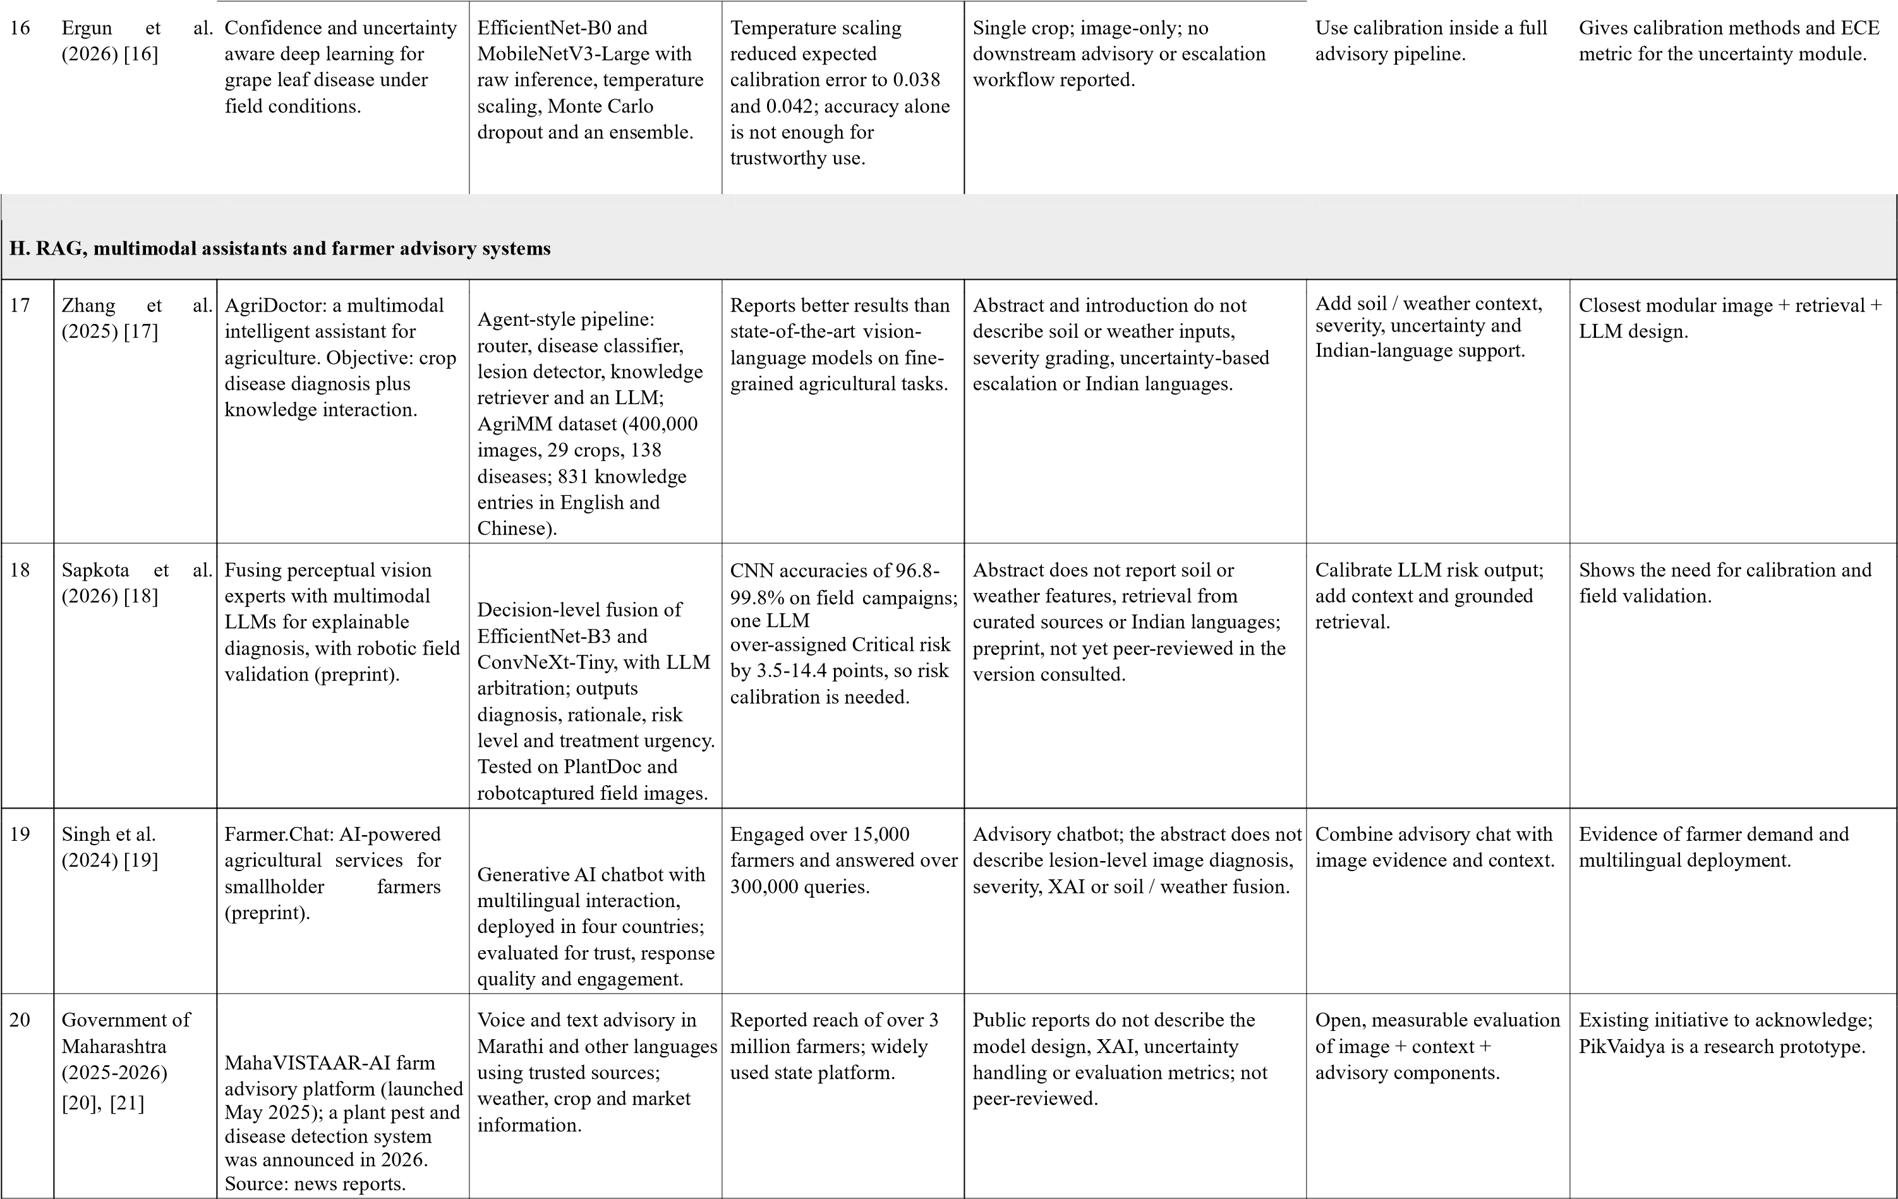

Table 2: Feature coverage of the closest related systems (derived from Table 1)
Study | Disease detect. | Severity | Soil | Weather | Fusion | XAI | RAG | Recomm. | Multi-ling ual | Uncert. | Expert escal. | Field eval.
Roy et al. 2025 [11] | Y | - | Y | Y | Y | - | - | - | - | - | - | -
Nasir et al. 2025 [12] | Y | Y* | - | Y | Y | Y | - | - | - | - | - | -
Ben Abdallah et al. 2026 [13] | Y | - | - | Y | Y | Y | - | - | - | - | - | -
Albahli 2025 [9] | Y | - | P | Y | Y | - | - | - | - | - | - | Y
Zhang et al. 2025 [17] | Y | - | - | - | Y | - | Y | P | P | - | - | -
Sapkota et al. 2026 [18] | Y | P | - | - | Y | Y | - | P | - | P | - | Y
Ergun et al. 2026 [16] | Y | - | - | - | - | - | - | - | - | Y | - | Y
Farmer.Chat 2024 [19] | - | - | - | - | - | - | P | Y | Y | - | - | Y
MahaVISTAAR-AI [20], [21] | P | - | - | Y | - | - | P | Y | Y | - | - | Y
PikVaidya AI (proposed) | Pl | Pl | Pl | Pl | Pl | Pl | Pl | Pl | Pl | Pl | Pl | Pl
Y = reported in the text consulted; P = partly reported; - = not reported in the text consulted (not proof of absence); Y* = severity derived from weather or class mapping, not lesion measurement; Pl = planned in PikVaidya AI. Evaluation against measured results is still to be done.

2.3 Critical Analysis of the Literature
Image-only detection is mature but depends on the data. Early work reached very high accuracy on PlantVillage-type images [1], [2], but the same authors point to the need for more diverse training data, and later work built datasets of field and web images to narrow the gap between laboratory and real conditions [3], [4], [26]. Hybrid CNN and Transformer backbones continue to appear [5], although usually for one crop and without context.
Severity is studied less than detection. Wang et al. graded apple black rot into four stages [6]. Later multimodal work estimates severity from weather rather than from lesions [12].
Soil and weather are useful predictors, but are often studied separately from images. Soil sensor data [7] and meteorological data [8] can predict disease risk on their own; fusing them with images is more recent [9]-[13].
Explainability and uncertainty are growing topics. Visual explanations such as LIME and Grad-CAM are common for image models [14], [23], [25]; SHAP is used for tabular context [12], [24]. Uncertainty and calibration methods have been applied to image classifiers [15], [16]. A recent field study with an LLM arbitrator found that risk levels needed calibration [18].
Knowledge-grounded assistants. RAG [22] grounds language-model answers in retrieved documents. Agricultural examples include a modular image-plus-retrieval assistant [17], a deployed multilingual chatbot [19] and the Maharashtra platform [20], [21].

2.4 Identified Research Gap
Table 2 shows that individual components have been studied: disease detection, severity, soil and weather inputs, image-context fusion, XAI, retrieval, advisory chat, uncertainty and field-image evaluation. Several recent papers already combine two to four of them. Roy et al. [11] fuse images with soil and environmental data; Nasir et al. [12] combine disease classification, weather-based severity and LIME / SHAP; Ben Abdallah et al. [13] add meteorological features, Grad-CAM and LLM explanations; Zhang et al. [17] link an image classifier, lesion detector, retriever and LLM. These papers are not hidden by this project; PikVaidya AI builds on them.
Within the studies consulted, the following aspects remain insufficiently covered. This is an evidence-based reading of Tables 1 and 2, not a claim that no unpublished or proprietary system exists.
Remaining gap and evidence | How PikVaidya AI addresses or extends it
G1. Lesion-based severity inside a fused pipeline.  Severity is absent in most fusion studies [9]-[11], [13], or derived from weather or class mapping rather than measured on the leaf [12]. | A separate severity module (Mild / Moderate / Severe) driven by the image, with class definitions and metrics set by the available annotated data; context adjusts the advice, not the measured severity.
G2. Image, soil and weather with realistic inputs.  Fusion work often needs IoT or drone sensors [9], [11] or uses image and weather datasets that were not collected together [12]. | Smartphone image plus farmer-entered or API-supplied context. Paired data are scarce, so the plan includes an image-only versus multimodal comparison and a rule-based context fallback if paired data cannot be collected.
G3. Explanations that farmers can use. Explanations are mainly technical heat-maps or feature plots [12], [14]; LLM text in [13] is not described as grounded in curated sources. | Grad-CAM for the image, SHAP for context factors, then a plainlanguage explanation tied to retrieved sources.  Faithfulness, expert review and farmer understanding are all evaluated.
Remaining gap and evidence | How PikVaidya AI addresses or extends it
G4. Evidence-grounded, context-aware  recommendations. Retrieval-based assistants [17], [19] are not described as using severity, soil and weather together; fusion papers do not retrieve advice. | RAG over ICAR, university, government and peer-reviewed material, filtered by crop, disease, severity, stage and region, with source citations and safety rules for chemical advice.
G5. Uncertainty linked to action. Uncertainty and calibration exist for image classifiers [15], [16], but the reviewed fusion and assistant papers do not describe an abstain, ask-for-more or expert-referral policy; LLM risk output may be mis-calibrated [18]. | Calibrated confidence and rule checks before any advice is shown; low-confidence, severe or out-of-scope cases trigger a request for more information or expert referral.
G6. End-to-end and field-realistic evaluation in Marathi. Most studies report component metrics on public datasets; the Maharashtra platform [20], [21] is documented mainly through news reports. | Component and end-to-end evaluation (Section 13), including image-only versus multimodal ablation, XAI faithfulness, RAG groundedness and Marathi / English usability, with all values treated as targets until measured.

2.5 Position of PikVaidya AI
PikVaidya AI is presented as an integrated research and engineering framework that builds on [1]-[27] and addresses G1-G6 in a bounded setting (a few crops, one state). Its contribution is the integration, the openly reported evaluation and the safety design, and not the invention of any single technique.

3. Motivation and Problem Statement

3.1 Motivation
Farmers need timely and understandable help when a crop shows a problem. They must interpret symptoms, decide what information matters and choose a next step. The literature shows that detection from images alone can be accurate on benchmark data but is less reliable outside the conditions it was trained on [1], [4], and that weather and soil change both the likelihood and severity of disease [7], [8], [12]. Farmers also describe problems in everyday Marathi, and trust depends on understanding why a system gave its answer.

3.2 Problem Statement
To design, implement and evaluate an explainable multimodal AI framework that accepts a crop image and farmer-provided crop, soil, location and weather context, estimates disease and severity, explains the result, retrieves verified agricultural knowledge, and gives context-aware recommendations in Marathi and English, while communicating uncertainty and referring low-confidence or out-of-scope cases to an expert.

3.3 Core Design Principle
The system combines visual evidence, farmer and field context, and verified knowledge instead of depending on an LLM alone. An uncertain assessment is never presented as a confirmed diagnosis. Every response states the possible problem, its estimated severity, why the system thinks so, the recommended next step, the sources and the level of confidence.

4. Objectives and Scope

4.1 Objectives
The primary objective is to provide accessible, explainable and evidence-grounded crop-health guidance through an integrated AI decision-support framework. The specific objectives are:
- Detect possible diseases and pest damage from crop images for the selected crops.
- Estimate severity as Mild, Moderate or Severe, with classes and metrics set by the available data.
- Use soil, weather, location and crop-stage information as context through multimodal fusion, and compare it with an image-only model.
- Explain each prediction with suitable XAI methods and communicate confidence in farmer-friendly terms.

4.2 MVP Scope and Future Extensions
Weather and soil context are part of the MVP, but in a form that is realistic for a smartphone user. Items marked as future extensions stay outside the MVP unless time allows them without weakening the core workflow.
Area | MVP (this project) | Future extension
Farmer, farm, crop data | Registration, farm and crop profiles, preferred language, crop stage. | Government ID integration (not planned for MVP).
Image analysis | Image upload and validation; disease detection for about 3-5 crops; three-level severity. | More crops; lesion segmentation for percentage severity; improved models.
Weather context | Temperature, humidity, rainfall and wind for the farm location from a weather API or farmer report; recent conditions. | Forecast-based risk alerts; extremeweather alerts.
Soil context | Soil type, pH, moisture and NPK where the farmer has them (soil test or soil health card). | IoT soil sensors; satellite and remotesensing data.
Fusion and XAI | Feature-level fusion with image-only baseline; Grad-CAM and SHAP explanations. | Attention-based fusion; counterfactual explanations.
RAG and recommendations | Controlled knowledge base; context-aware recommendations with sources. | Knowledge-graph (GraphRAG) retrieval.
Assistant | Marathi and English text chat. | Voice input, text-to-speech, more Indian languages.
Uncertainty and referral | Calibrated confidence, request for more information, expert referral records. | Live expert connection; yield prediction and market intelligence.

5. System Architecture
The architecture follows the pipeline in Figure 1. The farmer uses a web or mobile application to supply a crop image, crop type, crop age or growth stage, a description of the problem, soil information, location and weather information. The FastAPI backend validates the inputs, fetches weather data and orchestrates the AI pipeline. The multimodal fusion layer combines image features with context features. Disease detection, severity estimation and the XAI layer follow. The RAG knowledge base and the context-aware recommendation engine prepare the advice, and the Marathi / English assistant presents it. A final uncertainty check decides between showing the recommendation and requesting more information or an expert referral. Records are stored in PostgreSQL with pgvector.
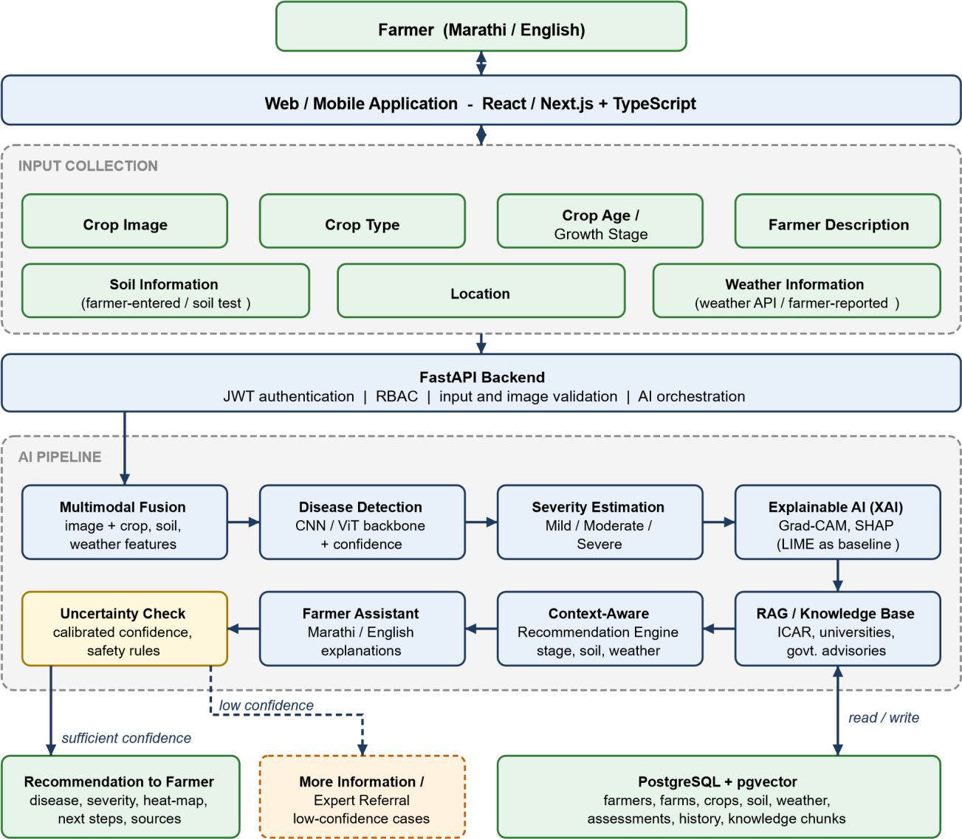
Figure 1: System architecture of PikVaidya AI

5.1 Farmer, Farm and Crop Data
The account stores name, mobile number, location, preferred language, farming experience and basic farm details. Data is organized as Farmer > Farm > Crops / Crop Cycles. A farm holds location, area, soil type and irrigation details; a crop record holds crop name, variety, sowing date and growth stage; soil test values and weather records are linked to the farm and date. This structured information is used as context by the AI pipeline. Aadhaar integration is not part of the MVP.

6. AI Components and Decision Engine

6.1 Input Context
Context features are: crop type, crop age or growth stage, location, temperature, humidity, rainfall, wind, recent weather, soil type, soil pH, soil moisture and soil nutrients where available. Missing values are allowed and are flagged, so that the system can ask for them instead of guessing.

6.2 Multimodal Fusion
The image branch produces an image embedding with a CNN or Vision Transformer backbone (for example EfficientNet, ConvNeXt or ViT, chosen after experiments [5], [9], [12]). A second branch encodes the context features with a small neural network. The two are combined by feature-level fusion (concatenation followed by a classifier, or attention if it helps). Three variants are compared in an ablation study: imageonly, late fusion of separate image and context models as in [12], and the proposed feature-level fusion. Paired image-and-context datasets are scarce. The team will look for public paired datasets, collect a small field dataset with expert labels where possible, and otherwise use context as a rule-based risk modifier based on agronomic literature. Which option is used will depend on the data actually obtained.

6.3 Disease Detection
Outputs are: possible disease, pest damage, nutrient deficiency, water stress, physical damage, healthy, or unknown / low-confidence. Only crops and classes supported by usable datasets are included. PlantVillagestyle data [26] may be used for pre-training, and field-style data such as PlantDoc [4] and images collected locally are used for validation and testing, because laboratory images alone give an optimistic picture [1], [4].

6.4 Severity Estimation
Severity is a separate component with the classes Mild, Moderate and Severe. Two approaches are considered: classification of severity stages as in [6], and lesion segmentation to compute the percentage of affected leaf area with thresholds. The choice, the class definitions and the metrics depend on the annotated data that can be obtained, and an agronomy expert will be asked to review the thresholds. No severity accuracy is claimed in this synopsis.

6.5 Soil and Weather Context
Weather and soil data are inputs to fusion and to the recommendation engine. Weather is retrieved by location and date, with farmer-reported conditions as a fallback. Soil values come from the farmer, a soil test or a soil health card. IoT sensors, satellite data and forecast-based alerts are future extensions.

6.6 Explainable AI Layer
XAI is an explicit component, and each technique is used only where it fits the model. Grad-CAM [23] highlights the leaf regions that influenced a convolutional image classifier. SHAP [24] shows which soil, weather and crop features pushed the result. Attention visualization is used only if a Vision Transformer is selected. LIME [25] is a model-agnostic comparison baseline. The farmer sees the highlighted image, a plain-language sentence such as which spots and which weather conditions mattered, and a confidence level in words (high, medium, low) rather than raw probabilities.

6.7 Uncertainty and Expert Escalation
Confidence is calibrated on a validation set, for example with temperature scaling, Monte Carlo dropout or an ensemble [15], [16]. Thresholds are chosen from validation results. If confidence is low, the crop or class is out of scope, required information is missing, or severity is high, the system says "Unable to determine reliably", asks for more information or another image, and records an expert referral. The system complements expert and extension services and does not replace them.

7. Agricultural RAG and Knowledge Base
A controlled knowledge base supplies the language model with relevant, trusted information instead of relying only on its general learned knowledge [22]. Sources are ICAR, agricultural universities, government agriculture departments, official crop advisories, government schemes, peer-reviewed research and verified extension material. This grounds recommendations in agricultural evidence, makes sources traceable and allows the knowledge base to be updated without changing the model.
Step | Activity | Output
1. Collection | Gather official and verified documents for the selected crops and problems. | Source documents
2. Cleaning | Remove duplicate or unusable material; standardize content. | Standardized content
3. Chunking | Divide documents into sections; add metadata (crop, disease, severity, growth stage, region, source). | Retrievable chunks
4. Embedding | Convert chunks into vectors using a multilingual embedding model so that Marathi and English queries can be matched. | Embeddings
5. Storage | Store embeddings with metadata in PostgreSQL / pgvector. | Searchable knowledge
6. Retrieval | Find chunks matching the predicted disease, severity, crop stage, region and the farmer's question. | Evidence
7. Grounding | Give the evidence, image result, severity and context to the LLM. | Grounded draft
8. Validation | Check that the answer stays within the retrieved evidence and system scope; attach sources. | Validated response

8. Context-Aware Recommendation Engine and Multilingual Farmer Assistant

8.1 Context-Aware Recommendation Engine
The engine receives the disease, severity, confidence, crop stage, weather, soil and region, retrieves matching advisories, and drafts a recommendation in a fixed structure: observed symptoms, possible causes, why the context matters, severity, recommended next step, uncertainty, sources, and expert referral when needed. Recommendations are grouped as monitoring, cultural practices, irrigation or nutrient adjustment, and chemical control. Chemical advice is given only when an official source supports it, and always with a note to follow the label and consult an agriculture officer. The system does not issue automatic pesticide prescriptions.

8.2 Multilingual Farmer Assistant
The assistant accepts questions in Marathi or English, for example a Marathi description of spots on cotton leaves or "My sugarcane leaves are turning yellow". It turns the text into structured symptoms, maps local terms for symptoms and diseases to standard names, retrieves knowledge and answers in the farmer's preferred language. Translation and language quality will be checked with Marathi-speaking reviewers. Voice input is a future extension.

9. Database Design
PostgreSQL with pgvector stores relational data and knowledge embeddings.
Group | Tables
Accounts and farms | users, farmers, farms, crops, crop_cycles
Context | soil_records, weather_records
Assessments | crop_images, symptom_reports, ai_assessments (disease, severity, confidence), xai_artifacts (heat-maps, feature importance), recommendations, recommendation_sources
Conversations | conversations, messages
Knowledge base | knowledge_documents, knowledge_chunks
Support and traceability | expert_referrals, feedback, audit_logs, model_versions
The main relationship is User > Farmer > Farm > Crop Cycle > Images / Soil / Weather / Assessments / Recommendations. This keeps information across crop cycles and future interactions.

10. Technology Stack and Backend Design
Component | Proposed Technology | Purpose
Frontend | React / Next.js + TypeScript | Responsive farmer interface, Marathi / English
Backend | Python + FastAPI | REST APIs, authentication, orchestration
Database | PostgreSQL + pgvector | Application data and knowledge embeddings
Computer vision | PyTorch; CNN / ViT backbones | Disease detection and severity
Context and fusion | Weather API; tabular encoder; feature-level fusion | Soil and weather context
XAI | Grad-CAM, SHAP, LIME libraries | Explanations
RAG and LLM | Multilingual embeddings; vector retrieval;  LLM | Grounded recommendations and chat
Security | JWT, RBAC, audit logs | Access control and traceability
Deployment | Docker / cloud as appropriate | Packaging and deployment

10.1 Backend Modules
core (configuration, database, security), users, farms, crops, context (soil and weather), assessments, reports, experts, ai (orchestrator, fusion, detection, severity, XAI, recommendation, response validation) and knowledge (ingestion, embeddings, retrieval).

10.2 Important APIs
Area | Endpoints
Auth, farmer | POST /api/v1/auth/register, POST /api/v1/auth/login, GET /api/v1/auth/me, GET and PUT /api/v1/farmer/profile
Farms, crops | POST and GET /api/v1/farms, /api/v1/crops; GET /api/v1/farms/{farm_id}, /api/v1/crops/{crop_id}
Context | POST and GET /api/v1/farms/{farm_id}/soil; GET /api/v1/farms/{farm_id}/weather
AI | POST /api/v1/ai/assessment, /api/v1/ai/image-analysis, /api/v1/ai/chat
History, expert | GET /api/v1/assessments, /api/v1/assessments/{id}; POST and GET /api/v1/expert/referral

11. System Methodology and Process Flowchart
The methodology is an end-to-end pipeline in which every stage adds evidence or a check, and the LLM stays inside a controlled workflow (Figure 2). Two decision points protect the farmer: an input check at the start and a confidence, grounding and safety check before anything is shown.

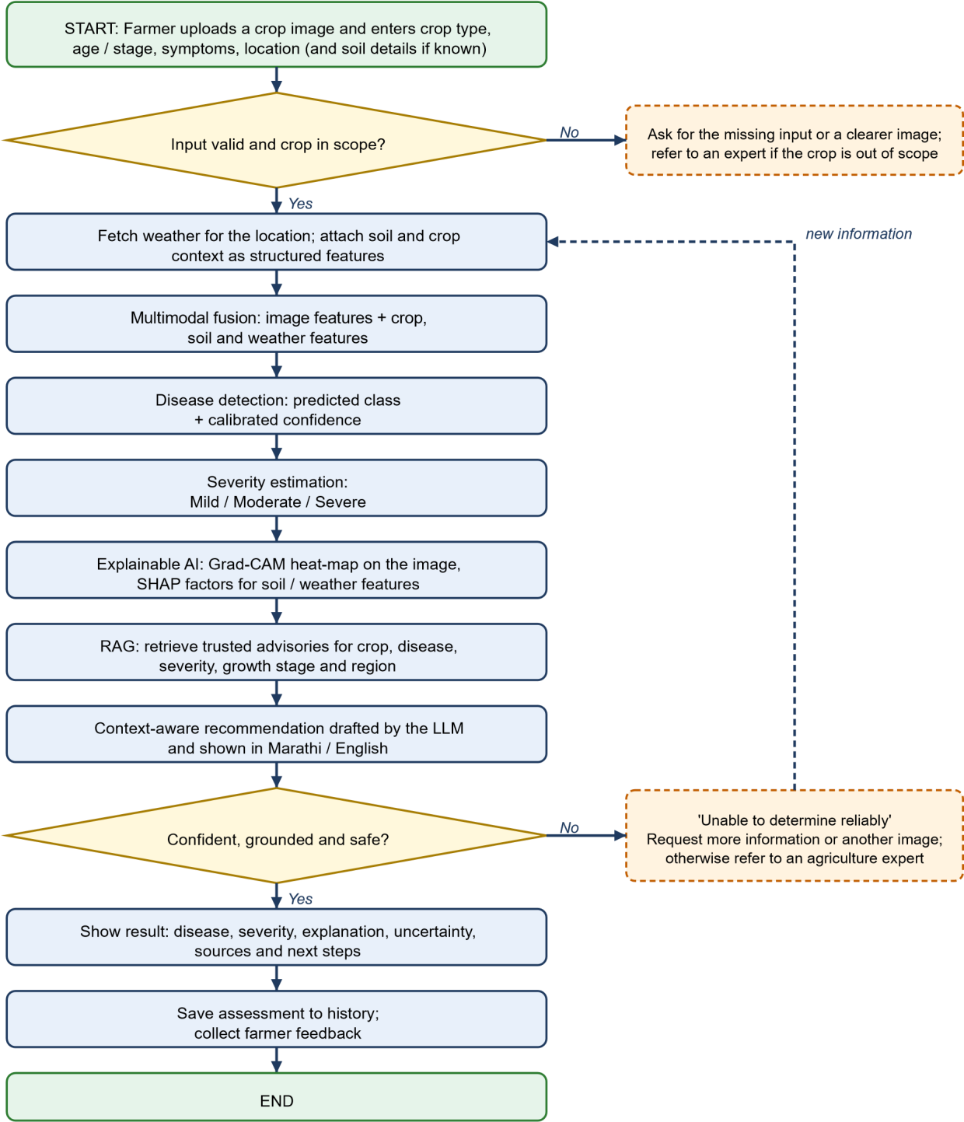
Figure 2: Flowchart of the PikVaidya AI assessment process

11.1 Example Use Case
A tomato farmer notices brown spots on leaves, selects tomato, enters the crop age and location, and uploads an image. The system fetches recent weather, asks for soil details if known, and runs the fused model. It reports a possible disease, a severity level and a heat-map of the affected area, and shows that recent humidity increased the risk. The RAG engine retrieves official advice for that crop, disease, severity and growth stage, and the assistant presents the next steps in Marathi or English with sources. If confidence is low, the farmer is asked for another image or more details, and an expert referral can be raised.

12. Expected Outcomes
The expected outcome is a working prototype of the full farmer-to-advisory workflow, evaluated as an engineering and research system and not only as a demonstration:
- Farmer registration, farm and crop management, and soil and weather context handling.
- Disease detection and three-level severity estimation for the selected MVP crops.
- A multimodal fusion model with a documented comparison against an image-only model.
- An XAI layer with heat-maps and context-factor explanations.
- A RAG knowledge base of verified sources and a context-aware recommendation engine.
- A Marathi and English assistant with uncertainty handling and expert referral.
- An evaluation framework and results for each component and for the complete workflow.

13. Evaluation Methodology
Each major component is evaluated separately and then the complete workflow. All values are targets or evaluation plans until experiments are actually carried out; this synopsis reports no results.
Component | Metrics / method
Disease detection | Accuracy, precision, recall, F1-score and confusion matrix on a held-out test set, reported per class; separate test on field-style images.
Severity estimation | Accuracy and macro F1 for severity classes; mean absolute error (MAE) if severity is ordinal or a percentage. Classes and metrics depend on the available dataset.
Multimodal model | Image-only versus late-fusion versus feature-level fusion on the same test data; report differences with appropriate statistical checks where the sample allows.
XAI | Explanation faithfulness (for example deletion / insertion tests); localization overlap with expert lesion marks where available; expert review; human understandability.
Uncertainty | Calibration error, selective accuracy (accuracy on answered cases versus rate of referral).
RAG | Retrieval relevance, source correctness, groundedness and answer faithfulness.
Recommendation | Expert agreement, relevance, safety and context appropriateness on a set of test cases reviewed by an agriculture expert.
Assistant | Response quality, language usability (Marathi and English), latency, hallucination rate. Comparison algorithms (for example embedding cosine similarity, ROUGE / BLEU and consistency across repeated generations) compare model answers with reference answers and with each other; exact algorithms are chosen during development.
System | End-to-end response time, reliability, security checks, and usability (task completion and farmer understanding).

14. Security, Privacy and Safety
The platform stores farmer and farm information and processes uploaded images, so security and privacy are project requirements:
- JWT authentication, password hashing, role-based access control (RBAC) and database access control.
- HTTPS in deployed environments, input validation and image-file validation.
- Audit logs; secure handling of credentials and API keys; model-version tracking.
- Minimum personal data collection, with a data deletion and retention policy.

14.1 Agricultural Safety Principle
The system does not promise 100% disease detection, guaranteed yield or profit, automatic pesticide prescriptions without evidence and safeguards, replacement of agriculture officers or scientists, perfect weather information, or coverage of every crop and disease. It gives AI-assisted guidance and possible assessments based on available evidence, communicates uncertainty and refers uncertain or severe cases to a human expert.

15. Project Timeline and Development Roadmap
The phases below can be aligned with the academic calendar. The core crop-health workflow comes before extensions.
Phase | Work Package | Major Activities | Deliverable
1 | Research and scope | Literature review, crops, datasets, trusted sources, data availability | Approved scope and source plan
2 | Architecture | PostgreSQL schema, FastAPI foundation, authentication, API design | Backend foundation
3 | Farmer module | Registration, profile, farm, crop, soil and weather context | Working farmer module
4 | Image AI | Dataset preparation, disease detection, severity, evaluation | Evaluated image model
5 | Multimodal fusion | Context features, fusion variants, image-only baseline, ablation | Fusion model and comparison
6 | XAI | Grad-CAM, SHAP, explanation text, expert review | Explanation layer
7 | Knowledge base and  RAG | Documents, chunking, multilingual embeddings, retrieval tests | Agricultural RAG corpus
8 | Recommendation and  assistant | Recommendation engine, Marathi / English assistant, uncertainty and referral | Integrated AI pipeline
9 | Frontend | Farmer workflow, upload, dashboard, chat, language switch | Working frontend
10 | Testing | Component and end-to-end evaluation, security, usability | Evaluation results
11 | Deployment and documentation | Docker, final integration, report, demonstration | Prototype and submission

16. Team Roles and Responsibilities
Role | Responsibilities
Backend and AI Integration Lead | FastAPI, PostgreSQL, APIs, authentication, orchestration, RAG, fusion integration and deployment.
Frontend / Product Lead | React / Next.js, dashboard, image upload, chat, Marathi / English experience, responsive design.
Joint Responsibilities | Datasets, model training and evaluation, XAI, testing, documentation and final presentation.
Work may be divided, but the project is integrated as one end-to-end system and demonstrated from farmer input to validated recommendation and history storage.

17. Project Innovation and Contribution
The project does not claim that multimodal fusion, severity estimation, XAI, RAG or multilingual advisory is new in itself; the literature in Section 2 shows that each has been studied and that some combinations exist [11]-[13], [17]. The contribution is the integration of these components into one farmer-oriented workflow, with lesion-based severity, soil and weather context, layered explanations, evidence-grounded recommendations, uncertainty-triggered expert referral and Marathi / English interaction, and a measured evaluation of each part and of the whole. It builds on and acknowledges existing Maharashtra and national initiatives [20], [21], [27]. The scope is intentionally bounded to a few crops and one state.

18. Limitations
- Only a limited set of crops and crop-health problems is covered.
- Performance depends on the quality, diversity and representativeness of datasets; paired imageandcontext data may be limited, and laboratory-style images may overestimate field accuracy [1], [4].
- Severity classes depend on available annotation and expert review.
- Soil values may be missing or outdated; weather data is only as accurate as its source.
- XAI heat-maps and feature plots show what influenced a model, but they are not proof of correct diagnosis.
- Language understanding and translation quality may vary across farmer expressions and agricultural terms.
- The system is advisory and gives no laboratory confirmation.
- No performance value can be claimed until the models and pipeline are tested.

19. Requirements

19.1 Functional Requirements
- User registration, login, farmer profile and preferred language; farm and crop-cycle management.
- Image upload and validation; entry or retrieval of soil, weather and location context.
- Disease detection, severity estimation, XAI explanation and uncertainty communication.
- Marathi / English chatbot with knowledge retrieval and context-aware recommendations.
- Assessment history, advisory report, request for more information, expert referral and feedback.

19.2 Non-Functional Requirements
- Security and privacy: authentication, authorization, protected communication, minimal data, deletion policy.
- Reliability and usability: graceful handling of invalid, incomplete and low-confidence cases; simple farmer workflows.
- Maintainability, scalability, traceability: modular components; ability to add crops and documents; model versions and audit logs.

19.3 Hardware and Development Requirements
A development computer for the frontend, backend and database; GPU or cloud compute for training and testing vision models according to dataset size; internet access for packages, weather API and optional cloud services; web and mobile devices for testing.

20. Future Scope
Possible later work includes IoT soil and field sensors, satellite and remote-sensing data, forecast-based disease-risk alerts, voice input and text-to-speech, more crops and Indian languages, lesion segmentation for percentage severity, knowledge-graph (GraphRAG) retrieval, live expert connection, integration with state and national advisory platforms, yield prediction, market intelligence and advanced farm analytics. These stay outside the MVP unless they can be built and evaluated without weakening the core workflow.

21. Conclusion
PikVaidya AI proposes a practical, bounded and measurable framework for explainable, context-aware crop disease diagnosis and farming advice. It combines a crop image with soil, weather and farm context, estimates disease and severity, explains the result, grounds recommendations in verified agricultural sources, and communicates uncertainty in Marathi and English, with expert referral when evidence is insufficient.
The literature review shows that many individual components already exist, and that the remaining gaps are in lesion-based severity within fused pipelines, realistic context inputs, farmer-usable explanations, evidence-grounded context-aware advice, uncertainty linked to action, and end-to-end evaluation. The project addresses these gaps in a limited setting and does not claim universal diagnosis or the replacement of experts. All performance values will be reported only after the planned experiments are carried out.

References
- S. P. Mohanty, D. P. Hughes, and M. Salathé, “Using deep learning for image-based plant disease detection,” Front. Plant Sci., vol. 7, Art. no. 1419, Sep. 2016, doi: 10.3389/fpls.2016.01419.
- K. P. Ferentinos, “Deep learning models for plant disease detection and diagnosis,” Comput. Electron. Agric., vol. 145, pp. 311–318, Feb. 2018, doi: 10.1016/j.compag.2018.01.009.
- A. Ramcharan, K. Baranowski, P. McCloskey, B. Ahmed, J. Legg, and D. P. Hughes, “Deep learning for imagebasedcassava disease detection,” Front. Plant Sci., vol. 8, Art. no. 1852, Oct. 2017, doi:
10.3389/fpls.2017.01852.
- D. Singh, N. Jain, P. Jain, P. Kayal, S. Kumawat, and N. Batra, “PlantDoc: A dataset for visual plant diseasedetection,” in Proc. 7th ACM IKDD CoDS and 25th COMAD, Hyderabad, India, Jan. 2020, doi:
10.1145/3371158.3371196.
- E. Ergün, “Attention-enhanced hybrid deep learning model for robust mango leaf disease classification via ConvNeXtand vision transformer fusion,” Front. Plant Sci., vol. 16, 2025, doi: 10.3389/fpls.2025.1638520.
- G. Wang, Y. Sun, and J. Wang, “Automatic image-based plant disease severity estimation using deep learning,”Comput. Intell. Neurosci., vol. 2017, Art. no. 2917536, Jul. 2017, doi: 10.1155/2017/2917536.
- G. R. Babu, M. Gokuldhev, and P. S. Brahmanandam, “Integrating IoT for soil monitoring and hybrid machinelearning in predicting tomato crop disease in a typical South India station,” Sensors, vol. 24, no. 19, Art. no. 6177, Sep. 2024, doi: 10.3390/s24196177.
- P. Bagchi, B. Sawicka, Z. Stamenkovic, D. Markovic, and D. Bhattacharjee, “Potato late blight outbreak: A study onadvanced classification models based on meteorological data,” Sensors, vol. 24, no. 23, Art. no. 7864, Dec. 2024, doi: 10.3390/s24237864.
- S. Albahli, “AgriFusionNet: A lightweight deep learning model for multisource plant disease diagnosis,” Agriculture, vol. 15, no. 14, Art. no. 1523, 2025, doi: 10.3390/agriculture15141523.
- S.-H. Xu and S. Wang, “An intelligent identification for pest and disease detection in wheat leaf based onenvironmental data using multimodal data fusion,” Front. Plant Sci., vol. 16, Art. no. 1608515, 2025, doi:
10.3389/fpls.2025.1608515.
- H. Roy, S. Dhar, A. Deyasi, and P. Saha, “Multimodal deep learning approach for disease prediction in rice andpotato crops using leaf imaging, environmental, and soil data,” in Human-Centric Smart Computing (ICHCSC 2024), S.
Bhattacharyya et al., Eds., Smart Innovation, Systems and Technologies, vol. 440. Singapore: Springer, 2025, pp. 557–567, doi: 10.1007/978-981-96-3420-0_45.
- N. Nasir et al., “Interpretable deep multimodal-based tomato disease diagnosis and severity estimation,” Sci. Rep., vol. 15, Art. no. 37919, Oct. 2025, doi: 10.1038/s41598-025-21611-4.
- E. Ben Abdallah, R. Grati, and K. Boukadi, “Interpretable multi-modal plant disease detection using CNN fusion and
LLM-based explanations with meteorological insights,” in Advanced Information Networking and Applications (AINA 2026), L. Barolli, W. K. G. Seah, and I. Woungang, Eds., Lecture Notes on Data Engineering and Communications Technologies, vol. 298. Cham, Switzerland: Springer, 2026, pp. 292–303, doi:
10.1007/978-3-032-23311-0_25.
- N. Nigar, H. M. Faisal, M. Umer, O. Oki, and J. M. Lukose, “Improving plant disease classification withdeeplearning-based prediction model using explainable artificial intelligence,” IEEE Access, vol. 12, pp. 100005–100014, 2024, doi: 10.1109/ACCESS.2024.3428553.
- S. Hernández and J. L. López, “Uncertainty quantification for plant disease detection using Bayesian deep learning,”Appl. Soft Comput., vol. 96, Art. no. 106597, 2020, doi: 10.1016/j.asoc.2020.106597.
- E. Ergün, H. Okumus, O. E. Cinar, and N. Batan, “Confidence and uncertainty aware deep learning for reliable grapeleaf disease diagnosis under real world field conditions,” Front. Plant Sci., vol. 17, Art. no. 1839652, 2026, doi:
10.3389/fpls.2026.1839652.
- M. Zhang et al., “AgriDoctor: A multimodal intelligent assistant for agriculture,” arXiv:2509.17044, 2025.
- R. Sapkota, K. I. Roumeliotis, P. Xie, N. D. Tselikas, L. Xiang, and M. Karkee, “Fusing perceptual vision expertswith multimodal large language models for explainable plant disease diagnosis: From benchmark imagery to real-world robotic field validation,” arXiv:2608.24934, 2026.
- N. Singh et al., “Farmer.Chat: Scaling AI-powered agricultural services for smallholder farmers,” arXiv:2409.08916, 2024.
- “Maharashtra launches ‘MahaVISTAAR-AI’ to digitally empower farmers with AI-driven services,” Elets eGov, May 2025. [Online]. Available: https://egov.eletsonline.com/2025/05/maharashtra-launches-mahavistaar-ai-to-digita llyempower-farmers-with-ai-driven-services/
- “Maharashtra launches MahaAgX and India’s first Bhili tribal LLM at AI4Agri2026,” AgroSpectrum India, Feb. 2026. [Online]. Available: https://agrospectrumindia.com/2026/02/22/maharashtra-launches-mahaagx-and-indias-fir st-bhili-tribal-llm-at-ai4agri2026.html
- P. Lewis et al., “Retrieval-augmented generation for knowledge-intensive NLP tasks,” in Advances in Neural Information Processing Systems, vol. 33, 2020, pp. 9459–9474.
- R. R. Selvaraju, M. Cogswell, A. Das, R. Vedantam, D. Parikh, and D. Batra, “Grad-CAM: Visual explanations fromdeep networks via gradient-based localization,” in Proc. IEEE Int. Conf. Comput. Vis. (ICCV), 2017, pp. 618– 626, doi: 10.1109/ICCV.2017.74.
- S. M. Lundberg and S.-I. Lee, “A unified approach to interpreting model predictions,” in Advances in Neural Information Processing Systems, vol. 30, 2017, pp. 4765–4774.
- M. T. Ribeiro, S. Singh, and C. Guestrin, “‘Why should I trust you?’: Explaining the predictions of any classifier,” inProc. 22nd ACM SIGKDD Int. Conf. Knowl. Discovery Data Mining, 2016, pp. 1135–1144, doi:
10.1145/2939672.2939778.
- D. P. Hughes and M. Salathé, “An open access repository of images on plant health to enable the development ofmobile disease diagnostics through machine learning and crowdsourcing,” arXiv:1511.08060, 2015.
- “Shivraj Singh Chouhan to launch ‘Bharat-VISTAAR’,” Global Agriculture, Feb. 2026. [Online]. Available: https:// www.global-agriculture.com/india-region/ai-farmer-revolution-to-begin-from-jaipur-union-minister-mr-shivraj-sing h-chouhan-to-launch-bharat-vistaar/

