Celebrate a fall evening with drumming and dancing at…

# Falmouth Drum and Dance

a community drum and dance experience

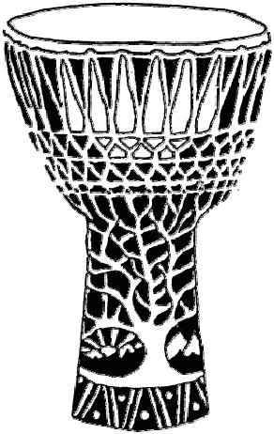

## Saturday, September 28th 2024

**7pm to 10pm**

**Cape Symphony’s Falmouth Recital Hall**

**60 Highfield Drive, Falmouth, MA**

We'll dance, play, and spin to a mix of rhythm jams. Bring hand drums, percussion, and flow art toys, or simply come to dance and enjoy.

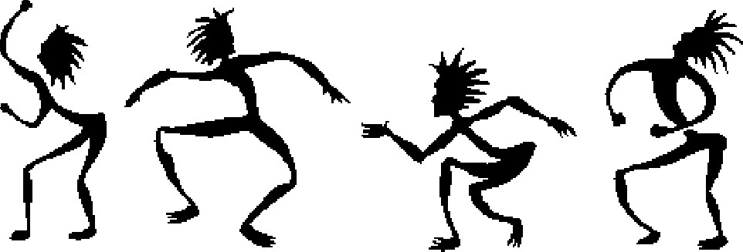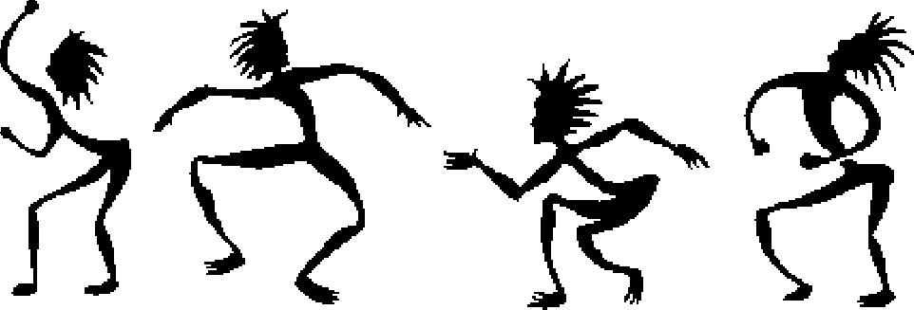

It's free and open to all ages! Listen and co-create. Bring your friends and family! Spread the word…

For more information and to volunteer: www.DrumAndDance.net

  