Celebrate a fall evening with drumming and dancing at…

Wellfleet Drum and Dance
a community drum and dance experience

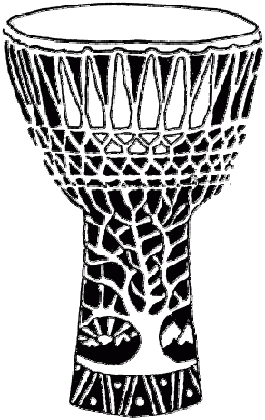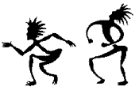

Saturday, November 14th 2026
7pm to 10pm
Wellfleet Adult Community Center
715 Old Kings Hwy, Wellfleet, MA

Celebrate an evening with drumming and dancing! Wellfleet Drum and Dance is about listening to each other, co-creating music and dancing our spirit. We welcome drummers, dancers, and rhythm/flow artists of all kinds.

We'll dance and play to a mix of traditional West African rhythms and organized rhythm jams, with a focus on the dancers. You're welcome to bring your own hand drums and percussion, flow toys, or simply come to dance and enjoy.

The event is free, family-friendly, and is open to all ages and experience levels. Bring music from your heart and a sharing spirit.
Bring water to drink. No alcohol please.


Wellfleet Drum & Dance is a collaboration between
Critical Mass, ✨Drumz✨,, and Movement Arts Cape Cod.

More information at DrumAndDance.net

