Celebrate a fall evening with drumming and dancing at…

Wellfleet Drum and Dance
a community drum and dance experience

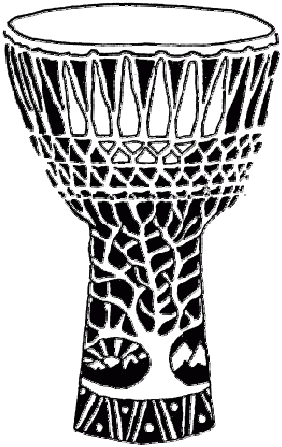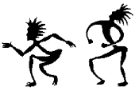

Saturday, November 14th 2026
7pm to 10pm
Wellfleet Adult Community Center
715 Old Kings Hwy, Wellfleet, MA
We'll dance, play, and spin to a mix of rhythm jams. Bring hand drums, percussion, and flow art toys, or simply come to dance and enjoy.

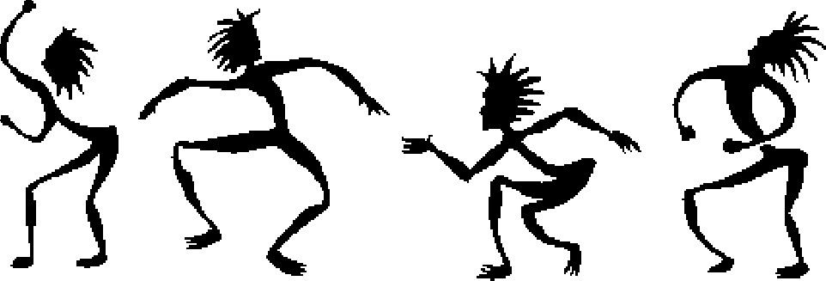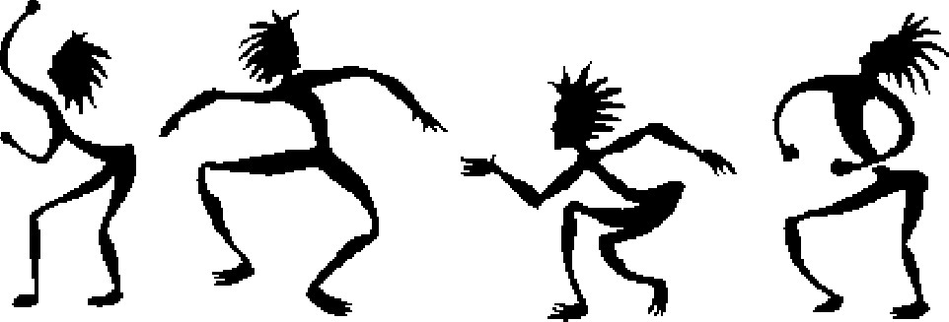

It's free and open to all ages! Listen and co-create. Bring your friends and family! Spread the word…

For more information and to volunteer: www.DrumAndDance.net


