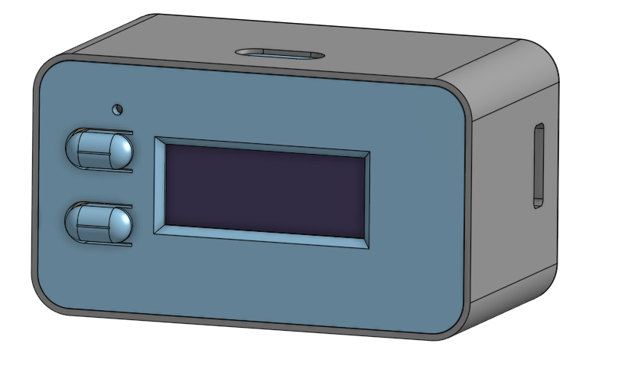

Screw-Post to Connect

2 Motors

UP+DOWN Buttons

uUSB Charging Port

OLED Display

**Charging:**

1. Use standard micro-USB cable to charge battery. Charging will take approx. 1hour.
2. Battery icon will read full- and the pack voltage should be around ~4.2Vdc when charged

**How To Use:**

1. Press ANY button to wake device up
2. Press Up/Dwn Button to set to desired mode #1-10
3. Set to Mode #0 to turn off device. Will resume sleep in a few seconds

**How To Modify Motor Waveforms OR Reprogram Device –** See Github repo readme

**How To Wire Motors**

