

**CS6004 –Application Development**

Group Coursework 2014-15

Fast Tracking Cab Service

Name: Asif Akraf, Mohammed Zaeem

ID Number: 14048315 – Zaeem

14048316 – Asif

Date: Tuesday, 15 September 2015

First Supervisor: Mr. Dumindu Pahalawatte

**Declaration**

**Module: CS6004 Deadline: Tuesday 7th November 2015 at 3.00pm**

**Module Leader: Mr. Dumindu Pahalawattha Student ID: ,**14048315

PLAGIARISM

You are reminded that there exist regulations concerning plagiarism. Extracts from these regulations are printed below. Please sign below to say that you have read and understand these extracts:

(Signature :) ______________________ Date: 07/11/15

This header sheet should be attached to the work you submit. No work will be accepted without it.

Extracts from University *Regulations* onCheating, Plagiarism and Collusion

Section 2.3: "The following broad types of offence can be identified and are provided as indicative examples…

Cheating: including taking unauthorised material into an examination; consulting unauthorised material outside the examination hall during the examination; obtaining an unseen examination paper in advance of the examination; copying from another examinee; using an unauthorised calculator during the examination or storing unauthorised material in the memory of a programmable calculator which is taken into the examination; copying coursework.

Falsifying data in experimental results.

Personation, where a substitute takes an examination or test on behalf of the candidate. Both candidate and substitute may be guilty of an offence under these Regulations.

Bribery or attempted bribery of a person thought to have some influence on the candidate's assessment.

Collusion to present joint work as the work solely of one individual.

Plagiarism, where the work or ideas of another are presented as the candidate's own.

Other conduct calculated to secure an advantage on assessment.

(viii)Assisting in any of the above.

Some notes on what this means for students:

1.Copying another student's work is an offence, whether from a copy on paper or from a computer file, and in whatever form the intellectual property being copied takes, including text, mathematical notation and computer programs.

2.Taking extracts from published sources *without attribution* is an offence. To quote ideas, sometimes using extracts, is generally to be encouraged. Quoting ideas is achieved by stating an author's argument and attributing it, perhaps by quoting, immediately in the text, his or her name and year of publication, e.g. "e = mc2 (Einstein 1905)". A *references* section at the end of your work should then list all such references in alphabetical order of authors' surnames. (There are variations on this referencing system which your tutors may prefer you to use.) If you wish to quote a paragraph or so from published work then indent the quotation on both left and right margins, using an italic font where practicable, and introduce the quotation with an attribution.

# Table of Contents

Table of Contents i

Table of Figures ii

1. Introduction 1

2. Scope 1

3. Objective 1

General Objective 1

3.1. Specific Objectives 1

4. Functionality of the Project 2

5. Architecture of the program 3

Use case Diagram 3

Class Diagram 4

6. Database Architecture 5

ER Diagram 5

7. Testing 6

7.1. Testing Overview 6

7.2. Test Plan 7

7.3 Test Cases 9

8. User Manual 12

**8.1.** **Prerequisite** 12

**8.2.** **How to Us** 12

Conclusion 18

Group Member 18

# Table of Figures

Figure 1 Use Case diagram 3

Figure 2 Class Diagram 4

Figure 3 ER Diagram 5

Figure 4 Home Screen 12

Figure 5 Login Page 13

Figure 6 Dashboard 14

Figure 7 FTCS Control Panel 15

Figure 8 Add Supervisor 16

Figure 9 Add City 16

Figure 10 Booking 17

# Introduction

Various online systems make the life of human very comfortable. By some clicks only, we can get whatever you want at home. Fast Track Cab Service (FTCS) is an organization specializing in vehicle rental. Having number of subsidiaries across the country and fleet of vehicles. It also employs number of staff with varied responsibility.

The project will make it possible to book cars online within few clicks only. Some people cannot afford of having a car, for those people this system becomes very helpful. Using these system customers can book cars as per their need and comfort from nearest subsidiary.

# Scope

The project will focus on vehicle rental and reservation along with managing the details of customers and employees. The scope of this project is developing web based system for FTCS.

# Objective

## General Objective

The general objective of the project is to develop a best ‘fit for purpose’ Vehicle Rental Management System.

## Specific Objectives

In order to attain the general objective, the following list of specific objectives is set:

* To develop a web based application.
* To develop an application to manage vehicle rental process.

# Functionality of the Project

The system provides the features for booking a car online. It includes several functionalities describes as below:

* **User registration**

Customers can register to use the site. As it will the basic requirement to access and use other services available via web application once the accounts get approve by FTCS employee.

* **Approve customer registration.**

Employees of FTCS with sufficient access level will be able to approve customer registration after verification.

* **Manage vehicle fleet.**

Authorized employees will be able to add, delete edit vehicle details along with assigning them to subsidiaries.

* **Rent Vehicles**

Employees will be able to approve vehicles customer requested for rent

* **Checking for Availability:**

When booking a car, the customer will be able to check the availability of the car.

* **Manage Employee**

The administrator will be able to add new employees to the system, manage their details and define their access level.

* **View reports**

Employees of FTCS will be able to view customized report such as number of vehicle available, vehicle rented out in the particular.

# Architecture of the program

## Use case Diagram

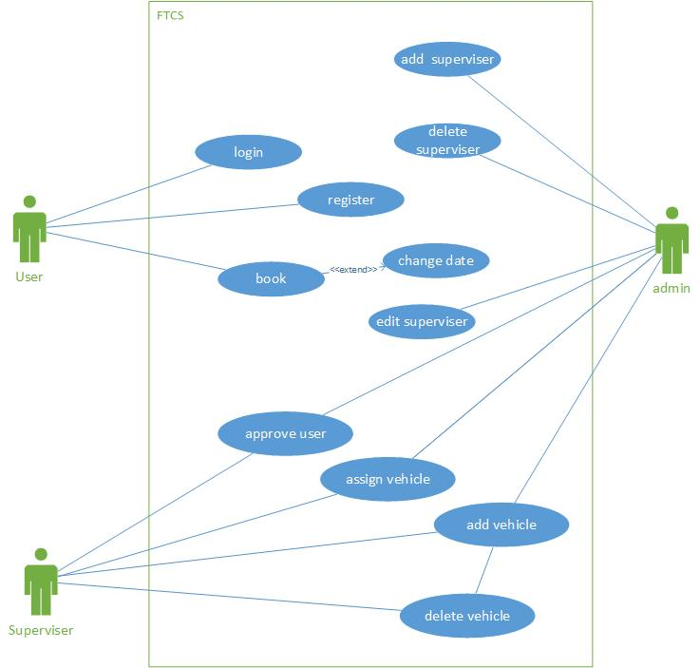

Figure 1 Use Case diagram

## Class Diagram

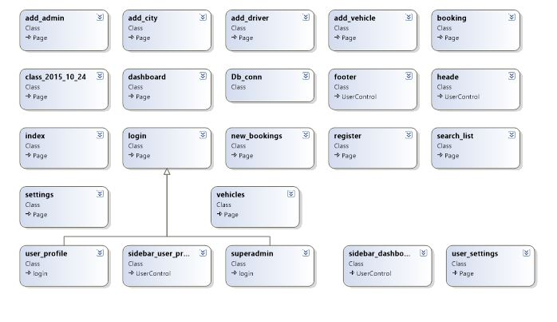

Figure 2 Class Diagram

# **Database** Architecture

## ER Diagram

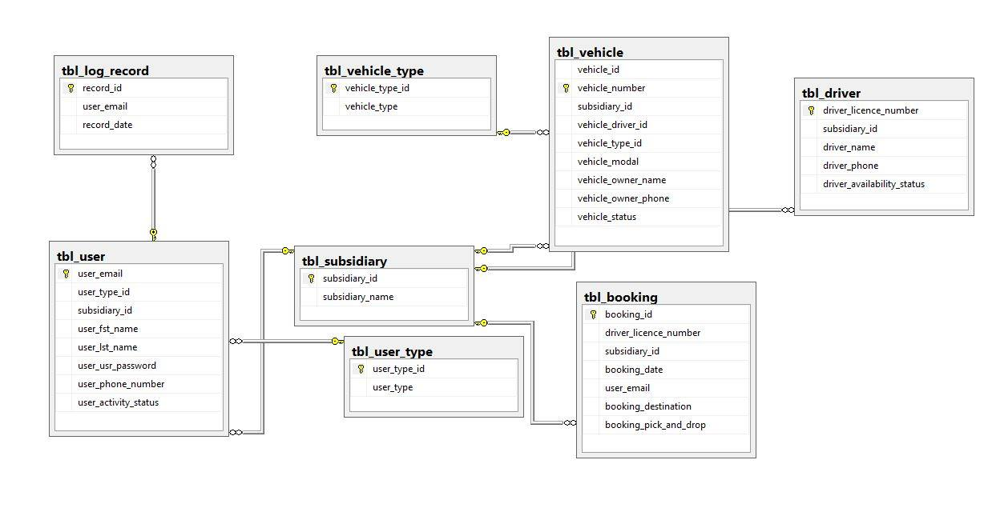

Figure 3 ER Diagram

# Testing

## Testing Overview

Testing Application in order to prevent it from causing bugs is a very crucial thing to do when in a software project. Eventhough the application will developed under great care and accuracy , the testing play vital part to determine that system has reached the expected goal without giving any unintentional errors. The most used testing methods are white box testing and black box testing.

White box testing is one of the testing methodology which applied to test mainly on the security and strength of the application developed. When it comes to white box testing, the tester looks at the source code of application to make sure that it followed the expected structure by writing more codes to debug the source code. Obviously tester has to have a quite an amount of skill in the language used to develop the application. This testing will also result in designing the application in a proper way.

The other methodology that follow by tester in the industry is black box testing and this task usually executed by Quality Assurance Engineers. QAs directive to pay more attention in quality and functional strength of the system. These system testers do not have a throw knowledge in the programming languages. The objective is black box testing is to determine whether the input and expected output are executing in a proper way.

## Test Plan

|  |  |  |  |  |
| --- | --- | --- | --- | --- |
| **Serial Number** | **Test Case ID** | **Test Case Name** | **Steps/Action** | **Expected Results** |
|  |  | Giving wrong credential in login page | Enter “pingpong” as username and “123” as password | The page should not redirect to main page and display error message |
|  |  | Giving the correct login information | Enter “abdullah”, “adb123” as username and password | Login successful, redirect to main page |
|  |  | Giving correct user name and invalid password | Enter “abdullah”, “as1” as username and password | The page should not redirect to main page |
|  |  | Make new booking with empty fields. | Keep all necessary fields empty in the booking form. | Error message should be displayed informing required fields cannot be empty |
|  |  | Making a new booking with required information | Entering up all the necessary(required) information available in the form | Booking should be completed and wait for supervisors’ approval and notify customer. |
|  |  | Booking an already book vehicle which is not available on particular time period. | Enter all required details. Select the vehicle which is not available on particular date by. Select the date from date picker | Notify user that the particular vehicle is not available to the user. |
|  |  | checking the browser compatibility | accessing the sites in different browsers | the site should load in a proper way |
|  |  | user registration check – giving wrong information | giving some abnormal information | user should not get registered |
|  |  | Giving already registered user’s email | input the username “jess@nnnn.cm” | Should display error message |
|  |  | Giving correct user information | entering a new and valid user information | user will get register |
|  |  | Giving password less than six characters | Input any six character from the keyboard | Display error message |
|  |  | make sure authentication works fine | log in as customer and try to access admin page | the browser should not redirect and display an error |

Table 1 Test Plan

## 7.3 Test Cases

|  |  |
| --- | --- |
| **Test Case** | **01** |
| Test Objectives | Giving wrong credential in login page |
| Test Data | Enter “pingpong” as username and “123” as password |
| Expected Results | The page should not redirect to main page and user sh |
| Actual Results | the page didn’t redirect |
| Conclusion | Actual result matched the expected result |
| Evidence |  |

Table 2 Test Case 1

|  |  |
| --- | --- |
| **Test Case** | **02** |
| Test Objectives | Giving correct credential in login page |
| Test Data | Enter “pingpong” as username and “abd123” as password |
| Expected Results | The page should not redirect to main.php |
| Actual Results | the page didn’t redirect |
| Conclusion | Actual result matched the expected result |
| Evidence |  |

|  |  |
| --- | --- |
| **Test Case** | **03** |
| Test Objectives | Giving correct username and wrong password credential in login page |
| Test Data | Enter “pingpong” as username and “123” as password |
| Expected Results | The page should not redirect to main.php |
| Actual Results | the page didn’t redirect |
| Conclusion | Actual result matched the expected result |
| Evidence |  |

# User Manual

Note: This user manual is intended for employees of FTCS, term user is used instead of employee in the manual.

### **Prerequisite**

1. A PC equipped with a modern browser
2. A good internet connection.

### **How to Us**

1. Visit the site using the URL provided to you. User will be taken to a similar interface as in the figure below.

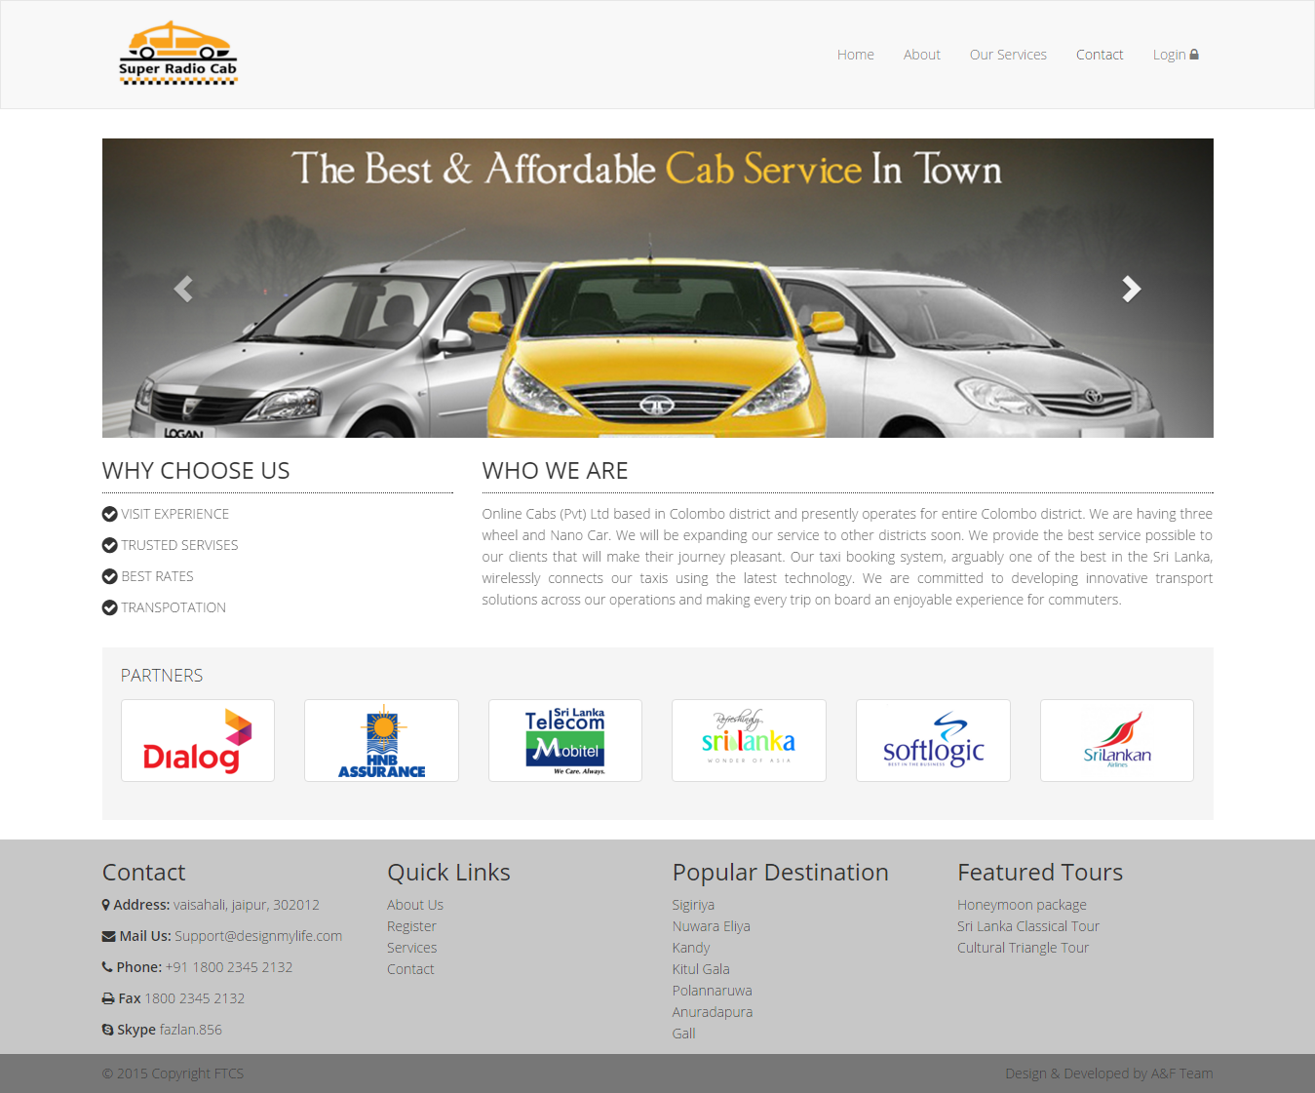

Figure 4 Home Screen

1. Click on the login link, once you have clicked you will be taken to the login page. Where you need to enter username and password credentials provided to you.

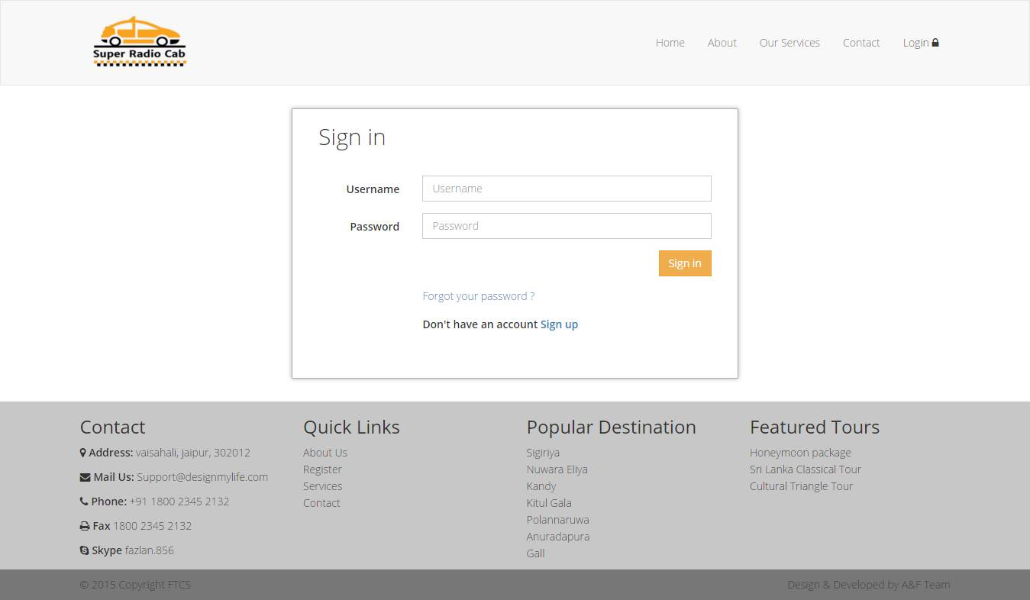

Figure 5 Login Page

1. Once credentials are authenticated you will be redirected to the Dashboard.In dashboard user can see the summary of the branch activities and links to reports of organization as whole and branch activities.

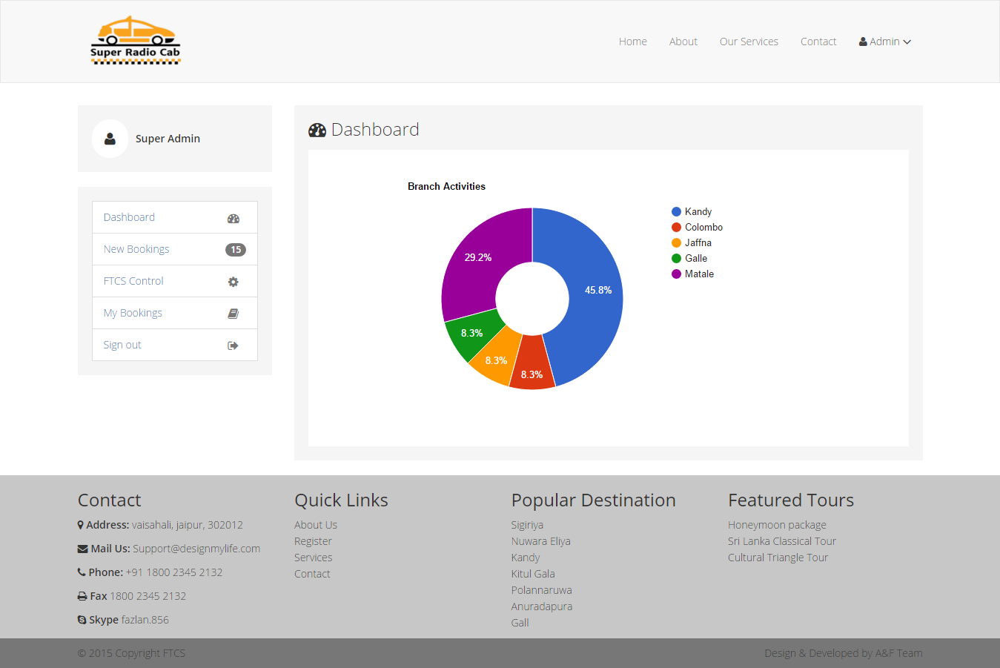

Figure 6 Dashboard

1. The user will be provided with links to other components of the system as per the access level granted. Once the user clicks on FTCS Control link, user will be redirected to the FTCS Control page.

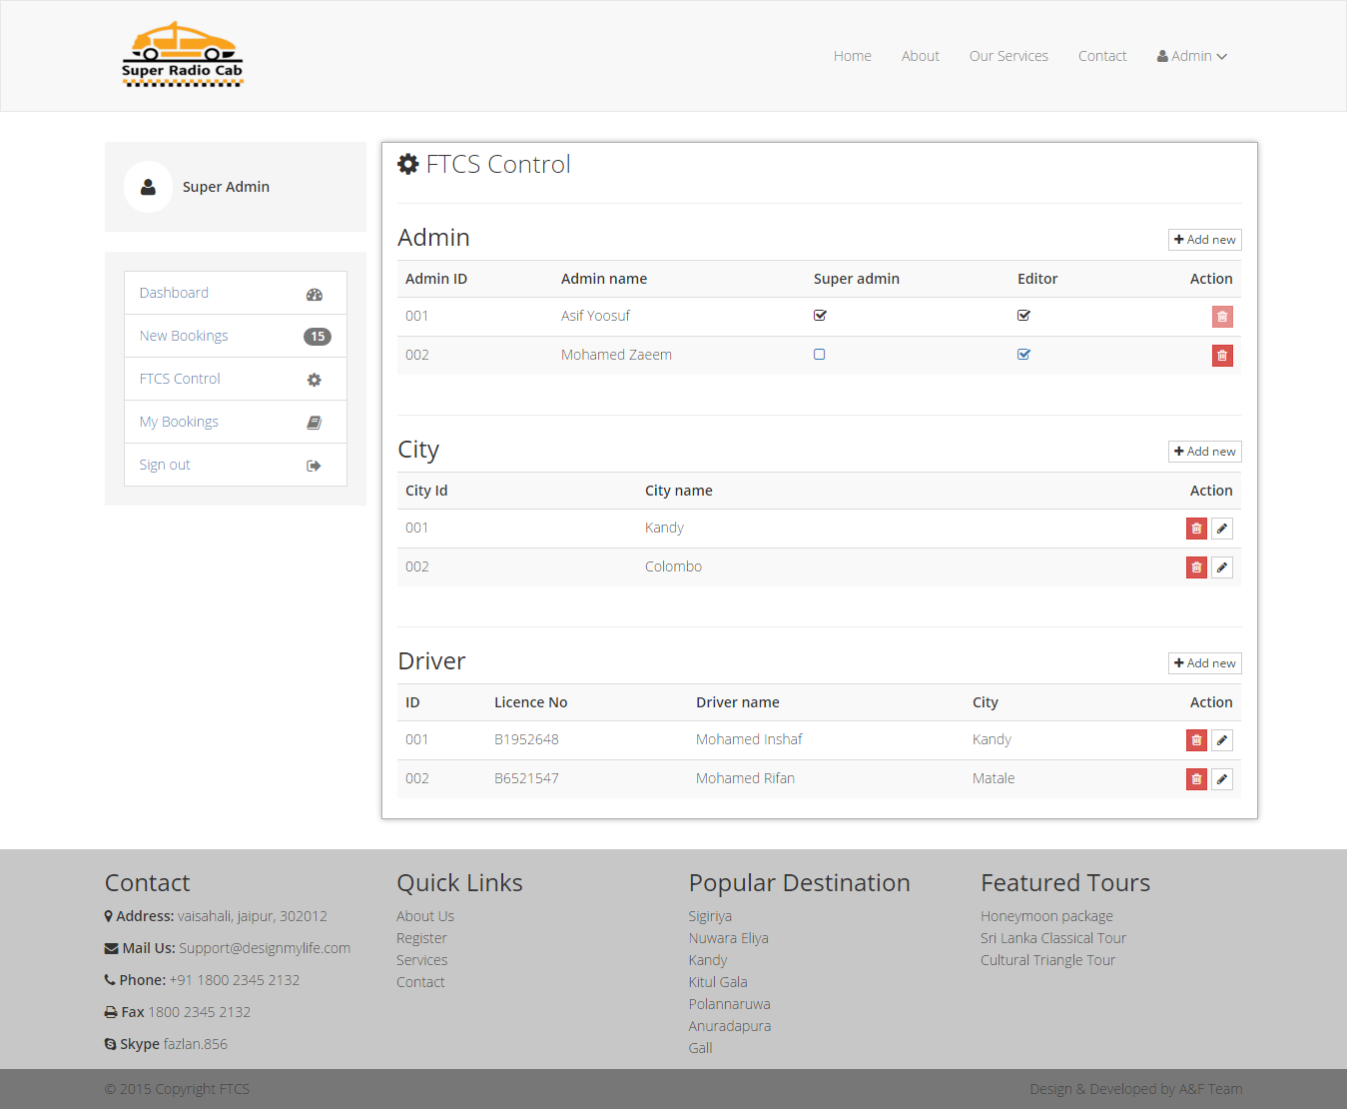

Figure 7 FTCS Control Panel

1. Using this control panel, user can add, delete, update records related admin of the site, cities, drivers, vehicle and etc. User can add record to respective table using the Add button provided. Whereas other action such as delete & update can be performed using action menu provided in each record.

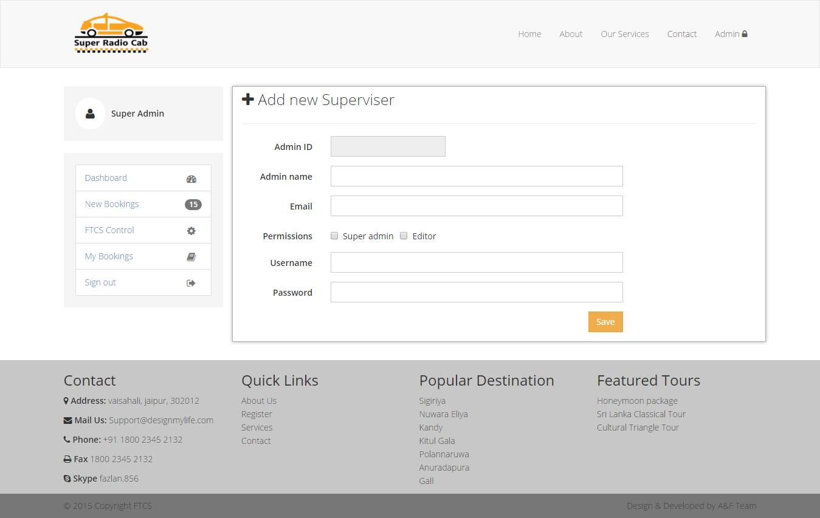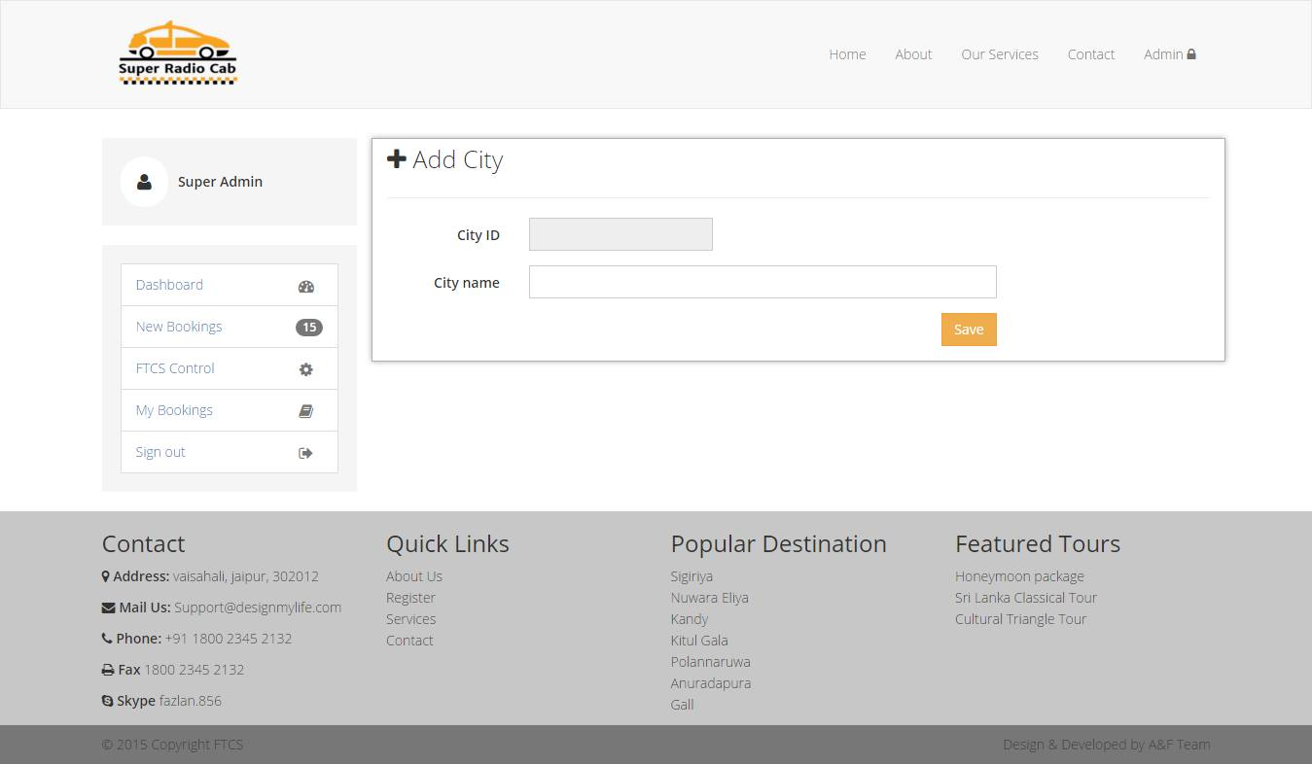

Figure 8 Add Supervisor

Figure 9 Add City

1. User will also be able to confirm or reject the bookings made by customers by clicking on the link Bookings. Once clicked the user will be redirected to Bookings page. In this page user will be presented with new bookings made. User should be able to confirm or reject the bookings using the actions menu.

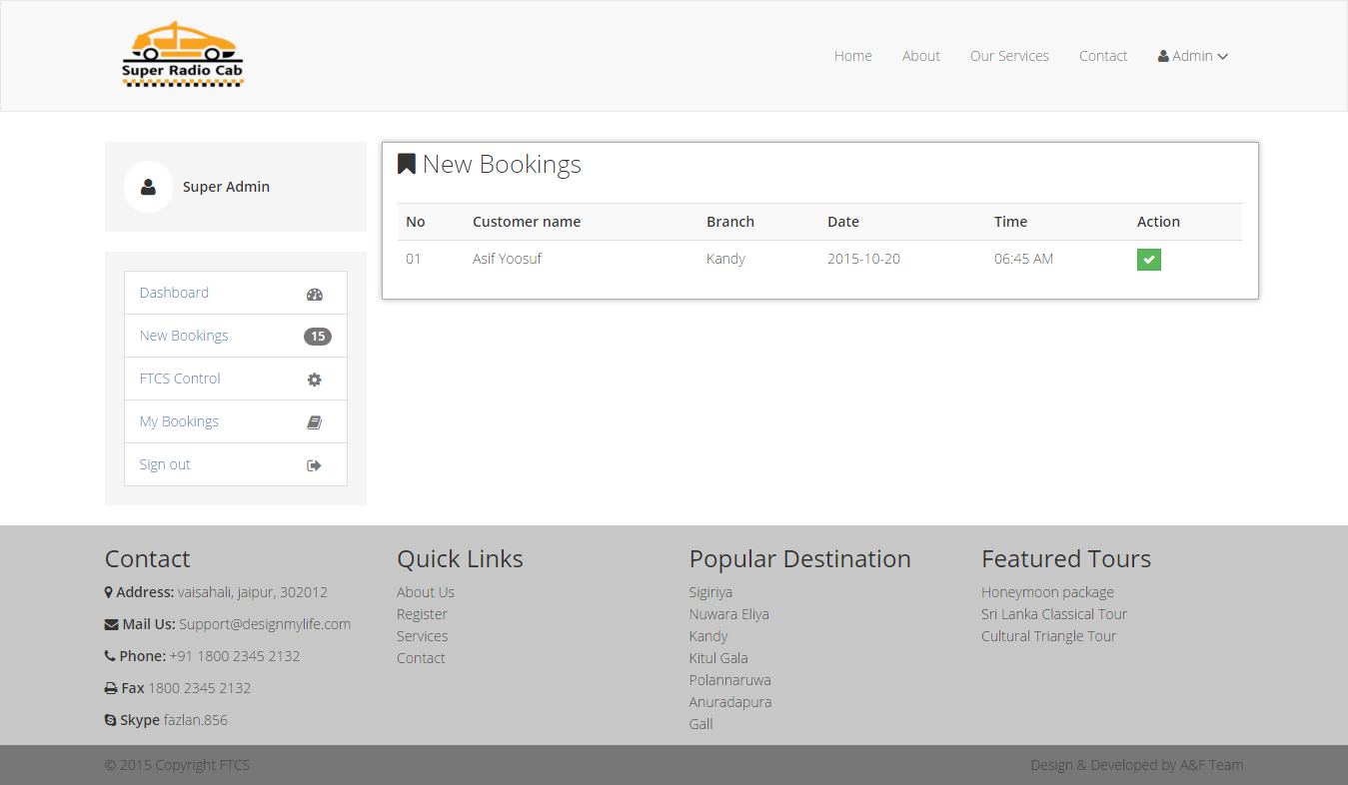

Figure 10 Booking

1. User should sign out from the system after each session when not interacting with the web application.

# Conclusion

In this project, we have developed a web based application to manage vehicle rental process. This process is developed using ASP.Net with C# and SQL Database,

Using ASP.Net C# is that it’s a modern, high level language and it’s easy to learn, and has its own garbage collector. It is a combination of all the other languages, it's composed of different components of different languages, all joined into one.

As this was a group project using visual studio aided in development. IntelliSense was really useful because of its code competition feature. Further using Visual Studio was really useful when to maintain the project. Because of the sources are saved and maintained in specific folder, it was less complicated and easy to share the sources between us. Using SQL Studio with Management Studio provided GUI to create and edit databases from time to time.

## Group Member

1. Asif Akraf.

Being assigned to a group of two, every tasks of project was divided between me and my partner, although the percentage work differed for both of us in according to the task done.

Using visual studio for developing an online application with ASP.net really came in handy because of the rich features it provided in its IDE. Running the site to check features was easy. Adding new item to interfaces, coding was made easier by Visual Studio/ Using SQL Server added more ease in development. of the database.

Although was faced with some problem like throwing of exception while using why trying to connect to database or null value error. Which was possible to correct when looking the connection string property of Database. Using date picker which provided seemed to less user friendly to be included in the project for which JQuery scripts were used/

* 1. Mohammed Zaeem

Was assigned to a group of two by the tutor. From the beginning of the project I and my partner discussed that we would do all the project task, but the amount of work would vary according expertise of us in the area. Because of it I was mostly into Database Development, documentation, back development. Whereas my partner was mostly into UI, Back end development, documentation.

Using visual studio was really beneficial while developing the web application. Because I was able to debug the application by virtually hosting with just a click on the button, without having to be worried host in every time with changes. Auto code completion was another area which really contributed well in development. ASP.net with C# being a high-level server side language made possible to develop a highly reliable and powerful system. In which many inbuilt function like cryptography, in built role base authentication and etc. Also SQL Server with Management studio made possible to create database, manage relationship and tables.