**WaefreBeorn 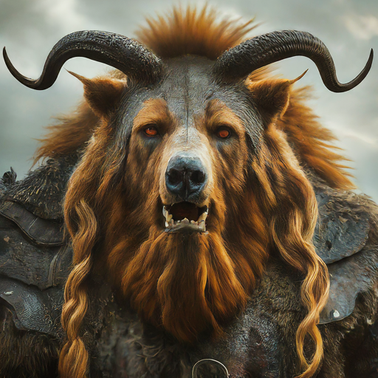WuBu**