SUNWAYMAN T16R Cu新品推荐
T16R Cu宣传标语：传承尊贵，紫铜经典
SUNWAYMAN年度典藏精品手电 T16R Cu
明镜*智芯*致精巧
380流明钥匙扣级手电
380 Lumens Exquisite Pocket Flashlight
配图：T16R Cu的形象宣传全图2张
紫铜，品质纯净，颜色靓丽，导电性、导热性﹑延展性和耐蚀性，天然具有做精品手电的基质，SUNWAYMAN年度典藏手电T16R Cu，呈现给您！
高品质紫铜，CNC数控机床精确切割而成，表面做特殊的防氧化处理，色泽典雅，颇具古风。
Elegant Copper Edition

Exquisitely-machined T16R Cu

380 Lumens Keychain Flashlight

Copper is known for its purity, beautiful color, good conduction of electricity, heat, and great ductility and corrosion-reistance, making this material ideal for exquisite collector flashlight, we proudly bring you the Sunwayman T16R Cu!

Elaborately CNC machined from quality copper and with anti-oxidation finish, this light is of elegance and beauty.
1、智芯*致精巧
*智能控制芯片，功能强大，操控方便
*小巧精致做到极致
筒头： MM，筒身： MM，筒尾： MM
让人惊叹的三围，比其它同类产品体积至少减少20%
Intelligent Chip in Exquisite Body
Powerful Functions, Easy Operation
Super-compact structure with diameters of mm head， mm body and mm tail, making this light at least 20% smaller in volume compared with its competitors
2、透光率达到97%的凸透镜
*选用镜片级凸透镜
*浑圆、柔和的光斑，强度事宜，适合EDC在暗黑环境中使用，不伤眼，不闪烁
Convex lens with as high as 97% light transmittance
Quality reflector ensures soft and ideal beam pattern in the dark to protect eyes
3、精致不锈钢侧按键，手感舒适，键程适中
Stainless steel side switch button provides comfortable hand-feel with proper journey
4、自锁功能，防止误操作，保证使用安全
*短按一次按键、再迅速长按（两秒以内），LED闪烁一次，即可锁定按键，解锁亦然
*防止手电置于口袋、旅行袋、背包中无意打开手电，造成不必要的照明浪费、损耗电池、耽误工作
Locking Function Avoids Accidental Activation
Depress-and-hold the switch button within 2 seconds until the LED flash once to lock the light and perform the same operation to unlock it
Effectively protect the light from accidental activation when carrying in bag or pocket.

5、新一代、更加可靠的电子防反接电路，即使无意装反电池，手电绝不损伤
（配图电子原件特写）
Upgraded and reliable reverse battery protection circuit

7、主灯精选CREE XM-L2 U2 LED核心，最高亮可达1000流明
（配图最高亮、爆闪、SOS示意图)
Fitted with XM-L2 U2 LED, Outputs up to 1000 Lumens

8、使用体积适中的单节CR123A(16340)供电系统
Powered by one single CR123A（16340）battery

9、微电流待机，待机电流不超过30uA，可使手电安全长期待机
As low as 30μA standby current
10、全球一流智能记忆芯片，自动记忆上次关机时的亮度，贴心呵护
World-class memory chip, considerate memory function
11、恒流电路，亮度恒定，不闪烁，不伤眼，人性化照明
Constant current circuit, constant output
11、智能低电压保护功能，保护电池不过放
Low-voltage protection to avoid battery over discharge
12、高档不锈钢手电抱夹，可牢靠挂于背包、口袋等位置
Stainless Steel Clip could be attached on backpack, pocket etc.
13、配合SUNWAYMAN高档头灯带，可作为头灯使用，有效拓展使用范围
Compatible with the Optional Sunwayman headband, can be used as a headlamp for broaden vision
16、尾部平整，可以倒立于水平面，充当蜡烛使用。
Tail-stand capable, can be used as a candle
17、手电各个位置示意图，如图
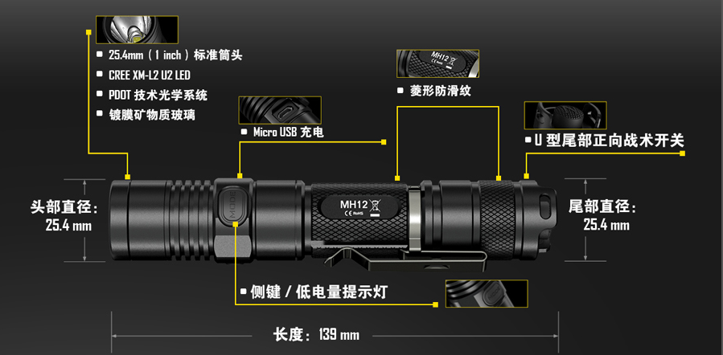
标准筒头 Standard Diameter of 25.4mm
光学系统 Optical System
Coated Mineral Glass Lens
头部直径 Head Diameter
充电 Charging System
侧键/低电量提示灯 Side Switch/Low-voltage Indicator Lamp
长度 Length
菱形防滑纹 Diamond Knurling
正向。。。。 U-shaped Tail Forward Clickie Switch
Tail Diameter

P1
文案：

明镜*智芯*致精巧——380流明钥匙扣级手电

SUNWAYMAN T16R Cu，是一款非常轻巧的钥匙扣手电，它使用一节CR123A(16340)电池，它将小巧精致做到了极致！同时，它选用了透光率高达95%的镜片级凸透镜，光斑柔和而明亮，长时间近身照明也不会感觉眼睛不舒适。具有侧按开关锁定保护系统，避免误操作带来的浪费和误工。具有曜石黑、苍穹灰二色可选的III级硬质氧化镀膜表面处理，耐汗、耐腐蚀！精选CREE XM-L2 U3照明核心，亮度最高可达380流明，MINI的体积可方便的悬挂于钥匙扣上，作为EDC之照明利器，也可以作为馈赠之佳品！

380 Lumens Exquisite Pocket Flashlight
SUNWAYMAN T16R Cu is one compact key chain flashlight, powered by one single CR123A (16340) battery, fitted with CREE XM-L2 U3 LED and outputs up to 380 lumens. Built with convex lens which has as high as 95% light transmittance and soft beam pattern for long time lighting without hurting your eyes. Locking function is added by depressing the stainless steel side switch to avoid accidental activation of the light when carrying in the bag or pocket. Military Specification Type-III hard anodized body comes in two popular colors of dark black and sky gray. T16R Cu is one ideal key chain light to carry with easily as a backup for emergencies or daily use.

