1-using dd command create empty file with size of 20MB (hint: count 40000, bs=512)

2-attach the file as loop device using losetup command (hint: use losetup -f to allocate free device)

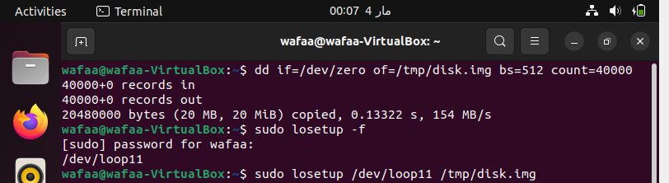

3-using fdisk command, create new partition into the loop device (`fdisk /dev/loop<??>` where <??> is the device number)

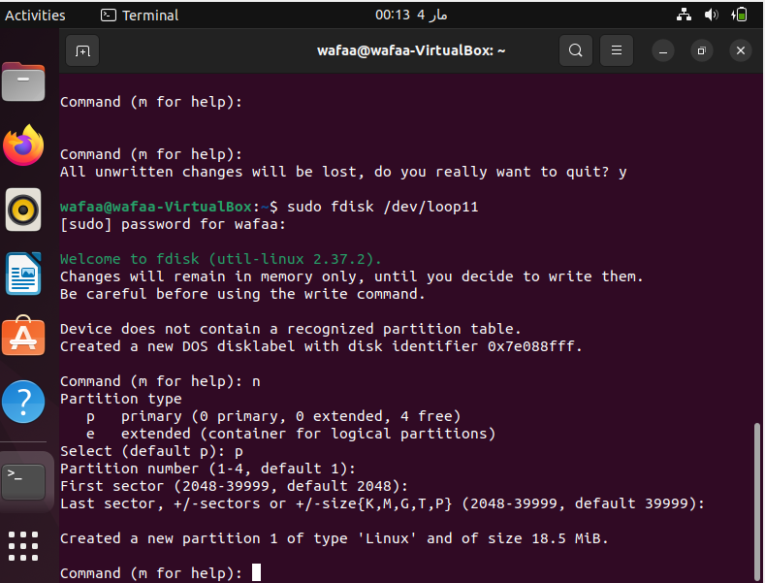4-format the new partition using mkfs.ext4 command

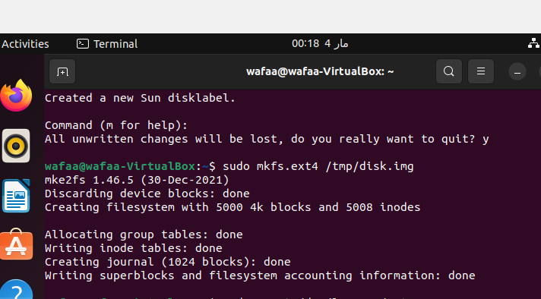

5-mount the formatted partition into /mnt directory

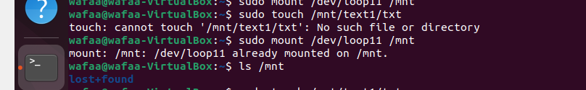

6-create some files inside the mounted /mnt directory

7-unmount /mnt directory using umount command

8-using `apt` command, search and install `gparted` program

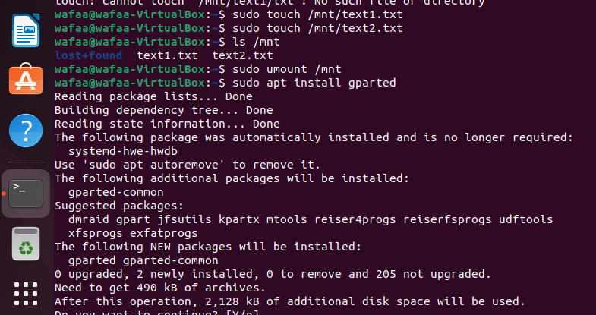

9-navigate and use gparted to detect the the new partition.

