1-create user called itiuser1,itiuser2:

sudo useradd itiuser1

sudo useradd itiuser2

2-create group called ps_team:

sudo groupadd os_team

3-create directory called os_team_workspace:

mkdir os_team_workspace

4-assign os_team gp to directory:

sudo chgrp os_team os_team workspace

4-1- change mod to setgid:

sudo chmod g+s os_team workspace

5-add itiuser1,itiuser2 to os_teamgroup:

sudo usermod -a -G os_team itiuser1

sudo usermod -a -G os_team itiuser2

6-create directory mydir1,mydir2:

Mkdir mydir1 mydir2

sudo chown itiuser1 mydir1

sudo chown itiuser2 mydir2

7- tree mod

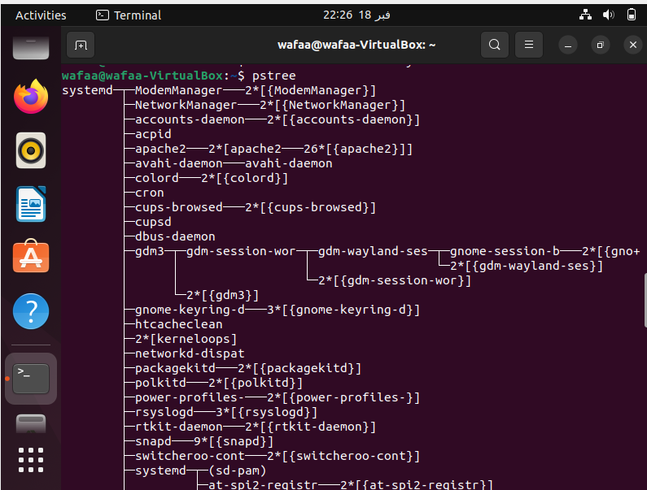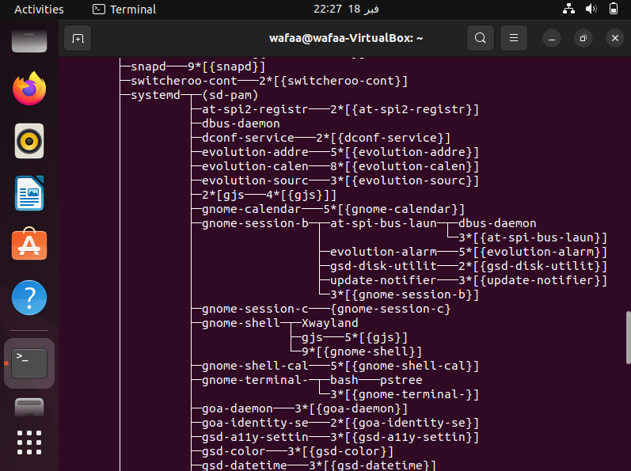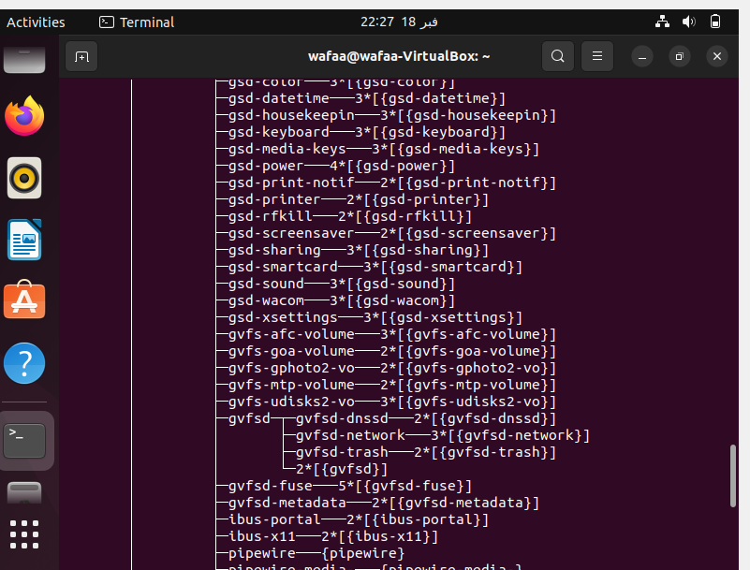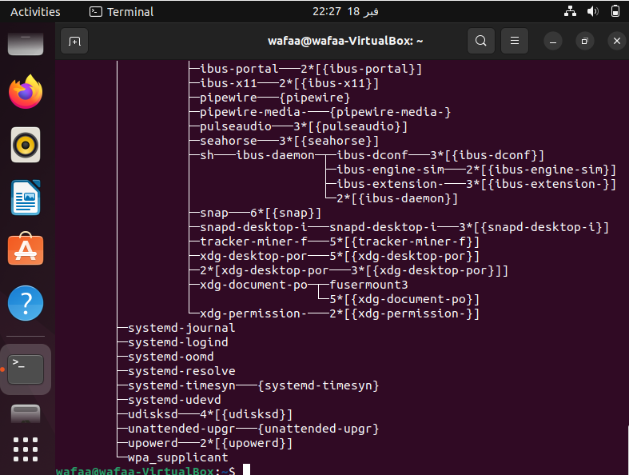

Tail -f /var/log/syslog:

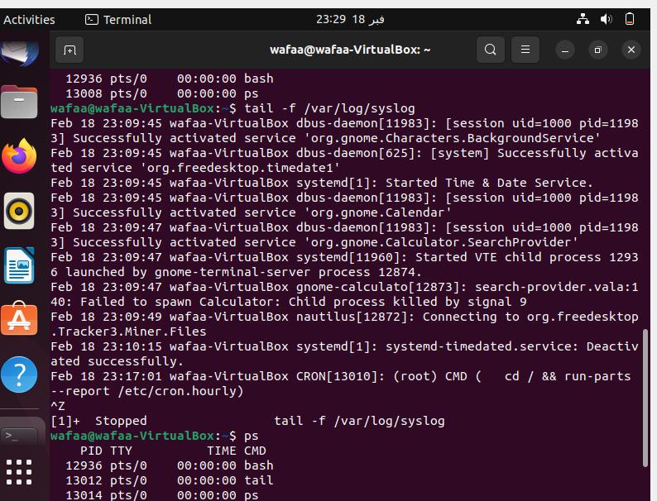

Kill tail:

