**PERFORMANCE**

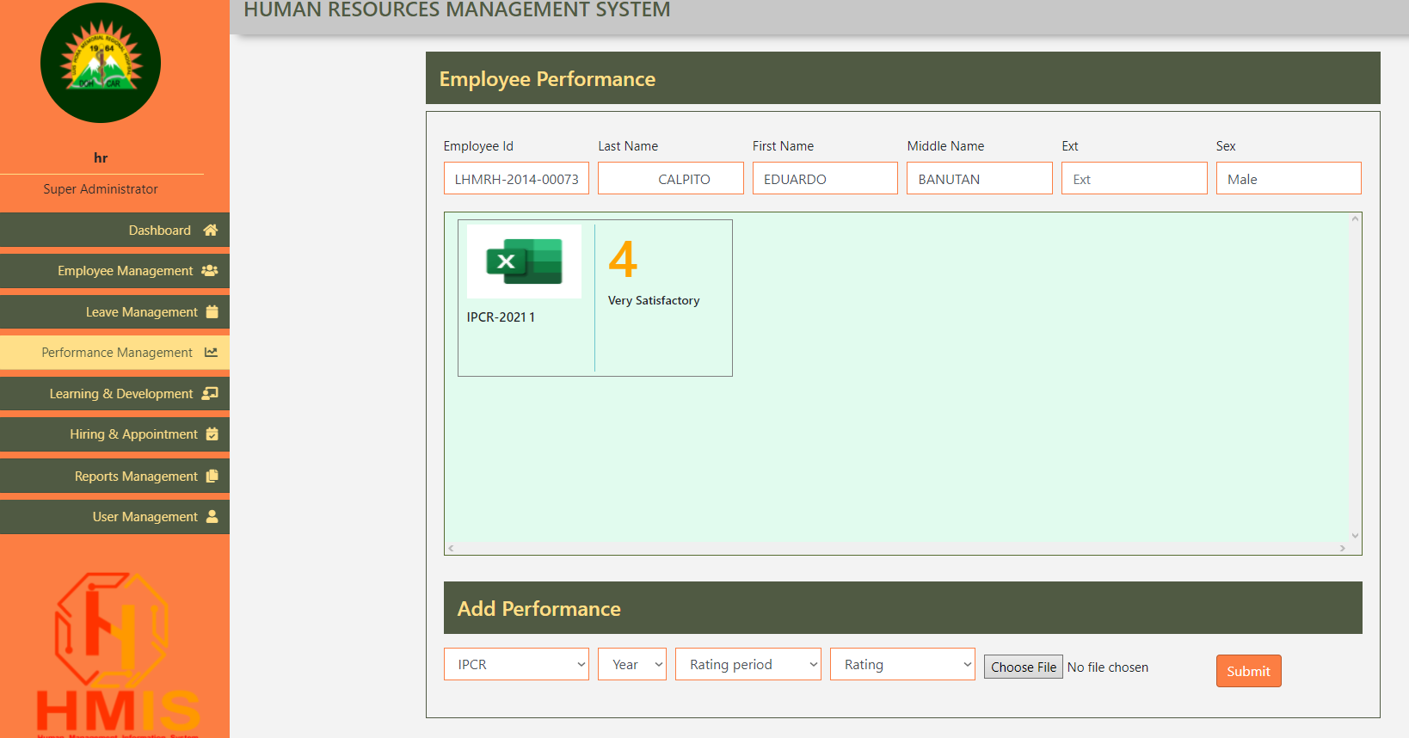

1. Please put X or delete in this part so the employee, superadmin and hr admin can remove and change the file.
2. All IPCR and DPCR upload can also go directly to the File 201 folder of the employee.

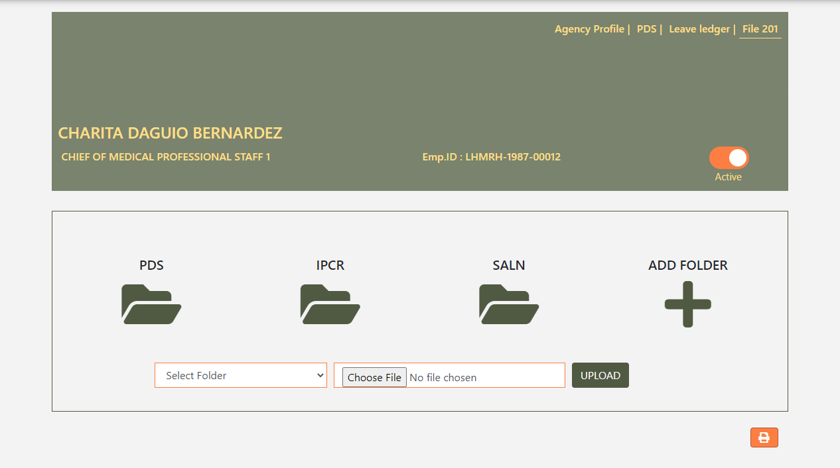

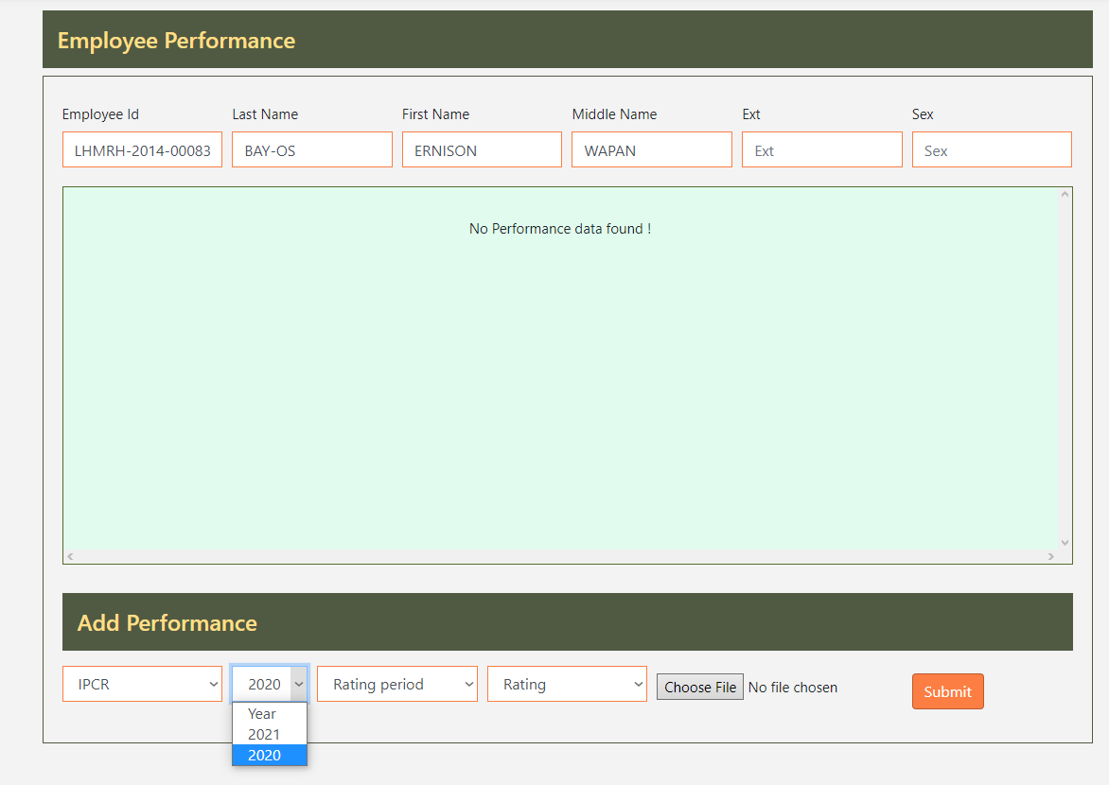

1. Please add additional year here

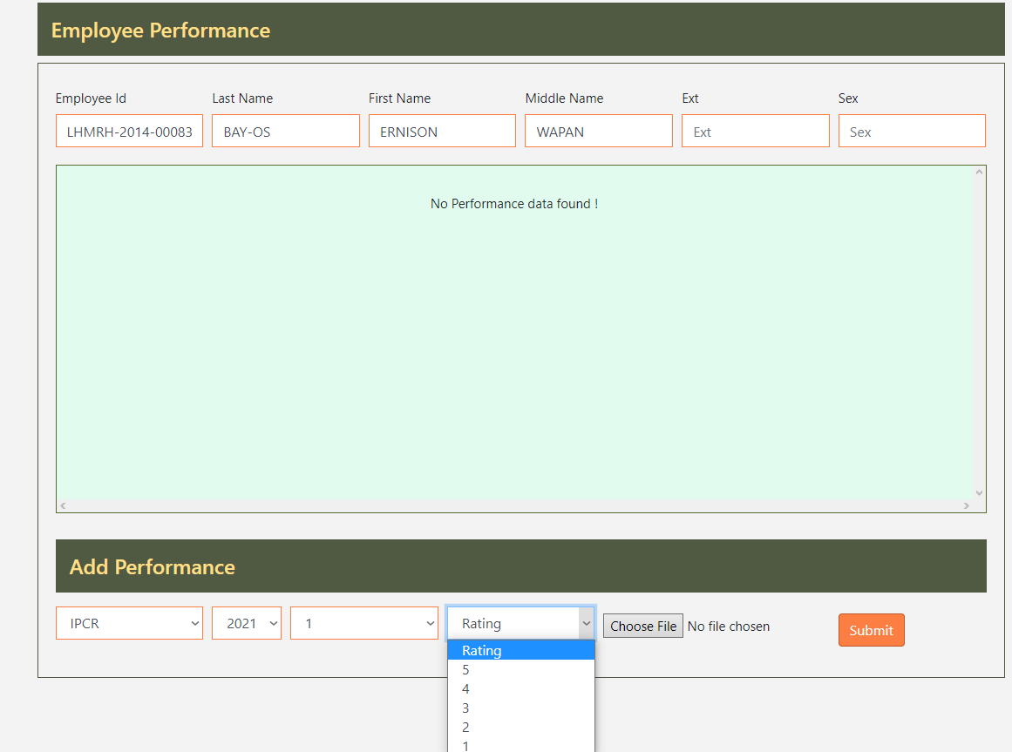

1. Please make this selection into input (integer only). IT is because ratings can have decimal like 4.5, 3.5, 2.3 etc…

**LEARNING AND DEVELOPMENT**

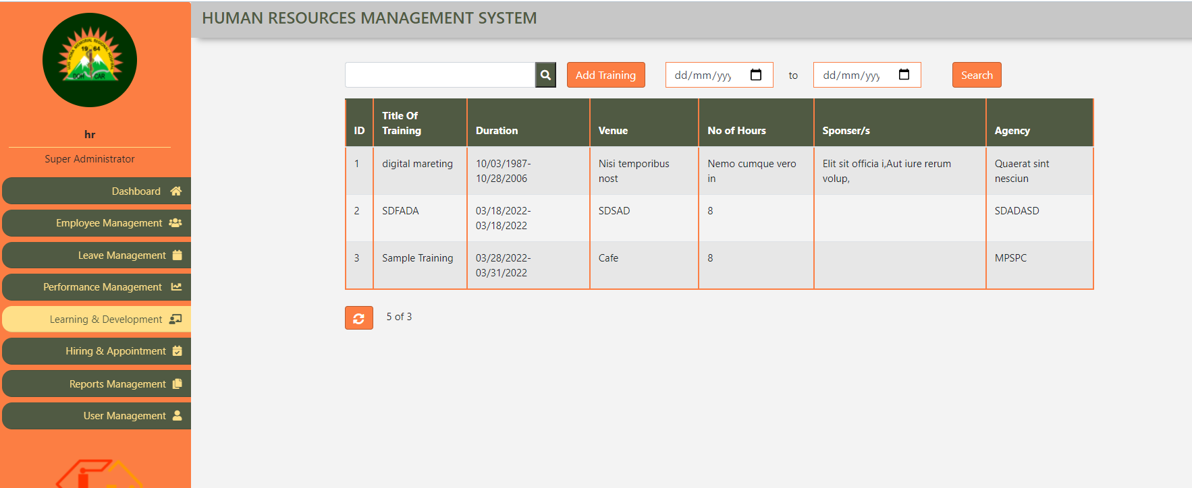

1. This part will only be for super admin and hr admin user.
2. Please add Edit and Delete action / function here. There are cases of postponed seminars and canceled seminars.
3. Please add TRAININGS AND SEMINARS just above the table.
4. Please add this table below to show the summary of trainings of the employees.

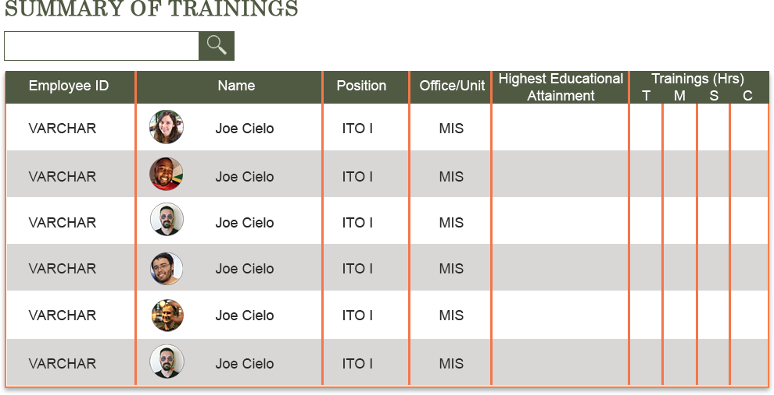



2

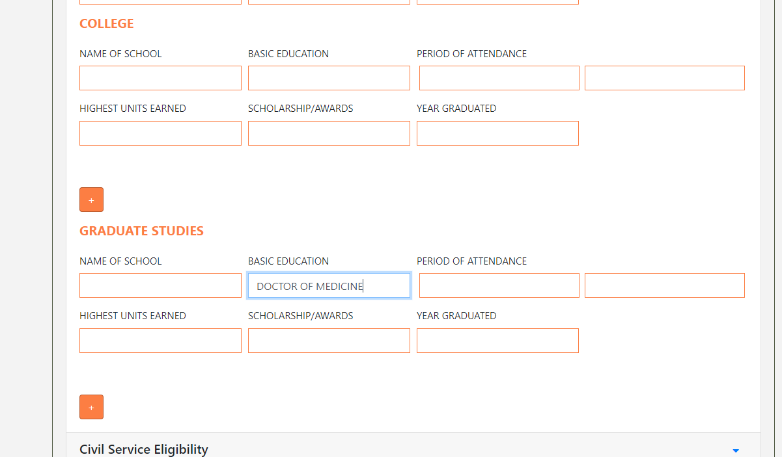

1

1. Gets the Latest/Highest Education of the employee. Gets the value in the Basic Education FIELD.
2. This column gets the TOTAL HOURS per TYPE OF TRAINING.
3. Please provide print button below

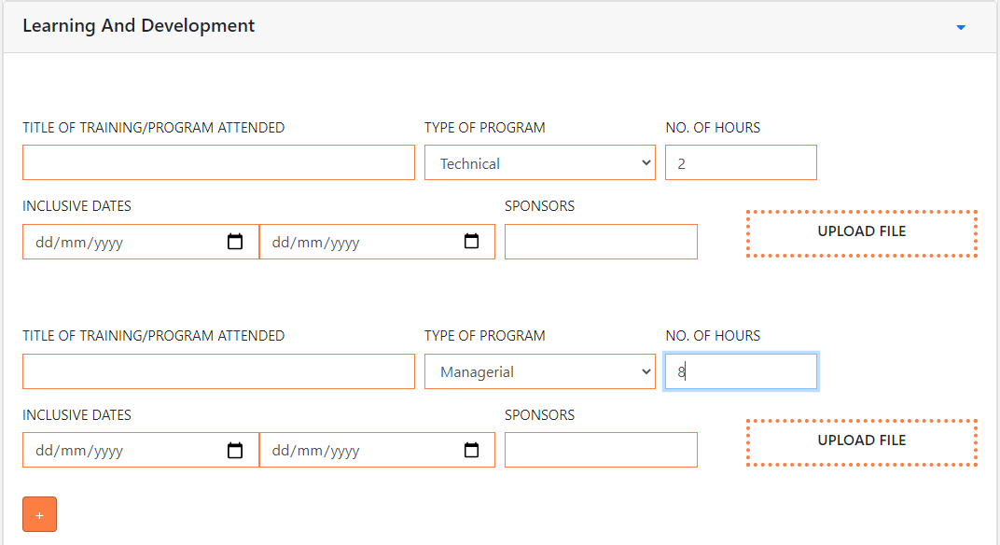

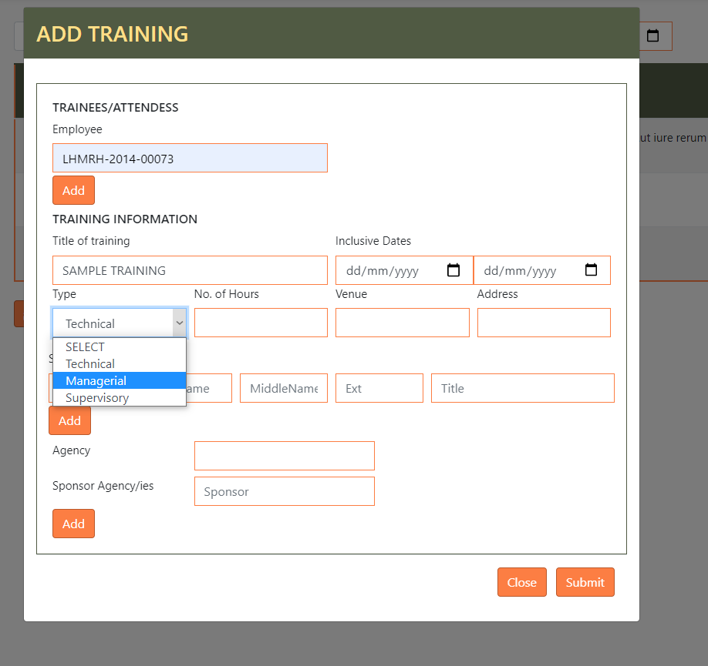

1. Please ADD CLERICAL here.
2. Once an Employee is added, this training/seminar will automatically go into the employee Learning and Development PDS record.

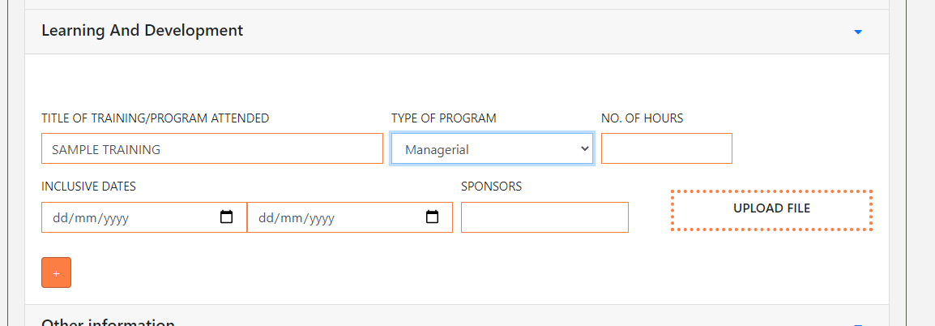

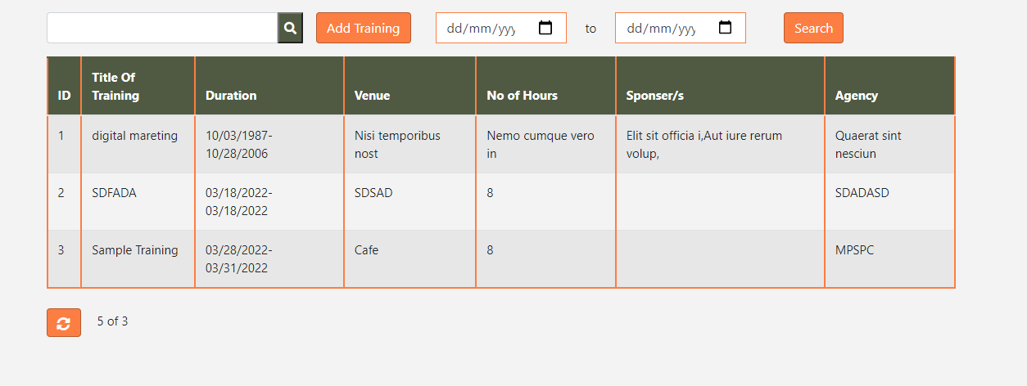

1. In the EMPLOYEE account, please remove this part. Only the Superadmin and HR admin can add training.

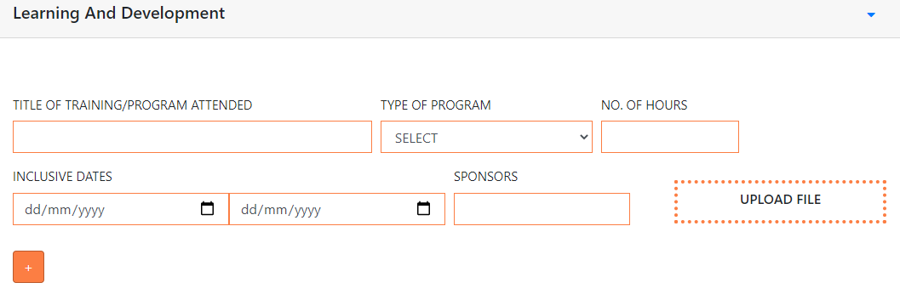

1. Please change this to UPLOAD CERTIFICATE. Pdf File only
2. The file uploaded will also go into FILE 201 tab under CERTIFICATES FOLDER (automatically added once an employee start to add certificate - if possible).