Testing Issues.

1. I cannot add a role to a user. See screenshots and replicate on your end  
     
   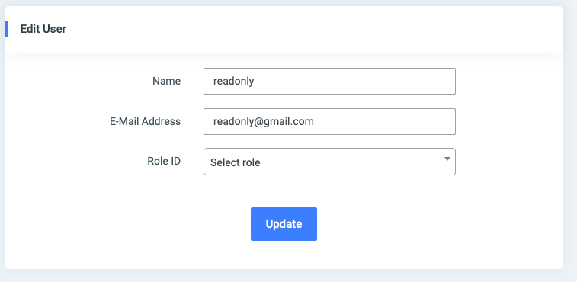

I then select a role to update: Consumer  
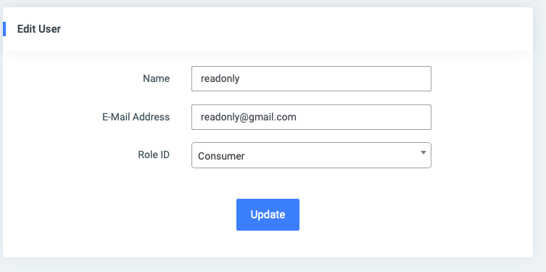

When I click on **Update,** the application crashes  
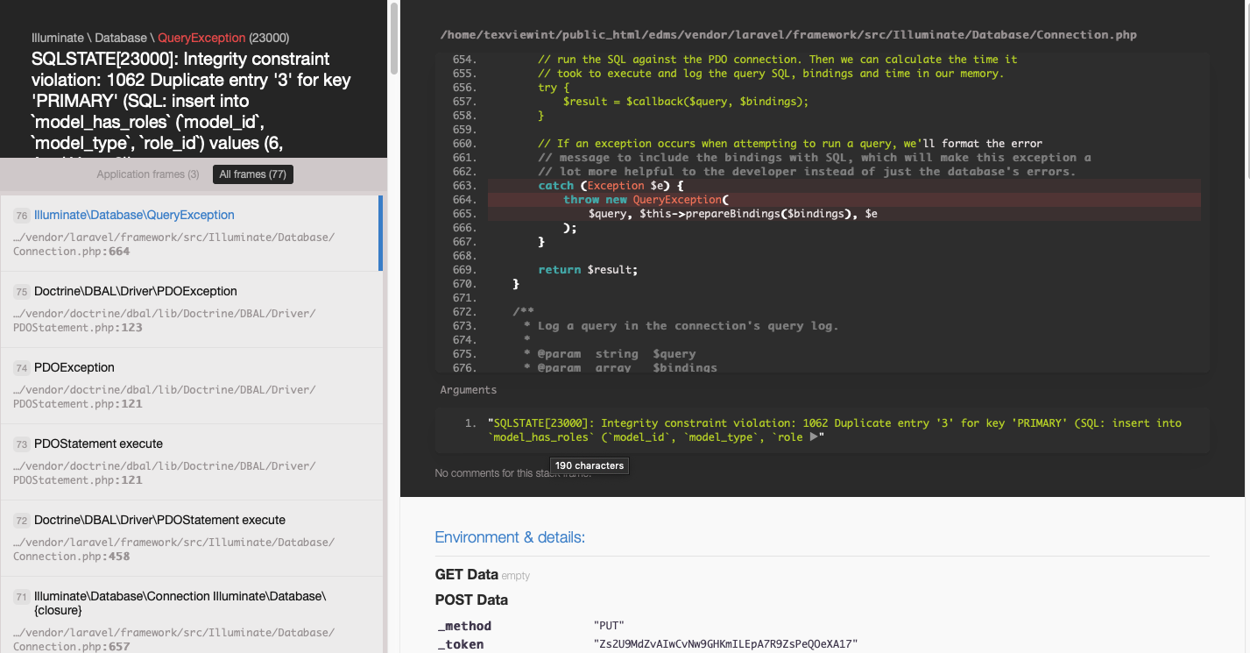

1. Modifications required in Edit Patient Screen  
     
   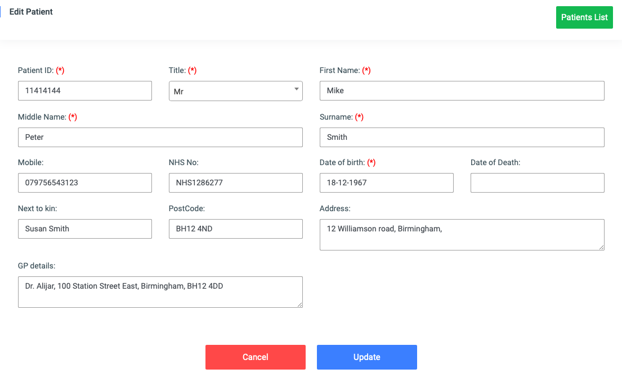

Middle Name is not mandatory  
 change ‘Next to kin’ to ‘Next Of Kin’

1. Previous versions not displaying the versions   
   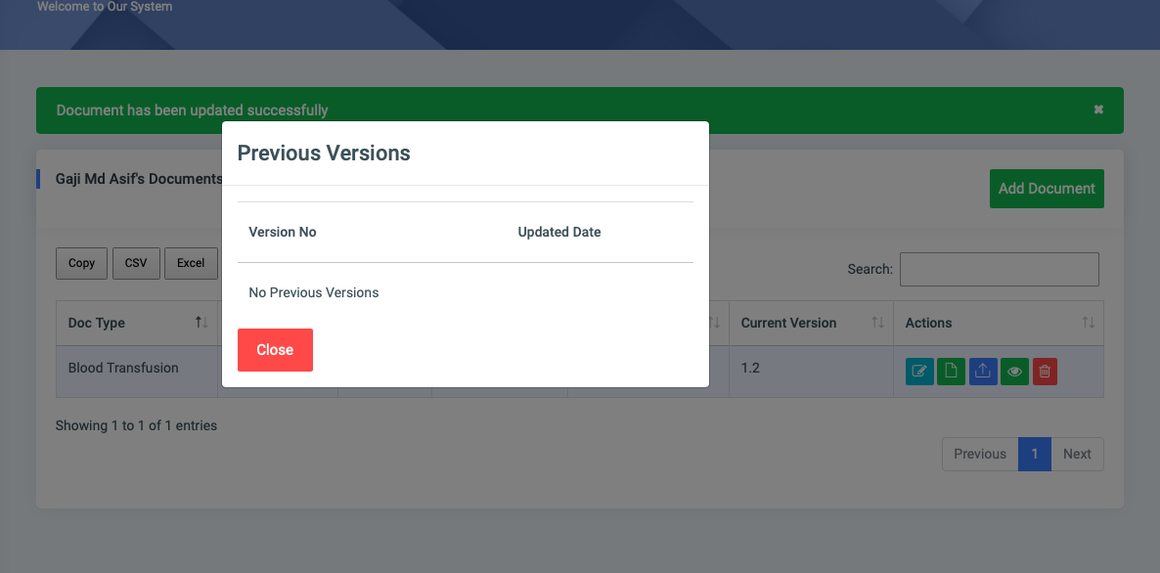  
     
   I updated the metadata of the above document. And when saved, the version changed from 1.1 to 1.2 as expected.  
   However, when I click on the previous version Action button, it does not display the previous version.
2. Can you please display the Patient details on the Document Screen

From this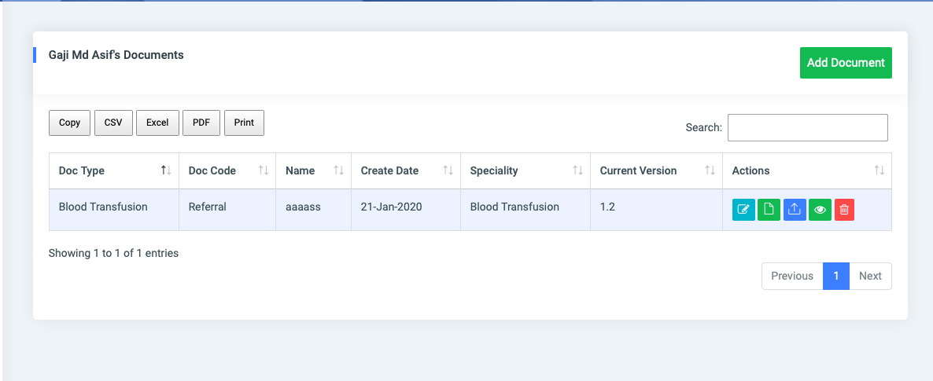

To this

