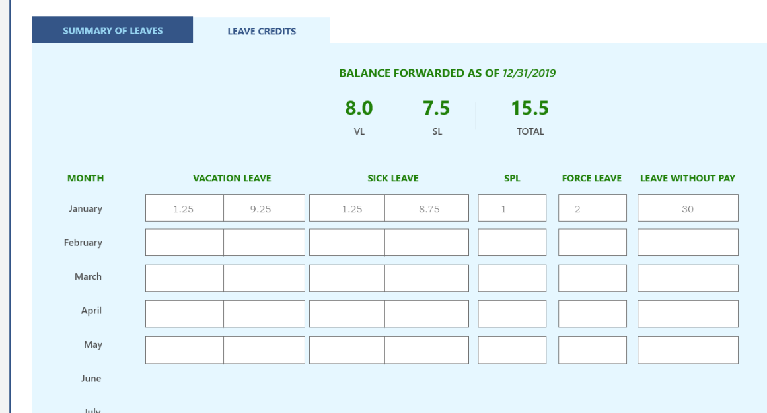

10.25

1.25

5.25

9.0

1.25

-3.0

7.25

-2.0

1. Please make this (red box) area editable as this is where the system starts its computation.
2. This (blue box) computes the vl and sl.

Examples:

1. (Orange Box) The employee has 1.25pts added to his leave credit because he/she did not file a vacation leave in this month.
   1. 1.25 + 8.0 (Balance as of prev year) = 9.25
   2. Same goes with Sick leave column
   3. The employee has 1 day Special Privilege Leave and 2 Force leaves acquired
2. (Green Box) The employee acquired a 2-days vacation leave equivalent to 2.0 less for its leave credits. He, however did not file for sick leave that is why he has 1.25 additional leave credit for sick leave.
3. In March, the employee has 3-days vacation equivalent to 3.0pts deducted from his vacation leave credits. But additional 1.25pts because he did not use any sick leave.