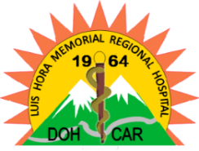 Republic of the Philippines

Department of Health

LUIS HORA MEMORIAL REGIONAL HOSPITAL

Abatan, Bauko Mountain Province

[lhmrh_doh@yahoo.com](mailto:lhmrh_doh@yahoo.com)

CERTIFICATION

This is to certify that as per record available in this office, Mrs. Arcadia D. Wawey, Midwife I, this agency has an undependable leave balance as of February 1979, to wit:

VACATION LEAVE 164.902

SICK LEAVE 402.042

**TOTAL 566.944 days**

This certify that the above stated earned leave credits was accumulated from the period of February 20, 1979 to November 13, 2020.

This certification is issued to support the Terminal Leave Benefit Claim of Mrs. Wawey.

Issued this 5th day of October 2020 at the Luis Hora Memorial Regional Hospital, Abatan, Bauko Mountain Province.

**PAMELA C. PAKIPAC, RND, MPA**

Administrative Officer V

Head, Human Resource Management Office