Software Engineering Department

Ort Braude College

Capstone Project Phase B

Bus Routes Scheduler

Project Number: 22-2-D-3

Supervisor:

Zeev Frenkel

Wafa Ghanem 315842427

[Wafagha3@gmail.com](mailto:Wafagha3@gmail.com)

Leran Dagash 315668392

[Leran158@gmail.com](mailto:Leran158@gmail.com)

**User guide**

## Packages used:

Networkx

Apache MXnet

Numpy

Tensorflow

Anvil

Matplotlib

These packages must be installed prior starting, the user must make sure the packages versions support the other packages.

The code we provided makes sure the required packages are installed (until the due date of the assignment)

## Training the model & statistics.

For training the model from the start, the user must run the code in Training-Bus_Router.ipynb we provided on google colab, a few changes must be done:

1.The user must connect to their own google drive account

2.The user must change the paths to their own google drive account to save and load the model parameters

After those changes are done, the user now can run all the cells either by choosing runtime->run all from the nav bar of google colab, or by running each cell one by one.

Once all the cells finish running the user can see the results in the output box under each cell.

Fig. 1. Mounting the drive.

Fig. 2. Changing the path to your desired path.

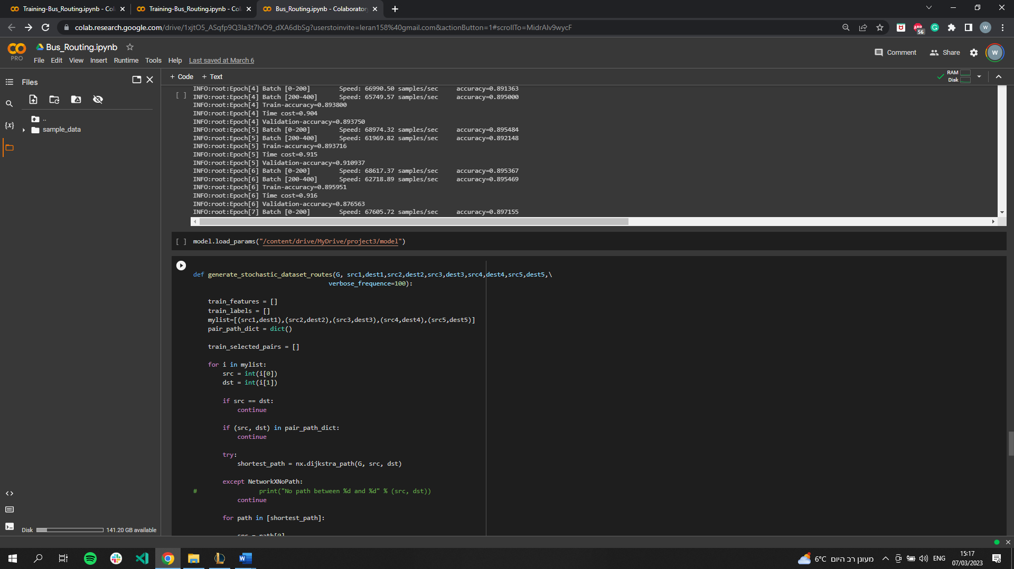

Fig. 3. Changing the path to the desired path.

Fig. 4. running the cells

## Using the model.

After training the model for at least one time, now we should have the model parameters saved in our google drive, the user can now run the cells without the cells containing the model training and result/tests.

## Using anvil server.

After running all the cells ,the last cell is used for the anvil server ,once its running it runs for ever(or until the google colab runtime is disconnected), once this cell is running the user can head to the public URL to use the anvil interface, the user can calculate 5 routes of their choice, the source and destination must be numbers between 0-49 ,once the user filled the five routes source and destination fields he then can click calculate routes to see the resulted routes, when clicking the route# button the route # is shown, the user can click back in order to calculate 5 different routes

Our application starts from Startup window (Fig. 6). The user enters the source and destination of each route (numbers between 0 and 49) then clicks calculate routes. The user will be transferred to the next window (Fig. 7), the user now can click on the desired route to see the route calculated (Fig. 8). The user may click on the back button to calculate different 5 routes.

Fig. 6. Startup and Planning window

Fig. 7. The user can click on the route desired to see the calculated route.

Fig. 8. The user clicked on route1 to see the first calculated route.