
TITLE OF WORK: CS4127 A1-WAFEE37707
MODULE CODE AND TITLE:
CS4127
Web Development
MODULE LEADER: Noorsyamimi Haji Abdur Ajak
WORD COUNT: 1676
LCB ID AND ESSEX ID NUMBER:
LCB/6354 AND WAFEE37707
GitHub Repository: https://wafeeka737.github.io/LabVenture/

Table of Contents
1.Initial Design Plan & Wireframes 4
2. Development Log / Process Summary 9
3. Testing and Deployment Steps 11
4.JavaScript Features Description 16
REFERENCES 19

1.Initial Design Plan & Wireframes
The goal of Labventure website is to create an interactive and educational platform for learners to explore and learn simple science experiments.
The main design plan focused on making the website visually engaging, with readable fonts, consistent colors and buttons across pages, while remaining user-friendly and accessible across all devices. The initial design plan included five pages which are, Home, Deep Dive, Experiment, Activity and FAQ. Wireframes were sketched using Canva, highlighting page layout, navigation, interactive elements and responsive design considerations.
1.1 Home Page Wireframe:
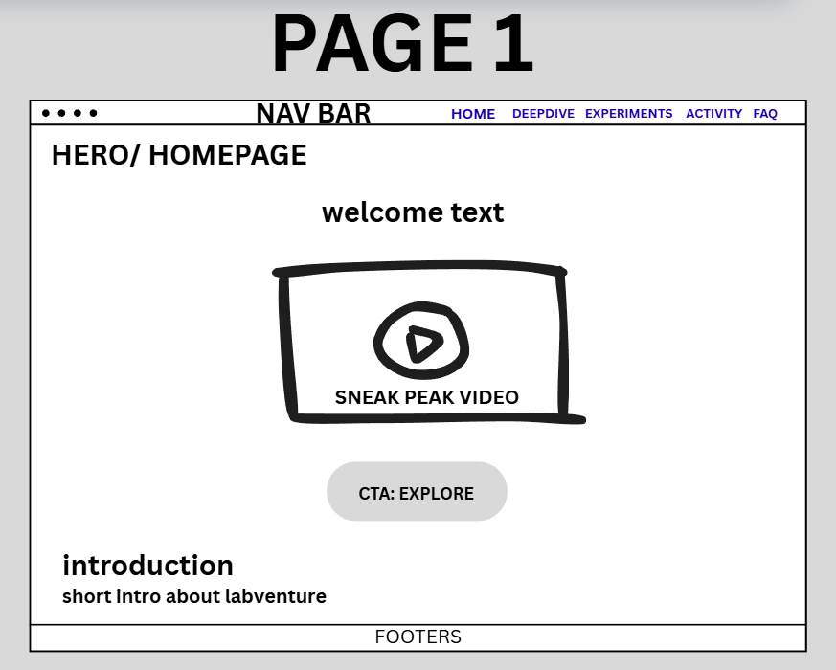
This wireframe above illustrates the Home Page layout, featuring welcome message, a self-edited sneak-peek video created from scratch to give an idea what this website will cover and a responsive “Start Exploring” button. Moreover, it also displays the navigation bar above for easy access to other pages and will consistently appear throughout the website. As for the colors, soft pastels were applied for background and contrasting buttons were chosen to create a fun yet readable interface suitable for educational purposes. The hero section was designed to immediately engage users and direct them to the Experiments page with a sense of curiosity. A minimal footer is also included at the bottom of all pages, indicating where the copyright information (“© 2025 LabVenture | Created by Wafeeka”) will appear in the final design.

1.2 Deep Dive Page Wireframe:
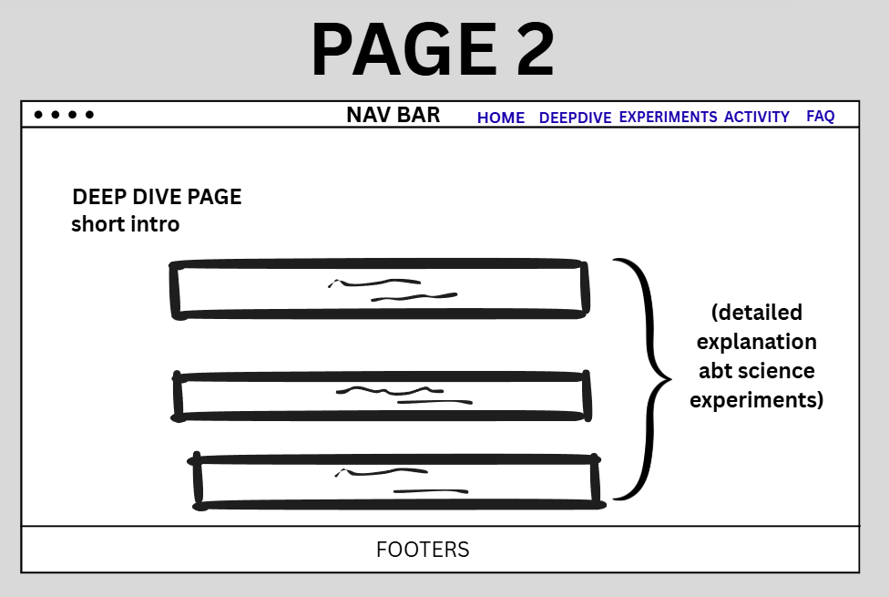
This wireframe page provides detailed explanations of the scientific principles behind each experiment, including concepts in physics, chemistry, and biology. Each article section explains a principle behind the experiment in simple terms, such as chemical reactions, density, and fragrance formulation (Science Buddies, 2019; Goel, 2025; TalkFragrance, 2025), and presented in a clean, readable structure enhancing comprehension for learners of all ages.

1.3 Experiments Page Wireframe:
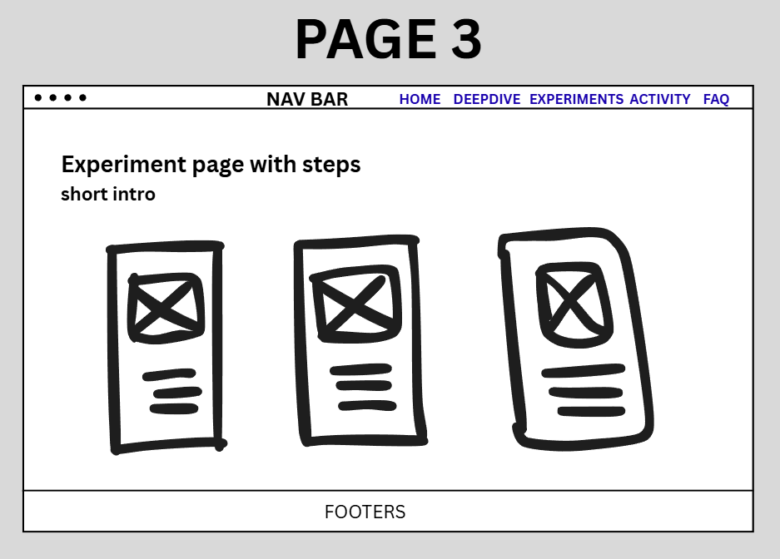
The wireframe above displays three science experiments in card layout, including image placements, headings, step-by-step-instructions and a brief scientific explanation. This layout was designed for clarity and clear visual appeal for each experiment as this allows users to quickly understand through pictures, along with simple steps and science behind the experiment.

1.4 Activity Page Wireframe:
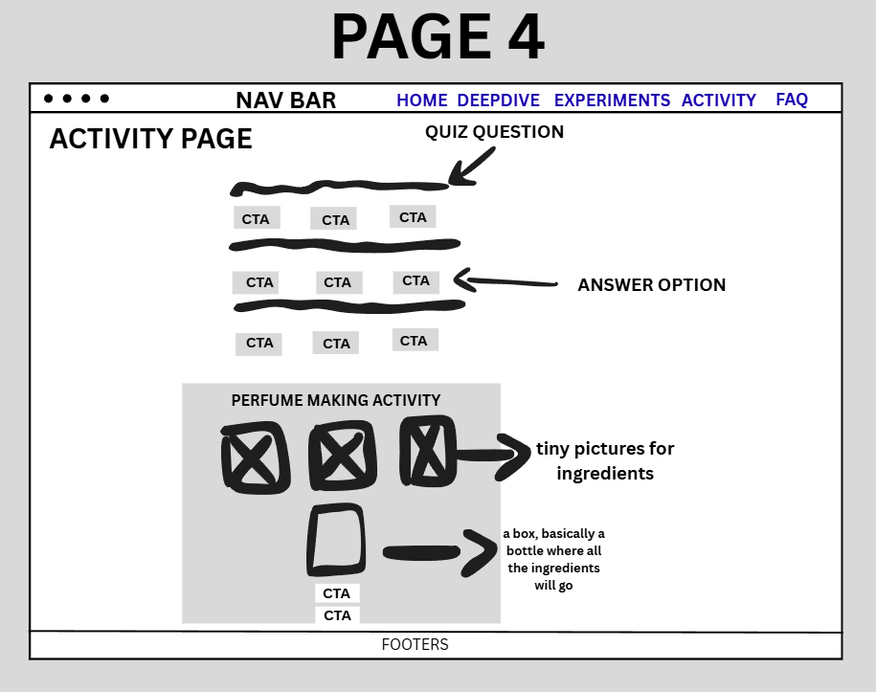
This wireframe includes interactive quiz section and the perfume mixing activity, allowing users to apply what they have learned through experiments and explanations. This activity page illustrates placement of quiz questions where the users know whether their answer is correct or wrong by clicking the button and making own perfume section where users can use their creativity and knowledge to drag and drop the perfume inside the box. This ensures users can easily interact with content and receive instant responses to enhance engagement.

1.5 FAQ Page Wireframe:
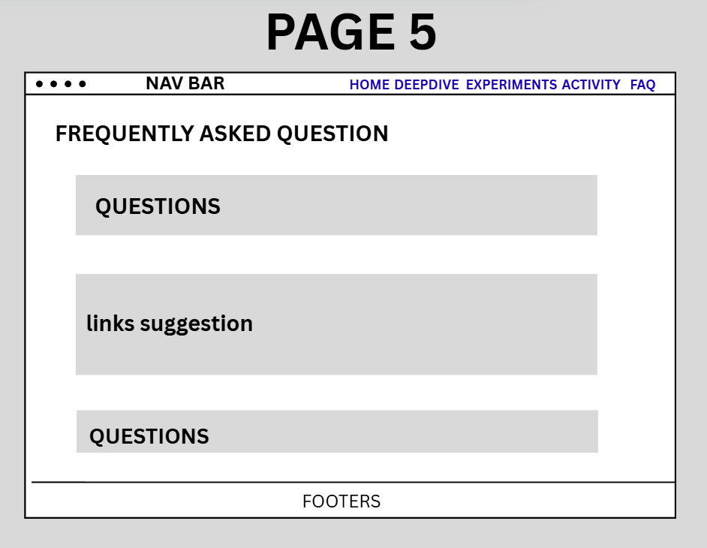
The FAQ page wireframe (page 5, final page) offers a well-organized layout with clear questions and answers, designed for user usability and accessibility. Additionally, by including only credible external links, such as National Geographic, Science News, and Science.org (National Geographic Society, n.d.; Society for Science & the Public, n.d.; American Association for the Advancement of Science, n.d.), the page encourages users to expand their science knowledge effortlessly, without the need to search for information themselves. This not only enhances learning but also ensures reliability, promotes engagement, and allows users to find trustworthy resources quickly.

2. Development Log / Process Summary
The development of LabVenture website followed a systematic, structured workflow, progressing through planning, design and layout, coding and testing. This phased approach ensured the creation of a fully functional, interactive and engaging educational that is reliable and user-friendly for all learners. The development workflow is described in the steps below. Showing how technology is applied on the website, mainly highlighting HTML, CSS, and JavaScript were implemented to build the website and how testing and debugging were carried out to refine the site.
Step 1: HTML Structure
HTML5 was used to structure all the pages semantically. For clarity and accessibility, the <header>, <nav>, <section>, <article>, and <footer> elements were implemented. Navigation menus used <ul> and <li> lists with clickable <a> links.
Step 2: CSS Styling
To make the website more appealing and fun, an external CSS file was used to maintain a consistent style across the site. Flexbox was applied for responsive layouts, including the experiment cards and perfume ingredient sections. Buttons, hero sections, quizzes, and the interactive bottle activity were styled for visual appeal. Media queries ensured the site works on both desktop and mobile, auto adjusting font sizes, element widths, and card stacking on smaller screens.
Step 3: JavaScript Implementation
Added interactive features using JavaScript and ensured it is mobile friendly works on desktop devices. There are several interactive features that were implemented using JavaScript which are:
- The “Start Explore” button redirects users from Home to the Experiments page.
- Quizzes provide instant feedback on answers with visual cues (green for correct, red for incorrect).
- The Perfume Activity allows users to drag ingredients into a bottle or tap on them to mix scents. The “Done” button displays a random congratulatory message, and the “Reset” button clears the activity.
- Mobile tap support ensures usability for touch devices.
Event listeners were used to handle user interactions while dynamic DOM provides page update instantly to show immediate visual changes.
Step 4: Testing and Debugging
To make sure websites run well across all devices, it was tested on mobile devices and in multiple browsers such as Chrome and Edge to ensure smooth responsiveness, accessibility and functionality. While testing, some minor issues occurred such as incorrect HTML tag usage, missing alt text, and small layout inconsistencies were corrected. As it goes, the drag-and-drop feature didn’t register clicks on mobile devices, which was resolved by adding a click event listener for tap interaction. Moreover, styling the experiment cards consistently across pages was tricky, as a result, flexbox and different spacing values were tested to fix it. Fixed minor HTML issues like, <b>/<br> misuse and validated images and links.
Furthermore, when developing the “Mix Your Own Perfume” interactive activity, two issues were encountered. First, the ingredient images (Citrus, Flower, Woods) did not load, instead it appeared as broken icons as shown in the screenshot below. This happened because the image paths were incorrect. Solved this problem by double checking my folder structure and updating the <img> src paths to match the actual location of the images. After correcting the paths, the images were displayed properly as expected.
Second the drop area (the “bottle” box where users place the ingredients) did not appear as intended. The size, border style and background color did not match the planned design because of the wrong CSS class. Hours were spent reviewing the style sheet, fixing issues, and updating the class selectors so the drop box matched the original wireframe design (correct width, border, and background color) as expected. After correcting the CSS and ensuring the HTML class names matched properly, the drop area appeared correctly and worked with the drag-and-drop JavaScript.
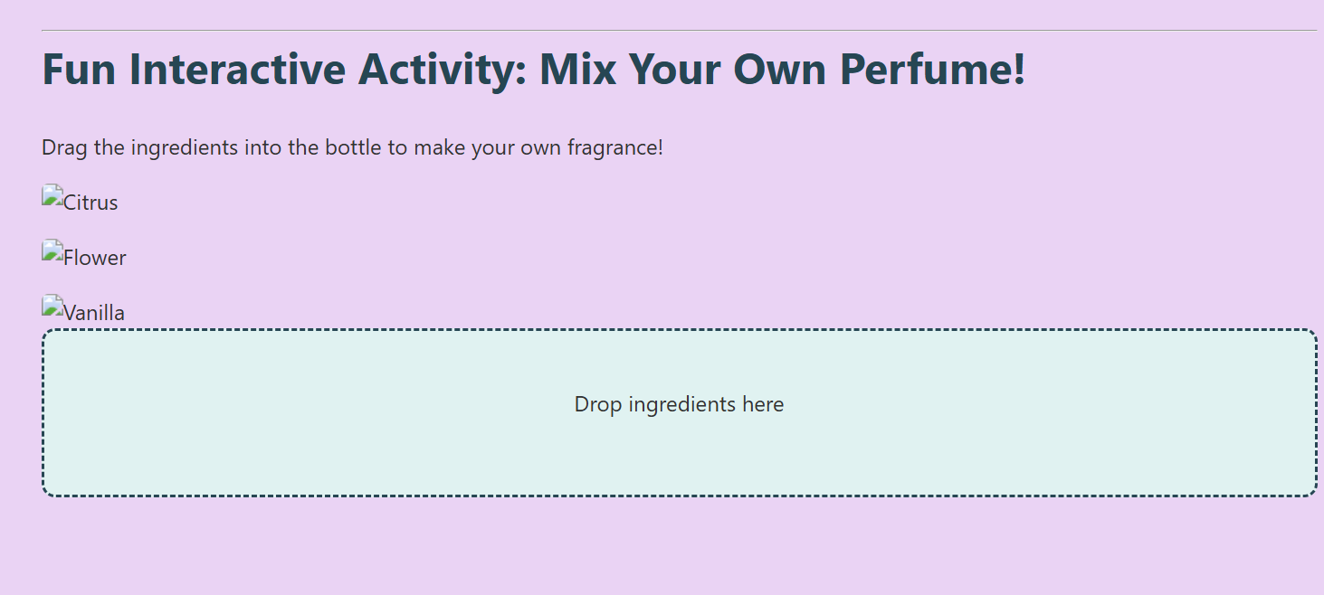

3. Testing and Deployment Steps
Tested every page of the website using online validation tools which are W3C Markup Validation Service for HTML code and CSS was validated using the W3C CSS Validation Service to ensure all the website features worked perfectly and looked consistent across different devices and browsers. This helped to identify coding errors and helped to correct them by giving explanations to the errors, ensuring that the site adhered to web standards. Evidence and solutions to the errors are shown on the following page below. After fixing these, no further errors were found. The website was then deployed to GitHub Pages, making it publicly accessible and fully functional.

Evidence of testing:
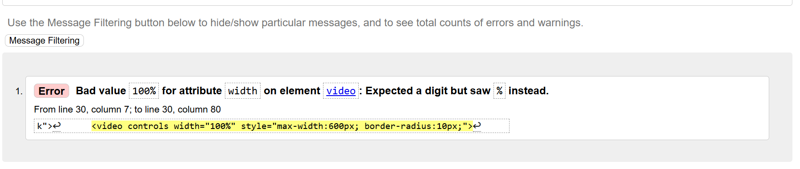
As shown in the picture above, the error occurred because the width attribute of the <video> tag only accepts numbers, so using a percentage (100%) is invalid and it was fixed by setting the width in CSS instead.

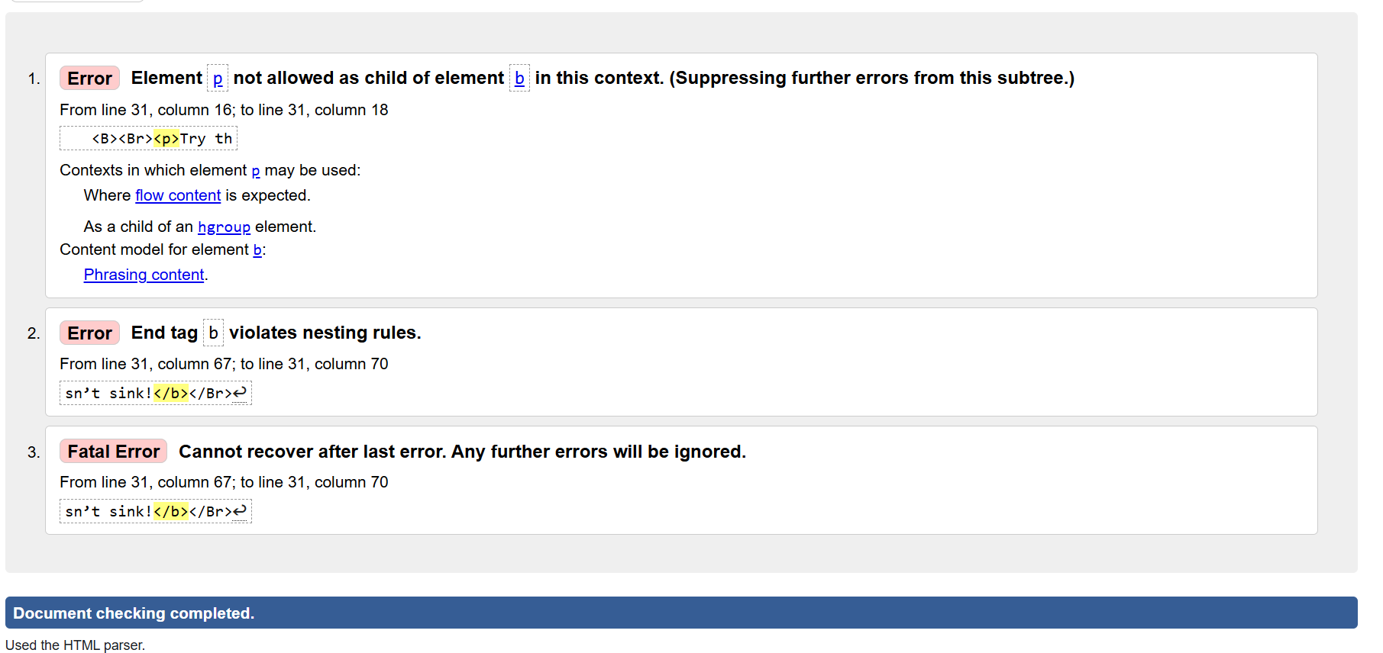
The error above occurred because the <p> (paragraph) element was placed inside a <b> (bold) tag, which resulted in invalid HTML, so it was fixed by placing <strong> inside the <p> and removing invalid </br> tags.

Image evidence confirming that all HTML and CSS pages are error-free after corrections.
index.html page:
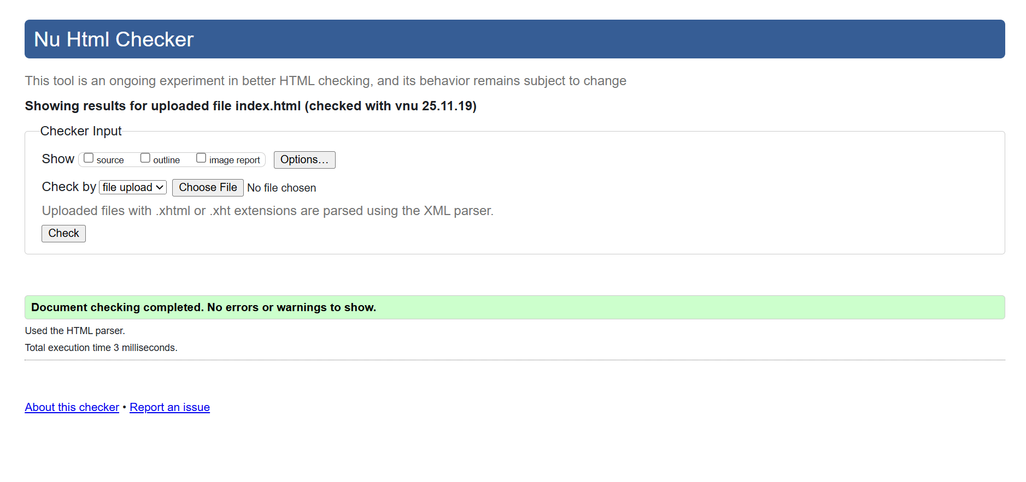

deepdive.html page:
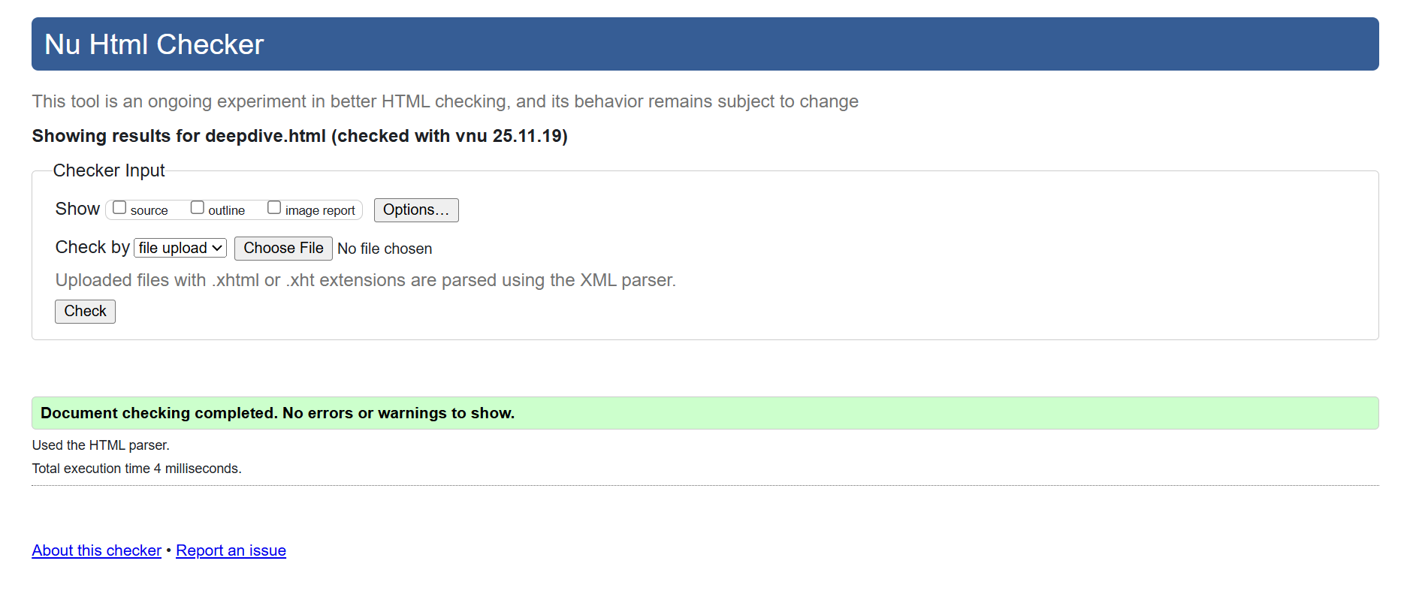

experiments.html page:
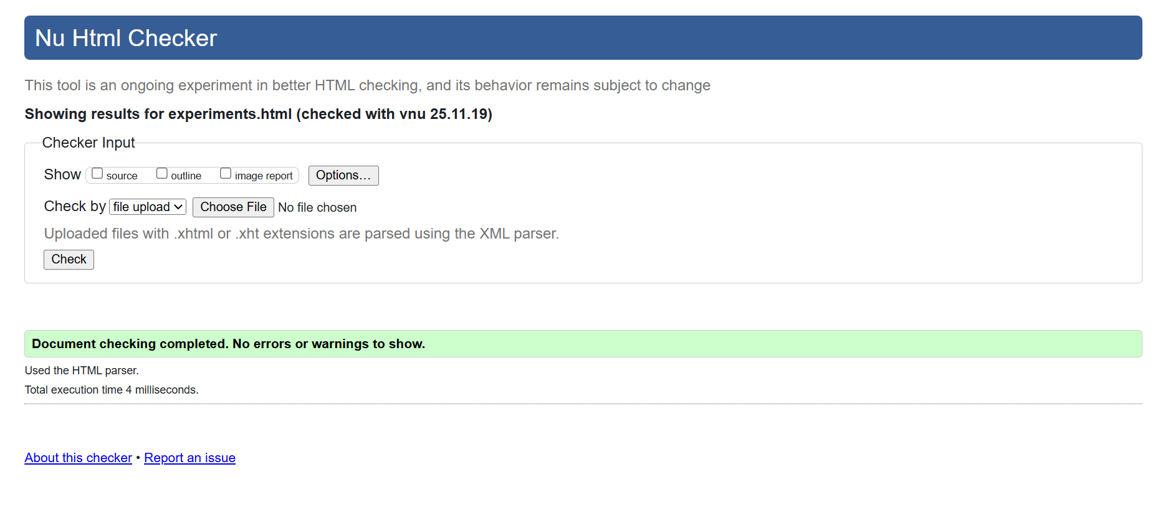
activity.html page
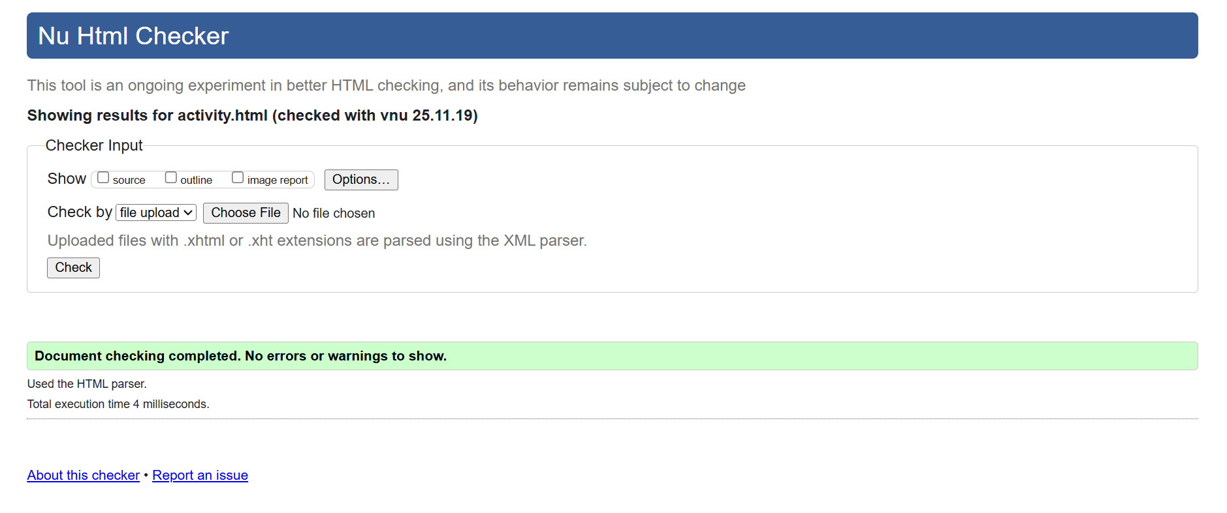

faq.html page:
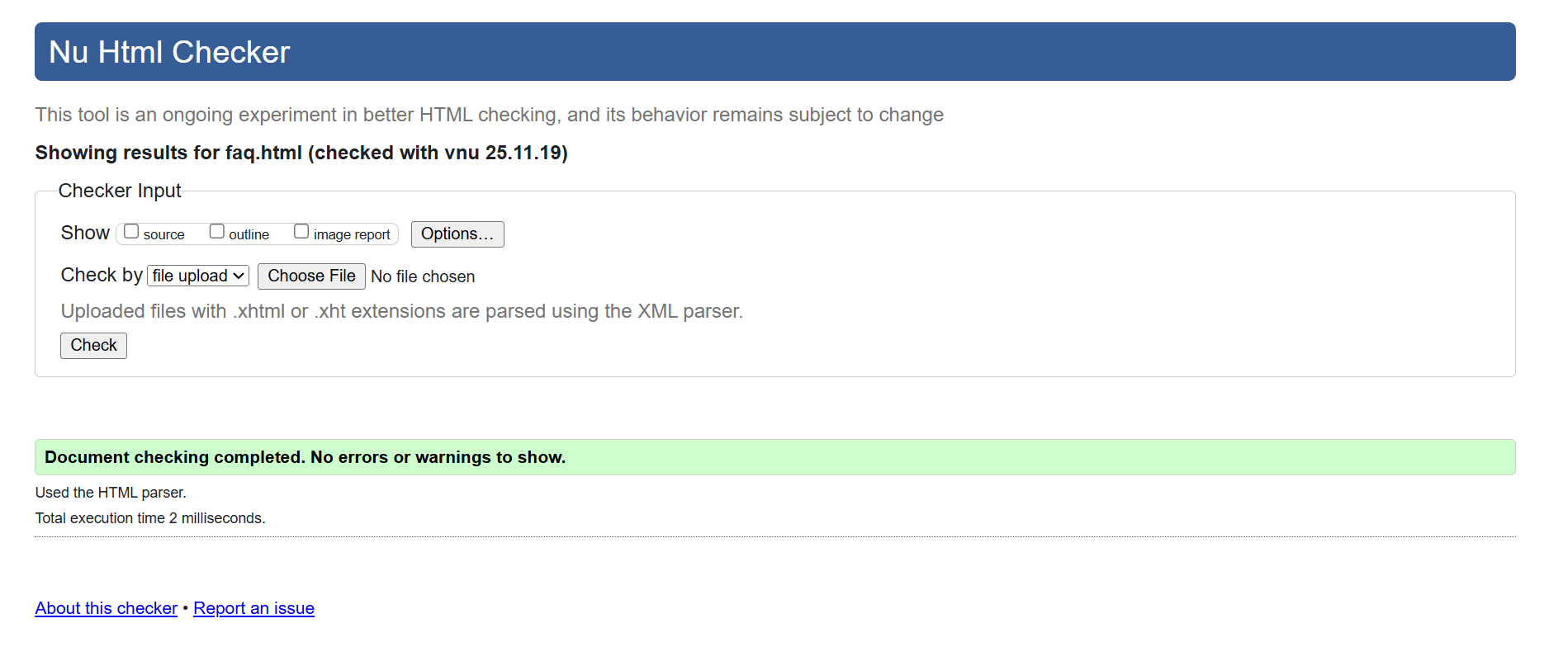

Style.css page:
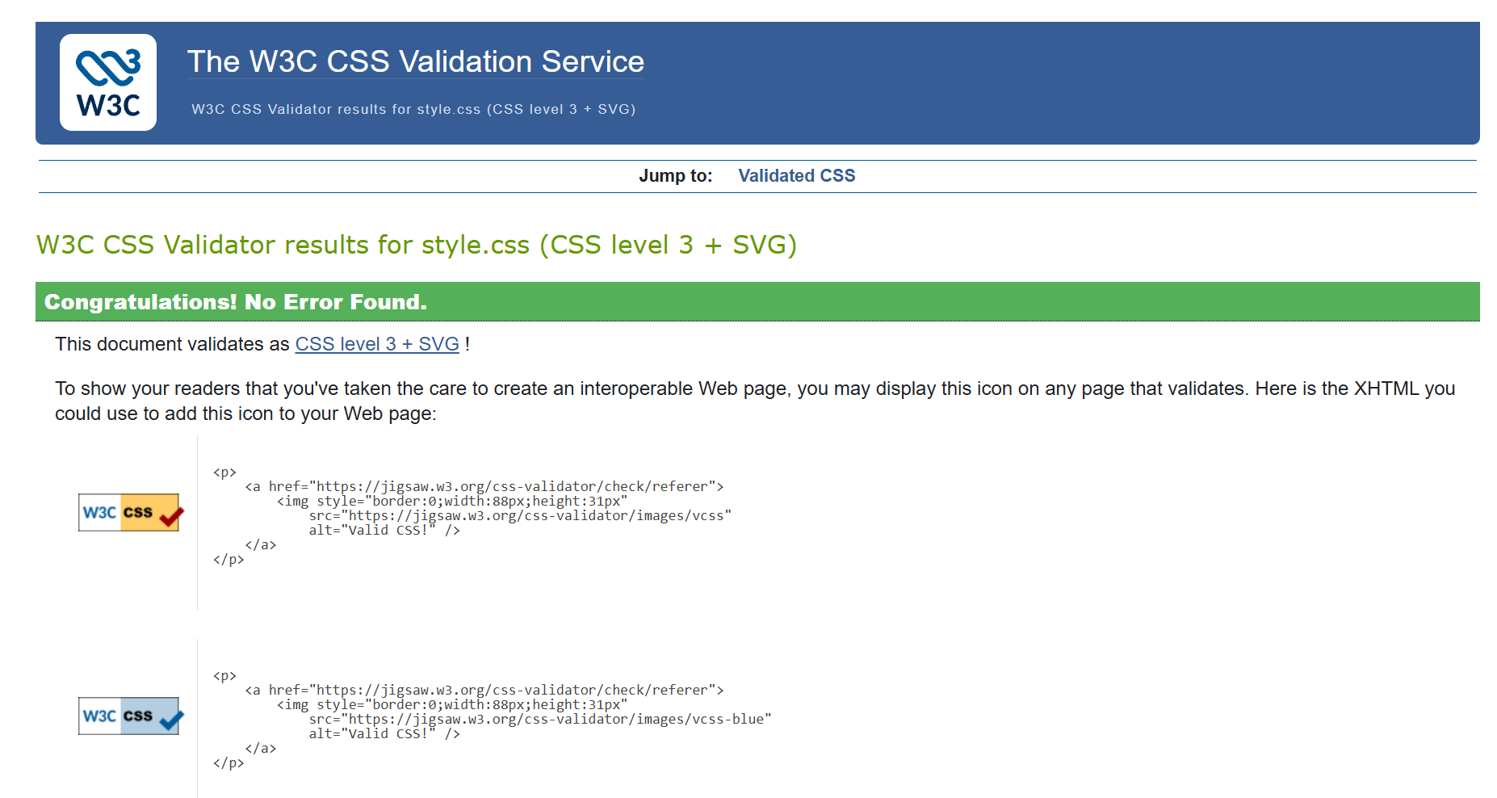

4.JavaScript Features Description
JavaScript was used to make the website interactive, more engaging and to improve user experience by enabling dynamic content updates, real-time feedback and interactive activities. As a result, these features make learning both fun and intuitive, while keeping learners interested and actively involved rather than passive viewing. The following features demonstrate how JavaScript was applied to support navigation, quizzes, and hands-on activities across different devices.
1.Start Explore Button
- Function: Redirects users from the Home page to the Experiments page.
- Purpose: Provides clear and user-friendly navigation and encourages users to explore the website.
2. Quizzes (Activity Page)
- Function: Buttons check answers and display immediate feedback, highlighting correct answers in green and wrong answers in red.
- Purpose: Promotes interactive learning and reinforces concepts through instant feedback.
3. Perfume Drag-and-Drop Activity
- Function: Users can drag or tap ingredients into a virtual perfume bottle. The “Done” button shows a confirmation message, while the “Reset” button clears the activity.
- Purpose: Provides a hands-on interactive experience that demonstrates chemistry concepts in an engaging way.
4. Time-Based Greeting
- Function: Displays a greeting (morning, afternoon, evening) based on the user’s current time.
- Purpose: Adds a personalized touch to welcome users and make the page feel interactive.

Here are few JavaScript Demo screenshots:
1. Time-Based Greeting shows a personalized greeting based on the current time of day.

2. Quiz Interaction Screenshot: Displays instant feedback after selecting an answer.
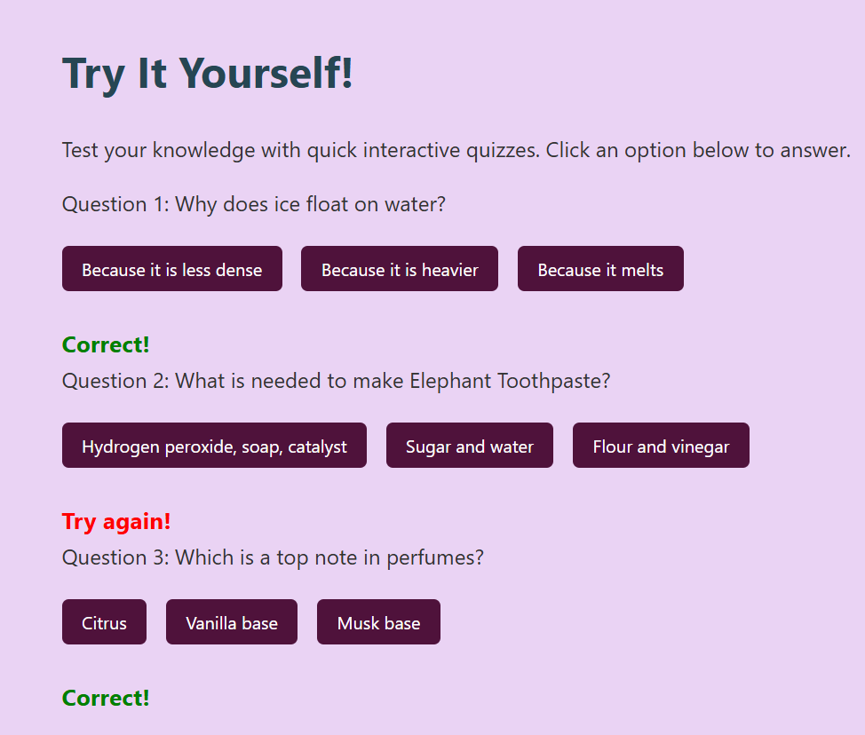

3. Perfume Activity in Action: Shows drag-and-drop interaction with dynamic updates.
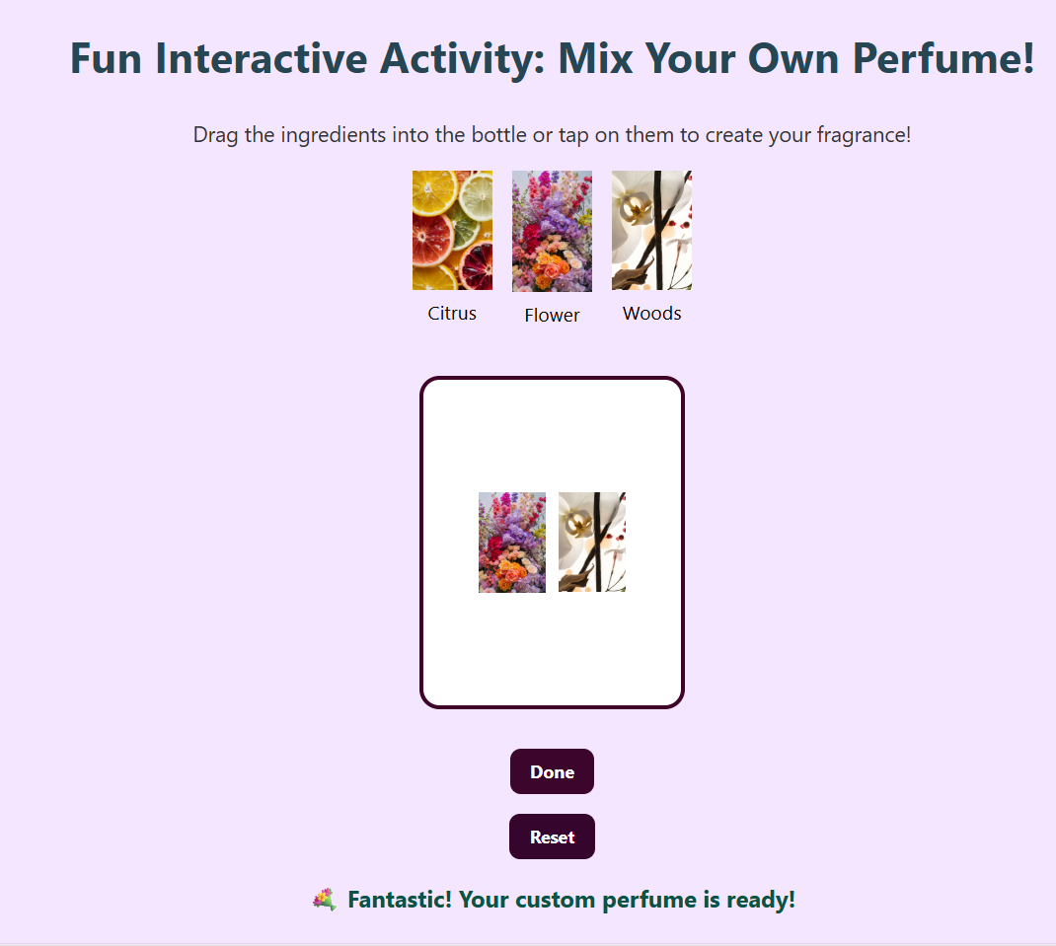

CONCLUSION
To conclude, the website successfully achieves its goal by providing users with informative, user-friendly and interactive working features across devices. The content is well-organized and provided with clear information and reliable links, allowing users to expand their knowledge without extra searching. However, although challenges occurred during development, they were resolved through careful testing and adjustments. Overall, the website demonstrates effective use of HTML, CSS, and JavaScript to create an intuitive and user-friendly learning platform.

REFERENCES
American Association for the Advancement of Science (AAAS). (n.d.) Science. Available at: Science | AAAS (Accessed: 20 November 2025).
Childhood Magic. (no date) Elephant Toothpaste experiment [Pinterest pin]. Available at: Elephant Toothpaste (Accessed: 15 November 2025).
Goel, A. (2025) ‘Why Does Ice Float on Water?’, Decoding Biosphere, 29 January. Available at: Why Does Ice Float on Water? – Decoding Biosphere (Accessed: 16 November 2025).
Mrs.B. (no date) Untitled pin [Pinterest pin]. Available at: Pin on website assignment (Accessed: 15 November 2025).
Nain’s Art. (no date) Untitled artwork [Pinterest pin]. Available at: Pin on website assignment (Accessed: 15 November 2025).
National Geographic Society. (n.d.) Science. Available at: Science | National Geographic (Accessed: 20 November 2025).
Sarah. (no date) Untitled pin [Pinterest pin]. Available at: Pin on website assignment (Accessed: 15 November 2025).
Science Buddies. (2019) ‘Elephant Toothpaste | STEM Activity’, Science Buddies. Available at: Elephant Toothpaste | STEM Activity (Accessed: 15 November 2025).
Society for Science & the Public. (n.d.) Science News. Available at: Science News | The latest news from all areas of science (Accessed: 20 November 2025).
Space NK. (no date) PHLUR Vanilla Skin Eau De Parfum [Pinterest pin]. Available at: PHLUR Vanilla Skin Eau De Parfum (Accessed: 15 November 2025).
StockCake. (no date) Crystalline Ice Dance [Pinterest pin]. Available at: Crystalline Ice Dance (Accessed: 15 November 2025).
TalkFragrance. (2025) ‘Discover How to Make Your Own Fragrance with Natural Oils’, TalkFragrance. Available at: Make Your Own Fragrance: A Guide To Natural Perfumery (Accessed: 17 November 2025).

