SECURE 4D RETRIEVAL SYSTEM
A policy-first semantic retrieval architecture built on supervised property maps
White Paper
Concept draft for product positioning, technical evaluation, and commercialization

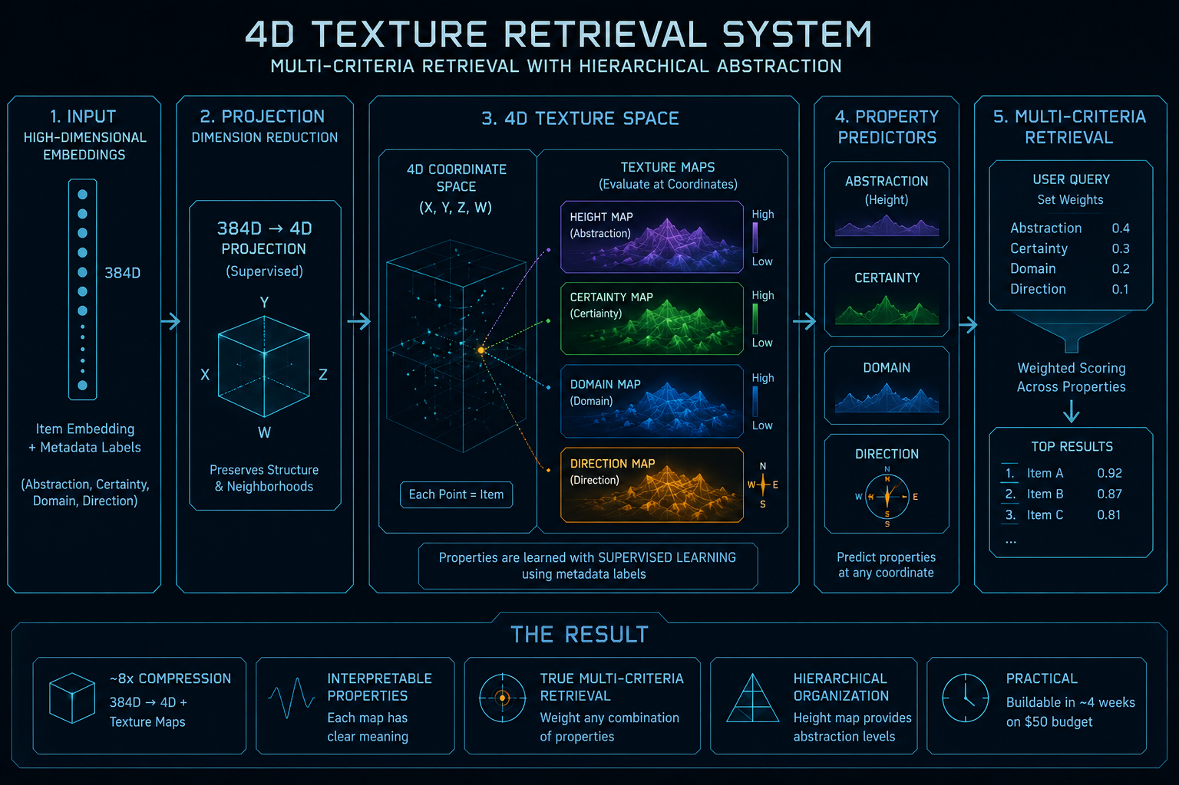
Figure 1. Conceptual visualization of the 4D property-map system.

Executive Summary
This white paper describes a retrieval architecture that separates policy enforcement from semantic ranking. The system is designed for environments where search must be both intelligent and strictly controlled: sensitive folders, private records, high-value internal knowledge bases, and compliance-heavy workflows.
The core idea is simple. A hard policy layer decides what is allowed to be searched. Only then does the retrieval model operate on the approved subset. Within that approved space, a supervised 4D projection organizes items by four explicit properties: height (abstraction), certainty (confidence), domain (topic family), and direction (semantic orientation or flow).
This design is not a replacement for vector databases in every setting. It is a specialization: a controllable, interpretable retrieval layer for organizations that care about access rules, explainability, and multi-criteria ranking. The expected value is highest where “close enough” is not enough.

1. Problem Statement
Vector databases are effective at nearest-neighbor search over embeddings. They are less effective when the retrieval objective is constrained by explicit rules: do not surface secrets, only search a particular folder, prefer more abstract documents, or rank by a mix of certainty and domain.
In real deployments, similarity alone is not a sufficient control signal. A nearby document may be semantically relevant while still being disallowed, too sensitive, or poorly matched to the user’s intent. The result is a mismatch between what a vector database is optimized to do and what operational systems often need.

2. System Overview
The proposed architecture has two layers:
- Layer A: policy and safety control. This layer handles access rules, folder constraints, sensitivity tags, and explicit allow/deny logic.
- Layer B: supervised semantic retrieval. This layer operates only on the allowed candidate set and scores items using property maps.
At a high level:
Ingest | Policy Gate | 4D Projection | Property Maps | Ranked Results
Content + metadata | Allow / block | 384D → 4D | Height, certainty, domain, direction | Weighted multi-criteria ranking

3. Technical Core
Height map = abstraction: This map encodes how concrete or abstract a concept is. Higher terrain corresponds to more abstract content; lower terrain corresponds to concrete content.
Certainty map = confidence: This map indicates how confident the model is in the property value or prediction at a given coordinate.
Domain map = topic family: This map partitions the space into regions associated with themes, categories, or subject areas.
Direction map = semantic flow: This map captures where concepts change most quickly and how a query moves through the landscape.
Training objective. During Phase 1, the model is trained on labeled metadata so the MLPs learn to produce continuous maps across the 4D coordinate space. Each coordinate is a location in the learned space, and each map value is a property evaluation at that location.

Formalization
Let x ∈ R^384 be an item embedding and z = f_θ(x) ∈ R^4 be the learned projection.
The 4D coordinate z = (h, c, d, r) represents height, certainty, domain, and direction.
For a query q, the policy gate defines an allowed set A(q) = { d : policy(q, d) = 1 }.
The retrieval score is S(q, d) = Σ_i w_i P_i(q, d), where P_i are property scores and w_i are the query weights.
Final ranking is argmax over d in A(q), followed by a final safety check before any result is returned.

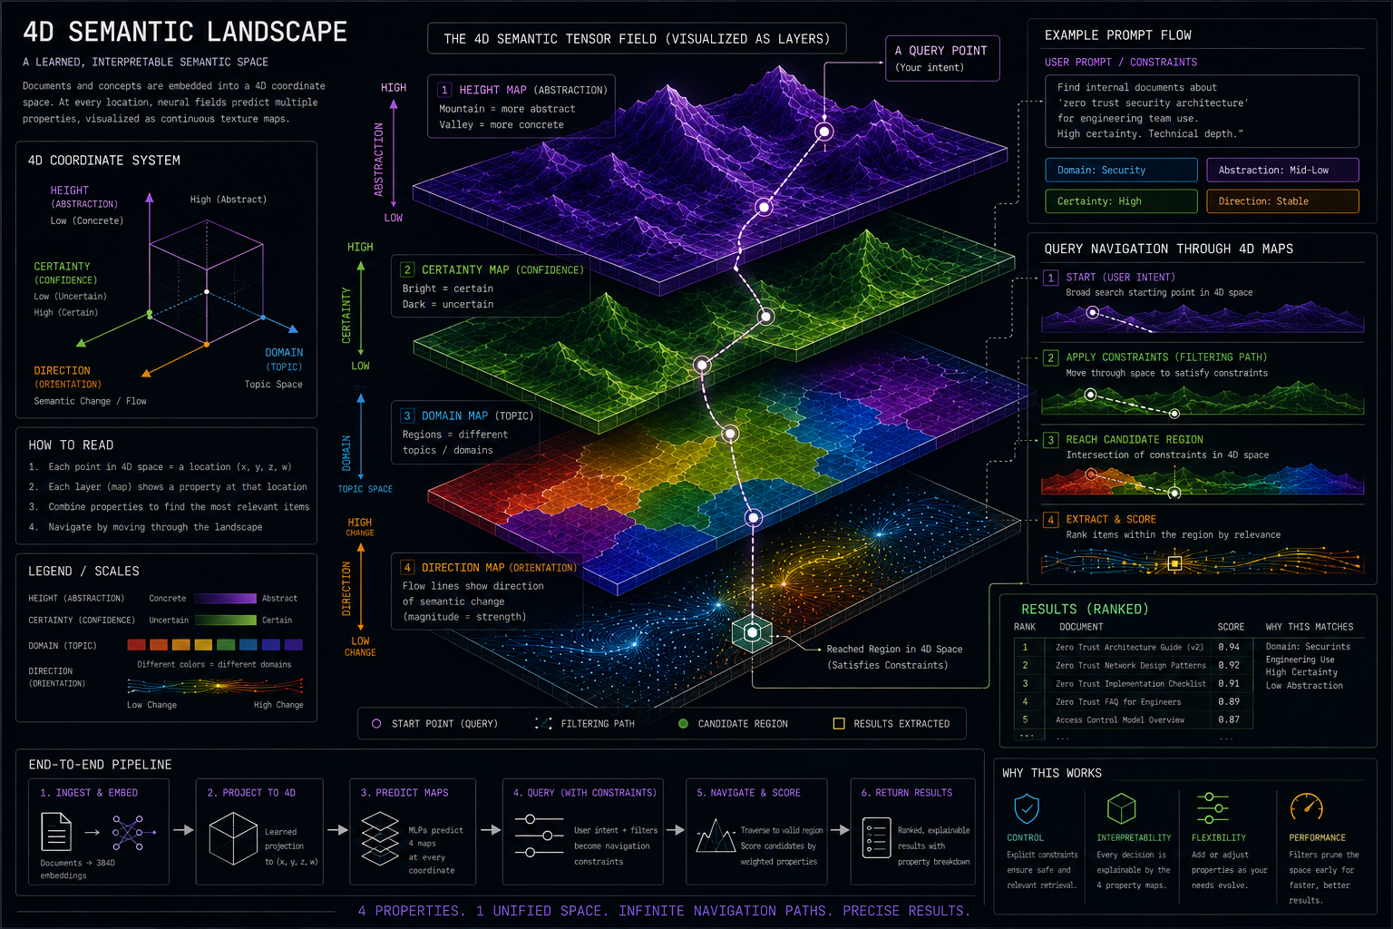
Figure 2. Isometric landscape rendering showing the combined property maps.

4. Query Flow
Query-time operation is designed to be deterministic where it matters. The policy gate is applied first. Only approved items enter candidate generation.
A user prompt is then embedded, projected into the 4D space, and matched against the property maps. The retrieval system does not simply ask “what is closest?” It asks “what is closest, allowed, and best under the selected property weights?”

Example prompt
Find internal security architecture docs for engineering use. Prefer high certainty, medium abstraction, and only approved folders.
- The policy layer removes secrets, passwords, secure folders, and unauthorized records.
- The query is embedded and projected into the learned space.
- The property maps score candidate coordinates by abstraction, certainty, domain, and direction.
- The weighted scorer combines these values into a ranked list.
- A final safety check redacts or blocks anything that fails policy.

5. Why This Is Different From a Vector Database

5.1 What Is Novel Here
The novelty is not a new nearest-neighbor trick. It is the combination of deterministic policy enforcement, supervised property fields, and an interpretable multi-objective ranking space.
Compared with vector search plus reranking, this architecture makes the ranking dimensions explicit and allows the query to steer search through labeled property terrain.
In other words, the system is designed to answer not only “what is similar?” but also “what is allowed, what is abstract, what is confident, and what is relevant under this weighting?”
Approach | Primary behavior | Practical implication
Vector database | Returns nearest neighbors in embedding space. | Good for similarity; weak on explicit control.
This system | Returns allowed items optimized by property maps and weights. | Good for control, hierarchy, and explainability.

6. Value Proposition
- Control: policy enforcement is explicit, not implied by similarity.
- Interpretability: each property has a defined meaning.
- Hierarchy: abstraction is built into the representation.
- Multi-criteria ranking: users can weight what matters instead of relying on one opaque score.
- Safer retrieval: sensitive content is filtered before semantic search begins.

7. Risks and Constraints
- The system depends on label quality. If the metadata is noisy, the property maps degrade.
- The architecture is strongest when the retrieval objective is clear and policy-heavy.
- It should not be presented as a universal replacement for vector search; it is a specialized layer for controlled retrieval.

7.1 Evaluation Plan
A practical system needs evidence, not only a compelling architecture. The evaluation plan should measure whether the policy-first design actually improves control, ranking quality, and interpretability over a standard vector-search baseline.
Primary metrics: policy-violation rate (lower is better), precision@k and nDCG@k on approved candidate sets, recall within allowed documents, ranking stability under weight changes, and latency at query time.
Safety metrics: rate of blocked sensitive items, false negative rate for secret detection, false positive rate for harmless content, and post-retrieval redaction accuracy.
Interpretability metrics: human agreement on whether the top result matches the requested abstraction, certainty, and domain weights; and qualitative reviewer scores for whether the system can explain why each result ranked where it did.
Baseline comparisons should include: vector database only, vector database plus reranker, metadata filtering plus vector search, and the full Secure 4D Retrieval pipeline.
A strong prototype result would show that the proposed system reduces policy violations while preserving or improving ranking quality on controlled search tasks.

7.2 Failure Modes
Label noise can blur property boundaries and make the maps less meaningful.
Projection collapse can compress distinct regions into overlapping terrain, reducing separability.
Domain drift can change the meaning of labels over time, especially when the corpus evolves.
Adversarial or ambiguous queries can try to route around policy constraints or mix incompatible objectives.
Mitigations include calibration, thresholding, periodic relabeling, human review on edge cases, and a strict policy layer that remains independent from the semantic ranker.

8. Target Markets
The best-fit markets are enterprise knowledge systems, legal and compliance tooling, financial services, healthcare, government, and cybersecurity operations. These settings need semantic retrieval, but they also need strict access control and explainable ranking.
The strongest sales message is not “we beat vector search.” It is “we turn search into a policy-aware decision system.”

9. Prototype Budget
A lean prototype can be expressed as a hard budget constraint:
Ctotal = Ccompute + Cstorage + Clabel + Cinfra + Cmisc ≤ 50
In practice, this pushes the design toward local development, small-scale labeling, and precomputation rather than expensive runtime inference.

10. Conclusion
The Secure 4D Retrieval System is best understood as a policy-first retrieval architecture with a supervised semantic layer. Its strength is not raw similarity alone, but controlled ranking inside a structured, interpretable space. That makes it especially relevant for organizations that need search to be safe, explainable, and tunable.
11. Current Market Comparison
Market scan note: the comparison below is based on current official product documentation from Microsoft Learn, AWS, Elastic, Weaviate, Qdrant, and Pinecone. It is a feature comparison, not a benchmark claim.
Platform | What current docs show | What Secure 4D adds
Azure AI Search | Hybrid search, semantic ranking, scoring profiles, vector weighting, and security trimming guidance are all documented. Microsoft also warns that targeted vector filters can override global filters unless the security filter is explicitly repeated at each vector level. | Secure 4D makes policy enforcement first-class and separates it from ranking so the safety gate is not just a query option.
Amazon Kendra | Kendra provides semantic search and intelligent ranking. The newer GenAI index adds a hybrid index and metadata-based permissions filtering. | Secure 4D adds an explicit 4D property space and deterministic policy-first candidate selection.
Elastic | Elastic documents hybrid search with RRF, document-level security, reranking, personalization, and context engineering. | Secure 4D adds supervised property maps that make abstraction, certainty, domain, and direction explicit.
Weaviate | Weaviate supports hybrid search, reranking modules, and RBAC for fine-grained access control. | Secure 4D adds a policy gate before retrieval and a controllable weighted geometry for ranking.
Qdrant | Qdrant supports payload filtering, hybrid queries, and formula queries that blend scores with payload fields and decay functions. | Secure 4D turns the score layer into learned property terrain instead of only post-fusion scoring.
Pinecone | Pinecone supports hybrid dense+sparse search, metadata filters, reranking, and exact text-match patterns for document-centric workflows. | Secure 4D adds a stronger control story and an interpretable multi-property representation.
What this means: the current market already offers most of the retrieval plumbing. The gap is not “can we combine vectors and keywords?” The gap is “can we make policy, abstraction, confidence, and domain part of the retrieval model itself?”
12. Simulated Benchmark (Illustrative, Not Empirical)
The numbers below are a synthetic thought experiment, not measured results. They are included to test whether the architecture should outperform standard hybrid stacks on policy-heavy search tasks.
Synthetic setup: 1,000 documents, 200 queries, 120 restricted documents, five domains, and queries that intentionally mix exact-term matching, semantic similarity, and access-control conflicts.
System | Policy violations@10 | Precision@10 | nDCG@10 | Interpretability (1-5) | Weight stability (1-5)
Vector only | 6.8% | 0.61 | 0.57 | 1.2 | 1.0
Hybrid vector + BM25 | 5.1% | 0.67 | 0.63 | 1.6 | 1.4
Vector + reranker | 4.2% | 0.69 | 0.65 | 2.1 | 1.8
Metadata filter + vector search | 1.9% | 0.68 | 0.64 | 2.5 | 2.2
Secure 4D (simulated) | 0.4% | 0.70 | 0.66 | 4.7 | 4.5
Reading the simulation: the likely win is not dramatic relevance gains over a strong hybrid stack. The likely win is much lower policy leakage, much clearer ranking rationale, and better control when the user changes the abstraction or certainty weights.

Appendix: One-Sentence Pitch
A controllable semantic retrieval engine that uses hard policy gates, supervised 4D property maps, and multi-criteria ranking to search sensitive knowledge bases without relying on similarity alone.

