**Installation Info**

The application has been installed at:

E:\SixS\Transfer Order Auto-Receiver

There are a couple notable files located in this folder:

* AutoReceiver.exe
  + The main executable. This is the program that need to be fired by the schedule.
* AutoReceiever.exe.config
  + The primary configuration file. This contains the user and password used to connect to Epicor, the instance that will be accessed and other options.
* NLog.config
  + This is the configuration file for the logging. This contains the SMTP server info and the destination email addresses. Additionally, there are options allowing the log to be dumped to a file on disk.

**Scheduling**

All scheduling is handled by the Windows Task Scheduler.

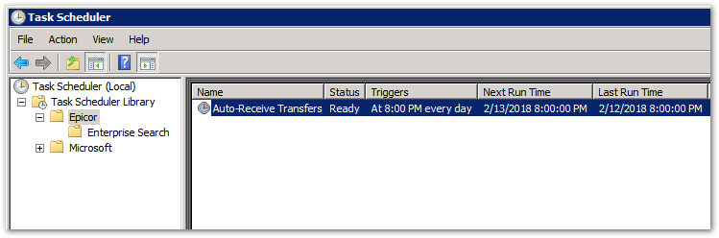

* Manual Execution
  + Right-click the task (“Auto-Receive Transfers”) and select ‘Run’ to initiate an immediate execution.
* Schedule Adjustments
  + Right-click the task and select ‘Properties’. From here you can access and adjust the scheduling settings.  
    