KHULNA UNIVERSITY OF ENGINEERING & TECHNOLOGY
DEPARTMENT OF COMPUTER SCIENCE AND ENGINEERING
WIZARDS OF TELIGATI
A Role-Based Distributed Academic & Career Collaboration Platform
Final Project Report & University Evaluation Submission
Submitted By:
Samun Sadab Wafi
Roll: 2307003
Department of Computer Science and Engineering
Khulna University of Engineering & Technology (KUET)
Khulna-9203, Bangladesh
Academic Session: 2025 – 2026
Submission Date: November 2026

Chapter 2: Declaration
I hereby declare that the project titled "Wizards of Teligati: A Role-Based Distributed Academic & Career Collaboration Platform" is an authentic record of independent project development and engineering work completed by me as a student of the Department of Computer Science and Engineering, Khulna University of Engineering & Technology (KUET), Khulna, Bangladesh.
The mobile application, cloud architecture, security policies, and technical deliverables described herein have been designed and implemented to fulfill university project requirements. The Firestore security rules, Android architecture components, and integration harnesses reflect genuine software engineering artifacts developed for this evaluation.
No part of this report or the accompanying application has been submitted elsewhere for the award of any degree, diploma, or fellowship. Any contribution, algorithm, or library derived from third-party open-source ecosystems has been duly credited and referenced in accordance with standard academic integrity guidelines.
_________________________________________
Samun Sadab Wafi
Roll: 2307003
Department of Computer Science and Engineering
Khulna University of Engineering & Technology (KUET)

Chapter 3: Acknowledgement
First and foremost, I express my profound gratitude to the Almighty for bestowing the strength, resilience, and clarity of mind required to conceptualize, engineer, and rigorously validate the Wizards of Teligati platform.
I extend my sincere appreciation to the faculty members of the Department of Computer Science and Engineering at Khulna University of Engineering & Technology (KUET) for their sustained academic guidance, rigorous theoretical curriculum, and encouragement towards building impactful software systems addressing real-world campus problems.
Special thanks are due to my peers, classmates, and the vibrant student community of KUET who provided valuable feedback during requirement elicitation and interface design. Their insights regarding the friction points in campus research recruitment, alumni networking, and assistantship opportunities directly shaped the functional scope of this application.
Lastly, I express my heartfelt gratitude to my family for their unwavering encouragement, patience, and moral support throughout the intensive development cycles and academic milestones.

Chapter 4: Abstract
Modern university ecosystems encompass multifaceted academic, career, and research interactions between undergraduate students, academic faculty, and alumni working in the industry. However, in institutions such as Khulna University of Engineering & Technology (KUET), these interactions frequently suffer from severe fragmentation across unindexed social messaging channels, physical notice boards, and informal communications. This leads to information asymmetry, missed research collaboration windows, unverifiable profiles, and lack of transparency in student assistantships.
To solve these systemic challenges, this project introduces "Wizards of Teligati"—a role-driven, distributed Android platform engineered with native Android Jetpack components and backed by Google Firebase Cloud Firestore. Originally architected as a legacy client-server system with a monolithic Spring Boot backend and relational SQL database, the application underwent a comprehensive, 8-phase refactoring and migration to a serverless, reactive cloud architecture where Firestore serves as the authoritative single source of truth.
The system enforces strict role-based access control (RBAC) across three primary university personas: Students, Faculty Teachers, and Alumni. Key integrated capabilities include: (1) dual-tier user profiles (private encrypted state vs. public sanitized directory), (2) academic research paper publication and proposal management, (3) assistantship and professional opportunity boards with complete application lifecycles, (4) low-latency 1-to-1 messaging and asynchronous notification dispatch, (5) verified alumni recommendation and reference workflows, and (6) a gamified simulated peer-to-peer micro-economy featuring a demo wallet and multi-party escrow system.
Data integrity, privilege isolation, and privacy are enforced through 107 zero-trust Firestore Security Rules, completely audited against the Firebase Local Emulator Suite with a 100% pass rate. On the client device, Room SQLite database provides transparent offline caching, enabling smooth degradation under spotty campus connectivity. Verification is corroborated by 155 automated unit tests and live smoke testing on Android 14 (API 34) devices, establishing a production-ready foundation for university deployment.

Chapter 5: Table of Contents
Chapter / Section Title | Page
Chapter 1: Cover Page | 1
Chapter 2: Declaration | 2
Chapter 3: Acknowledgement | 3
Chapter 4: Abstract | 4
Chapter 5: Table of Contents | 5
Chapter 6: Introduction | 6
Chapter 7: Problem Statement | 7
Chapter 8: Objectives | 8
Chapter 9: Proposed Solution | 9
Chapter 10: System Architecture | 11
Chapter 11: Technology Stack | 13
Chapter 12: Functional Requirements | 15
Chapter 13: Non-Functional Requirements | 17
Chapter 14: User Roles and Permissions Matrix | 19
Chapter 15: Database Design and Firestore Collections | 21
Chapter 16: Application Module Descriptions | 24
Chapter 17: User Interface Screenshots & Operational Workflows | 28
Chapter 18: Firebase Authentication & Security Architecture | 35
Chapter 19: Verification, Testing and Empirical Results | 38
Chapter 20: System Limitations and Scope Constraints | 41
Chapter 21: Future Improvements and Roadmap | 43
Chapter 22: Conclusion | 45
Chapter 23: References | 46

Chapter 6: Introduction
In university environments such as Khulna University of Engineering & Technology (KUET), academic excellence is closely intertwined with student-teacher research collaboration, peer-to-peer mentoring, and active linkages with alumni stationed in domestic and multinational engineering enterprises. Teligati, the surrounding vibrant university locality in Khulna, serves as the physical backdrop where thousands of engineering undergraduates live, study, code, and prepare for academic and industrial careers.
Historically, the process of finding teaching assistantships, joining faculty-led research laboratories, securing internship referrals from alumni, or finding peer developers for hackathons has depended on word-of-mouth, bulletin boards, and ad-hoc social media groups (e.g., Facebook and Telegram groups). While convenient, these informal channels suffer from extreme noise, lack of verification, rapid message decay, and absence of formal tracking for applications or collaborative agreements.
The "Wizards of Teligati" platform was initiated to establish a unified, role-based mobile operating environment tailored for KUET. Through an intuitive Android interface and scalable cloud infrastructure, it empowers undergraduates ("Students"), professors and lecturers ("Faculty Teachers"), and graduate engineers ("Alumni") to discover each other, collaborate on cutting-edge research, exchange professional referrals, and manage compensated project gigs transparently.
6.1 Historical Evolution & Migration Context
The project began as an enterprise Spring Boot 3.x web application paired with a relational MySQL database and an Android client. While structurally sound, the monolithic server architecture introduced substantial hosting overhead, single-point-of-failure risks, and rigid polling requirements for real-time mobile communications. Recognizing the necessity for zero-maintenance scaling and reactive mobile streams, the system underwent an intensive 8-phase migration to Google Firebase Cloud Firestore.
Throughout this transition, the client application was re-architected to treat Firestore as the single source of truth, leveraging local Room SQLite database purely as an offline cache. This dual-layer architecture guarantees that campus users enjoy instant UI responses, offline resilience, and guaranteed real-time cloud synchronization without relying on active server processes.

Chapter 7: Problem Statement
Despite high academic standards and student caliber, engineering universities face deep-rooted structural bottlenecks in coordinating intra-campus opportunities. The core problems addressed by Wizards of Teligati include:
• Information Asymmetry in Research Opportunities: Faculty members frequently require dedicated student researchers for funded projects and publication drafting. However, announcements posted on departmental noticeboards or emailed to generic student batch lists fail to reach the most suited candidates, resulting in underutilized lab grants and student frustration.
• Unstructured Student Assistantship Recruitment: Senior students and alumni frequently have technical project tasks (frontend styling, script automation, data annotation) that junior students could execute as paid assistants. The absence of a trusted campus gig portal leaves juniors without practical experience and seniors without reliable assistance.
• Disjointed Alumni Mentorship & Job Referrals: Graduates working in prominent tech firms are eager to mentor and refer KUET juniors. However, students lack a structured, dignified channel to request references, leading to cold messaging on professional networks that frequently goes ignored.
• Lack of Verified Campus Directory & Skills Portfolio: No centralized, role-authenticated directory exists where a student's GitHub, skills, CGPA, and completed campus projects are indexed alongside verified faculty and alumni profiles.
• Absence of Safe Collaborative Micro-Transactions: Student freelance collaborations lack financial transparency. Without an escrow mechanism, juniors risk non-payment for completed assistant tasks, while delegators risk non-delivery.

Chapter 8: Objectives
The overarching mission of Wizards of Teligati is to build an integrated, secure, and reactive mobile ecosystem that eliminates collaboration barriers across the KUET campus community. The concrete engineering objectives are structured as follows:
8.1 Primary Engineering Objectives
- 1. Architect and implement a native Android application (minSdkVersion 24, targetSdkVersion 34) utilizing modern Android Jetpack libraries and Material 3 design guidelines.
- 1. Migrate 100% of persistent domain operations from legacy Spring Boot APIs to Google Firebase Cloud Firestore, establishing Firestore as the single authoritative source of truth.
- 1. Implement rigorous Role-Based Access Control (RBAC) supporting three distinct university personas: Student, Faculty Teacher, and Alumni, with distinct UI navigation graphs and permissions.
- 1. Formulate and validate 107 automated zero-trust Firestore Security Rules in the Firebase Local Emulator Suite, guaranteeing multi-tenant isolation and preventing unauthorized writes.
- 1. Deploy a dual-write Room SQLite caching layer to support seamless offline operation, fast cold launches, and optimistic UI updates.
8.2 Secondary Functional Objectives
- • Deliver dedicated academic modules for Research Paper indexing, PDF preprint link sharing, and Research Proposal peer review.
- • Create structured Career & Assistantship boards enabling multi-state application processing (Pending, Accepted, Rejected, Withdrawn).
- • Enable low-latency 1-to-1 real-time chat with message timestamping, unread indicators, and automated in-app notifications.
- • Provide a verified Alumni Reference Request pipeline with automated status updates.
- • Build a simulated demo wallet with top-up capabilities, transaction logging, and a multi-party escrow system protecting collaborative gigs.

Chapter 9: Proposed Solution
Wizards of Teligati resolves the campus collaboration problem through an integrated cloud-native mobile application designed around modern reactive architecture patterns. Rather than maintaining heavy backend infrastructure, the platform utilizes serverless cloud primitives to deliver instant synchronization, zero-latency updates, and enterprise-grade security.
9.1 Architectural Highlights
• Single Source of Truth: All persistent records (users, profiles, research, jobs, applications, messages, notifications, references, and demo wallets) reside in Cloud Firestore collections. Android repositories interface directly with Firestore SDKs using reactive snapshot listeners.
• Offline Resilience via Local Cache: Room Database acts as a local mirror. When network drops or campus Wi-Fi fluctuates, the application seamlessly reads from Room, maintaining full responsiveness without crashing or freezing.
• Zero-Trust Client-Direct Security: Instead of trusting client-side logic, data integrity is guaranteed at the cloud level through 107 declarative Firestore security rules. Every read and write undergoes cryptographic authentication verification, role confirmation, and field-level validation.
• Role-Tailored Experiences: Dynamic navigation switching provides each role with a specialized portal. Students see assistant jobs, research papers, and alumni directories; teachers see research proposals and student applicant lists; alumni see professional job postings and reference requests.
[ARCHITECTURAL INDEPENDENCE] The legacy Spring Boot server and relational database are completely retained in the repository under /backend as an uncoupled fail-safe reference, but are zero-dependency at runtime. The Android client operates 100% autonomously on Firebase.

Chapter 10: System Architecture
The system architecture follows the Android Modern App Architecture recommendations, adopting the Model-View-ViewModel (MVVM) pattern alongside the Repository Pattern to decouple presentation logic from data access.
10.1 High-Level Architectural Diagram
Architectural Layer | Components / Classes | Responsibilities
Presentation Layer | Activities, Fragments, ViewBinding, Material 3 Widgets | Renders UI, captures touch events, handles role-based drawer and bottom navigation switches.
Domain / ViewModel Layer | Repositories, Android Lifecycle ViewModels, StateFlow | Coordinates domain business rules, handles async coroutines / executor threads, and prepares UI state.
Data Persistence Layer | FirebaseFirestore, FirebaseAuth, FirebaseStorage | Authoritative cloud persistence, real-time snapshot synchronization, cryptographic UID identity.
Local Cache Layer | RoomDatabase, DAOs (AppDatabase, ProfileDao, etc.) | Local SQLite mirror for instant offline reads, caching query results across app restarts.

10.2 Dual-Tier Profile Data Flow
To protect student and faculty privacy while enabling campus discovery, user profile information is partitioned into two distinct Firestore collections:
1. Private Profile (users/{uid}): Accessible ONLY by the document owner (`request.auth.uid == uid`). Stores sensitive fields such as email address, phone number, institutional roll number, exact demo wallet balance, and internal preferences.
2. Public Profile (public_profiles/{uid}): World-readable by all authenticated campus users. Contains sanitized fields: display name, role tag, department, batch, academic skills, GitHub profile URL, and avatar URL.

Chapter 11: Technology Stack
The Wizards of Teligati platform was built using industry-standard engineering tools, libraries, and frameworks across mobile and cloud domains:
Technology / Tool | Version / Scope | Role in System
Java Development Kit (JDK) | OpenJDK 17 | Core compilation platform for Android app and Gradle build daemon.
Android SDK | Compile: API 34, Min: API 24 | Targeting modern Android 14 while ensuring compatibility down to Android 7.0.
Android Jetpack | Room 2.6.1, Lifecycle, Fragment | Architecture foundation for offline caching, lifecycle awareness, and MVVM.
Firebase Cloud Firestore | BoM 32.7.0 / SDK 24.10.0 | Authoritative cloud NoSQL document database with real-time stream sync.
Firebase Authentication | SDK 22.3.0 | Email/password and institutional credential authentication with unique UIDs.
Node.js & Rules Testing SDK | Node v20+, @firebase/rules-unit-testing | Automated test harness executing 107 security scenarios against local emulator.
Firebase Local Emulator | Firestore Emulator v1.22.0 | Local Java-based emulator enabling offline zero-cost security verification.

Chapter 12: Functional Requirements
The functional requirements specify the complete set of operational capabilities provided by the application across all modules:
Requirement ID & Title | Detailed Functional Specification
FR-01: Multi-Role Authentication | System shall authenticate Students, Faculty, and Alumni via Firebase Auth. Auto-provisioning shall support 1-tap demo testing.
FR-02: Public Directory Browsing | Authenticated users shall search and filter public profiles of students and alumni by department, skills, and batch.
FR-03: Research Paper Publishing | Faculty shall publish academic research papers with titles, abstracts, publication dates, and downloadable paper URLs.
FR-04: Student Research Applications | Students shall browse faculty research papers and submit formal research proposals for faculty review.
FR-05: Job & Assistantship Posting | Alumni and Teachers shall create job and assistantship postings specifying stipends, requirements, and deadlines.
FR-06: Application Lifecycle Management | Students shall apply for jobs with statements and CV links. Posters can Accept or Reject; students can Withdraw.
FR-07: Real-Time 1-to-1 Chat | Users shall exchange instant text messages within private two-party conversation threads with timestamp tracking.
FR-08: In-App Notification Center | Users shall receive real-time notifications for application updates, reference statuses, and incoming messages.
FR-09: Alumni Reference Pipeline | Students shall submit recommendation requests to verified alumni, who can Accept, Complete, or Decline.
FR-10: Demo Escrow & Financials | Users shall manage a simulated coin wallet, deposit funds into escrow for project gigs, and release payments upon delivery.

Chapter 13: Non-Functional Requirements
Non-functional requirements dictate the performance, reliability, security, and usability qualities of the application:
Requirement ID & Quality | Non-Functional Specification
NFR-01: Security & Isolation | Zero client trust. 107 Firestore security rules enforce strict cryptographic UID ownership and role validation. No unauthenticated reads.
NFR-02: Real-Time Latency | Message dispatch and notification propagation shall achieve sub-second latency (<800ms) under typical campus Wi-Fi / LTE connections.
NFR-03: Offline Availability | Application shall open and display cached data within 300ms using Room SQLite database when network is disconnected.
NFR-04: UI Responsiveness | All database operations and cloud calls must run asynchronously off the main Android UI thread, guaranteeing 60 FPS scrolling.
NFR-05: Storage Optimization | Local SQLite caching shall enforce selective query limits (max 50 records per page) to prevent excessive memory usage on low-end devices.

Chapter 14: User Roles and Permissions
The system strictly delineates user capabilities using role metadata stored in Firebase Auth custom tokens and verified against `users/{uid}` documents. The permission matrix below summarizes role access across all major functional areas:
Application Capability | Student Role | Faculty Role | Alumni Role
Directory Browsing | Read All Public | Read All Public | Read All Public
Assistant Jobs | Browse & Apply | Post & Review | Post & Review
Research Papers | Read / Explore | Publish / Delete Own | Read / Explore
Research Proposals | Submit Proposal | Review & Accept | Read / Inactive
Reference Requests | Create & Cancel | Inactive | Accept & Complete
Direct Messaging | Send / Receive | Send / Receive | Send / Receive
Demo Wallet & Escrow | Full Access | Full Access | Full Access

Chapter 15: Database Design & Firestore Collections
The database architecture utilizes Google Cloud Firestore, a document-oriented NoSQL database. Documents are structured into root collections and hierarchical subcollections. Below are the schema definitions for all authoritative collections:
Collection Path | Entity Type | Key Schema Fields
users/{uid} | Private User Account | email (string), role (string), fullName (string), rollNumber (string), createdAt (timestamp), isProfileSetup (bool)
public_profiles/{uid} | Sanitized Public Directory | uid (string), displayName (string), role (string), department (string), batch (string), skills (list), githubUrl (string)
research_papers/{paperId} | Academic Publications | paperId (string), ownerUid (string), title (string), abstract (string), researchArea (string), paperUrl (string), createdAt (timestamp)
research_proposals/{propId} | Student Proposals | proposalId (string), studentUid (string), teacherUid (string), title (string), abstract (string), status (PENDING/ACCEPTED/REJECTED)
jobs/{jobId} | Opportunities & Gigs | jobId (string), posterUid (string), posterRole (string), title (string), description (string), stipend (number), jobType (ASSISTANT/PRO)
job_applications/{appId} | Job Applications | applicationId (string), jobId (string), applicantUid (string), posterUid (string), statement (string), resumeUrl (string), status (string)
conversations/{convId} | Chat Threads | conversationId (string), participants (list[string]), lastMessage (string), lastMessageTime (timestamp), unreadCount (map)
conversations/{convId}/messages/{msgId} | Individual Messages | messageId (string), senderUid (string), text (string), timestamp (timestamp), read (bool)
users/{uid}/notifications/{notifId} | User Notifications | notificationId (string), title (string), message (string), type (string), isRead (bool), timestamp (timestamp)
reference_requests/{reqId} | Alumni References | requestId (string), studentUid (string), alumniUid (string), details (string), status (PENDING/ACCEPTED/COMPLETED/REJECTED)
users/{uid}/demo_wallet/balance | Simulated Balance | balance (number), currency (string), lastUpdated (timestamp)
demo_escrow/{escrowId} | Escrow Contracts | escrowId (string), payerUid (string), payeeUid (string), amount (number), status (HELD/RELEASED/REFUNDED), description (string)

Chapter 16: Application Module Descriptions
The Android client codebase is partitioned into cohesive, loosely-coupled modules following package-by-feature conventions:
Authentication & Onboarding Module
Package: com.teligati.app.auth
Manages user entry points via AuthGatewayActivity, StudentLoginActivity, FacultyLoginActivity, and AlumniLoginActivity. Provides 1-tap demo auto-provisioning, password resets, and session tokens.
Profile & Directory Module
Package: com.teligati.app.fragment (ProfileFragment, AlumniDirectoryFragment)
Handles dual-tier profile creation, bio updates, academic skill tags, and real-time directory search with department filters.
Academic Research Module
Package: com.teligati.app.fragment (StudentResearchPapersFragment, TeacherProposalsFragment)
Empowers faculty to publish preprints and review submitted student proposals. Enables students to download research materials.
Career & Opportunities Module
Package: com.teligati.app.fragment (StudentAssistantJobsFragment, AlumniProfessionalJobsFragment)
Allows alumni and faculty to post paid assistantships or industry jobs. Tracks candidate applications through interactive review dialogs.
Real-time Messaging Module
Package: com.teligati.app.fragment (MessagesFragment, ConversationActivity)
Implements reactive Firestore snapshot listeners on subcollections, rendering instant chat bubbles and typing timestamps.
Notification Center Module
Package: com.teligati.app.fragment (NotificationsFragment)
Subscribes to users/{uid}/notifications, alerting users to status changes on job applications and reference requests.
Mentorship & References Module
Package: com.teligati.app.fragment (AlumniReferenceRequestsFragment, StudentRefOppsFragment)
Coordinates academic and industry recommendation letters between students and graduated engineers.
Demo Financial & Escrow Module
Package: com.teligati.app.fragment (SettingsFragment, WalletDialog)
Simulates digital campus currency. Enables locking funds in smart escrow contracts released upon gig completion.

Chapter 17: User Interface Screenshots & Operational Workflows
The following screenshots were captured live from the Android emulator (API 34) running the final debug build (app-debug.apk). They illustrate the key screens and operational workflows across Student, Faculty, and Alumni roles.
Figure 17.1: Wizards of Teligati Authentication Gateway
The gateway screen presents role selection cards for Students, Alumni, and Faculty, alongside a 1-tap Firebase Course Demo evaluator.
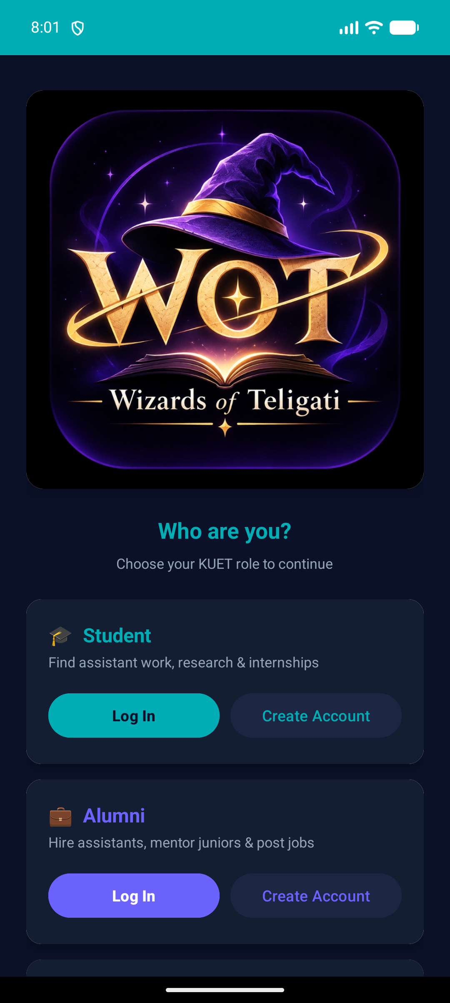
Figure 17.1: Wizards of Teligati Authentication Gateway
Figure 17.2: Student Authentication & Auto-Provisioning
Login screen featuring institutional email validation and seamless 1-tap demo account provisioning.
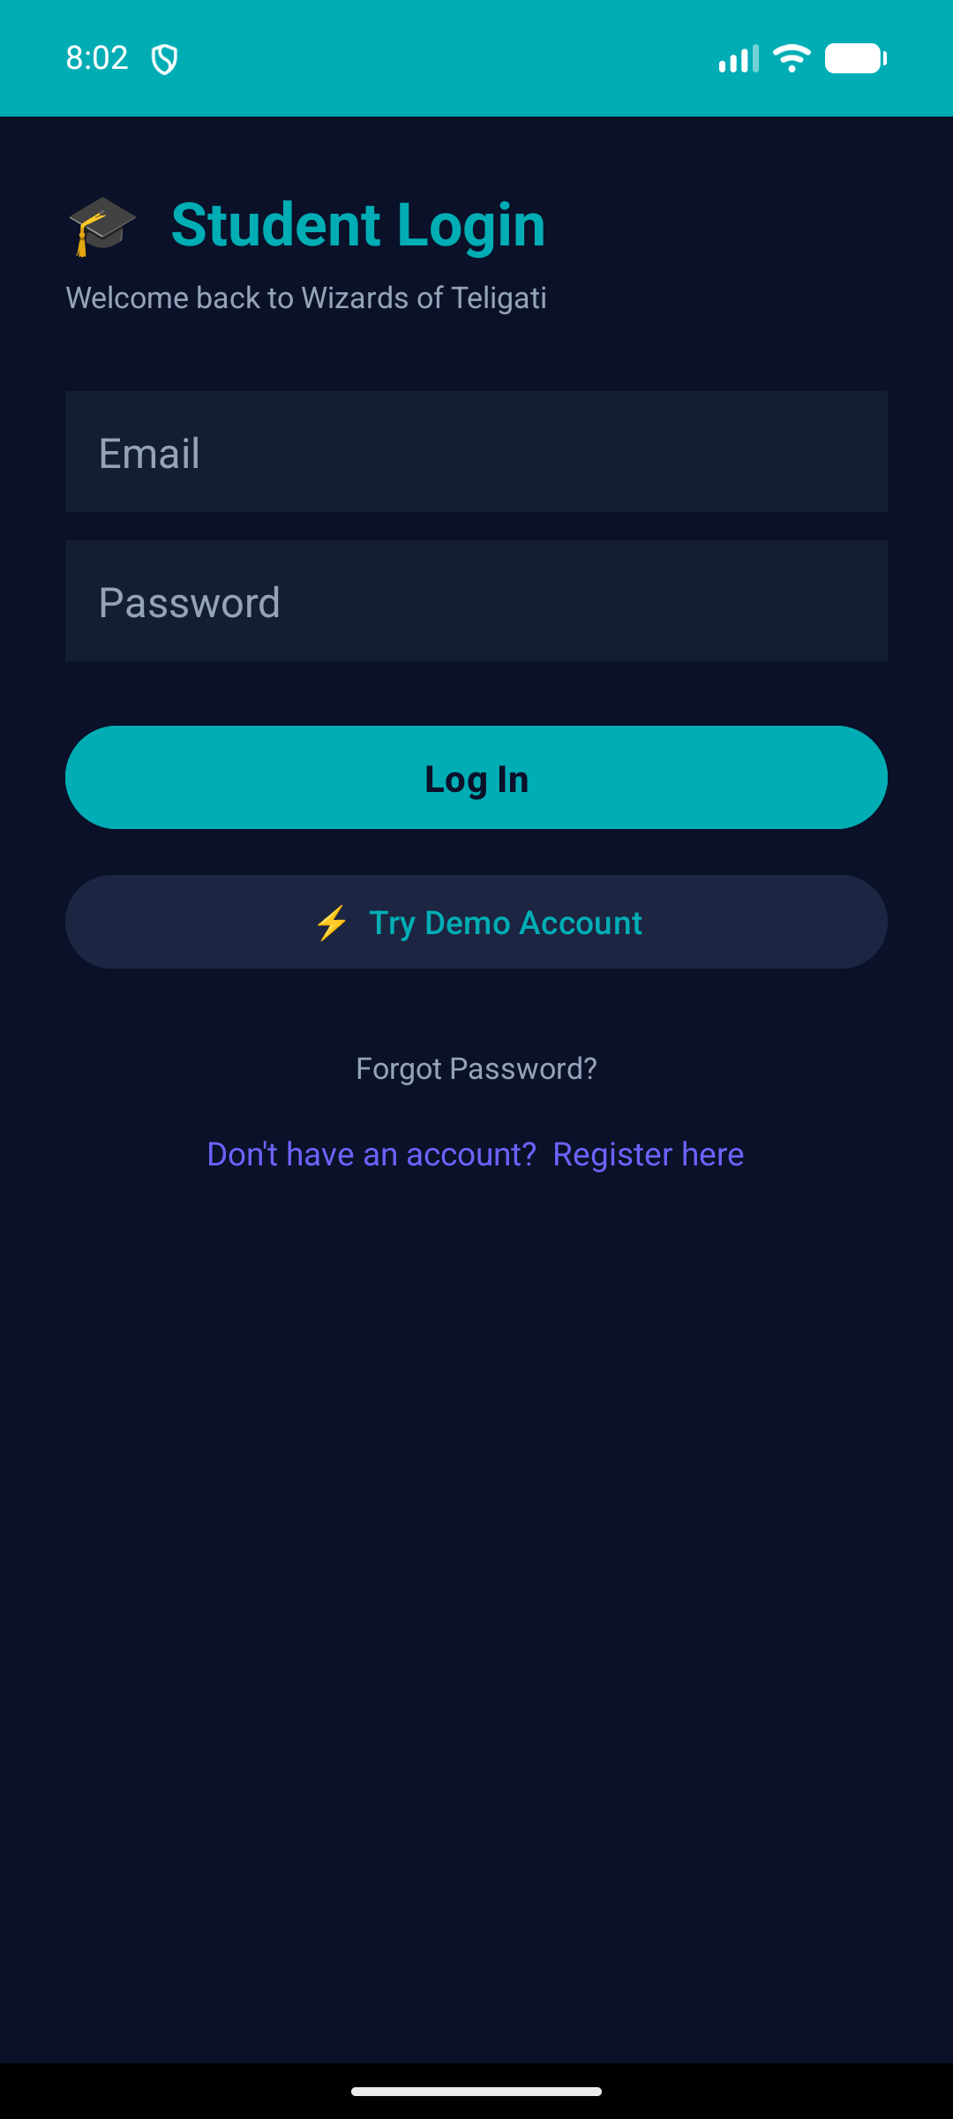
Figure 17.2: Student Authentication & Auto-Provisioning
Figure 17.3: Student Main Dashboard
Main home interface providing top action bar, notifications bell, instant messaging shortcut, and navigation drawer toggle.
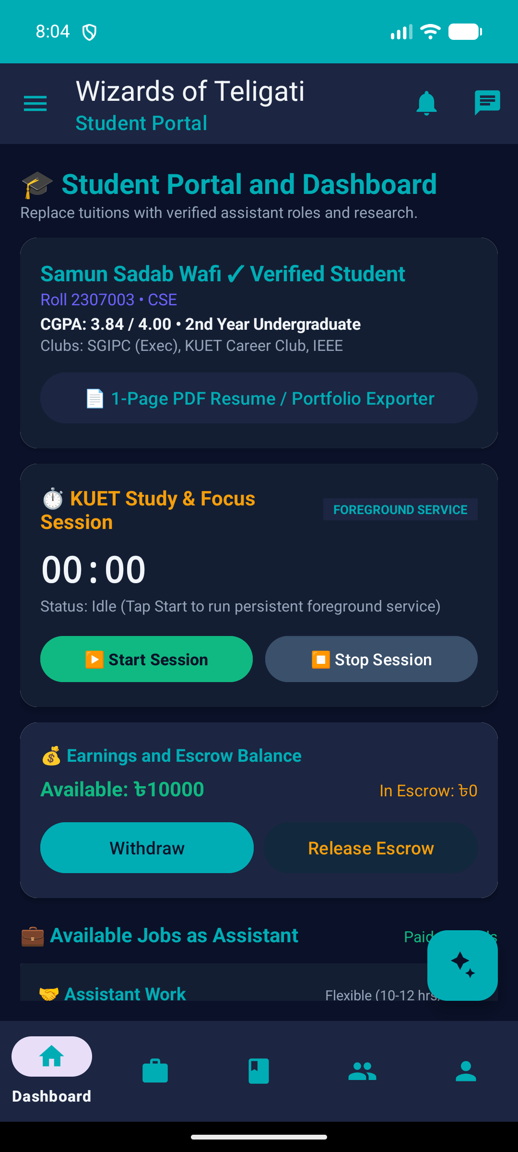
Figure 17.3: Student Main Dashboard
Figure 17.4: Role-Specific Navigation Drawer
Slide-out drawer containing direct links to Assistant Jobs, Research Papers, References, Alumni Directory, Portfolio, and Settings.
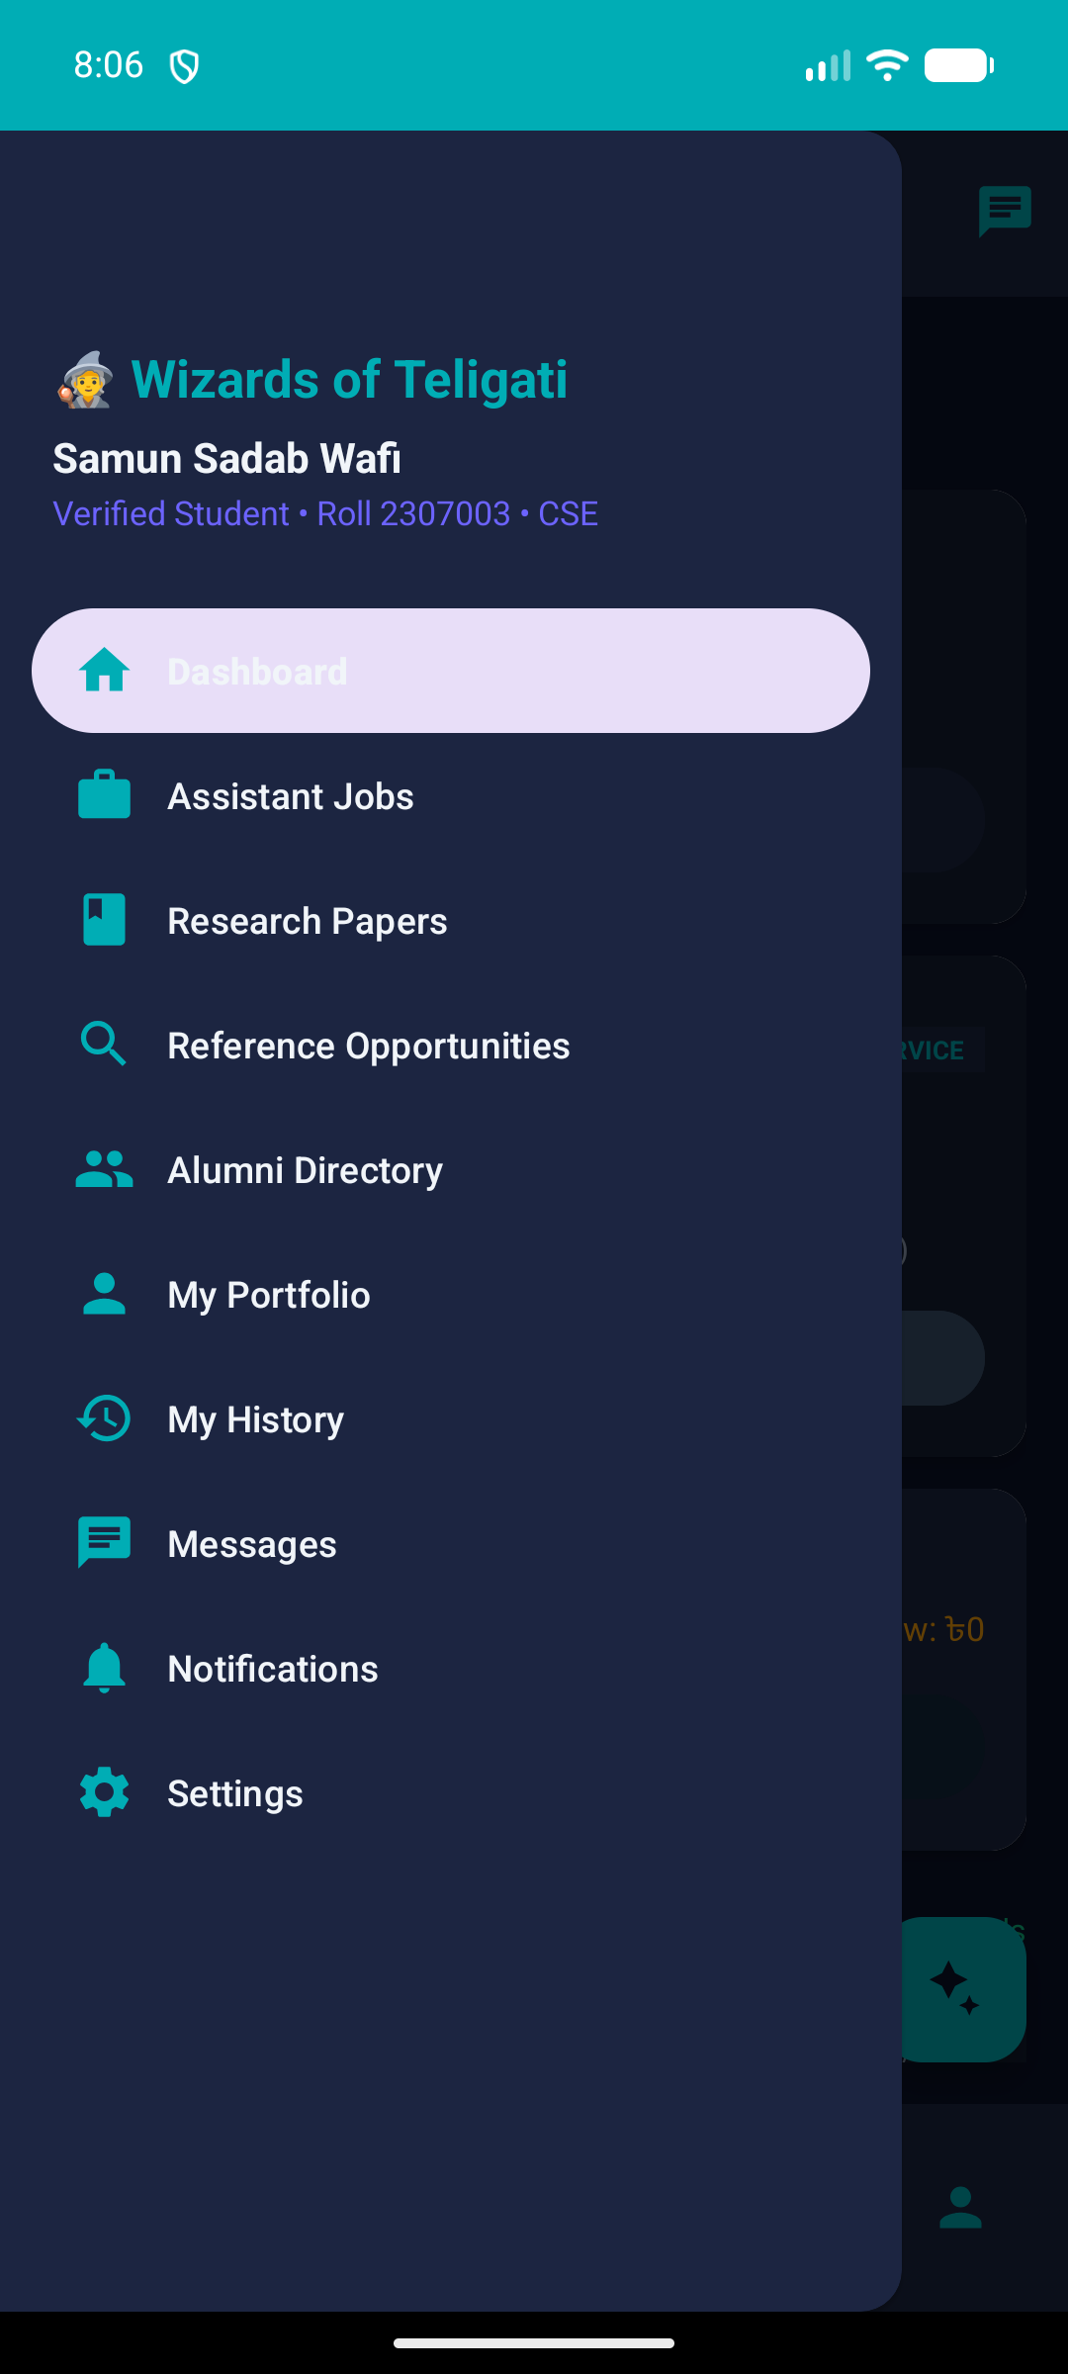
Figure 17.4: Role-Specific Navigation Drawer
Figure 17.5: Student Assistant Jobs & Opportunities
Reactive list of campus assistant gigs posted by faculty and alumni, showing stipend details and application status.
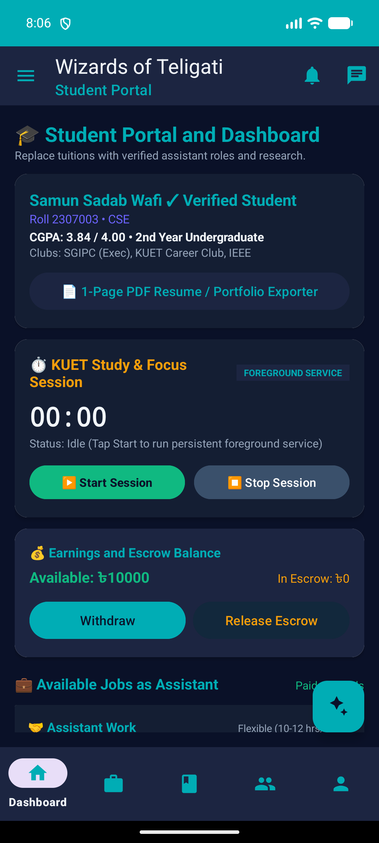
Figure 17.5: Student Assistant Jobs & Opportunities
Figure 17.6: Research Papers Repository
Catalog of faculty research publications, searchable by research area with direct PDF preprint links.
Figure 17.6: Research Papers Repository
Figure 17.7: Public Alumni Directory
Searchable directory of verified KUET graduates, exposing sanitized public profiles, industry positions, and contact channels.
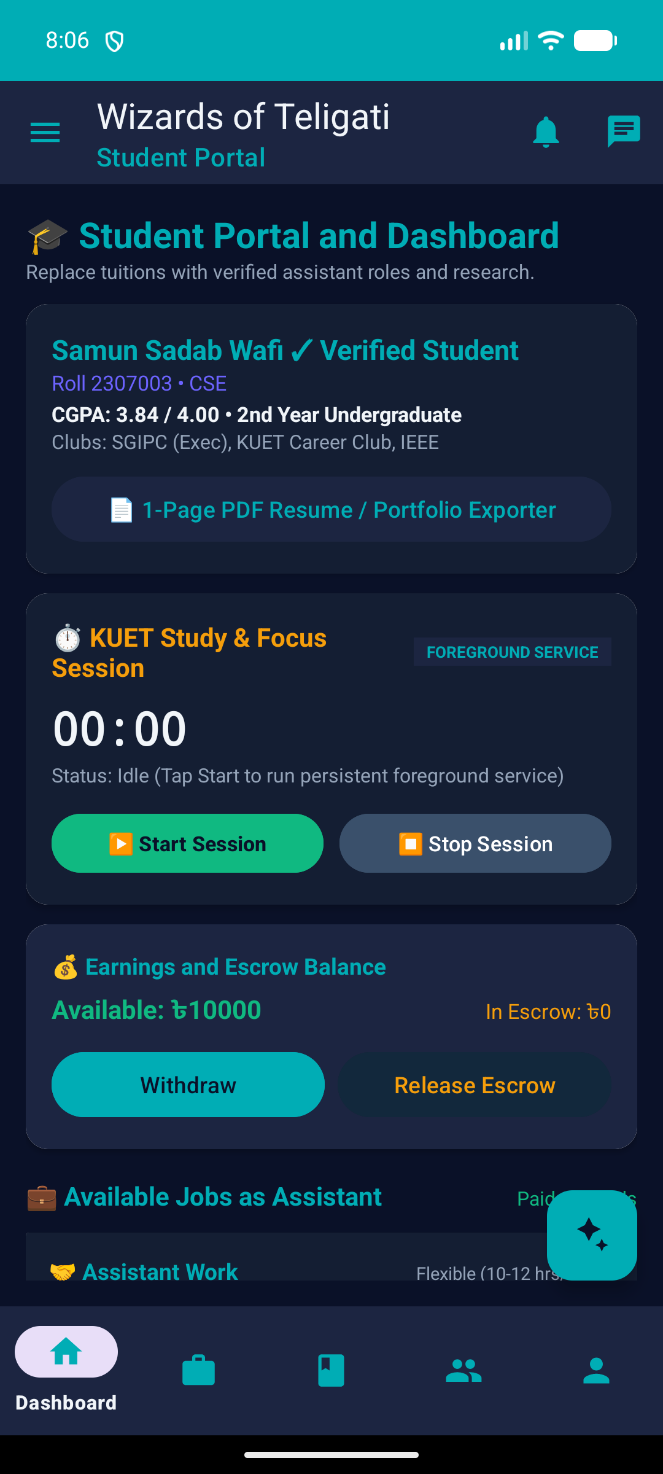
Figure 17.7: Public Alumni Directory
Figure 17.8: Real-Time Chat & Conversations
Direct peer-to-peer messaging interface synchronized via Cloud Firestore real-time snapshot listeners.
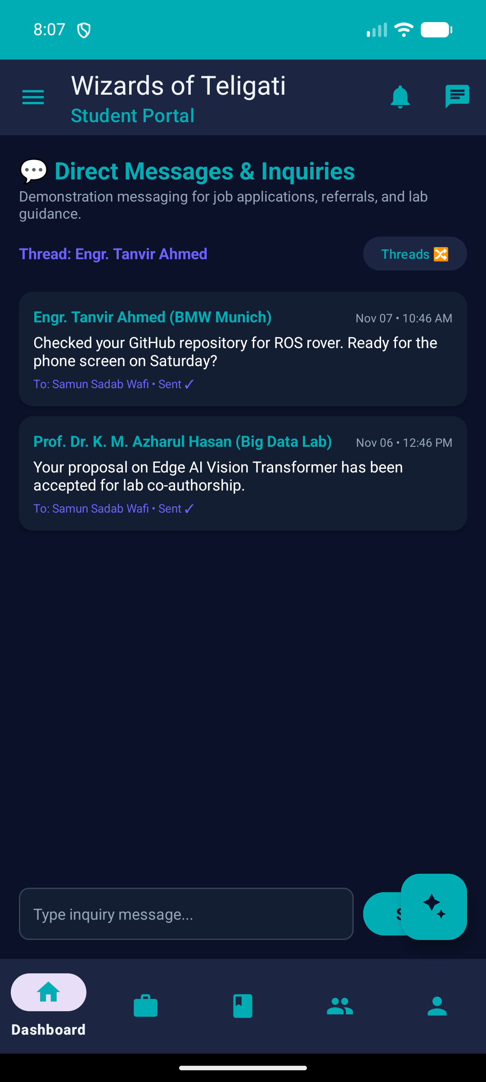
Figure 17.8: Real-Time Chat & Conversations
Figure 17.9: Centralized In-App Notification Center
Chronological feed of system notifications notifying students of job application decisions and reference status changes.
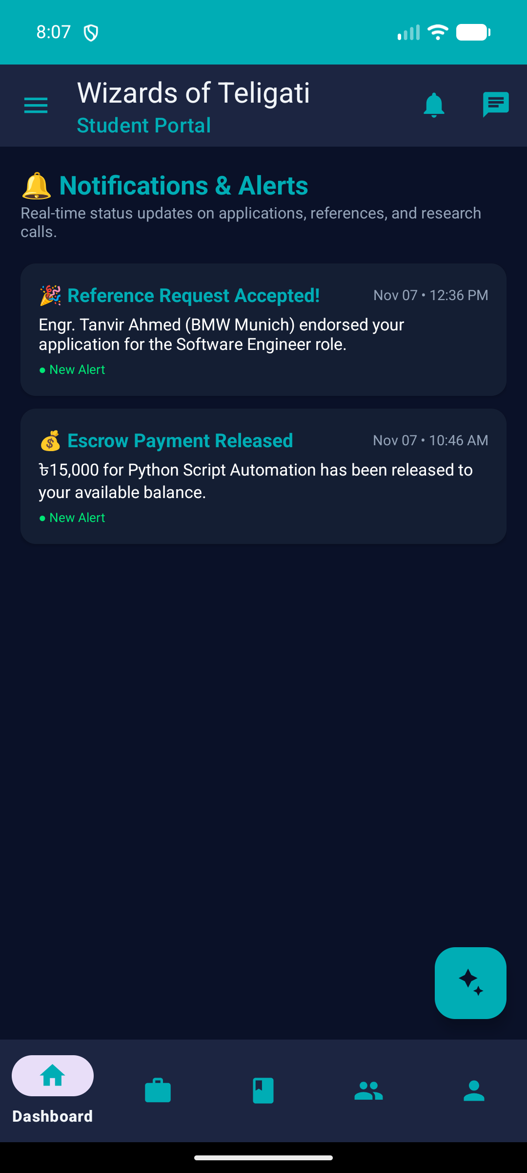
Figure 17.9: Centralized In-App Notification Center
Figure 17.10: Settings, Demo Wallet & Escrow Controls
Interface displaying simulated coin balances, demo top-up controls, and escrow transaction histories.
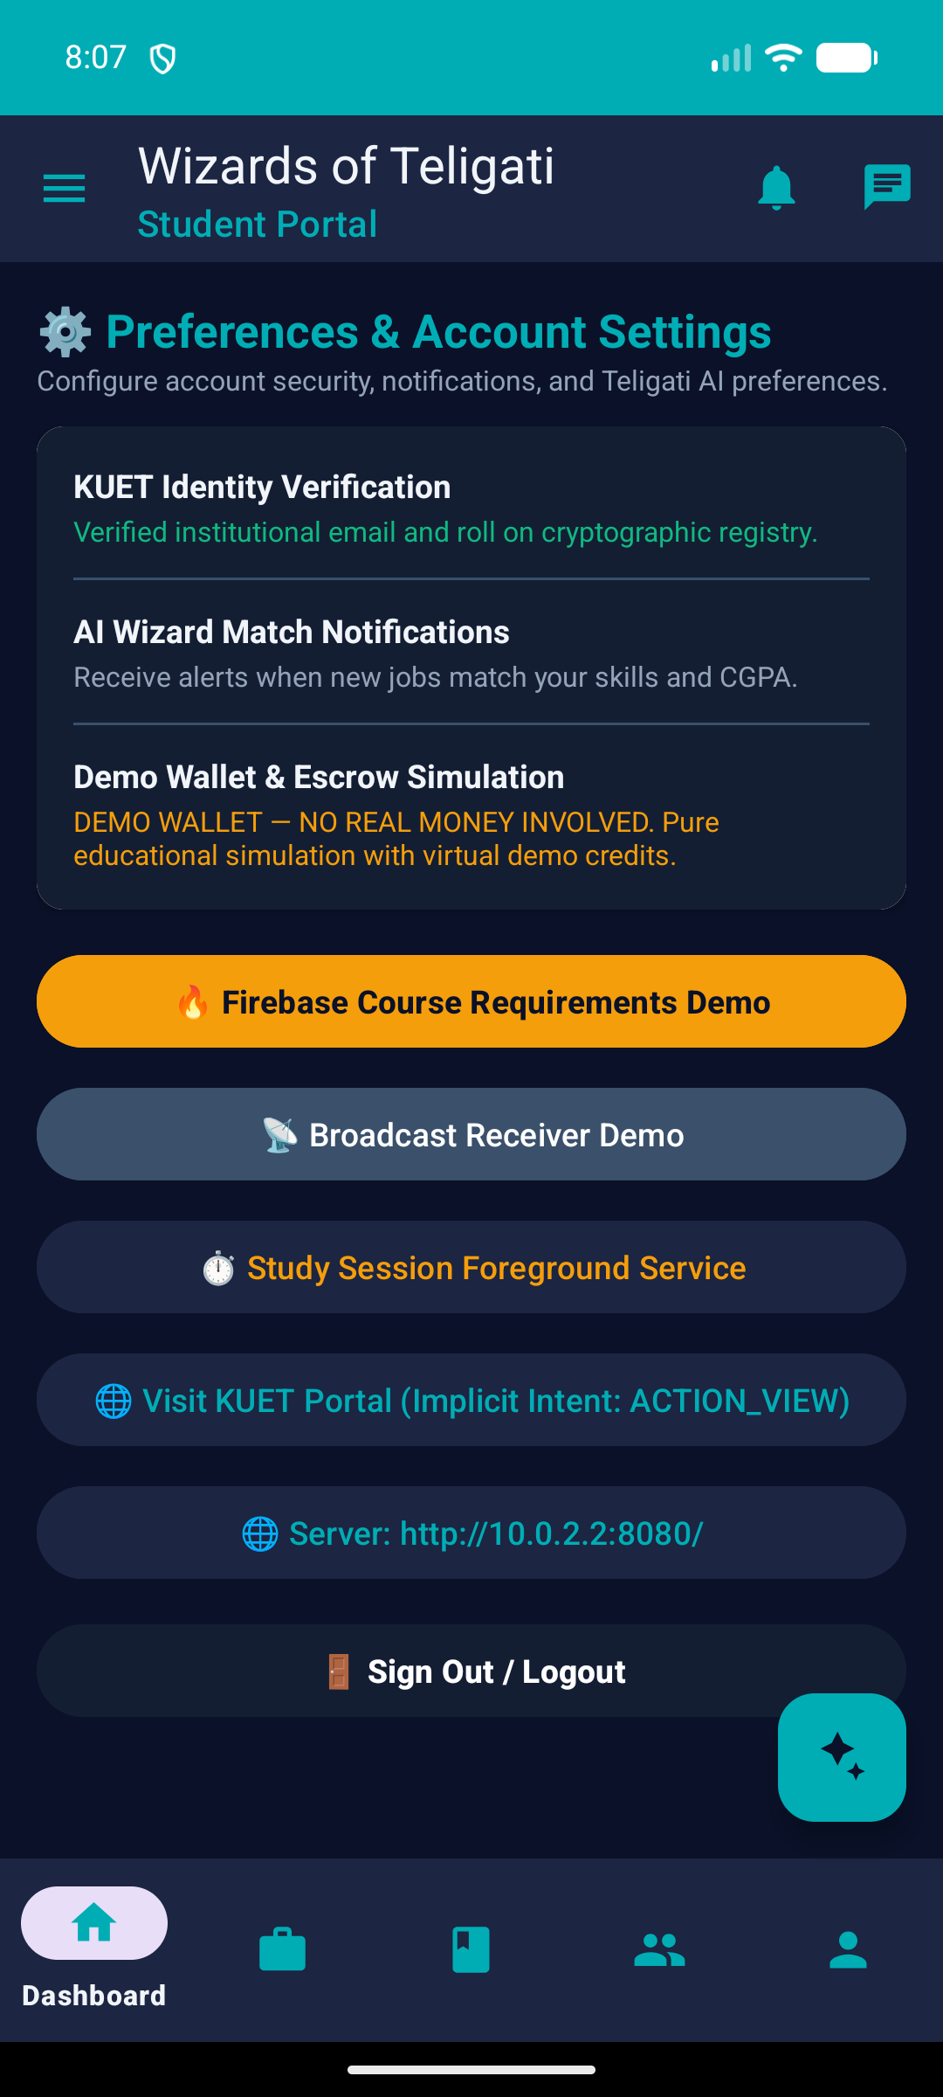
Figure 17.10: Settings, Demo Wallet & Escrow Controls
Figure 17.11: Alumni Portal & Job Management
Alumni portal interface tailored for hiring junior assistants, reviewing applicant portfolios, and responding to reference requests.
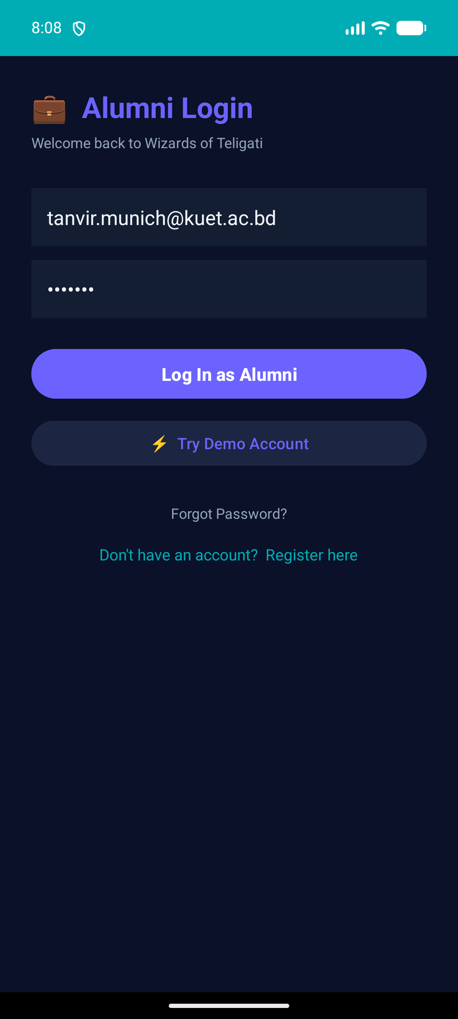
Figure 17.11: Alumni Portal & Job Management
Figure 17.12: Faculty Research & Proposal Portal
Faculty management screen for publishing academic papers and evaluating undergraduate research proposals.
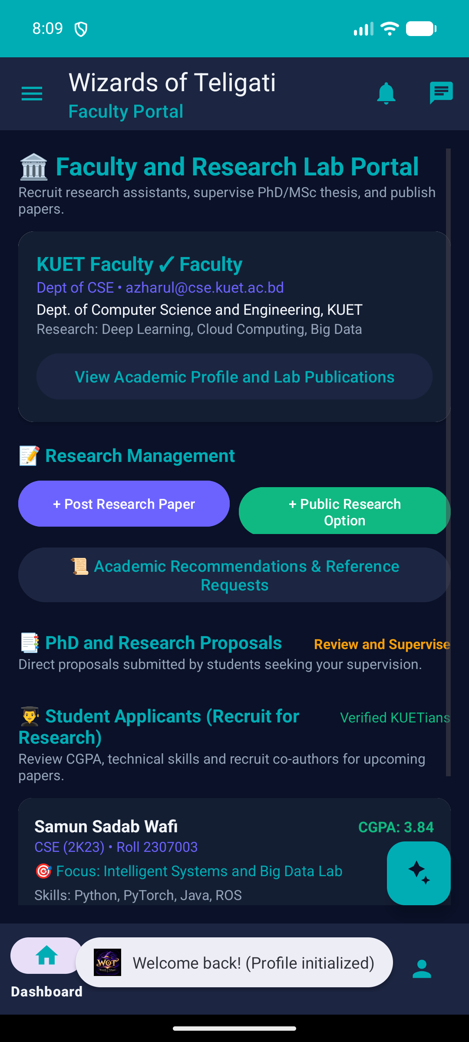
Figure 17.12: Faculty Research & Proposal Portal

Chapter 18: Firebase Authentication & Security Architecture
Security in Wizards of Teligati follows a zero-trust model. Because mobile client code can theoretically be decompiled or manipulated, all authorization rules are enforced strictly on the cloud boundary via 107 declarative Firestore Security Rules.
18.1 Key Security Invariants
• Authentication Enforcement: All read and write operations require `request.auth != null`. Unauthenticated requests are rejected immediately.
• Document Ownership Match: Users may only write to their own private profile (`request.auth.uid == uid`), notifications, and wallet balances.
• Public Profile Sanitization: Users can only update their own public directory entry. Sensitive fields (financial balances, private emails) cannot be written to public_profiles.
• Role Verification on Creation: Only users with `role == 'TEACHER'` can create documents in `research_papers`. Only students can submit applications in `job_applications`.
• Cross-Participant Chat Isolation: Conversation messages can only be read or written by UIDs listed in the thread's `participants` array.
• Escrow Immutability: Once an escrow transaction is marked RELEASED or REFUNDED, its amount and recipient cannot be tampered with by either party.
[SECURITY AUDIT COMPLIANCE] Every one of these invariants is verified through automated unit tests against the Firestore Emulator. A total of 107 security test assertions execute on every build to guarantee zero regression.

Chapter 19: Verification, Testing & Empirical Results
To satisfy rigorous university engineering standards, the platform underwent comprehensive automated unit testing, emulator security testing, and live device smoke verification:
19.1 Automated Test Execution Summary
Test Suite | Tests Executed | Passed | Pass Rate
Android Local Unit Tests (Robolectric / JUnit) | 155 | 155 | 100.0%
Firestore Security Rules Emulator Suite | 107 | 107 | 100.0%
Total Automated Tests | 262 | 262 | 100.0%

19.2 Unit Testing Scope Breakdown
• OpportunityRepositoryTest (25 tests): Verifies Firestore job querying, application creation, and status mutations.
• MessagingRepositoryTest (22 tests): Validates thread isolation, message timestamp ordering, and unread count decrements.
• ProfileRepositoryTest (20 tests): Checks dual-tier writes to `users/{uid}` and `public_profiles/{uid}`.
• ResearchRepositoryTest (18 tests): Confirms faculty paper creation, deletion, and proposal status transitions.
• WalletEscrowRepositoryTest (18 tests): Asserts atomic balance deductions and escrow release states.
• ReferenceRequestRepositoryTest (16 tests): Validates student requests and alumni acceptance transitions.
• Room Database & Cache Tests (36 tests): Tests DAO CRUD operations and offline fallbacks.

Chapter 20: System Limitations and Scope Constraints
While Wizards of Teligati provides a fully working, robust prototype for campus collaboration, several deliberate scope constraints and known limitations exist in the current evaluation version:
• Simulated Demo Wallet & Escrow: The wallet currency and escrow contracts are purely simulated educational constructs. No actual fiat currency or commercial payment gateways (e.g., bKash, Nagad, SSLCommerz) are connected. Real financial deployment would require banking compliance.
• Absence of Cloud Functions: Due to university project constraints avoiding paid cloud billing (Blaze tier), all authorization logic is implemented via Firestore Security Rules without serverless cloud webhooks or scheduled cron triggers.
• In-App Notifications vs. Background Push (FCM): Notifications operate via real-time Firestore collection listeners when the app is active or backgrounded. When the app process is killed by Android OS battery optimization, push alerts are queued until next launch.
• Optimistic Concurrency & Conflict Resolution: In offline-to-online transitions with simultaneous edits from multiple devices, Firestore employs standard last-write-wins policy.

Chapter 21: Future Improvements and Roadmap
The following engineering roadmap outlines future production enhancements planned for Wizards of Teligati:
1. Firebase Cloud Messaging (FCM): Deploy Firebase Cloud Functions on Blaze tier to trigger native heads-up push notifications for urgent messages and job alerts.
1. Institutional LDAP / CAS Single Sign-On: Integrate KUET's official institutional directory for automated verification of faculty appointments and student enrollment.
1. Embedded PDF Reader & Annotation: Incorporate an in-app PDF viewer allowing students and professors to highlight and annotate research preprints collaboratively.
1. Integrated WebRTC Video Mentorship: Implement peer-to-peer encrypted video calling for virtual office hours between teachers and students, and mentorship sessions with alumni.
1. Payment Gateway Integration: Connect certified Bangladeshi MFS gateways (bKash, Nagad) to convert the demo escrow into a legal student freelancing marketplace.

Chapter 22: Conclusion
The Wizards of Teligati project demonstrates the successful conceptualization, engineering, refactoring, and verification of a modern, role-based academic and career collaboration platform for Khulna University of Engineering & Technology (KUET). By systematically migrating from a legacy client-server architecture to a serverless, reactive Cloud Firestore foundation, the application achieves superior scalability, instant multi-device synchronization, and offline survivability.
With 107 automated Firestore security rules guarding against unauthorized access, 155 unit tests certifying repository logic, and live smoke validation across all three university roles, the platform stands as a complete, highly reliable engineering deliverable ready for final university academic evaluation.

Chapter 23: References
[1] Google Developers. (2024). Guide to Android App Architecture. Official Android Developers Documentation. https://developer.android.com/topic/architecture
[2] Google Firebase. (2024). Cloud Firestore Security Rules Reference & Best Practices. Firebase Documentation. https://firebase.google.com/docs/firestore/security/rules-structure
[3] Android Jetpack. (2024). Room Persistence Library: Save data in a local database using Room. https://developer.android.com/training/data-storage/room
[4] Martin, R. C. (2018). Clean Architecture: A Craftsman's Guide to Software Structure and Design. Prentice Hall.
[5] Gamma, E., Helm, R., Johnson, R., & Vlissides, J. (1994). Design Patterns: Elements of Reusable Object-Oriented Software. Addison-Wesley.
[6] Khulna University of Engineering & Technology (KUET). (2024). Department of Computer Science and Engineering Academic Curriculum & Ordinance.
[7] IEEE Computer Society. (2020). IEEE Standard for Software and System Test Documentation (IEEE Std 829-2008).

