Nama = Muhammad Wafiq Kamaluddin

NRP = 2210181042

1. histogram.

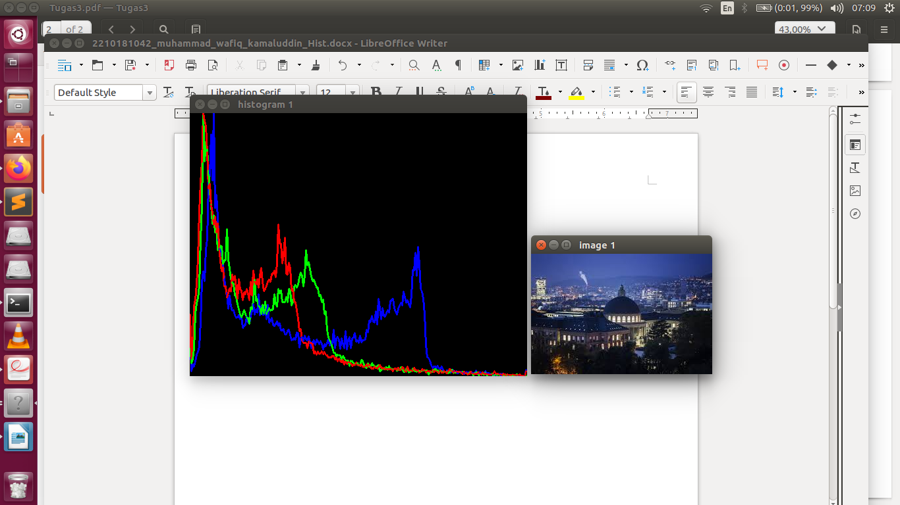

Histogram 3 channel RGB.

2. histogram stretching.



Histogram asal.

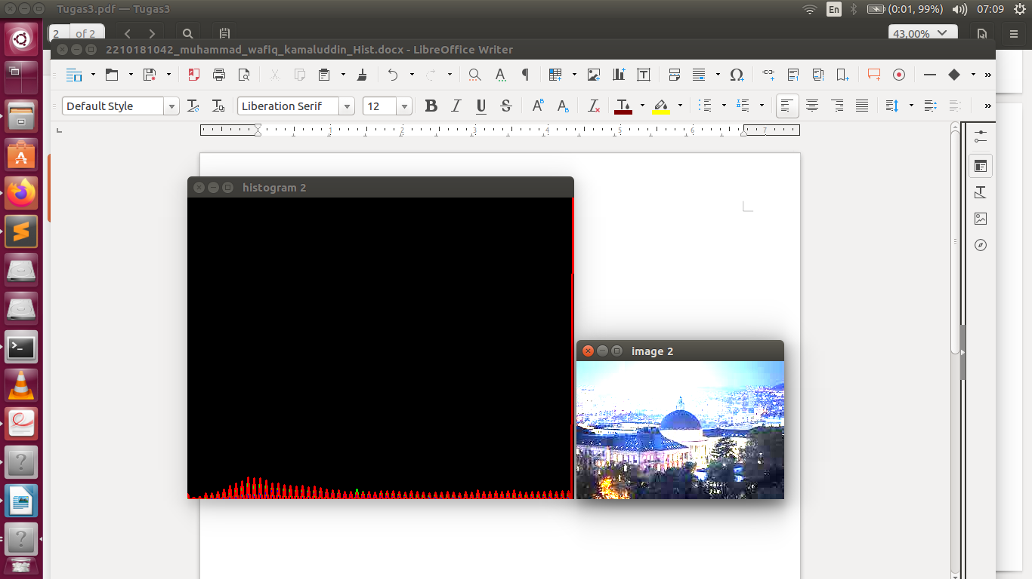Histogram hasil setelah kontrast dinaikkan 4 kali.

3. adaptive tresholding.

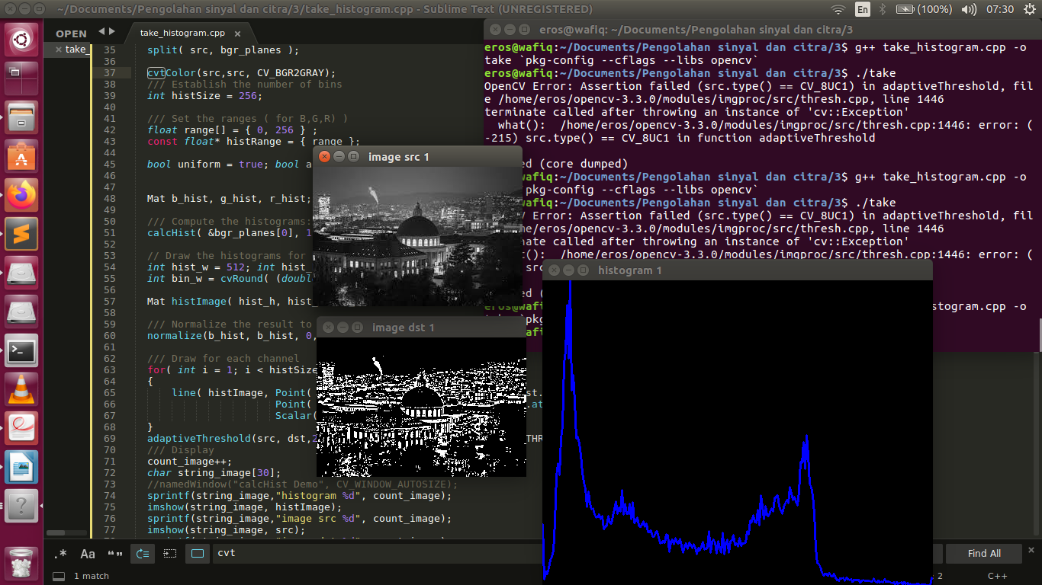

Adaptive thresholding mula mula.

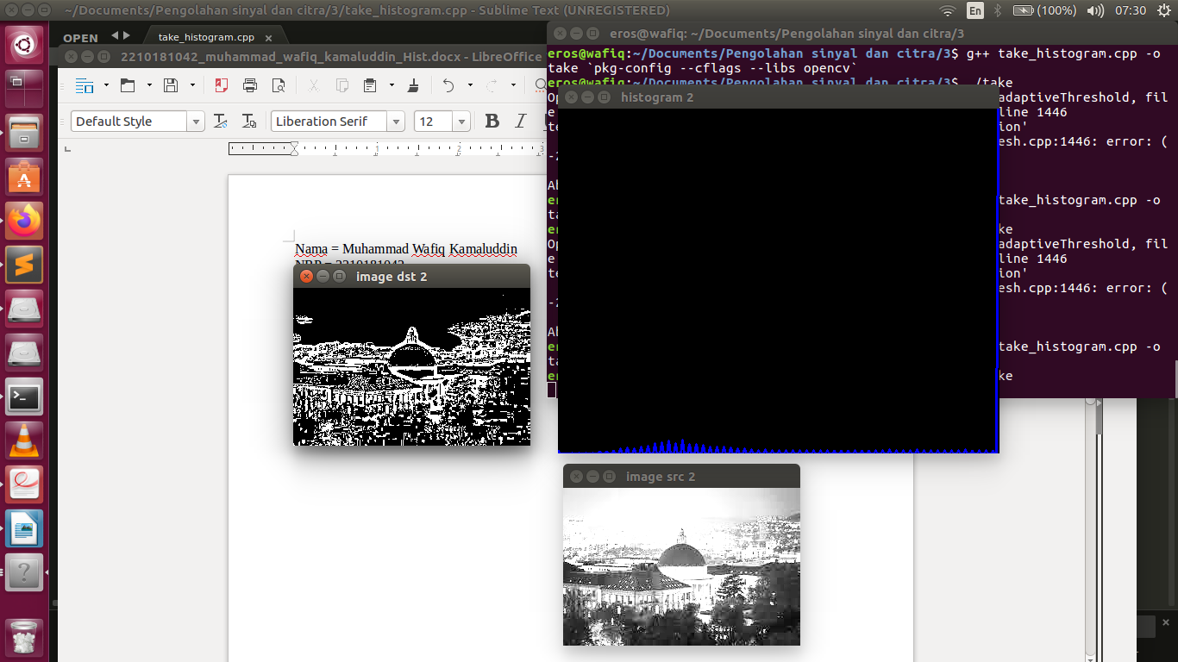

Adaptive thresholding setelah histogram stretching.