The Ram Roaster
Team 8

"Where there's a Ram, we'll Roast it!"

Revision | Description
1.0 | Originated document.
1.1 | Modified document name to Team_08.doc
1.2 | Modified metadata.
1.3 | Changed the tagline.
1.4 | Changed the product name.
1.5 | Edited a team member’s name.
1.6 | Added system overview blocks.
1.7 | Added abbreviations for readers.
1.8 | Added system overview descriptions
1.9 | Scope added.
2.0 | Sections 4 and 6 stubbed.
X.X | Section 3 is fixed
X.x | Tests for the control board were stubbed

Table of Contents
1. Scope 4
2. Abbreviations 4
3. System Overview 4
3.1. Onboard User Interface 4
3.2. USB Debugger 5
3.3. Microcontroller 5
3.4. Navigation System 5
3.4.1. GPS Unit 6
3.4.2. Optical Sensors 6
3.5. Motion System 6
3.5.1. Motors 6
3.5.2. Motor Controller System 6
3.6. Power System 6
3.6.1. Batteries 6
3.6.2. Voltage Regulation System 7
4. Hardware 7
4.1. … 7
4.2. Power System 7
5. Power Analysis 7
6. Test Process 7
6.1. AtoD Verification 7
6.2. Circuit 1 ? 7
6.3. Circuit 2 ? 7

Table of Figures
Figure 1 System Overview 4
Figure 2 Onboard User Interface 4
Figure 3 USB Debugger Overview 5
Figure 4 Microcontroller Overview 5
Figure 5 Navigation System Overview 5
Figure 6 Navigation System Overview 6
Figure 7 Power System Overview 6

Scope
Have you ever needed groceries but didn’t want to go out? What if your child is at soccer practice and you didn’t feel like going to get them? Well, fret no more! With THE RAM ROASTER you no longer have to leave the comfort of your home. This state-of-the-art vehicle will follow a line of black electrical tape to the destination of your choice. All you have to do is unroll a few miles of black electrical tape and this car will do all those boring tasks for you! THE RAM ROASTER also uses the latest in Global Positioning System technology to navigate to common establishments in order to take care of chores as directed by the user. With two modes of navigation and a top speed of a quarter of a mile per hour, this vehicle will have all of your daily tasks completed… eventually.

Abbreviations
CPU – Central Processing Unit: the component of the product that performs all of the number crunching for the car.
GPS – Global Positioning System: the system that allows a device to determine its current location on Earth.
LED – Light Emitting Diode: a circuit component that emits light, which is used for providing a user interface.
LCD – Liquid Crystal Display: a component that outputs useful information to the user.
QSK – Quick Start Kit: the development environment that our product is built with.
USB – Universal Serial Bus: the protocol and hardware for interfacing with the vehicle’s onboard computer.

System Overview
Onboard User Interface
Microcontroller
USB
Debugger

Power
System
Motion
System
Navigation
System
Figure 1 System Overview

Onboard User Interface
Micro
Controller
Switches

LED

LCD

Figure 2 Onboard User Interface
The user can interact with the vehicle through the buttons and onboard dial. This allows the user to adjust the vehicle’s settings without the use of a computer. The user then, receives feedback from the LCD screen and the use of LEDs.

USB Debugger
Micro
Controller
Debugger Interface

USB Debugger

Figure 3 USB Debugger Overview

The USB debugger allows the vehicle to be connected to a computer so that new information can be transferred to the onboard computer. It also allows an advanced user to troubleshoot the current code in the onboard computer.

Microcontroller
Microcontroller
External
Input

External
Output

Figure 4 Microcontroller Overview
The Microcontroller is the heart of the system. It processes inputs from: the users, sensors, and the GPS unit. It uses these inputs to cause the vehicle to follow lines or navigate through GPS waypoints.

Navigation System
Microcontroller
GPS Unit

Optical Sensors

Figure 5 Navigation System Overview
The navigation system provides the vehicle with information for travelling. The navigation system comprises a GPS Unit and optical sensors.

GPS Unit
The GPS unit provides the vehicle with its current location on Earth, which allows it to navigate to a desired location.

Optical Sensors
The optical sensors are used by the vehicle to detect black lines, which it then follows.

Motion System
Microcontroller
Motors

Movement

Motor Controller
System

Figure 6 Navigation System Overview

The motion system is comprised of the motors and their controllers. This is the heart of what moves the vehicle from place to place.

Motors
The motors are connected to the vehicles wheels which are controlled by the microcontroller and the motor controller system.

Motor Controller System
The motor controller system contains the circuitry use to activate the motors in either direction at any number of speeds.

Power System
Batteries

Voltage
Regulation
System
Figure 7 Power System Overview

Batteries
The vehicle runs uses 4 AA batteries, which provide the requisite raw power to the microcontroller, motors, and other devices connected to the vehicle.

Voltage Regulation System
The voltage regulation system takes the raw batteries input and controls it to a level which the microcontroller and other circuitry can comfortably use.

Hardware
Describe hardware.

Motion System

Motor Controller System

The motion system is comprised of the motors and the control board that is used to drive the motors with the requisite voltages. The main structure that controls the voltages applied to the motors is called a full H-Bridge. Each motor is controlled by its own H-Bridge. The control board implementation consists of two ZXMP4A16G P-channel Metal Oxide Semiconductor Field Effect Transistors (MOSFETs) and four ZXMN6A09G N-channel MOSFETs. These MOSFETs are current limited by 1206 package resistors as seen in the figure below:
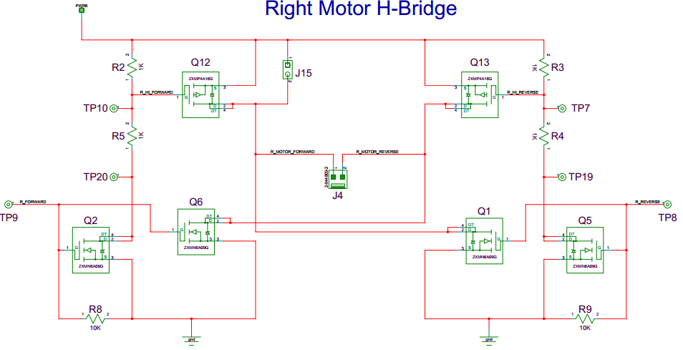
Figure 8 Right Motor Full H Bridge
Assuming that both R_FORWARD and R_REVERSE are configured to be low when the control board and QSK are connected together the motor in the middle will not be activated. When the R_FORWARD signal is activated from the QSK board’s port 3 pin 0, Q12 and Q6 allow current to flow through the motor creating a voltage drop of positive raw battery voltage between J4. When the R_FORWARD signal is deactivated and the R_REVERSE signal is active from the QSK board’s port 3 pin 1, Q13 and Q1 allow current to flow through the motor creating a voltage drop of negative raw battery voltage between J4. This is how each motor is able to travel forward and reverse.
Let us suppose that the R_FORWARD signal was still active when the R_REVERSE signal is applied. This would create a condition where the motor would be bypassed and the current would “shoot through” the transistors. This would likely damage, if not destroy, the H Bridge due to the amount of current that would run through the MOSFETs. Therefore much care should be exercised when programming the application of signals to the motors in order to avoid this occurring.
Below we have a figure of the Left motor full H bridge for completeness, which operates very similarly to the right motor H bridge.
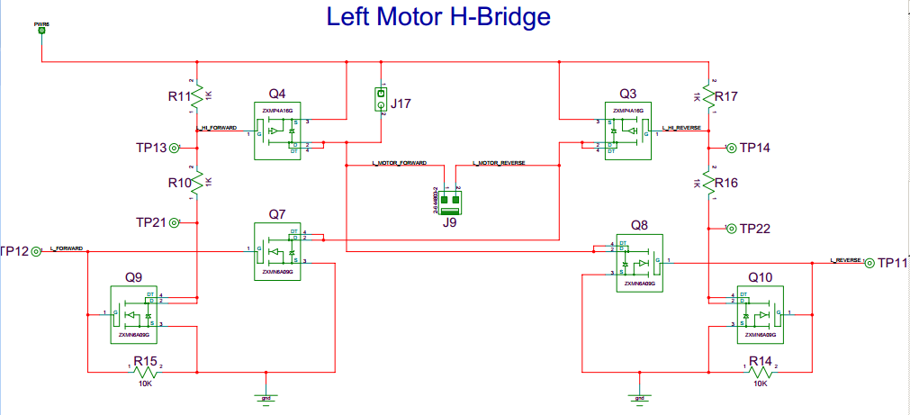
Figure 9 Left Motor Full H Bridge
The main difference between the Right Motor Full H Bridge and the Left Motor Full H Bridge is where the FORWARD and REVERSE signals are derived from on the QSK. The L_FORWARD signal comes from port 3 pin 2 and L_REVERSE comes from port 3 pin 3.

Motors
The vehicle consists of two 120:1 DC brushed motors that are connected to the control board by means of removable connectors. These connectors are crimped on to insulated stranded wire, which is soldered on to the connectors of the motors. The connectors on the motors are very fragile; therefore care must be exercised in order to not break this connection, once the connectors are attached to the motor.
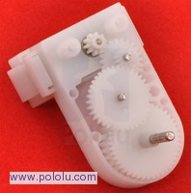

Figure 10 Opened Motor for vehicle

Microcontroller
The microcontroller that this vehicle is equipped with is the M30620FC from BNS solutions. This microcontroller is hosted on the Renesas QSK62P Quick Start Kit shown below:
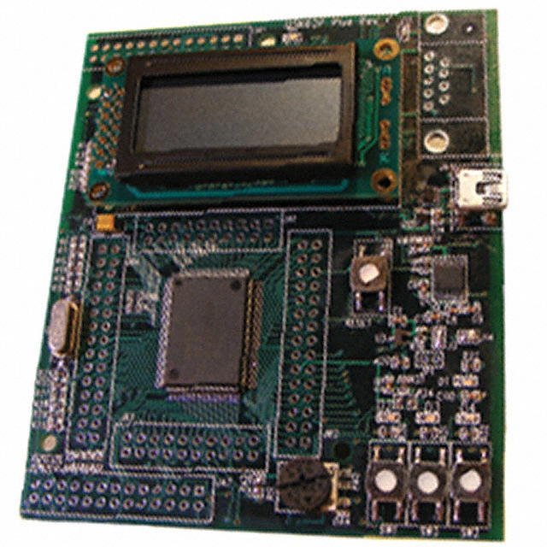
Figure 11 Renesas QSK62P Quick Start Kit
In order to properly connect the control board to the QSK board, a female connector must be soldered to the QSK Board as shown below:
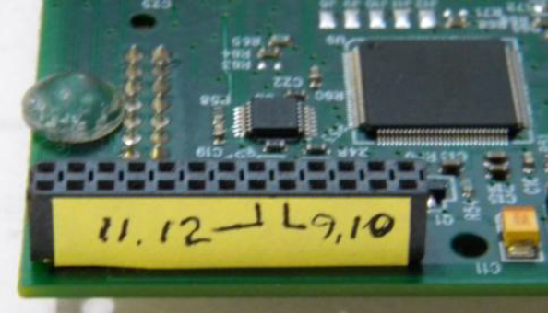
Figure 12 Connection to Control Board
In order for the QSK’s LCD to be powered from the control board, a modification to the female connector and the LCD circuit needs to be made. A jumper must be soldered to these circuits as shown below:
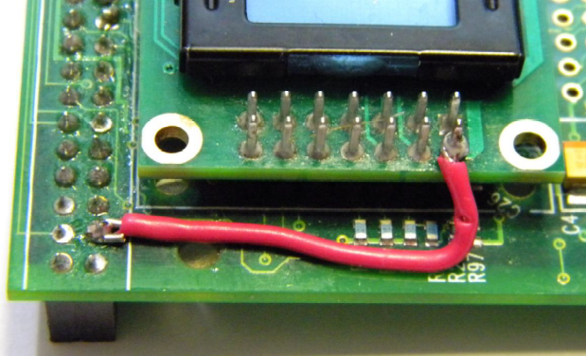
Figure 13 LCD circuit connected to the Control Board

Power Analysis
Provide a description of the power consumption of each part. How long will it last running off of a battery(s).

Test Process

Control Board Tests
Before assembly, one should verify that J7 and J8 are not shorted by using a multi-meter and measuring a resistance in the range of mega-ohms.
After installing C2, C3, C4, C10, C11, and C12, verify J7 and J8 are not shorted by using a multi-meter and measuring a resistance in the range of mega-ohms. This test could also be done after installing each component to be thorough thus looking for a resistance in the range of mega-ohms.
// Can be cut for Power System tests
After installing U2, verify that only pins 4 and 5 are the only pins that are shorted by using a multi-meter.
After installing the U2 power circuit, verify that J7 and J8 are not shorted by using a multi-meter.
After installing the battery connectors, set a DC power supply to 4 volts, probe J8 with a multi-meter and connect the power supply for less than 3 seconds to confirm a reading of 3.3 volts.
After installing U1, confirm with a multi-meter that there is no short circuiting between the pins.
After installing the voltage regulator circuit set a DC power supply to 4 volts. Probe J5 with a multi-meter and connect the power supply for less than 3 seconds to confirm a reading of 1.8 volts. If J5 does not read 1.8 volts, confirm that the DC power supply is connected to the control. If the DC power supply is confirmed to have an output of 4 volts, probe J8 with the multi-meter to confirm that there is a very high resistance as well as having an output of 3.3 volts.
// End of power system test
After installing Q6 and Q7, test the motor connectors by probing them with either an oscilloscope or a multi-meter. Connect the battery to the control board. Use a jumper lead in order to connect J6 pin 1 to J6 pin 15 to confirm the raw battery voltage is output between the Left motor connector. Use a jumper lead in order to connect J6 pin 1 to J6 pin 17 to confirm the raw battery voltage is output between the Right motor connector.
After visually inspecting the control board for potentially shorted components, probe J8 with a multi-meter to confirm a resistance in the range of mega-ohms. Connect the battery pack and QSK board to the control board and download the tutorial program to confirm operation of the board on battery power. It may be necessary to adjust the installed R13 to control the function of the LCD screen.
After removing the short circuit between J15 and J17, use a multi-meter to test for a resistance in the order of mega-ohms between the two junctions.
After installing Q1 and Q8, test the motor connectors by probing them with either an oscilloscope or a multi-meter. Connect the battery to the control board. Use a jumper lead in order to connect J6 pin 1 to J6 pin 16 to confirm the raw battery voltage is output at J15. Use a jumper lead in order to connect J6 pin 1 to J6 pin 18 to confirm the raw battery voltage is output at J17.
Connect the battery to the control board and probe TP19, TP20, TP21, and TP22 with a multi-meter. These test points should all read the raw battery voltage.
After installing C2 and C4, connect the battery pack to the control board and probe J8 with a multi-meter in order to confirm an output voltage of approximately 3.3 volts. With the battery pack connected, probe J5 with a multi-meter in order to confirm a reading of approximately 1.8 volts.
After installing Q2, Q5, Q9, and Q10, connect the battery pack to the control board and probe TP10, TP7, TP13, and TP14 with a multi-meter. Connect a jumper lead to J6 pin 1 to J6 pin 15 to confirm that TP10 outputs half of the raw battery voltage. Connect a jumper lead to J6 pin 1 to J6 pin 16 to confirm that TP7 outputs half of the raw battery voltage. Connect a jumper lead to J6 pin 1 to J6 pin 17 to confirm that TP13 outputs half of the raw battery voltage. Connect a jumper lead to J6 pin 1 to J6 pin 18 to confirm that TP14 outputs half of the raw battery voltage.
After installing Q3, Q4, Q12, and Q13, connect the battery pack to the control board and connect the motors to the control board. Connect a jumper lead to J6 pin 1 to J6 pin 15 to confirm that the right motor is moving in the forward direction. Connect a jumper lead to J6 pin 1 to J6 pin 16 to confirm that the right motor is moving in the reverse direction. Connect a jumper lead to J6 pin 1 to J6 pin 17 to confirm that the left motor is moving in the forward direction. Connect a jumper lead to J6 pin 1 to J6 pin 18 to confirm that the left motor is moving in the reverse direction.
Confirm with an oscilloscope that JA6 pins 16 and 18 are not active while JA6 pins 15 and 17 are active.
After installing R1, R18, and Q11, using an oscilloscope probe D2 and confirm its function with software.
Visually check for shorts after all of the LEDs have been installed.
Circuit 1 ?
Did you use an Oscilloscope?

Circuit 2 ?
Did you use an Oscilloscope?

