Assignment_1

Wagner Quiros Pereira

4/25/2017

## R Markdown Practice

**Monthly precipitation**

climate = read.table("clim.txt", header=T)  
boxplot(climate$rain~climate$month,  
 ylab="Precipitation/inches",  
 xlab="Month", col="blue")

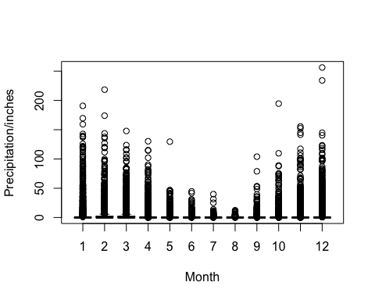

**Monthly minimum average temperature**

climate = read.table("clim.txt", header=T)  
boxplot(climate$tmin~climate$month,  
 ylab="Average of Minimum Temperature/Fahrenheit",  
 xlab="Month", col="lightblue")

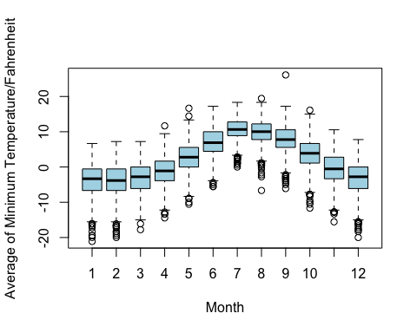

**Monthly maximum average temperature**

climate = read.table("clim.txt", header=T)  
boxplot(climate$tmax~climate$month,  
 ylab="Average of Maximum Temperature/Fahrenheit",  
 xlab="Month", col="blue")

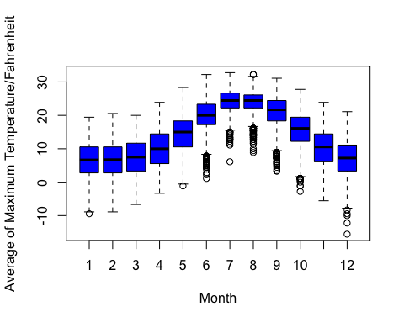

**Annual rain A**

rainfall= read.table("clim.txt", header=T)  
boxplot(rainfall$rain~rainfall$year,  
 ylab="Precipitation/inches/year",  
 xlab="Year", col="orange")

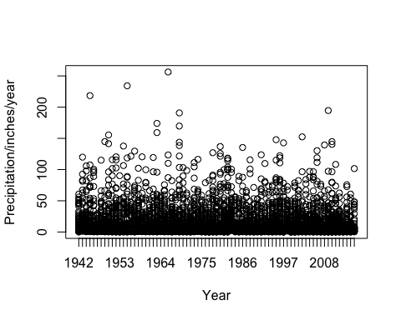

**Annual Mean Rainfall**

YearMeanST <- aggregate (rainfall$rain ~ year, data = rainfall, FUN = function(x) {c(MEAN = mean(x), SD= sd (x))})  
names(YearMeanST)

## [1] "year" "rainfall$rain"

YearMeanSTTable <- do.call(data.frame, YearMeanST)  
colnames(YearMeanSTTable) <- c("Year", "Mean", "SD")  
View(YearMeanSTTable)  
boxplot(YearMeanSTTable$Mean~YearMeanSTTable$Year,  
 ylab="Average Precipitation/inches/year",  
 xlab="Year", col="blue")

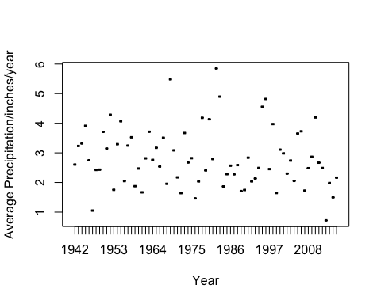

**Wettest year using the mean**

result=which.max(YearMeanSTTable$Mean)  
YearMeanSTTable[result,]

## Year Mean SD  
## 41 1982 5.850351 18.62009

**Driest year using the mean**

result=which.min(YearMeanSTTable$Mean)  
YearMeanSTTable[result,]

## Year Mean SD  
## 72 2013 0.7216384 2.850297

**Wet and Dry Season Picture from Guanacaste, Costa Rica. Tropical Dry Forest**

**Subsetting seasons**

View(climate)  
range(climate$month)

## [1] 1 12

climate$period <- ifelse(climate$month %in% c(3,4,5),"Spring",  
ifelse(climate$month %in% c(6,7,8), "Summer",  
ifelse(climate$month %in% c(9,10,11), "Fall", "Winter")))  
boxplot(climate$rain~climate$period,  
ylab="Mean Precipitation/inches/year",  
xlab="Year", col="blue")

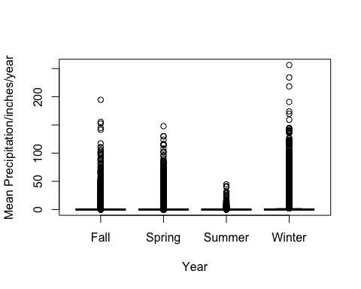

SeasonMeanSD <- aggregate (climate$rain ~ period, data = climate, FUN = function(x) {c(MEAN = mean(x), SD= sd (x))})  
names(SeasonMeanSD)

## [1] "period" "climate$rain"

SeasonMeanSTTable <- do.call(data.frame, SeasonMeanSD)  
colnames(SeasonMeanSTTable) <- c("Period", "Mean", "SD")  
View(SeasonMeanSTTable)  
boxplot(SeasonMeanSTTable$Mean~SeasonMeanSTTable$Period,  
 ylab="Average Precipitation/inches/year",  
 xlab="Period", col="blue")

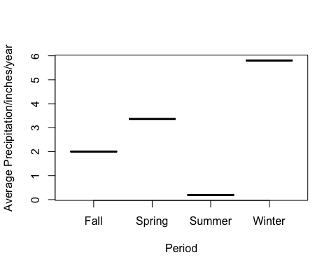

**Driest season using the mean**

result=which.min(SeasonMeanSD$`climate$rain`)  
SeasonMeanSD[result,]

## period climate$rain.MEAN climate$rain.SD  
## 3 Summer 0.1909786 1.6607996

**Wettest season using the mean**

result=which.max(SeasonMeanSTTable$Mean)  
SeasonMeanSD[result,]

## period climate$rain.MEAN climate$rain.SD  
## 4 Winter 5.802871 17.226921