Brucellosis Cases

2024-02-06

Table of Contents

## Descriptive Statistics

*The results reported in this file were coded in the* **county_models.R** *file*

Among Camels, the majority of cases (91.30%) are clinically confirmed, with a smaller proportion (8.70%) being lab confirmed; no cases were post-mortem. In the case of Cattle, clinical confirmation dominates (55.34%), followed by lab confirmation (41.26%), and a minor portion through post-mortem (3.40%). Goats show a significant reliance on clinical confirmation (82.16%), while lab confirmation accounts for 17.84%, and no post-mortem cases were reported. Humans exhibit a considerable reliance on lab confirmation (77.98%), with clinical confirmation comprising 22.02%, and no post-mortem cases. Sheep cases are predominantly clinically confirmed (79.27%), with lab-confirmed cases making up 20.73%, and no instances of post-mortem diagnosis.

Number of cases according to the type of Diagnosis

| Species | Diagnosis | Cases | Percent(%) |
| --- | --- | --- | --- |
| Camels | Clinically confirmed | 21.0 | 91.30 |
| Camels | Lab confirmed | 2.0 | 8.70 |
| Camels | Post Mortem | 0.0 | 0.00 |
| Cattle | Clinically confirmed | 228.0 | 55.34 |
| Cattle | Lab confirmed | 170.0 | 41.26 |
| Cattle | Post Mortem | 14.0 | 3.40 |
| Goats | Clinically confirmed | 815.0 | 82.16 |
| Goats | Lab confirmed | 177.0 | 17.84 |
| Goats | Post Mortem | 0.0 | 0.00 |
| Humans | Clinically confirmed | 945046.3 | 22.78 |
| Humans | Lab confirmed | 3203162.0 | 77.22 |
| Humans | Post Mortem | 0.0 | 0.00 |
| Sheep | Clinically confirmed | 65.0 | 79.27 |
| Sheep | Lab confirmed | 17.0 | 20.73 |
| Sheep | Post Mortem | 0.0 | 0.00 |

The descriptive statistics for the incidence rate of Brucellosis among Camels, Cattle, Goats, Humans, and Sheep are presented in the table 2. The human incidence was calculated per 1,000 population while the incidence for the other species was calculated per 1,000,000 population.

Descriptive Statistics for Incidence Rate

| Species | Mean Incidence Rate | Minimum | Median | Maximum | Standard Deviation |
| --- | --- | --- | --- | --- | --- |
| Human | 1.0457179 | 0.0007 | 0.66 | 12 | 1.12 |
| Goat | 0.1719278 | 0.0000 | 0.00 | 235 | 3.94 |
| Cattle | 0.0505520 | 0.0000 | 0.00 | 122 | 2.42 |
| Camel | 0.0261548 | 0.0000 | 0.00 | 24 | 0.52 |
| Sheep | 0.0154518 | 0.0000 | 0.00 | 45 | 0.69 |

## Test for stationarity and Differencing

The Augmented Dickey-Fuller test was used to test for stationarity. The test was conducted for the data both at National and County level. At county level, the results were as shown below

Results of Augmented Dickey-Fuller Test for Stationarity at County Level

| variable | statistic | P.Value |
| --- | --- | --- |
| Human Incidence | -5.656 | 0.01 |
| Cattle Incidence | -16.099 | 0.01 |
| Camel Incidence | -13.467 | 0.01 |
| Goat Incidence | -15.560 | 0.01 |
| Sheep Incidence | -16.118 | 0.01 |

At county level, all the variables were stationary at 5% level of significance. At national level, the results were as shown below

Results of Augmented Dickey-Fuller Test for Stationarity at National Level

| Variable | Statistic | P.Value |
| --- | --- | --- |
| Human Incidence | -1.728 | 0.689 |
| Cattle Incidence | -3.847 | 0.027 |
| Camel Incidence | NaN | NaN |
| Goat Incidence | -1.713 | 0.682 |
| Sheep Incidence | -1.079 | 0.909 |

At national level, the human incidence variable was not stationary at 5% level of significance. Thus, to make it stationary, the variables were differenced at lag 1

## Trend

The trend for all animal incidence rate combined was as shown below

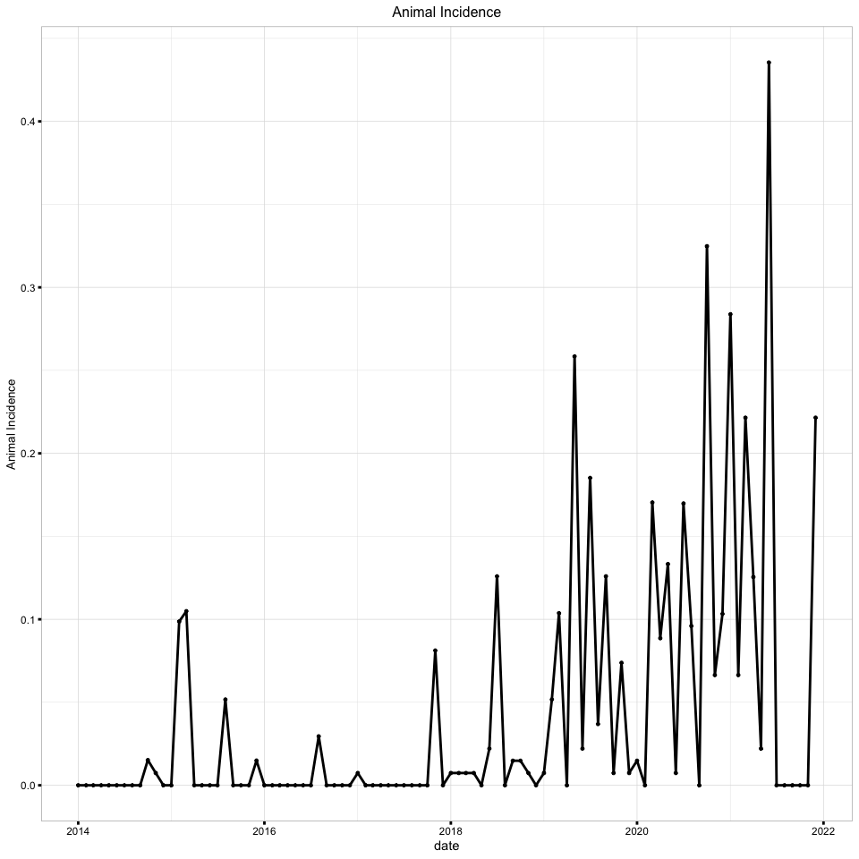

The trend for humans as well as individual species was as shown below with points

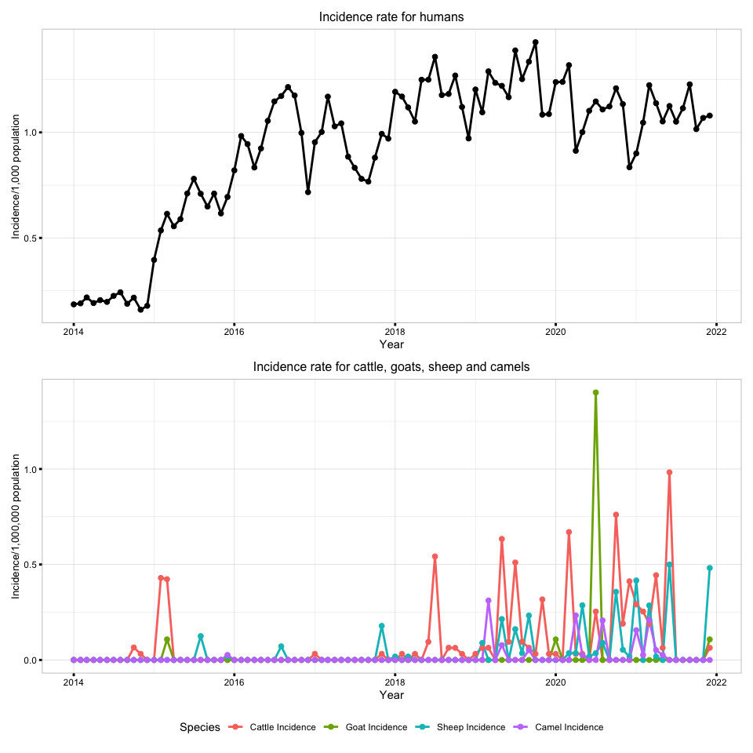

The incidences were also smoothed using the moving average method, at 4 months. The plot for animal incidence combined and smoothed was as shown below;

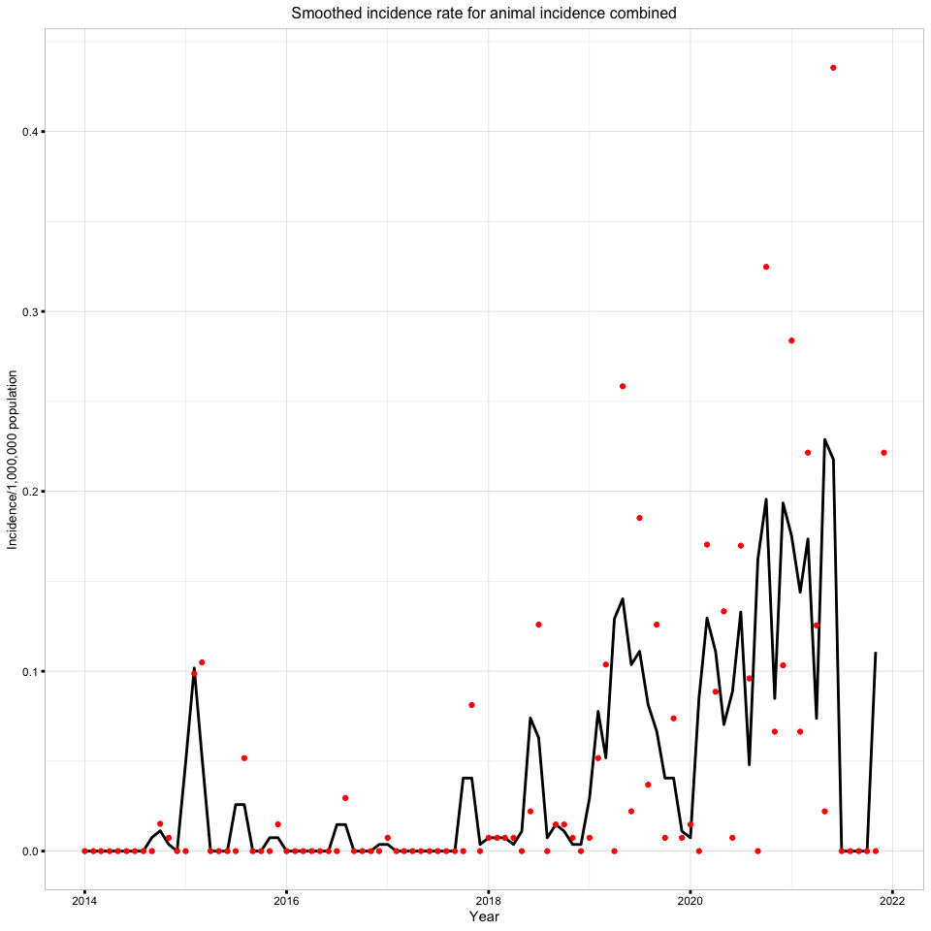

While, for human and other species smoothed were as shown below;

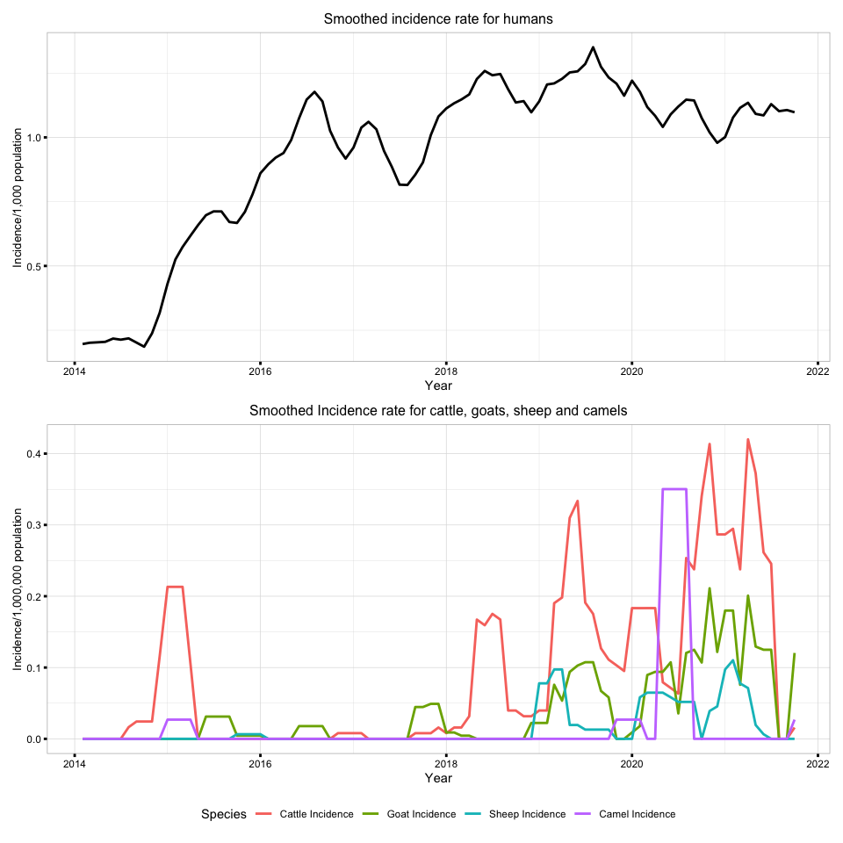

With points

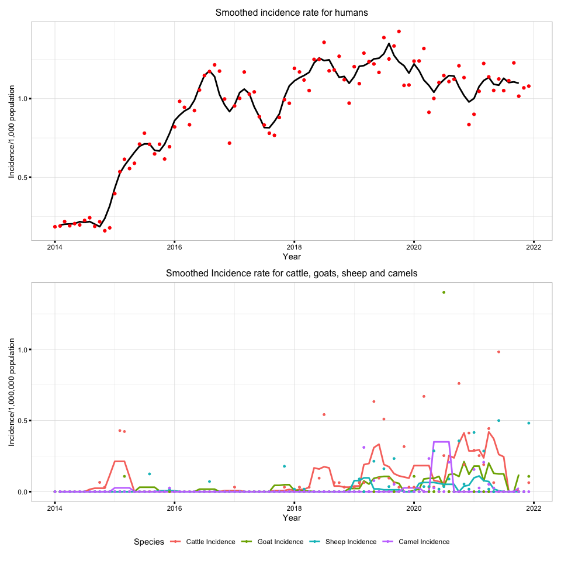

## Spatial

The spatial distribution of the incidence rate of Brucellosis in animals combined and humans was as shown below

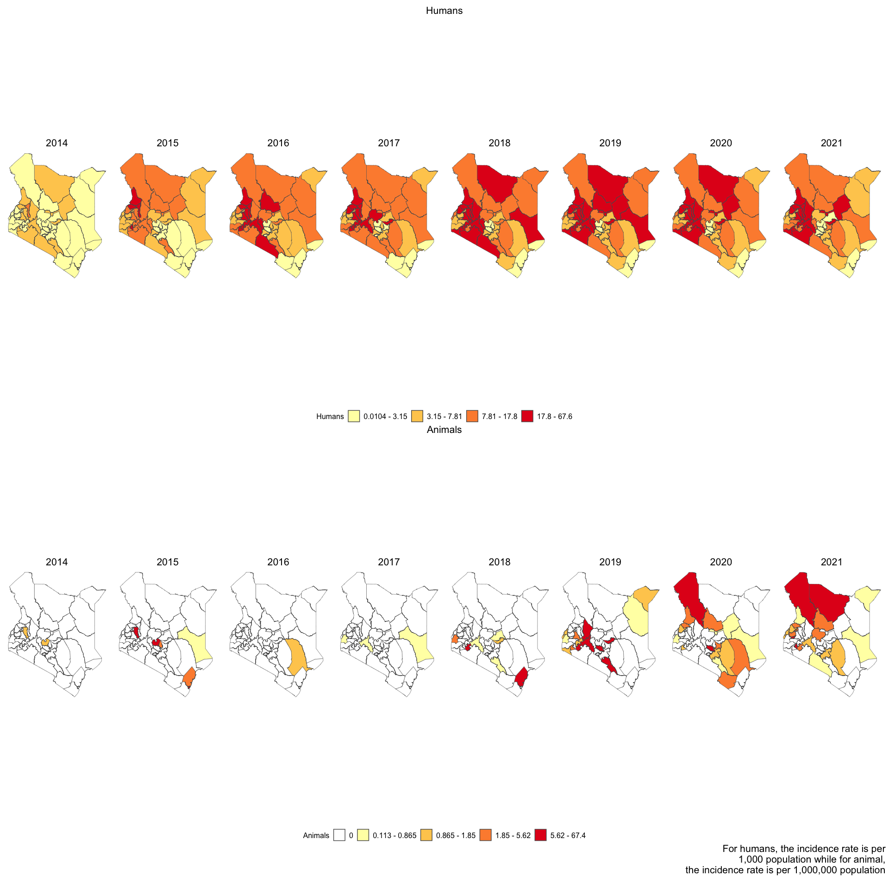

The spatial distribution of the incidence rate of Brucellosis among Camels, Cattle, Goats, Humans, and Sheep are presented in the below,

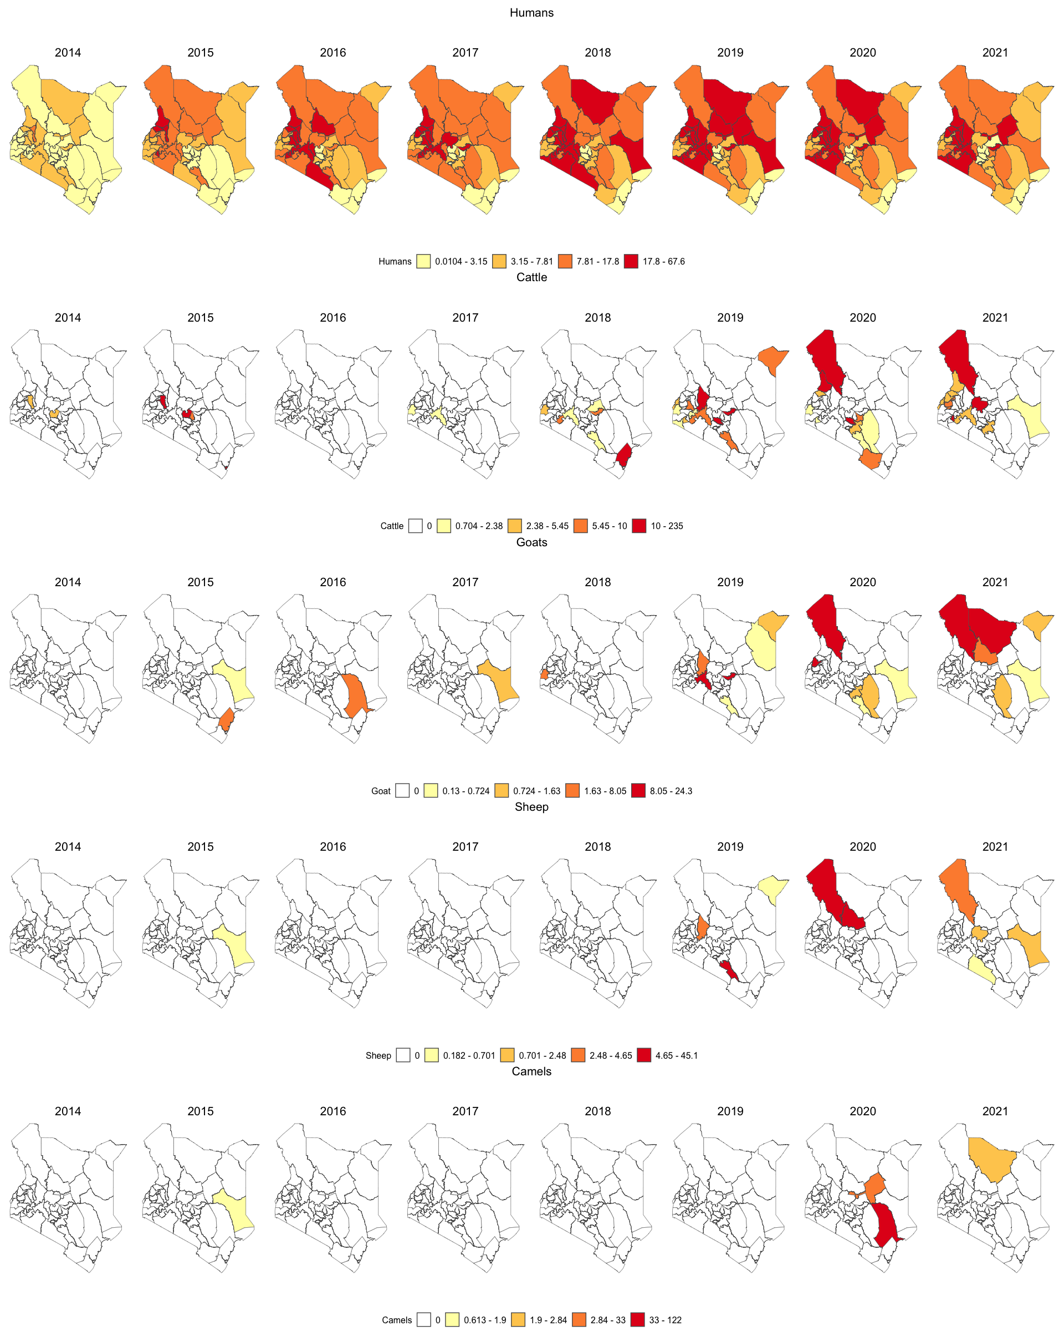

## Correlation

The correlation between the incidence rate of Brucellosis among Camels, Cattle, Goats, Humans, and Sheep were calculated in different lags. There was a high correlation between cattle and goat incidence across all lags. This correlation plot was used to determine the best lag to test for association between the human incidence and animal incidences. The incidence rates for this plot were not differenced.

The correlation plot shows the correlation between the human incidence rate and other species incidence rate. Also, it shows the correlation among the independent variables, which are the animal species.

To check for a correlation between a variable and another variable, you check the variable on the x-axis and then the other variable of interest on the y-axis. The corresponding value at the box in the intersection the correlation between the two.

Correlation is a statistical measure that describes the extent to which two variables change together. In other words, it quantifies the degree to which there is a relationship between two variables.The most common measure of correlation is the correlation coefficient. It ranges from -1 to 1, where: 1: Perfect positive correlation (as one variable increases, the other variable increases). 0: No correlation and -1: Perfect negative correlation (as one variable increases, the other variable decreases).

Interpretation:

* Positive correlation: As one variable increases, the other tends to increase.
* Negative correlation: As one variable increases, the other tends to decrease.
* No correlation: Changes in one variable do not predict changes in the other.

**Correlation does not imply causality** - This statement emphasizes that just because two variables are correlated does not mean that one causes the other. Correlation indicates a statistical association or relationship, but it does not provide information about the cause-and-effect relationship.

Example: Ice cream sales and drowning incidents are positively correlated (both increase in summer), but it would be incorrect to conclude that buying more ice cream causes more drownings, and that’s the main difference between the linear regression and correlation.

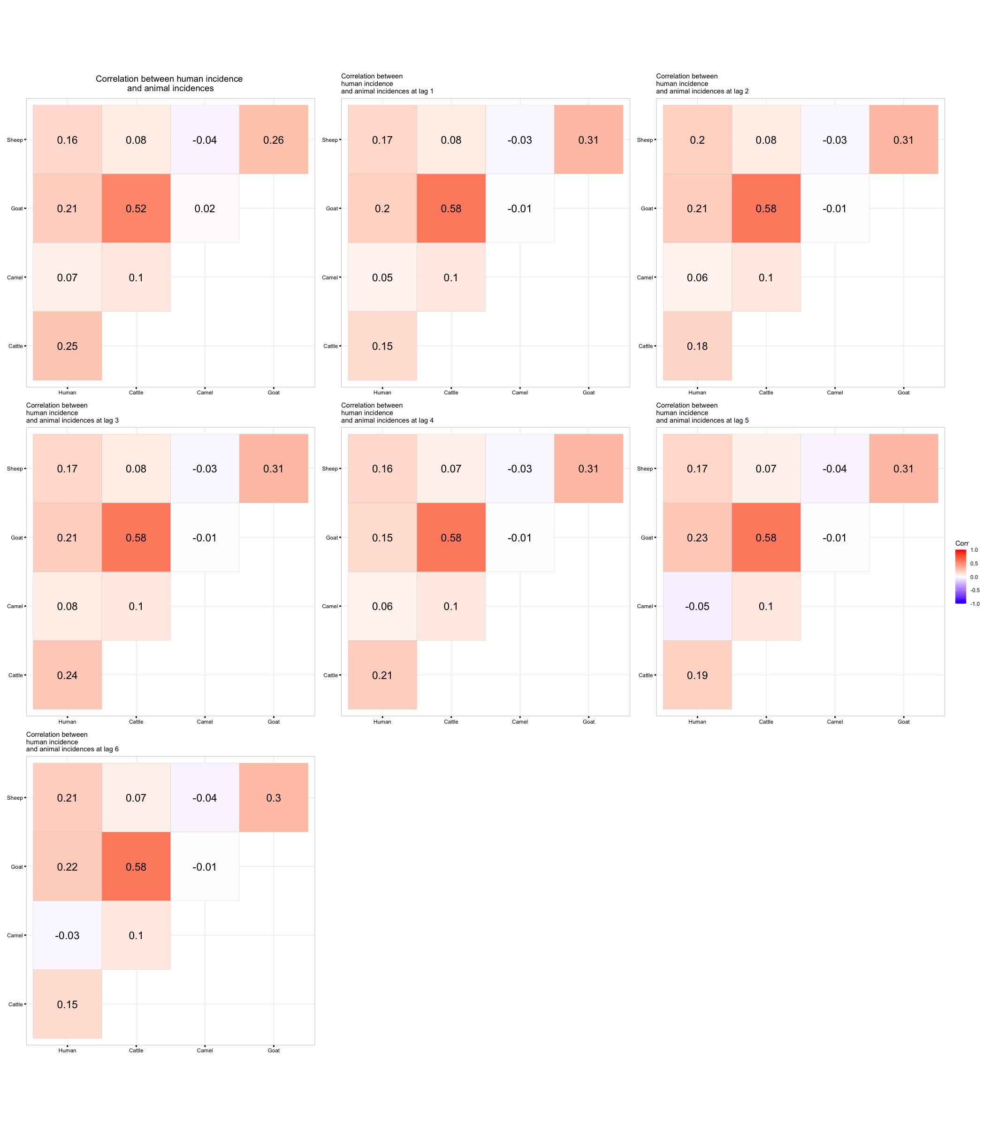

## Models

We run the models for data with NAs (which were represented by zero) and without NAs for both combined and individual

### Model for Individual Incidence with NA

Time Series Linear Model results for no lag (lag = 0)

| variable | estimate | std.error | statistic | p.value | conf_low | conf_high | significance | r_squared | AIC | adj_r_squared |
| --- | --- | --- | --- | --- | --- | --- | --- | --- | --- | --- |
| (Intercept) | 0.867 | 0.039 | 22.245 | 0.000 | 0.803 | 0.931 | Significant | 0.0884196 | -203.3878 | 0.048 |
| Camel incidence | 0.128 | 0.240 | 0.534 | 0.595 | -0.267 | 0.523 | Not Significant | 0.0884196 | -203.3878 | 0.048 |
| Sheep incidence | 0.830 | 0.689 | 1.205 | 0.231 | -0.303 | 1.963 | Not Significant | 0.0884196 | -203.3878 | 0.048 |
| Cattle incidence | 0.355 | 0.214 | 1.661 | 0.100 | 0.004 | 0.707 | Significant | 0.0884196 | -203.3878 | 0.048 |
| Goat Incidence | 0.252 | 0.404 | 0.622 | 0.535 | -0.414 | 0.917 | Not Significant | 0.0884196 | -203.3878 | 0.048 |

Time Series Linear Model results at lag 1

| variable | estimate | std.error | statistic | p.value | conf_low | conf_high | significance | r_squared | AIC | adj_r_squared |
| --- | --- | --- | --- | --- | --- | --- | --- | --- | --- | --- |
| (Intercept) | 0.890 | 0.039 | 22.897 | 0.000 | 0.826 | 0.954 | Significant | 0.0581396 | -201.8335 | 0.016 |
| Camel incidence | 0.120 | 0.240 | 0.499 | 0.619 | -0.275 | 0.515 | Not Significant | 0.0581396 | -201.8335 | 0.016 |
| Sheep incidence | 0.827 | 0.700 | 1.181 | 0.241 | -0.325 | 1.979 | Not Significant | 0.0581396 | -201.8335 | 0.016 |
| Cattle incidence | 0.118 | 0.227 | 0.521 | 0.604 | -0.255 | 0.491 | Not Significant | 0.0581396 | -201.8335 | 0.016 |
| Goat Incidence | 0.435 | 0.485 | 0.897 | 0.372 | -0.363 | 1.233 | Not Significant | 0.0581396 | -201.8335 | 0.016 |

Time Series Linear Model results at lag 2

| variable | estimate | std.error | statistic | p.value | conf_low | conf_high | significance | r_squared | AIC | adj_r_squared |
| --- | --- | --- | --- | --- | --- | --- | --- | --- | --- | --- |
| (Intercept) | 0.892 | 0.038 | 23.484 | 0.000 | 0.830 | 0.955 | Significant | 0.074424 | -205.2586 | 0.033 |
| Camel incidence | 0.124 | 0.233 | 0.530 | 0.598 | -0.260 | 0.507 | Not Significant | 0.074424 | -205.2586 | 0.033 |
| Sheep incidence | 1.021 | 0.680 | 1.502 | 0.137 | -0.097 | 2.139 | Not Significant | 0.074424 | -205.2586 | 0.033 |
| Cattle incidence | 0.183 | 0.220 | 0.832 | 0.408 | -0.179 | 0.545 | Not Significant | 0.074424 | -205.2586 | 0.033 |
| Goat Incidence | 0.340 | 0.471 | 0.722 | 0.472 | -0.434 | 1.115 | Not Significant | 0.074424 | -205.2586 | 0.033 |

Time Series Linear Model results at lag 3

| variable | estimate | std.error | statistic | p.value | conf_low | conf_high | significance | r_squared | AIC | adj_r_squared |
| --- | --- | --- | --- | --- | --- | --- | --- | --- | --- | --- |
| (Intercept) | 0.895 | 0.037 | 24.028 | 0.000 | 0.834 | 0.956 | Significant | 0.0854428 | -208.0381 | 0.044 |
| Camel incidence | 0.144 | 0.227 | 0.634 | 0.528 | -0.230 | 0.517 | Not Significant | 0.0854428 | -208.0381 | 0.044 |
| Sheep incidence | 0.884 | 0.662 | 1.336 | 0.185 | -0.204 | 1.973 | Not Significant | 0.0854428 | -208.0381 | 0.044 |
| Cattle incidence | 0.314 | 0.214 | 1.466 | 0.146 | -0.038 | 0.667 | Not Significant | 0.0854428 | -208.0381 | 0.044 |
| Goat Incidence | 0.188 | 0.458 | 0.410 | 0.683 | -0.566 | 0.942 | Not Significant | 0.0854428 | -208.0381 | 0.044 |

### Model for Individual Incidence without NA

Time Series Linear Model results for no lag (lag = 0)

| variable | estimate | std.error | statistic | p.value | conf_low | conf_high | significance | r_squared | AIC | adj_r_squared |
| --- | --- | --- | --- | --- | --- | --- | --- | --- | --- | --- |
| (Intercept) | 1.039 | 0.062 | 16.688 | 0.000 | 0.937 | 1.142 | Significant | 0.0172867 | -93.42655 | -0.037 |
| Cattle incidence | 0.080 | 0.204 | 0.395 | 0.695 | -0.255 | 0.415 | Not Significant | 0.0172867 | -93.42655 | -0.037 |
| Goat Incidence | 0.164 | 0.341 | 0.480 | 0.634 | -0.397 | 0.724 | Not Significant | 0.0172867 | -93.42655 | -0.037 |

Time Series Linear Model results at lag 1

| variable | estimate | std.error | statistic | p.value | conf_low | conf_high | significance | r_squared | AIC | adj_r_squared |
| --- | --- | --- | --- | --- | --- | --- | --- | --- | --- | --- |
| (Intercept) | 1.107 | 0.054 | 20.541 | 0.000 | 1.019 | 1.196 | Significant | 0.0487482 | -102.2289 | -0.006 |
| Cattle incidence | -0.206 | 0.186 | -1.106 | 0.276 | -0.512 | 0.100 | Not Significant | 0.0487482 | -102.2289 | -0.006 |
| Goat Incidence | 0.415 | 0.345 | 1.201 | 0.238 | -0.153 | 0.983 | Not Significant | 0.0487482 | -102.2289 | -0.006 |

Time Series Linear Model results at lag 2

| variable | estimate | std.error | statistic | p.value | conf_low | conf_high | significance | r_squared | AIC | adj_r_squared |
| --- | --- | --- | --- | --- | --- | --- | --- | --- | --- | --- |
| (Intercept) | 1.121 | 0.045 | 24.751 | 0.000 | 1.047 | 1.196 | Significant | 0.0025292 | -115.9733 | -0.056 |
| Cattle incidence | -0.036 | 0.158 | -0.226 | 0.823 | -0.296 | 0.225 | Not Significant | 0.0025292 | -115.9733 | -0.056 |
| Goat Incidence | 0.073 | 0.297 | 0.247 | 0.806 | -0.415 | 0.562 | Not Significant | 0.0025292 | -115.9733 | -0.056 |

Time Series Linear Model results at lag 3

| variable | estimate | std.error | statistic | p.value | conf_low | conf_high | significance | r_squared | AIC | adj_r_squared |
| --- | --- | --- | --- | --- | --- | --- | --- | --- | --- | --- |
| (Intercept) | 1.140 | 0.040 | 28.379 | 0.000 | 1.074 | 1.206 | Significant | 0.0009649 | -122.8699 | -0.06 |
| Cattle incidence | -0.016 | 0.138 | -0.117 | 0.907 | -0.243 | 0.211 | Not Significant | 0.0009649 | -122.8699 | -0.06 |
| Goat Incidence | -0.024 | 0.259 | -0.094 | 0.926 | -0.450 | 0.401 | Not Significant | 0.0009649 | -122.8699 | -0.06 |

### Models for combined incidence with NA

Time Series Linear Model results for no lag (lag = 0)

| variable | estimate | std.error | statistic | p.value | conf_low | conf_high | significance | r_squared | AIC | adj_r_squared |
| --- | --- | --- | --- | --- | --- | --- | --- | --- | --- | --- |
| (Intercept) | 0.867 | 0.039 | 22.245 | 0.000 | 0.803 | 0.931 | Significant | 0.0884196 | -203.3878 | 0.048 |
| Camel incidence | 0.128 | 0.240 | 0.534 | 0.595 | -0.267 | 0.523 | Not Significant | 0.0884196 | -203.3878 | 0.048 |
| Sheep incidence | 0.830 | 0.689 | 1.205 | 0.231 | -0.303 | 1.963 | Not Significant | 0.0884196 | -203.3878 | 0.048 |
| Cattle incidence | 0.355 | 0.214 | 1.661 | 0.100 | 0.004 | 0.707 | Significant | 0.0884196 | -203.3878 | 0.048 |
| Goat Incidence | 0.252 | 0.404 | 0.622 | 0.535 | -0.414 | 0.917 | Not Significant | 0.0884196 | -203.3878 | 0.048 |

Time Series Linear Model results at lag 1

| variable | estimate | std.error | statistic | p.value | conf_low | conf_high | significance | r_squared | AIC | adj_r_squared |
| --- | --- | --- | --- | --- | --- | --- | --- | --- | --- | --- |
| (Intercept) | 0.890 | 0.039 | 22.897 | 0.000 | 0.826 | 0.954 | Significant | 0.0581396 | -201.8335 | 0.016 |
| Camel incidence | 0.120 | 0.240 | 0.499 | 0.619 | -0.275 | 0.515 | Not Significant | 0.0581396 | -201.8335 | 0.016 |
| Sheep incidence | 0.827 | 0.700 | 1.181 | 0.241 | -0.325 | 1.979 | Not Significant | 0.0581396 | -201.8335 | 0.016 |
| Cattle incidence | 0.118 | 0.227 | 0.521 | 0.604 | -0.255 | 0.491 | Not Significant | 0.0581396 | -201.8335 | 0.016 |
| Goat Incidence | 0.435 | 0.485 | 0.897 | 0.372 | -0.363 | 1.233 | Not Significant | 0.0581396 | -201.8335 | 0.016 |

Time Series Linear Model results at lag 2

| variable | estimate | std.error | statistic | p.value | conf_low | conf_high | significance | r_squared | AIC | adj_r_squared |
| --- | --- | --- | --- | --- | --- | --- | --- | --- | --- | --- |
| (Intercept) | 0.892 | 0.038 | 23.484 | 0.000 | 0.830 | 0.955 | Significant | 0.074424 | -205.2586 | 0.033 |
| Camel incidence | 0.124 | 0.233 | 0.530 | 0.598 | -0.260 | 0.507 | Not Significant | 0.074424 | -205.2586 | 0.033 |
| Sheep incidence | 1.021 | 0.680 | 1.502 | 0.137 | -0.097 | 2.139 | Not Significant | 0.074424 | -205.2586 | 0.033 |
| Cattle incidence | 0.183 | 0.220 | 0.832 | 0.408 | -0.179 | 0.545 | Not Significant | 0.074424 | -205.2586 | 0.033 |
| Goat Incidence | 0.340 | 0.471 | 0.722 | 0.472 | -0.434 | 1.115 | Not Significant | 0.074424 | -205.2586 | 0.033 |

Time Series Linear Model results at lag 3

| variable | estimate | std.error | statistic | p.value | conf_low | conf_high | significance | r_squared | AIC | adj_r_squared |
| --- | --- | --- | --- | --- | --- | --- | --- | --- | --- | --- |
| (Intercept) | 0.895 | 0.037 | 24.028 | 0.000 | 0.834 | 0.956 | Significant | 0.0854428 | -208.0381 | 0.044 |
| Camel incidence | 0.144 | 0.227 | 0.634 | 0.528 | -0.230 | 0.517 | Not Significant | 0.0854428 | -208.0381 | 0.044 |
| Sheep incidence | 0.884 | 0.662 | 1.336 | 0.185 | -0.204 | 1.973 | Not Significant | 0.0854428 | -208.0381 | 0.044 |
| Cattle incidence | 0.314 | 0.214 | 1.466 | 0.146 | -0.038 | 0.667 | Not Significant | 0.0854428 | -208.0381 | 0.044 |
| Goat Incidence | 0.188 | 0.458 | 0.410 | 0.683 | -0.566 | 0.942 | Not Significant | 0.0854428 | -208.0381 | 0.044 |

### Model for Individual Incidence without NA

Time Series Linear Model results for no lag (lag = 0)

| variable | estimate | std.error | statistic | p.value | conf_low | conf_high | r_squared | adj_r_squared | AIC | significance |
| --- | --- | --- | --- | --- | --- | --- | --- | --- | --- | --- |
| (Intercept) | 0.871 | 0.038 | 22.852 | 0.000 | 0.808 | 0.934 | 0.0812337 | 0.071 | -208.634 | Significant |
| Animal Incidence | 1.212 | 0.421 | 2.883 | 0.005 | 0.521 | 1.904 | 0.0812337 | 0.071 | -208.634 | Significant |

Time Series Linear Model results at lag 1

| variable | estimate | std.error | statistic | p.value | conf_low | conf_high | r_squared | adj_r_squared | AIC | significance |
| --- | --- | --- | --- | --- | --- | --- | --- | --- | --- | --- |
| (Intercept) | 0.892 | 0.038 | 23.457 | 0.000 | 0.830 | 0.955 | 0.048173 | 0.038 | -206.8335 | Significant |
| Animal Incidence | 0.935 | 0.431 | 2.170 | 0.033 | 0.226 | 1.644 | 0.048173 | 0.038 | -206.8335 | Significant |

Time Series Linear Model results at lag 2

| variable | estimate | std.error | statistic | p.value | conf_low | conf_high | r_squared | adj_r_squared | AIC | significance |
| --- | --- | --- | --- | --- | --- | --- | --- | --- | --- | --- |
| (Intercept) | 0.896 | 0.037 | 24.066 | 0.000 | 0.835 | 0.957 | 0.0607288 | 0.051 | -209.878 | Significant |
| Animal Incidence | 1.024 | 0.420 | 2.439 | 0.017 | 0.333 | 1.714 | 0.0607288 | 0.051 | -209.878 | Significant |

Time Series Linear Model results at lag 3

| variable | estimate | std.error | statistic | p.value | conf_low | conf_high | r_squared | adj_r_squared | AIC | significance |
| --- | --- | --- | --- | --- | --- | --- | --- | --- | --- | --- |
| (Intercept) | 0.900 | 0.036 | 24.711 | 0.000 | 0.840 | 0.960 | 0.0758008 | 0.066 | -213.0627 | Significant |
| Animal Incidence | 1.115 | 0.408 | 2.732 | 0.008 | 0.444 | 1.787 | 0.0758008 | 0.066 | -213.0627 | Significant |

### Model for Individual Incidence without NA

Time Series Linear Model results for no lag (lag = 0)

| variable | estimate | std.error | statistic | p.value | conf_low | conf_high | r_squared | adj_r_squared | AIC | significance |
| --- | --- | --- | --- | --- | --- | --- | --- | --- | --- | --- |
| (Intercept) | 0.871 | 0.038 | 22.852 | 0.000 | 0.808 | 0.934 | 0.0812337 | 0.071 | -208.634 | Significant |
| Animal Incidence | 1.212 | 0.421 | 2.883 | 0.005 | 0.521 | 1.904 | 0.0812337 | 0.071 | -208.634 | Significant |

Time Series Linear Model results at lag 1

| variable | estimate | std.error | statistic | p.value | conf_low | conf_high | r_squared | adj_r_squared | AIC | significance |
| --- | --- | --- | --- | --- | --- | --- | --- | --- | --- | --- |
| (Intercept) | 0.892 | 0.038 | 23.457 | 0.000 | 0.830 | 0.955 | 0.048173 | 0.038 | -206.8335 | Significant |
| Animal Incidence | 0.935 | 0.431 | 2.170 | 0.033 | 0.226 | 1.644 | 0.048173 | 0.038 | -206.8335 | Significant |

Time Series Linear Model results at lag 2

| variable | estimate | std.error | statistic | p.value | conf_low | conf_high | r_squared | adj_r_squared | AIC | significance |
| --- | --- | --- | --- | --- | --- | --- | --- | --- | --- | --- |
| (Intercept) | 0.896 | 0.037 | 24.066 | 0.000 | 0.835 | 0.957 | 0.0607288 | 0.051 | -209.878 | Significant |
| Animal Incidence | 1.024 | 0.420 | 2.439 | 0.017 | 0.333 | 1.714 | 0.0607288 | 0.051 | -209.878 | Significant |

Time Series Linear Model results at lag 3

| variable | estimate | std.error | statistic | p.value | conf_low | conf_high | r_squared | adj_r_squared | AIC | significance |
| --- | --- | --- | --- | --- | --- | --- | --- | --- | --- | --- |
| (Intercept) | 0.900 | 0.036 | 24.711 | 0.000 | 0.840 | 0.960 | 0.0758008 | 0.066 | -213.0627 | Significant |
| Animal Incidence | 1.115 | 0.408 | 2.732 | 0.008 | 0.444 | 1.787 | 0.0758008 | 0.066 | -213.0627 | Significant |

## Model for Each specific County

### For individuL Species

Time series linear regression model was fit for all the counties for data with NAs and the one without giving the following results. Some counties didn’t have results because they contained zero incidences in all the predictors (cattle, goat, sheep, and camel incidence). Also, the models have also been tested only at **lag 2 and 3**. The NA in the dataframe, indicates that the variable had zero incidence.

The models for complete case of combined animal incidence was not run because the models with NA had sensible results, Hence no need of going to the complete case.

In the folder, you will find the results of the models as follows;

1. *individual_animal_incidence_per_county_lag2.csv* - Results for individual animal incidences per county (at lag 2) with NA.
2. *individual_animal_incidence_per_county_lag3.csv* - Results for individual animal incidences per county (at lag 3) with NA.
3. *all_animal_incidence_per_county_lag2.csv* - Results for all animal incidences per county at lag2.
4. *all_animal_incidence_per_county_lag3.csv* - Results for all animal incidences per county at lag3.

The models were fit at lag 2 and lag 3. The results were as follows;

#### lag 2 individual incidence

Time Series Linear Model results at lag 2 individual incidence, for each county, with NAs

| county | variable | estimate | std.error | statistic | p.value | conf_low | conf_high | significant |
| --- | --- | --- | --- | --- | --- | --- | --- | --- |
| Baringo | (Intercept) | 1.568 | 0.087 | 17.946 | 0.000 | 1.424 | 1.711 | Significant |
| Baringo | Cattle incidence | 0.548 | 0.486 | 1.128 | 0.262 | -0.251 | 1.347 | Not Significant |
| Baringo | Goat Incidence | 0.369 | 0.259 | 1.421 | 0.159 | -0.058 | 0.795 | Not Significant |
| Baringo | Sheep incidence | -1.718 | 1.636 | -1.051 | 0.296 | -4.409 | 0.972 | Not Significant |
| Baringo | Camel incidence | NA | NA | NA | NA | NA | NA | NA |
| Embu | (Intercept) | 0.465 | 0.038 | 12.328 | 0.000 | 0.403 | 0.527 | Significant |
| Embu | Cattle incidence | 0.102 | 0.072 | 1.415 | 0.160 | -0.017 | 0.221 | Not Significant |
| Embu | Goat Incidence | NA | NA | NA | NA | NA | NA | NA |
| Embu | Sheep incidence | NA | NA | NA | NA | NA | NA | NA |
| Embu | Camel incidence | NA | NA | NA | NA | NA | NA | NA |
| Garissa | (Intercept) | 1.021 | 0.056 | 18.210 | 0.000 | 0.929 | 1.113 | Significant |
| Garissa | Cattle incidence | -5.202 | 6.176 | -0.842 | 0.402 | -15.361 | 4.957 | Not Significant |
| Garissa | Goat Incidence | 0.656 | 0.409 | 1.603 | 0.112 | -0.017 | 1.329 | Not Significant |
| Garissa | Sheep incidence | 1.973 | 2.975 | 0.663 | 0.509 | -2.922 | 6.868 | Not Significant |
| Garissa | Camel incidence | -1.352 | 0.881 | -1.535 | 0.128 | -2.801 | 0.097 | Not Significant |
| Isiolo | (Intercept) | 1.596 | 0.129 | 12.389 | 0.000 | 1.384 | 1.807 | Significant |
| Isiolo | Cattle incidence | NA | NA | NA | NA | NA | NA | NA |
| Isiolo | Goat Incidence | NA | NA | NA | NA | NA | NA | NA |
| Isiolo | Sheep incidence | NA | NA | NA | NA | NA | NA | NA |
| Isiolo | Camel incidence | 0.558 | 0.372 | 1.501 | 0.137 | -0.054 | 1.169 | Not Significant |
| Kajiado | (Intercept) | 1.097 | 0.050 | 21.778 | 0.000 | 1.014 | 1.180 | Significant |
| Kajiado | Cattle incidence | NA | NA | NA | NA | NA | NA | NA |
| Kajiado | Goat Incidence | NA | NA | NA | NA | NA | NA | NA |
| Kajiado | Sheep incidence | -0.275 | 1.106 | -0.249 | 0.804 | -2.096 | 1.545 | Not Significant |
| Kajiado | Camel incidence | NA | NA | NA | NA | NA | NA | NA |
| Kilifi | (Intercept) | 0.033 | 0.004 | 7.734 | 0.000 | 0.026 | 0.040 | Significant |
| Kilifi | Cattle incidence | -0.001 | 0.001 | -0.429 | 0.669 | -0.003 | 0.002 | Not Significant |
| Kilifi | Goat Incidence | -0.004 | 0.006 | -0.590 | 0.557 | -0.014 | 0.006 | Not Significant |
| Kilifi | Sheep incidence | NA | NA | NA | NA | NA | NA | NA |
| Kilifi | Camel incidence | NA | NA | NA | NA | NA | NA | NA |
| Kitui | (Intercept) | 0.696 | 0.041 | 17.063 | 0.000 | 0.629 | 0.763 | Significant |
| Kitui | Cattle incidence | 0.052 | 0.294 | 0.177 | 0.860 | -0.431 | 0.535 | Not Significant |
| Kitui | Goat Incidence | 0.153 | 0.482 | 0.316 | 0.752 | -0.641 | 0.946 | Not Significant |
| Kitui | Sheep incidence | NA | NA | NA | NA | NA | NA | NA |
| Kitui | Camel incidence | NA | NA | NA | NA | NA | NA | NA |
| Kwale | (Intercept) | 0.095 | 0.024 | 3.904 | 0.000 | 0.055 | 0.135 | Significant |
| Kwale | Cattle incidence | NA | NA | NA | NA | NA | NA | NA |
| Kwale | Goat Incidence | -0.086 | 0.200 | -0.428 | 0.670 | -0.415 | 0.244 | Not Significant |
| Kwale | Sheep incidence | NA | NA | NA | NA | NA | NA | NA |
| Kwale | Camel incidence | NA | NA | NA | NA | NA | NA | NA |
| Laikipia | (Intercept) | 0.905 | 0.057 | 15.957 | 0.000 | 0.812 | 0.998 | Significant |
| Laikipia | Cattle incidence | -0.031 | 0.038 | -0.824 | 0.412 | -0.093 | 0.031 | Not Significant |
| Laikipia | Goat Incidence | NA | NA | NA | NA | NA | NA | NA |
| Laikipia | Sheep incidence | NA | NA | NA | NA | NA | NA | NA |
| Laikipia | Camel incidence | NA | NA | NA | NA | NA | NA | NA |
| Machakos | (Intercept) | 0.441 | 0.023 | 18.873 | 0.000 | 0.403 | 0.480 | Significant |
| Machakos | Cattle incidence | -0.050 | 0.083 | -0.601 | 0.549 | -0.185 | 0.086 | Not Significant |
| Machakos | Goat Incidence | 0.030 | 0.312 | 0.096 | 0.924 | -0.483 | 0.543 | Not Significant |
| Machakos | Sheep incidence | NA | NA | NA | NA | NA | NA | NA |
| Machakos | Camel incidence | NA | NA | NA | NA | NA | NA | NA |
| Makueni | (Intercept) | 0.670 | 0.042 | 15.812 | 0.000 | 0.600 | 0.740 | Significant |
| Makueni | Cattle incidence | -0.189 | 0.114 | -1.665 | 0.099 | -0.376 | -0.002 | Significant |
| Makueni | Goat Incidence | -0.207 | 0.472 | -0.438 | 0.662 | -0.984 | 0.570 | Not Significant |
| Makueni | Sheep incidence | -0.005 | 0.009 | -0.515 | 0.608 | -0.019 | 0.010 | Not Significant |
| Makueni | Camel incidence | NA | NA | NA | NA | NA | NA | NA |
| Mandera | (Intercept) | 0.500 | 0.034 | 14.494 | 0.000 | 0.443 | 0.556 | Significant |
| Mandera | Cattle incidence | 0.077 | 0.066 | 1.165 | 0.247 | -0.032 | 0.187 | Not Significant |
| Mandera | Goat Incidence | 0.179 | 0.272 | 0.658 | 0.512 | -0.268 | 0.626 | Not Significant |
| Mandera | Sheep incidence | 0.081 | 1.088 | 0.075 | 0.941 | -1.708 | 1.871 | Not Significant |
| Mandera | Camel incidence | NA | NA | NA | NA | NA | NA | NA |
| Meru | (Intercept) | 0.337 | 0.020 | 16.696 | 0.000 | 0.304 | 0.370 | Significant |
| Meru | Cattle incidence | -0.005 | 0.123 | -0.040 | 0.968 | -0.207 | 0.197 | Not Significant |
| Meru | Goat Incidence | -0.018 | 0.012 | -1.492 | 0.139 | -0.038 | 0.002 | Not Significant |
| Meru | Sheep incidence | NA | NA | NA | NA | NA | NA | NA |
| Meru | Camel incidence | NA | NA | NA | NA | NA | NA | NA |
| Mombasa | (Intercept) | 0.053 | 0.007 | 7.790 | 0.000 | 0.042 | 0.064 | Significant |
| Mombasa | Cattle incidence | 0.000 | 0.000 | -0.522 | 0.603 | -0.001 | 0.000 | Not Significant |
| Mombasa | Goat Incidence | NA | NA | NA | NA | NA | NA | NA |
| Mombasa | Sheep incidence | NA | NA | NA | NA | NA | NA | NA |
| Mombasa | Camel incidence | NA | NA | NA | NA | NA | NA | NA |
| Nakuru | (Intercept) | 1.546 | 0.055 | 28.325 | 0.000 | 1.457 | 1.636 | Significant |
| Nakuru | Cattle incidence | 0.134 | 0.158 | 0.852 | 0.397 | -0.125 | 0.394 | Not Significant |
| Nakuru | Goat Incidence | -0.006 | 0.053 | -0.121 | 0.904 | -0.094 | 0.081 | Not Significant |
| Nakuru | Sheep incidence | NA | NA | NA | NA | NA | NA | NA |
| Nakuru | Camel incidence | NA | NA | NA | NA | NA | NA | NA |
| Samburu | (Intercept) | 1.234 | 0.068 | 18.162 | 0.000 | 1.123 | 1.346 | Significant |
| Samburu | Cattle incidence | NA | NA | NA | NA | NA | NA | NA |
| Samburu | Goat Incidence | -0.009 | 0.094 | -0.099 | 0.922 | -0.164 | 0.145 | Not Significant |
| Samburu | Sheep incidence | 0.063 | 0.093 | 0.677 | 0.500 | -0.090 | 0.216 | Not Significant |
| Samburu | Camel incidence | NA | NA | NA | NA | NA | NA | NA |
| Taita Taveta | (Intercept) | 0.335 | 0.026 | 12.829 | 0.000 | 0.292 | 0.378 | Significant |
| Taita Taveta | Cattle incidence | -0.025 | 0.041 | -0.605 | 0.546 | -0.093 | 0.043 | Not Significant |
| Taita Taveta | Goat Incidence | NA | NA | NA | NA | NA | NA | NA |
| Taita Taveta | Sheep incidence | NA | NA | NA | NA | NA | NA | NA |
| Taita Taveta | Camel incidence | NA | NA | NA | NA | NA | NA | NA |
| Tana River | (Intercept) | 0.345 | 0.041 | 8.343 | 0.000 | 0.277 | 0.413 | Significant |
| Tana River | Cattle incidence | NA | NA | NA | NA | NA | NA | NA |
| Tana River | Goat Incidence | 0.027 | 0.118 | 0.232 | 0.817 | -0.167 | 0.222 | Not Significant |
| Tana River | Sheep incidence | NA | NA | NA | NA | NA | NA | NA |
| Tana River | Camel incidence | 0.000 | 0.003 | 0.012 | 0.991 | -0.005 | 0.005 | Not Significant |
| Tharaka Nithi | (Intercept) | 1.418 | 0.101 | 14.104 | 0.000 | 1.253 | 1.584 | Significant |
| Tharaka Nithi | Cattle incidence | 0.009 | 0.090 | 0.105 | 0.916 | -0.139 | 0.158 | Not Significant |
| Tharaka Nithi | Goat Incidence | 0.124 | 0.172 | 0.718 | 0.475 | -0.160 | 0.407 | Not Significant |
| Tharaka Nithi | Sheep incidence | NA | NA | NA | NA | NA | NA | NA |
| Tharaka Nithi | Camel incidence | NA | NA | NA | NA | NA | NA | NA |
| Turkana | (Intercept) | 0.964 | 0.041 | 23.691 | 0.000 | 0.897 | 1.031 | Significant |
| Turkana | Cattle incidence | 0.017 | 0.016 | 1.076 | 0.285 | -0.009 | 0.043 | Not Significant |
| Turkana | Goat Incidence | 0.005 | 0.064 | 0.074 | 0.941 | -0.100 | 0.110 | Not Significant |
| Turkana | Sheep incidence | 0.103 | 0.077 | 1.339 | 0.184 | -0.023 | 0.229 | Not Significant |
| Turkana | Camel incidence | NA | NA | NA | NA | NA | NA | NA |
| Uasin Gishu | (Intercept) | 2.138 | 0.116 | 18.478 | 0.000 | 1.947 | 2.328 | Significant |
| Uasin Gishu | Cattle incidence | -0.099 | 0.077 | -1.296 | 0.198 | -0.225 | 0.027 | Not Significant |
| Uasin Gishu | Goat Incidence | NA | NA | NA | NA | NA | NA | NA |
| Uasin Gishu | Sheep incidence | NA | NA | NA | NA | NA | NA | NA |
| Uasin Gishu | Camel incidence | NA | NA | NA | NA | NA | NA | NA |
| Wajir | (Intercept) | 0.734 | 0.043 | 16.932 | 0.000 | 0.662 | 0.805 | Significant |
| Wajir | Cattle incidence | NA | NA | NA | NA | NA | NA | NA |
| Wajir | Goat Incidence | -0.197 | 0.672 | -0.293 | 0.770 | -1.302 | 0.908 | Not Significant |
| Wajir | Sheep incidence | NA | NA | NA | NA | NA | NA | NA |
| Wajir | Camel incidence | NA | NA | NA | NA | NA | NA | NA |
| West Pokot | (Intercept) | 3.348 | 0.190 | 17.619 | 0.000 | 3.035 | 3.660 | Significant |
| West Pokot | Cattle incidence | 0.228 | 0.135 | 1.686 | 0.095 | 0.006 | 0.450 | Significant |
| West Pokot | Goat Incidence | NA | NA | NA | NA | NA | NA | NA |
| West Pokot | Sheep incidence | NA | NA | NA | NA | NA | NA | NA |
| West Pokot | Camel incidence | NA | NA | NA | NA | NA | NA | NA |

Time Series Linear Model results at lag 2 for individual incidence, for each county, without NAs

| county | variable | estimate | std.error | statistic | p.value | conf_low | conf_high | significant |
| --- | --- | --- | --- | --- | --- | --- | --- | --- |
| Baringo | (Intercept) | 2.752 | NaN | NaN | NaN | NaN | NaN | NA |
| Baringo | Cattle incidence | NA | NA | NA | NA | NA | NA | NA |
| Baringo | Goat Incidence | NA | NA | NA | NA | NA | NA | NA |
| Bomet | (Intercept) | 1.175 | 0.201 | 5.839 | 0.001 | 0.844 | 1.507 | Significant |
| Bomet | Cattle incidence | 0.046 | 0.078 | 0.591 | 0.573 | -0.082 | 0.175 | Not Significant |
| Bomet | Goat Incidence | NA | NA | NA | NA | NA | NA | NA |
| Bungoma | (Intercept) | 2.775 | NaN | NaN | NaN | NaN | NaN | NA |
| Bungoma | Cattle incidence | 0.314 | NaN | NaN | NaN | NaN | NaN | NA |
| Bungoma | Goat Incidence | NA | NA | NA | NA | NA | NA | NA |
| Busia | (Intercept) | 0.672 | 0.054 | 12.423 | 0.051 | 0.583 | 0.761 | Significant |
| Busia | Cattle incidence | NA | NA | NA | NA | NA | NA | NA |
| Busia | Goat Incidence | NA | NA | NA | NA | NA | NA | NA |
| Embu | (Intercept) | 0.987 | 0.172 | 5.750 | 0.110 | 0.705 | 1.270 | Significant |
| Embu | Cattle incidence | NA | NA | NA | NA | NA | NA | NA |
| Embu | Goat Incidence | NA | NA | NA | NA | NA | NA | NA |
| Garissa | (Intercept) | 1.023 | NaN | NaN | NaN | NaN | NaN | NA |
| Garissa | Cattle incidence | NA | NA | NA | NA | NA | NA | NA |
| Garissa | Goat Incidence | NA | NA | NA | NA | NA | NA | NA |
| Kakamega | (Intercept) | -1.122 | NaN | NaN | NaN | NaN | NaN | NA |
| Kakamega | Cattle incidence | 0.421 | NaN | NaN | NaN | NaN | NaN | NA |
| Kakamega | Goat Incidence | 1.967 | NaN | NaN | NaN | NaN | NaN | NA |
| Kericho | (Intercept) | 2.416 | NaN | NaN | NaN | NaN | NaN | NA |
| Kericho | Cattle incidence | NA | NA | NA | NA | NA | NA | NA |
| Kericho | Goat Incidence | NA | NA | NA | NA | NA | NA | NA |
| Kilifi | (Intercept) | 0.046 | NaN | NaN | NaN | NaN | NaN | NA |
| Kilifi | Cattle incidence | NA | NA | NA | NA | NA | NA | NA |
| Kilifi | Goat Incidence | NA | NA | NA | NA | NA | NA | NA |
| Kirinyaga | (Intercept) | 0.002 | NaN | NaN | NaN | NaN | NaN | NA |
| Kirinyaga | Cattle incidence | NA | NA | NA | NA | NA | NA | NA |
| Kirinyaga | Goat Incidence | NA | NA | NA | NA | NA | NA | NA |
| Kisii | (Intercept) | 3.074 | 0.125 | 24.570 | 0.026 | 2.868 | 3.280 | Significant |
| Kisii | Cattle incidence | 0.013 | 0.007 | 1.879 | 0.311 | 0.002 | 0.025 | Significant |
| Kisii | Goat Incidence | NA | NA | NA | NA | NA | NA | NA |
| Kitui | (Intercept) | 0.806 | NaN | NaN | NaN | NaN | NaN | NA |
| Kitui | Cattle incidence | NA | NA | NA | NA | NA | NA | NA |
| Kitui | Goat Incidence | NA | NA | NA | NA | NA | NA | NA |
| Laikipia | (Intercept) | 0.757 | NaN | NaN | NaN | NaN | NaN | NA |
| Laikipia | Cattle incidence | NA | NA | NA | NA | NA | NA | NA |
| Laikipia | Goat Incidence | NA | NA | NA | NA | NA | NA | NA |
| Machakos | (Intercept) | 0.334 | 0.014 | 24.668 | 0.002 | 0.312 | 0.356 | Significant |
| Machakos | Cattle incidence | 0.012 | 0.002 | 7.274 | 0.018 | 0.009 | 0.015 | Significant |
| Machakos | Goat Incidence | 0.071 | 0.028 | 2.571 | 0.124 | 0.026 | 0.116 | Significant |
| Makueni | (Intercept) | 1.895 | 0.089 | 21.278 | 0.000 | 1.749 | 2.042 | Significant |
| Makueni | Cattle incidence | -1.026 | 0.060 | -16.979 | 0.000 | -1.125 | -0.926 | Significant |
| Makueni | Goat Incidence | -0.190 | 0.019 | -10.062 | 0.002 | -0.221 | -0.159 | Significant |
| Mandera | (Intercept) | 1.055 | 0.066 | 16.055 | 0.040 | 0.947 | 1.163 | Significant |
| Mandera | Cattle incidence | NA | NA | NA | NA | NA | NA | NA |
| Mandera | Goat Incidence | NA | NA | NA | NA | NA | NA | NA |
| Meru | (Intercept) | 0.510 | NaN | NaN | NaN | NaN | NaN | NA |
| Meru | Cattle incidence | NA | NA | NA | NA | NA | NA | NA |
| Meru | Goat Incidence | NA | NA | NA | NA | NA | NA | NA |
| Migori | (Intercept) | 1.242 | NaN | NaN | NaN | NaN | NaN | NA |
| Migori | Cattle incidence | NA | NA | NA | NA | NA | NA | NA |
| Migori | Goat Incidence | NA | NA | NA | NA | NA | NA | NA |
| Mombasa | (Intercept) | 0.009 | NaN | NaN | NaN | NaN | NaN | NA |
| Mombasa | Cattle incidence | NA | NA | NA | NA | NA | NA | NA |
| Mombasa | Goat Incidence | NA | NA | NA | NA | NA | NA | NA |
| Murang’a | (Intercept) | 0.107 | NaN | NaN | NaN | NaN | NaN | NA |
| Murang’a | Cattle incidence | 0.000 | NaN | NaN | NaN | NaN | NaN | NA |
| Murang’a | Goat Incidence | NA | NA | NA | NA | NA | NA | NA |
| Nakuru | (Intercept) | 1.865 | 0.149 | 12.515 | 0.001 | 1.620 | 2.111 | Significant |
| Nakuru | Cattle incidence | -0.002 | 0.006 | -0.376 | 0.732 | -0.013 | 0.008 | Not Significant |
| Nakuru | Goat Incidence | NA | NA | NA | NA | NA | NA | NA |
| Nandi | (Intercept) | 1.587 | NaN | NaN | NaN | NaN | NaN | NA |
| Nandi | Cattle incidence | 1.685 | NaN | NaN | NaN | NaN | NaN | NA |
| Nandi | Goat Incidence | -0.308 | NaN | NaN | NaN | NaN | NaN | NA |
| Nyamira | (Intercept) | 1.610 | 0.309 | 5.209 | 0.035 | 1.102 | 2.119 | Significant |
| Nyamira | Cattle incidence | -0.013 | 0.063 | -0.206 | 0.856 | -0.117 | 0.091 | Not Significant |
| Nyamira | Goat Incidence | NA | NA | NA | NA | NA | NA | NA |
| Nyeri | (Intercept) | 0.156 | NaN | NaN | NaN | NaN | NaN | NA |
| Nyeri | Cattle incidence | -0.002 | NaN | NaN | NaN | NaN | NaN | NA |
| Nyeri | Goat Incidence | NA | NA | NA | NA | NA | NA | NA |
| Siaya | (Intercept) | 0.708 | 0.133 | 5.306 | 0.006 | 0.489 | 0.928 | Significant |
| Siaya | Cattle incidence | -0.014 | 0.010 | -1.400 | 0.234 | -0.030 | 0.002 | Not Significant |
| Siaya | Goat Incidence | NA | NA | NA | NA | NA | NA | NA |
| Taita Taveta | (Intercept) | 0.343 | 0.101 | 3.396 | 0.182 | 0.177 | 0.510 | Significant |
| Taita Taveta | Cattle incidence | NA | NA | NA | NA | NA | NA | NA |
| Taita Taveta | Goat Incidence | NA | NA | NA | NA | NA | NA | NA |
| Tharaka Nithi | (Intercept) | 2.048 | 0.750 | 2.730 | 0.112 | 0.814 | 3.282 | Significant |
| Tharaka Nithi | Cattle incidence | -0.078 | 0.151 | -0.514 | 0.659 | -0.326 | 0.171 | Not Significant |
| Tharaka Nithi | Goat Incidence | NA | NA | NA | NA | NA | NA | NA |
| Trans Nzoia | (Intercept) | 2.672 | 0.945 | 2.826 | 0.217 | 1.116 | 4.227 | Significant |
| Trans Nzoia | Cattle incidence | -0.151 | 0.243 | -0.621 | 0.646 | -0.552 | 0.249 | Not Significant |
| Trans Nzoia | Goat Incidence | 0.442 | 0.336 | 1.316 | 0.414 | -0.111 | 0.994 | Not Significant |
| Turkana | (Intercept) | 1.210 | 0.068 | 17.908 | 0.000 | 1.098 | 1.321 | Significant |
| Turkana | Cattle incidence | -0.015 | 0.005 | -2.879 | 0.064 | -0.024 | -0.006 | Significant |
| Turkana | Goat Incidence | 0.094 | 0.029 | 3.252 | 0.047 | 0.046 | 0.142 | Significant |
| Uasin Gishu | (Intercept) | 0.504 | NaN | NaN | NaN | NaN | NaN | NA |
| Uasin Gishu | Cattle incidence | 0.050 | NaN | NaN | NaN | NaN | NaN | NA |
| Uasin Gishu | Goat Incidence | NA | NA | NA | NA | NA | NA | NA |
| Vihiga | (Intercept) | 0.877 | NaN | NaN | NaN | NaN | NaN | NA |
| Vihiga | Cattle incidence | -0.011 | NaN | NaN | NaN | NaN | NaN | NA |
| Vihiga | Goat Incidence | NA | NA | NA | NA | NA | NA | NA |
| West Pokot | (Intercept) | 5.363 | 0.497 | 10.798 | 0.008 | 4.546 | 6.180 | Significant |
| West Pokot | Cattle incidence | -0.036 | 0.067 | -0.528 | 0.650 | -0.146 | 0.075 | Not Significant |
| West Pokot | Goat Incidence | NA | NA | NA | NA | NA | NA | NA |

#### lag 3 individual incidence

Time Series Linear Model results at lag 3 individual incidence, for each county, with NAs

| county | variable | estimate | std.error | statistic | p.value | conf_low | conf_high | significant |
| --- | --- | --- | --- | --- | --- | --- | --- | --- |
| Baringo | (Intercept) | 1.584 | 0.087 | 18.148 | 0.000 | 1.440 | 1.727 | Significant |
| Baringo | Cattle incidence | 0.516 | 0.483 | 1.070 | 0.287 | -0.277 | 1.310 | Not Significant |
| Baringo | Goat Incidence | 0.366 | 0.258 | 1.422 | 0.159 | -0.057 | 0.790 | Not Significant |
| Baringo | Sheep incidence | -1.644 | 1.625 | -1.012 | 0.314 | -4.317 | 1.029 | Not Significant |
| Baringo | Camel incidence | NA | NA | NA | NA | NA | NA | NA |
| Embu | (Intercept) | 0.460 | 0.037 | 12.422 | 0.000 | 0.399 | 0.521 | Significant |
| Embu | Cattle incidence | 0.167 | 0.071 | 2.356 | 0.021 | 0.050 | 0.284 | Significant |
| Embu | Goat Incidence | NA | NA | NA | NA | NA | NA | NA |
| Embu | Sheep incidence | NA | NA | NA | NA | NA | NA | NA |
| Embu | Camel incidence | NA | NA | NA | NA | NA | NA | NA |
| Garissa | (Intercept) | 1.023 | 0.057 | 17.953 | 0.000 | 0.929 | 1.117 | Significant |
| Garissa | Cattle incidence | -1.347 | 6.276 | -0.215 | 0.831 | -11.671 | 8.977 | Not Significant |
| Garissa | Goat Incidence | 0.499 | 0.416 | 1.201 | 0.233 | -0.185 | 1.183 | Not Significant |
| Garissa | Sheep incidence | 0.316 | 3.024 | 0.104 | 0.917 | -4.659 | 5.290 | Not Significant |
| Garissa | Camel incidence | -1.066 | 0.895 | -1.191 | 0.237 | -2.539 | 0.406 | Not Significant |
| Isiolo | (Intercept) | 1.620 | 0.131 | 12.387 | 0.000 | 1.405 | 1.835 | Significant |
| Isiolo | Cattle incidence | NA | NA | NA | NA | NA | NA | NA |
| Isiolo | Goat Incidence | NA | NA | NA | NA | NA | NA | NA |
| Isiolo | Sheep incidence | NA | NA | NA | NA | NA | NA | NA |
| Isiolo | Camel incidence | 0.241 | 0.375 | 0.641 | 0.523 | -0.377 | 0.858 | Not Significant |
| Kajiado | (Intercept) | 1.098 | 0.050 | 21.816 | 0.000 | 1.016 | 1.181 | Significant |
| Kajiado | Cattle incidence | NA | NA | NA | NA | NA | NA | NA |
| Kajiado | Goat Incidence | NA | NA | NA | NA | NA | NA | NA |
| Kajiado | Sheep incidence | -0.508 | 1.106 | -0.459 | 0.647 | -2.326 | 1.311 | Not Significant |
| Kajiado | Camel incidence | NA | NA | NA | NA | NA | NA | NA |
| Kilifi | (Intercept) | 0.034 | 0.004 | 7.773 | 0.000 | 0.026 | 0.041 | Significant |
| Kilifi | Cattle incidence | -0.001 | 0.001 | -0.403 | 0.688 | -0.003 | 0.002 | Not Significant |
| Kilifi | Goat Incidence | -0.005 | 0.006 | -0.730 | 0.467 | -0.015 | 0.006 | Not Significant |
| Kilifi | Sheep incidence | NA | NA | NA | NA | NA | NA | NA |
| Kilifi | Camel incidence | NA | NA | NA | NA | NA | NA | NA |
| Kitui | (Intercept) | 0.704 | 0.041 | 17.219 | 0.000 | 0.637 | 0.771 | Significant |
| Kitui | Cattle incidence | -0.059 | 0.292 | -0.202 | 0.840 | -0.540 | 0.422 | Not Significant |
| Kitui | Goat Incidence | 0.135 | 0.481 | 0.280 | 0.780 | -0.656 | 0.925 | Not Significant |
| Kitui | Sheep incidence | NA | NA | NA | NA | NA | NA | NA |
| Kitui | Camel incidence | NA | NA | NA | NA | NA | NA | NA |
| Kwale | (Intercept) | 0.095 | 0.024 | 3.904 | 0.000 | 0.055 | 0.135 | Significant |
| Kwale | Cattle incidence | NA | NA | NA | NA | NA | NA | NA |
| Kwale | Goat Incidence | -0.086 | 0.200 | -0.428 | 0.670 | -0.415 | 0.244 | Not Significant |
| Kwale | Sheep incidence | NA | NA | NA | NA | NA | NA | NA |
| Kwale | Camel incidence | NA | NA | NA | NA | NA | NA | NA |
| Laikipia | (Intercept) | 0.903 | 0.057 | 15.900 | 0.000 | 0.810 | 0.997 | Significant |
| Laikipia | Cattle incidence | -0.021 | 0.038 | -0.563 | 0.575 | -0.083 | 0.041 | Not Significant |
| Laikipia | Goat Incidence | NA | NA | NA | NA | NA | NA | NA |
| Laikipia | Sheep incidence | NA | NA | NA | NA | NA | NA | NA |
| Laikipia | Camel incidence | NA | NA | NA | NA | NA | NA | NA |
| Machakos | (Intercept) | 0.441 | 0.023 | 18.932 | 0.000 | 0.403 | 0.480 | Significant |
| Machakos | Cattle incidence | -0.074 | 0.082 | -0.893 | 0.374 | -0.209 | 0.062 | Not Significant |
| Machakos | Goat Incidence | 0.212 | 0.311 | 0.683 | 0.496 | -0.299 | 0.723 | Not Significant |
| Machakos | Sheep incidence | NA | NA | NA | NA | NA | NA | NA |
| Machakos | Camel incidence | NA | NA | NA | NA | NA | NA | NA |
| Makueni | (Intercept) | 0.669 | 0.042 | 15.748 | 0.000 | 0.599 | 0.739 | Significant |
| Makueni | Cattle incidence | -0.146 | 0.114 | -1.287 | 0.201 | -0.334 | 0.041 | Not Significant |
| Makueni | Goat Incidence | -0.305 | 0.473 | -0.644 | 0.521 | -1.084 | 0.474 | Not Significant |
| Makueni | Sheep incidence | -0.008 | 0.009 | -0.884 | 0.379 | -0.023 | 0.007 | Not Significant |
| Makueni | Camel incidence | NA | NA | NA | NA | NA | NA | NA |
| Mandera | (Intercept) | 0.499 | 0.034 | 14.656 | 0.000 | 0.443 | 0.555 | Significant |
| Mandera | Cattle incidence | 0.139 | 0.066 | 2.119 | 0.037 | 0.031 | 0.247 | Significant |
| Mandera | Goat Incidence | 0.039 | 0.269 | 0.147 | 0.884 | -0.402 | 0.481 | Not Significant |
| Mandera | Sheep incidence | 0.387 | 1.074 | 0.360 | 0.719 | -1.380 | 2.154 | Not Significant |
| Mandera | Camel incidence | NA | NA | NA | NA | NA | NA | NA |
| Meru | (Intercept) | 0.333 | 0.020 | 16.364 | 0.000 | 0.300 | 0.367 | Significant |
| Meru | Cattle incidence | 0.063 | 0.124 | 0.511 | 0.611 | -0.141 | 0.267 | Not Significant |
| Meru | Goat Incidence | -0.004 | 0.012 | -0.353 | 0.725 | -0.025 | 0.016 | Not Significant |
| Meru | Sheep incidence | NA | NA | NA | NA | NA | NA | NA |
| Meru | Camel incidence | NA | NA | NA | NA | NA | NA | NA |
| Mombasa | (Intercept) | 0.054 | 0.007 | 7.805 | 0.000 | 0.042 | 0.065 | Significant |
| Mombasa | Cattle incidence | 0.000 | 0.000 | -0.654 | 0.515 | -0.001 | 0.000 | Not Significant |
| Mombasa | Goat Incidence | NA | NA | NA | NA | NA | NA | NA |
| Mombasa | Sheep incidence | NA | NA | NA | NA | NA | NA | NA |
| Mombasa | Camel incidence | NA | NA | NA | NA | NA | NA | NA |
| Nakuru | (Intercept) | 1.568 | 0.055 | 28.708 | 0.000 | 1.478 | 1.658 | Significant |
| Nakuru | Cattle incidence | 0.064 | 0.157 | 0.405 | 0.687 | -0.195 | 0.322 | Not Significant |
| Nakuru | Goat Incidence | -0.004 | 0.053 | -0.077 | 0.939 | -0.091 | 0.083 | Not Significant |
| Nakuru | Sheep incidence | NA | NA | NA | NA | NA | NA | NA |
| Nakuru | Camel incidence | NA | NA | NA | NA | NA | NA | NA |
| Samburu | (Intercept) | 1.247 | 0.068 | 18.389 | 0.000 | 1.135 | 1.358 | Significant |
| Samburu | Cattle incidence | NA | NA | NA | NA | NA | NA | NA |
| Samburu | Goat Incidence | 0.024 | 0.093 | 0.254 | 0.800 | -0.130 | 0.177 | Not Significant |
| Samburu | Sheep incidence | 0.019 | 0.092 | 0.202 | 0.840 | -0.133 | 0.170 | Not Significant |
| Samburu | Camel incidence | NA | NA | NA | NA | NA | NA | NA |
| Taita Taveta | (Intercept) | 0.336 | 0.026 | 12.782 | 0.000 | 0.293 | 0.379 | Significant |
| Taita Taveta | Cattle incidence | 0.001 | 0.041 | 0.020 | 0.984 | -0.067 | 0.069 | Not Significant |
| Taita Taveta | Goat Incidence | NA | NA | NA | NA | NA | NA | NA |
| Taita Taveta | Sheep incidence | NA | NA | NA | NA | NA | NA | NA |
| Taita Taveta | Camel incidence | NA | NA | NA | NA | NA | NA | NA |
| Tana River | (Intercept) | 0.341 | 0.041 | 8.281 | 0.000 | 0.273 | 0.409 | Significant |
| Tana River | Cattle incidence | NA | NA | NA | NA | NA | NA | NA |
| Tana River | Goat Incidence | 0.048 | 0.118 | 0.405 | 0.687 | -0.146 | 0.242 | Not Significant |
| Tana River | Sheep incidence | NA | NA | NA | NA | NA | NA | NA |
| Tana River | Camel incidence | 0.002 | 0.003 | 0.751 | 0.455 | -0.003 | 0.008 | Not Significant |
| Tharaka Nithi | (Intercept) | 1.425 | 0.101 | 14.139 | 0.000 | 1.260 | 1.591 | Significant |
| Tharaka Nithi | Cattle incidence | 0.020 | 0.090 | 0.225 | 0.823 | -0.128 | 0.169 | Not Significant |
| Tharaka Nithi | Goat Incidence | 0.024 | 0.173 | 0.137 | 0.891 | -0.261 | 0.308 | Not Significant |
| Tharaka Nithi | Sheep incidence | NA | NA | NA | NA | NA | NA | NA |
| Tharaka Nithi | Camel incidence | NA | NA | NA | NA | NA | NA | NA |
| Turkana | (Intercept) | 0.982 | 0.041 | 23.785 | 0.000 | 0.914 | 1.050 | Significant |
| Turkana | Cattle incidence | 0.006 | 0.016 | 0.402 | 0.688 | -0.020 | 0.033 | Not Significant |
| Turkana | Goat Incidence | 0.027 | 0.064 | 0.415 | 0.679 | -0.079 | 0.132 | Not Significant |
| Turkana | Sheep incidence | 0.020 | 0.077 | 0.260 | 0.795 | -0.107 | 0.147 | Not Significant |
| Turkana | Camel incidence | NA | NA | NA | NA | NA | NA | NA |
| Uasin Gishu | (Intercept) | 2.133 | 0.116 | 18.372 | 0.000 | 1.942 | 2.324 | Significant |
| Uasin Gishu | Cattle incidence | -0.076 | 0.077 | -0.985 | 0.327 | -0.202 | 0.051 | Not Significant |
| Uasin Gishu | Goat Incidence | NA | NA | NA | NA | NA | NA | NA |
| Uasin Gishu | Sheep incidence | NA | NA | NA | NA | NA | NA | NA |
| Uasin Gishu | Camel incidence | NA | NA | NA | NA | NA | NA | NA |
| Wajir | (Intercept) | 0.741 | 0.043 | 17.185 | 0.000 | 0.670 | 0.812 | Significant |
| Wajir | Cattle incidence | NA | NA | NA | NA | NA | NA | NA |
| Wajir | Goat Incidence | -0.271 | 0.665 | -0.407 | 0.685 | -1.365 | 0.824 | Not Significant |
| Wajir | Sheep incidence | NA | NA | NA | NA | NA | NA | NA |
| Wajir | Camel incidence | NA | NA | NA | NA | NA | NA | NA |
| West Pokot | (Intercept) | 3.357 | 0.191 | 17.572 | 0.000 | 3.042 | 3.671 | Significant |
| West Pokot | Cattle incidence | 0.184 | 0.136 | 1.353 | 0.179 | -0.040 | 0.407 | Not Significant |
| West Pokot | Goat Incidence | NA | NA | NA | NA | NA | NA | NA |
| West Pokot | Sheep incidence | NA | NA | NA | NA | NA | NA | NA |
| West Pokot | Camel incidence | NA | NA | NA | NA | NA | NA | NA |

Time Series Linear Model results at lag 3 for individual incidence, for each county, without NAs

| county | variable | estimate | std.error | statistic | p.value | conf_low | conf_high | significant |
| --- | --- | --- | --- | --- | --- | --- | --- | --- |
| Bomet | (Intercept) | 1.385 | 0.103 | 13.476 | 0.000 | 1.216 | 1.554 | Significant |
| Bomet | Cattle incidence | -0.009 | 0.018 | -0.486 | 0.644 | -0.039 | 0.021 | Not Significant |
| Bomet | Goat Incidence | NA | NA | NA | NA | NA | NA | NA |
| Bungoma | (Intercept) | 3.022 | NaN | NaN | NaN | NaN | NaN | NA |
| Bungoma | Cattle incidence | 0.157 | NaN | NaN | NaN | NaN | NaN | NA |
| Bungoma | Goat Incidence | NA | NA | NA | NA | NA | NA | NA |
| Busia | (Intercept) | 0.834 | NaN | NaN | NaN | NaN | NaN | NA |
| Busia | Cattle incidence | -0.069 | NaN | NaN | NaN | NaN | NaN | NA |
| Busia | Goat Incidence | NA | NA | NA | NA | NA | NA | NA |
| Embu | (Intercept) | 0.987 | 0.172 | 5.750 | 0.110 | 0.705 | 1.270 | Significant |
| Embu | Cattle incidence | NA | NA | NA | NA | NA | NA | NA |
| Embu | Goat Incidence | NA | NA | NA | NA | NA | NA | NA |
| Garissa | (Intercept) | 1.023 | NaN | NaN | NaN | NaN | NaN | NA |
| Garissa | Cattle incidence | NA | NA | NA | NA | NA | NA | NA |
| Garissa | Goat Incidence | NA | NA | NA | NA | NA | NA | NA |
| Kakamega | (Intercept) | 0.306 | 0.011 | 27.428 | 0.023 | 0.287 | 0.324 | Significant |
| Kakamega | Cattle incidence | 0.039 | 0.003 | 11.510 | 0.055 | 0.034 | 0.045 | Significant |
| Kakamega | Goat Incidence | NA | NA | NA | NA | NA | NA | NA |
| Kericho | (Intercept) | 2.416 | NaN | NaN | NaN | NaN | NaN | NA |
| Kericho | Cattle incidence | NA | NA | NA | NA | NA | NA | NA |
| Kericho | Goat Incidence | NA | NA | NA | NA | NA | NA | NA |
| Kilifi | (Intercept) | 0.046 | NaN | NaN | NaN | NaN | NaN | NA |
| Kilifi | Cattle incidence | NA | NA | NA | NA | NA | NA | NA |
| Kilifi | Goat Incidence | NA | NA | NA | NA | NA | NA | NA |
| Kirinyaga | (Intercept) | 0.002 | NaN | NaN | NaN | NaN | NaN | NA |
| Kirinyaga | Cattle incidence | NA | NA | NA | NA | NA | NA | NA |
| Kirinyaga | Goat Incidence | NA | NA | NA | NA | NA | NA | NA |
| Kisii | (Intercept) | 3.289 | 0.226 | 14.578 | 0.044 | 2.918 | 3.660 | Significant |
| Kisii | Cattle incidence | -0.003 | 0.013 | -0.248 | 0.845 | -0.025 | 0.018 | Not Significant |
| Kisii | Goat Incidence | NA | NA | NA | NA | NA | NA | NA |
| Kitui | (Intercept) | 0.806 | NaN | NaN | NaN | NaN | NaN | NA |
| Kitui | Cattle incidence | NA | NA | NA | NA | NA | NA | NA |
| Kitui | Goat Incidence | NA | NA | NA | NA | NA | NA | NA |
| Laikipia | (Intercept) | 0.757 | NaN | NaN | NaN | NaN | NaN | NA |
| Laikipia | Cattle incidence | NA | NA | NA | NA | NA | NA | NA |
| Laikipia | Goat Incidence | NA | NA | NA | NA | NA | NA | NA |
| Machakos | (Intercept) | 0.451 | 0.062 | 7.303 | 0.018 | 0.350 | 0.553 | Significant |
| Machakos | Cattle incidence | -0.006 | 0.007 | -0.806 | 0.505 | -0.018 | 0.006 | Not Significant |
| Machakos | Goat Incidence | -0.113 | 0.120 | -0.938 | 0.447 | -0.311 | 0.085 | Not Significant |
| Makueni | (Intercept) | 0.682 | 1.388 | 0.491 | 0.657 | -1.602 | 2.966 | Not Significant |
| Makueni | Cattle incidence | -0.227 | 0.983 | -0.231 | 0.832 | -1.844 | 1.390 | Not Significant |
| Makueni | Goat Incidence | -0.028 | 0.308 | -0.091 | 0.933 | -0.535 | 0.478 | Not Significant |
| Mandera | (Intercept) | 1.055 | 0.066 | 16.055 | 0.040 | 0.947 | 1.163 | Significant |
| Mandera | Cattle incidence | NA | NA | NA | NA | NA | NA | NA |
| Mandera | Goat Incidence | NA | NA | NA | NA | NA | NA | NA |
| Meru | (Intercept) | 0.510 | NaN | NaN | NaN | NaN | NaN | NA |
| Meru | Cattle incidence | NA | NA | NA | NA | NA | NA | NA |
| Meru | Goat Incidence | NA | NA | NA | NA | NA | NA | NA |
| Migori | (Intercept) | 1.242 | NaN | NaN | NaN | NaN | NaN | NA |
| Migori | Cattle incidence | NA | NA | NA | NA | NA | NA | NA |
| Migori | Goat Incidence | NA | NA | NA | NA | NA | NA | NA |
| Mombasa | (Intercept) | 0.009 | NaN | NaN | NaN | NaN | NaN | NA |
| Mombasa | Cattle incidence | NA | NA | NA | NA | NA | NA | NA |
| Mombasa | Goat Incidence | NA | NA | NA | NA | NA | NA | NA |
| Murang’a | (Intercept) | 0.109 | NaN | NaN | NaN | NaN | NaN | NA |
| Murang’a | Cattle incidence | -0.005 | NaN | NaN | NaN | NaN | NaN | NA |
| Murang’a | Goat Incidence | NA | NA | NA | NA | NA | NA | NA |
| Nakuru | (Intercept) | 1.823 | 0.150 | 12.122 | 0.001 | 1.576 | 2.071 | Significant |
| Nakuru | Cattle incidence | 0.000 | 0.001 | 0.120 | 0.912 | -0.002 | 0.002 | Not Significant |
| Nakuru | Goat Incidence | NA | NA | NA | NA | NA | NA | NA |
| Nandi | (Intercept) | 6.586 | 0.609 | 10.815 | 0.059 | 5.585 | 7.588 | Significant |
| Nandi | Cattle incidence | -0.203 | 0.136 | -1.499 | 0.375 | -0.427 | 0.020 | Not Significant |
| Nandi | Goat Incidence | NA | NA | NA | NA | NA | NA | NA |
| Nyamira | (Intercept) | 3.046 | 1.418 | 2.148 | 0.165 | 0.713 | 5.378 | Significant |
| Nyamira | Cattle incidence | -0.686 | 0.650 | -1.055 | 0.402 | -1.756 | 0.384 | Not Significant |
| Nyamira | Goat Incidence | NA | NA | NA | NA | NA | NA | NA |
| Nyeri | (Intercept) | 0.290 | NaN | NaN | NaN | NaN | NaN | NA |
| Nyeri | Cattle incidence | -0.034 | NaN | NaN | NaN | NaN | NaN | NA |
| Nyeri | Goat Incidence | NA | NA | NA | NA | NA | NA | NA |
| Siaya | (Intercept) | 0.514 | 0.150 | 3.434 | 0.026 | 0.268 | 0.760 | Significant |
| Siaya | Cattle incidence | 0.005 | 0.004 | 1.123 | 0.324 | -0.002 | 0.012 | Not Significant |
| Siaya | Goat Incidence | NA | NA | NA | NA | NA | NA | NA |
| Taita Taveta | (Intercept) | 0.343 | 0.101 | 3.396 | 0.182 | 0.177 | 0.510 | Significant |
| Taita Taveta | Cattle incidence | NA | NA | NA | NA | NA | NA | NA |
| Taita Taveta | Goat Incidence | NA | NA | NA | NA | NA | NA | NA |
| Tharaka Nithi | (Intercept) | 1.759 | 0.202 | 8.698 | 0.013 | 1.426 | 2.091 | Significant |
| Tharaka Nithi | Cattle incidence | -0.032 | 0.062 | -0.514 | 0.659 | -0.134 | 0.070 | Not Significant |
| Tharaka Nithi | Goat Incidence | NA | NA | NA | NA | NA | NA | NA |
| Trans Nzoia | (Intercept) | 2.453 | 0.314 | 7.822 | 0.016 | 1.937 | 2.969 | Significant |
| Trans Nzoia | Cattle incidence | NA | NA | NA | NA | NA | NA | NA |
| Trans Nzoia | Goat Incidence | -0.251 | 0.269 | -0.933 | 0.449 | -0.693 | 0.191 | Not Significant |
| Turkana | (Intercept) | 1.221 | 0.190 | 6.427 | 0.008 | 0.909 | 1.534 | Significant |
| Turkana | Cattle incidence | 0.013 | 0.039 | 0.329 | 0.764 | -0.052 | 0.078 | Not Significant |
| Turkana | Goat Incidence | -0.031 | 0.068 | -0.457 | 0.679 | -0.143 | 0.081 | Not Significant |
| Uasin Gishu | (Intercept) | 1.550 | NaN | NaN | NaN | NaN | NaN | NA |
| Uasin Gishu | Cattle incidence | -0.030 | NaN | NaN | NaN | NaN | NaN | NA |
| Uasin Gishu | Goat Incidence | NA | NA | NA | NA | NA | NA | NA |
| Vihiga | (Intercept) | 0.850 | NaN | NaN | NaN | NaN | NaN | NA |
| Vihiga | Cattle incidence | -0.009 | NaN | NaN | NaN | NaN | NaN | NA |
| Vihiga | Goat Incidence | NA | NA | NA | NA | NA | NA | NA |
| West Pokot | (Intercept) | 5.596 | 0.320 | 17.511 | 0.003 | 5.070 | 6.121 | Significant |
| West Pokot | Cattle incidence | -0.070 | 0.040 | -1.729 | 0.226 | -0.136 | -0.003 | Significant |
| West Pokot | Goat Incidence | NA | NA | NA | NA | NA | NA | NA |

#### lag 2 combined incidence

Time Series Linear Model results at lag 2 combined incidence, for each county, with NAs

| county | variable | estimate | std.error | statistic | p.value | conf_low | conf_high | significant |
| --- | --- | --- | --- | --- | --- | --- | --- | --- |
| Murang’a | (Intercept) | 0.107 | NaN | NaN | NaN | NaN | NaN | NA |
| Murang’a | Animal Incidence | NA | NA | NA | NA | NA | NA | NA |
| Mandera | (Intercept) | 0.347 | NaN | NaN | NaN | NaN | NaN | NA |
| Mandera | Animal Incidence | NA | NA | NA | NA | NA | NA | NA |
| Vihiga | (Intercept) | 0.712 | NaN | NaN | NaN | NaN | NaN | NA |
| Vihiga | Animal Incidence | NA | NA | NA | NA | NA | NA | NA |
| West Pokot | (Intercept) | 4.902 | NaN | NaN | NaN | NaN | NaN | NA |
| West Pokot | Animal Incidence | NA | NA | NA | NA | NA | NA | NA |

#### lag 3 combined incidence

Time Series Linear Model results at lag 3 combined incidence, for each county, with NAs

| county | variable | estimate | std.error | statistic | p.value | conf_low | conf_high | significant |
| --- | --- | --- | --- | --- | --- | --- | --- | --- |
| Tharaka Nithi | (Intercept) | 1.707 | NaN | NaN | NaN | NaN | NaN | NA |
| Tharaka Nithi | Animal Incidence | NA | NA | NA | NA | NA | NA | NA |
| Turkana | (Intercept) | 1.059 | NaN | NaN | NaN | NaN | NaN | NA |
| Turkana | Animal Incidence | NA | NA | NA | NA | NA | NA | NA |
| Trans Nzoia | (Intercept) | 2.354 | 0.515 | 4.568 | 0.137 | 1.506 | 3.202 | Significant |
| Trans Nzoia | Animal Incidence | NA | NA | NA | NA | NA | NA | NA |
| Nyamira | (Intercept) | 1.315 | NaN | NaN | NaN | NaN | NaN | NA |
| Nyamira | Animal Incidence | NA | NA | NA | NA | NA | NA | NA |
| Vihiga | (Intercept) | 0.836 | NaN | NaN | NaN | NaN | NaN | NA |
| Vihiga | Animal Incidence | NA | NA | NA | NA | NA | NA | NA |
| Bungoma | (Intercept) | 3.268 | NaN | NaN | NaN | NaN | NaN | NA |
| Bungoma | Animal Incidence | NA | NA | NA | NA | NA | NA | NA |

# Significant Variales per County

The siginificant variables per county were selected, both for individual species and all the species combined at lag 2 and at lag 4. At lag 2, the results are as follows;

## Lag 2

Significant variables for individual species at lag 2, for each county

| county | variable | estimate | std.error | statistic | p.value | conf_low | conf_high | significant |
| --- | --- | --- | --- | --- | --- | --- | --- | --- |
| Baringo | (Intercept) | 1.568 | 0.087 | 17.946 | 0.000 | 1.424 | 1.711 | Significant |
| Embu | (Intercept) | 0.465 | 0.038 | 12.328 | 0.000 | 0.403 | 0.527 | Significant |
| Garissa | (Intercept) | 1.021 | 0.056 | 18.210 | 0.000 | 0.929 | 1.113 | Significant |
| Isiolo | (Intercept) | 1.596 | 0.129 | 12.389 | 0.000 | 1.384 | 1.807 | Significant |
| Kajiado | (Intercept) | 1.097 | 0.050 | 21.778 | 0.000 | 1.014 | 1.180 | Significant |
| Kilifi | (Intercept) | 0.033 | 0.004 | 7.734 | 0.000 | 0.026 | 0.040 | Significant |
| Kitui | (Intercept) | 0.696 | 0.041 | 17.063 | 0.000 | 0.629 | 0.763 | Significant |
| Kwale | (Intercept) | 0.095 | 0.024 | 3.904 | 0.000 | 0.055 | 0.135 | Significant |
| Laikipia | (Intercept) | 0.905 | 0.057 | 15.957 | 0.000 | 0.812 | 0.998 | Significant |
| Machakos | (Intercept) | 0.441 | 0.023 | 18.873 | 0.000 | 0.403 | 0.480 | Significant |
| Makueni | (Intercept) | 0.670 | 0.042 | 15.812 | 0.000 | 0.600 | 0.740 | Significant |
| Makueni | Cattle incidence | -0.189 | 0.114 | -1.665 | 0.099 | -0.376 | -0.002 | Significant |
| Mandera | (Intercept) | 0.500 | 0.034 | 14.494 | 0.000 | 0.443 | 0.556 | Significant |
| Meru | (Intercept) | 0.337 | 0.020 | 16.696 | 0.000 | 0.304 | 0.370 | Significant |
| Mombasa | (Intercept) | 0.053 | 0.007 | 7.790 | 0.000 | 0.042 | 0.064 | Significant |
| Nakuru | (Intercept) | 1.546 | 0.055 | 28.325 | 0.000 | 1.457 | 1.636 | Significant |
| Samburu | (Intercept) | 1.234 | 0.068 | 18.162 | 0.000 | 1.123 | 1.346 | Significant |
| Taita Taveta | (Intercept) | 0.335 | 0.026 | 12.829 | 0.000 | 0.292 | 0.378 | Significant |
| Tana River | (Intercept) | 0.345 | 0.041 | 8.343 | 0.000 | 0.277 | 0.413 | Significant |
| Tharaka Nithi | (Intercept) | 1.418 | 0.101 | 14.104 | 0.000 | 1.253 | 1.584 | Significant |
| Turkana | (Intercept) | 0.964 | 0.041 | 23.691 | 0.000 | 0.897 | 1.031 | Significant |
| Uasin Gishu | (Intercept) | 2.138 | 0.116 | 18.478 | 0.000 | 1.947 | 2.328 | Significant |
| Wajir | (Intercept) | 0.734 | 0.043 | 16.932 | 0.000 | 0.662 | 0.805 | Significant |
| West Pokot | (Intercept) | 3.348 | 0.190 | 17.619 | 0.000 | 3.035 | 3.660 | Significant |
| West Pokot | Cattle incidence | 0.228 | 0.135 | 1.686 | 0.095 | 0.006 | 0.450 | Significant |

For combined species, the significant variables per county were as follows;

Significant variables at lag 2, for each county for all the animal incidences combined

| county | variable | estimate | std.error | statistic | p.value | conf_low | conf_high | significant |
| --- | --- | --- | --- | --- | --- | --- | --- | --- |

## Lag 3

Significant variables for individual species at lag 4, for each county

| county | variable | estimate | std.error | statistic | p.value | conf_low | conf_high | significant |
| --- | --- | --- | --- | --- | --- | --- | --- | --- |
| Baringo | (Intercept) | 1.584 | 0.087 | 18.148 | 0.000 | 1.440 | 1.727 | Significant |
| Embu | (Intercept) | 0.460 | 0.037 | 12.422 | 0.000 | 0.399 | 0.521 | Significant |
| Embu | Cattle incidence | 0.167 | 0.071 | 2.356 | 0.021 | 0.050 | 0.284 | Significant |
| Garissa | (Intercept) | 1.023 | 0.057 | 17.953 | 0.000 | 0.929 | 1.117 | Significant |
| Isiolo | (Intercept) | 1.620 | 0.131 | 12.387 | 0.000 | 1.405 | 1.835 | Significant |
| Kajiado | (Intercept) | 1.098 | 0.050 | 21.816 | 0.000 | 1.016 | 1.181 | Significant |
| Kilifi | (Intercept) | 0.034 | 0.004 | 7.773 | 0.000 | 0.026 | 0.041 | Significant |
| Kitui | (Intercept) | 0.704 | 0.041 | 17.219 | 0.000 | 0.637 | 0.771 | Significant |
| Kwale | (Intercept) | 0.095 | 0.024 | 3.904 | 0.000 | 0.055 | 0.135 | Significant |
| Laikipia | (Intercept) | 0.903 | 0.057 | 15.900 | 0.000 | 0.810 | 0.997 | Significant |
| Machakos | (Intercept) | 0.441 | 0.023 | 18.932 | 0.000 | 0.403 | 0.480 | Significant |
| Makueni | (Intercept) | 0.669 | 0.042 | 15.748 | 0.000 | 0.599 | 0.739 | Significant |
| Mandera | (Intercept) | 0.499 | 0.034 | 14.656 | 0.000 | 0.443 | 0.555 | Significant |
| Mandera | Cattle incidence | 0.139 | 0.066 | 2.119 | 0.037 | 0.031 | 0.247 | Significant |
| Meru | (Intercept) | 0.333 | 0.020 | 16.364 | 0.000 | 0.300 | 0.367 | Significant |
| Mombasa | (Intercept) | 0.054 | 0.007 | 7.805 | 0.000 | 0.042 | 0.065 | Significant |
| Nakuru | (Intercept) | 1.568 | 0.055 | 28.708 | 0.000 | 1.478 | 1.658 | Significant |
| Samburu | (Intercept) | 1.247 | 0.068 | 18.389 | 0.000 | 1.135 | 1.358 | Significant |
| Taita Taveta | (Intercept) | 0.336 | 0.026 | 12.782 | 0.000 | 0.293 | 0.379 | Significant |
| Tana River | (Intercept) | 0.341 | 0.041 | 8.281 | 0.000 | 0.273 | 0.409 | Significant |
| Tharaka Nithi | (Intercept) | 1.425 | 0.101 | 14.139 | 0.000 | 1.260 | 1.591 | Significant |
| Turkana | (Intercept) | 0.982 | 0.041 | 23.785 | 0.000 | 0.914 | 1.050 | Significant |
| Uasin Gishu | (Intercept) | 2.133 | 0.116 | 18.372 | 0.000 | 1.942 | 2.324 | Significant |
| Wajir | (Intercept) | 0.741 | 0.043 | 17.185 | 0.000 | 0.670 | 0.812 | Significant |
| West Pokot | (Intercept) | 3.357 | 0.191 | 17.572 | 0.000 | 3.042 | 3.671 | Significant |

For combined species, the significant variables per county were as follows;

Significant variables at lag 4, for each county for all the animal incidences combined

| county | variable | estimate | std.error | statistic | p.value | conf_low | conf_high | significant |
| --- | --- | --- | --- | --- | --- | --- | --- | --- |
| Baringo | (Intercept) | 1.584 | 0.087 | 18.148 | 0.000 | 1.440 | 1.727 | Significant |
| Embu | (Intercept) | 0.460 | 0.037 | 12.422 | 0.000 | 0.399 | 0.521 | Significant |
| Embu | Cattle incidence | 0.167 | 0.071 | 2.356 | 0.021 | 0.050 | 0.284 | Significant |
| Garissa | (Intercept) | 1.023 | 0.057 | 17.953 | 0.000 | 0.929 | 1.117 | Significant |
| Isiolo | (Intercept) | 1.620 | 0.131 | 12.387 | 0.000 | 1.405 | 1.835 | Significant |
| Kajiado | (Intercept) | 1.098 | 0.050 | 21.816 | 0.000 | 1.016 | 1.181 | Significant |
| Kilifi | (Intercept) | 0.034 | 0.004 | 7.773 | 0.000 | 0.026 | 0.041 | Significant |
| Kitui | (Intercept) | 0.704 | 0.041 | 17.219 | 0.000 | 0.637 | 0.771 | Significant |
| Kwale | (Intercept) | 0.095 | 0.024 | 3.904 | 0.000 | 0.055 | 0.135 | Significant |
| Laikipia | (Intercept) | 0.903 | 0.057 | 15.900 | 0.000 | 0.810 | 0.997 | Significant |
| Machakos | (Intercept) | 0.441 | 0.023 | 18.932 | 0.000 | 0.403 | 0.480 | Significant |
| Makueni | (Intercept) | 0.669 | 0.042 | 15.748 | 0.000 | 0.599 | 0.739 | Significant |
| Mandera | (Intercept) | 0.499 | 0.034 | 14.656 | 0.000 | 0.443 | 0.555 | Significant |
| Mandera | Cattle incidence | 0.139 | 0.066 | 2.119 | 0.037 | 0.031 | 0.247 | Significant |
| Meru | (Intercept) | 0.333 | 0.020 | 16.364 | 0.000 | 0.300 | 0.367 | Significant |
| Mombasa | (Intercept) | 0.054 | 0.007 | 7.805 | 0.000 | 0.042 | 0.065 | Significant |
| Nakuru | (Intercept) | 1.568 | 0.055 | 28.708 | 0.000 | 1.478 | 1.658 | Significant |
| Samburu | (Intercept) | 1.247 | 0.068 | 18.389 | 0.000 | 1.135 | 1.358 | Significant |
| Taita Taveta | (Intercept) | 0.336 | 0.026 | 12.782 | 0.000 | 0.293 | 0.379 | Significant |
| Tana River | (Intercept) | 0.341 | 0.041 | 8.281 | 0.000 | 0.273 | 0.409 | Significant |
| Tharaka Nithi | (Intercept) | 1.425 | 0.101 | 14.139 | 0.000 | 1.260 | 1.591 | Significant |
| Turkana | (Intercept) | 0.982 | 0.041 | 23.785 | 0.000 | 0.914 | 1.050 | Significant |
| Uasin Gishu | (Intercept) | 2.133 | 0.116 | 18.372 | 0.000 | 1.942 | 2.324 | Significant |
| Wajir | (Intercept) | 0.741 | 0.043 | 17.185 | 0.000 | 0.670 | 0.812 | Significant |
| West Pokot | (Intercept) | 3.357 | 0.191 | 17.572 | 0.000 | 3.042 | 3.671 | Significant |

## Significant Variables without the intercept

## At lag 2

We selected the significant variables for each county, omitting the intercept. Note, this does not imply that we run a regression without the intercept, but rather is for showing a sizeable table for the significant variables, thus, from the above results, we just removed the rows for the intercept. The results are as follows;

1. For individual species

Significant variables for individual species at lag 2, for each county

| county | variable | estimate | std.error | statistic | p.value | conf_low | conf_high | significant |
| --- | --- | --- | --- | --- | --- | --- | --- | --- |
| Makueni | Cattle incidence | -0.189 | 0.114 | -1.665 | 0.099 | -0.376 | -0.002 | Significant |
| West Pokot | Cattle incidence | 0.228 | 0.135 | 1.686 | 0.095 | 0.006 | 0.450 | Significant |

1. For all the species combined

Significant variables at lag 2, for each county for all the animal incidences combined

| county | variable | estimate | std.error | statistic | p.value | conf_low | conf_high | significant |
| --- | --- | --- | --- | --- | --- | --- | --- | --- |

## At lag 3

1. For individual species

Significant variables for individual species at lag 4, for each county

| county | variable | estimate | std.error | statistic | p.value | conf_low | conf_high | significant |
| --- | --- | --- | --- | --- | --- | --- | --- | --- |
| Embu | Cattle incidence | 0.167 | 0.071 | 2.356 | 0.021 | 0.050 | 0.284 | Significant |
| Mandera | Cattle incidence | 0.139 | 0.066 | 2.119 | 0.037 | 0.031 | 0.247 | Significant |

1. For all the species combined

Significant variables at lag 4, for each county for all the animal incidences combined

| county | variable | estimate | std.error | statistic | p.value | conf_low | conf_high | significant |
| --- | --- | --- | --- | --- | --- | --- | --- | --- |
| Embu | Cattle incidence | 0.167 | 0.071 | 2.356 | 0.021 | 0.050 | 0.284 | Significant |
| Mandera | Cattle incidence | 0.139 | 0.066 | 2.119 | 0.037 | 0.031 | 0.247 | Significant |

# Choosing the most Favourable Lag

The table below illustrates the average correlation between human brucellosis incidence and the incidence of other species. The correlation values were computed by summing the correlations between human incidence and each other species and then dividing by the total number of variables. The results indicate that lag 3 is the most favorable lag for the model, as it demonstrates the highest average correlation among all lags. This was done only for the data without NAs

Average correlation between human incidence and other species incidence

| Lag | Average Correlation |
| --- | --- |
| 0 | 0.1725 |
| 1 | 0.1425 |
| 2 | 0.1625 |
| 3 | 0.1750 |
| 4 | 0.1450 |
| 5 | 0.1350 |
| 6 | 0.1375 |

After fitting the time series model to each of the lag, the R-squared, adjusted R-squared and the AIC of the model at each lag was calculated giving the following results for the individual species

The AIC, R-Squared and Adjusted R-Squared for each lag for individual species. The data as been arranged in decreasing order of Adjusted R-Squared

| Lag | R-Squared(%) | Adjusted R-Squared(%) | AIC |
| --- | --- | --- | --- |
| 1 | 4.87 | -0.6 | -102.23 |
| 0 | 1.73 | -3.7 | -93.43 |
| 2 | 0.25 | -5.6 | -115.97 |
| 3 | 0.10 | -6.0 | -122.87 |

Lag 3, has the second highest adjusted R-squared. The model for the data with no lag had the highest adjusted R-squared. This was the same for the combined animal cases as shown in the table below:

The AIC, R-Squared and Adjusted R-Squared for each lag for combined species. The data as been arranged in decreasing order of Adjusted R-Squared

| Lag | R-Squared(%) | Adjusted R-Squared(%) | AIC |
| --- | --- | --- | --- |
| 0 | 8.12 | 7.1 | -208.63 |
| 3 | 7.58 | 6.6 | -213.06 |
| 2 | 6.07 | 5.1 | -209.88 |
| 1 | 4.82 | 3.8 | -206.83 |

The adjusted R-squared is interepreted as, taking lag 3 as an example: *2.6% of the total variation in the human brucellosis incidence is explained by animal brucellosis incidence*. The higher the adjusted R-squared the better the model.