Brucellosis Incidence Rate

2023-12-05

## Descriptive Statistics

*The results reported in this file were coded in the* **county_models.R** *file*

Among Camels, the majority of cases (91.30%) are clinically confirmed, with a smaller proportion (8.70%) being lab confirmed; no cases were post-mortem. In the case of Cattle, clinical confirmation dominates (55.34%), followed by lab confirmation (41.26%), and a minor portion through post-mortem (3.40%). Goats show a significant reliance on clinical confirmation (82.16%), while lab confirmation accounts for 17.84%, and no post-mortem cases were reported. Humans exhibit a considerable reliance on lab confirmation (77.98%), with clinical confirmation comprising 22.02%, and no post-mortem cases. Sheep cases are predominantly clinically confirmed (79.27%), with lab-confirmed cases making up 20.73%, and no instances of post-mortem diagnosis.

Number of cases according to the type of Diagnosis

| Species | Diagnosis | Cases | Percent(%) |
| --- | --- | --- | --- |
| Camels | Clinically confirmed | 21.0 | 91.30 |
| Camels | Lab confirmed | 2.0 | 8.70 |
| Camels | Post Mortem | 0.0 | 0.00 |
| Cattle | Clinically confirmed | 228.0 | 55.34 |
| Cattle | Lab confirmed | 170.0 | 41.26 |
| Cattle | Post Mortem | 14.0 | 3.40 |
| Goats | Clinically confirmed | 815.0 | 82.16 |
| Goats | Lab confirmed | 177.0 | 17.84 |
| Goats | Post Mortem | 0.0 | 0.00 |
| Humans | Clinically confirmed | 904217.3 | 22.02 |
| Humans | Lab confirmed | 3202945.0 | 77.98 |
| Humans | Post Mortem | 0.0 | 0.00 |
| Sheep | Clinically confirmed | 65.0 | 79.27 |
| Sheep | Lab confirmed | 17.0 | 20.73 |
| Sheep | Post Mortem | 0.0 | 0.00 |

The descriptive statistics for the incidence rate of Brucellosis among Camels, Cattle, Goats, Humans, and Sheep are presented in the table 2. The human incidence was calculated per 1,000 population while the incidence for the other species was calculated per 1,000,000 population.

Descriptive Statistics for Incidence Rate

| Species | Mean Incidence Rate | Minimum | Median | Maximum | Standard Deviation |
| --- | --- | --- | --- | --- | --- |
| Human | 1.0890892 | 0.0007 | 0.71 | 12 | 1.14 |
| Goat | 0.2116064 | 0.0000 | 0.00 | 235 | 4.37 |
| Cattle | 0.1983081 | 0.0000 | 0.00 | 690 | 10.64 |
| Camel | 0.0303408 | 0.0000 | 0.00 | 122 | 1.88 |
| Sheep | 0.0162596 | 0.0000 | 0.00 | 45 | 0.71 |

## Test for stationarity and Differencing

The Augmented Dickey-Fuller test was used to test for stationarity. The test was conducted for the data both at National and County level. At county level, the results were as shown below

Results of Augmented Dickey-Fuller Test for Stationarity at County Level

| variable | statistic | P.Value |
| --- | --- | --- |
| Human Incidence | -5.212 | 0.01 |
| Cattle Incidence | -15.067 | 0.01 |
| Camel Incidence | -15.784 | 0.01 |
| Goat Incidence | -15.745 | 0.01 |
| Sheep Incidence | -15.712 | 0.01 |

At county level, all the variables were stationary at 5% level of significance. At national level, the results were as shown below

Results of Augmented Dickey-Fuller Test for Stationarity at National Level

| Variable | Statistic | P.Value |
| --- | --- | --- |
| Human Incidence | -2.404 | 0.410 |
| Cattle Incidence | -4.546 | 0.010 |
| Camel Incidence | -4.392 | 0.010 |
| Goat Incidence | -4.343 | 0.010 |
| Sheep Incidence | -3.992 | 0.013 |

At national level, the human incidence variable was not stationary at 5% level of significance. Thus, to make it stationary, the variables were differenced at lag 1

## Trend

The trend for all animal incidence rate combined was as shown below

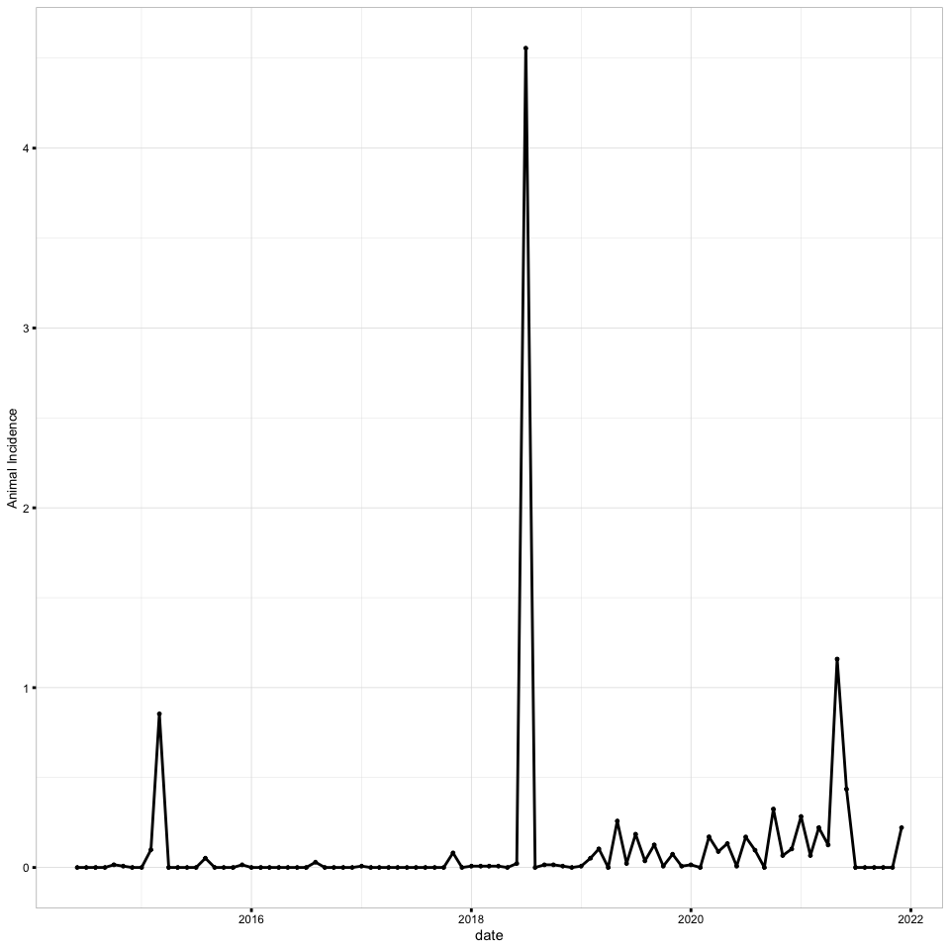

The trend for humans as well as individual species was as shown below

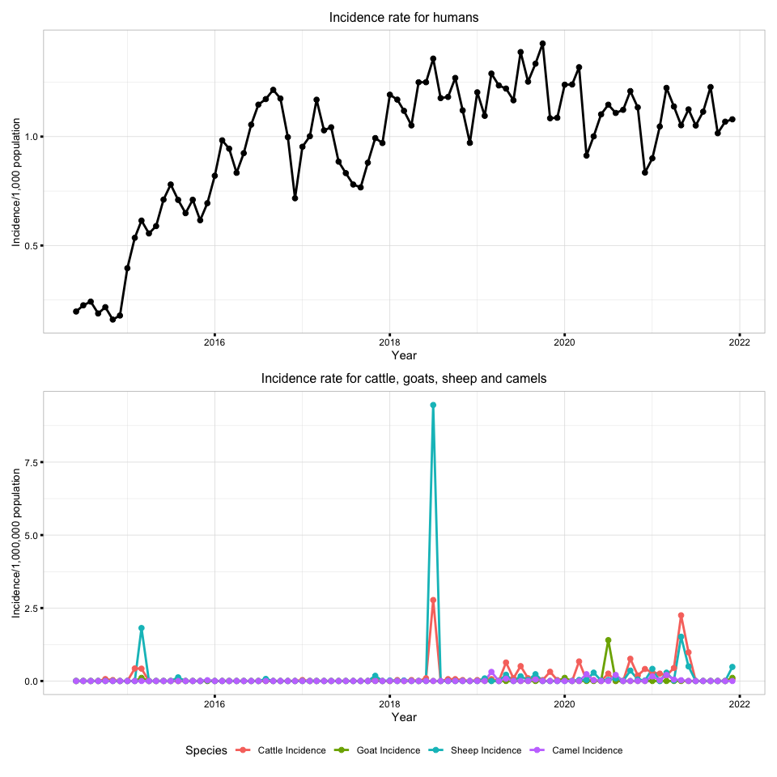

The incidences were also smoothed using the moving average method, at 4 months. The plot for animal incidence combined and smoothed was as shown below;

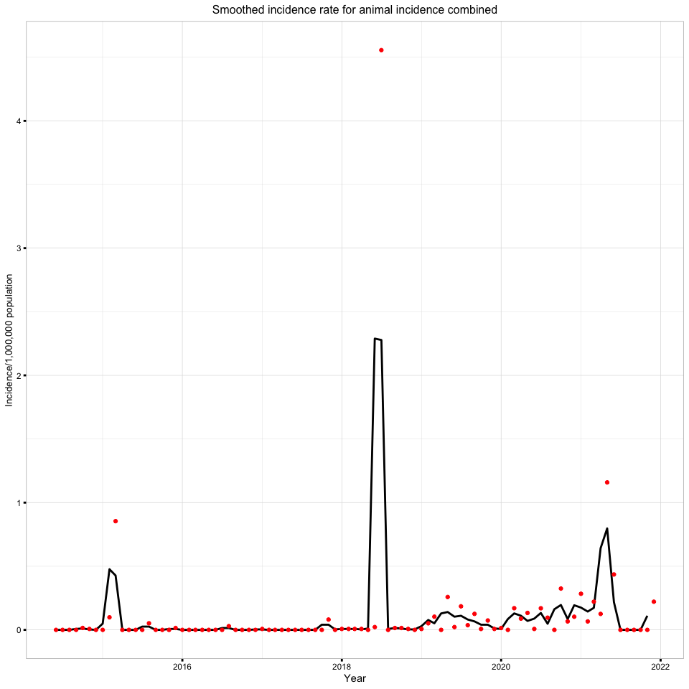

While, for human and other species smoothed were as shown below;

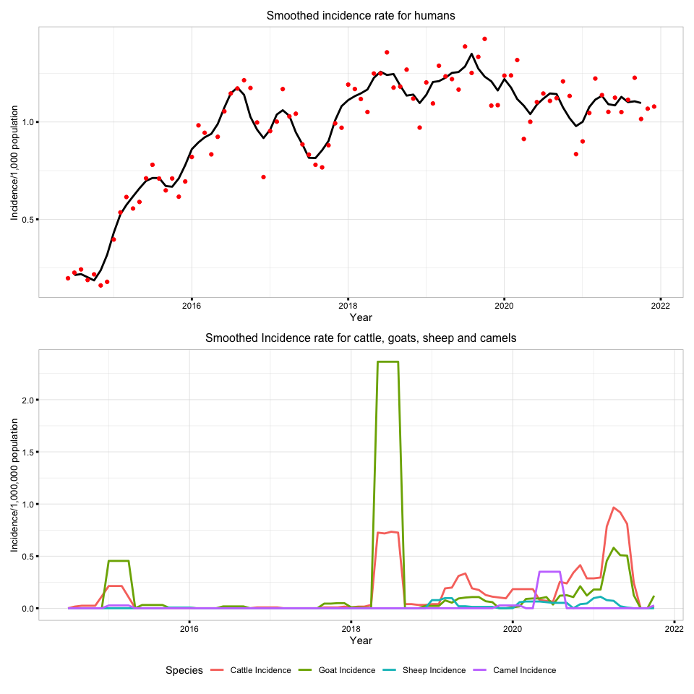

With points

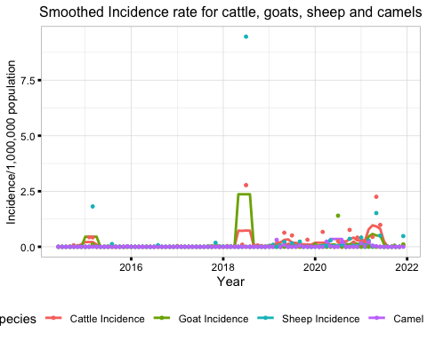

## Spatial

The spatial distribution of the incidence rate of Brucellosis in animals combined and humans was as shown below

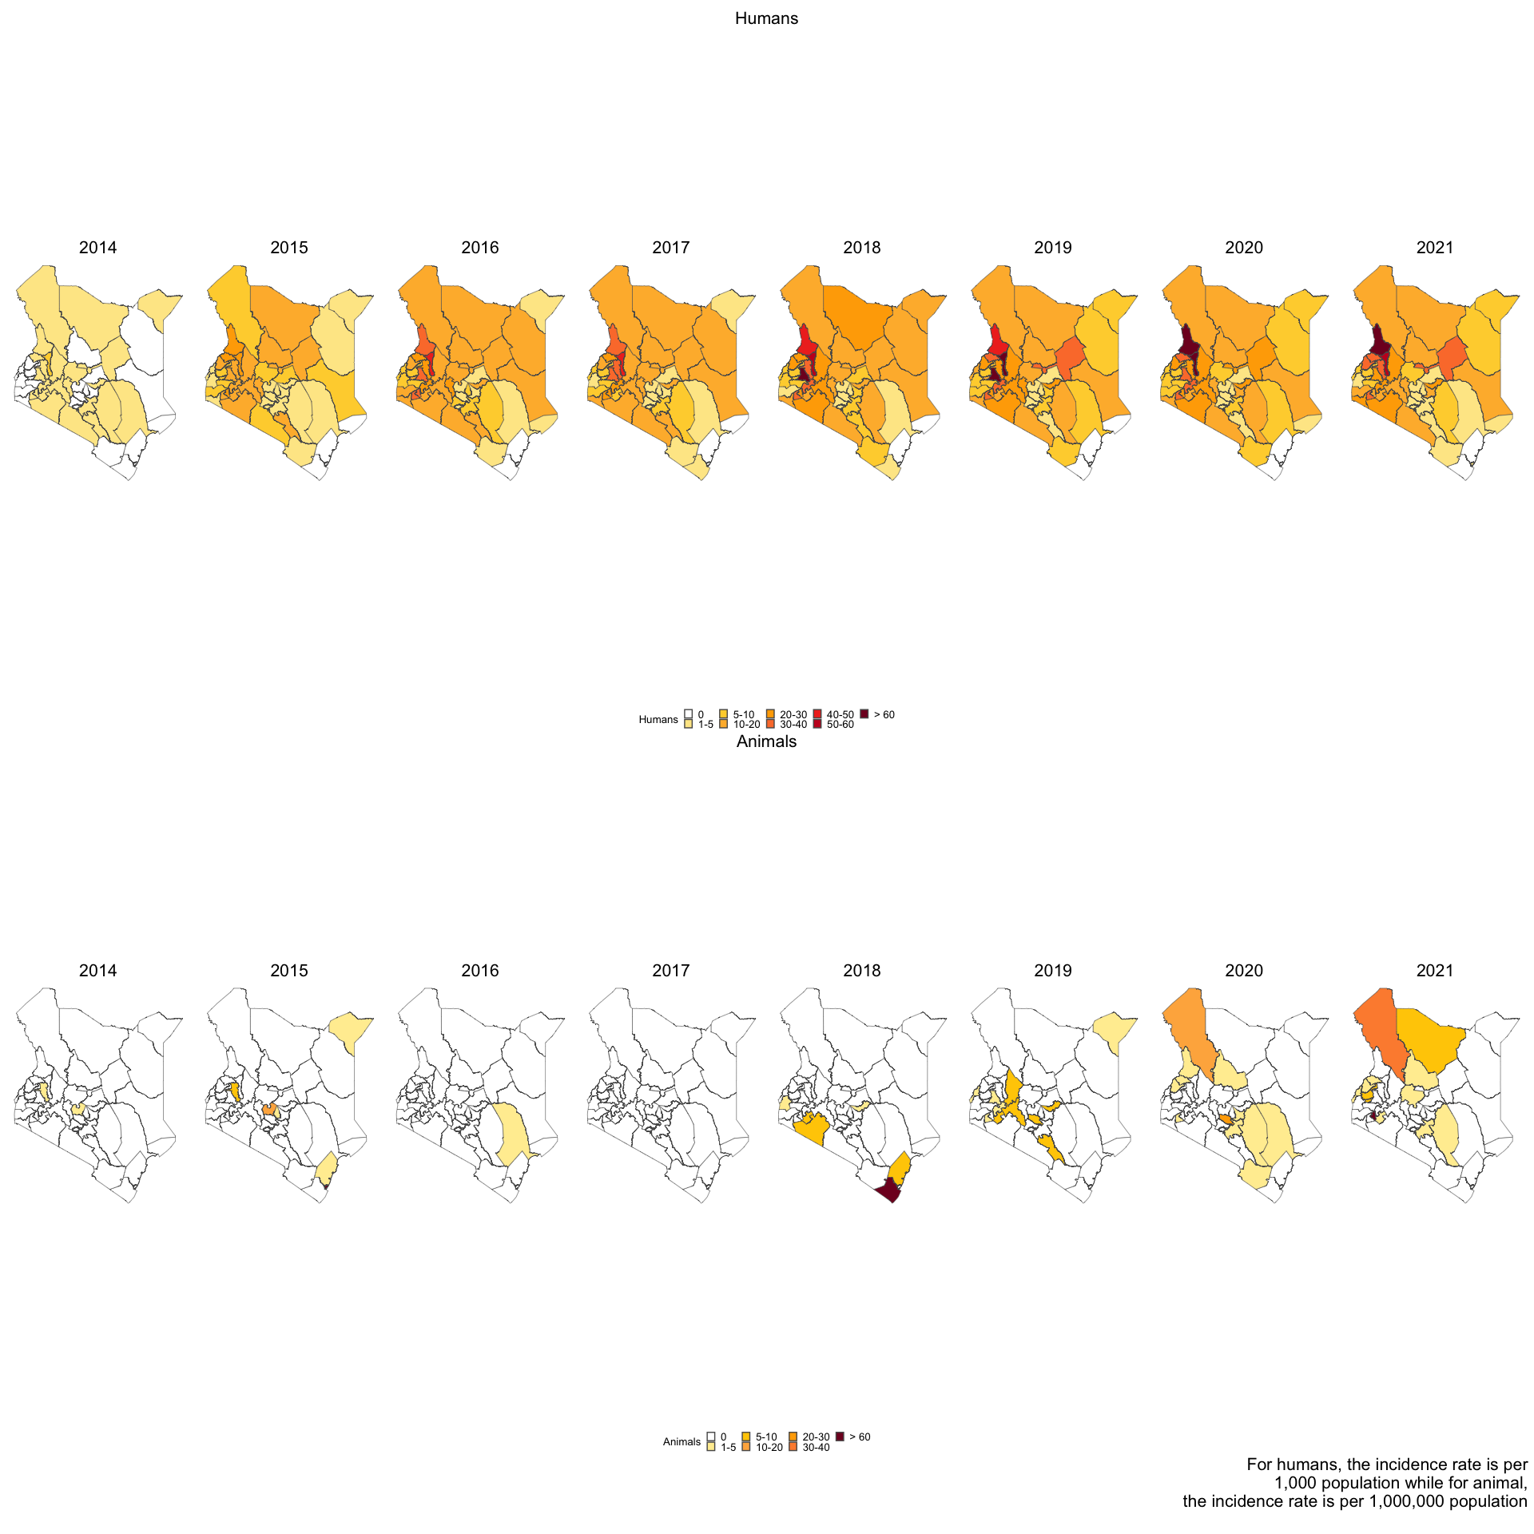

The spatial distribution of the incidence rate of Brucellosis among Camels, Cattle, Goats, Humans, and Sheep are presented in the below,

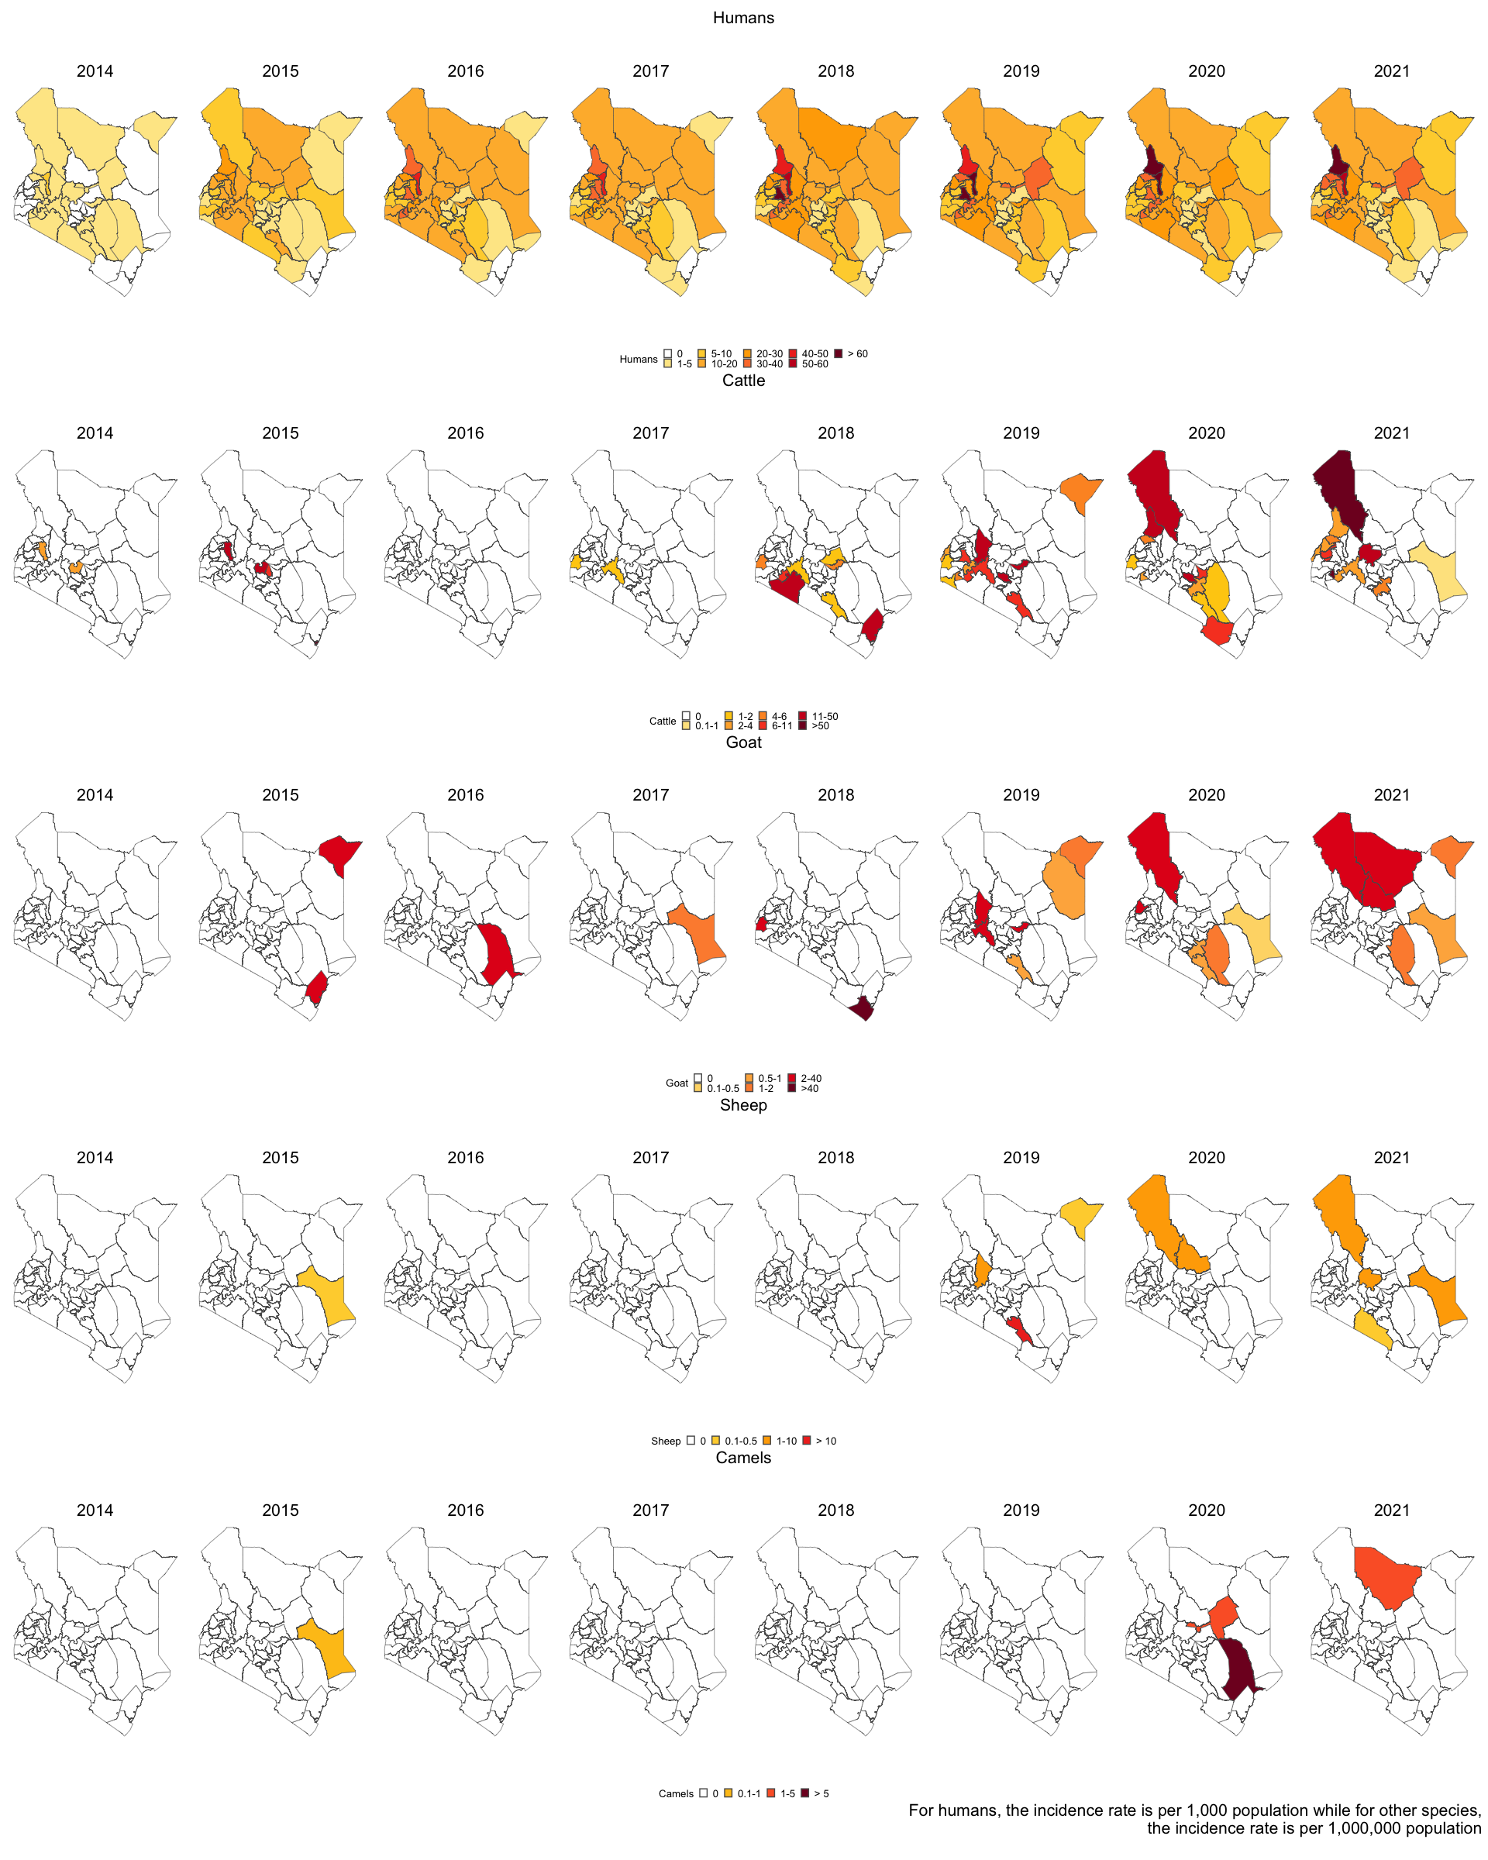

## Correlation

The correlation between the incidence rate of Brucellosis among Camels, Cattle, Goats, Humans, and Sheep were calculated in different lags. There was a high correlation between cattle and goat incidence across all lags. This correlation plot was used to determine the best lag to test for association between the human incidence and animal incidences. The incidence rates for this plot were not differenced.

The correlation plot shows the correlation between the human incidence rate and other species incidence rate. Also, it shows the correlation among the independent variables, which are the animal species.

To check for a correlation between a variable and another variable, you check the variable on the x-axis and then the other variable of interest on the y-axis. The corresponding value at the box in the intersection the correlation between the two.

Correlation is a statistical measure that describes the extent to which two variables change together. In other words, it quantifies the degree to which there is a relationship between two variables.The most common measure of correlation is the correlation coefficient. It ranges from -1 to 1, where: 1: Perfect positive correlation (as one variable increases, the other variable increases). 0: No correlation and -1: Perfect negative correlation (as one variable increases, the other variable decreases).

Interpretation:

* Positive correlation: As one variable increases, the other tends to increase.
* Negative correlation: As one variable increases, the other tends to decrease.
* No correlation: Changes in one variable do not predict changes in the other.

**Correlation does not imply causality** - This statement emphasizes that just because two variables are correlated does not mean that one causes the other. Correlation indicates a statistical association or relationship, but it does not provide information about the cause-and-effect relationship.

Example: Ice cream sales and drowning incidents are positively correlated (both increase in summer), but it would be incorrect to conclude that buying more ice cream causes more drownings, and that’s the main difference between the linear regression and correlation.

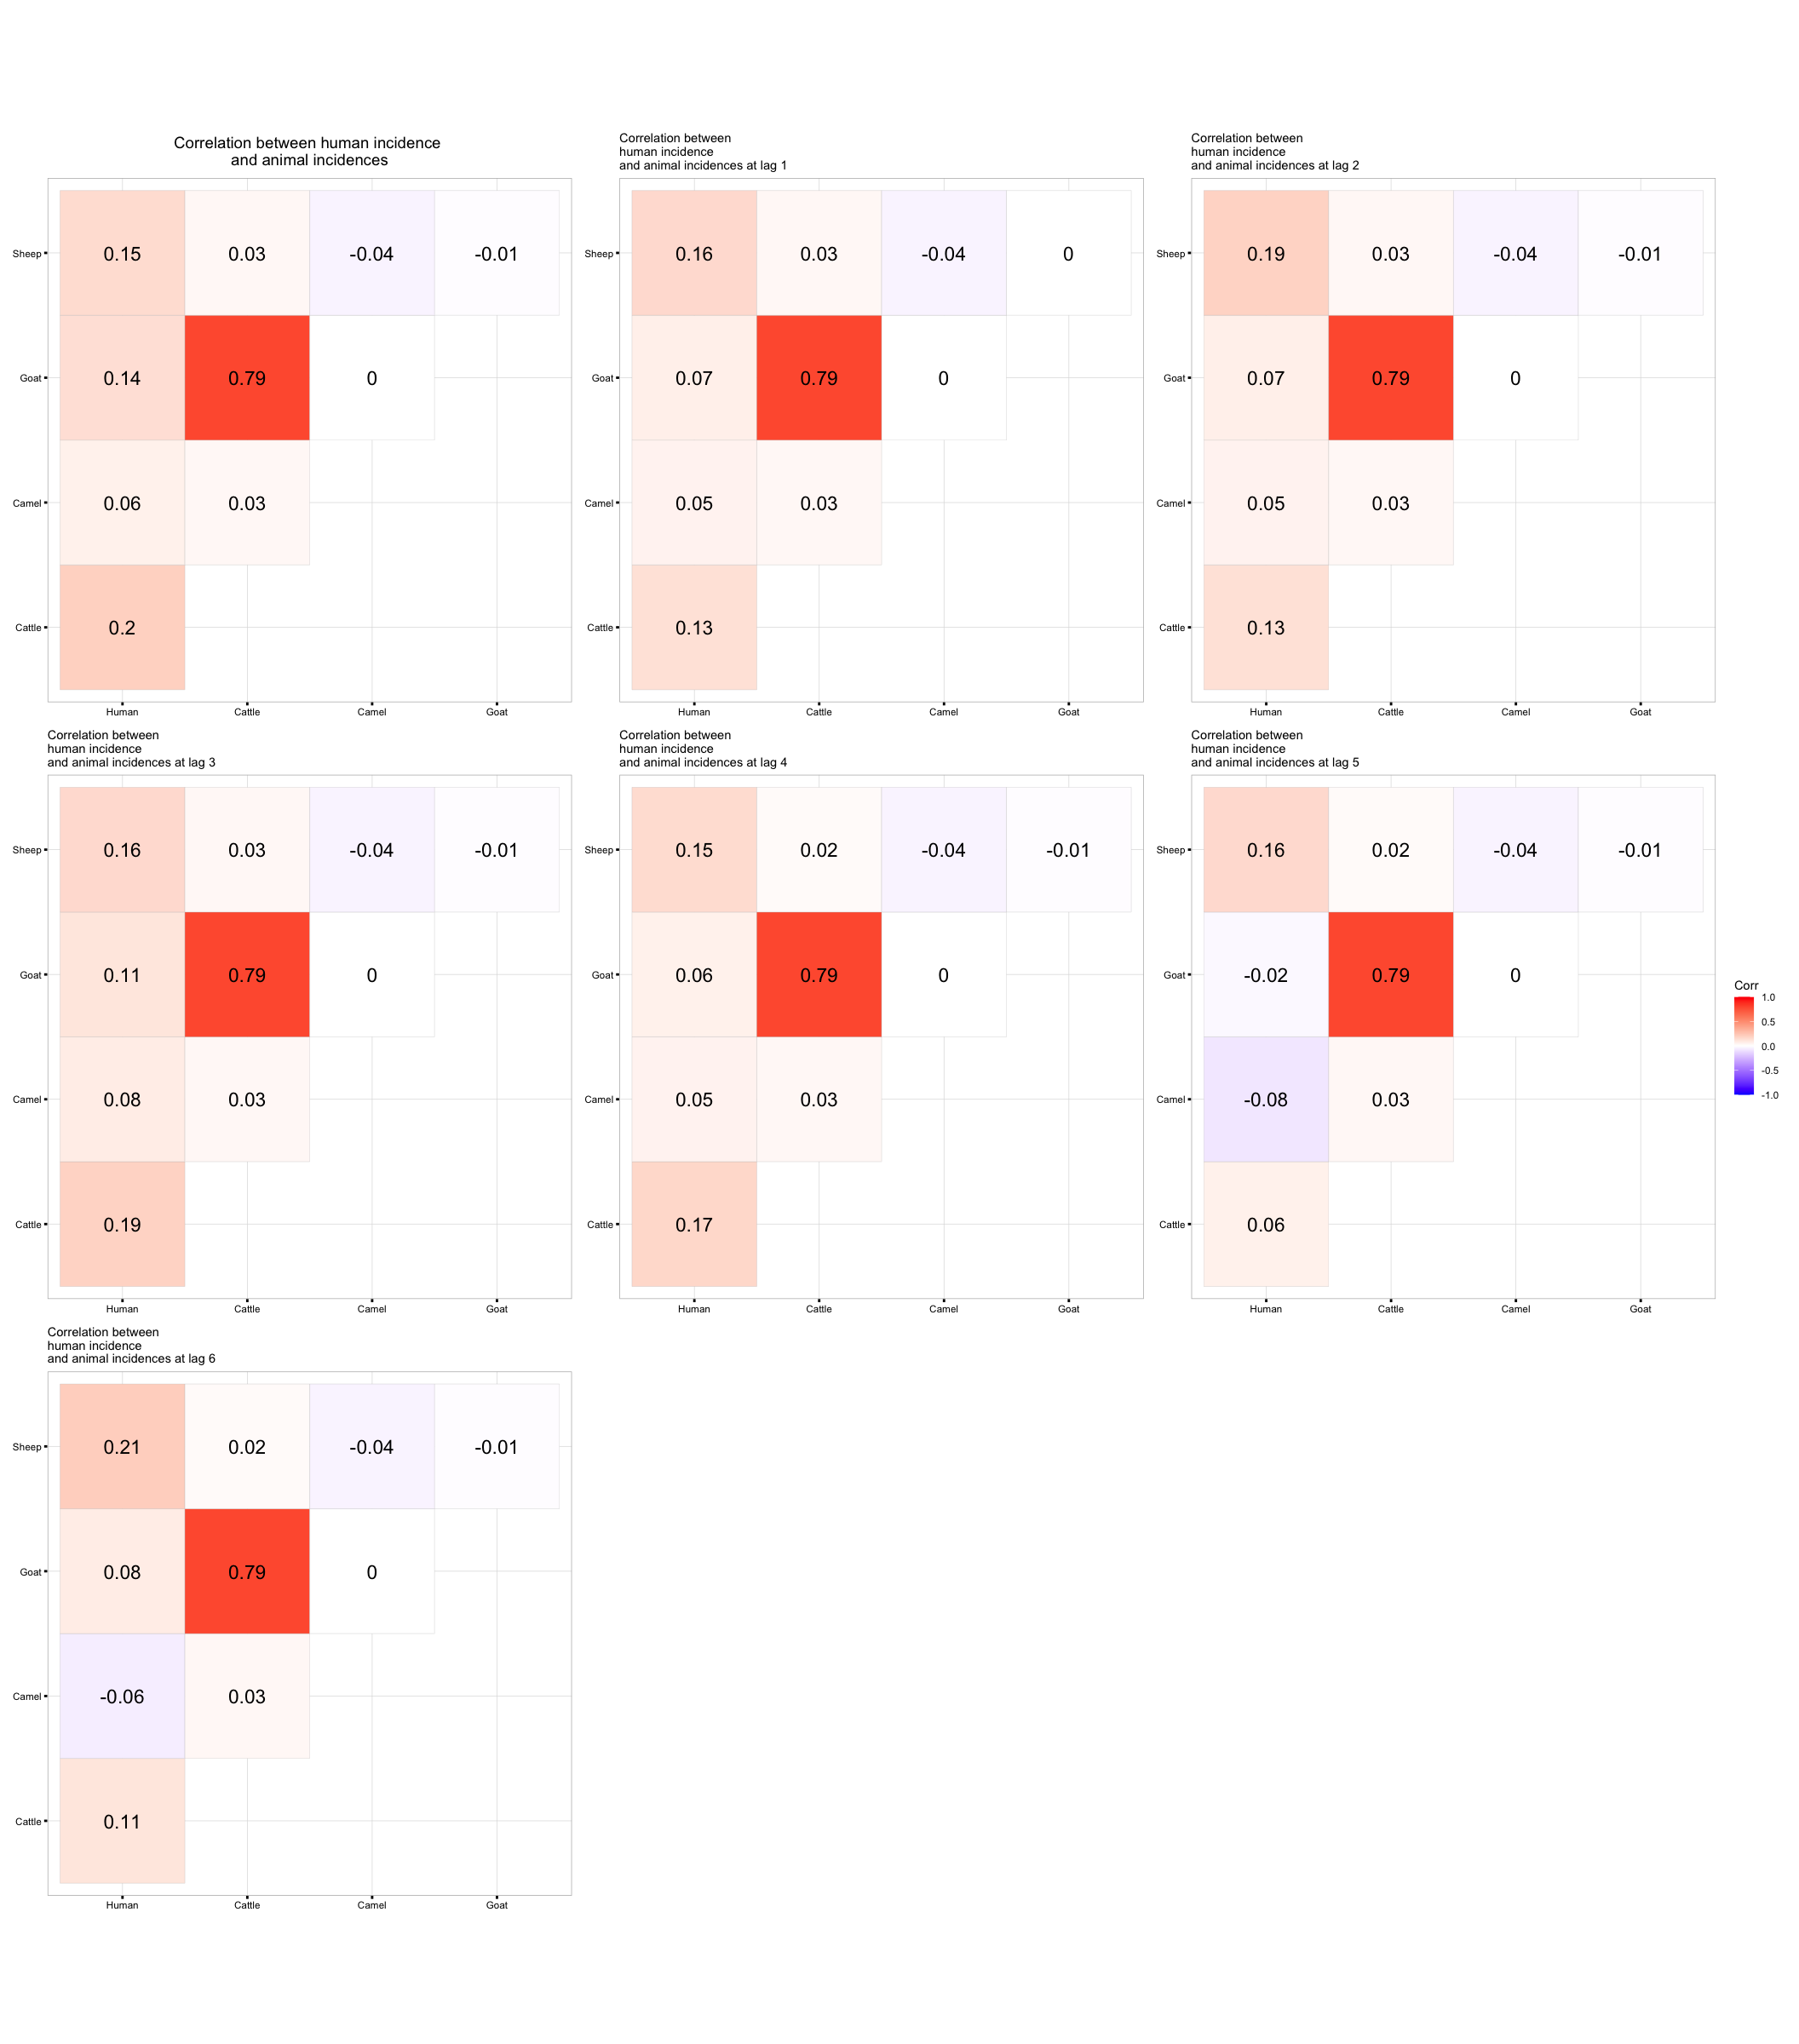

## Models

### 1. Non Differenced Case

We first fit a time series linear model to the original data (original data implying non-differenced) at different lags. Lag 1 to Lag 6. The results of the models were as tabulated in the tables below. Note that the significance was calculated at **10% level of significance**.

In the folder,you can find the full data frames as follows;

1. *non_diff_individual.csv* - Results for non-differenced individual species model.
2. *non_diff_full.csv* - Results for non-differenced all species combined species model.
3. *diff_individual.csv* - Results for differenced individual species model.
4. *diff_full.csv* - Results for differenced all species combined model.

Time Series Linear Model results for no lag (lag = 0)

| variable | estimate | std.error | statistic | p.value | conf_low | conf_high | significance |
| --- | --- | --- | --- | --- | --- | --- | --- |
| (Intercept) | 0.924 | 0.035 | 26.223 | 0.000 | 0.866 | 0.982 | Significant |
| Camel incidence | 0.129 | 0.216 | 0.598 | 0.551 | -0.226 | 0.484 | Not Significant |
| Sheep incidence | 0.808 | 0.600 | 1.346 | 0.182 | -0.180 | 1.796 | Not Significant |
| Cattle incidence | 0.182 | 0.129 | 1.415 | 0.161 | -0.030 | 0.394 | Not Significant |
| Goat Incidence | -0.016 | 0.051 | -0.320 | 0.750 | -0.101 | 0.068 | Not Significant |

Time Series Linear Model results at lag 1

| variable | estimate | std.error | statistic | p.value | conf_low | conf_high | significance |
| --- | --- | --- | --- | --- | --- | --- | --- |
| (Intercept) | 0.941 | 0.035 | 27.029 | 0.000 | 0.884 | 0.998 | Significant |
| Camel incidence | 0.090 | 0.212 | 0.422 | 0.674 | -0.260 | 0.439 | Not Significant |
| Sheep incidence | 0.849 | 0.590 | 1.441 | 0.153 | -0.121 | 1.819 | Not Significant |
| Cattle incidence | 0.129 | 0.127 | 1.013 | 0.314 | -0.080 | 0.337 | Not Significant |
| Goat Incidence | -0.020 | 0.050 | -0.400 | 0.690 | -0.103 | 0.063 | Not Significant |

Time Series Linear Model results at lag 2

| variable | estimate | std.error | statistic | p.value | conf_low | conf_high | significance |
| --- | --- | --- | --- | --- | --- | --- | --- |
| (Intercept) | 0.947 | 0.034 | 28.062 | 0.000 | 0.892 | 1.003 | Significant |
| Camel incidence | 0.102 | 0.204 | 0.499 | 0.619 | -0.234 | 0.439 | Not Significant |
| Sheep incidence | 1.009 | 0.568 | 1.777 | 0.079 | 0.075 | 1.943 | Significant |
| Cattle incidence | 0.123 | 0.122 | 1.008 | 0.316 | -0.078 | 0.324 | Not Significant |
| Goat Incidence | -0.019 | 0.049 | -0.400 | 0.690 | -0.099 | 0.060 | Not Significant |

Time Series Linear Model results at lag 3

| variable | estimate | std.error | statistic | p.value | conf_low | conf_high | significance |
| --- | --- | --- | --- | --- | --- | --- | --- |
| (Intercept) | 0.951 | 0.033 | 29.145 | 0.000 | 0.898 | 1.005 | Significant |
| Camel incidence | 0.135 | 0.196 | 0.685 | 0.495 | -0.189 | 0.458 | Not Significant |
| Sheep incidence | 0.812 | 0.545 | 1.488 | 0.141 | -0.086 | 1.709 | Not Significant |
| Cattle incidence | 0.172 | 0.117 | 1.465 | 0.147 | -0.021 | 0.365 | Not Significant |
| Goat Incidence | -0.024 | 0.047 | -0.513 | 0.610 | -0.101 | 0.053 | Not Significant |

Time Series Linear Model results at lag 4

| variable | estimate | std.error | statistic | p.value | conf_low | conf_high | significance |
| --- | --- | --- | --- | --- | --- | --- | --- |
| (Intercept) | 0.963 | 0.032 | 30.555 | 0.000 | 0.912 | 1.015 | Significant |
| Camel incidence | 0.078 | 0.188 | 0.415 | 0.679 | -0.232 | 0.388 | Not Significant |
| Sheep incidence | 0.708 | 0.523 | 1.352 | 0.180 | -0.153 | 1.569 | Not Significant |
| Cattle incidence | 0.197 | 0.113 | 1.745 | 0.085 | 0.011 | 0.382 | Significant |
| Goat Incidence | -0.047 | 0.045 | -1.046 | 0.299 | -0.120 | 0.027 | Not Significant |

Time Series Linear Model results at lag 5

| variable | estimate | std.error | statistic | p.value | conf_low | conf_high | significance |
| --- | --- | --- | --- | --- | --- | --- | --- |
| (Intercept) | 0.986 | 0.031 | 32.262 | 0.000 | 0.936 | 1.037 | Significant |
| Camel incidence | -0.136 | 0.181 | -0.750 | 0.456 | -0.434 | 0.162 | Not Significant |
| Sheep incidence | 0.687 | 0.504 | 1.363 | 0.177 | -0.142 | 1.516 | Not Significant |
| Cattle incidence | 0.126 | 0.109 | 1.164 | 0.248 | -0.052 | 0.305 | Not Significant |
| Goat Incidence | -0.044 | 0.043 | -1.020 | 0.311 | -0.115 | 0.027 | Not Significant |

Time Series Linear Model results at lag 6

| variable | estimate | std.error | statistic | p.value | conf_low | conf_high | significance |
| --- | --- | --- | --- | --- | --- | --- | --- |
| (Intercept) | 0.992 | 0.029 | 34.634 | 0.000 | 0.945 | 1.040 | Significant |
| Camel incidence | -0.090 | 0.169 | -0.534 | 0.595 | -0.368 | 0.188 | Not Significant |
| Sheep incidence | 0.885 | 0.469 | 1.885 | 0.063 | 0.113 | 1.657 | Significant |
| Cattle incidence | 0.076 | 0.101 | 0.754 | 0.453 | -0.090 | 0.242 | Not Significant |
| Goat Incidence | -0.007 | 0.040 | -0.167 | 0.868 | -0.073 | 0.059 | Not Significant |

**A model was also fit for all the animal incidences combined, and at different lags (lag 1 to lag 6), as shown in the tables below;**

Time Series Linear Model results for no lag (lag = 0)

| variable | estimate | std.error | statistic | p.value | conf_low | conf_high | significance |
| --- | --- | --- | --- | --- | --- | --- | --- |
| (Intercept) | 0.951 | 0.033 | 29.148 | 0.000 | 0.897 | 1.005 | Significant |
| Animal Incidence | 0.097 | 0.064 | 1.520 | 0.132 | -0.008 | 0.203 | Not Significant |

Time Series Linear Model results at lag 1

| variable | estimate | std.error | statistic | p.value | conf_low | conf_high | significance |
| --- | --- | --- | --- | --- | --- | --- | --- |
| (Intercept) | 0.965 | 0.032 | 30.084 | 0.000 | 0.912 | 1.018 | Significant |
| Animal Incidence | 0.052 | 0.063 | 0.832 | 0.407 | -0.051 | 0.155 | Not Significant |

Time Series Linear Model results at lag 2

| variable | estimate | std.error | statistic | p.value | conf_low | conf_high | significance |
| --- | --- | --- | --- | --- | --- | --- | --- |
| (Intercept) | 0.973 | 0.031 | 31.141 | 0.000 | 0.922 | 1.025 | Significant |
| Animal Incidence | 0.050 | 0.061 | 0.830 | 0.409 | -0.050 | 0.150 | Not Significant |

Time Series Linear Model results at lag 3

| variable | estimate | std.error | statistic | p.value | conf_low | conf_high | significance |
| --- | --- | --- | --- | --- | --- | --- | --- |
| (Intercept) | 0.979 | 0.030 | 32.372 | 0.000 | 0.929 | 1.028 | Significant |
| Animal Incidence | 0.075 | 0.058 | 1.281 | 0.204 | -0.021 | 0.171 | Not Significant |

Time Series Linear Model results at lag 4

| variable | estimate | std.error | statistic | p.value | conf_low | conf_high | significance |
| --- | --- | --- | --- | --- | --- | --- | --- |
| (Intercept) | 0.991 | 0.029 | 33.894 | 0.000 | 0.943 | 1.039 | Significant |
| Animal Incidence | 0.045 | 0.056 | 0.797 | 0.427 | -0.048 | 0.137 | Not Significant |

Time Series Linear Model results at lag 5

| variable | estimate | std.error | statistic | p.value | conf_low | conf_high | significance |
| --- | --- | --- | --- | --- | --- | --- | --- |
| (Intercept) | 1.006 | 0.028 | 35.708 | 0.000 | 0.959 | 1.052 | Significant |
| Animal Incidence | 0.000 | 0.054 | 0.002 | 0.999 | -0.088 | 0.089 | Not Significant |

Time Series Linear Model results at lag 6

| variable | estimate | std.error | statistic | p.value | conf_low | conf_high | significance |
| --- | --- | --- | --- | --- | --- | --- | --- |
| (Intercept) | 1.011 | 0.026 | 38.232 | 0.000 | 0.967 | 1.054 | Significant |
| Animal Incidence | 0.042 | 0.050 | 0.827 | 0.411 | -0.041 | 0.124 | Not Significant |

### 2. Differenced Case

Time series models were also fit for the differenced data, and at different lags (lag 1 to lag 6), as shown in the tables below;

Time Series Linear Model results for no lag (lag = 0) (differenced)

| variable | estimate | std.error | statistic | p.value | conf_low | conf_high | significance |
| --- | --- | --- | --- | --- | --- | --- | --- |
| (Intercept) | 0.010 | 0.014 | 0.717 | 0.475 | -0.013 | 0.032 | Not Significant |
| Camel incidence | 0.031 | 0.066 | 0.466 | 0.643 | -0.078 | 0.140 | Not Significant |
| Sheep incidence | 0.003 | 0.187 | 0.016 | 0.987 | -0.305 | 0.311 | Not Significant |
| Cattle incidence | 0.028 | 0.049 | 0.570 | 0.570 | -0.053 | 0.109 | Not Significant |
| Goat Incidence | 0.007 | 0.018 | 0.400 | 0.690 | -0.022 | 0.036 | Not Significant |

Time Series Linear Model results at lag 1 (differenced)

| variable | estimate | std.error | statistic | p.value | conf_low | conf_high | significance |
| --- | --- | --- | --- | --- | --- | --- | --- |
| (Intercept) | 0.010 | 0.014 | 0.695 | 0.489 | -0.013 | 0.032 | Not Significant |
| Camel incidence | -0.021 | 0.067 | -0.317 | 0.752 | -0.132 | 0.089 | Not Significant |
| Sheep incidence | -0.093 | 0.190 | -0.487 | 0.627 | -0.405 | 0.220 | Not Significant |
| Cattle incidence | -0.047 | 0.050 | -0.933 | 0.354 | -0.129 | 0.036 | Not Significant |
| Goat Incidence | 0.005 | 0.018 | 0.278 | 0.782 | -0.024 | 0.034 | Not Significant |

Time Series Linear Model results at lag 2 (differenced)

| variable | estimate | std.error | statistic | p.value | conf_low | conf_high | significance |
| --- | --- | --- | --- | --- | --- | --- | --- |
| (Intercept) | 0.010 | 0.014 | 0.680 | 0.498 | -0.013 | 0.033 | Not Significant |
| Camel incidence | 0.004 | 0.068 | 0.063 | 0.950 | -0.107 | 0.115 | Not Significant |
| Sheep incidence | 0.165 | 0.191 | 0.864 | 0.390 | -0.150 | 0.480 | Not Significant |
| Cattle incidence | -0.037 | 0.050 | -0.739 | 0.462 | -0.120 | 0.046 | Not Significant |
| Goat Incidence | 0.005 | 0.018 | 0.291 | 0.772 | -0.024 | 0.035 | Not Significant |

Time Series Linear Model results at lag 3 (differenced)

| variable | estimate | std.error | statistic | p.value | conf_low | conf_high | significance |
| --- | --- | --- | --- | --- | --- | --- | --- |
| (Intercept) | 0.010 | 0.014 | 0.728 | 0.469 | -0.013 | 0.033 | Not Significant |
| Camel incidence | 0.038 | 0.068 | 0.568 | 0.571 | -0.073 | 0.150 | Not Significant |
| Sheep incidence | -0.027 | 0.192 | -0.139 | 0.890 | -0.342 | 0.289 | Not Significant |
| Cattle incidence | 0.020 | 0.051 | 0.390 | 0.697 | -0.063 | 0.103 | Not Significant |
| Goat Incidence | 0.007 | 0.018 | 0.369 | 0.713 | -0.023 | 0.036 | Not Significant |

Time Series Linear Model results at lag 4 (differenced)

| variable | estimate | std.error | statistic | p.value | conf_low | conf_high | significance |
| --- | --- | --- | --- | --- | --- | --- | --- |
| (Intercept) | 0.010 | 0.014 | 0.710 | 0.480 | -0.013 | 0.033 | Not Significant |
| Camel incidence | 0.073 | 0.068 | 1.079 | 0.284 | -0.038 | 0.184 | Not Significant |
| Sheep incidence | 0.036 | 0.191 | 0.186 | 0.853 | -0.279 | 0.350 | Not Significant |
| Cattle incidence | 0.073 | 0.050 | 1.455 | 0.150 | -0.010 | 0.156 | Not Significant |
| Goat Incidence | -0.020 | 0.018 | -1.132 | 0.261 | -0.050 | 0.009 | Not Significant |

Time Series Linear Model results at lag 5 (differenced)

| variable | estimate | std.error | statistic | p.value | conf_low | conf_high | significance |
| --- | --- | --- | --- | --- | --- | --- | --- |
| (Intercept) | 0.011 | 0.014 | 0.784 | 0.435 | -0.012 | 0.034 | Not Significant |
| Camel incidence | -0.135 | 0.066 | -2.056 | 0.043 | -0.243 | -0.027 | Significant |
| Sheep incidence | -0.182 | 0.186 | -0.982 | 0.329 | -0.487 | 0.123 | Not Significant |
| Cattle incidence | -0.026 | 0.049 | -0.525 | 0.601 | -0.106 | 0.055 | Not Significant |
| Goat Incidence | -0.012 | 0.017 | -0.670 | 0.505 | -0.040 | 0.017 | Not Significant |

Time Series Linear Model results at lag 6 (differenced)

| variable | estimate | std.error | statistic | p.value | conf_low | conf_high | significance |
| --- | --- | --- | --- | --- | --- | --- | --- |
| (Intercept) | 0.011 | 0.014 | 0.767 | 0.445 | -0.013 | 0.035 | Not Significant |
| Camel incidence | -0.017 | 0.068 | -0.251 | 0.802 | -0.129 | 0.095 | Not Significant |
| Sheep incidence | 0.094 | 0.193 | 0.489 | 0.626 | -0.223 | 0.411 | Not Significant |
| Cattle incidence | -0.042 | 0.054 | -0.791 | 0.431 | -0.131 | 0.046 | Not Significant |
| Goat Incidence | 0.030 | 0.019 | 1.584 | 0.117 | -0.001 | 0.061 | Not Significant |

**A model was also fit for all the animal incidences combined, differenced and at different lags (lag 1 to lag 6), as shown in the tables below;**

Time Series Linear Model results for no lag (lag = 0) (differenced)

| variable | estimate | std.error | statistic | p.value | conf_low | conf_high | significance |
| --- | --- | --- | --- | --- | --- | --- | --- |
| (Intercept) | 0.010 | 0.013 | 0.729 | 0.468 | -0.012 | 0.032 | Not Significant |
| Animal Incidence | 0.033 | 0.019 | 1.762 | 0.082 | 0.002 | 0.064 | Significant |

Time Series Linear Model results at lag 1 (differenced)

| variable | estimate | std.error | statistic | p.value | conf_low | conf_high | significance |
| --- | --- | --- | --- | --- | --- | --- | --- |
| (Intercept) | 0.010 | 0.014 | 0.704 | 0.483 | -0.013 | 0.032 | Not Significant |
| Animal Incidence | -0.021 | 0.019 | -1.097 | 0.276 | -0.053 | 0.011 | Not Significant |

Time Series Linear Model results at lag 2 (differenced)

| variable | estimate | std.error | statistic | p.value | conf_low | conf_high | significance |
| --- | --- | --- | --- | --- | --- | --- | --- |
| (Intercept) | 0.010 | 0.014 | 0.687 | 0.494 | -0.013 | 0.032 | Not Significant |
| Animal Incidence | -0.013 | 0.019 | -0.672 | 0.503 | -0.045 | 0.019 | Not Significant |

Time Series Linear Model results at lag 3 (differenced)

| variable | estimate | std.error | statistic | p.value | conf_low | conf_high | significance |
| --- | --- | --- | --- | --- | --- | --- | --- |
| (Intercept) | 0.010 | 0.014 | 0.739 | 0.462 | -0.013 | 0.033 | Not Significant |
| Animal Incidence | 0.027 | 0.019 | 1.394 | 0.167 | -0.005 | 0.059 | Not Significant |

Time Series Linear Model results at lag 4 (differenced)

| variable | estimate | std.error | statistic | p.value | conf_low | conf_high | significance |
| --- | --- | --- | --- | --- | --- | --- | --- |
| (Intercept) | 0.010 | 0.014 | 0.707 | 0.481 | -0.013 | 0.033 | Not Significant |
| Animal Incidence | 0.007 | 0.020 | 0.373 | 0.710 | -0.025 | 0.040 | Not Significant |

Time Series Linear Model results at lag 5 (differenced)

| variable | estimate | std.error | statistic | p.value | conf_low | conf_high | significance |
| --- | --- | --- | --- | --- | --- | --- | --- |
| (Intercept) | 0.011 | 0.014 | 0.777 | 0.439 | -0.012 | 0.034 | Not Significant |
| Animal Incidence | -0.043 | 0.019 | -2.247 | 0.027 | -0.074 | -0.012 | Significant |

Time Series Linear Model results at lag 6 (differenced)

| variable | estimate | std.error | statistic | p.value | conf_low | conf_high | significance |
| --- | --- | --- | --- | --- | --- | --- | --- |
| (Intercept) | 0.011 | 0.014 | 0.740 | 0.461 | -0.013 | 0.034 | Not Significant |
| Animal Incidence | 0.034 | 0.020 | 1.721 | 0.089 | 0.001 | 0.066 | Significant |

## Model for Each specific County

### For individuL Species

Time series linear regression model was fit for all the counties giving the following results. Some counties didn’t have results because they contained zero incidences in all the predictors (cattle, goat, sheep, and camel incidence). Also, the models have also been tested only at **lag 3**. The NA in the dataframe, indicates that the variable had zero incidence.

In the folder, you will find the results of the models as follows;

1. *individual_animal_incidence_per_county_lag2.csv* - Results for individual animal incidences per county (at lag 2).
2. *all_animal_incidence_per_county_lag2.csv* - Results for all animal incidences per county at lag2.
3. *individual_animal_incidence_per_county_lag4.csv* - Results for individual animal incidences per county (at lag 4).
4. *all_animal_incidence_per_county_lag4.csv* - Results for all animal incidences per county at lag4.

The models were fit at lag 2 and lag 4. The results were as follows;

## Lag 2

Time Series Linear Model results at lag 2, for each county

| county | variable | estimate | std.error | statistic | p.value | conf_low | conf_high | significant |
| --- | --- | --- | --- | --- | --- | --- | --- | --- |
| Baringo | (Intercept) | 1.646 | 0.085 | 19.297 | 0.000 | 1.505 | 1.786 | Significant |
| Baringo | Cattle incidence | 0.484 | 0.461 | 1.050 | 0.297 | -0.274 | 1.242 | Not Significant |
| Baringo | Goat Incidence | 0.344 | 0.246 | 1.399 | 0.165 | -0.060 | 0.749 | Not Significant |
| Baringo | Sheep incidence | -1.522 | 1.552 | -0.981 | 0.330 | -4.076 | 1.032 | Not Significant |
| Baringo | Camel incidence | NA | NA | NA | NA | NA | NA | NA |
| Bomet | (Intercept) | 0.919 | 0.042 | 21.675 | 0.000 | 0.850 | 0.989 | Significant |
| Bomet | Cattle incidence | 0.096 | 0.049 | 1.979 | 0.051 | 0.016 | 0.176 | Significant |
| Bomet | Goat Incidence | NA | NA | NA | NA | NA | NA | NA |
| Bomet | Sheep incidence | NA | NA | NA | NA | NA | NA | NA |
| Bomet | Camel incidence | NA | NA | NA | NA | NA | NA | NA |
| Bungoma | (Intercept) | 1.713 | 0.083 | 20.663 | 0.000 | 1.577 | 1.849 | Significant |
| Bungoma | Cattle incidence | 0.639 | 0.553 | 1.156 | 0.251 | -0.270 | 1.548 | Not Significant |
| Bungoma | Goat Incidence | 0.034 | 0.086 | 0.389 | 0.698 | -0.108 | 0.175 | Not Significant |
| Bungoma | Sheep incidence | NA | NA | NA | NA | NA | NA | NA |
| Bungoma | Camel incidence | NA | NA | NA | NA | NA | NA | NA |
| Busia | (Intercept) | 0.629 | 0.080 | 7.842 | 0.000 | 0.497 | 0.761 | Significant |
| Busia | Cattle incidence | -0.034 | 0.207 | -0.163 | 0.871 | -0.373 | 0.306 | Not Significant |
| Busia | Goat Incidence | NA | NA | NA | NA | NA | NA | NA |
| Busia | Sheep incidence | NA | NA | NA | NA | NA | NA | NA |
| Busia | Camel incidence | NA | NA | NA | NA | NA | NA | NA |
| Embu | (Intercept) | 0.476 | 0.039 | 12.269 | 0.000 | 0.412 | 0.540 | Significant |
| Embu | Cattle incidence | 0.099 | 0.072 | 1.366 | 0.175 | -0.020 | 0.218 | Not Significant |
| Embu | Goat Incidence | NA | NA | NA | NA | NA | NA | NA |
| Embu | Sheep incidence | NA | NA | NA | NA | NA | NA | NA |
| Embu | Camel incidence | NA | NA | NA | NA | NA | NA | NA |
| Garissa | (Intercept) | 1.076 | 0.054 | 20.093 | 0.000 | 0.988 | 1.164 | Significant |
| Garissa | Cattle incidence | -4.680 | 5.737 | -0.816 | 0.417 | -14.118 | 4.758 | Not Significant |
| Garissa | Goat Incidence | 0.607 | 0.380 | 1.596 | 0.114 | -0.019 | 1.232 | Not Significant |
| Garissa | Sheep incidence | 1.705 | 2.764 | 0.617 | 0.539 | -2.843 | 6.252 | Not Significant |
| Garissa | Camel incidence | -1.442 | 0.818 | -1.762 | 0.082 | -2.788 | -0.096 | Significant |
| Isiolo | (Intercept) | 1.633 | 0.131 | 12.441 | 0.000 | 1.417 | 1.849 | Significant |
| Isiolo | Cattle incidence | NA | NA | NA | NA | NA | NA | NA |
| Isiolo | Goat Incidence | NA | NA | NA | NA | NA | NA | NA |
| Isiolo | Sheep incidence | NA | NA | NA | NA | NA | NA | NA |
| Isiolo | Camel incidence | 0.547 | 0.373 | 1.467 | 0.146 | -0.066 | 1.160 | Not Significant |
| Kajiado | (Intercept) | 1.137 | 0.050 | 22.773 | 0.000 | 1.055 | 1.219 | Significant |
| Kajiado | Cattle incidence | NA | NA | NA | NA | NA | NA | NA |
| Kajiado | Goat Incidence | NA | NA | NA | NA | NA | NA | NA |
| Kajiado | Sheep incidence | -0.364 | 1.067 | -0.341 | 0.734 | -2.120 | 1.392 | Not Significant |
| Kajiado | Camel incidence | NA | NA | NA | NA | NA | NA | NA |
| Kakamega | (Intercept) | 0.492 | 0.018 | 27.930 | 0.000 | 0.463 | 0.521 | Significant |
| Kakamega | Cattle incidence | -0.008 | 0.036 | -0.222 | 0.825 | -0.068 | 0.052 | Not Significant |
| Kakamega | Goat Incidence | NA | NA | NA | NA | NA | NA | NA |
| Kakamega | Sheep incidence | NA | NA | NA | NA | NA | NA | NA |
| Kakamega | Camel incidence | NA | NA | NA | NA | NA | NA | NA |
| Kericho | (Intercept) | 2.142 | 0.100 | 21.479 | 0.000 | 1.978 | 2.306 | Significant |
| Kericho | Cattle incidence | 0.691 | 0.460 | 1.502 | 0.137 | -0.066 | 1.447 | Not Significant |
| Kericho | Goat Incidence | NA | NA | NA | NA | NA | NA | NA |
| Kericho | Sheep incidence | NA | NA | NA | NA | NA | NA | NA |
| Kericho | Camel incidence | NA | NA | NA | NA | NA | NA | NA |
| Kilifi | (Intercept) | 0.033 | 0.004 | 7.734 | 0.000 | 0.026 | 0.040 | Significant |
| Kilifi | Cattle incidence | -0.001 | 0.001 | -0.429 | 0.669 | -0.003 | 0.002 | Not Significant |
| Kilifi | Goat Incidence | -0.004 | 0.006 | -0.590 | 0.557 | -0.014 | 0.006 | Not Significant |
| Kilifi | Sheep incidence | NA | NA | NA | NA | NA | NA | NA |
| Kilifi | Camel incidence | NA | NA | NA | NA | NA | NA | NA |
| Kirinyaga | (Intercept) | 0.271 | 0.026 | 10.253 | 0.000 | 0.227 | 0.314 | Significant |
| Kirinyaga | Cattle incidence | -0.031 | 0.029 | -1.078 | 0.284 | -0.078 | 0.016 | Not Significant |
| Kirinyaga | Goat Incidence | NA | NA | NA | NA | NA | NA | NA |
| Kirinyaga | Sheep incidence | NA | NA | NA | NA | NA | NA | NA |
| Kirinyaga | Camel incidence | NA | NA | NA | NA | NA | NA | NA |
| Kisii | (Intercept) | 2.299 | 0.095 | 24.157 | 0.000 | 2.143 | 2.456 | Significant |
| Kisii | Cattle incidence | 0.258 | 0.227 | 1.135 | 0.259 | -0.116 | 0.632 | Not Significant |
| Kisii | Goat Incidence | NA | NA | NA | NA | NA | NA | NA |
| Kisii | Sheep incidence | NA | NA | NA | NA | NA | NA | NA |
| Kisii | Camel incidence | NA | NA | NA | NA | NA | NA | NA |
| Kitui | (Intercept) | 0.714 | 0.041 | 17.481 | 0.000 | 0.647 | 0.781 | Significant |
| Kitui | Cattle incidence | 0.047 | 0.289 | 0.163 | 0.871 | -0.428 | 0.523 | Not Significant |
| Kitui | Goat Incidence | 0.123 | 0.475 | 0.259 | 0.796 | -0.659 | 0.905 | Not Significant |
| Kitui | Sheep incidence | NA | NA | NA | NA | NA | NA | NA |
| Kitui | Camel incidence | NA | NA | NA | NA | NA | NA | NA |
| Kwale | (Intercept) | 0.094 | 0.024 | 3.853 | 0.000 | 0.054 | 0.134 | Significant |
| Kwale | Cattle incidence | NA | NA | NA | NA | NA | NA | NA |
| Kwale | Goat Incidence | 0.000 | 0.000 | -0.009 | 0.993 | -0.001 | 0.001 | Not Significant |
| Kwale | Sheep incidence | NA | NA | NA | NA | NA | NA | NA |
| Kwale | Camel incidence | NA | NA | NA | NA | NA | NA | NA |
| Laikipia | (Intercept) | 0.937 | 0.058 | 16.215 | 0.000 | 0.842 | 1.032 | Significant |
| Laikipia | Cattle incidence | -0.033 | 0.037 | -0.888 | 0.377 | -0.094 | 0.028 | Not Significant |
| Laikipia | Goat Incidence | NA | NA | NA | NA | NA | NA | NA |
| Laikipia | Sheep incidence | NA | NA | NA | NA | NA | NA | NA |
| Laikipia | Camel incidence | NA | NA | NA | NA | NA | NA | NA |
| Machakos | (Intercept) | 0.455 | 0.024 | 19.118 | 0.000 | 0.416 | 0.494 | Significant |
| Machakos | Cattle incidence | -0.060 | 0.082 | -0.729 | 0.468 | -0.194 | 0.075 | Not Significant |
| Machakos | Goat Incidence | 0.030 | 0.308 | 0.097 | 0.923 | -0.477 | 0.537 | Not Significant |
| Machakos | Sheep incidence | NA | NA | NA | NA | NA | NA | NA |
| Machakos | Camel incidence | NA | NA | NA | NA | NA | NA | NA |
| Makueni | (Intercept) | 0.688 | 0.044 | 15.706 | 0.000 | 0.616 | 0.760 | Significant |
| Makueni | Cattle incidence | -0.200 | 0.114 | -1.749 | 0.084 | -0.387 | -0.012 | Significant |
| Makueni | Goat Incidence | -0.222 | 0.474 | -0.469 | 0.640 | -1.002 | 0.558 | Not Significant |
| Makueni | Sheep incidence | -0.005 | 0.009 | -0.557 | 0.579 | -0.020 | 0.010 | Not Significant |
| Makueni | Camel incidence | NA | NA | NA | NA | NA | NA | NA |
| Mandera | (Intercept) | 0.530 | 0.035 | 15.350 | 0.000 | 0.474 | 0.587 | Significant |
| Mandera | Cattle incidence | 0.080 | 0.064 | 1.246 | 0.216 | -0.026 | 0.185 | Not Significant |
| Mandera | Goat Incidence | -0.034 | 0.032 | -1.065 | 0.290 | -0.086 | 0.018 | Not Significant |
| Mandera | Sheep incidence | 0.641 | 0.729 | 0.879 | 0.382 | -0.558 | 1.840 | Not Significant |
| Mandera | Camel incidence | NA | NA | NA | NA | NA | NA | NA |
| Meru | (Intercept) | 0.347 | 0.021 | 16.781 | 0.000 | 0.313 | 0.381 | Significant |
| Meru | Cattle incidence | -0.011 | 0.122 | -0.091 | 0.927 | -0.213 | 0.190 | Not Significant |
| Meru | Goat Incidence | -0.019 | 0.012 | -1.537 | 0.128 | -0.039 | 0.001 | Not Significant |
| Meru | Sheep incidence | NA | NA | NA | NA | NA | NA | NA |
| Meru | Camel incidence | NA | NA | NA | NA | NA | NA | NA |
| Migori | (Intercept) | 1.196 | 0.062 | 19.340 | 0.000 | 1.095 | 1.298 | Significant |
| Migori | Cattle incidence | 0.126 | 0.382 | 0.330 | 0.742 | -0.502 | 0.754 | Not Significant |
| Migori | Goat Incidence | NA | NA | NA | NA | NA | NA | NA |
| Migori | Sheep incidence | NA | NA | NA | NA | NA | NA | NA |
| Migori | Camel incidence | NA | NA | NA | NA | NA | NA | NA |
| Mombasa | (Intercept) | 0.055 | 0.007 | 7.833 | 0.000 | 0.043 | 0.066 | Significant |
| Mombasa | Cattle incidence | 0.000 | 0.000 | -0.543 | 0.589 | -0.001 | 0.000 | Not Significant |
| Mombasa | Goat Incidence | NA | NA | NA | NA | NA | NA | NA |
| Mombasa | Sheep incidence | NA | NA | NA | NA | NA | NA | NA |
| Mombasa | Camel incidence | NA | NA | NA | NA | NA | NA | NA |
| Murang’a | (Intercept) | 0.128 | 0.008 | 16.206 | 0.000 | 0.115 | 0.141 | Significant |
| Murang’a | Cattle incidence | -0.001 | 0.001 | -0.716 | 0.476 | -0.003 | 0.001 | Not Significant |
| Murang’a | Goat Incidence | NA | NA | NA | NA | NA | NA | NA |
| Murang’a | Sheep incidence | NA | NA | NA | NA | NA | NA | NA |
| Murang’a | Camel incidence | NA | NA | NA | NA | NA | NA | NA |
| Nakuru | (Intercept) | 1.586 | 0.052 | 30.784 | 0.000 | 1.501 | 1.671 | Significant |
| Nakuru | Cattle incidence | 0.112 | 0.147 | 0.764 | 0.447 | -0.129 | 0.353 | Not Significant |
| Nakuru | Goat Incidence | -0.001 | 0.049 | -0.022 | 0.982 | -0.082 | 0.080 | Not Significant |
| Nakuru | Sheep incidence | NA | NA | NA | NA | NA | NA | NA |
| Nakuru | Camel incidence | NA | NA | NA | NA | NA | NA | NA |
| Nandi | (Intercept) | 2.933 | 0.190 | 15.461 | 0.000 | 2.621 | 3.245 | Significant |
| Nandi | Cattle incidence | 1.058 | 0.509 | 2.080 | 0.040 | 0.221 | 1.895 | Significant |
| Nandi | Goat Incidence | NA | NA | NA | NA | NA | NA | NA |
| Nandi | Sheep incidence | NA | NA | NA | NA | NA | NA | NA |
| Nandi | Camel incidence | NA | NA | NA | NA | NA | NA | NA |
| Narok | (Intercept) | 1.597 | 0.075 | 21.311 | 0.000 | 1.474 | 1.721 | Significant |
| Narok | Cattle incidence | 0.055 | 0.030 | 1.795 | 0.076 | 0.005 | 0.105 | Significant |
| Narok | Goat Incidence | NA | NA | NA | NA | NA | NA | NA |
| Narok | Sheep incidence | NA | NA | NA | NA | NA | NA | NA |
| Narok | Camel incidence | NA | NA | NA | NA | NA | NA | NA |
| Nyamira | (Intercept) | 1.738 | 0.074 | 23.528 | 0.000 | 1.617 | 1.860 | Significant |
| Nyamira | Cattle incidence | -0.009 | 0.009 | -1.013 | 0.314 | -0.023 | 0.006 | Not Significant |
| Nyamira | Goat Incidence | NA | NA | NA | NA | NA | NA | NA |
| Nyamira | Sheep incidence | NA | NA | NA | NA | NA | NA | NA |
| Nyamira | Camel incidence | NA | NA | NA | NA | NA | NA | NA |
| Nyandarua | (Intercept) | 1.431 | 0.059 | 24.260 | 0.000 | 1.334 | 1.528 | Significant |
| Nyandarua | Cattle incidence | -0.303 | 0.135 | -2.252 | 0.027 | -0.524 | -0.082 | Significant |
| Nyandarua | Goat Incidence | NA | NA | NA | NA | NA | NA | NA |
| Nyandarua | Sheep incidence | NA | NA | NA | NA | NA | NA | NA |
| Nyandarua | Camel incidence | NA | NA | NA | NA | NA | NA | NA |
| Nyeri | (Intercept) | 0.190 | 0.008 | 22.382 | 0.000 | 0.176 | 0.204 | Significant |
| Nyeri | Cattle incidence | -0.001 | 0.002 | -0.222 | 0.825 | -0.004 | 0.003 | Not Significant |
| Nyeri | Goat Incidence | NA | NA | NA | NA | NA | NA | NA |
| Nyeri | Sheep incidence | NA | NA | NA | NA | NA | NA | NA |
| Nyeri | Camel incidence | NA | NA | NA | NA | NA | NA | NA |
| Samburu | (Intercept) | 1.272 | 0.067 | 19.053 | 0.000 | 1.162 | 1.381 | Significant |
| Samburu | Cattle incidence | NA | NA | NA | NA | NA | NA | NA |
| Samburu | Goat Incidence | -0.015 | 0.091 | -0.161 | 0.873 | -0.164 | 0.135 | Not Significant |
| Samburu | Sheep incidence | 0.058 | 0.090 | 0.642 | 0.522 | -0.090 | 0.205 | Not Significant |
| Samburu | Camel incidence | NA | NA | NA | NA | NA | NA | NA |
| Siaya | (Intercept) | 0.437 | 0.024 | 18.238 | 0.000 | 0.397 | 0.476 | Significant |
| Siaya | Cattle incidence | -0.012 | 0.060 | -0.201 | 0.841 | -0.111 | 0.087 | Not Significant |
| Siaya | Goat Incidence | -0.043 | 0.051 | -0.846 | 0.400 | -0.127 | 0.041 | Not Significant |
| Siaya | Sheep incidence | NA | NA | NA | NA | NA | NA | NA |
| Siaya | Camel incidence | NA | NA | NA | NA | NA | NA | NA |
| Taita Taveta | (Intercept) | 0.345 | 0.026 | 13.094 | 0.000 | 0.302 | 0.389 | Significant |
| Taita Taveta | Cattle incidence | -0.027 | 0.041 | -0.666 | 0.507 | -0.094 | 0.040 | Not Significant |
| Taita Taveta | Goat Incidence | NA | NA | NA | NA | NA | NA | NA |
| Taita Taveta | Sheep incidence | NA | NA | NA | NA | NA | NA | NA |
| Taita Taveta | Camel incidence | NA | NA | NA | NA | NA | NA | NA |
| Tana River | (Intercept) | 0.359 | 0.043 | 8.317 | 0.000 | 0.288 | 0.430 | Significant |
| Tana River | Cattle incidence | NA | NA | NA | NA | NA | NA | NA |
| Tana River | Goat Incidence | 0.023 | 0.120 | 0.194 | 0.847 | -0.175 | 0.221 | Not Significant |
| Tana River | Sheep incidence | NA | NA | NA | NA | NA | NA | NA |
| Tana River | Camel incidence | 0.000 | 0.003 | -0.023 | 0.982 | -0.006 | 0.005 | Not Significant |
| Tharaka Nithi | (Intercept) | 1.482 | 0.102 | 14.502 | 0.000 | 1.314 | 1.650 | Significant |
| Tharaka Nithi | Cattle incidence | -0.001 | 0.089 | -0.007 | 0.994 | -0.147 | 0.146 | Not Significant |
| Tharaka Nithi | Goat Incidence | 0.109 | 0.170 | 0.642 | 0.522 | -0.171 | 0.390 | Not Significant |
| Tharaka Nithi | Sheep incidence | NA | NA | NA | NA | NA | NA | NA |
| Tharaka Nithi | Camel incidence | NA | NA | NA | NA | NA | NA | NA |
| Trans Nzoia | (Intercept) | 2.230 | 0.084 | 26.456 | 0.000 | 2.091 | 2.369 | Significant |
| Trans Nzoia | Cattle incidence | 0.048 | 0.148 | 0.323 | 0.747 | -0.195 | 0.290 | Not Significant |
| Trans Nzoia | Goat Incidence | NA | NA | NA | NA | NA | NA | NA |
| Trans Nzoia | Sheep incidence | NA | NA | NA | NA | NA | NA | NA |
| Trans Nzoia | Camel incidence | NA | NA | NA | NA | NA | NA | NA |
| Turkana | (Intercept) | 0.999 | 0.039 | 25.407 | 0.000 | 0.934 | 1.063 | Significant |
| Turkana | Cattle incidence | 0.004 | 0.013 | 0.295 | 0.769 | -0.017 | 0.024 | Not Significant |
| Turkana | Goat Incidence | -0.004 | 0.061 | -0.073 | 0.942 | -0.104 | 0.095 | Not Significant |
| Turkana | Sheep incidence | 0.110 | 0.073 | 1.517 | 0.133 | -0.009 | 0.229 | Not Significant |
| Turkana | Camel incidence | NA | NA | NA | NA | NA | NA | NA |
| Uasin Gishu | (Intercept) | 2.225 | 0.115 | 19.305 | 0.000 | 2.036 | 2.415 | Significant |
| Uasin Gishu | Cattle incidence | -0.106 | 0.074 | -1.433 | 0.155 | -0.229 | 0.016 | Not Significant |
| Uasin Gishu | Goat Incidence | NA | NA | NA | NA | NA | NA | NA |
| Uasin Gishu | Sheep incidence | NA | NA | NA | NA | NA | NA | NA |
| Uasin Gishu | Camel incidence | NA | NA | NA | NA | NA | NA | NA |
| Vihiga | (Intercept) | 0.715 | 0.041 | 17.433 | 0.000 | 0.647 | 0.782 | Significant |
| Vihiga | Cattle incidence | 0.040 | 0.070 | 0.571 | 0.570 | -0.075 | 0.155 | Not Significant |
| Vihiga | Goat Incidence | NA | NA | NA | NA | NA | NA | NA |
| Vihiga | Sheep incidence | NA | NA | NA | NA | NA | NA | NA |
| Vihiga | Camel incidence | NA | NA | NA | NA | NA | NA | NA |
| Wajir | (Intercept) | 0.756 | 0.043 | 17.655 | 0.000 | 0.685 | 0.826 | Significant |
| Wajir | Cattle incidence | NA | NA | NA | NA | NA | NA | NA |
| Wajir | Goat Incidence | -0.232 | 0.653 | -0.356 | 0.723 | -1.307 | 0.842 | Not Significant |
| Wajir | Sheep incidence | NA | NA | NA | NA | NA | NA | NA |
| Wajir | Camel incidence | NA | NA | NA | NA | NA | NA | NA |
| West Pokot | (Intercept) | 3.511 | 0.186 | 18.867 | 0.000 | 3.205 | 3.817 | Significant |
| West Pokot | Cattle incidence | 0.211 | 0.129 | 1.640 | 0.104 | -0.001 | 0.423 | Not Significant |
| West Pokot | Goat Incidence | NA | NA | NA | NA | NA | NA | NA |
| West Pokot | Sheep incidence | NA | NA | NA | NA | NA | NA | NA |
| West Pokot | Camel incidence | NA | NA | NA | NA | NA | NA | NA |

### For all the species combined

The model (at lag 2) for all the animal incidences combined were as follows;

Time Series Linear Model results at lag 2, for each county for all the animal incidences combined

| county | variable | estimate | std.error | statistic | p.value | conf_low | conf_high | significant |
| --- | --- | --- | --- | --- | --- | --- | --- | --- |
| Bungoma | (Intercept) | 1.718 | 0.083 | 20.719 | 0.000 | 1.582 | 1.855 | Significant |
| Bungoma | Animal Incidence | 0.111 | 0.168 | 0.657 | 0.513 | -0.166 | 0.388 | Not Significant |
| Busia | (Intercept) | 0.615 | 0.082 | 7.494 | 0.000 | 0.480 | 0.750 | Significant |
| Busia | Animal Incidence | 0.073 | 0.141 | 0.519 | 0.605 | -0.158 | 0.304 | Not Significant |
| Elgeyo Marakwet | (Intercept) | 3.882 | 0.197 | 19.693 | 0.000 | 3.558 | 4.207 | Significant |
| Elgeyo Marakwet | Animal Incidence | 0.366 | 0.828 | 0.442 | 0.660 | -0.996 | 1.729 | Not Significant |
| Embu | (Intercept) | 0.479 | 0.039 | 12.269 | 0.000 | 0.415 | 0.544 | Significant |
| Embu | Animal Incidence | 0.130 | 0.164 | 0.793 | 0.430 | -0.140 | 0.399 | Not Significant |
| Homa Bay | (Intercept) | 0.641 | 0.038 | 16.772 | 0.000 | 0.578 | 0.704 | Significant |
| Homa Bay | Animal Incidence | 0.443 | 0.234 | 1.896 | 0.061 | 0.059 | 0.828 | Significant |
| Isiolo | (Intercept) | 1.581 | 0.127 | 12.494 | 0.000 | 1.373 | 1.789 | Significant |
| Isiolo | Animal Incidence | 3.860 | 1.168 | 3.305 | 0.001 | 1.938 | 5.781 | Significant |
| Kakamega | (Intercept) | 0.489 | 0.017 | 28.239 | 0.000 | 0.461 | 0.518 | Significant |
| Kakamega | Animal Incidence | 0.932 | 0.762 | 1.223 | 0.224 | -0.321 | 2.186 | Not Significant |
| Kericho | (Intercept) | 2.157 | 0.101 | 21.361 | 0.000 | 1.991 | 2.323 | Significant |
| Kericho | Animal Incidence | 0.340 | 4.970 | 0.068 | 0.946 | -7.836 | 8.515 | Not Significant |
| Kiambu | (Intercept) | 0.338 | 0.013 | 26.548 | 0.000 | 0.317 | 0.359 | Significant |
| Kiambu | Animal Incidence | -0.037 | 0.035 | -1.072 | 0.287 | -0.095 | 0.020 | Not Significant |
| Kisii | (Intercept) | 2.307 | 0.095 | 24.337 | 0.000 | 2.151 | 2.463 | Significant |
| Kisii | Animal Incidence | 0.087 | 0.097 | 0.899 | 0.371 | -0.072 | 0.246 | Not Significant |
| Kisumu | (Intercept) | 0.569 | 0.025 | 22.665 | 0.000 | 0.528 | 0.610 | Significant |
| Kisumu | Animal Incidence | -0.080 | 0.060 | -1.335 | 0.185 | -0.178 | 0.019 | Not Significant |
| Kitui | (Intercept) | 0.708 | 0.040 | 17.538 | 0.000 | 0.641 | 0.774 | Significant |
| Kitui | Animal Incidence | 0.157 | 0.127 | 1.236 | 0.220 | -0.052 | 0.365 | Not Significant |
| Laikipia | (Intercept) | 0.945 | 0.058 | 16.179 | 0.000 | 0.849 | 1.041 | Significant |
| Laikipia | Animal Incidence | -0.567 | 0.479 | -1.182 | 0.240 | -1.355 | 0.222 | Not Significant |
| Machakos | (Intercept) | 0.443 | 0.022 | 20.351 | 0.000 | 0.407 | 0.478 | Significant |
| Machakos | Animal Incidence | 0.002 | 0.001 | 3.521 | 0.001 | 0.001 | 0.003 | Significant |
| Mandera | (Intercept) | 0.534 | 0.035 | 15.242 | 0.000 | 0.476 | 0.591 | Significant |
| Mandera | Animal Incidence | -0.001 | 0.274 | -0.005 | 0.996 | -0.452 | 0.449 | Not Significant |
| Marsabit | (Intercept) | 1.276 | 0.050 | 25.718 | 0.000 | 1.194 | 1.358 | Significant |
| Marsabit | Animal Incidence | 0.104 | 0.096 | 1.081 | 0.283 | -0.054 | 0.262 | Not Significant |
| Meru | (Intercept) | 0.341 | 0.021 | 16.435 | 0.000 | 0.307 | 0.376 | Significant |
| Meru | Animal Incidence | 0.025 | 0.039 | 0.640 | 0.524 | -0.039 | 0.089 | Not Significant |
| Migori | (Intercept) | 1.196 | 0.062 | 19.339 | 0.000 | 1.095 | 1.298 | Significant |
| Migori | Animal Incidence | 0.030 | 0.086 | 0.352 | 0.726 | -0.112 | 0.172 | Not Significant |
| Mombasa | (Intercept) | 0.054 | 0.007 | 7.765 | 0.000 | 0.043 | 0.066 | Significant |
| Mombasa | Animal Incidence | -0.003 | 0.106 | -0.030 | 0.976 | -0.177 | 0.171 | Not Significant |
| Murang’a | (Intercept) | 0.128 | 0.008 | 16.145 | 0.000 | 0.115 | 0.141 | Significant |
| Murang’a | Animal Incidence | -0.022 | 0.081 | -0.275 | 0.784 | -0.155 | 0.111 | Not Significant |
| Nairobi | (Intercept) | 0.211 | 0.010 | 20.496 | 0.000 | 0.194 | 0.228 | Significant |
| Nairobi | Animal Incidence | -0.001 | 0.002 | -0.435 | 0.665 | -0.003 | 0.002 | Not Significant |
| Nakuru | (Intercept) | 1.592 | 0.050 | 31.550 | 0.000 | 1.509 | 1.675 | Significant |
| Nakuru | Animal Incidence | 0.034 | 0.020 | 1.741 | 0.085 | 0.002 | 0.066 | Significant |
| Narok | (Intercept) | 1.592 | 0.075 | 21.215 | 0.000 | 1.468 | 1.715 | Significant |
| Narok | Animal Incidence | 0.193 | 0.100 | 1.931 | 0.057 | 0.029 | 0.358 | Significant |
| Nyamira | (Intercept) | 1.719 | 0.075 | 22.990 | 0.000 | 1.596 | 1.842 | Significant |
| Nyamira | Animal Incidence | 0.240 | 0.310 | 0.775 | 0.440 | -0.269 | 0.750 | Not Significant |
| Nyandarua | (Intercept) | 1.413 | 0.061 | 23.350 | 0.000 | 1.314 | 1.513 | Significant |
| Nyandarua | Animal Incidence | 0.047 | 0.084 | 0.561 | 0.576 | -0.091 | 0.186 | Not Significant |
| Nyeri | (Intercept) | 0.191 | 0.008 | 22.686 | 0.000 | 0.177 | 0.205 | Significant |
| Nyeri | Animal Incidence | -0.002 | 0.001 | -1.275 | 0.206 | -0.004 | 0.001 | Not Significant |
| Siaya | (Intercept) | 0.434 | 0.023 | 18.895 | 0.000 | 0.396 | 0.471 | Significant |
| Siaya | Animal Incidence | -0.008 | 0.017 | -0.460 | 0.647 | -0.036 | 0.020 | Not Significant |
| Taita Taveta | (Intercept) | 0.337 | 0.026 | 12.908 | 0.000 | 0.294 | 0.380 | Significant |
| Taita Taveta | Animal Incidence | 0.096 | 0.063 | 1.520 | 0.132 | -0.008 | 0.199 | Not Significant |
| Tana River | (Intercept) | 0.357 | 0.044 | 8.037 | 0.000 | 0.284 | 0.430 | Significant |
| Tana River | Animal Incidence | 0.034 | 0.186 | 0.184 | 0.855 | -0.271 | 0.340 | Not Significant |
| Tharaka Nithi | (Intercept) | 1.486 | 0.100 | 14.910 | 0.000 | 1.322 | 1.650 | Significant |
| Tharaka Nithi | Animal Incidence | 0.229 | 0.492 | 0.465 | 0.643 | -0.581 | 1.039 | Not Significant |
| Trans Nzoia | (Intercept) | 2.228 | 0.083 | 26.858 | 0.000 | 2.092 | 2.365 | Significant |
| Trans Nzoia | Animal Incidence | 0.110 | 0.159 | 0.690 | 0.492 | -0.152 | 0.371 | Not Significant |
| Turkana | (Intercept) | 1.008 | 0.039 | 25.532 | 0.000 | 0.943 | 1.073 | Significant |
| Turkana | Animal Incidence | 0.044 | 0.078 | 0.561 | 0.576 | -0.085 | 0.172 | Not Significant |
| Uasin Gishu | (Intercept) | 2.225 | 0.118 | 18.880 | 0.000 | 2.031 | 2.419 | Significant |
| Uasin Gishu | Animal Incidence | -0.322 | 0.391 | -0.824 | 0.412 | -0.966 | 0.321 | Not Significant |
| Vihiga | (Intercept) | 0.714 | 0.041 | 17.290 | 0.000 | 0.646 | 0.782 | Significant |
| Vihiga | Animal Incidence | 0.010 | 0.017 | 0.557 | 0.579 | -0.019 | 0.038 | Not Significant |
| Wajir | (Intercept) | 0.763 | 0.042 | 18.004 | 0.000 | 0.693 | 0.832 | Significant |
| Wajir | Animal Incidence | -0.084 | 0.053 | -1.578 | 0.118 | -0.172 | 0.004 | Not Significant |
| West Pokot | (Intercept) | 3.525 | 0.188 | 18.781 | 0.000 | 3.217 | 3.834 | Significant |
| West Pokot | Animal Incidence | 0.450 | 0.414 | 1.086 | 0.281 | -0.232 | 1.131 | Not Significant |
| Baringo | (Intercept) | 1.651 | 0.085 | 19.509 | 0.000 | 1.512 | 1.790 | Significant |
| Baringo | Animal Incidence | 2.932 | 2.984 | 0.983 | 0.328 | -1.976 | 7.840 | Not Significant |
| Bomet | (Intercept) | 0.958 | 0.041 | 23.198 | 0.000 | 0.890 | 1.026 | Significant |
| Bomet | Animal Incidence | -0.116 | 0.106 | -1.091 | 0.278 | -0.291 | 0.059 | Not Significant |
| Kilifi | (Intercept) | 0.033 | 0.004 | 7.729 | 0.000 | 0.026 | 0.040 | Significant |
| Kilifi | Animal Incidence | -0.009 | 0.029 | -0.308 | 0.759 | -0.057 | 0.039 | Not Significant |

## Lag 4

Time Series Linear Model results at lag 2, for each county

| county | variable | estimate | std.error | statistic | p.value | conf_low | conf_high | significant |
| --- | --- | --- | --- | --- | --- | --- | --- | --- |
| Baringo | (Intercept) | 1.667 | 0.083 | 20.028 | 0.000 | 1.530 | 1.804 | Significant |
| Baringo | Cattle incidence | 0.655 | 0.445 | 1.472 | 0.145 | -0.077 | 1.386 | Not Significant |
| Baringo | Goat Incidence | 0.263 | 0.237 | 1.110 | 0.270 | -0.127 | 0.654 | Not Significant |
| Baringo | Sheep incidence | -1.945 | 1.498 | -1.299 | 0.198 | -4.409 | 0.518 | Not Significant |
| Baringo | Camel incidence | NA | NA | NA | NA | NA | NA | NA |
| Bomet | (Intercept) | 0.921 | 0.043 | 21.647 | 0.000 | 0.851 | 0.991 | Significant |
| Bomet | Cattle incidence | 0.089 | 0.049 | 1.823 | 0.072 | 0.009 | 0.169 | Significant |
| Bomet | Goat Incidence | NA | NA | NA | NA | NA | NA | NA |
| Bomet | Sheep incidence | NA | NA | NA | NA | NA | NA | NA |
| Bomet | Camel incidence | NA | NA | NA | NA | NA | NA | NA |
| Bungoma | (Intercept) | 1.710 | 0.083 | 20.692 | 0.000 | 1.574 | 1.846 | Significant |
| Bungoma | Cattle incidence | 0.725 | 0.551 | 1.317 | 0.191 | -0.181 | 1.632 | Not Significant |
| Bungoma | Goat Incidence | 0.046 | 0.086 | 0.533 | 0.596 | -0.096 | 0.187 | Not Significant |
| Bungoma | Sheep incidence | NA | NA | NA | NA | NA | NA | NA |
| Bungoma | Camel incidence | NA | NA | NA | NA | NA | NA | NA |
| Busia | (Intercept) | 0.635 | 0.080 | 7.931 | 0.000 | 0.504 | 0.767 | Significant |
| Busia | Cattle incidence | -0.120 | 0.206 | -0.584 | 0.561 | -0.460 | 0.219 | Not Significant |
| Busia | Goat Incidence | NA | NA | NA | NA | NA | NA | NA |
| Busia | Sheep incidence | NA | NA | NA | NA | NA | NA | NA |
| Busia | Camel incidence | NA | NA | NA | NA | NA | NA | NA |
| Embu | (Intercept) | 0.468 | 0.038 | 12.466 | 0.000 | 0.407 | 0.530 | Significant |
| Embu | Cattle incidence | 0.198 | 0.070 | 2.828 | 0.006 | 0.083 | 0.314 | Significant |
| Embu | Goat Incidence | NA | NA | NA | NA | NA | NA | NA |
| Embu | Sheep incidence | NA | NA | NA | NA | NA | NA | NA |
| Embu | Camel incidence | NA | NA | NA | NA | NA | NA | NA |
| Garissa | (Intercept) | 1.086 | 0.055 | 19.818 | 0.000 | 0.996 | 1.177 | Significant |
| Garissa | Cattle incidence | -0.829 | 5.872 | -0.141 | 0.888 | -10.489 | 8.831 | Not Significant |
| Garissa | Goat Incidence | 0.158 | 0.389 | 0.406 | 0.686 | -0.482 | 0.798 | Not Significant |
| Garissa | Sheep incidence | -0.007 | 2.829 | -0.003 | 0.998 | -4.662 | 4.647 | Not Significant |
| Garissa | Camel incidence | -1.101 | 0.838 | -1.315 | 0.192 | -2.479 | 0.277 | Not Significant |
| Isiolo | (Intercept) | 1.662 | 0.132 | 12.546 | 0.000 | 1.444 | 1.880 | Significant |
| Isiolo | Cattle incidence | NA | NA | NA | NA | NA | NA | NA |
| Isiolo | Goat Incidence | NA | NA | NA | NA | NA | NA | NA |
| Isiolo | Sheep incidence | NA | NA | NA | NA | NA | NA | NA |
| Isiolo | Camel incidence | -0.250 | 0.376 | -0.664 | 0.508 | -0.869 | 0.369 | Not Significant |
| Kajiado | (Intercept) | 1.141 | 0.050 | 22.963 | 0.000 | 1.059 | 1.222 | Significant |
| Kajiado | Cattle incidence | NA | NA | NA | NA | NA | NA | NA |
| Kajiado | Goat Incidence | NA | NA | NA | NA | NA | NA | NA |
| Kajiado | Sheep incidence | -1.086 | 1.062 | -1.023 | 0.309 | -2.833 | 0.661 | Not Significant |
| Kajiado | Camel incidence | NA | NA | NA | NA | NA | NA | NA |
| Kakamega | (Intercept) | 0.492 | 0.018 | 27.882 | 0.000 | 0.463 | 0.521 | Significant |
| Kakamega | Cattle incidence | 0.001 | 0.036 | 0.015 | 0.988 | -0.059 | 0.060 | Not Significant |
| Kakamega | Goat Incidence | NA | NA | NA | NA | NA | NA | NA |
| Kakamega | Sheep incidence | NA | NA | NA | NA | NA | NA | NA |
| Kakamega | Camel incidence | NA | NA | NA | NA | NA | NA | NA |
| Kericho | (Intercept) | 2.152 | 0.101 | 21.345 | 0.000 | 1.986 | 2.318 | Significant |
| Kericho | Cattle incidence | 0.226 | 0.465 | 0.485 | 0.629 | -0.539 | 0.990 | Not Significant |
| Kericho | Goat Incidence | NA | NA | NA | NA | NA | NA | NA |
| Kericho | Sheep incidence | NA | NA | NA | NA | NA | NA | NA |
| Kericho | Camel incidence | NA | NA | NA | NA | NA | NA | NA |
| Kilifi | (Intercept) | 0.033 | 0.004 | 7.781 | 0.000 | 0.026 | 0.040 | Significant |
| Kilifi | Cattle incidence | -0.001 | 0.001 | -0.504 | 0.616 | -0.003 | 0.002 | Not Significant |
| Kilifi | Goat Incidence | -0.005 | 0.006 | -0.801 | 0.425 | -0.015 | 0.005 | Not Significant |
| Kilifi | Sheep incidence | NA | NA | NA | NA | NA | NA | NA |
| Kilifi | Camel incidence | NA | NA | NA | NA | NA | NA | NA |
| Kirinyaga | (Intercept) | 0.269 | 0.027 | 10.135 | 0.000 | 0.225 | 0.312 | Significant |
| Kirinyaga | Cattle incidence | -0.014 | 0.029 | -0.491 | 0.625 | -0.062 | 0.033 | Not Significant |
| Kirinyaga | Goat Incidence | NA | NA | NA | NA | NA | NA | NA |
| Kirinyaga | Sheep incidence | NA | NA | NA | NA | NA | NA | NA |
| Kirinyaga | Camel incidence | NA | NA | NA | NA | NA | NA | NA |
| Kisii | (Intercept) | 2.312 | 0.096 | 24.137 | 0.000 | 2.154 | 2.469 | Significant |
| Kisii | Cattle incidence | 0.096 | 0.229 | 0.419 | 0.676 | -0.280 | 0.472 | Not Significant |
| Kisii | Goat Incidence | NA | NA | NA | NA | NA | NA | NA |
| Kisii | Sheep incidence | NA | NA | NA | NA | NA | NA | NA |
| Kisii | Camel incidence | NA | NA | NA | NA | NA | NA | NA |
| Kitui | (Intercept) | 0.713 | 0.041 | 17.536 | 0.000 | 0.646 | 0.780 | Significant |
| Kitui | Cattle incidence | 0.273 | 0.288 | 0.948 | 0.345 | -0.200 | 0.746 | Not Significant |
| Kitui | Goat Incidence | -0.023 | 0.473 | -0.048 | 0.962 | -0.800 | 0.755 | Not Significant |
| Kitui | Sheep incidence | NA | NA | NA | NA | NA | NA | NA |
| Kitui | Camel incidence | NA | NA | NA | NA | NA | NA | NA |
| Kwale | (Intercept) | 0.093 | 0.024 | 3.832 | 0.000 | 0.053 | 0.134 | Significant |
| Kwale | Cattle incidence | NA | NA | NA | NA | NA | NA | NA |
| Kwale | Goat Incidence | 0.000 | 0.000 | 0.182 | 0.856 | 0.000 | 0.001 | Not Significant |
| Kwale | Sheep incidence | NA | NA | NA | NA | NA | NA | NA |
| Kwale | Camel incidence | NA | NA | NA | NA | NA | NA | NA |
| Laikipia | (Intercept) | 0.934 | 0.058 | 16.122 | 0.000 | 0.839 | 1.030 | Significant |
| Laikipia | Cattle incidence | -0.018 | 0.037 | -0.482 | 0.631 | -0.079 | 0.043 | Not Significant |
| Laikipia | Goat Incidence | NA | NA | NA | NA | NA | NA | NA |
| Laikipia | Sheep incidence | NA | NA | NA | NA | NA | NA | NA |
| Laikipia | Camel incidence | NA | NA | NA | NA | NA | NA | NA |
| Machakos | (Intercept) | 0.457 | 0.024 | 19.305 | 0.000 | 0.418 | 0.496 | Significant |
| Machakos | Cattle incidence | -0.088 | 0.081 | -1.078 | 0.284 | -0.222 | 0.046 | Not Significant |
| Machakos | Goat Incidence | 0.006 | 0.307 | 0.020 | 0.984 | -0.499 | 0.511 | Not Significant |
| Machakos | Sheep incidence | NA | NA | NA | NA | NA | NA | NA |
| Machakos | Camel incidence | NA | NA | NA | NA | NA | NA | NA |
| Makueni | (Intercept) | 0.689 | 0.044 | 15.757 | 0.000 | 0.617 | 0.761 | Significant |
| Makueni | Cattle incidence | -0.155 | 0.114 | -1.357 | 0.178 | -0.342 | 0.033 | Not Significant |
| Makueni | Goat Incidence | -0.469 | 0.473 | -0.992 | 0.324 | -1.248 | 0.309 | Not Significant |
| Makueni | Sheep incidence | -0.009 | 0.009 | -0.976 | 0.332 | -0.023 | 0.006 | Not Significant |
| Makueni | Camel incidence | NA | NA | NA | NA | NA | NA | NA |
| Mandera | (Intercept) | 0.537 | 0.035 | 15.510 | 0.000 | 0.480 | 0.593 | Significant |
| Mandera | Cattle incidence | 0.052 | 0.064 | 0.804 | 0.423 | -0.054 | 0.157 | Not Significant |
| Mandera | Goat Incidence | -0.049 | 0.032 | -1.545 | 0.126 | -0.101 | 0.003 | Not Significant |
| Mandera | Sheep incidence | 0.190 | 0.730 | 0.260 | 0.795 | -1.010 | 1.390 | Not Significant |
| Mandera | Camel incidence | NA | NA | NA | NA | NA | NA | NA |
| Meru | (Intercept) | 0.346 | 0.021 | 16.785 | 0.000 | 0.312 | 0.380 | Significant |
| Meru | Cattle incidence | 0.052 | 0.122 | 0.428 | 0.670 | -0.149 | 0.253 | Not Significant |
| Meru | Goat Incidence | -0.020 | 0.012 | -1.639 | 0.105 | -0.040 | 0.000 | Not Significant |
| Meru | Sheep incidence | NA | NA | NA | NA | NA | NA | NA |
| Meru | Camel incidence | NA | NA | NA | NA | NA | NA | NA |
| Migori | (Intercept) | 1.192 | 0.062 | 19.368 | 0.000 | 1.091 | 1.293 | Significant |
| Migori | Cattle incidence | 0.386 | 0.380 | 1.017 | 0.312 | -0.239 | 1.011 | Not Significant |
| Migori | Goat Incidence | NA | NA | NA | NA | NA | NA | NA |
| Migori | Sheep incidence | NA | NA | NA | NA | NA | NA | NA |
| Migori | Camel incidence | NA | NA | NA | NA | NA | NA | NA |
| Mombasa | (Intercept) | 0.055 | 0.007 | 7.831 | 0.000 | 0.043 | 0.066 | Significant |
| Mombasa | Cattle incidence | 0.000 | 0.000 | -0.529 | 0.598 | -0.001 | 0.000 | Not Significant |
| Mombasa | Goat Incidence | NA | NA | NA | NA | NA | NA | NA |
| Mombasa | Sheep incidence | NA | NA | NA | NA | NA | NA | NA |
| Mombasa | Camel incidence | NA | NA | NA | NA | NA | NA | NA |
| Murang’a | (Intercept) | 0.128 | 0.008 | 16.179 | 0.000 | 0.115 | 0.141 | Significant |
| Murang’a | Cattle incidence | -0.001 | 0.001 | -0.607 | 0.545 | -0.003 | 0.002 | Not Significant |
| Murang’a | Goat Incidence | NA | NA | NA | NA | NA | NA | NA |
| Murang’a | Sheep incidence | NA | NA | NA | NA | NA | NA | NA |
| Murang’a | Camel incidence | NA | NA | NA | NA | NA | NA | NA |
| Nakuru | (Intercept) | 1.583 | 0.052 | 30.695 | 0.000 | 1.498 | 1.667 | Significant |
| Nakuru | Cattle incidence | 0.196 | 0.147 | 1.336 | 0.185 | -0.045 | 0.437 | Not Significant |
| Nakuru | Goat Incidence | -0.036 | 0.049 | -0.729 | 0.468 | -0.117 | 0.045 | Not Significant |
| Nakuru | Sheep incidence | NA | NA | NA | NA | NA | NA | NA |
| Nakuru | Camel incidence | NA | NA | NA | NA | NA | NA | NA |
| Nandi | (Intercept) | 2.950 | 0.192 | 15.394 | 0.000 | 2.635 | 3.266 | Significant |
| Nandi | Cattle incidence | 0.801 | 0.514 | 1.558 | 0.123 | -0.045 | 1.646 | Not Significant |
| Nandi | Goat Incidence | NA | NA | NA | NA | NA | NA | NA |
| Nandi | Sheep incidence | NA | NA | NA | NA | NA | NA | NA |
| Nandi | Camel incidence | NA | NA | NA | NA | NA | NA | NA |
| Narok | (Intercept) | 1.605 | 0.076 | 21.109 | 0.000 | 1.480 | 1.731 | Significant |
| Narok | Cattle incidence | 0.023 | 0.031 | 0.756 | 0.452 | -0.027 | 0.074 | Not Significant |
| Narok | Goat Incidence | NA | NA | NA | NA | NA | NA | NA |
| Narok | Sheep incidence | NA | NA | NA | NA | NA | NA | NA |
| Narok | Camel incidence | NA | NA | NA | NA | NA | NA | NA |
| Nyamira | (Intercept) | 1.736 | 0.074 | 23.441 | 0.000 | 1.614 | 1.858 | Significant |
| Nyamira | Cattle incidence | -0.007 | 0.009 | -0.767 | 0.445 | -0.021 | 0.008 | Not Significant |
| Nyamira | Goat Incidence | NA | NA | NA | NA | NA | NA | NA |
| Nyamira | Sheep incidence | NA | NA | NA | NA | NA | NA | NA |
| Nyamira | Camel incidence | NA | NA | NA | NA | NA | NA | NA |
| Nyandarua | (Intercept) | 1.430 | 0.059 | 24.178 | 0.000 | 1.333 | 1.527 | Significant |
| Nyandarua | Cattle incidence | -0.287 | 0.135 | -2.128 | 0.036 | -0.509 | -0.065 | Significant |
| Nyandarua | Goat Incidence | NA | NA | NA | NA | NA | NA | NA |
| Nyandarua | Sheep incidence | NA | NA | NA | NA | NA | NA | NA |
| Nyandarua | Camel incidence | NA | NA | NA | NA | NA | NA | NA |
| Nyeri | (Intercept) | 0.190 | 0.008 | 22.360 | 0.000 | 0.176 | 0.204 | Significant |
| Nyeri | Cattle incidence | 0.000 | 0.002 | -0.083 | 0.934 | -0.004 | 0.004 | Not Significant |
| Nyeri | Goat Incidence | NA | NA | NA | NA | NA | NA | NA |
| Nyeri | Sheep incidence | NA | NA | NA | NA | NA | NA | NA |
| Nyeri | Camel incidence | NA | NA | NA | NA | NA | NA | NA |
| Samburu | (Intercept) | 1.276 | 0.067 | 19.102 | 0.000 | 1.166 | 1.385 | Significant |
| Samburu | Cattle incidence | NA | NA | NA | NA | NA | NA | NA |
| Samburu | Goat Incidence | 0.033 | 0.091 | 0.369 | 0.713 | -0.116 | 0.183 | Not Significant |
| Samburu | Sheep incidence | -0.041 | 0.090 | -0.455 | 0.650 | -0.188 | 0.107 | Not Significant |
| Samburu | Camel incidence | NA | NA | NA | NA | NA | NA | NA |
| Siaya | (Intercept) | 0.425 | 0.024 | 17.907 | 0.000 | 0.386 | 0.464 | Significant |
| Siaya | Cattle incidence | 0.085 | 0.060 | 1.433 | 0.155 | -0.013 | 0.184 | Not Significant |
| Siaya | Goat Incidence | -0.019 | 0.051 | -0.374 | 0.709 | -0.102 | 0.064 | Not Significant |
| Siaya | Sheep incidence | NA | NA | NA | NA | NA | NA | NA |
| Siaya | Camel incidence | NA | NA | NA | NA | NA | NA | NA |
| Taita Taveta | (Intercept) | 0.342 | 0.026 | 12.936 | 0.000 | 0.298 | 0.385 | Significant |
| Taita Taveta | Cattle incidence | 0.008 | 0.041 | 0.200 | 0.842 | -0.059 | 0.076 | Not Significant |
| Taita Taveta | Goat Incidence | NA | NA | NA | NA | NA | NA | NA |
| Taita Taveta | Sheep incidence | NA | NA | NA | NA | NA | NA | NA |
| Taita Taveta | Camel incidence | NA | NA | NA | NA | NA | NA | NA |
| Tana River | (Intercept) | 0.360 | 0.043 | 8.340 | 0.000 | 0.289 | 0.431 | Significant |
| Tana River | Cattle incidence | NA | NA | NA | NA | NA | NA | NA |
| Tana River | Goat Incidence | -0.018 | 0.120 | -0.153 | 0.879 | -0.216 | 0.179 | Not Significant |
| Tana River | Sheep incidence | NA | NA | NA | NA | NA | NA | NA |
| Tana River | Camel incidence | 0.000 | 0.003 | 0.103 | 0.918 | -0.005 | 0.006 | Not Significant |
| Tharaka Nithi | (Intercept) | 1.382 | 0.091 | 15.259 | 0.000 | 1.233 | 1.531 | Significant |
| Tharaka Nithi | Cattle incidence | 0.294 | 0.079 | 3.728 | 0.000 | 0.164 | 0.424 | Significant |
| Tharaka Nithi | Goat Incidence | 0.387 | 0.151 | 2.564 | 0.012 | 0.139 | 0.635 | Significant |
| Tharaka Nithi | Sheep incidence | NA | NA | NA | NA | NA | NA | NA |
| Tharaka Nithi | Camel incidence | NA | NA | NA | NA | NA | NA | NA |
| Trans Nzoia | (Intercept) | 2.214 | 0.084 | 26.478 | 0.000 | 2.076 | 2.351 | Significant |
| Trans Nzoia | Cattle incidence | 0.183 | 0.146 | 1.254 | 0.213 | -0.057 | 0.424 | Not Significant |
| Trans Nzoia | Goat Incidence | NA | NA | NA | NA | NA | NA | NA |
| Trans Nzoia | Sheep incidence | NA | NA | NA | NA | NA | NA | NA |
| Trans Nzoia | Camel incidence | NA | NA | NA | NA | NA | NA | NA |
| Turkana | (Intercept) | 0.999 | 0.039 | 25.383 | 0.000 | 0.934 | 1.064 | Significant |
| Turkana | Cattle incidence | -0.009 | 0.013 | -0.729 | 0.468 | -0.030 | 0.011 | Not Significant |
| Turkana | Goat Incidence | 0.053 | 0.061 | 0.867 | 0.388 | -0.047 | 0.152 | Not Significant |
| Turkana | Sheep incidence | 0.089 | 0.073 | 1.220 | 0.226 | -0.031 | 0.208 | Not Significant |
| Turkana | Camel incidence | NA | NA | NA | NA | NA | NA | NA |
| Uasin Gishu | (Intercept) | 2.207 | 0.117 | 18.935 | 0.000 | 2.016 | 2.399 | Significant |
| Uasin Gishu | Cattle incidence | -0.015 | 0.075 | -0.199 | 0.843 | -0.138 | 0.109 | Not Significant |
| Uasin Gishu | Goat Incidence | NA | NA | NA | NA | NA | NA | NA |
| Uasin Gishu | Sheep incidence | NA | NA | NA | NA | NA | NA | NA |
| Uasin Gishu | Camel incidence | NA | NA | NA | NA | NA | NA | NA |
| Vihiga | (Intercept) | 0.718 | 0.041 | 17.474 | 0.000 | 0.650 | 0.785 | Significant |
| Vihiga | Cattle incidence | 0.005 | 0.070 | 0.077 | 0.938 | -0.110 | 0.121 | Not Significant |
| Vihiga | Goat Incidence | NA | NA | NA | NA | NA | NA | NA |
| Vihiga | Sheep incidence | NA | NA | NA | NA | NA | NA | NA |
| Vihiga | Camel incidence | NA | NA | NA | NA | NA | NA | NA |
| Wajir | (Intercept) | 0.754 | 0.043 | 17.609 | 0.000 | 0.684 | 0.825 | Significant |
| Wajir | Cattle incidence | NA | NA | NA | NA | NA | NA | NA |
| Wajir | Goat Incidence | -0.021 | 0.654 | -0.032 | 0.974 | -1.096 | 1.054 | Not Significant |
| Wajir | Sheep incidence | NA | NA | NA | NA | NA | NA | NA |
| Wajir | Camel incidence | NA | NA | NA | NA | NA | NA | NA |
| West Pokot | (Intercept) | 3.522 | 0.187 | 18.804 | 0.000 | 3.214 | 3.830 | Significant |
| West Pokot | Cattle incidence | 0.160 | 0.130 | 1.231 | 0.222 | -0.054 | 0.373 | Not Significant |
| West Pokot | Goat Incidence | NA | NA | NA | NA | NA | NA | NA |
| West Pokot | Sheep incidence | NA | NA | NA | NA | NA | NA | NA |
| West Pokot | Camel incidence | NA | NA | NA | NA | NA | NA | NA |

### For all the species combined

The model (at lag 4) for all the animal incidences combined were as follows;

Time Series Linear Model results at lag 3, for each county for all the animal incidences combined

| county | variable | estimate | std.error | statistic | p.value | conf_low | conf_high | significant |
| --- | --- | --- | --- | --- | --- | --- | --- | --- |
| Elgeyo Marakwet | (Intercept) | 3.854 | 0.194 | 19.843 | 0.000 | 3.535 | 4.174 | Significant |
| Elgeyo Marakwet | Animal Incidence | 0.584 | 0.394 | 1.482 | 0.142 | -0.064 | 1.233 | Not Significant |
| Embu | (Intercept) | 0.474 | 0.040 | 11.791 | 0.000 | 0.408 | 0.540 | Significant |
| Embu | Animal Incidence | 0.064 | 0.069 | 0.930 | 0.355 | -0.049 | 0.177 | Not Significant |
| Garissa | (Intercept) | 1.085 | 0.054 | 20.086 | 0.000 | 0.996 | 1.173 | Significant |
| Garissa | Animal Incidence | -0.198 | 0.227 | -0.872 | 0.386 | -0.571 | 0.175 | Not Significant |
| Homa Bay | (Intercept) | 0.647 | 0.039 | 16.661 | 0.000 | 0.583 | 0.711 | Significant |
| Homa Bay | Animal Incidence | 0.146 | 0.163 | 0.898 | 0.372 | -0.122 | 0.414 | Not Significant |
| Kajiado | (Intercept) | 1.131 | 0.050 | 22.553 | 0.000 | 1.048 | 1.213 | Significant |
| Kajiado | Animal Incidence | 0.193 | 0.306 | 0.631 | 0.530 | -0.311 | 0.697 | Not Significant |
| Kakamega | (Intercept) | 0.491 | 0.018 | 27.847 | 0.000 | 0.462 | 0.520 | Significant |
| Kakamega | Animal Incidence | 0.019 | 0.163 | 0.115 | 0.909 | -0.249 | 0.287 | Not Significant |
| Kiambu | (Intercept) | 0.336 | 0.013 | 26.484 | 0.000 | 0.315 | 0.357 | Significant |
| Kiambu | Animal Incidence | -0.191 | 0.558 | -0.342 | 0.733 | -1.109 | 0.727 | Not Significant |
| Kisii | (Intercept) | 2.315 | 0.095 | 24.442 | 0.000 | 2.160 | 2.471 | Significant |
| Kisii | Animal Incidence | 0.240 | 0.668 | 0.360 | 0.720 | -0.859 | 1.340 | Not Significant |
| Kitui | (Intercept) | 0.715 | 0.040 | 17.693 | 0.000 | 0.648 | 0.781 | Significant |
| Kitui | Animal Incidence | 0.015 | 0.041 | 0.372 | 0.711 | -0.052 | 0.083 | Not Significant |
| Laikipia | (Intercept) | 0.944 | 0.058 | 16.150 | 0.000 | 0.847 | 1.040 | Significant |
| Laikipia | Animal Incidence | -0.120 | 0.111 | -1.086 | 0.280 | -0.303 | 0.062 | Not Significant |
| Machakos | (Intercept) | 0.453 | 0.024 | 19.290 | 0.000 | 0.415 | 0.492 | Significant |
| Machakos | Animal Incidence | -0.111 | 0.193 | -0.574 | 0.567 | -0.428 | 0.207 | Not Significant |
| Mandera | (Intercept) | 0.521 | 0.032 | 16.294 | 0.000 | 0.469 | 0.574 | Significant |
| Mandera | Animal Incidence | 0.003 | 0.001 | 3.679 | 0.000 | 0.002 | 0.005 | Significant |
| Meru | (Intercept) | 0.346 | 0.021 | 16.377 | 0.000 | 0.311 | 0.380 | Significant |
| Meru | Animal Incidence | -0.078 | 0.165 | -0.471 | 0.639 | -0.349 | 0.194 | Not Significant |
| Migori | (Intercept) | 1.188 | 0.062 | 19.131 | 0.000 | 1.085 | 1.290 | Significant |
| Migori | Animal Incidence | 0.126 | 0.120 | 1.048 | 0.297 | -0.072 | 0.324 | Not Significant |
| Mombasa | (Intercept) | 0.055 | 0.007 | 7.866 | 0.000 | 0.044 | 0.067 | Significant |
| Mombasa | Animal Incidence | -0.010 | 0.013 | -0.792 | 0.430 | -0.032 | 0.011 | Not Significant |
| Murang’a | (Intercept) | 0.128 | 0.008 | 16.311 | 0.000 | 0.115 | 0.141 | Significant |
| Murang’a | Animal Incidence | -0.011 | 0.011 | -1.023 | 0.309 | -0.029 | 0.007 | Not Significant |
| Nairobi | (Intercept) | 0.209 | 0.010 | 20.506 | 0.000 | 0.192 | 0.226 | Significant |
| Nairobi | Animal Incidence | 0.217 | 0.155 | 1.399 | 0.165 | -0.038 | 0.473 | Not Significant |
| Nakuru | (Intercept) | 1.598 | 0.051 | 31.369 | 0.000 | 1.514 | 1.682 | Significant |
| Nakuru | Animal Incidence | 0.469 | 0.521 | 0.900 | 0.371 | -0.389 | 1.327 | Not Significant |
| Nandi | (Intercept) | 3.025 | 0.191 | 15.835 | 0.000 | 2.711 | 3.339 | Significant |
| Nandi | Animal Incidence | -0.028 | 0.028 | -1.001 | 0.319 | -0.074 | 0.018 | Not Significant |
| Narok | (Intercept) | 1.597 | 0.076 | 21.136 | 0.000 | 1.473 | 1.722 | Significant |
| Narok | Animal Incidence | 0.043 | 0.029 | 1.469 | 0.145 | -0.005 | 0.092 | Not Significant |
| Nyandarua | (Intercept) | 1.416 | 0.061 | 23.270 | 0.000 | 1.316 | 1.516 | Significant |
| Nyandarua | Animal Incidence | 0.007 | 0.081 | 0.081 | 0.936 | -0.127 | 0.140 | Not Significant |
| Nyeri | (Intercept) | 0.188 | 0.008 | 22.093 | 0.000 | 0.174 | 0.202 | Significant |
| Nyeri | Animal Incidence | 0.045 | 0.035 | 1.306 | 0.195 | -0.012 | 0.103 | Not Significant |
| Samburu | (Intercept) | 1.265 | 0.065 | 19.339 | 0.000 | 1.158 | 1.373 | Significant |
| Samburu | Animal Incidence | 0.129 | 0.091 | 1.420 | 0.159 | -0.021 | 0.279 | Not Significant |
| Siaya | (Intercept) | 0.432 | 0.023 | 18.788 | 0.000 | 0.394 | 0.470 | Significant |
| Siaya | Animal Incidence | 0.000 | 0.004 | 0.044 | 0.965 | -0.006 | 0.007 | Not Significant |
| Tana River | (Intercept) | 0.363 | 0.043 | 8.535 | 0.000 | 0.293 | 0.434 | Significant |
| Tana River | Animal Incidence | -0.024 | 0.031 | -0.763 | 0.447 | -0.075 | 0.027 | Not Significant |
| Tharaka Nithi | (Intercept) | 1.472 | 0.099 | 14.927 | 0.000 | 1.310 | 1.634 | Significant |
| Tharaka Nithi | Animal Incidence | 0.350 | 0.238 | 1.473 | 0.144 | -0.041 | 0.741 | Not Significant |
| Trans Nzoia | (Intercept) | 2.233 | 0.086 | 25.867 | 0.000 | 2.091 | 2.375 | Significant |
| Trans Nzoia | Animal Incidence | 0.032 | 0.363 | 0.088 | 0.930 | -0.565 | 0.628 | Not Significant |
| Turkana | (Intercept) | 1.005 | 0.038 | 26.238 | 0.000 | 0.942 | 1.068 | Significant |
| Turkana | Animal Incidence | 0.294 | 0.189 | 1.554 | 0.124 | -0.017 | 0.605 | Not Significant |
| Uasin Gishu | (Intercept) | 2.203 | 0.117 | 18.887 | 0.000 | 2.011 | 2.395 | Significant |
| Uasin Gishu | Animal Incidence | 0.016 | 0.223 | 0.070 | 0.945 | -0.352 | 0.383 | Not Significant |
| Vihiga | (Intercept) | 0.714 | 0.042 | 17.076 | 0.000 | 0.645 | 0.783 | Significant |
| Vihiga | Animal Incidence | 0.032 | 0.083 | 0.383 | 0.702 | -0.104 | 0.168 | Not Significant |
| Wajir | (Intercept) | 0.763 | 0.043 | 17.623 | 0.000 | 0.692 | 0.835 | Significant |
| Wajir | Animal Incidence | -0.146 | 0.144 | -1.016 | 0.312 | -0.383 | 0.090 | Not Significant |
| West Pokot | (Intercept) | 3.489 | 0.187 | 18.703 | 0.000 | 3.182 | 3.796 | Significant |
| West Pokot | Animal Incidence | 0.147 | 0.078 | 1.889 | 0.062 | 0.019 | 0.274 | Significant |
| Baringo | (Intercept) | 1.677 | 0.084 | 19.935 | 0.000 | 1.539 | 1.815 | Significant |
| Baringo | Animal Incidence | -0.168 | 0.105 | -1.592 | 0.115 | -0.341 | 0.006 | Not Significant |
| Bomet | (Intercept) | 0.948 | 0.042 | 22.833 | 0.000 | 0.880 | 1.016 | Significant |
| Bomet | Animal Incidence | 0.055 | 0.091 | 0.600 | 0.550 | -0.095 | 0.205 | Not Significant |
| Bungoma | (Intercept) | 1.738 | 0.081 | 21.402 | 0.000 | 1.604 | 1.872 | Significant |
| Bungoma | Animal Incidence | 2.207 | 2.863 | 0.771 | 0.443 | -2.502 | 6.917 | Not Significant |
| Busia | (Intercept) | 0.626 | 0.080 | 7.797 | 0.000 | 0.494 | 0.758 | Significant |
| Busia | Animal Incidence | 0.125 | 0.207 | 0.603 | 0.548 | -0.215 | 0.465 | Not Significant |
| Kilifi | (Intercept) | 0.032 | 0.004 | 7.646 | 0.000 | 0.025 | 0.039 | Significant |
| Kilifi | Animal Incidence | 0.369 | 0.200 | 1.842 | 0.069 | 0.039 | 0.699 | Significant |
| Kirinyaga | (Intercept) | 0.264 | 0.027 | 9.882 | 0.000 | 0.220 | 0.308 | Significant |
| Kirinyaga | Animal Incidence | 0.052 | 0.072 | 0.728 | 0.469 | -0.066 | 0.170 | Not Significant |

` # Significant Variales per County The siginificant variables per county were selected, both for individual species and all the species combined at lag 2 and at lag 4. At lag 2, the results are as follows;

## Lag 2

Significant variables for individual species at lag 2, for each county

| county | variable | estimate | std.error | statistic | p.value | conf_low | conf_high | significant |
| --- | --- | --- | --- | --- | --- | --- | --- | --- |
| Baringo | (Intercept) | 1.646 | 0.085 | 19.297 | 0.000 | 1.505 | 1.786 | Significant |
| Bomet | (Intercept) | 0.919 | 0.042 | 21.675 | 0.000 | 0.850 | 0.989 | Significant |
| Bomet | Cattle incidence | 0.096 | 0.049 | 1.979 | 0.051 | 0.016 | 0.176 | Significant |
| Bungoma | (Intercept) | 1.713 | 0.083 | 20.663 | 0.000 | 1.577 | 1.849 | Significant |
| Busia | (Intercept) | 0.629 | 0.080 | 7.842 | 0.000 | 0.497 | 0.761 | Significant |
| Embu | (Intercept) | 0.476 | 0.039 | 12.269 | 0.000 | 0.412 | 0.540 | Significant |
| Garissa | (Intercept) | 1.076 | 0.054 | 20.093 | 0.000 | 0.988 | 1.164 | Significant |
| Garissa | Camel incidence | -1.442 | 0.818 | -1.762 | 0.082 | -2.788 | -0.096 | Significant |
| Isiolo | (Intercept) | 1.633 | 0.131 | 12.441 | 0.000 | 1.417 | 1.849 | Significant |
| Kajiado | (Intercept) | 1.137 | 0.050 | 22.773 | 0.000 | 1.055 | 1.219 | Significant |
| Kakamega | (Intercept) | 0.492 | 0.018 | 27.930 | 0.000 | 0.463 | 0.521 | Significant |
| Kericho | (Intercept) | 2.142 | 0.100 | 21.479 | 0.000 | 1.978 | 2.306 | Significant |
| Kilifi | (Intercept) | 0.033 | 0.004 | 7.734 | 0.000 | 0.026 | 0.040 | Significant |
| Kirinyaga | (Intercept) | 0.271 | 0.026 | 10.253 | 0.000 | 0.227 | 0.314 | Significant |
| Kisii | (Intercept) | 2.299 | 0.095 | 24.157 | 0.000 | 2.143 | 2.456 | Significant |
| Kitui | (Intercept) | 0.714 | 0.041 | 17.481 | 0.000 | 0.647 | 0.781 | Significant |
| Kwale | (Intercept) | 0.094 | 0.024 | 3.853 | 0.000 | 0.054 | 0.134 | Significant |
| Laikipia | (Intercept) | 0.937 | 0.058 | 16.215 | 0.000 | 0.842 | 1.032 | Significant |
| Machakos | (Intercept) | 0.455 | 0.024 | 19.118 | 0.000 | 0.416 | 0.494 | Significant |
| Makueni | (Intercept) | 0.688 | 0.044 | 15.706 | 0.000 | 0.616 | 0.760 | Significant |
| Makueni | Cattle incidence | -0.200 | 0.114 | -1.749 | 0.084 | -0.387 | -0.012 | Significant |
| Mandera | (Intercept) | 0.530 | 0.035 | 15.350 | 0.000 | 0.474 | 0.587 | Significant |
| Meru | (Intercept) | 0.347 | 0.021 | 16.781 | 0.000 | 0.313 | 0.381 | Significant |
| Migori | (Intercept) | 1.196 | 0.062 | 19.340 | 0.000 | 1.095 | 1.298 | Significant |
| Mombasa | (Intercept) | 0.055 | 0.007 | 7.833 | 0.000 | 0.043 | 0.066 | Significant |
| Murang’a | (Intercept) | 0.128 | 0.008 | 16.206 | 0.000 | 0.115 | 0.141 | Significant |
| Nakuru | (Intercept) | 1.586 | 0.052 | 30.784 | 0.000 | 1.501 | 1.671 | Significant |
| Nandi | (Intercept) | 2.933 | 0.190 | 15.461 | 0.000 | 2.621 | 3.245 | Significant |
| Nandi | Cattle incidence | 1.058 | 0.509 | 2.080 | 0.040 | 0.221 | 1.895 | Significant |
| Narok | (Intercept) | 1.597 | 0.075 | 21.311 | 0.000 | 1.474 | 1.721 | Significant |
| Narok | Cattle incidence | 0.055 | 0.030 | 1.795 | 0.076 | 0.005 | 0.105 | Significant |
| Nyamira | (Intercept) | 1.738 | 0.074 | 23.528 | 0.000 | 1.617 | 1.860 | Significant |
| Nyandarua | (Intercept) | 1.431 | 0.059 | 24.260 | 0.000 | 1.334 | 1.528 | Significant |
| Nyandarua | Cattle incidence | -0.303 | 0.135 | -2.252 | 0.027 | -0.524 | -0.082 | Significant |
| Nyeri | (Intercept) | 0.190 | 0.008 | 22.382 | 0.000 | 0.176 | 0.204 | Significant |
| Samburu | (Intercept) | 1.272 | 0.067 | 19.053 | 0.000 | 1.162 | 1.381 | Significant |
| Siaya | (Intercept) | 0.437 | 0.024 | 18.238 | 0.000 | 0.397 | 0.476 | Significant |
| Taita Taveta | (Intercept) | 0.345 | 0.026 | 13.094 | 0.000 | 0.302 | 0.389 | Significant |
| Tana River | (Intercept) | 0.359 | 0.043 | 8.317 | 0.000 | 0.288 | 0.430 | Significant |
| Tharaka Nithi | (Intercept) | 1.482 | 0.102 | 14.502 | 0.000 | 1.314 | 1.650 | Significant |
| Trans Nzoia | (Intercept) | 2.230 | 0.084 | 26.456 | 0.000 | 2.091 | 2.369 | Significant |
| Turkana | (Intercept) | 0.999 | 0.039 | 25.407 | 0.000 | 0.934 | 1.063 | Significant |
| Uasin Gishu | (Intercept) | 2.225 | 0.115 | 19.305 | 0.000 | 2.036 | 2.415 | Significant |
| Vihiga | (Intercept) | 0.715 | 0.041 | 17.433 | 0.000 | 0.647 | 0.782 | Significant |
| Wajir | (Intercept) | 0.756 | 0.043 | 17.655 | 0.000 | 0.685 | 0.826 | Significant |
| West Pokot | (Intercept) | 3.511 | 0.186 | 18.867 | 0.000 | 3.205 | 3.817 | Significant |

For combined species, the significant variables per county were as follows;

Significant variables at lag 2, for each county for all the animal incidences combined

| county | variable | estimate | std.error | statistic | p.value | conf_low | conf_high | significant |
| --- | --- | --- | --- | --- | --- | --- | --- | --- |
| Bungoma | (Intercept) | 1.718 | 0.083 | 20.719 | 0.000 | 1.582 | 1.855 | Significant |
| Busia | (Intercept) | 0.615 | 0.082 | 7.494 | 0.000 | 0.480 | 0.750 | Significant |
| Elgeyo Marakwet | (Intercept) | 3.882 | 0.197 | 19.693 | 0.000 | 3.558 | 4.207 | Significant |
| Embu | (Intercept) | 0.479 | 0.039 | 12.269 | 0.000 | 0.415 | 0.544 | Significant |
| Homa Bay | (Intercept) | 0.641 | 0.038 | 16.772 | 0.000 | 0.578 | 0.704 | Significant |
| Homa Bay | Animal Incidence | 0.443 | 0.234 | 1.896 | 0.061 | 0.059 | 0.828 | Significant |
| Isiolo | (Intercept) | 1.581 | 0.127 | 12.494 | 0.000 | 1.373 | 1.789 | Significant |
| Isiolo | Animal Incidence | 3.860 | 1.168 | 3.305 | 0.001 | 1.938 | 5.781 | Significant |
| Kakamega | (Intercept) | 0.489 | 0.017 | 28.239 | 0.000 | 0.461 | 0.518 | Significant |
| Kericho | (Intercept) | 2.157 | 0.101 | 21.361 | 0.000 | 1.991 | 2.323 | Significant |
| Kiambu | (Intercept) | 0.338 | 0.013 | 26.548 | 0.000 | 0.317 | 0.359 | Significant |
| Kisii | (Intercept) | 2.307 | 0.095 | 24.337 | 0.000 | 2.151 | 2.463 | Significant |
| Kisumu | (Intercept) | 0.569 | 0.025 | 22.665 | 0.000 | 0.528 | 0.610 | Significant |
| Kitui | (Intercept) | 0.708 | 0.040 | 17.538 | 0.000 | 0.641 | 0.774 | Significant |
| Laikipia | (Intercept) | 0.945 | 0.058 | 16.179 | 0.000 | 0.849 | 1.041 | Significant |
| Machakos | (Intercept) | 0.443 | 0.022 | 20.351 | 0.000 | 0.407 | 0.478 | Significant |
| Machakos | Animal Incidence | 0.002 | 0.001 | 3.521 | 0.001 | 0.001 | 0.003 | Significant |
| Mandera | (Intercept) | 0.534 | 0.035 | 15.242 | 0.000 | 0.476 | 0.591 | Significant |
| Marsabit | (Intercept) | 1.276 | 0.050 | 25.718 | 0.000 | 1.194 | 1.358 | Significant |
| Meru | (Intercept) | 0.341 | 0.021 | 16.435 | 0.000 | 0.307 | 0.376 | Significant |
| Migori | (Intercept) | 1.196 | 0.062 | 19.339 | 0.000 | 1.095 | 1.298 | Significant |
| Mombasa | (Intercept) | 0.054 | 0.007 | 7.765 | 0.000 | 0.043 | 0.066 | Significant |
| Murang’a | (Intercept) | 0.128 | 0.008 | 16.145 | 0.000 | 0.115 | 0.141 | Significant |
| Nairobi | (Intercept) | 0.211 | 0.010 | 20.496 | 0.000 | 0.194 | 0.228 | Significant |
| Nakuru | (Intercept) | 1.592 | 0.050 | 31.550 | 0.000 | 1.509 | 1.675 | Significant |
| Nakuru | Animal Incidence | 0.034 | 0.020 | 1.741 | 0.085 | 0.002 | 0.066 | Significant |
| Narok | (Intercept) | 1.592 | 0.075 | 21.215 | 0.000 | 1.468 | 1.715 | Significant |
| Narok | Animal Incidence | 0.193 | 0.100 | 1.931 | 0.057 | 0.029 | 0.358 | Significant |
| Nyamira | (Intercept) | 1.719 | 0.075 | 22.990 | 0.000 | 1.596 | 1.842 | Significant |
| Nyandarua | (Intercept) | 1.413 | 0.061 | 23.350 | 0.000 | 1.314 | 1.513 | Significant |
| Nyeri | (Intercept) | 0.191 | 0.008 | 22.686 | 0.000 | 0.177 | 0.205 | Significant |
| Siaya | (Intercept) | 0.434 | 0.023 | 18.895 | 0.000 | 0.396 | 0.471 | Significant |
| Taita Taveta | (Intercept) | 0.337 | 0.026 | 12.908 | 0.000 | 0.294 | 0.380 | Significant |
| Tana River | (Intercept) | 0.357 | 0.044 | 8.037 | 0.000 | 0.284 | 0.430 | Significant |
| Tharaka Nithi | (Intercept) | 1.486 | 0.100 | 14.910 | 0.000 | 1.322 | 1.650 | Significant |
| Trans Nzoia | (Intercept) | 2.228 | 0.083 | 26.858 | 0.000 | 2.092 | 2.365 | Significant |
| Turkana | (Intercept) | 1.008 | 0.039 | 25.532 | 0.000 | 0.943 | 1.073 | Significant |
| Uasin Gishu | (Intercept) | 2.225 | 0.118 | 18.880 | 0.000 | 2.031 | 2.419 | Significant |
| Vihiga | (Intercept) | 0.714 | 0.041 | 17.290 | 0.000 | 0.646 | 0.782 | Significant |
| Wajir | (Intercept) | 0.763 | 0.042 | 18.004 | 0.000 | 0.693 | 0.832 | Significant |
| West Pokot | (Intercept) | 3.525 | 0.188 | 18.781 | 0.000 | 3.217 | 3.834 | Significant |
| Baringo | (Intercept) | 1.651 | 0.085 | 19.509 | 0.000 | 1.512 | 1.790 | Significant |
| Bomet | (Intercept) | 0.958 | 0.041 | 23.198 | 0.000 | 0.890 | 1.026 | Significant |
| Kilifi | (Intercept) | 0.033 | 0.004 | 7.729 | 0.000 | 0.026 | 0.040 | Significant |

## Lag 4

Significant variables for individual species at lag 4, for each county

| county | variable | estimate | std.error | statistic | p.value | conf_low | conf_high | significant |
| --- | --- | --- | --- | --- | --- | --- | --- | --- |
| Baringo | (Intercept) | 1.667 | 0.083 | 20.028 | 0.000 | 1.530 | 1.804 | Significant |
| Bomet | (Intercept) | 0.921 | 0.043 | 21.647 | 0.000 | 0.851 | 0.991 | Significant |
| Bomet | Cattle incidence | 0.089 | 0.049 | 1.823 | 0.072 | 0.009 | 0.169 | Significant |
| Bungoma | (Intercept) | 1.710 | 0.083 | 20.692 | 0.000 | 1.574 | 1.846 | Significant |
| Busia | (Intercept) | 0.635 | 0.080 | 7.931 | 0.000 | 0.504 | 0.767 | Significant |
| Embu | (Intercept) | 0.468 | 0.038 | 12.466 | 0.000 | 0.407 | 0.530 | Significant |
| Embu | Cattle incidence | 0.198 | 0.070 | 2.828 | 0.006 | 0.083 | 0.314 | Significant |
| Garissa | (Intercept) | 1.086 | 0.055 | 19.818 | 0.000 | 0.996 | 1.177 | Significant |
| Isiolo | (Intercept) | 1.662 | 0.132 | 12.546 | 0.000 | 1.444 | 1.880 | Significant |
| Kajiado | (Intercept) | 1.141 | 0.050 | 22.963 | 0.000 | 1.059 | 1.222 | Significant |
| Kakamega | (Intercept) | 0.492 | 0.018 | 27.882 | 0.000 | 0.463 | 0.521 | Significant |
| Kericho | (Intercept) | 2.152 | 0.101 | 21.345 | 0.000 | 1.986 | 2.318 | Significant |
| Kilifi | (Intercept) | 0.033 | 0.004 | 7.781 | 0.000 | 0.026 | 0.040 | Significant |
| Kirinyaga | (Intercept) | 0.269 | 0.027 | 10.135 | 0.000 | 0.225 | 0.312 | Significant |
| Kisii | (Intercept) | 2.312 | 0.096 | 24.137 | 0.000 | 2.154 | 2.469 | Significant |
| Kitui | (Intercept) | 0.713 | 0.041 | 17.536 | 0.000 | 0.646 | 0.780 | Significant |
| Kwale | (Intercept) | 0.093 | 0.024 | 3.832 | 0.000 | 0.053 | 0.134 | Significant |
| Laikipia | (Intercept) | 0.934 | 0.058 | 16.122 | 0.000 | 0.839 | 1.030 | Significant |
| Machakos | (Intercept) | 0.457 | 0.024 | 19.305 | 0.000 | 0.418 | 0.496 | Significant |
| Makueni | (Intercept) | 0.689 | 0.044 | 15.757 | 0.000 | 0.617 | 0.761 | Significant |
| Mandera | (Intercept) | 0.537 | 0.035 | 15.510 | 0.000 | 0.480 | 0.593 | Significant |
| Meru | (Intercept) | 0.346 | 0.021 | 16.785 | 0.000 | 0.312 | 0.380 | Significant |
| Migori | (Intercept) | 1.192 | 0.062 | 19.368 | 0.000 | 1.091 | 1.293 | Significant |
| Mombasa | (Intercept) | 0.055 | 0.007 | 7.831 | 0.000 | 0.043 | 0.066 | Significant |
| Murang’a | (Intercept) | 0.128 | 0.008 | 16.179 | 0.000 | 0.115 | 0.141 | Significant |
| Nakuru | (Intercept) | 1.583 | 0.052 | 30.695 | 0.000 | 1.498 | 1.667 | Significant |
| Nandi | (Intercept) | 2.950 | 0.192 | 15.394 | 0.000 | 2.635 | 3.266 | Significant |
| Narok | (Intercept) | 1.605 | 0.076 | 21.109 | 0.000 | 1.480 | 1.731 | Significant |
| Nyamira | (Intercept) | 1.736 | 0.074 | 23.441 | 0.000 | 1.614 | 1.858 | Significant |
| Nyandarua | (Intercept) | 1.430 | 0.059 | 24.178 | 0.000 | 1.333 | 1.527 | Significant |
| Nyandarua | Cattle incidence | -0.287 | 0.135 | -2.128 | 0.036 | -0.509 | -0.065 | Significant |
| Nyeri | (Intercept) | 0.190 | 0.008 | 22.360 | 0.000 | 0.176 | 0.204 | Significant |
| Samburu | (Intercept) | 1.276 | 0.067 | 19.102 | 0.000 | 1.166 | 1.385 | Significant |
| Siaya | (Intercept) | 0.425 | 0.024 | 17.907 | 0.000 | 0.386 | 0.464 | Significant |
| Taita Taveta | (Intercept) | 0.342 | 0.026 | 12.936 | 0.000 | 0.298 | 0.385 | Significant |
| Tana River | (Intercept) | 0.360 | 0.043 | 8.340 | 0.000 | 0.289 | 0.431 | Significant |
| Tharaka Nithi | (Intercept) | 1.382 | 0.091 | 15.259 | 0.000 | 1.233 | 1.531 | Significant |
| Tharaka Nithi | Cattle incidence | 0.294 | 0.079 | 3.728 | 0.000 | 0.164 | 0.424 | Significant |
| Tharaka Nithi | Goat Incidence | 0.387 | 0.151 | 2.564 | 0.012 | 0.139 | 0.635 | Significant |
| Trans Nzoia | (Intercept) | 2.214 | 0.084 | 26.478 | 0.000 | 2.076 | 2.351 | Significant |
| Turkana | (Intercept) | 0.999 | 0.039 | 25.383 | 0.000 | 0.934 | 1.064 | Significant |
| Uasin Gishu | (Intercept) | 2.207 | 0.117 | 18.935 | 0.000 | 2.016 | 2.399 | Significant |
| Vihiga | (Intercept) | 0.718 | 0.041 | 17.474 | 0.000 | 0.650 | 0.785 | Significant |
| Wajir | (Intercept) | 0.754 | 0.043 | 17.609 | 0.000 | 0.684 | 0.825 | Significant |
| West Pokot | (Intercept) | 3.522 | 0.187 | 18.804 | 0.000 | 3.214 | 3.830 | Significant |

For combined species, the significant variables per county were as follows;

Significant variables at lag 4, for each county for all the animal incidences combined

| county | variable | estimate | std.error | statistic | p.value | conf_low | conf_high | significant |
| --- | --- | --- | --- | --- | --- | --- | --- | --- |
| Elgeyo Marakwet | (Intercept) | 3.854 | 0.194 | 19.843 | 0.000 | 3.535 | 4.174 | Significant |
| Embu | (Intercept) | 0.474 | 0.040 | 11.791 | 0.000 | 0.408 | 0.540 | Significant |
| Garissa | (Intercept) | 1.085 | 0.054 | 20.086 | 0.000 | 0.996 | 1.173 | Significant |
| Homa Bay | (Intercept) | 0.647 | 0.039 | 16.661 | 0.000 | 0.583 | 0.711 | Significant |
| Kajiado | (Intercept) | 1.131 | 0.050 | 22.553 | 0.000 | 1.048 | 1.213 | Significant |
| Kakamega | (Intercept) | 0.491 | 0.018 | 27.847 | 0.000 | 0.462 | 0.520 | Significant |
| Kiambu | (Intercept) | 0.336 | 0.013 | 26.484 | 0.000 | 0.315 | 0.357 | Significant |
| Kisii | (Intercept) | 2.315 | 0.095 | 24.442 | 0.000 | 2.160 | 2.471 | Significant |
| Kitui | (Intercept) | 0.715 | 0.040 | 17.693 | 0.000 | 0.648 | 0.781 | Significant |
| Laikipia | (Intercept) | 0.944 | 0.058 | 16.150 | 0.000 | 0.847 | 1.040 | Significant |
| Machakos | (Intercept) | 0.453 | 0.024 | 19.290 | 0.000 | 0.415 | 0.492 | Significant |
| Mandera | (Intercept) | 0.521 | 0.032 | 16.294 | 0.000 | 0.469 | 0.574 | Significant |
| Mandera | Animal Incidence | 0.003 | 0.001 | 3.679 | 0.000 | 0.002 | 0.005 | Significant |
| Meru | (Intercept) | 0.346 | 0.021 | 16.377 | 0.000 | 0.311 | 0.380 | Significant |
| Migori | (Intercept) | 1.188 | 0.062 | 19.131 | 0.000 | 1.085 | 1.290 | Significant |
| Mombasa | (Intercept) | 0.055 | 0.007 | 7.866 | 0.000 | 0.044 | 0.067 | Significant |
| Murang’a | (Intercept) | 0.128 | 0.008 | 16.311 | 0.000 | 0.115 | 0.141 | Significant |
| Nairobi | (Intercept) | 0.209 | 0.010 | 20.506 | 0.000 | 0.192 | 0.226 | Significant |
| Nakuru | (Intercept) | 1.598 | 0.051 | 31.369 | 0.000 | 1.514 | 1.682 | Significant |
| Nandi | (Intercept) | 3.025 | 0.191 | 15.835 | 0.000 | 2.711 | 3.339 | Significant |
| Narok | (Intercept) | 1.597 | 0.076 | 21.136 | 0.000 | 1.473 | 1.722 | Significant |
| Nyandarua | (Intercept) | 1.416 | 0.061 | 23.270 | 0.000 | 1.316 | 1.516 | Significant |
| Nyeri | (Intercept) | 0.188 | 0.008 | 22.093 | 0.000 | 0.174 | 0.202 | Significant |
| Samburu | (Intercept) | 1.265 | 0.065 | 19.339 | 0.000 | 1.158 | 1.373 | Significant |
| Siaya | (Intercept) | 0.432 | 0.023 | 18.788 | 0.000 | 0.394 | 0.470 | Significant |
| Tana River | (Intercept) | 0.363 | 0.043 | 8.535 | 0.000 | 0.293 | 0.434 | Significant |
| Tharaka Nithi | (Intercept) | 1.472 | 0.099 | 14.927 | 0.000 | 1.310 | 1.634 | Significant |
| Trans Nzoia | (Intercept) | 2.233 | 0.086 | 25.867 | 0.000 | 2.091 | 2.375 | Significant |
| Turkana | (Intercept) | 1.005 | 0.038 | 26.238 | 0.000 | 0.942 | 1.068 | Significant |
| Uasin Gishu | (Intercept) | 2.203 | 0.117 | 18.887 | 0.000 | 2.011 | 2.395 | Significant |
| Vihiga | (Intercept) | 0.714 | 0.042 | 17.076 | 0.000 | 0.645 | 0.783 | Significant |
| Wajir | (Intercept) | 0.763 | 0.043 | 17.623 | 0.000 | 0.692 | 0.835 | Significant |
| West Pokot | (Intercept) | 3.489 | 0.187 | 18.703 | 0.000 | 3.182 | 3.796 | Significant |
| West Pokot | Animal Incidence | 0.147 | 0.078 | 1.889 | 0.062 | 0.019 | 0.274 | Significant |
| Baringo | (Intercept) | 1.677 | 0.084 | 19.935 | 0.000 | 1.539 | 1.815 | Significant |
| Bomet | (Intercept) | 0.948 | 0.042 | 22.833 | 0.000 | 0.880 | 1.016 | Significant |
| Bungoma | (Intercept) | 1.738 | 0.081 | 21.402 | 0.000 | 1.604 | 1.872 | Significant |
| Busia | (Intercept) | 0.626 | 0.080 | 7.797 | 0.000 | 0.494 | 0.758 | Significant |
| Kilifi | (Intercept) | 0.032 | 0.004 | 7.646 | 0.000 | 0.025 | 0.039 | Significant |
| Kilifi | Animal Incidence | 0.369 | 0.200 | 1.842 | 0.069 | 0.039 | 0.699 | Significant |
| Kirinyaga | (Intercept) | 0.264 | 0.027 | 9.882 | 0.000 | 0.220 | 0.308 | Significant |

## Significant Variables without the intercept

## At lag 2

We selected the significant variables for each county, omitting the intercept. Note, this does not imply that we run a regression without the intercept, but rather is for showing a sizeable table for the significant variables, thus, from the above results, we just removed the rows for the intercept. The results are as follows;

1. For individual species

Significant variables for individual species at lag 2, for each county

| county | variable | estimate | std.error | statistic | p.value | conf_low | conf_high | significant |
| --- | --- | --- | --- | --- | --- | --- | --- | --- |
| Bomet | Cattle incidence | 0.096 | 0.049 | 1.979 | 0.051 | 0.016 | 0.176 | Significant |
| Garissa | Camel incidence | -1.442 | 0.818 | -1.762 | 0.082 | -2.788 | -0.096 | Significant |
| Makueni | Cattle incidence | -0.200 | 0.114 | -1.749 | 0.084 | -0.387 | -0.012 | Significant |
| Nandi | Cattle incidence | 1.058 | 0.509 | 2.080 | 0.040 | 0.221 | 1.895 | Significant |
| Narok | Cattle incidence | 0.055 | 0.030 | 1.795 | 0.076 | 0.005 | 0.105 | Significant |
| Nyandarua | Cattle incidence | -0.303 | 0.135 | -2.252 | 0.027 | -0.524 | -0.082 | Significant |

1. For all the species combined

Significant variables at lag 2, for each county for all the animal incidences combined

| county | variable | estimate | std.error | statistic | p.value | conf_low | conf_high | significant |
| --- | --- | --- | --- | --- | --- | --- | --- | --- |
| Homa Bay | Animal Incidence | 0.443 | 0.234 | 1.896 | 0.061 | 0.059 | 0.828 | Significant |
| Isiolo | Animal Incidence | 3.860 | 1.168 | 3.305 | 0.001 | 1.938 | 5.781 | Significant |
| Machakos | Animal Incidence | 0.002 | 0.001 | 3.521 | 0.001 | 0.001 | 0.003 | Significant |
| Nakuru | Animal Incidence | 0.034 | 0.020 | 1.741 | 0.085 | 0.002 | 0.066 | Significant |
| Narok | Animal Incidence | 0.193 | 0.100 | 1.931 | 0.057 | 0.029 | 0.358 | Significant |

## At lag 4

1. For individual species

Significant variables for individual species at lag 4, for each county

| county | variable | estimate | std.error | statistic | p.value | conf_low | conf_high | significant |
| --- | --- | --- | --- | --- | --- | --- | --- | --- |
| Bomet | Cattle incidence | 0.089 | 0.049 | 1.823 | 0.072 | 0.009 | 0.169 | Significant |
| Embu | Cattle incidence | 0.198 | 0.070 | 2.828 | 0.006 | 0.083 | 0.314 | Significant |
| Nyandarua | Cattle incidence | -0.287 | 0.135 | -2.128 | 0.036 | -0.509 | -0.065 | Significant |
| Tharaka Nithi | Cattle incidence | 0.294 | 0.079 | 3.728 | 0.000 | 0.164 | 0.424 | Significant |
| Tharaka Nithi | Goat Incidence | 0.387 | 0.151 | 2.564 | 0.012 | 0.139 | 0.635 | Significant |

1. For all the species combined

Significant variables at lag 4, for each county for all the animal incidences combined

| county | variable | estimate | std.error | statistic | p.value | conf_low | conf_high | significant |
| --- | --- | --- | --- | --- | --- | --- | --- | --- |
| Mandera | Animal Incidence | 0.003 | 0.001 | 3.679 | 0.000 | 0.002 | 0.005 | Significant |
| West Pokot | Animal Incidence | 0.147 | 0.078 | 1.889 | 0.062 | 0.019 | 0.274 | Significant |
| Kilifi | Animal Incidence | 0.369 | 0.200 | 1.842 | 0.069 | 0.039 | 0.699 | Significant |